**ENR 261 Spring 2018 Simulink Homework**

**General Instructions:**

Save your all your Matlab files for this chapter in the folder named **Simulink** located inside your local repository on your USB Memory Stick. When finished be sure to add, commit, and push your changes to your remote repository on GitHub.

**Assigned Exercises**

Create the Simulink Tutorials on the following pages.

Required File Name: **Tutorial_Simulink_1.slx**

1. We will not be using the Matlab Editor in this chapter so you should create the following desktop layout and save it with the name **SimulinkInterface**.

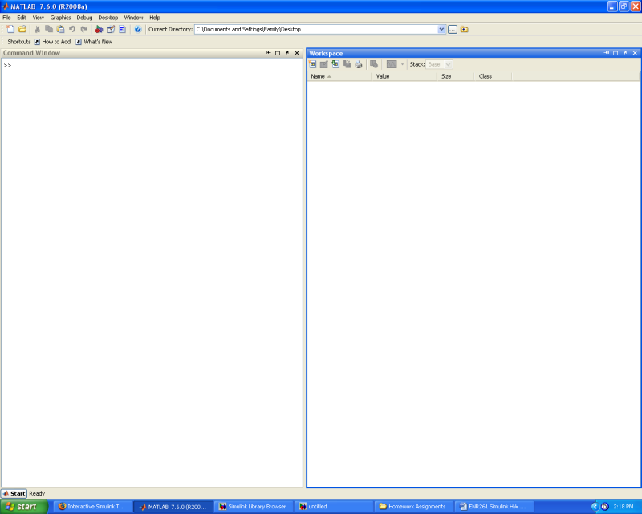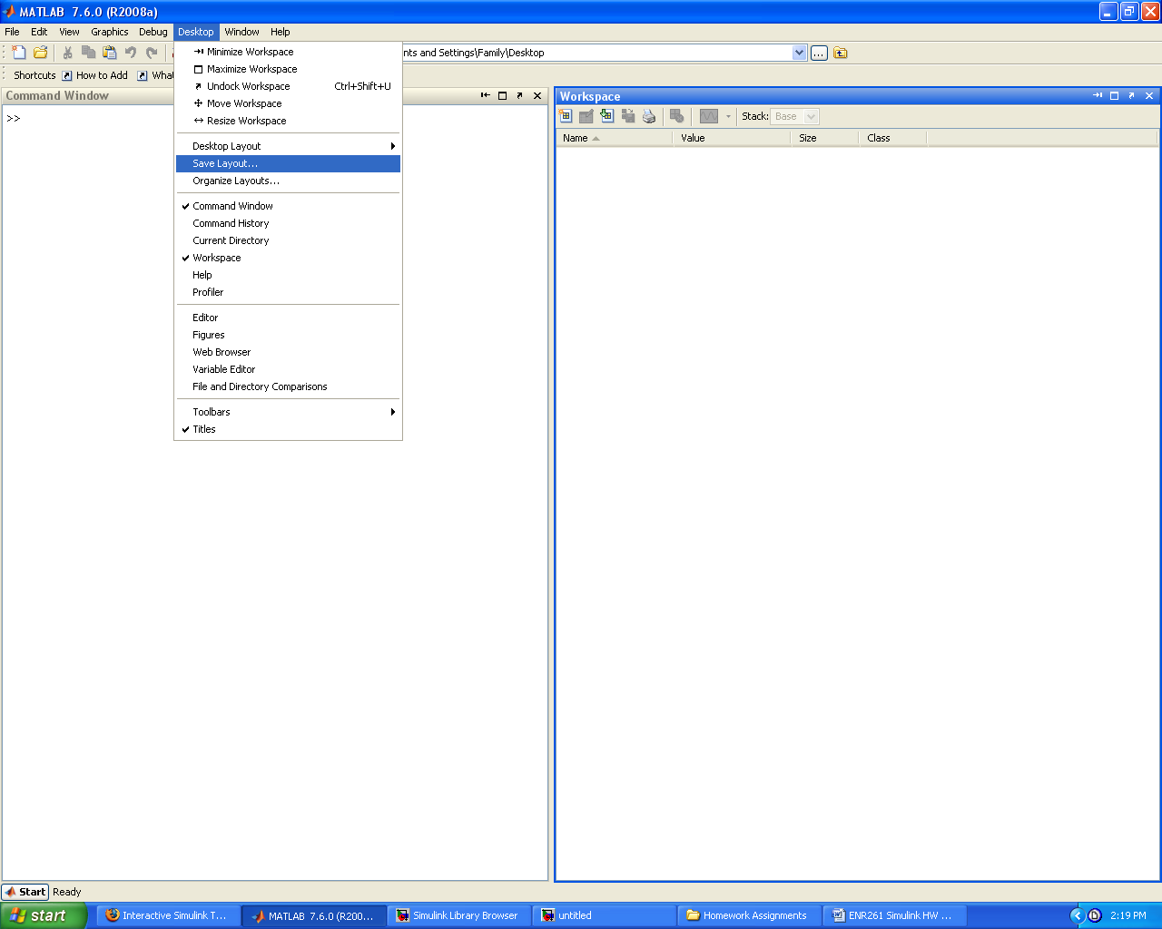

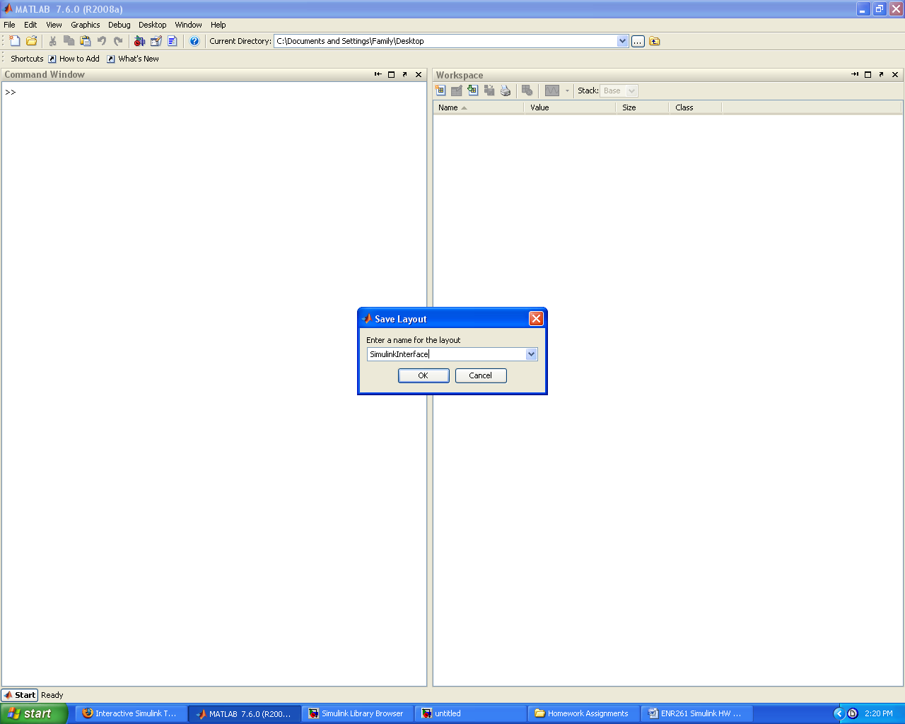

2. Refer to the following link for the online **On-Ramp** **Tutorials**. <https://www.mathworks.com/academia/student_center/tutorials/source/simulink/onramp/player.html>

3. You will need to watch and listen (you will need sound) the first two On-Ramp modules below in order to complete **Tutorial_Simulink_1.slx**

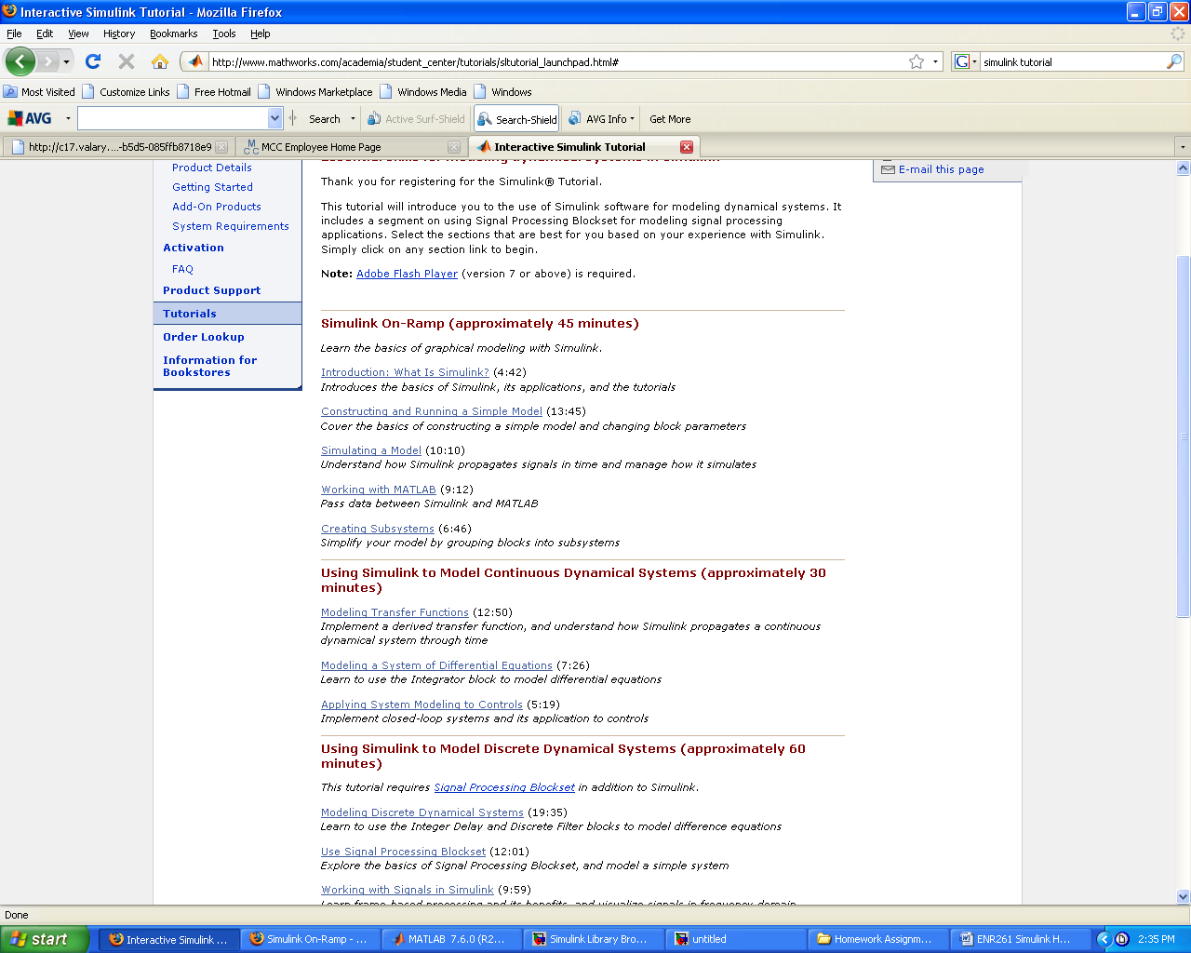

7. Launch Simulink within Matlab by clicking on the Simulink Icon.

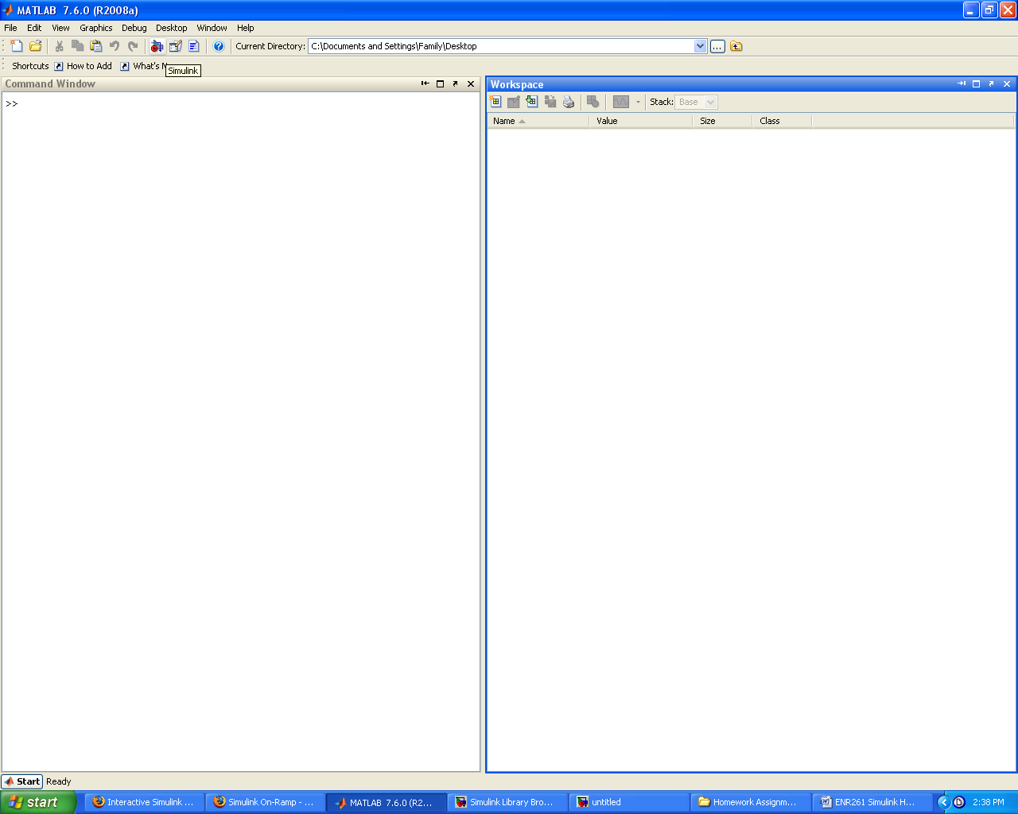

8. Create the Simulink file to implement the function: A*sin(t) where A is defined in the Matlab Workspace. Display the output with a scope. Use descriptive labels for all components and connecting lines as shown below.

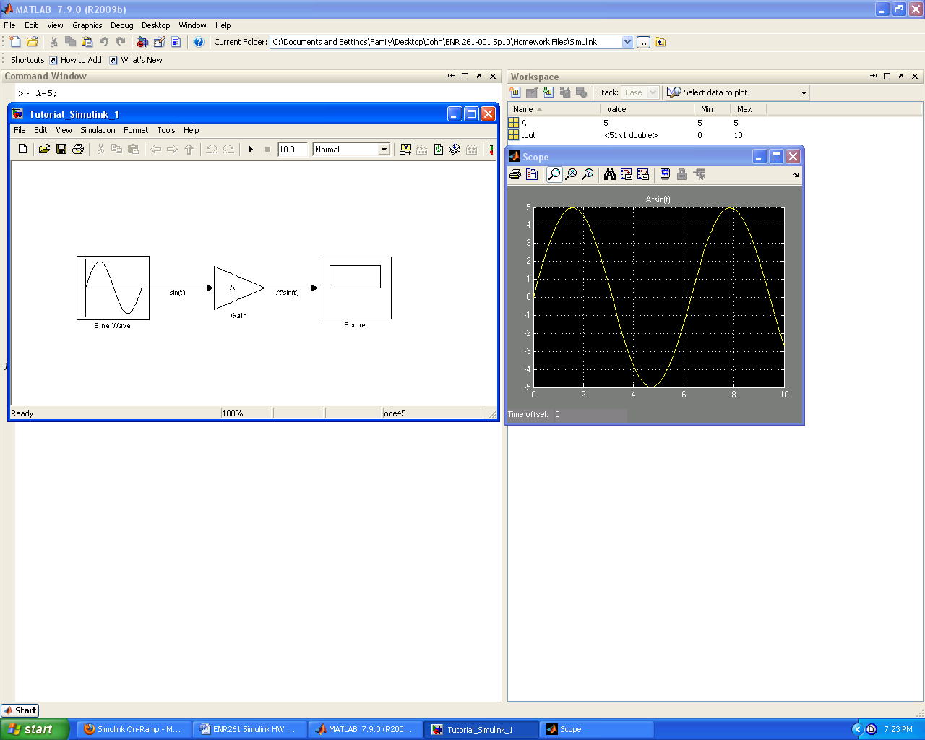

9. To add a Block Description to your Simulink model follow the steps below.

A. Double Click in the Simulink Model window and a small rectangle and blinking cursor should appear.

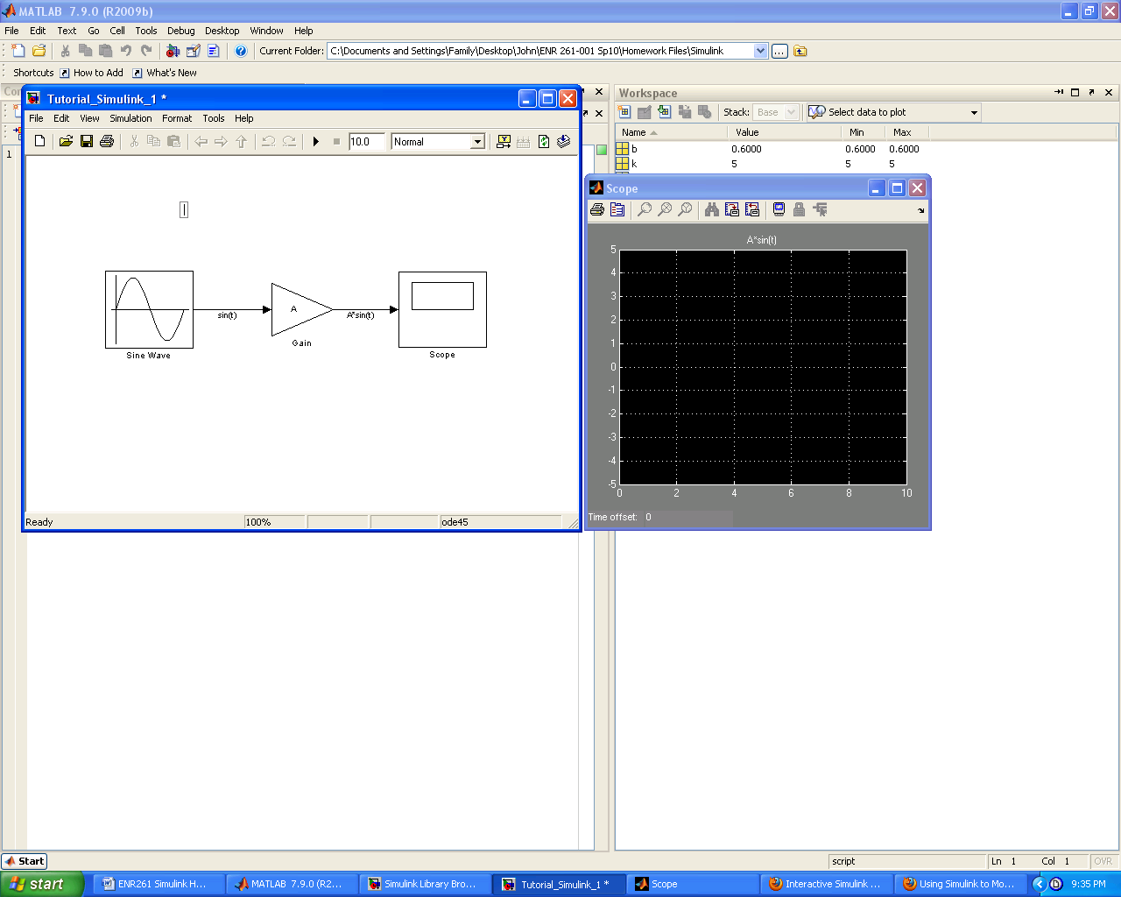

B. Type in the filename, your name, and a description of the model.

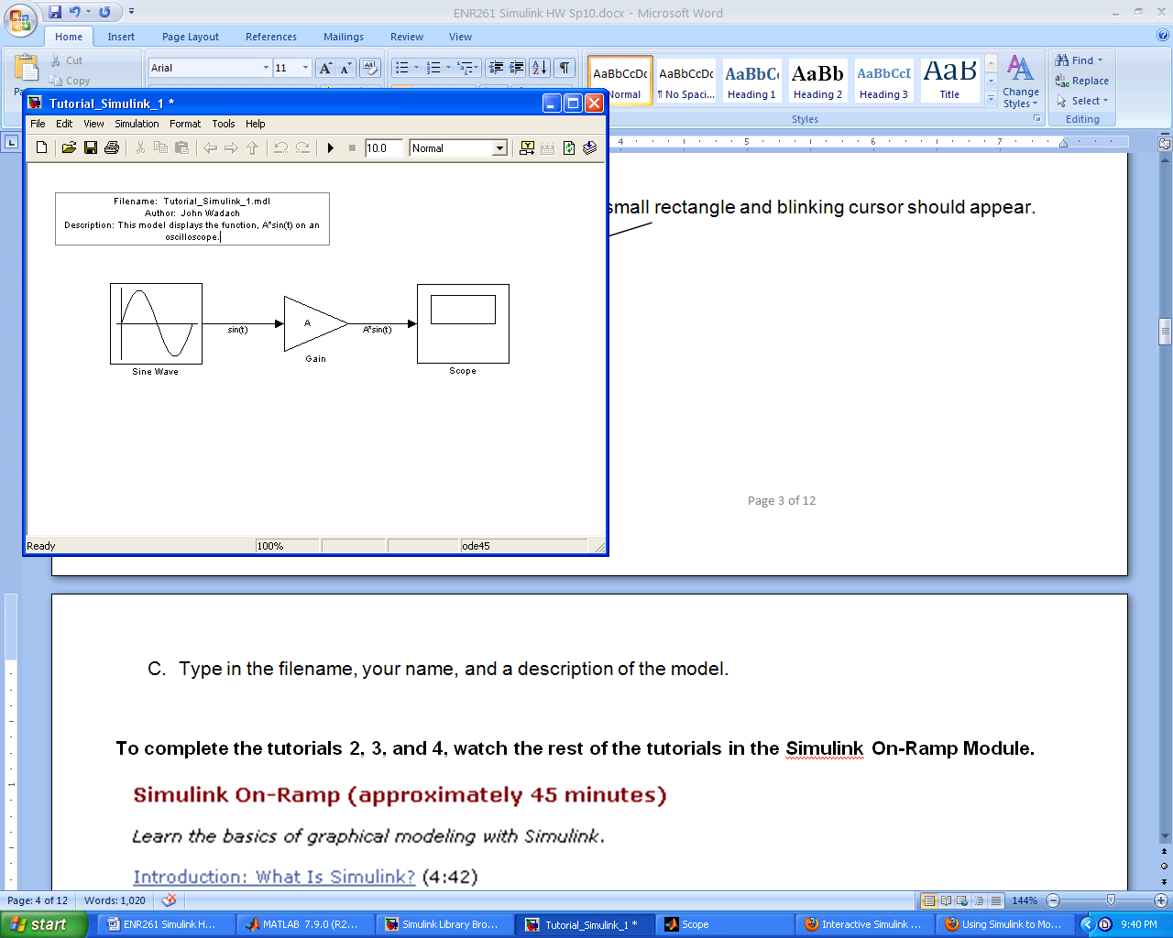

C. Click on the annotation block to select it and then click on Edit/Annotation Properties

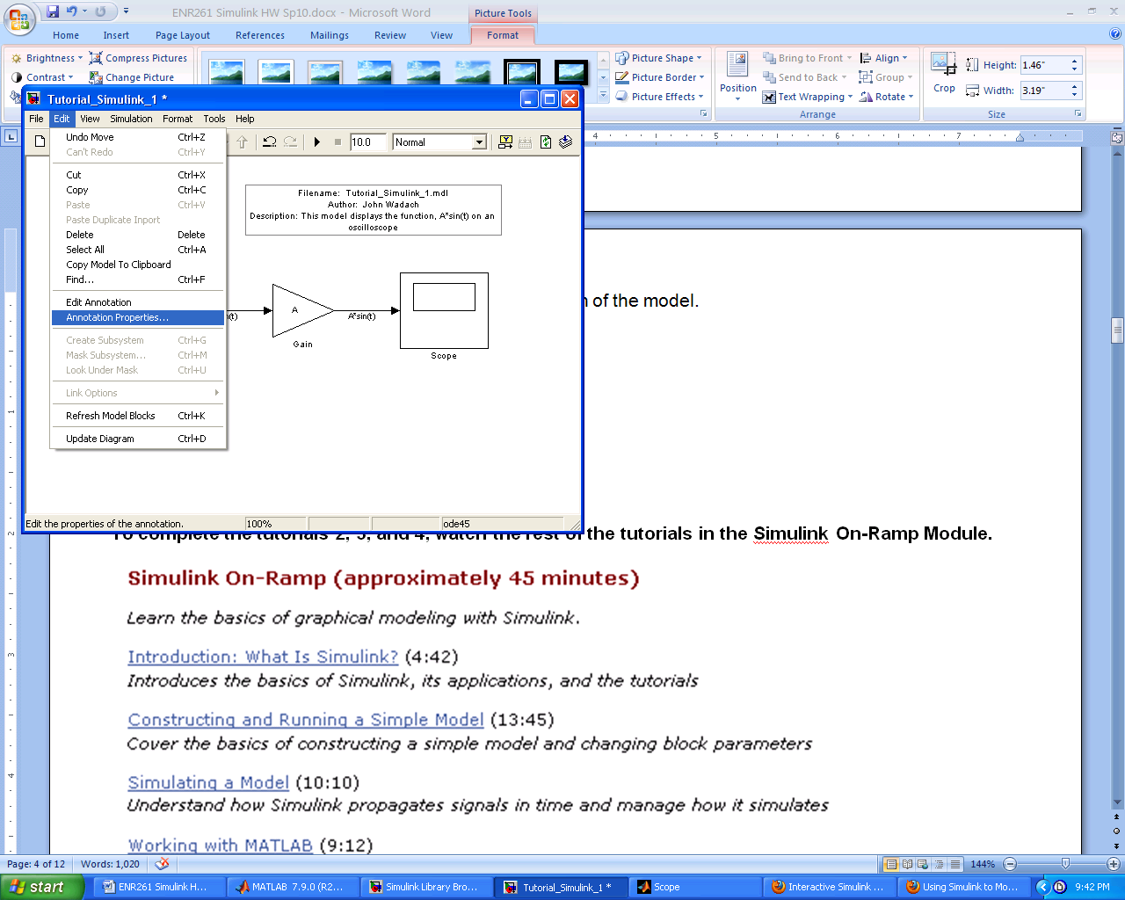

D. Select Drop Shadow, Left Justification then click on the Font and change the size to 16. You can now align the text as shown below.

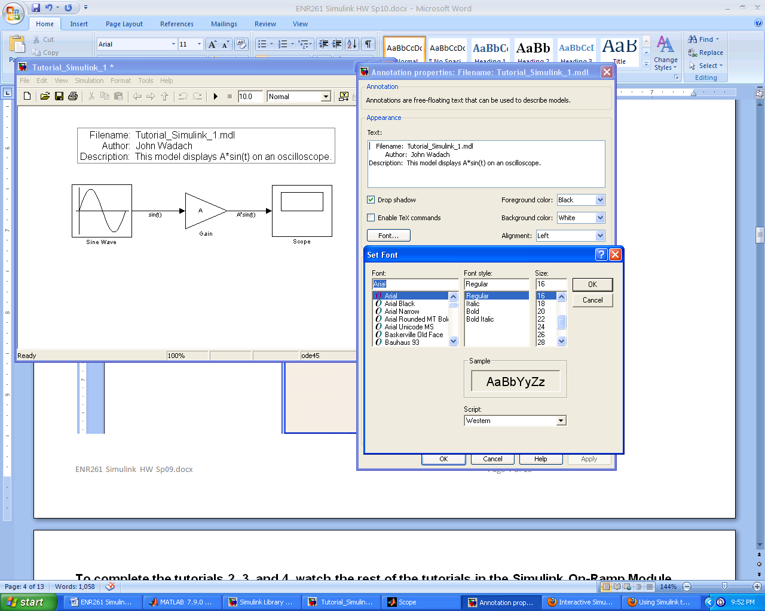

**To complete the tutorials 2, 3, and 4, watch the rest of the tutorials in the Simulink On-Ramp Module.**

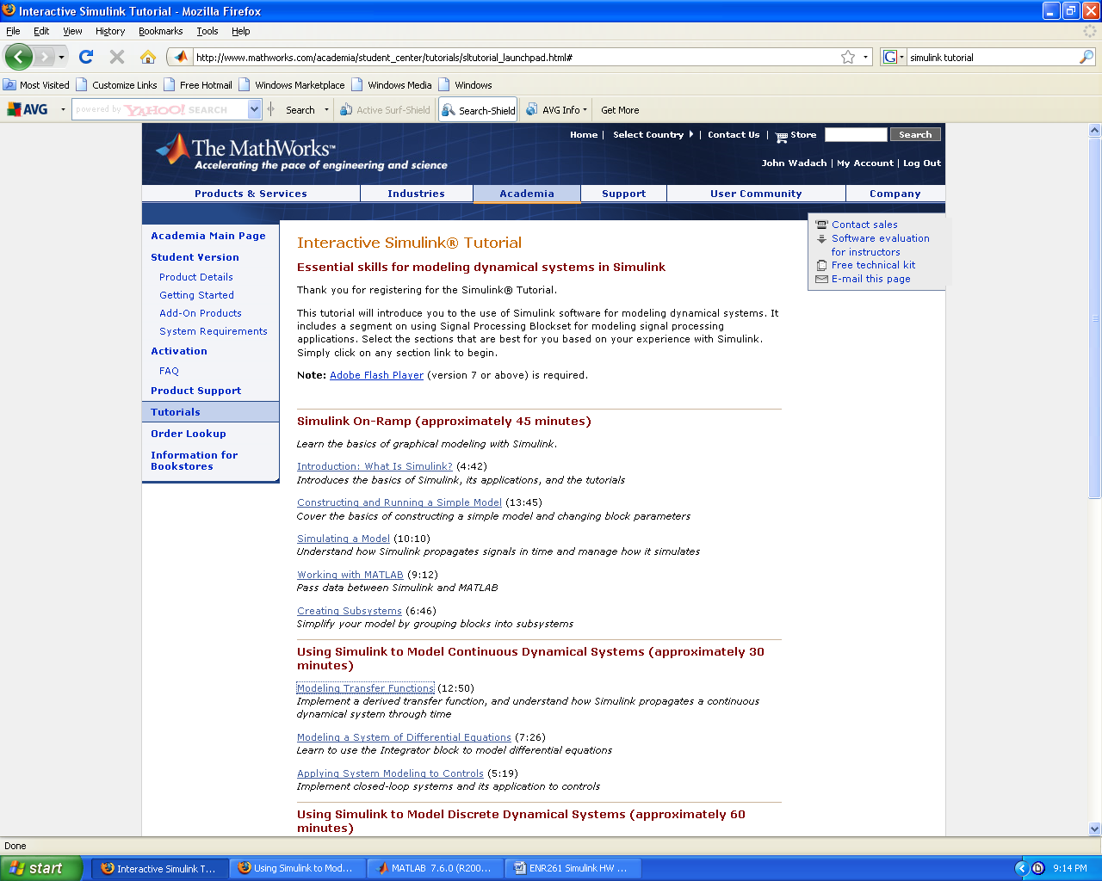

Required File Name: **Tutorial_Simulink_2.slx**

1. Create the Simulink file to implement the function: 5*(sin(t) + sin(2*t)) – 10 with a maximum step size of 0.1 and a total run time of 40. Display the output with a scope. Use descriptive labels for all components and connecting lines as shown below.
2. Display the output with a scope.

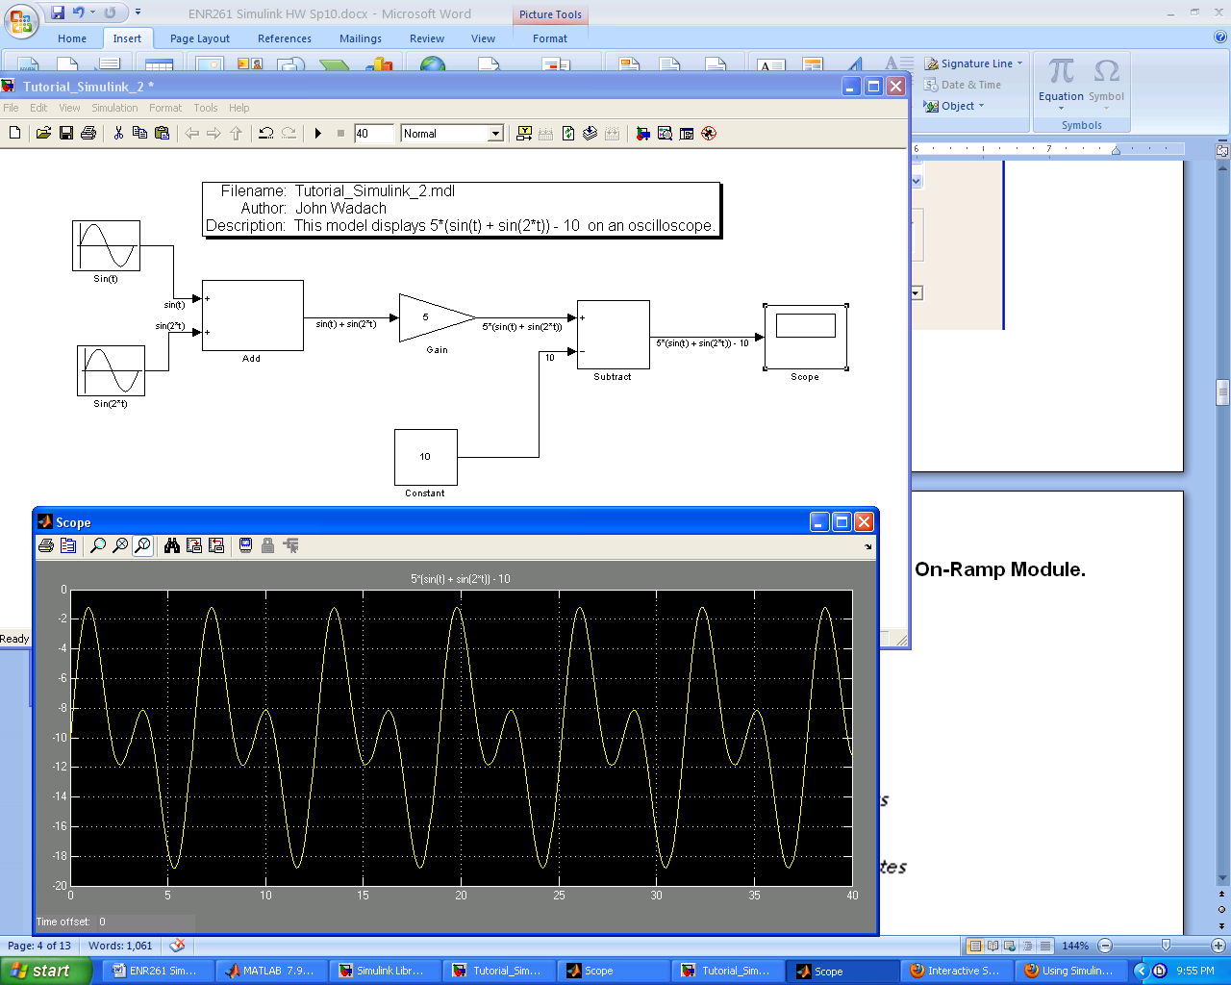

Required File Name: **Tutorial_Simulink_3.slx**

1. In the Matlab Workspace define two column vectors as shown below.

t = [0: 0.05: 10]’; u = sin(t.^2);

2. In the Matlab Workspace define the array named input1 = [t u];

3. Import the input1 values into a Simulink model to implement the following equation:

y(t) = 2*u(t) for t >= 5

y(t) = 5*u(t) for t < 5

4. Set the max step size in the Simulink Model to 0.05 .

5. Export the values of u(t) and y(t) from the Simulink Model to the Matlab Workspace in a variable named **output**.

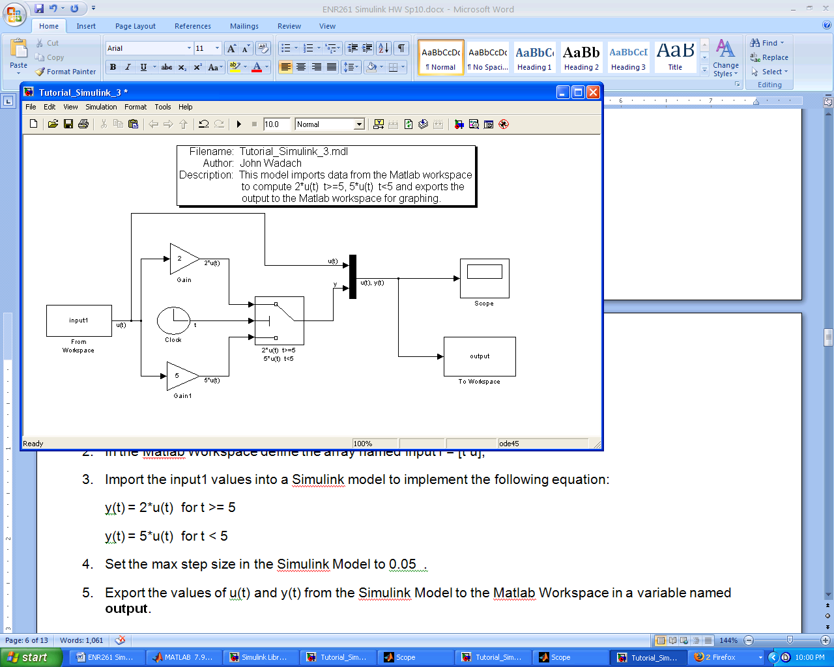

6. In the Matlab Command Window execute the command **plot(tout, output.data).**

7. Edit your plot in the figure window so that it appears as on the next page. Save the figure with the name **Tutorial_Simulink_3.fig** .

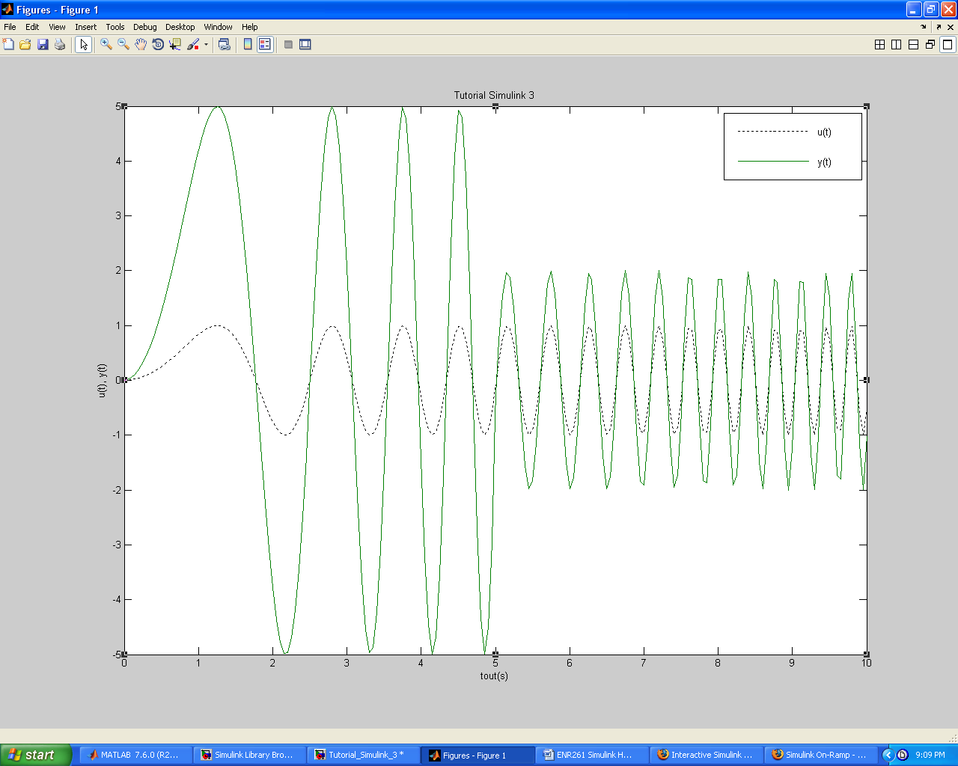

Required File Name: **Tutorial_Simulink_4.slx**

1. Modify **Tutorial_Simulink_3.slx and save it as Tutorial_Simulink_4.slx** by making the following changes.

a. Create a Subsystem for all components except the **From Workspace**, **Scope** and **To Workspace Blocks**.

b. Remove the Mux Block in the subsystem and create two outputs labeled u(t) out and y(t).

c. Replace the From Workspace Block with a Sine Wave Block. Double click on the Sine Wave Block and make sure that Time(t) uses Simulation Time.

d. Replace the To Workspace Block with a second scope.

e. Run the simulation from 0 to 10 seconds using the default step size.

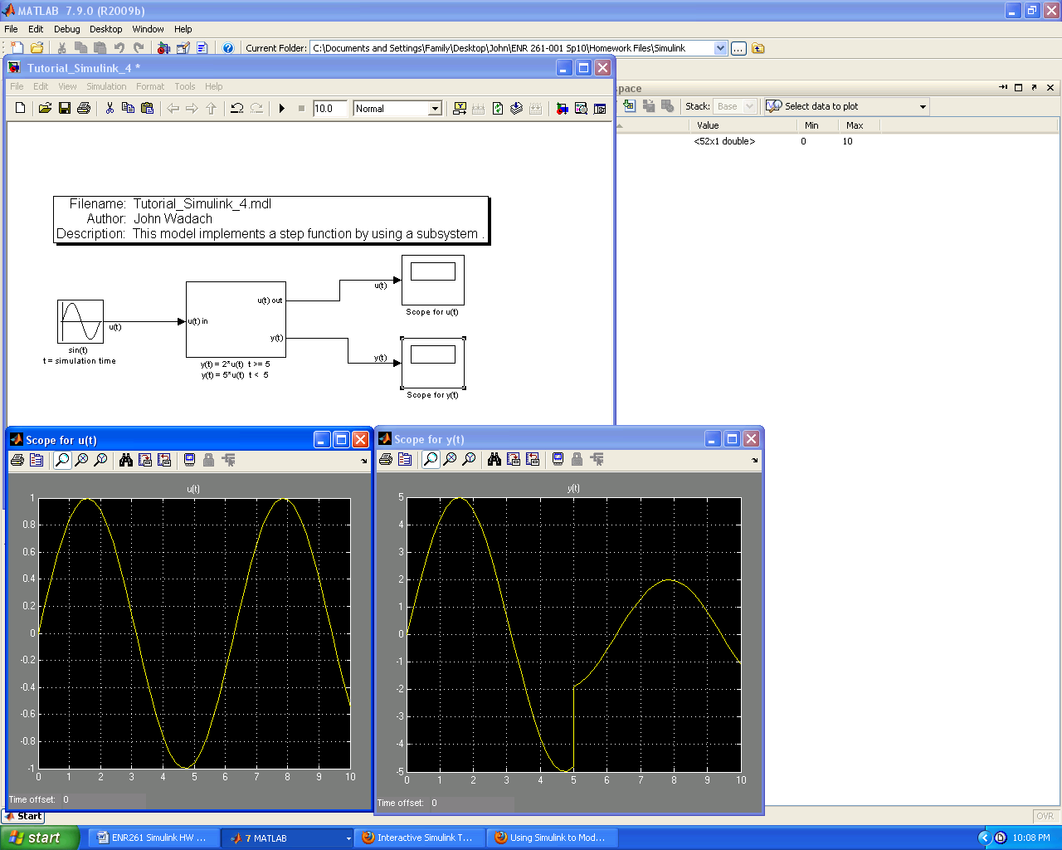

**To complete tutorials 5 and 6 watch the first two tutorials in the Using Simulink to Model Continuous Dynamical Systems.**

**Unfortunately I have been unable to locate this portion of the On-Ramp Tutorials however, the models are shown in the images below (with the exception of the Laplace transform. What you have learned thus far is enough to get you through the remaining tutorials.**

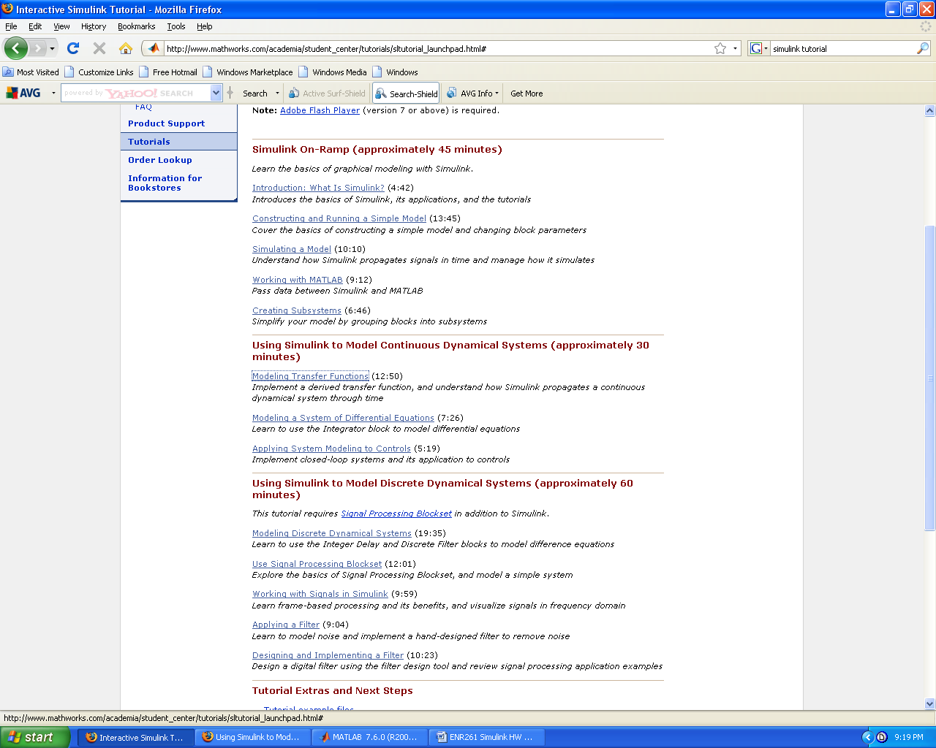

Required File Name: **Tutorial_Simulink_5.slx**

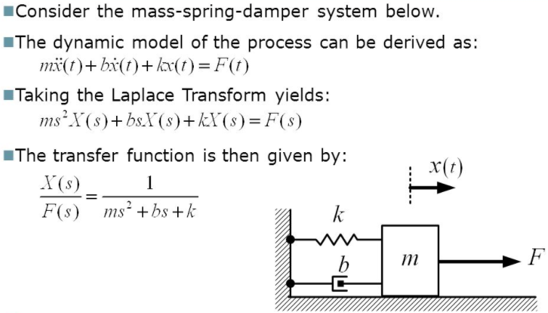

1. Construct a Simulink file to model a Mass-Spring-Damper System using a Laplace Transform with m=1, b=0.6, k=5, and F(t)= a step function with an initial value of 0 and final value of 10.

2. *Hint:* You should use a Transfer Fcn block and set the denominator coefficients to [m b k] to create a Laplace Transform Transfer Function. More details as to why can be found in the Help Documentation.

3. Define m, b, and k in the Matlab Workspace so the program user can easily change these values.

4. Display the results from 0 to 15 seconds in steps of 0.1 sec using an oscilloscope as shown below.

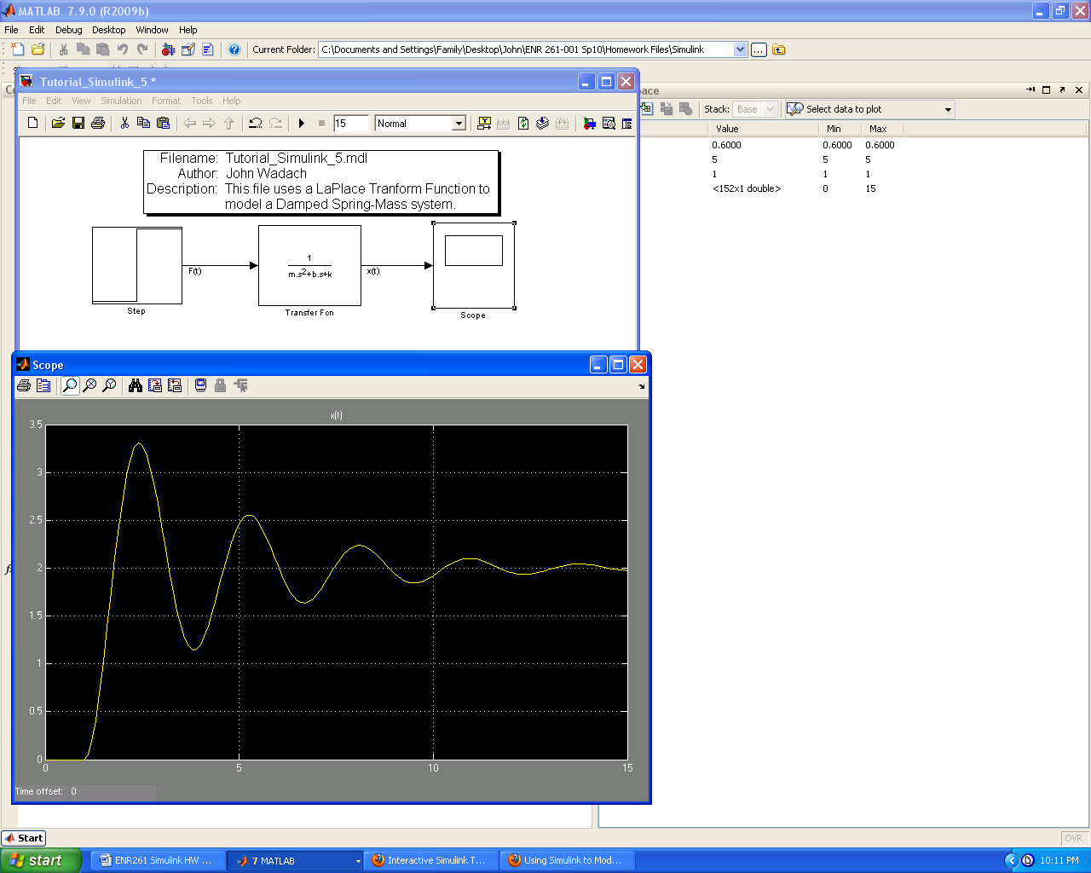

Required File Name: **Tutorial_Simulink_6.slx**

1. Construct a Simulink file to model a Mass-Spring-Damper System using a second order differential equation with m=1, b=0.6, k=5, x0=10, v0=0, and F=0.

2. Define m, b, k, x0, and v0 in the Matlab Workspace so the program user can easily change these values.

3. Display the results from 0 to 15 seconds in steps of 0.1 sec using an oscilloscope.

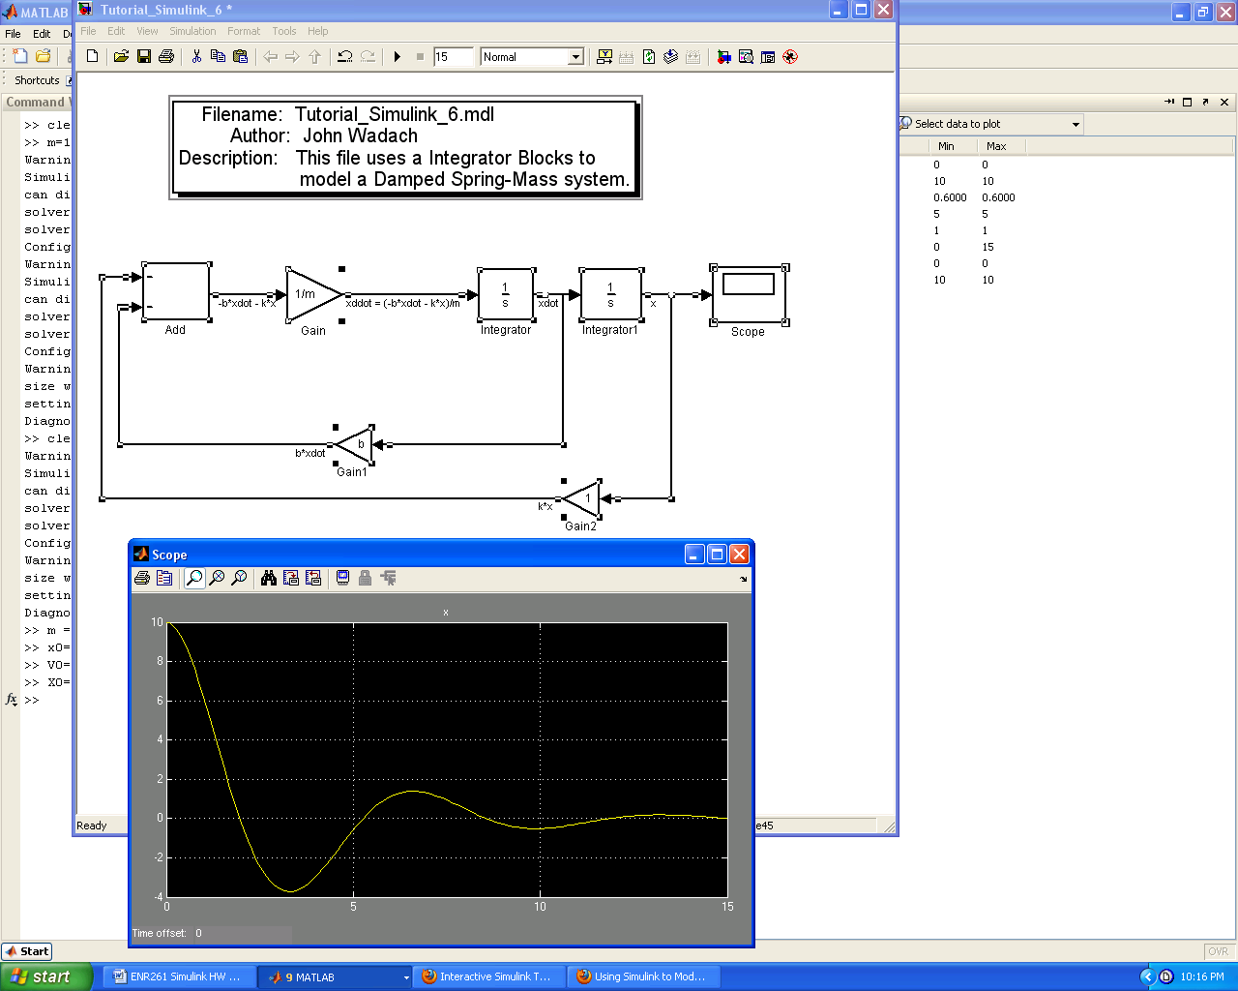

Complete the programs on the following pages for **Extra Credit**

**Extra Credit** File Name: **Program_Simulink_1.slx**

1. Create a Simulink model for problem 21 from chapter 10 of the Gilat book but note that the rate of change of the height should be negative because as time increases, the height (y) decreases.

2. Define y0, g, and rh in the Matlab workspace.

3. The sqrt and square functions are located in the Math Function block that can be found in the Math Operations Library of Simulink.

4. Display the value of y in an oscilloscope from 0 to 3000 seconds. Use your oscilloscope image to determine the time to the nearest second that y reaches 0.1 m. Print this value in your title block of your model. You can use zoom with the oscilloscope image to improve your estimate.

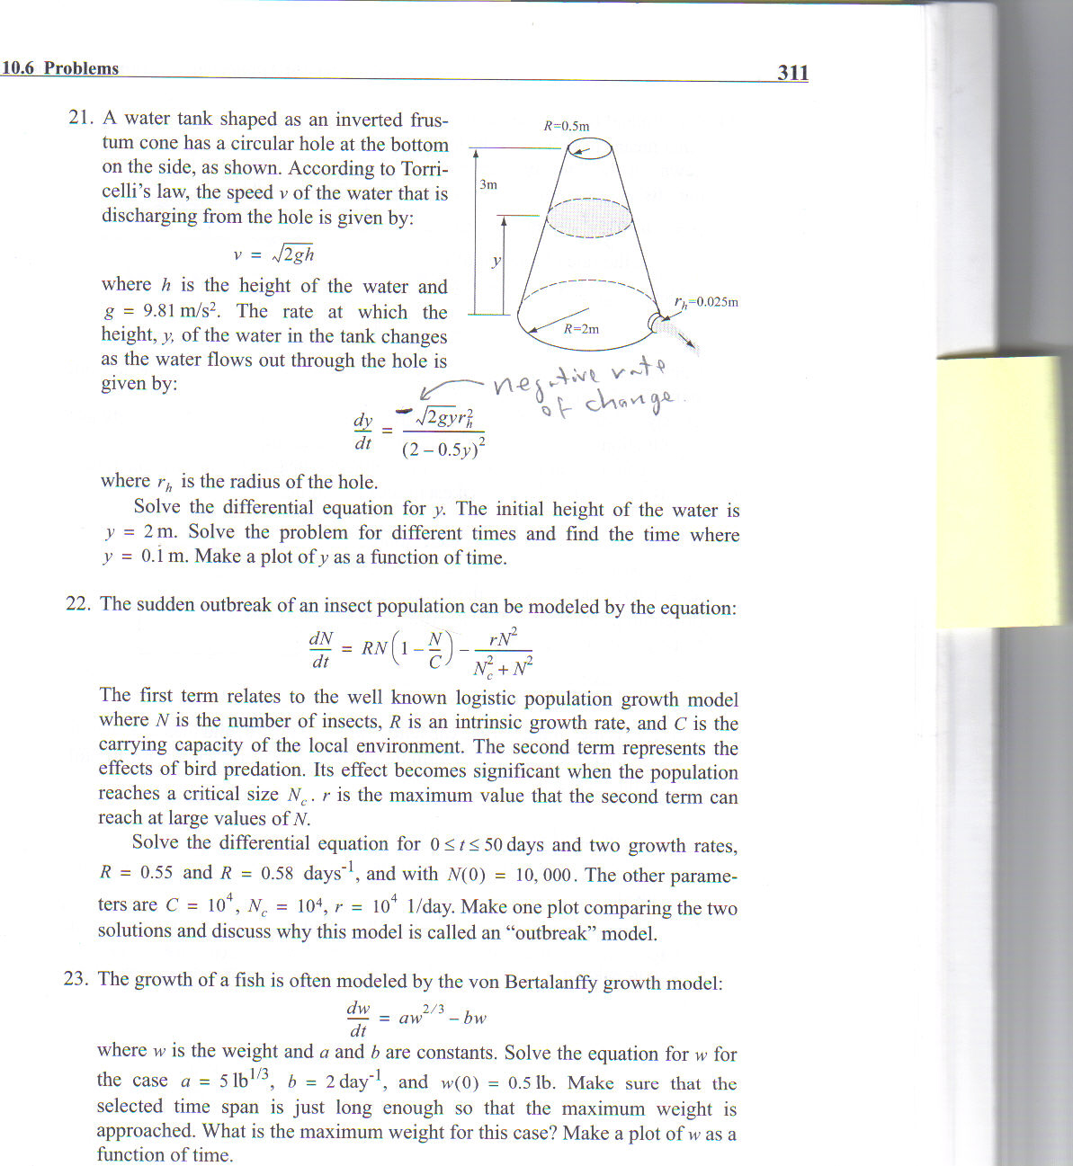

**Extra Credit** File Name: **Program_Simulink_2.slx**

1. Create a Simulink model for problem 21 from chapter 11.

2. In order to simulate the movement of the circuit switch from B to A when Vr > 5v, you will need a **Switch Block** and a **MinMax Running Resettable Block** (found in the Math Operations Library). You will need the MinMax Running Resettable Block so that when Vr exceeds 5v for the first time, it will maintain an output of 5v to the Switch block so that 0 volts is selected instead of Vs.

3. Define R, L, and Vs in the Matlab workspace.

4. Display the value of Vr in an oscilloscope from 0 to 2.0 seconds.

5. You will need to set the maximum step size to 0.001 second.

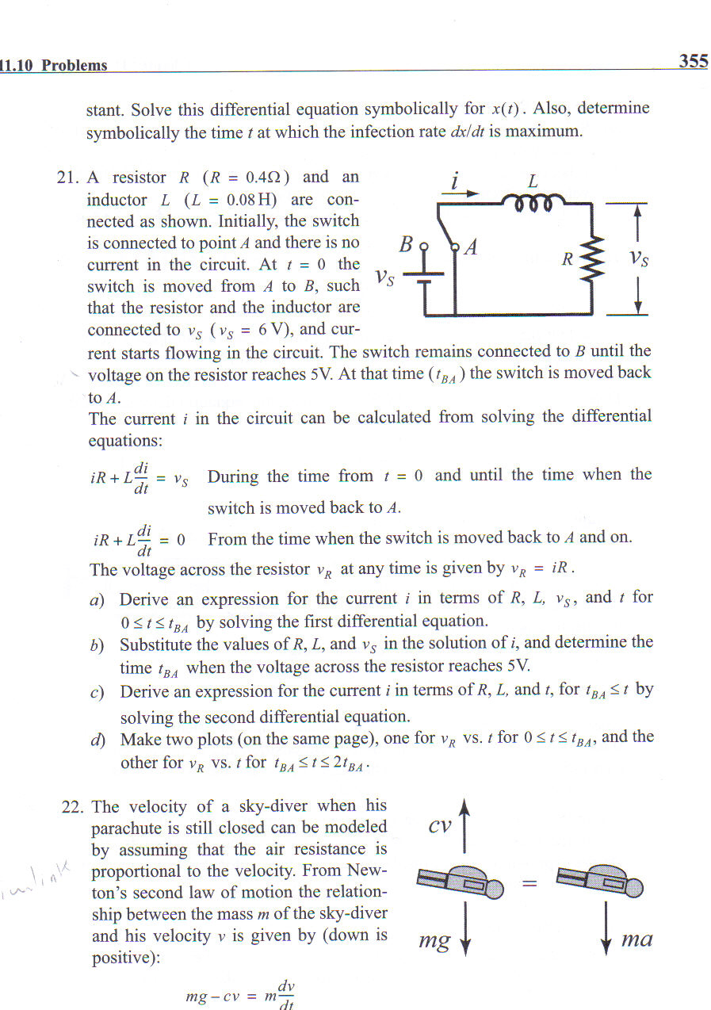

**Extra Credit** File Name: **Program_Simulink_3.slx**

1. Create a Simulink model for problem 24 from chapter 10 of the Gilat book.

2. Display the acceleration, velocity, and position graphs from 0 to 13 seconds using oscilloscopes.

3. Output the velocity and position values to the workspace and use them to create a matrix variable named table with tout in the first column, position in the second column, and velocity in the third column.

4. Use your table matrix to determine the time, to the nearest tenth of a second, when the plane comes to rest. Also record the position when this occurs. Type these values into your Simulink heading block.

