**Question 15.1: Relational Operator Review**

How would you fill in the blanks below to see if the variable

avg

is equal to the variable

avg_long_way

and store the result in a new variable called

are_they_equal

?

______________ = avg     ___________ avg_long_way;

**Question 15.2: The Key Concepts**

Before we continue learning about functions, recall the four key concepts we just learned about MATLAB functions.  
1) Functions exist to make it easy to run snippets of __________ with different ______________.  
2) Functions make your code easier to __________  and easier to type.  
3) Functions can accept multiple ___________  and can return any number of _________________.  
4) Well written ________________ text is critical to writing a good function.

**Question 15.3: Which files are in the current working directory?**

Look at the screenshot provided, which area lists the current working directory?

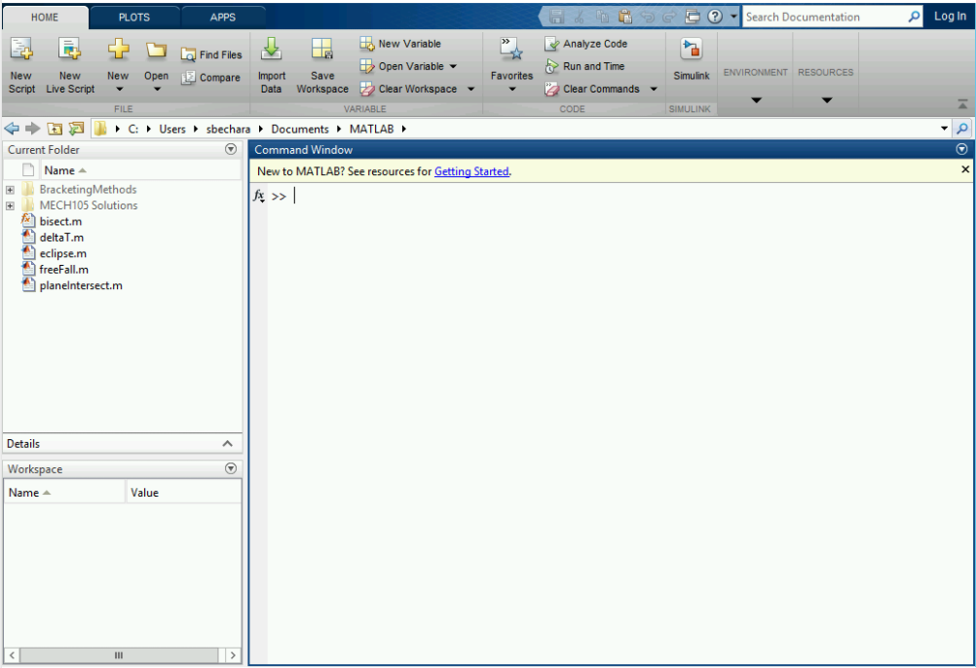

1. Current Folder
2. Command Window
3. Workspace

**Question 15.4: What does everything mean?**

From the function definition we decided

function ​[volume] = sphere_vol(radii)

match the code with the correct description.

1. Function output variable
2. Radii function name
3. Volume required first word
4. Sphere_vol input variable

**Question 15.5: What is the path?**

Earlier in this book we discussed the importance of the "Current Working Directory". When working with functions, it becomes critical to remember what folder you are currently in, and what folder your functions are stored in. To review, look at the screenshot of the MATLAB GUI provided. What is the current working directory of this user?

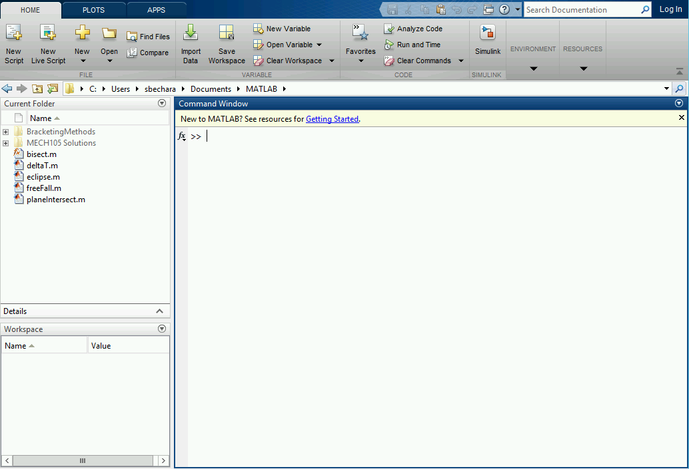

1. My documents
2. Impossible to tell
3. C:/Users/sbechara/Documents/MATLAB

**Personal Reflection – Chapter 15**

What do you think about the content of this chapter? Do you think it makes sense? Do you see why functions are useful? Are you still confused about it? Do some personal reflection about your learning.

**Request for feedback – Chapter 15**

What did you think of this chapter? Anything stand out as exceptionally good? Anything that you would like to see differently? Any feedback is appreciated.