# Instructions for Everyone

* Shoot for ~10 problems per chapter.
* Do 4 chapters a week.
* Can do solutions, by hand or MATLAB
* Questions can be: multiple choice, **numeric answer**, word answer, fill in the blank, matching, or sorting. Or essay question.

# Bios

**Owen Wahl** – Owen Wahl is an undergraduate student at Colorado State University pursuing a dual degree in Biomedical and Mechanical Engineering. He has worked at the Orthopaedic Bioengineering Research Laboratory where he conducted biomechanical testing on guinea pig femurs to understand the effects of inflammaging. After graduation, Owen hopes to advance innovative medical solutions that improve lives around the world. When he isn’t studying, you might find him playing ice hockey, soccer, or spikeball, or maybe even ruining friendships in Settlers of Catan.

**Maddie D’Amato** – Maddie D’Amato is a student at Colorado State University in the process of getting a dual degree in Biomedical and Mechanical Engineering. She currently works at the Orthopaedic Bioengineering Research Lab (OBRL) and after she graduates, she is interested in working with orthopedics and prosthetics. Maddie enjoys rock climbing, specifically sport climbing, and she never passes up an opportunity to play Just Dance. She absolutely adores all animals and it is her dream to meet a sloth one day.

**Erin Estrada** – Erin Estrada is an undergrad at CSU due to graduate in 2021 with her bachelor's degrees in Biomedical and Mechanical Engineering. She is originally from Arizona and loves to travel and hopes to find a job that will accommodate her wayfaring personality. On a typical weekend, Erin can most likely be found studying, painting in her basement “studio”, or hammocking with her dogs. She has an extensive houseplant collection and when she has the time, she enjoys baking for her friends.

**Michael Poland –** Michael Poland graduated from Colorado State University in 2020 with bachelor’s degrees in Biomedical Engineering and Mechanical Engineering. He is originally from Grand Junction, Colorado, and he enjoys hiking, skiing, and that smell when you just finished vacuuming. He got a C in Mech 103 because he didn’t yet know how to be a good student, but he worked hard and figured it out. In the future, he hopes to have a career that challenges him creatively, a house in the mountains, and a lot of close friends.

# Chapter 3

**Problem 1 (sorting) – Owen:**

Sort the following 14’ers in Colorado from largest to smallest using the provided measurements (used google to find each one):

La Plata Peak – 4.377 km

Mt. Harvard – 2.73 mi

Pikes Peak – 169,380 in

Mt. Lincoln – 14,295 ft

Mt. Evans – 4,348 m

**Problem 2 (numeric answer) – Owen:**

Your crazy friend wants to take you extreme skydiving, for some reason. He tells you that you will be jumping out of a plane from about 4000 meters high. That doesn’t sound that bad, but you’re used to using feet for measurements. Convert the measurement above to feet to see how scary the jump really is (<https://www.chattanoogaskydivingcompany.com/dropzone/skydiving-articles/what-height-do-you-skydive-from/>).

**Problem 3 (numeric answer) – Owen:**

The average hip-hop track typically has between 60-100 beats per minute (BPM). It turns out that the average resting heart rate is also between 60-100 BPM. Convert an average of 80 BPM to:

a) Hz, or cycles per second (s^-1)

b) Beats per year

(<https://www.mayoclinic.org/healthy-lifestyle/fitness/expert-answers/heart-rate/faq-20057979>, <https://learningmusic.ableton.com/make-beats/tempo-and-genre.html>)

**Problem 4 (numeric answer) – Owen:**

My microwave oven is rated at 1000 Watts, meaning it uses 1000 Joules/second to cook food. I pour out some milk refrigerated at 4°C into a 350 mL mug. I need to boil the milk for hot chocolate, but I don’t know how long to run the microwave. The heat capacity of milk is about 0.94 calories*mL^-1* °C^-1, meaning it takes 0.94 calories to heat 1 mL of milk 1 °C. How long should I microwave the milk in order to achieve boiling temperature? Use 1 calorie = 4.184 Joules for your calculations. (This is based off of a Quora post I found: <https://www.quora.com/How-much-do-microwaves-heat-food-by>. Also used <https://www.engineeringtoolbox.com/specific-heat-fluids-d_151.html> and <https://www.fda.gov/consumers/consumer-updates/are-you-storing-food-safely>).

**Problem 5 (fill in the blank/essay) – Owen:**

The Reynolds number *Re* is often used to determine the properties of a flowing fluid. The number is *dimensionless* and consists of fluid density *ρ* (kg*m^-3), length of fluid flow over a surface *L* (m), fluid velocity *V* (m*s^-1), and fluid viscosity *μ* (kg*m^-1*s^-1). Arrange these variables in order to form Reynolds number. What might be the value of a dimensionless number?

**Problem 6 (fill in the blank) – Maddie:**

You and your friend had a great idea to build a training ramp to master your Heelys skills before heading to the skate park. Your friend designs it and hands you the dimensions for the wood and metal needed for construction. It’s your job to go to the hardware store and buy the materials. When arrive, you quickly realize that all the materials in the store are premeasured in centimeters and for some odd reason your friend used a confusing mixture of units. Not only is this inconvenient, but as an engineer, you know it is bad practice and can lead to issues. Now it’s up to you to convert all the measurements to centimeters in order to save the project. The fate of your Heelys skills is on the line. Below is the shopping list from your friend that needs to be fixed. Write your final answer to 2 decimal places.

|  |
| --- |
| Heelys Ramp Materials List  1) ´50 pieces of 0.02 m by 1.219e-3 km by 2.032e+8 nm long lumber  2) ´10 pieces of 152.4 mm by 0.667 ft by 9525000 nm plywood  3) ´4 pieces of 10.16 cm by 1.516e-4 mi by ¾ in plywood  4) ´5 pieces of 4 in by 1 ft by 6350 mm Masonite  5) ´1 piece of 19.05 mm by 5.333 yd steel pipe |

**Problem 7 – Michael:**

In 1999, NASA and Lockheed Martin Astronautics collaborated on a robotic space probe called the Mars Climate Orbiter. As the name implies, its mission was to gather Martian climate and atmospheric data. Upon its arrival to Mars, it approached at an unexpected trajectory and was destroyed. The $125 million disaster was caused by a unit miscommunication. Lockheed Martin sent NASA critical data in English units instead of SI units. Convert the following English units to SI units to save NASA millions of dollars.

Radius of Mars: 2106.1 miles

Mars Gravitational Acceleration: 12.18 feet/s2

Mars Climate Orbiter Mass: 1407 lbs

Universal Gravitational Constant (G): 1.0697x10-9 ft3*lbm-1*s-2

**Problem 8 – Erin:**

You and your friends are participating in a marathon. You brought all the snacks and drinks necessary to sustain yourselves through the entire event and you are making great time. You began first thing in the morning at 6 am and now, exactly 30 hours later, you are about to start season 3 of Grey’s Anatomy. With the first two seasons out of the way, you have 327 episodes left to go, and each one averages 43 minutes in length. Assuming you don’t have to watch commercials, and you finish at exactly 6 am one month (31 days) after starting the first episode of season 1, how much time did you spend doing other things during this time (i.e. eating, sleeping, being productive members of society, etc.)? Give your answer in units of hours.

# Chapter 3 Solutions

**Solution 1 – Owen:** Can be sorted by any measurement:

1. Mt. Harvard – 2.73 mi * 5280 ft/1 mi = **14,414 ft**
2. La Plata – 4.377 km * 10^3 m/1 km * 100 cm/1 m * 2.54 in/1 cm * 1 ft/12 in = **14,360 ft**
3. Mt. Lincoln – 1**4,295 ft**
4. Mt. Evans – 4,348 m * 100 cm/1m * 1 in/2.54 cm * 1 ft/12 in = **14,265 ft**
5. Pikes Peak – 169,380 in * 1 ft/12 in = **14,115 ft**

**Solution 2 – Owen:** 4000 m * 100 cm/1m * 1 in/2.54 cm * 1 ft/12 in = **13,123 ft**

**Solution 3 – Owen:**

a) 80 BPM * 1 s^-1/60 BPM = 1 min/60 s = **1.33 Hz**

b) 80 BPM * 60 min/1 hr * 24 hr/1 day * 365 days/1 year = **4.2 * 10^7 beats/year**

**Solution 4 – Owen:** Boiling temperature = 100 °C -- milk needs to be heated 96 °C

1. 94 °C * 350 mL * 0.94 cal/(mL* °C) = 30,926 cal
2. 30,926 cal * 4.184 J/1 cal = 129,394 J
3. 129,394 J * 1 s/1000 J = **129 seconds = 2 minutes 9 seconds**

**Solution 5 – Owen:** *Re* = **(*ρ* * *L* * *V)/μ***= (kg*m^3*s)/(kg*m^3*s) = 1

The last part doesn’t have to be included, but I thought it might be interesting. Dimensionless numbers are good for scaling variables between models and prototypes for designs. An example would be testing drag on a sport car in a wind tunnel. The value of these number can also represent the overall state of a system, rather than one dimension of a system. Reynolds number represents the state of a flow system, for instance.

**Solution 6 – Maddie:** (fill in the blank) ==> need to add work

1. **60.69** cm by **121.92** cm by **20.32** cm
2. **15.24** cm by **20.32** cm by **0.9525** cm
3. **10.16** cm by **25.40** cm by **1.905** cm
4. **10.16** cm by **30.48** cm by **0.635** cm
5. **1.905** cm by **487.68** cm

**Solution 7 – Michael:**

Radius of Mars: **3,389.4 km**

Mars Gravitational Acceleration: **3.71 m*s^-2**

Mars Climate Orbiter Mass: **638.1 kg**

Universal Gravitational Constant (G): **6.68 x 10^-11 m^3 *kg^-1*s^-2**

**Solution 8 – Erin:**

Time between starting season 3 and finishing season 16:

31 days * 744 hours

744 hours – 30 hours = 714 hours

Time to watch 327 episodes:

327 episodes * 43 min/episode = 14,061 min

Time spent doing other things:

714 hours – 234.35 hours = **479.65 hours**

# Chapter 4

**Problem 1 (matching) – Owen:**

Match the following scenarios with the appropriate method of cell addressing (hint: simulate each scenario in excel!):

Scenarios

1) Dan is running a weight loss program and calculates the weight loss of each patient using Excel. Dan records the before and after weights side-by-side for each participant. He wants to record the range for all participants efficiently.

2) Charles wants to calculate the Reynolds number of the flow in tubes with different diameters. He wants to run the water at various speeds through each tube. He chooses five different water speeds to run through three differently sized tubes, where rows contain velocity and columns contain diameter. Density and viscosity are constant and don’t need to be included.

3) Sadie is recording different values of bending stress for different materials. Each row in an Excel table represents a type of metal (i.e. plastic, metal, wood) and each column represents a variation of each material (i.e. aluminum, polyethylene, oak wood). She realizes the machine used to test each material was uncalibrated during testing and has to multiply all values by a calibration factor.

Cell Referencing Methods

Relative

Absolute

Mixed

**Problem 2 (numerical answer) – Owen:**

Below are Lebron James’ season point averages over his career from newest to oldest (<https://stats.nba.com/player/2544/>):

25.7, 27.4, 27.5, 26.4, 25.3, 25.3, 27.1, 26.8, 27.1, 26.7, 29.7, 28.4, 30.0, 27.3, 31.4, 27.2, 20.9

a) Find the average of the last ten totals using Excel.

b) Find the median of the last ten totals using Excel.

c) Find the standard deviation of his averages over the last ten years using Excel.

**Problem 3 (numerical answer) – Owen:**

A tennis ball is launched multiple times from a launcher. It always reaches the same height of 15 meters, but is launched at different angles relative to the ground. The angles are provided below:

15°, 85°, 63°, 42°, 21°, 79°, 50°, 34°, 59°, 19°

Use the appropriate trigonometric function in Excel to find the horizontal distance each ball was launched before reaching a height of 15 m. **Note:** the trigonometric functions in Excel assume all inputs are in radians.

**Problem 4 (matching and free response) – Maddie:**

Dominic has been a dedicated Call of Duty player for years now and he loves the newest version, Call of Duty: Warzone. For fun, he wants to keep track of his game play in Excel. So far, he has recorded data in Excel for 8 weeks, which can be seen in the image below.

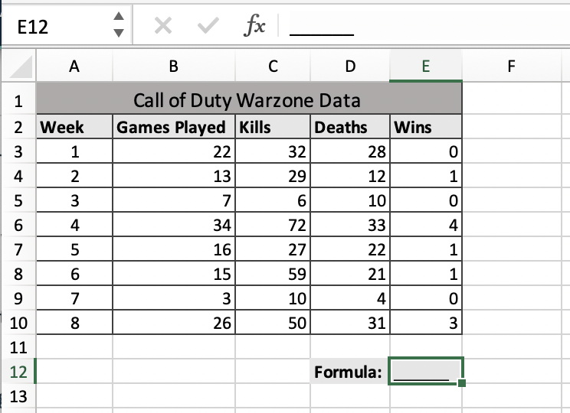

Part 1: (matching) Dominic made a list of the calculations he wants to make from his data. Help him out by matching the type of calculation to the formula or function he would need to input into cell E12.

|  |  |
| --- | --- |
| 1) Average number of games played over all 8 weeks | A) |
| 2) Kill to death ratio for week 5 | B) |
| 3) Total number of games won in the first four weeks | C) |
| 4) Maximum number of kills over all 8 weeks | D) |
| 5) Minimum number of deaths from week 3 to week 7 | E) |
| 6) Total number of games won over all 8 weeks | F) |
| 7) Average number of games won over all 8 weeks | G) |
|  | H) |
|  | I) |
|  | J) |
|  | K) |
|  | L) |

Part 2: (free response) Dominic wants to start a new column in F2 to easily keep track of his kill to death ratios for each week without having to enter individualized equations into each cell. Explain in detail how would he go about doing this. Reference the image below.

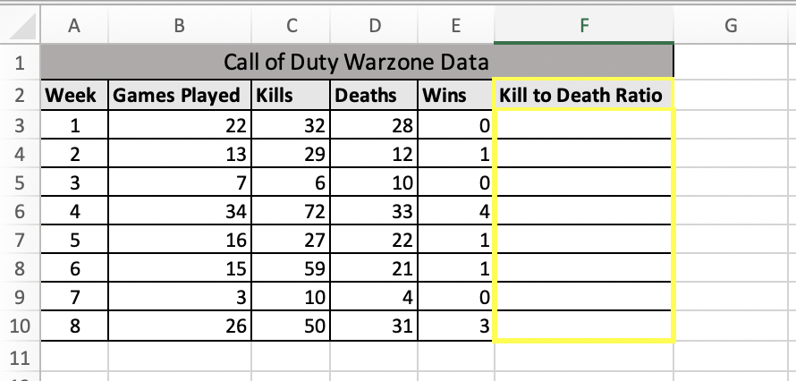

**Problem 5 (fill in the blank)– Maddie:**

Sierra is thinking about going on a road trip from Fort Collins, CO, but she can’t decide where to go. She created an Excel spreadsheet to layout the places she wants to travel which can be seen below.

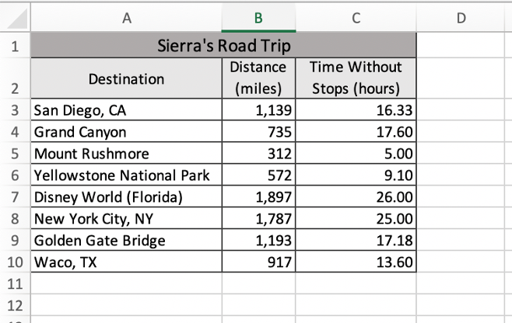

Sierra entered some functions into Excel to get the data she wants. Finish the following statements made regarding Sierra’s road trip calculations.

(recommend doing the calculations by hand at first to understand but can use excel to double check)

Fill in the blank: (round all numerical answers to 2 decimal places)

a. Sierra wants to find the total number of miles she would drive if she were to take all these trips. She enters the function = sum(B3:B10) into a random cell which outputs _____.

b. Sierra types = min(B4:B8) into cell D11 and the resulting value is _____.

c. The function = avg(C3:C10) outputs _____.

d. Sierra types the function =max(C3:C10) into a random cell find ____________.

e. The function = sum(C5:C9) / 5 outputs _____.

f. If Sierra wants to calculate the ratio of miles per hour if she goes to Yellowstone National Park, she will need to enter the function = ________ and the answer will be _____.

**Problem 6 (multiple choice) – Maddie:**

For a physics lab you are testing the maximum height of a projectile for 5 different objects. You’ve already ran the test by individually loading your objects into a projectile launcher and the data you have collected can be seen in the Excel spreadsheet below.

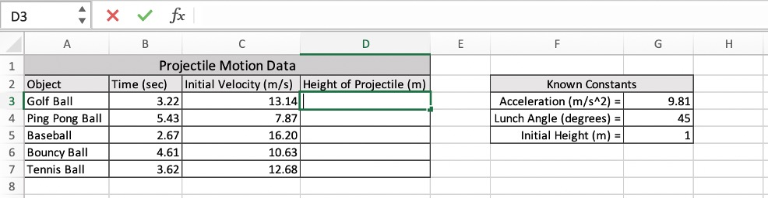

Instead of calculating the height of each projectile individually, you decide to create a column starting In D2 called ‘Hight of Projectile’. You insert you the formula you need into D3 so you can simply drag down the fill handle to easily calculate the projectile height for all the objects.

The equation needed to find the height of a projectile (y) is given below.

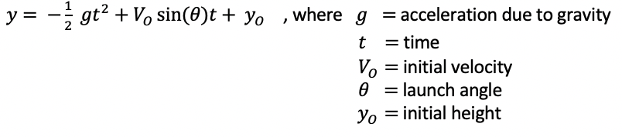

What will the formula that you type into cell D3 look like?

1. …
2. 
3. 
4. …

# Chapter 4 Solutions

**Solution 1 – Owen:**

1) **Relative** – Record before and after weights for multiple participants, calculate a range for one participant, then repeat for all others

2) **Mixed** – Using the formula for *Re*, plot five sample velocities in rows and three tube sizes in columns. For velocity, set the column variable as absolute. For pipe diameter, set the row variable as absolute.

3) **Absolute** – Define a calibration factor, and multiply every value by the cell containing the factor using absolute referencing.

**Solution 2 – Owen:** A screenshot of the data in Excel is provided below:

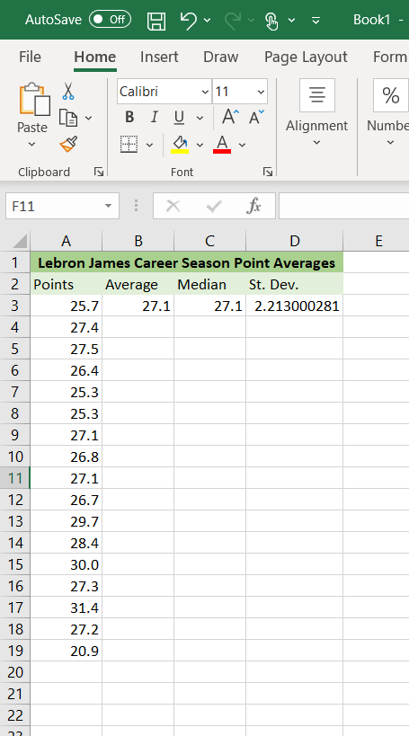

a) Calculate the average by using =AVERAGE(A3:A19), **Answer = 27.1**

b) Calculate the median by using =MEDIAN(A3:A19), **Answer = 27.1**

c) Calculate the standard deviation by using =STDEV.P(A3:A19), **Answer = 2.213**

**Solution 3 – Owen:** A screenshot of the data in Excel is provided below:

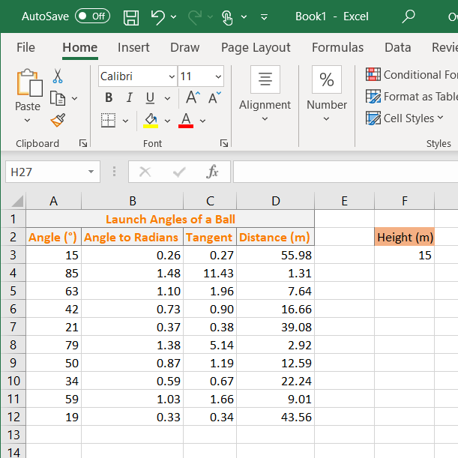

Steps:

1) List all of the angles as provided.

2) Convert all angles to radians using the function =RADIANS(). Copy the function to the remaining rows.

3) Calculate the tangent of each angle using =TAN(). Copy the function to the remaining rows.

4) Using tan(θ) = height/distance, solve for distance by inputting =height/tangent. In the example above, this would be =$F$3/C3 if you reference the height in its own cell. Copy the input to the remaining rows.

**Solution 4 – Maddie:**

Part 1: (matching)

1) = E) average(B3:B10)

2) = A) C7/D7

3) = J) sum(E3:E6)

4) = H) max(C3:C10)

5) = K) min(D5:D9)

6) = D) sum(E3:E10)

7) = G) sum(E3:E10) / 8

Part 2: (free response)

Start a new column in F2 called Kill to Death ratio. IN cell F3 enter the formula… and drag down or use colon…

Step 1) 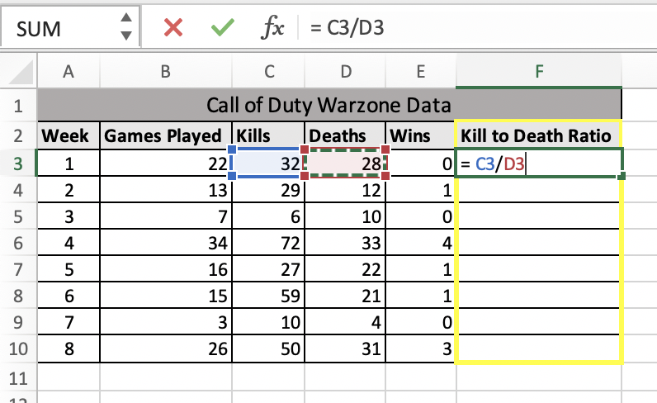

Step 2) 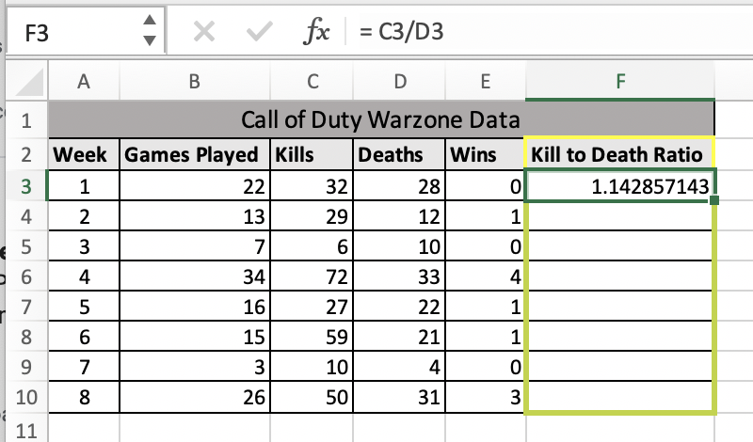

Step 3) 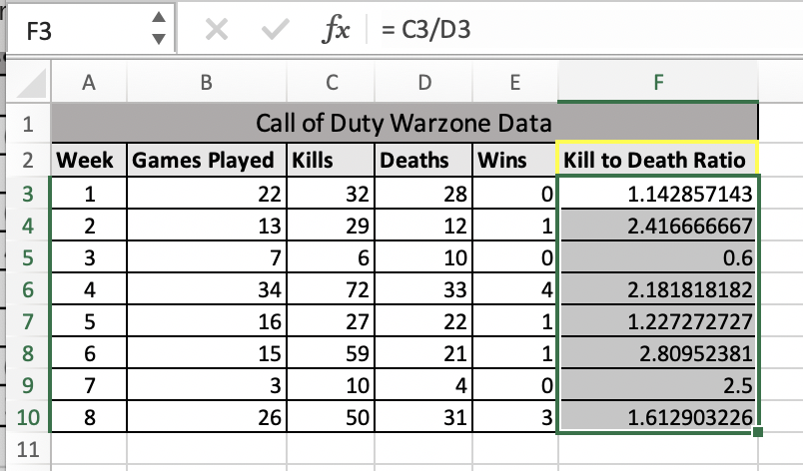

**Solution 5 – Maddie:** (fill in the blank)

1. 8,552
   1. 1,139 + 735 + 312 + 572 + 1,897 + 1,787 + 1,193 + 917 = 8,552
2. 312
   1. Cells B4:B18 = 735, 312, 572, 1,897, 1,787 and out of these values, the minimum is 312
3. an error / no value
   1. avg (cell range) is not a known function in excel, the correct function is average (cell range)
4. the trip that will take the longest time / the maximum time of all destinations / maximum hours of a trip
5. 16.46
   1. (5.00 + 9.10 + 26.00 + 25.00 + 17.18) / 5 = 82.28 / 5 = 16.46
6. answer 1: B6/C6 answer 2: 62.86
   1. answer 1: The ratio of miles per hour divides the number of miles by the number of hours. Since the problem asked for the ratio for Yellowstone National Park, the values needed are stored in 6.
   2. answer 2: 572/9.10

**Solution 6 – Maddie:** (multiple choice)

The answer is c. because... (can go into why others are wrong)

# Chapter 5

**Problem 1 (fill in the blank) – Owen:**

Below are variations of charts showing the number of MECH 103 homework problems I can complete in an hour vs the number of energy drinks I consume. Each chart is not obeying one of the graphing guidelines. Match each chart with the graphing guideline not being obeyed.

Graphs

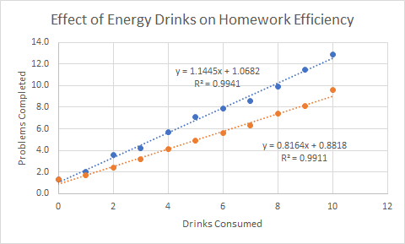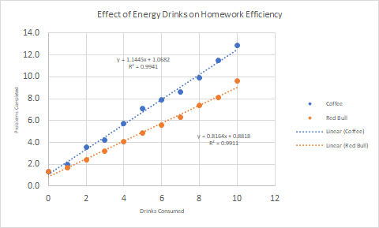

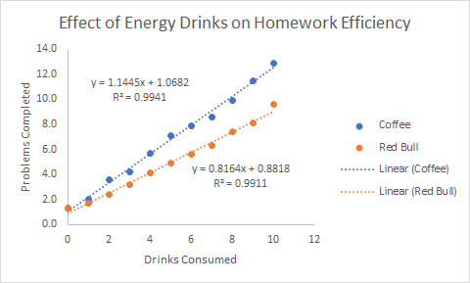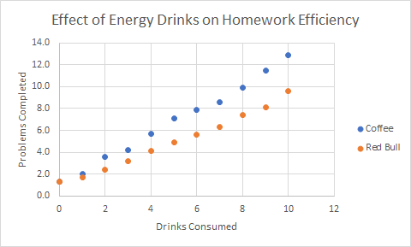

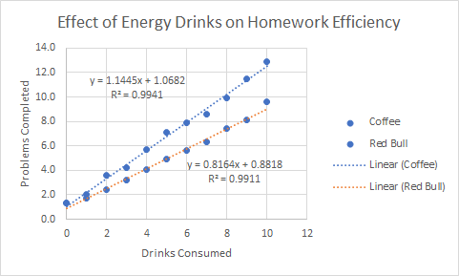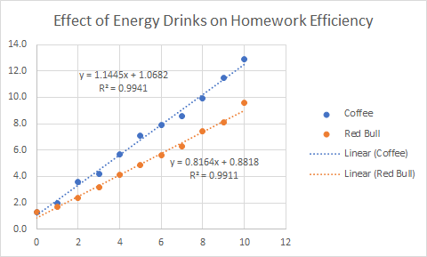

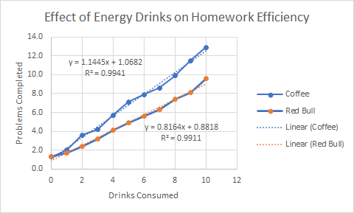

Graphing Guidelines:

1. Label axes clearly
2. Provide grid lines
3. Include a legend
4. Never connect the dots
5. Include a trendline for theoretical values
6. Different colors for each set
7. Legible Font

**Problem 2 (sorting) – Owen:**

Sort the following chart options from least trash to most trash (I think this is funny, could be a homework problem that only requires the least trash options to be column and scatterplot):

Waterfall, Pie, Treemap, 3D Column, Funnel, Column, Radar, Box & Whisker, Line, Scatterplot

**Problem 3 (fill in the blank/essay) – Owen:**

Fill in the blanks with either **Column Chart** or **Scatter Plot** after determining the reasonable way to plot the data gathered in each scenario below. Explain why.

Scenario 1: Lily is using a MicroCT scanner to analyze the characteristics of spongey bone in four separate groups of guinea pigs. One of these characteristics is trabecular thickness, which is the average size of the individual trabeculae in the bone. Each group has a specific sample size. She calculates the average of the individual averages for each group and would like to plot the results side by side.

Scenario 2: Rosa runs the 2-mile race in track & field. Running two miles is equivalent to running eight laps around the track. Rosa and her coach want to determine how fast she can run it at the beginning of the season. She begins running and her coach tracks the time it takes to complete each lap. Coach then plots the Rosa’s time for each lap.

Scenario 3: Clay performs mechanical testing on different iron alloys and would like to make a force vs. displacement curve for each alloy. For each test, he loads an alloy in the tester and compresses the metal slowly. The tester records the force and displacement incrementally until the test is complete, resulting in a ton of data points.

**Problem 4 (file-picture upload/essay) – Owen:**

Tissue engineering is a promising form of regenerative medicine that uses differentiable stem cells, growth factors, and a housing scaffold to regenerate damaged tissue. The process of 3D printing scaffolds for tissue engineering is never easy and requires extensive trial and error. One major problem is layer sag, which may be caused by a variety of factors including fiber spacing, printhead feed rate, and filament extrusion rate. Experimental data comparing the spacing of fibers in the base layer to second layer sag is listed in the table below:

|  |  |
| --- | --- |
| Fiber Spacing (mm) | Layer Sag (mm) |
| 0.49 | 0.02 |
| 0.60 | 0.02 |
| 0.72 | 0.04 |
| 0.77 | 0.07 |
| 0.87 | 0.11 |
| 0.97 | 0.15 |
| 1.05 | 0.23 |
| 1.22 | 0.40 |
| 1.28 | 0.45 |
| 1.43 | 0.56 |
| 1.52 | 0.66 |
| 1.60 | 0.71 |
| 1.71 | 0.87 |
| 1.82 | 0.98 |
| 1.93 | 1.12 |
| 2.01 | 1.13 |

a) Create a scatterplot modeling the data. Include the necessary components specified in the chapter to make a good scatterplot. After setting the trendline, modify the y-axis so that the minimum value is zero. Make sure to include only the necessary number of decimal places in the axes.

b) What do you notice about the trend of the data? Does the linear trendline properly fit the data?

**Problem 5 (file-picture upload) – Owen:**

Some things really rub Dr. B the wrong way, leading to some of his infamous rants. The following is a list of some of the things that lead to a Dr. B rant and the average length of the rant:

* Refusing Vaccines: 4 minutes
* Flat Earth Conspiracists: 6 minutes
* Social Media: 9 minutes
* The Oscars: 15 minutes

Create a column chart comparing Dr. B rant times. Include the necessary components for a good column chart as described in the chapter. Include an axis title for both axes.

**Problem 6 (fill in the blank or free response –** doesn't matter just need a place to type**) – Maddie:**

Congratulations! You are the next contestant on a new game show on TV and to move into the finale, you have to answer one question correctly. That question is what are the 6 things wrong with the Excel chart that you see in a report. The image below comes up on the screen and you have to list all of the chart’s flaws or it is the end of the line for you. GO!

(insert chart)

1. ____________
2. ____________
3. ____________
4. ____________
5. ____________
6. ____________

**Problem 7 (multiple choice – 4 parts) – Maddie:**

Margaux is the boss at major media company. One of her employees shows up to a meeting and gives the following presentation on TikTok.

(Insert Slide1) - hours average people spend on TikTok and other apps: 3D pi chart

(Insert Slide2) - # of users over the past 3 months: scatter plot

(Insert Slide3) - songs that have the most videos: column chart

Margaux soon notices that these slides need some improvement and some of the charts are just not passing her standards. Answer the following questions about each slide.

1. Question about slide 1

a. …

b. …

c. …

d. …

2. Question about slide 2

a. …

b. …

c. …

d. …

3. Question about slide 3

a. …

b. …

c. …

d. …

# Chapter 5 Solutions

**Solution 1 – Owen:**

Graphing Guidelines:

**Provide Grid Lines**

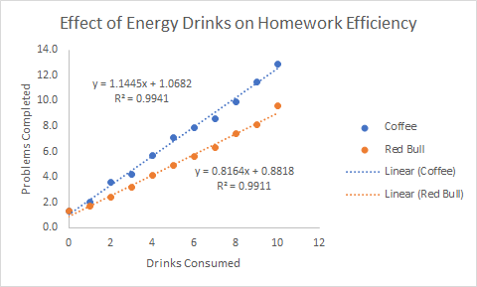

**Include a Trendline for Theoretical Values**



**Never Connect the Dots**



**Different Colors for each set (for some reason the trendline won’t turn blue when I copy and paste the graph)**



**Legible Font**



**Include a legend**



**Label the axes clearly**



**Solution 2 – Owen:**

1. Scatterplot
2. Column
3. Whatever order, rest are trash

OR

1. Column
2. Scatterplot
3. Whatever order, rest are trash

**Solution 3 – Owen:**

Scenario 1: Column – In this instance, categories are being compared side by side without a trend or continuity of the x variable. Therefore, it makes more sense to use a **column chart** to represent the data.

Scenario 2: Scatterplot – A **scatterplot** helps to show a trend over time in the easiest way possible. A trendline can be established more easily on a scatterplot than a column chart.

Scenario 3: Scatterplot – Data is recorded continuously during a process. Additionally, there are several individual data points to display. Therefore, a **scatterplot** is the most appropriate chart for this test.

**Solution 4 – Owen:**

a) Below is an example of an acceptable plot:

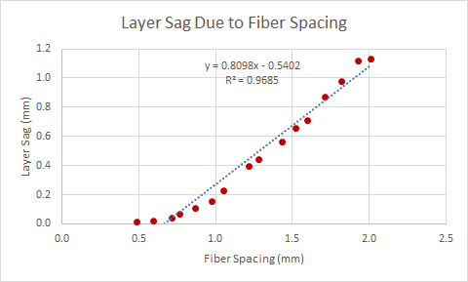

b) Most students may notice that the data, although fairly linear throughout, is not entirely linear. The linear trendline does not perfectly model the data (ideally this leads well into the next chapter).

**Solution 5 – Owen:**

Below is an example of an acceptable chart:

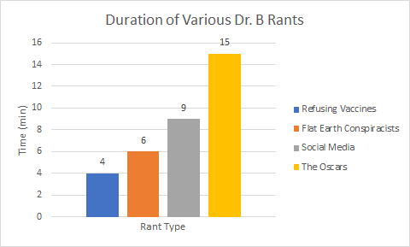

**Solution 6 – Maddie:** (fill in the blank or free response)

1. …
2. …
3. …
4. …
5. …
6. …

(answers are in no particular order)

**Solution 7 – Maddie:** (multiple choice)

1. Answer =
   1. Explanation:
2. Answer =
   1. Explanation:
3. Answer =
   1. Explanation:

# Chapter 6

**Problem 1 – Michael:**

Dr. Bechara is on a backpacking trip through the Rio Grande National Forest to climb Mt. Eolus. He sets up camp next to Hazel Lake and unpacks his fishing pole to catch dinner. He pulls a beautiful Rainbow Trout out of the water and throws it on the fire to cook. After a few minutes, he pulls it off. He knows it’s not finished cooking, but he’s *so hungry* from the day’s journey. Salt, pepper, and then Dr. B eats the semi-raw fish. Unbeknownst to him, a colony of 1000 Escherichia coli bacteria lived on that fish and are now floating around in his intestines. The symptoms for this bacterial infection are stomach cramps, diarrhea, and vomiting. Assume the colony doubles in size every 60 minutes, and there is no carrying capacity in the environment. How many bacteria will be living in his system when the symptoms develop 3 days later?

**Problem 2 – Erin:**

Many tropical plants are known for their ability to grow to enormous scales. Researchers have found that one important factor affecting the size to which the leaves of some species of plants can grow is the night-time temperature difference between the leaf and the surrounding air. Large leaves have a thicker boundary layer which slows sensible heat exchange with their surroundings leaving them unable to offset long-wave radiation losses to the nighttime sky. This puts large leaves at a disadvantage in cold regions as they are more prone to frost damage.

If a study found that there is a linear relationship between latitude and the average radius of a leaf found at that location, plot the average area of leaves found from the North Pole (90°N) to the Equator (0°) assuming the leaf is circular in shape. At the North Pole the average radius of a leaf was measured to be 0.056 cm while at the Equator the average radius was measured to be 75 cm.

**Problem 3 – Michael:**

1) In Major League Baseball, the league-wide average fastball velocity has been increasing since 2002. In Excel:

a) Create a scatter plot of the data below and apply a linear trendline.

b) Using this trendline, predict the average fastball speed in the years 2025 and 2050.

c) Are these predictions reasonable? Why or why not?<https://www.fangraphs.com/leaders.aspx?pos=all&stats=pit&lg=all&qual=0&type=4&season=2016&month=0&season1=1871&ind=0&team=0,ss&rost=0&age=0&filter=&players=0&startdate=&enddate=&page=1_50>

**Problem 4 (fill in the blank) – Owen:**

A beam that is pinned at both ends experiences maximum midspan deflection when force is applied at the midspan. The equation for deflection is:

δ = -(P*L^3)/(48*E*I)

Where P = applied load, L = span of the beam, E = elastic modulus of the material, and I = the moment of inertia of the beam. Choosing only one of these variables to use as an input results in a unique model. Fill in the blank next to each variable with the type of resulting model, assuming all other variables are held constant.

Applied load P:

Span of beam L:

Elastic Modulus E:

Moment of Inertia I:

**Problem 5 (essay/numerical/file-picture upload) – Owen:**

Blood flow in a vessel is often modeled by Poiseuille's Law:

Q = (ΔP*π*r^4)/(8*µ*L)

Where Q is blood flow, r is the radius of the vessel, µ is the blood viscosity, ΔP is the change of pressure over the span of the vessel, and L is the length of the vessel being analyzed.

a) Assuming all variables except for Q and r stay constant, what type of model is this? How do you know?

b) I’m at the gym for the first time in a while and start working out hard. Over time, the arteries bringing blood to my muscles begin to expand. Let’s analyze blood flow over a certain span of one of my arteries. Assume that the following variables remain constant: ΔP = 16,000 Pa (Pa = kg*m^-1*s^-2), L = 5 cm, and µ = 3.5 kg*m^-1*s^-1. Below is a table showing how the radius of the artery changes over time. Using Excel, calculate the resulting blood flow for each value of the radius (1 cm^3 = 1 mL).

|  |  |
| --- | --- |
| Radius (cm) | Blood Flow (mL/min) |
| 0.30 |  |
| 0.35 |  |
| 0.40 |  |
| 0.45 |  |
| 0.50 |  |
| 0.55 |  |
| 0.60 |  |
| 0.65 |  |
| 0.70 |  |
| 0.75 |  |

c) Plot the resulting values in Excel. Create an appropriate model for this situation.

(<http://hyperphysics.phy-astr.gsu.edu/hbase/ppois2.html>, <https://opentextbc.ca/anatomyandphysiology/chapter/20-2-blood-flow-blood-pressure-and-resistance/>, <https://physics.info/viscosity/>)

**Problem 6 (fill in the blank/numerical answer/picture-file upload) – Owen Wahl:**

Jarvis lives on the 12th floor of Durward Hall. He is tired of using the elevator to get to his room and wants to mix it up. Suddenly, he wonders if he can fold paper enough times to create a tower to reach the 12th floor. Consider what happens to the thickness of paper as you fold it:

a) What type of model would you use to demonstrate the relationship between the thickness of the paper and the number of folds?

b) Create a model for folding paper vs. paper thickness if the initial thickness of office paper is 0.1 mm. Assuming the average floor is about 14 feet, how many times would you have to fold a piece of paper to reach floor 12 of Durward?

c) Create a plot demonstrating this relationship in Excel. Include the output value for zero folds. Demonstrate the relationship in feet for this example. Double check your model by displaying the equation on the chart.

d) Jarvis realizes there might be a few problems with his plan. Create and plot another model demonstrating the relationship between the number of folds in paper and the area of an 8.5 x 11-inch piece of office paper. Include the output value for zero folds. Double check your model by displaying the equation on the chart.

# Chapter 6 Solutions

**Solution 1 – Michael:**

N = N0ekt

N0 = 1000

K = ln(2)/td

60 min = 3600 seconds

3 days = 86400 seconds

1000*e(ln(2)/3600)(86400) = **1.67x1010 bacteria**

**Solution 2 – Erin:**

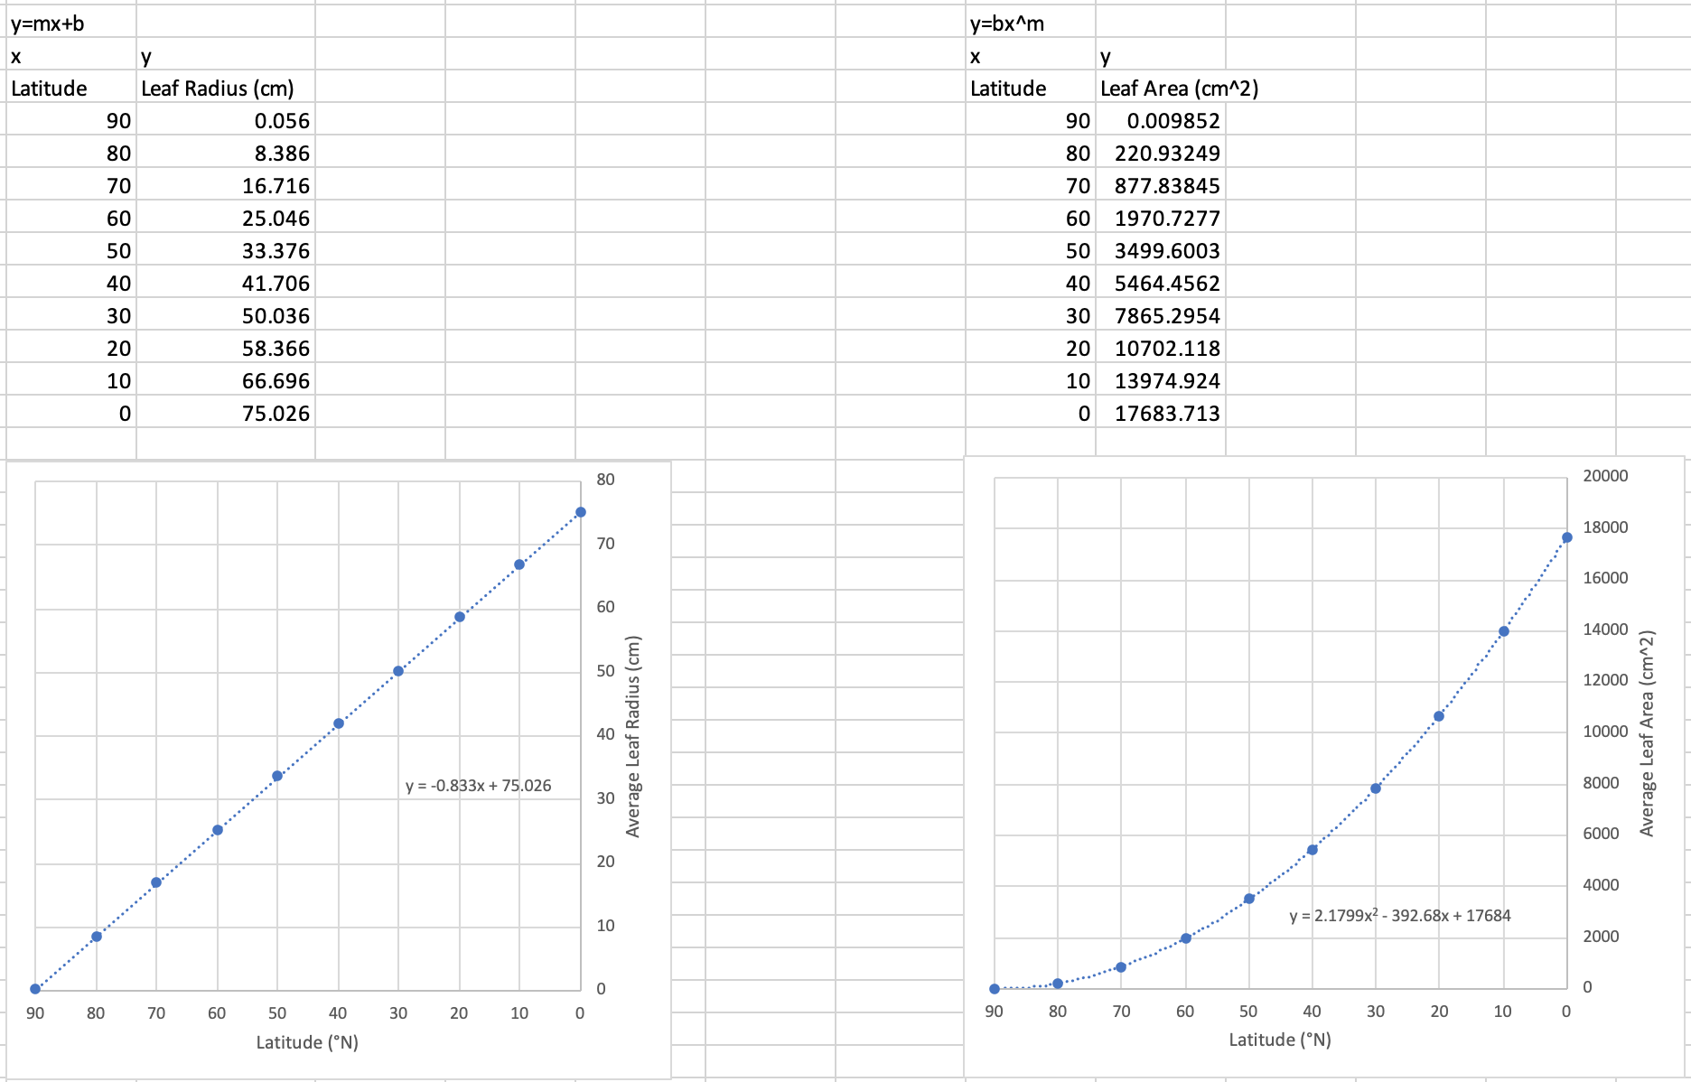

**Solution 3 – Michael:**

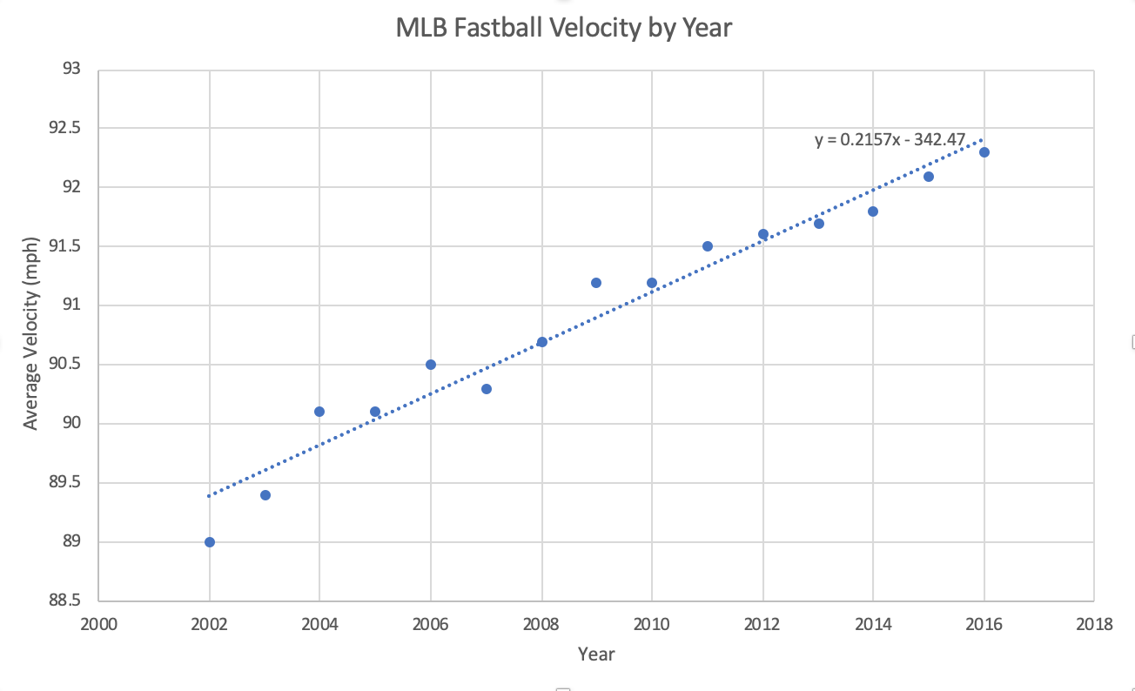

**2025 – 94.32**

**2050 – 99.72**

**Solution 4 – Owen:**

Applied Load P: **Linear Model (δ α P)**

Span of bridge L: **Power Model (δ α L^3)**

Elastic Modulus E: **Power Model (δ α E^-1)**

Moment of Inertia I: **Power Model (δ α I^-1)**

**Solution 5 – Owen:**

a) Poiseuille's Law is a power model given the following constraints. Since all but two variables are constant, the equation can be reduced to the following:

**Q α r^4**

This means that the blood flow is proportional to the radius raised to the power of four. Note the term “power” here. This is a power model, since a small change in the independent variable r leads to a dramatic increase of the variable Q.

b) To find each answer, a proper conversion factor needs to first be established that yields mL/min. First, the SI units of blood flow must be found:

(ΔP*π*r^4)/(8*µ*L) = (kg*m^-1*s^-2*cm^4)/(kg*m^-1*s^-1*cm) = cm^3/s

This works out nicely because 1 cm^3 = 1 mL. Initially, the first value, 0.3 cm, will be solved in Excel. The value of the radius is represented by an arbitrary cell – in this case, B3:

[(16,000)*(π)*(B3^4)]/[(8)*(3.5)*(5)] mL/s * 60 s/1 min = 174.49 mL/min

Repeating this for all given values of r yields the following table:

|  |  |
| --- | --- |
| Radius (cm) | Blood Flow (mL/min) |
| 0.30 | 174.49 |
| 0.35 | 323.27 |
| 0.40 | 551.48 |
| 0.45 | 883.37 |
| 0.50 | 1346.40 |
| 0.55 | 1971.26 |
| 0.60 | 2791.89 |
| 0.65 | 3845.44 |
| 0.70 | 5172.32 |
| 0.75 | 6816.13 |

c) The plot should look something like this:

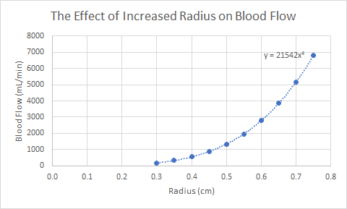

The power model fits perfectly here and yields the equation y = 2154x^4.

**Solution 5 – Owen Wahl:**

a) This would be an **exponential model**. The thickness of paper increases exponentially with the number of folds.

b) Follow the general model y = b*e^(m*x) (b0 = 0.1 mm)

Paper doubles in thickness with every fold:

0.2 mm = (0.1 mm)e^((1)(m)) => 2 = e^m => m = ln(2)

The model is **y = 0.1*e^(ln(2)*x)**

Durward height: 12 floors * 14 ft/1 floor * 12 in/1 ft * 2.54 cm/1 in * 10 mm/1 cm = 51,206.4 mm

Solve using appropriate values: 51,206.4 mm = 0.1 mm * e^(ln(2)*x) => 512,064 = e^(ln(2)*x)

=> ln(512,064) = ln(2)*x => x = 18.97 folds or **19 folds**

c) In Excel:

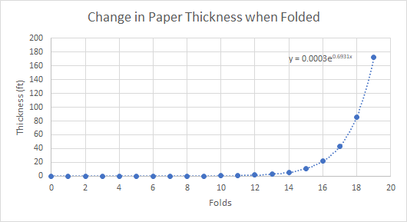

d) The thickness of the paper is modeled by exponential growth while the area of the paper is modeled by exponential decay:

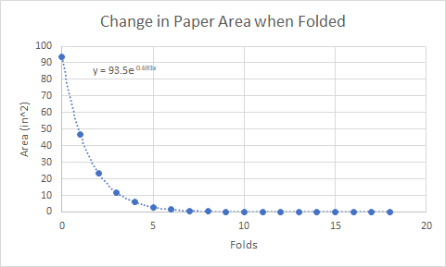

# Chapter 7

**Problem 1 – Michael:**

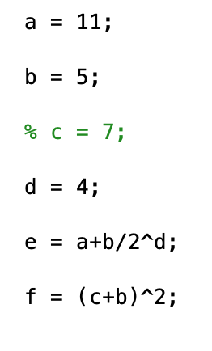

1) Given the variable definitions above, what will be the MATLAB output of the following commands?

>> A

>> rem(a, sqrt(d))

>> c

>> e + (a + b) / d

>> ceil(e + (a + b) / d)

>> 3 * f

**Problem 2 – Erin:**

Consider the window shown below. Match each number with its corresponding letter.

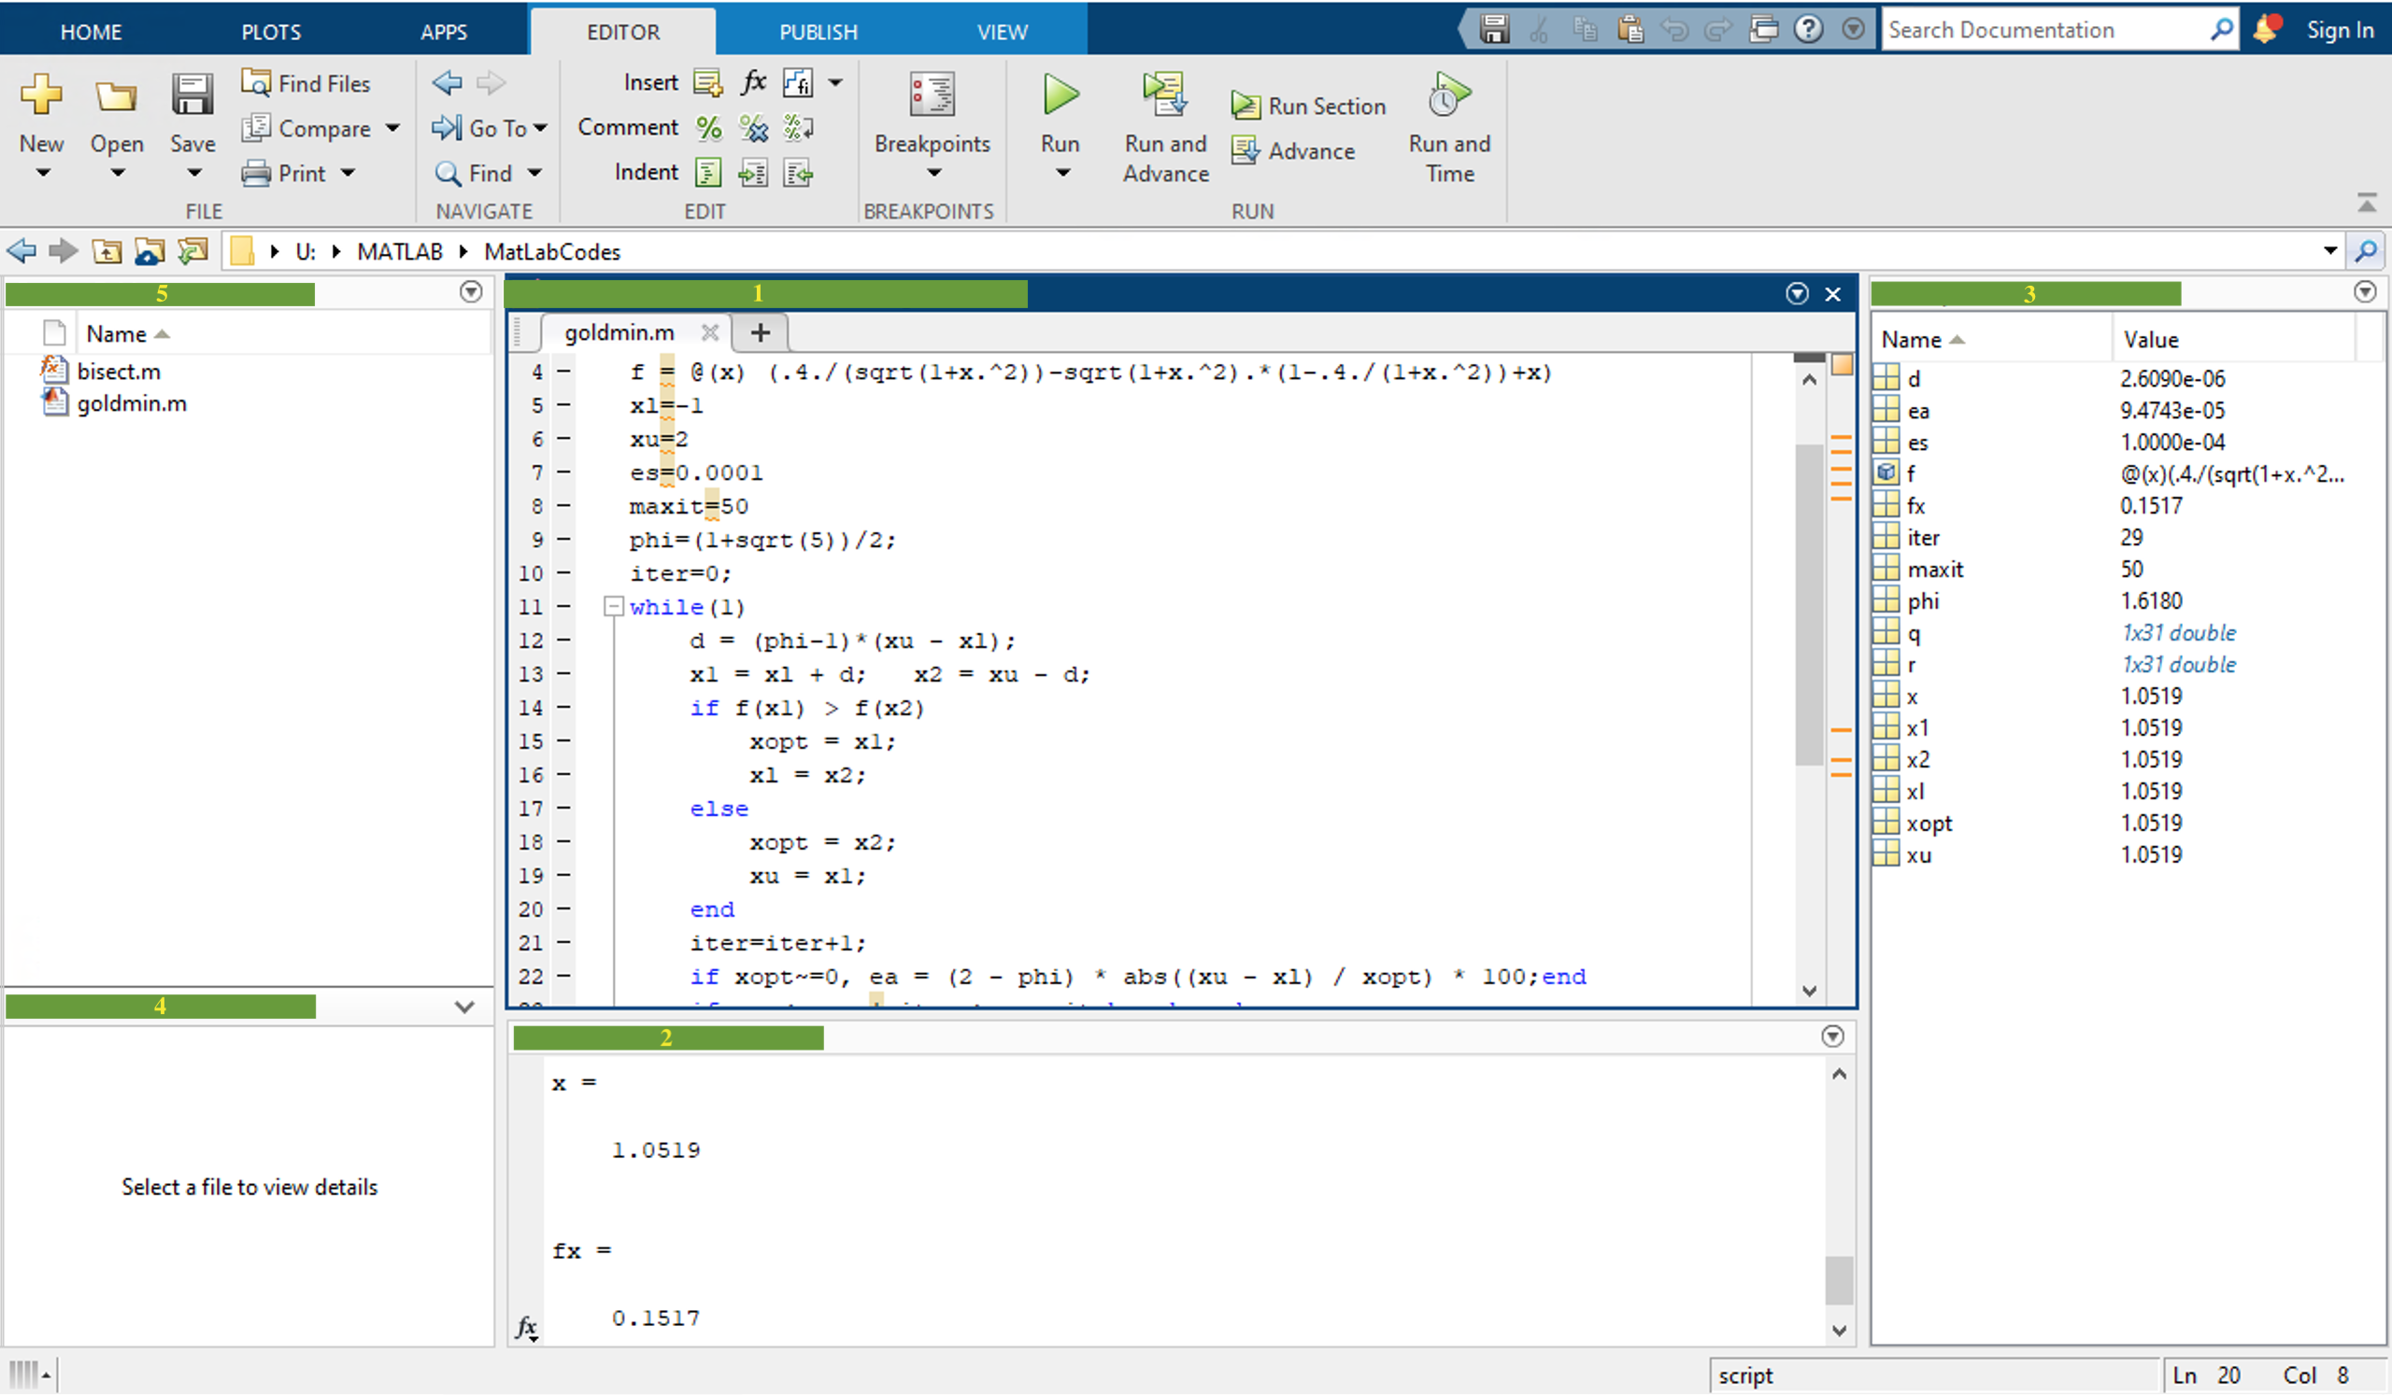

1. Editor
2. Workspace
3. Command window
4. Current Folder
5. Details

Suppose you were to add the following lines of code to the end of this example. What would your new outputs be? Where would they be displayed?

G=maxit*12+sin(x);

wv=fx*(G^0.5)

# Chapter 7 (Solutions)

**Solution 1 – Michael:** Variable is undefined, 1, variable is undefined, 15.3125, 16, variable is undefined

**Solution 2 – Erin:**

1 --- A. Editor

2 --- C. Command Window

3 --- B. Workspace

4 --- E. Details

5 --- D. Current Folder

G=600.01836 (displayed in ‘Workspace’ only)

wv=3.715933 (displayed in ‘Command Window’ and ‘Workspace’)

# Chapter 8

**Problem 1:** Luke is doing some landscaping around his home and wants to plant some privacy trees in his backyard. The portion of the perimeter of his yard he wishes to shield totals 85 ft in length. The trees he is looking at buying grow to a diameter of 5 ft when they are fully mature. Suppose Luke’s budget only allows for him to buy 15 trees. Is this enough to keep his neighbors’ prying eyes out of his yard? What is the minimum number of trees Luke could get away with purchasing?

# Chapter 13

**Problem 1: Michael**

It’s the year 2032, and you are hired by a political organization to code new automated voting machines. They instruct you to “rig” the machine, so their candidate, Kanye West, will be re-elected for his second term. You type up the following code. In its current state, the machine is fair.

A) Kanye is not expecting to do well with the older generation. Modify the if statements so that if a voter is older than 70, their vote won’t count.

B) Kanye’s opponent, Sam Bechara, is expecting to do VERY well with middle-aged suburban white women. Rig the if statements so that if the voter is a woman and is between 45 and 65 years old, their vote counts for both Bechara and Kanye.

C) Kanye’s best demographic will be 30 something African Americans. Modify the if statements so he will receive 2 votes instead of 1 if the voter is in this demographic, and add an else statement to subtract half of a vote from Bechara

D) Just to be safe, make all the votes go to Kanye.

%Presidential Election 2032

%Totally fair voting system

%Candidate vote totals

Kanye = 0;

Bechara = 0;

%inputdlg() function outputs a string type.

age_input = inputdlg('What is your age?', 'Age?');

%str2num converts age_input to a numeric type. Now we can use it.

age = str2num(age_input{1});

%race variable will equal 1 if American Indian is chosen, 2 if Asian, etc.

race = menu('Race', 'American Indian', 'Asian', 'Black or African American', 'Native Hawaiian', 'Hispanic or Latino', 'White', 'Other');

%sex variable will equal 1 for male if male is chosen, 2 for female

sex = menu('Sex', 'Male', 'Female');

%vote variable will equal 1 if Kanye is chosen, 2 if Bechara is chosen

vote = menu('Choose a Candidate', 'Kanye West', 'Sam Bechara');

if vote == 1

Kanye = Kanye + 1;

end

if vote == 2

Bechara = Bechara + 1;

end

# Chapter 14

**Problem 1: Michael**

During the 2002 NBA season, legendary basketball player Allen Iverson had developed a contentious relationship with the 76ers coach, Larry Brown, after he skipped practice on several occasions. The media, of course, picked up on the story, and Iverson’s emotions boiled over when he was asked about his actions during a press conference. During his rant, he said the word “practice” 23 times in 2 minutes. Write a for loop in MATLAB that prints the word “practice” 23 times on their own lines. Below each “practice”, include a counter that increments each loop. The output should look like the image below. Remember, practice and repetition are the only ways to become proficient in MATLAB!

“We talkin’ about practice, man!”

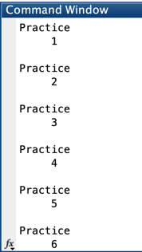

**Problem 2: Michael**

A newton’s cradle is a device that exhibits conservation of momentum and energy transfer. When the first ball is released, its potential energy converts to kinetic energy as it swings, and then its energy and momentum are transferred through each ball until the last ball swings up. Like in any system, energy is lost during this process. Friction in the strings, air resistance, and ball vibration are all reasons the cradle will eventually come to a stop. Assume the cradle loses 5% of its energy with every ball click. Write a while loop that tracks the percentage of energy in the system that terminates when the energy in the system is below 1% of its original value. How many clicks did it take for the cradle to stop?

# Chapter 14 (Solutions)

**Problem 1:**

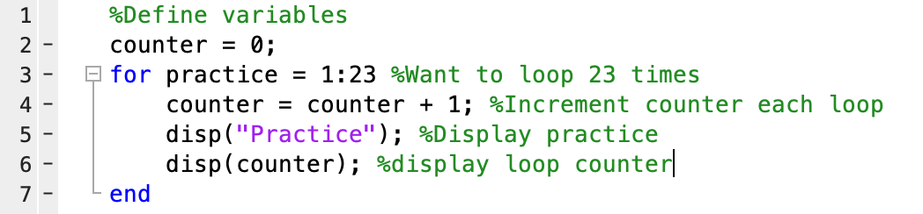

**Problem 2:**

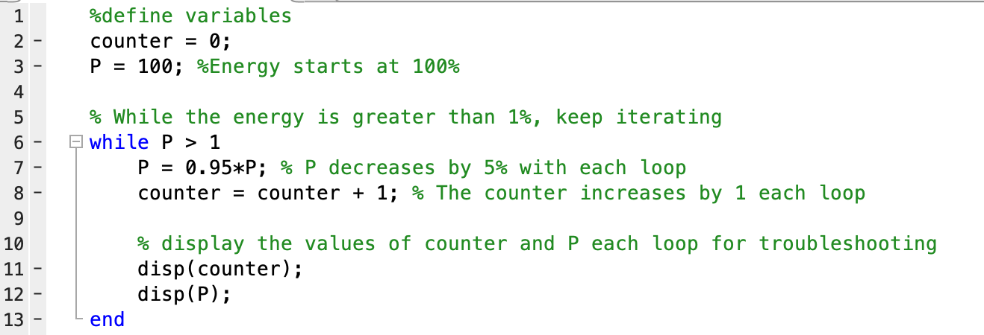

Typos in Book

Throughout the book:

* Figures aren’t numbered, instead labeled as Figure X
* The links to figure pictures are included in the caption

Ch 4:

* In Table 4.11 (excel functions) the function “=radians(angle in degrees)” is defined as “provides an estimation for pi”
* Inconsistent capitalization
  + high school or High School
  + Figure X or figure X
  + Video X or video X

Ch 6:

* First word of the section “Think Twice, Model Once” has the typo “sThere”
* Last paragraph of the section, sentences with no space between period and next letter: “...before you model it.What I am...”
* The end of the first paragraph in the “How to add a trendline” section is repeated twice: “also very similar to adding a legend or other chart element so this should be easy for you.also very similar to adding a legend or other chart element so this should be easy for you.”
* Is the ideal gas law a power model?
* Huge type in this sentence found in the Atmospheric Pressure section: “Furthermore, it is known that atmospheric pressure ul if you could provide existing plans of your hodecreases by about 12% for every 1000 meters that you go up.”
* Final mathematical model of atmospheric pressure: missing parentheses in model “ln(0.88”