Chapter 13: MATLAB Decisions

Figure X: If we want our computers to be "smart" we need to have a way for them to make decisions. https://pixabay.com/illustrations/artificial-intelligence-brain-think-3382507/

So far, the programs we have been writing are great at performing calculations but they are limited and not like software that you are used to using. We are used to software making "decisions" based on information. For example, when it is going to rain, Google Assistant (or Siri, or Alexfontconfiga, or whatever) can send you an alert reminding you to bring an umbrella. When it is going to be sunny, that same assistant might suggest wearing sunblock. The software underpinning those technologies has the capability to make decisions about what it tells you depending on the weather. I am certain that you can think of several other instances of computer programs making decisions.

Discussion 13.1: Decisions in software
This post is not anonymous. The professor and participants can see the responses and the author.
Briefly, share with your classmates a unique way that a computer program makes a decision in some software that you regularly use. You can pick any computer program you like! For example, one of my favorite video games growing up was Mario Kart 64. My sister was WAY better than me at racing but the power ups that you can collect change depending on what place you are in. Since I was usually in last place, and my sister was usually towards the front, the program made decisions to give me much more powerful items that allowed the race to be competitive! What is your story about computers making decisions?

The reason the scripts we have written so far seem so limited it that we haven't learned a way to control the flow of programs or have them make any decisions. Controlling the flow and allowing our programs to make decisions is what we will learn in this chapter.
Our mantra and guiding process for writing complex programs will be: think, sketch, code, test, repeat. We will use what we learned about thinking algorithmically to make sure that we think before we do anything. We will sketch to ensure that we come up with a robust plan. After coming up with a sketch, we will write our code. Then we will test the code using as many absurd and wide ranging possibilities we can think of. Finally, we will repeat the entire or part of the process until our code works the way we want it to!

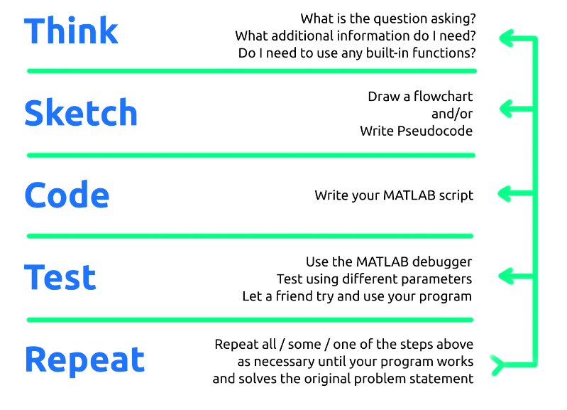
Figure X: Our mantra. Breathe it in. LIVE it.

Type caption for image (optional)
In this chapter we will learn:how to combine what we learned about thinking algorithmically with MATLAB syntax to make complex computer programs. That means learning:
- How to combine conditional statements with MATLAB if structures.
- How to use flowcharts to help understand our code.
- The specific syntax necessary to code if and the various derivatives of an if statement.
Type caption for image (optional)

Quick Note Before We Start
In my opinion it is critical to follow along with this chapter, even more so than previous chapters. Even if you have experience in other programming languages, the way that MATLAB handles loops and decisions is different. Make sure that you start MATLAB, create a new script, and follow along! It will help in two ways. First, you will get the experience from working on it today. Furthermore, by saving your script you can create good notes for future reference.

Conditional Statements
Now we are going to combine everything we have learned about MATLAB to allow our programs to make decisions. The trick is to combine what we learned about the relational and logical operators and thinking algorithmically to create what are called conditional statements.
A conditional statement is an if-then statement (there are a few other flavors that we will learn about shortly, but this is the most simple one). We already saw examples of these types of statements in the thinking algorithmically chapter, but here are a few examples of conditional statements to jog your memory:
- If I skip my brain workouts, then I will not understand the material.
- If I finish my homework on time, then I will receive a high grade on homework.
- If it is raining outside, then I will wear a jacket.

MATLAB if-end Statements
The most basic for of a conditional statement is the If-End statement. Generically in MATLAB, an If-End statement looks like this:
>> if < conditional expression is true >
>> < do this stuff>
>> end
Let's break this down:
- The MATLAB conditional statement must start with the keyword if
- The if is followed by a conditional expression. Recall that the < > indicate that you need to replace this with actual MATLAB code. A conditional expression is simply an expression with at least one relational operator, and any number of logical operators. For example: x > 12 is a conditional statement. So is angle > 25 & angle < 100.
- Next we have < do this stuff >. This is simply the MATLAB code that we want to exectute only if the conditional expression evaluates to true. MATLAB will automatically tab the text within the decision structure over to make it easy to read.
- Finally, the decision statement must be completed the keyword end.
The generic flowchart for this can be found in figure X below:

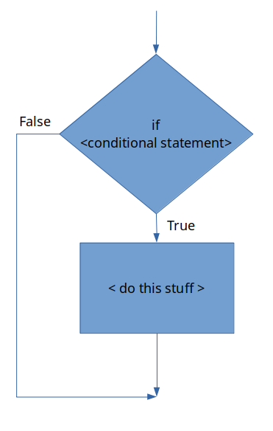
Figure X: A generic if-end statement flowchart.

Example - Hourly Worker Calculation
To see this in action lets create a short script that calculates the weekly wage of an hourly worker. This program can be used to calculate the pay based off the number of hours worked and the workers hourly wage using two variables: hours_worked and hourly_wage. If the worker works over 40 hours a week, they are compensated at 1.5x their normal hourly rate for only the hours worked over 40. For example, if a worked worked 42 hours at $10 an hour, they would get paid $10/hour for the 40 hours and $15/hour for the extra 2 hours over 40.
This is a perfect example of using our mantra: think, sketch, code, test, repeat! Do not skip your brain workout for these sections. For each of the prompts below I am expecting you to stop and actually work on this particular problem before moving on.

Type caption for image (optional)
Think - during the think phase you need to ask yourself and then answer a bunch of questions. I can't think for you but I can give you an example of my thinking process when solving the problem. Keep in mind that you might have other questions that need answering! That is OK! This is what I came up with as I was thinking.
- Do you understand what the problem is asking?
- What math is necessary to complete this problem?
- Can you calculate expected answers based off a few different variables? That way you will have numbers to compare your program against to make sure it works. Example: if hours_worked = 42 and hourly_wage = 10, we would expect pay = 430.
- How can you have the program calculate the correct value algorithmically? Remember, that means you need to write down the process into steps. Start with calculating the pay in the situation for under 40 hours week. Then move onto what would happen at 41 hours a week...
- What conditional statement if any is needed?
Type caption for image (optional)

Sketch - during the sketch phase, you need to draw a flowchart or write out pseudocode for your algorithm that will solve this problem. The sketch phase will often require several repeats of the think stage. As you are sketching more questions may pop into your head about how to best solve this problem. Before scrolling down below, take a minute and try to sketch out a flowchart or write out pseudocode for this particular problem. Don't skip out on giving it a try!


Figure X: Every time someone scrolls and looks at my flowchart before creating their own, this puppy doesn't get a snuggle! Don't be a monster! I was going to say the puppy gets hit but that is too dark. Look how cute he is! https://pixabay.com/photos/pug-puppy-dog-animal-cute-690566/

The flowchart that I created for this particular problem is located below in figure X.

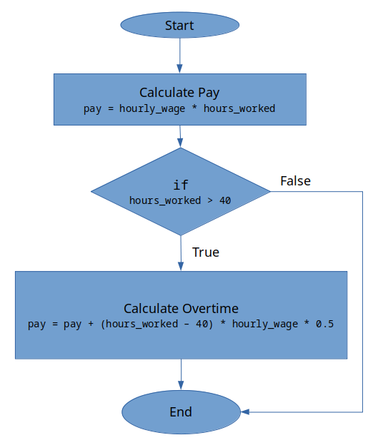
Figure X: My flowchart for the wage program. Note how there is both descriptive text and rough code.

Take a look at the flowchart. Hopefully it looks very similar to yours. Ask yourself the following questions before moving on.
- Do you understand how the flowchart works?
- Can you follow the logic?
- Why is the calculation beneath the "Calculate Overtime" step multiplying by 0.5 and not 1.5?
Do not move onto the next section until you understand the flowchart above in figure X.
Code - Now comes the fun part, translating our sketch into code! I highly encourage you to try this on your own before you look at my solution below! It is OK if you get stuck and struggle! That is what learning is about. Take a moment to review the generic version of the if-end statement so you have a good idea of the MATLAB syntax necessary to complete the problem.


Figure X: The lemur of judgement is majestically judging those who scroll down before trying to code on their own. Don't let the lemur down! https://pixabay.com/photos/animal-lemur-jungle-blur-close-up-1851671/

Did you try it on your own first? Good! Does your script work? If yes, good work! If not, it is OK! Struggling and practicing IS learning!

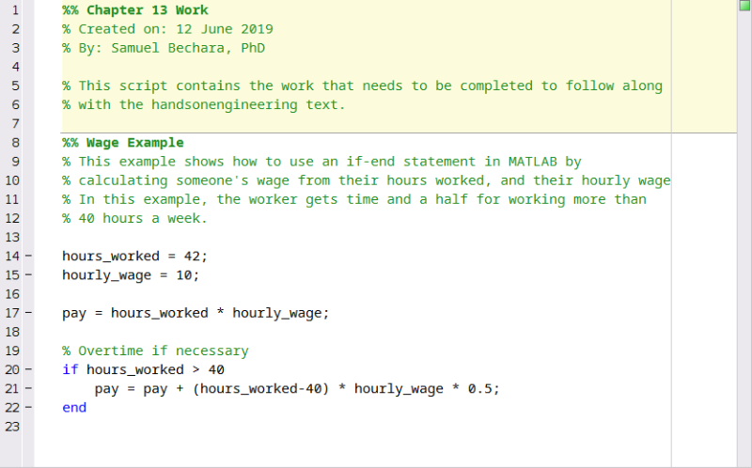
Figure X: Example of my script file that calculates the pay. Notice I used sections %% to keep things organized and I have nice headers and comments explaining what each section does.
When you run the script with these example numbers, hours_worked = 42 and hourly_wage=10, you can see that the value of the pay = 430!

Test - the testing phase might be the most fun. Just spend some time with the script to double check that it works. Try substituting different values in for variables and verifying by hand that the calculation works. This is an important step and becomes even more important the more complicated your scripts become! Just play around with it and make sure it works the way that you expect.

Question 13.1: Test the script!
Test the script that we just made. What would the pay be for someone who worked 75.6 hours at an hourly wage of $24.25/hour?

Hopefully by this point you understand how the if-end statements are structured and how they are written in MATLAB. The reality is that there has been very little new material in this chapter. We have simply learned how to apply previous concepts to new problems. There are a few other decisions structures MATLAB has that we should investigate.
The rest of the MATLAB conditional statements will be explained below and some example code will be provided but the think, sketch, code, test, repeat process will not be replicated in this much detail. The good thing is that the other MATLAB conditional statements are very similar and follow almost the exact same syntax.

MATLAB if-else-end Statements
There are instances when writing computer programs where it is beneficial to make decisions that will run one set of instructions if the conditional statement is true, and it will run a different set of instructions if the conditional statement is false. This is called an if-else-end statement.
Generically, an if-else-end statement looks like:
>> if < conditional expression is true >
>> < do this stuff>
>> else
>> < do other stuff >
>> end
Breaking this down:
- Notice that it is almost identical to the if-end statement with the exception that there is an else keyword.
- In this case we have created two different branches. The < do this stuff > runs only if the conditional statement is true. Conversely, the < do other stuff > will only run if the conditional statement is false. In this case, it is not possible to run both < do this stuff > and < do other stuff >.
The generic flowchart for an if-else-end statement can be seen in figure X below.

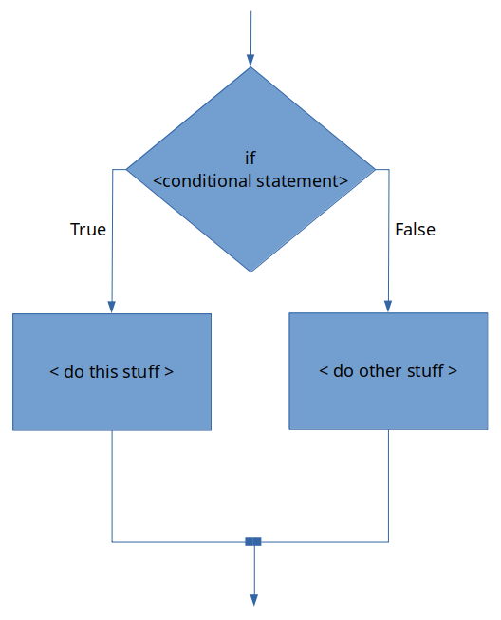
Figure X: The generic flowchart for the if-else-end statement.

You can see that the flowchart for an if-else-end statement is almost identical to an if-end statement, with the exception that an if-else-end statement can have two independent code blocks. Only one of the code blocks will be run depending on if the conditional statement evaluates as true or false.
Another thing to remember is that although our conditional statement was fairly simple in our wage example, that conditional statements can be complex! For example, try this problem.

Question 13.2: Consider the following [code]if-else-end[/code]
Do not just type this into MATLAB. Try it by hand first! That is how you learn.
Consider the following script file:
x = 10;
y = x - 4;
z = 2*x + y;

if x > y & z == 25
output = x + y + z;
else
output = x - y - z;
end
What is the value in the variable
output
when the program is finished running?

MATLAB if-elseif-else-end Statements
Previously, we just saw how we can use an if-else-end statement to essentially create two blocks of code that can be run independently depending on the outcome of the conditional statement. There is another MATLAB conditional structure that is even more flexible and actually allows you to have however many independent code blocks you would like. The if-elseif-else-end statement allows this.
Generically, the if-elseif-else-end statement looks like this:
>> if < conditional expression #1 is true >
>> < code block 1>
>> elseif < conditional expression #2 is true >
>> < code block 2 >
>> else *technically the else here is optional
>> < code block 3 >
>> end
As you can see, this is very similar to the statements we have been covering thus far. However, there are a couple of things to note:
- Technically, the else is optional in an if-elseif-else-end statement. If you look at the flowchart in figure X below, omitting the final else would be equivalent to chopping off the < code block 3 > chunk of code.
- In this generic example there is only one elseif statement with a corresponding conditional expression. However, MATLAB lets you have however many elseif statements that you need.
- Note that because of the logic of the statement, you only need 2 conditions to run 3 separate blocks of code. In general, when designing an if-elseif-else-end statement that has n different conditions, you need n−1 conditional statements.
The generic if-elseif-else-end flowchart is shown below in figure X. Again, keep in mind it can have any number of elseif < conditional expression > lines!

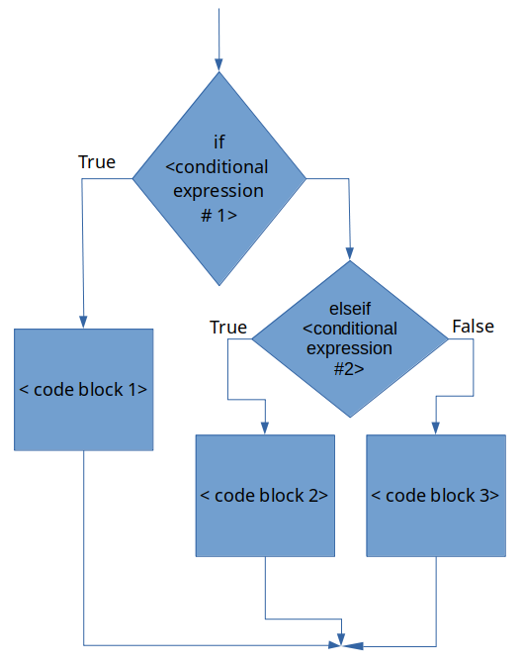
Figure X: The generic if-elseif-else-end statement flowchart.

Student Grades - if-elseif-else-end Example
I think that it is important to clarify the statement "when you have n different conditions, you need n−1 conditional statements". To do so, lets consider an example. Lets say that we have a variable grade that that contains the final numeric grade for a person in a class. Furthermore, lets say that this hypothetical class does not have + or - grades, instead the final letter grade is calculated as follows:

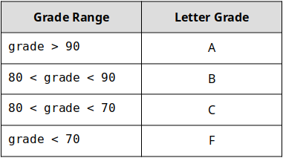
Table 13.1: Student grading scheme example.
The problem is to create a MATLAB script that can take take the numeric grade as a variable grade, and determine the letter grade associated with it and store that in a variable called letter_grade.
This may seem contrived because in this particular example, we will only have 1 grade but in the next chapter, we will learn techniques that will allow us to analyze any number of grades in the same fashion. What we are working on now will be the bones of that future algorithm!

Type caption for image (optional)
Think and Sketch - we can see that we have 4 different categories of grades. That means that n=4 (the grade can be an A, B, C, or F). Before you continue, can you create the flowchart necessary to complete this script? Take your time. I am hoping that by thinking and sketching it will be obvious why you only need n−1=3 conditional statements.
If you are feeling like a tough workout today, go ahead and try to program this script on your own. Go you! If your brain is too tired from that it is OK, but don't skip the flowchart part.
Type caption for image (optional)

I won't threaten you with puppies or lemurs anymore. I will trust that you care about your education and want to learn this material. Handshake?


Figure X: Our handshake agreement that you are actually working on the material. I love stock images so much. https://pixabay.com/photos/handshake-hands-laptop-monitor-3382503/

Here is my flowchart for the problem.

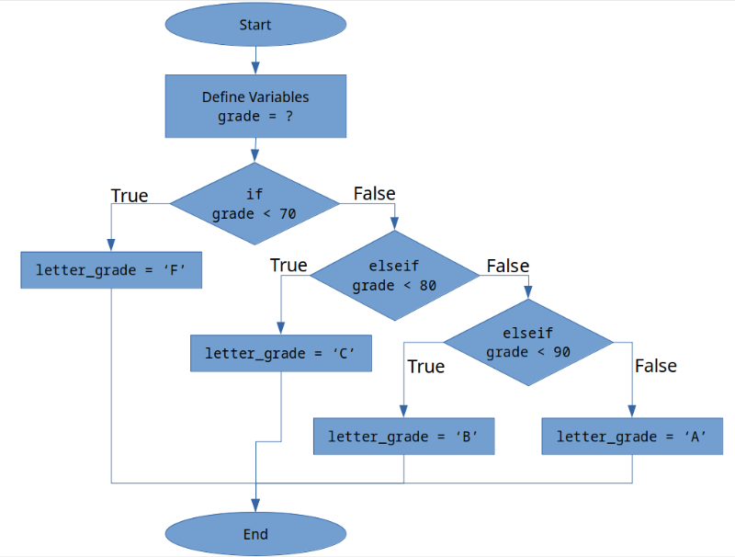
Figure X: My flowchart for the letter grade problem.

Take a moment to compare our flowcharts.
- Did you start from high to low? That is a common way of doing things and totally fine. Maybe I am just weird? It doesn't matter.
- Do you notice how my flow chart only has three conditional statements? THAT is what I meant by n conditions requires n−1 conditional statements. Here is the logic:
- if you scored less than 70, you get an F
- elseif you scored less than 80, you get a C
- elseif you scored less than 90, you get a B
- else, you get an A. (You do not need a conditional statement, because if you didn't get an F, C, or B, the only option left is an A!)

Type caption for image (optional)
Now is your chance to try and do the code, test, and repeat part of our process on your own to finish the problem! Even if you can't get it working perfectly, take some time and give it your best shot! Make sure you have a pen and paper handy and jot down notes, ideas, and snippets of code as you are working. You got this!
Type caption for image (optional)

My script solution follows in figure X.

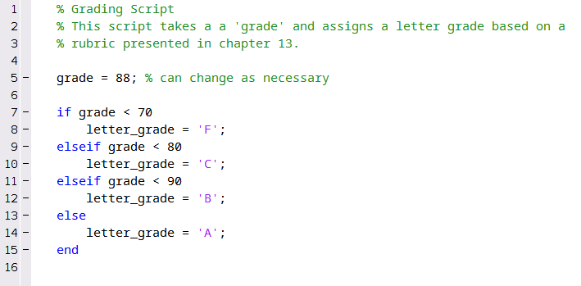
Figure X: My script solution

Nested Decisions
When designing your programs you may run into scenarios where it us useful to create nested decisions. Nested decisions describes the scenario of enclosing one decision into another. It may not seem intuitively obvious why this is necessary, but as your computer programs become more complex, it will be an extremely effective and useful strategy to consider.


Figure X: Nested decisions allow for some neat program capabilities!

For example, consider the following flowchart, which describes an algorithm a new mother might use to stop her baby from crying:

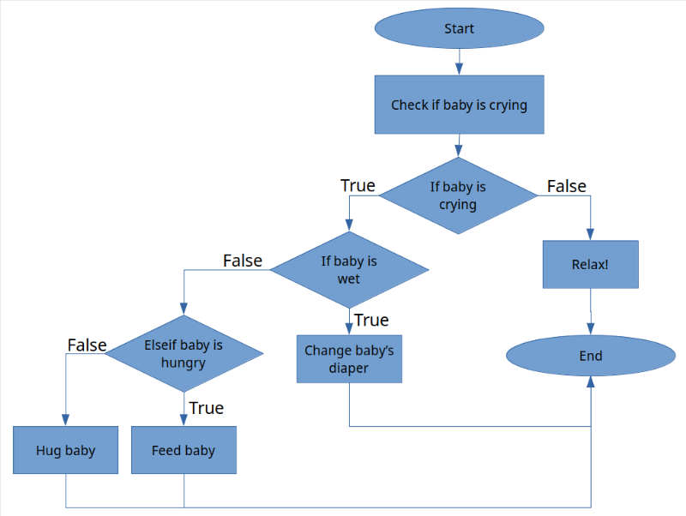
Figure X: Crying baby algorithm

Notice how the "If baby is wet" condition is nested inside of the "If baby is crying" condition. That is what we mean by nesting! There is no difference in the way that you write the code. You just can put one if after the other. The only little trick to nesting is remembering that each if needs a corresponding end. When you have several nested decisions, it can get confusing which end keyword is referring to which if keyword. To help organize your code, MATLAB will automatically apply a tab after each if statement. That way you can see what "level" you are in.
For an example, take a look at the code in figure X below. Keep in mind I do not expect you to understand what is happening in this code! (Spoiler: it is actually non-sensical code because I had to change some things to if statements so it didn't include programming concepts you haven't seen yet but that is not the point).

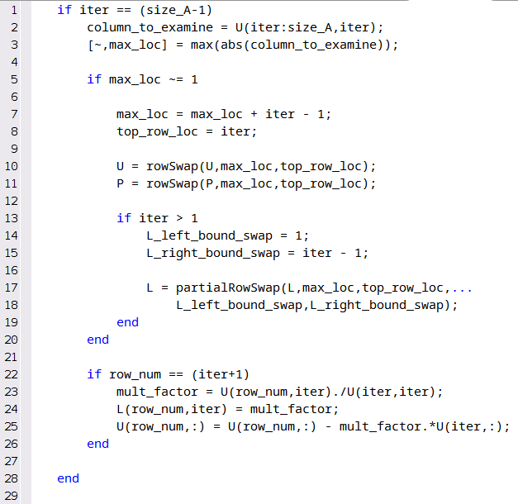
Figure X: Example non-sensical code of nesting

You should be able to create a flow chart of this code from figure X alone. The key is to notice that on line 5, there is a nested if statement. Furthermore, there is a 2nd level nested if statement on line 13. The other thing that you should notice is that MATLAB has automatically applied a tab after each if statement.
Go ahead and type in some non-sensical code into MATLAB to see this auto-tab in action. Or you can just copy the code in figure X.

Smart Indent
If you ever mess up your tabbing, don't worry! Just select all your text, right click, and select the "Smart Indent" option (see figure X below). Again, this is something that you should try yourself.

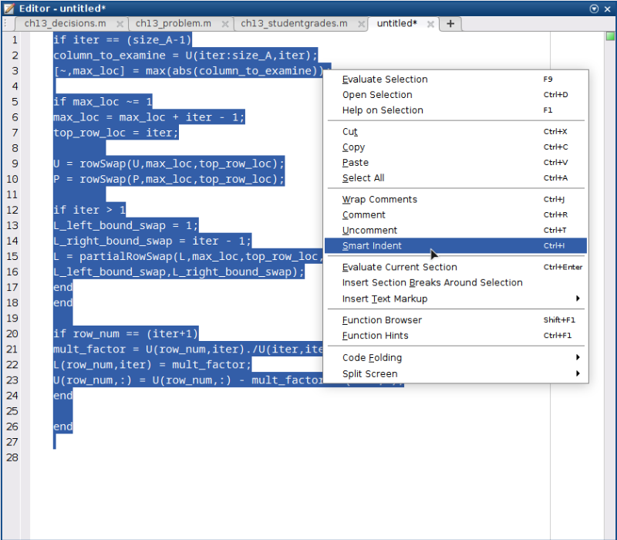
Figure X: Selecting text, right clicking, and then selecting "Smart Indent" will fix any indentation problems your code has and will make it easier to read!

End of Chapter Items
Personal Reflection - Chapter 13
This is a completely anonymous submission. The professor will be able to see the responses but the responses will not be attributed to an author. Your participation is required.
What do you think about the content of this chapter? Do you see how it ties into our previous chapter of thinking algorithmically? Do you think that you understand how these structures work in MATLAB? Do you have any cool ideas for programs that you can now make now that you have learned this? What do you think we are going to learn next? Do some personal reflection on your learning.

Request for Feedback - Chapter 13
This is a completely anonymous submission. The professor will be able to see the responses but the responses will not be attributed to an author. Your participation is required.
What did you think of this chapter? Anything stand out as exceptionally good? Anything that you would like to see differently? Any feedback is appreciated.

