Chapter 14: MATLAB Loops

Figure X: A little different but perhaps equally as terrifying of a loop! https://pixabay.com/photos/rollercoaster-looping-amusement-801833/

There are over 2.38 billion active Facebook users every month. Somehow, Facebook can send a "Happy Birthday" message to every single person that has Facebook. When you think about it, that is a remarkable feat!
Assuming an even distribution of Facebook users means that there are over 6,520,547 birthdays everyday!
365days/year2,380,000,000users​=6,520,547.95birthdays/day
For the sake of argument let's say that Facebook messages everyone saying "Happy Birthday! I just wanted to tell you Happy Birthday because I am a corporation that relies on you thinking of me as a human being!" That is 26 words.
The world record for typing speed is 216 words per minute. It would take the fastest person in the world 0.12 minutes or 7.22 seconds to type that message. Not bad!
216words/minute26words/message​=0.12minutes/message∗(60sec/min)=7.22sec
So if Facebook hired the fastest typist in the world, and locked them in a room and had them type that message to everyone in the world it would take them 544 days to write a short message to every person who had a birthday everyday.
7.22sec/message∗6,520,547messages=47,078,349seconds∗(1hour/3600seconds)=13,077hours∗(1day/24hours)=544days
Clearly, this isn't how Facebook does it. Not only is it extremely tedious, it is impossible. What they probably do, is have a single automated message and then loop through their database and send everybody that message who is having a birthday.
Whenever you run into a task that sounds tedious, it is likely a candidate for a computer! And you will probably need loops! So let's learn about them.
Remember our mantra and guiding process for writing complex programs is: think, sketch, code, test, repeat.

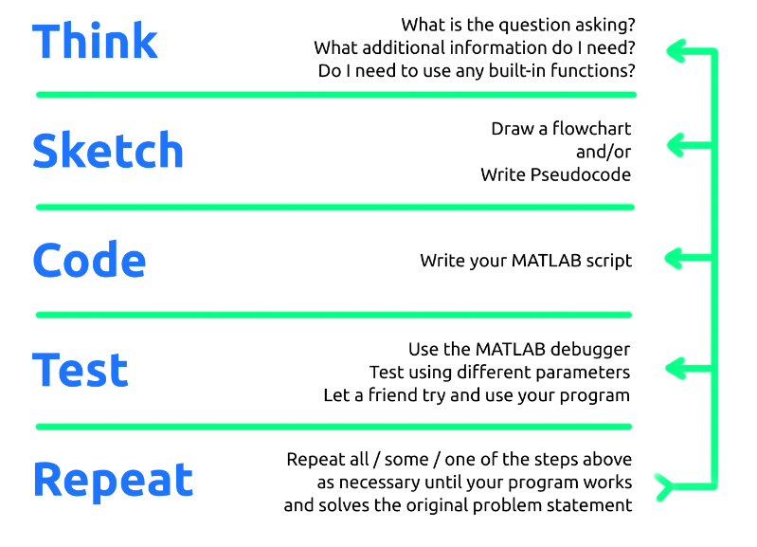
Figure X: Our mantra. Breathe it in. LIVE it.

Type caption for image (optional)
In this chapter we will learn how to program loops in MATLAB. That means learning:
- What a MATLAB for loop is and how it works.
- How to represent a for loop in a flowchart.
- The only case when it is appropriate to use a while loop and why it is dangerous.
Type caption for image (optional)

Maclaurin Expansion of sin(x) - A Tedious Example
Let's start this discussion by looking at a real world example (this one comes from the world of numerical methods, a crucial mechanical engineering course you will soon take!). We will be using this one particular example for a considerable percentage of this chapter.
If you are unfamiliar with maclaurin expansion (it is a special form of a taylor series expansion) that is OK! For now you should just understand that it is a way to approximate a function as a polynomial with an infinite number of terms. Khan academy has a great explanation if you would like to understand more (or if you need a quick refresher on infinite sums). If you are shaky on what this paragraph is saying, be sure to take a minute to check out those links and get up to speed.
For our purposes we will just understand that the following is true:
sin(x)=∑k=0∞​(2k+1)!−1kx2k+1​=x−3!x3​+5!x5​+7!x7​+...
Recall, this is saying that we can represent sin(x) as an infinite polynomial and it will equal sin(x) exactly as long as we have an ∞ number of terms.
Let's consider the case where we need to approximate sin(x) with MATLAB and we decide to use the Maclaurin expansion to do so. Clearly, we can't do an ∞ number of terms, that would take an ∞ amount of time! Instead, let's truncate the expansion to 3 terms and see if it is good enough.
sin(x)≈∑k=0k=2​(2k+1)!−1kx2k+1​=x−3!x3​+5!x5​
We can now use this approximation to estimate something like sin(2.618). Note, the angle in this case, 2.618, is in radians.
Before we move on...

Question 14.1: Reference check
In order to check our approximation of sin(2.618) you first need to calculate the analytical value (i.e. true value) of sin(2.618). What is the sin(2.618) equal to?

Now we know the correct answer. We are ready to calculate our approximation using a subset of the maclaurin expansion.
sin(2.618)≈2.618−3!2.6183​+5!2.6185​=0.6523
Ok, that isn't a terrible approximation but it isn't very good. What happens if we increase up to seven terms?
sin(x)≈∑k=0k=7​(2k+1)!−1kx2k+1​=x−3!x3​+5!x5​−7!x7​+9!x9​−11!x11​+13!x13​
Well, we can be sure that it will be more accurate but it is clear that the more terms that we add, the more tedious this process becomes. Imagine increasing our estimate to 20 terms! Whenever a process is tedious and repetitive, it is a perfect candidate to have a computer do it. In order for a computer to do it though, we need to transfer this process into an algorithm that can solve this problem for an arbitrary n number of terms.
Remember our mantra, think, sketch, code, test, repeat.

THINK - You need to stop and think! You should be asking yourself these types of questions (and more!):
- Do you understand the expansion?
- Do you understand our goal?
- Do you have an idea for a way to calculate this in MATLAB?
- What does an n number of terms mean?

SKETCH - I will trust that you spent a minute thinking about the problem and making sure that you understand all the moving pieces. You wouldn't skip a brain workout would you? The next step, is to sketch.

Type caption for image (optional)
Before you move on and look at my flowchart, can you create pseudocode or draw a flowchart that can can algorithmically solve this problem for an arbitrary n number of terms? It might be good to review what we learned in the thinking algorithmically chapter if you have not done so already.
Type caption for image (optional)

Keep in mind that it is OK if you are confused or stuck as long as you gave it an honest try! Here is my flowchart for this problem:

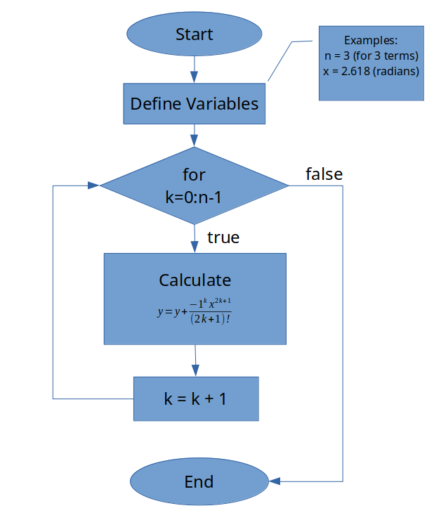
Figure X: My flowchart for the maclaurin series expansion of sin(x)

Now is a good time to go back to the think step. Look at my flowchart in figure X above and see if you can answer the following questions.
- Does the flowchart make sense to you?
- Do you understand how it works? Can you follow it along?
- Do you understand what the true and false text indicators are referring to?
- Do you understand why I have the little extra explanation box giving examples of variables?
We have now successfully completed the think and sketch stages of our process. In order to continue on with the next step, code, we need to learn how to program these types of structures into MATLAB. Lets take a break from this particular problem and investigate how to program the necessary functionality into MATLAB.

MATLAB For-End Loops
From our flowchart in figure X above, we can see that we are going to use a for loop. In the thinking algorithmically chapter we learned how and when to use a for loop. Now we just need to see how to program this type of loop into MATLAB.
Recall that for loops execute a pre-determined number of times. Generically, in MATLAB, they are programmed as follows:
for index_variable = first_pass : increment : last_pass
< code to be executed during the loop >
end
for-end Loop Important Details:
- for loops require 2 numbers to be defined: first_pass and last_pass.
- The number increment is optional. If it is omitted, the increment will default to 1.
- MATLAB will modify the index_variable by the increment amount specified at the start of each pass through the loop.
- The loop is completed when the index_variable value is greater than or equal to the last_pass number. In the flowchart below this is what is meant by the true/false condition on the for loop diamond box.
- The index_variable persists in the workspace after the loop is completed. That means you can check it to make sure that it worked the way that you expected it to.
- The index_variable can either be used in calculations inside of the loop if necessary or desired.
- Similarly to decision structures, the for and end lines of code should not end in a ;
- The first_pass, increment, and last_pass variables can actually contain functions or mathematical statements as long as they evaluate to a number.
- For example, consider an array named gamma is defined in the workspace: for kappa = 1:length(gamma) is valid because when the function length(gamma) is evaluated by MATLAB, an integer is returned. In this case the increment is equal to 1 because a specific increment was omitted. So if length(gamma) = 5, this loop would run 5 times.
The flowchart for the generic for loop is shown below in figure X.

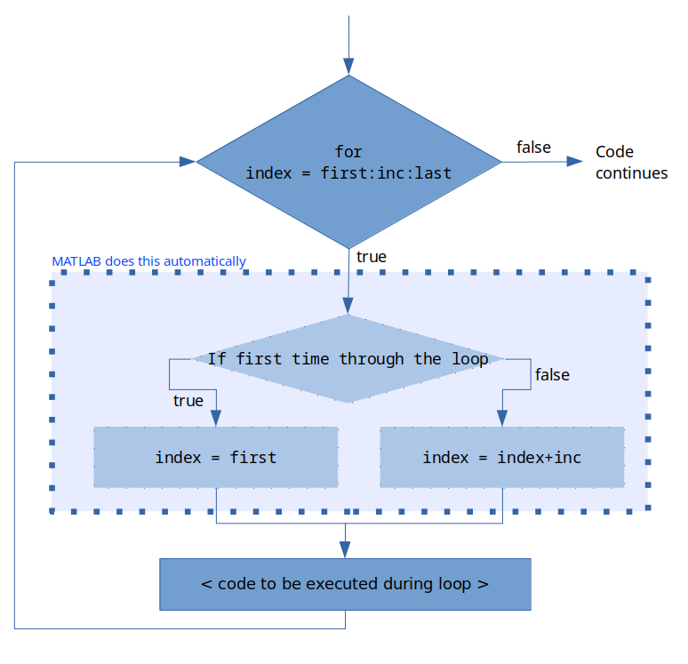
Figure X: Generic MATLAB for loop flowchart. The variable names are a little different than in the generic code example above (e.g. index_variable was shortened to index, etc) to preserve space but the logic is the same.

As an example, consider the example code below in figure X. This may look complicated but in practice it looks more complicated than it really is. See if you can follow the logic presented in the figure. It would also help to try and "follow along" on your own on a sheet of paper. See if you can follow the value variable throughout the looping process.

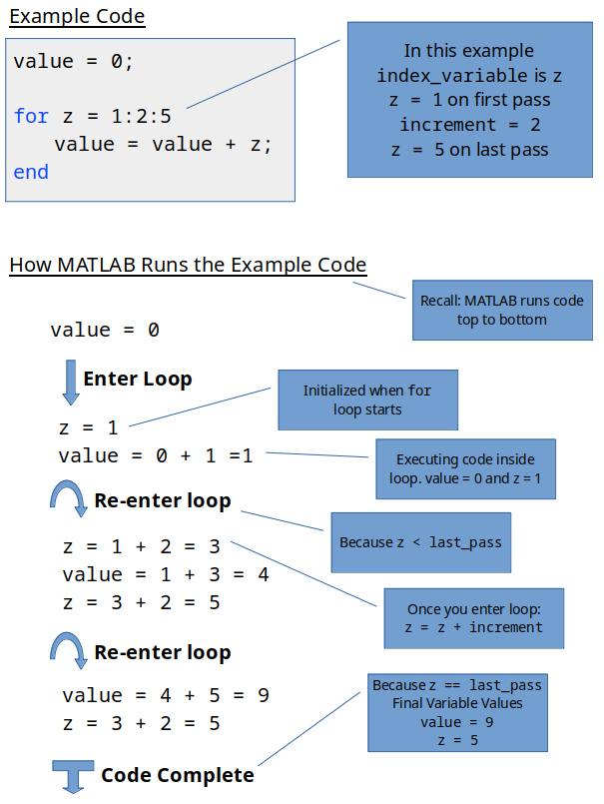
Figure X: An example for loop execution process. You can confirm this by executing the sample code in MATLAB on your own!

Type caption for image (optional)
You need to spend some time reviewing figures X and X to really understand how these loops work. If this explanation is confusing to you, try taking a break from this text, and looking at someone else's explanation. The important thing is that you understand what for loops are and how to use them.
If you search for "for loops" in youtube you can find hundreds of videos of people explaining these looping structures. Here is one such video.
Type caption for image (optional)

for-end Key Concept #1 - Loop Executed a Specified Number of Times
In the example loop: for z = 1:2:5 we can see that this loop will only run for a total of three times. The first time through the loop z = 1, the second time through, z = 3, and the last time through, z = 5. The key to remember is that the for-end loop will only run a specified number of times that is pre-determined based off the first line of the loop.


Figure X: The loop will only run a specified number of times. Unlike the roll of the dice, this is predetermined by the programmer. https://pixabay.com/illustrations/cube-random-luck-eye-numbers-1655118/

When designing your programs, it is important to think about how to define your index_variable and what values to specify for it so that you can control the number of passes through the loop.

Question 14.2: An Example For Loop
Consider the code:
sneetches = 0;
for stars = 0:5:25
sneetches = sneetches + stars;
end
How many times will the code inside this for-end loop be executed?

for-end Key Concept #2 - Follow the Variables
In addition to predicting the number of times loop code will execute you should also be able to "follow the variables" through the execution of the code. Following the variables is important so that you can troubleshoot errors in your loops and predict what values should be generated by your loop. An example of following the variables was shown in figure X above. The idea is that you can sketch what should happen when the code has been run.

Question 14.3: An Example For Loop
Consider the code:
sneetches = 0;
for stars = 0:5:25
sneetches = sneetches + stars;
end
What is the value of the
sneetches
variable when this code is run?

for-end Key Concept #3 - Analyze Arrays
The final important thing to consider when learning about for-end loops is that they can be used to analyze and build arrays. For example, lets consider that we have an array defined in the workspace as follows:
man_bear_pig = [1, 1, 2, 1, 4, 2, 4, 5];
As an example, lets say that we want to add all the values in this array (you can use the built-in sum() function for this but lets consider how to do this using loops as an example). We can use a for loop to cycle through all of the values in the array! This code will accomplish this:
sum = 0;
man_bear_pig = [1, 1, 2, 1, 4, 2, 4, 5];
for index = 1:length(man_bear_pig)
sum = sum + man_bear_pig(index);
end
The key here is to notice how the for loop was used to loop through every value of the array man_bear_pig. Since the increment is 1, we can use the index variable to access the data within the array. This is a common application of for loops and one that you need to have in your tool belt to be a successful programmer.

Question 14.4: Analyze the array
For this problem, consider the code:
sum = 0;
man_bear_pig = [1, 6, 2, 1, 4, 2, 9, 5, 3, 9, 2, 1, 4, 2, 7, 3];
for index = 1:2:length(man_bear_pig)
sum = sum + man_bear_pig(index);
end
Consider the 3rd pass through this loop. What is the value stored in
man_bear_pig(index)
on the 3rd pass through this loop?

Finishing the Maclaurin Example
Hopefully at this point you can at least understand how a for-end loop is supposed to work and what it might be used for. You should also start to understand what the 3 key concepts you should learn about these loops are. It is OK if you are a little shaky in your knowledge, but you should at least know what you need to learn.

Type caption for image (optional)
Returning to our Maclaurin series example, we are now ready for the code phase. Based off what you have learned about for loops, can you write the MATLAB code that accomplishes our programming goal. To remind you, the goal was:
Create a MATLAB script that can return the value of the Maclaurin series expansion of sin(x) for angle x in radians, for an arbitrary n number of terms.
- Recall the Maclaurin series expansion of sin(x) is: sin(x)=x−3!x3​+5!x5​+7!x7​+...
- Remember that although only 4 terms are shown in the bullet point above, that this is an ∞ sum
- When we say an arbitrary n number of terms, your script should allow the user to change a variable n to change how many terms are used in the estimation.
- For example, if the user specifies n = 3, and wants to estimate sin(1.15) by specifying x = 1.15, the program should calculate: (this is actually a pretty good estimate by the way)
Give it your best shot! Try and see if you can come up with this code on your own! I believe in you!
Type caption for image (optional)

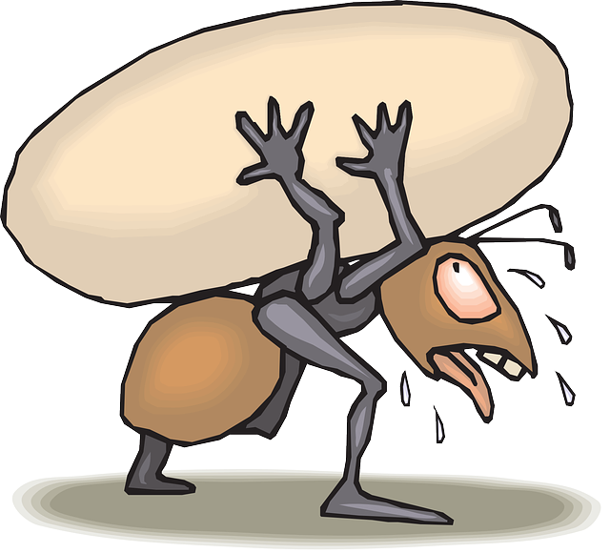
Figure X: I know this is difficult but no pain no gain! Give it your best shot!

My solution is shown below in figure X:

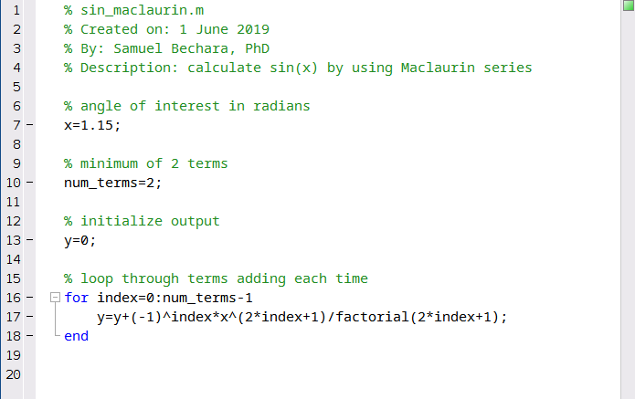
Figure X: My solution for the Maclaurin expansion of sin(x)

If you didn't get this exactly it is OK as long as you tried. Spend some time with the script above in figure X until you understand how it works. Keep practicing, reading, and watching YouTube video tutorials until this is starting to click!

The Dangerous Loop
This chapter would not be complete without a mention of while-end loops. They will be described below, however, I encourage you to only use while-end loops in cases where it is impossible to use for-end loops.

Figure X: Warning: while loops are DANGEROUS https://pixabay.com/vectors/sign-road-road-sign-traffic-2881876/
The reason I am warning about while-end loops before discussing them is that they are the only thing that we will learn in this book that can create ∞ loops.

What is an ∞ loop? Well why don't you go ahead and try one and see!

How to Kill (and Create) an Infinite Loop
Before I show you how to create an infinite loop, I will first tell you how to kill one.
To stop an infinite loop, select the MATLAB command window and hit ctrl+c on your keyboard. OK, ready to create an infinite loop? Create the following script, save is as to_infinity_and_beyond.m and click run. Once you get bored of seeing the numbers fly by, hit Ctrl+c on your keyboard to stop it.

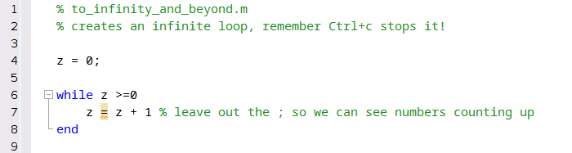
Figure X: To infinity, AND BEYOND! I hope Disney doesn't sue me...

What was going on there? The reason that while loops are dangerous is because they do not have a predetermined number of times that they run. Instead, while loops run until the condition they were initialized with is false. The reason this loop keeps running forever is that the initialized condition, z >= 0 was never made false. Since z started equal to 0, and all we did in the loop was keep adding positive values to it, z >= 0 was always true.

MATLAB while-end Loops
So what are while loops and what do they look like? The generic while-end loop is show below:
while < conditional expression is true >
< execute code >
< * YOU BETTER MAKE THAT CONDITION FALSE! * >
end
while Loop Important Details:
- Similar to for loops, while loops start with the keyword while and must be completed with the end keyword.
- It is vitally important that your while loop conditional expression is made false at some point during the execution of the loop. If it is not made false, you get an infinite loop.
You can think of while loops as over eager dogs. They will run themselves to death unless you tell them to stop. The way that you tell a while loop to stop is to make sure that at some point in the loop, the initial conditional expression becomes false.


Figure X: The while loop is the overenthusiastic sled dog of the loop world. Sled dogs do actually run themselves to death. https://pixabay.com/photos/dogs-huskies-animal-dog-racing-2921382/

The flowchart for the generic while loop is shown below in figure X:

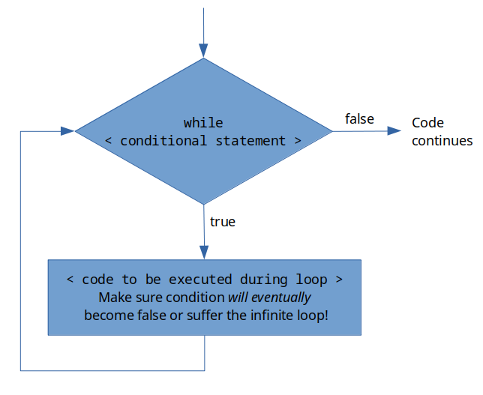
Figure X: A generic while loop flowchart

The beauty of while loops is that you can ensure that your code repeats itself until a specific condition is met. However, while loops should only be used in instances where you do not already know how many times the loop needs to be run.

Maclaurin Series Example - while Loop Edition
To see an instance where a while loop is necessary, let's consider the case of the Maclaurin series expansion of sin(x) one last time. In this case, lets flip the question a little bit. Lets say that the new question is, you want to know how many terms of the Maclaurin series are necessary to get an estimation of sin(x) that is 99% accurate.
We know from the Maclaurin series that if we keep adding terms, the estimation will get more and more accurate. We also know that we need an infinite number of terms to make the answer infinitely accurate. But how many terms are necessary to get our estimation of sin(x) 99% accurate? It will depend on the x that the user specifies but it actually might not take as many terms as you might think it does.
Here are a few tips to get you started:
- It is actually easier to use the error rather than accuracy. The formula for percent error is So 99% accurate would be less than 1% error.
- Use the built-in MATLAB function sin() to get a "true" value for sin(x). Even though it isn't 100% accurate, it is close enough for our purposes.
- Since you do not know how many terms it will take, you will need to use a while loop.

Type caption for image (optional)
I am not going to lie, I think that this is a pretty difficult problem. But we are here to workout our brains and difficult problems are our opportunity to show off our strength!
Try to complete the entire process: think, sketch, code, test, and repeat.
- Think - what is this problem asking for? Do you have anything already completed that can help you complete this?
- Sketch - Write out a flowchart or pseudocode for this problem and how you would solve it.
- Code - Give it your best shot! Make sure that you repeat the think and sketch phases as much as you need to!
- Test - Compare your MATLAB solution to your solution by hand (it won't take as many terms as you think!). Try with different x values and make sure that it is robust and it works.
- Repeat - repeat any steps necessary until you can get a working script.
I know this is difficult! You can do it!
Type caption for image (optional)

Discussion 14.1: What is your flowchart?
This post is not anonymous. The professor and participants can see the responses and the author.
For this discussion, upload a picture of your flowchart or write out your pseudocode that you came up with to solve the Maclaurin series "number of terms" problem described directly above. The coding part might be difficult but I have faith in your ability to come up with the algorithm! Take your time and think through it!

The code solution to the problem is shown below in figure X. Make sure that you give it an honest try before looking at the solution though! Do not skip your brain workouts, you will only cheat yourself.

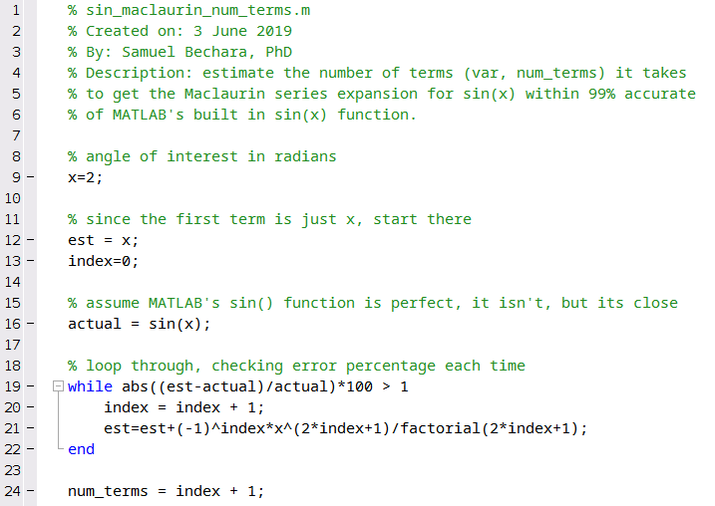
Figure X: The solution. The num_terms variable will be an integer that is equal to the number of terms necessary to get better than 99% accuracy.

Question 14.5: How many terms?
Using your script (or the solution shown in figure X above) how many terms are necessary to get better than 99% accuracy when using the Maclaurin series expansion for sin(x) when estimating x=1.874 radians?

A Final Note on Loops
Look, I get it. Programming is hard. Loops are hard. But remember that we are treating this as a brain workout. No one walks into a gym and expects to bench 500lbs right away! You need to workout for years before you get to that level. The good thing about programming, you do not need to practice for years to understand loops! You will need to practice though.
The other thing to remember is that not everyone is equal. Just like working out, some of your classmates or peers may get this faster than you. It doesn't matter. The only thing that matters is YOU. You need to take the time necessary to understand these concepts. I believe in you!

Challenge Question - Return to the Student Grade Analyzer
Speaking of practice, here is one last challenge question to end the chapter with. Remember last chapter when we used decisions to assign a letter grade to a numeric grade? Now consider the case where instead of a single numeric grade, you instead have an array of grades. Lets say that we have an array called grades that is a column vector that contains the final grades for everyone in a class. When you are working on this, only consider 10 or so grades but understand that your algorithm should work for any number of grades (my classes can often be 200+ students!).
Remember, the final grades are calculated as follows:

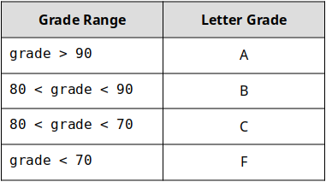
Table X: How letter grades are calculated from numeric grades

Can you create a MATLAB script that:
- Accepts a 1D row vector called grade that contains numeric grades.
- grade can have any number of grade entries.
- Upon completion, your script creates a corresponding 1D row vector called letter_grade array. The index of the arrays matches, so if grades(2) = 92, letter_grades(2) = 'A'
Good luck practicing! Remember our mantra and guiding process for writing complex programs is: think, sketch, code, test, repeat.

End of Chapter Items
Personal Reflection - Chapter 14
This is a completely anonymous submission. The professor will be able to see the responses but the responses will not be attributed to an author. Your participation is required.
What do you think about the content of this chapter? Did you at least attempt the challenge question? Why or why not? Do you think the content in this chapter makes sense? Do you see the logical progression and can you anticipate what we are going to learn next? Do some personal reflection about your learning.

Request for Feedback - Chapter 14
This is a completely anonymous submission. The professor will be able to see the responses but the responses will not be attributed to an author. Your participation is required.
What did you think of this chapter? Anything stand out as exceptionally good? Anything that you would like to see differently? Any feedback is appreciated.

