Introduction to Mechanical Engineering

A Hands On Approach

__________

Samuel Bechara, PhD

Introduction to Mechanical Engineering: A Hands On Approach
Copyright © 2020 by Samuel Bechara, PhD

All rights reserved. No part of this book may be reproduced or transmitted
in any form or by any means without written permission from the author.

ISBN (XXXXXXXXXXXXX)

Printed in USA by 48HrBooks (www.48HrBooks.com)
Dedication
Replace this type with own wording, saying who you are dedicating this book to, and why. Replace this type with own wording, saying who you are dedicating this book to, and why. If you don’t have a dedication, simply delete this entire page.
If you have further questions, contact 48HrBooks. Our regular business hours are Mon-Thurs. 8:30 am – 8 pm EST, and Friday 8:30 am – 5 pm. During these hours, you can reach us by phone, email or on-line chat. Outside of these hours, either call and leave a message or email us.
Phone: 800-231-0521
Email: info@48HrBooks.com
On-Line Chat: go to our website, www.48HrBooks.com.

Table of Contents

Foreword 1
Preface 3
Introduction 5
Chapter 1 7
Chapter 2 21
Chapter 3 37
Chapter 4 71
Chapter 5 93
Chapter 6 101
Chapter 7 113
Chapter 8 233
Chapter 9 247
Chapter 10 261
Chapter 11 281
Chapter 12 293

Chapter 0: How to use this textbook
This isn't your traditional, static, boring engineering textbook. Unless you have had experience with interactive e-books in the past, the process of "reading" this book is going to feel very unfamiliar. In addition to reading you will be: journaling your thoughts, discussing concepts with your peers, practicing problems, watching videos, and more.


Figure 0.1: Begone boring textbooks of old!

To make sure we are all on the same page (book pun already!), I have included a descriptions of the interactive components of this textbook, how they will be graded, and who will have access to what information. I would also like to introduce you to the analogy that we will be using in this book.

Welcome to the Gym for Your Mind!
In my opinion, learning is very similar to working out. I think this is such a perfect analogy that it is used throughout this book. Let's look at the similarities between learning and working out.

Lets say that you are physically weak and are unable to lift heavy objects. You dream of one day being able to deadlift 500 lbs (I have no idea if that is a lot but it sounds like a lot so lets go with it). What do you need to do to get better at deadlifting? You need to workout a lot. You are going to have to put serious time and effort into getting stronger. Furthermore, you will not be able to expect miracles without putting in the time. You can't just go to a gym, stand around, watch other people workout, and then after 15 weeks expect to be able to deadlift 500 lbs! You need to get your hands dirty, pick up the weights, start small, and build your way up.


Figure 0.2: You will be doing this, except with your brain!

Most people intuitively know this. If I told you that someone wanted to deadlift 500 lbs but that they went to a gym for 15 weeks but didn't really workout that hard, they kinda did the minimum, skimped on the workouts their personal trainer gave them, and then tried to max 500 lbs on the last day, how do you think that person would perform? Of course they would fail!

Similarly, if I told you a story about someone that also wanted to deadlift 500 lbs but they went to the gym for 15 weeks, worked out really hard, did everything the trainer suggested and more, and they tried to max 500 lbs on their last day, how do you think this person would perform? They would likely succeed.

In my opinion, learning works the exact same way. You could try and learn all of the material you learn at a University on your own. You likely have access to a public library that contains all of the information you will learn in college except it is free! The reason you pay for a University education is that you get a personalized workout experience. Your professors act as personal trainers that give you tasks to accomplish that will build your mental muscles that are right for your chosen career.

Engineering is one of the most difficult workout routines, you can think of it as training for an ironman triathlon. You are going to be building mental muscles you never even knew that you had. You need to workout your math, problem solving, physics, chemistry, programming, and more mental muscles. It isn't easy but it is rewarding.

As I mentioned before, this analogy will pop up throughout the book. Sometimes I will give you a task to complete that isn't graded or checked. Sometimes I will prompt you "not to skip your brain workout". In the end it is up to you though. I encourage you to take this analogy to heart and think about your goals. If you want to get good grades (deadlift 500 lbs at the end of the semester) and succeed as an engineer you are going to have to roll up your sleeves and practice and fail and practice and fail and practice and...succeed! (In this context I mean fail as in "not get it right away" and that is ok!)

Take a minute to think about the workout analogy in the context of your learning and answer the discussion post below.

Discussion 0.1: What is your goal?
This is a completely anonymous submission. The professor will be able to see the responses but the responses will not be attributed to an author. Your participation is required.
What is your goal this semester? What do you want to learn? Do you agree that this the workout is a good analogy for learning?

A Note on Your Brain
Remember that just like our bodies, everyone has a different brain at different levels of strength. Some of you will already have pretty good development on some of the brain muscles we will be working on. Others will be much weaker. That is OK! Learning is as individual as it gets in this world and the only person's learning you need to worry about is your own. Do not get discouraged if you think that someone else gets it before you. Do whatever it takes for you to succeed, even if that means that you need to work harder than some of your classmates. I believe in you!

Learning Goals
Each chapter will begin with a picture (for fun), a short introductory paragraph, and then some learning goals. They will always look like this:

This chapter will concentrate on learning idea X. That includes learning the following:
- Something cool
- Some other fun thing
You can use these learning goals as a "study guide" and will let you know when you have achieved mastery of a subject. If you look through a chapter's learning goals and can be absolutely certain that you have mastered everyone of the bullet points, then you have mastered the material in that chapter. It is a good idea to refer to these learning goals frequently throughout the semester, even for chapters that have already been completed to ensure that you are up to speed with the course.

How to Learn Software
In this book you will be learning how to use two software packages, Excel and MATLAB. As such it is necessary to give you a little information on how I expect you to approach learning this material.


Figure 0.3: Roll up those sleeves and get your hands dirty!

The key to learning how to use software is to roll up your sleeves and get your hands proverbially dirty. What I am trying to say is that just reading about Excel (or any software package really) is insufficient to learning Excel. What you really need to do is open up Microsoft Excel, and follow along with the material as you are learning it. For example, if you are reading about how to enter data into cells in Excel, you need to take a minute to practice that (again you should be able to see the connection to the workout analogy). In my opinion, the best way to learn the material on Excel and MATLAB is to have the book opened up in your web browser of choice, and also have the software package of interest opened up beside it. That way you can read and practice simultaneously.

Make sure that when you are reading, that you are also practicing simultaneously! The book is designed to take this into consideration and will often present you with links for further reading, or suggestions for problems to practice on your own. Do not skip these!

Personal Reflections
The personal reflection is your opportunity to vent and let the professor know about the triumphs or frustrations that you are having while learning. Maybe something you tried really worked and helped enhance your learning experience. We would love to hear what that is! Maybe you found that a habit that you had formed was impacting your learning. We would also like to hear about that. Really, anything that you want to write or let your professor know would be appropriate in a personal reflection.

Personal Reflection - Chapter 0
This is a completely anonymous submission. The professor will be able to see the responses but the responses will not be attributed to an author. Your participation is required.
We haven't really learned anything yet but now is a good opportunity to practice reflecting. Look back on your previous life (most of you are from high school but some of you undoubtedly will have been working, in the military, etc). What parts of your previous life will help you with being an engineering student?

Requests for Feedback
A request for feedback is your opportunity to let the author (me) know what you thought about the chapter.

Did you like the way it was written? Did you appreciate a little bit of levity that was sprinkled in? Did you find the exercises fun? (Notice how most of these are nice things? That is because people usually only bother to give feedback when they HATE something, it is also good for authors to know when things are working so don't forget to say something nice!)

In any case, please take a few minutes at the end of each chapter to think about how the material was presented, what worked, and what didn't.

Request for Feedback - Chapter 0
This is a completely anonymous submission. The professor will be able to see the responses but the responses will not be attributed to an author. Your participation is required.
This chapter is pretty short and we haven't really learned any new material yet, but it does give you a feel for what the rest of the book is going to be like. Do you appreciate the tone of the author? Do you think this is going to be a fun course? Are you excited to read the book based off this chapter? Any feedback is appreciated.

Image 0.1 courtesy of Dariusz Sankowski via Pixabay, under Pixabay Licence
Image 0.2 courtesy of Skeeze via Pixabay, under Pixabay Licence
Image 0.3 courtesy of Michael Gaida via Pixabay, under Pixabay Licence
Chapter 1: Is it a bird? Is it a plane?

Figure 1.1: Engineers bestow superhuman powers.
Typical engineering textbooks often start off be asking legitimate questions but respond by giving boring answers. The typical questions are:
- What does it mean to be an engineer?
- What do engineers do?
- What ethical problems arise with engineers?
These are valid questions for the starting engineering student and the answers are exciting!

Before we get any further, take a minute to write out a short description of what YOU think an engineer is and what they do:

Discussion 1.1: What is an engineer?
This post is anonymous to your classmates only. The professor can see the responses and the author.
Before we jump into this book, take a minute to reflect. After all, you chose this major for some reason. What do you think an engineer does? Why did you choose this major? Your answer doesn't need to be a page long, just write a few sentences to reflect.

In this chapter we will learn about engineering in general. That includes learning:
- What it means to be an engineer and what engineers do.
- What engineering careers look like and how they are projected to grow.
- How to approach your schooling and why I think that school is a gym for your mind.
- What engineering ethics are and how to approach ethical dilemmas.
- What the non-cognitive skills are for success as an engineer.
- The dangers of having a smart professor.

Engineers Give Humans Superpowers
Engineers build things that give people superpowers and in the process, make the world a better place. It really is that simple.


Figure 1.1: Engineers turn ordinary people into Superheros!

Currently, the fastest man in the world (for the 100m dash) tops out at approximately 44.72 km/h while running. Mechanical Engineers have developed vehicles that allow humans to travel at 120 km/h for sustained periods of time. These vehicles are comfortable, safe, relatively affordable, and more importantly, the user doesn't even have to break a sweat!

Pretend we are in 1918...
Consider, explaining to someone 100 years ago the powers that engineers have given mere mortals. Go ahead, close your eyes, and pretend that you are someone from 100 years ago. You can even come up with a old-timey name for yourself if it helps (my old-timey name is Horatio Winterberry). Go on wikipedia and try and see what life was like in 1918. That page should allow you to see a bunch of historically important events that happened over 100 years ago. Click through the Wikipedia page, do a little more background research, and get a good feel for the type of technology they had available to them.

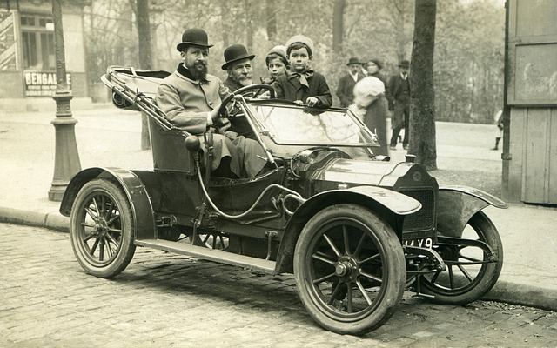
Figure 1.2: Horatio Winterberry in his new horseless carriage... probably

Now, continuing our imagination, someone comes from the future and tells you some of the things engineers have created. Engineers have made it so that a business man can travel to New York from London in a matter of hours! Engineers have created robotic prosthetics that can be controlled from a the mind of an amputee! Horatio Winterberry from 1918 would have thought you are crazy.

Discussion 1.2: Time traveler
This post is not anonymous. The professor and participants can see the responses and the author.
For this discussion, we are going to continue role playing as if we were from 1918. Consider being transported to the year 2018 for a year, long enough to learn about current technology. After a year you are transported back to 1918! Draft a short letter to your mother explaining a current technology to a person in 1918. To complete the old-timey feel, you can also hand-write your response and upload it instead!

Engineers are in the business of building things that give individual people and humanity as a whole super powers. Bio-engineers have made crops that can sit super close together so we can grow more food. Agricultural engineers improved agriculture. The list goes on.

Engineering Disciplines
Engineers are broken into several disciplines, typically by prepending a descriptor to "Engineer" that describes a broad category of things that they make that gives humans super powers. Example: Electrical Engineers use electronics to give people super powers.

Note: There are many more specialties than presented in this section. This list was decided as you can find most of these engineering majors at most large universities:
- Aerospace Engineering
- Agricultural Engineering
- Biomedical Engineering
- Chemical Engineering
- Civil Engineering
- Computer Engineering
- Electrical Engineering
- Environmental Engineering
- Industrial Engineering
- Mechanical Engineering

The US Bureau of Labor Statistics (BLS) has excellent information on these careers. They describe what they do, job outlook, pay, area information, and more. You can find a list of all the tracked engineering careers on the BLS website here. In addition to those careers, you should pursue the BLS site and look at other careers and options. You might be surprised what is growing fastest!

Question 1.1: BLS Stats on Engineering
Your task for this problem is to sort the engineering careers by "Job Outlook, 2016-2026" in descending order (High to Low). "Job Outlook, 2016-2026" represents a BLS estimation of how fast the engineering careers will grow in the next decade. Keep in mind the careers we are looking at are NOT tech jobs!
- Aerospace Engineering
- Industrial Engineering
- Agricultural Engineering
- Civil Engineering
- Computer Hardware Engineering
- Electrical Engineering
- Mechanical Engineering

Based off of the following activity you may think to yourself "Ah, I should switch my major to the career growing the fastest!". Not so fast. Part of being a good engineer is learning how to analyze and interpret information. For example: consider that Biomedical Engineering is projected to grow much more quickly than Computer Hardware Engineering (7% vs 5% respectively) then answer the following question.

Question 1.2: Another look at those statistics...
Look at the BLS projections for Biomedical Engineering vs Computer Hardware Engineering. Based off the projections, and even though Biomedical Engineering is growing faster, how many more Computer Hardware Engineers will be employed as compared to Biomedical Engineers in the year 2026?

Finally, spend some time purusing the BLS page for your chosen major or field you would like to go into. Click around on all the tabs. Looks at where they are employed, what they do, how much they are paid, etc. Then take some time to reflect.

Discussion 1.3: What is your major?
This post is anonymous to your classmates only. The professor can see the responses and the author.
What engineering major are you currently enrolled in? What does the BLS say they do? What type of thing do they make? Are you interested in making that thing? Make sure to write in your own words, plagiarism is not OK! If you are a double major, you can either pick one, or pick both to describe here.

Don't Do It for the Money
(or for your parents, or for prestige, etc)

Engineering is hard and there are right and wrong reasons to puruse it as a major. Several students pursue engineering because they heard that engineers make a lot of money. For example, the BLS says that the median pay for Chemical Engineers is $102,160! This is crazy seeing as how the median salary for employed workers in the US is currently $37,690. Before we continue, lets tell a little story...

Consider the following scenario:
Steve is an 18 year old about to graduate from Generic High School. Steve is very smart and exceptionally clever. He has always been interested in electronics, computers, and baseball. He built an arduino-based biometric lock for his bedroom to keep his sister out when he was only 7 years old. However, Steve has no muscular definition or hand eye coordination to speak of. Steve was the only player to strike out in his t-ball league (a record him and his dad laugh about often). As part of his high school capstone project Steve designed an "e-bat" that was able to measure the swing velocity and force imparted onto the ball for his High School Baseball team. Even though he didn't make the team, Steve was proud to see his e-bat used to enhance the performance of the players by giving them information on their swing speed, angle, etc. Steve graduates High School with a 3.9 GPA and gets a full ride scholarship offer from Colorado State University to study engineering. Steve has always been interested in baseball and hears that MLB players make a lot of money. Steve decides to skip college and instead he begins training to become an MLB baseball player.


Figure 1.3: DEFINITELY not Steve

What is the point of that weird story?
While we may be rooting for Steve (we all love an underdog story), it seems clear that his logic is absurd. Steve does not have the physical characteristics necessary to be a successful MLB player. While he might, with a lot of training and hard work, achieve this dream, it is more likely that he will fail. It is clear to us that Steve should have chosen that Colorado State University scholarship and studied Mechanical Engineering! Just like it is absurd for Steve to choose to be an MLB player, it is equally as absurd to arbitrarily choose a college major.

Engineering is hard and there are right and wrong reasons to pursue it as a major.
If you signed up for an engineering major because you think engineers make a lot of money (typically true but not always the case), or because your parents pushed you into it, you are going to be in for a long four years and a potentially miserable career. If you signed up because you love learning and are interested in making things that help turn ordinary people into super heros, you are in for a treat. Engineering school will equip you with the tools and mindset necessary to analyze problems and design novel solutions using technical knowledge and personal ingenuity.

However, if you are uninterested in working hard, long hours on difficult problems that require advanced mathematical understanding and computational thinking, you may want to look at other degree options that might be more interesting to you.

There are lots of college majors and it can be difficult to pick a potentially life long career when you are a freshman in college. I get it. But take some time to reflect.

Discussion 1.4: Do you have what it takes?
This post is anonymous to your classmates only. The professor can see the responses and the author.
- What are your strengths?
- What are your weaknesses?
- Do you have good time management skills?
- Are you ok with studying for long hours and working on hard problems without easy solutions?
Use this self reflection to make sure that you are in the right place. There are no right or wrong answers to these questions. They are simply for you to start having a conversation with your self about what is right for you.

Non Cognitive Skills For Success
The purpose of the proceeding section was not to get you to change majors! If you are interested in engineering please stick with it! In my experience, students drop out of engineering for two reasons:
- They think it is too hard and want to switch to an "easier" major
- They think they aren't smart enough
Both of these are not valid reasons to change your major as long as you are interested and really want to be an engineer. Yes, engineering is difficult and requires advanced mathematics, physics, and scientific training. Is that hard? Of course it is, but if you are interested in it, than you should also find it fun.

A lot of the problems that students have with engineering comes from the way society prepares us. Lets consider another story to illustrate what I mean by this.

Pretend you are going to a concert to see Yo Yo Ma play Bach's Cello Suite No. 1 in G Major. Go ahead and do yourself a favor, take a few minutes out of your day, close your eyes, and imagine being lucky enough to hear him play this for you live. Seriously, it is only a few minutes long and it is strikingly beautiful. Hit the play button, and close your eyes...

Video 1: Yo Yo Ma - Bach Cello Suite No.1 in G Major

Woah. He is good right? Did you listen to the whole thing? I think it is difficult to listen to that piece and not have some kind of emotion come flooding into your head. That is how good Yo Yo Ma is.

Now comes the million dollar question. Could you ever be that good? This is the question that society has prepared us to answer incorrectly. Society tells us no. Society tells us that Yo Yo Ma is super talented and that you could never do that because you aren't as talented as he is. It is easy to think that, well, Yo Yo Ma is super talented and I am not so I guess I can never play cello as good as he can so I won't start.

I am trying to tell you that you can be that good, you are just to lazy to put in the effort. That is OK, not everyone needs to be an amazing cellist. But you should be amazing at something which means that you are going to have to get to working hard and failing! What you don't see when you see someone do something amazing on YouTube is the countless hours of them failing, getting up, and trying it again. You don't see YouTube videos of Yo Yo Ma practicing the piece for hundreds, maybe thousands of hours before he is able to play it that well. It doesn't matter what amazing thing you are seeing, the story is the same. It is extremely rare for someone to just stumble upon wealth and success.

Do not delude yourself into thinking that you aren't smart enough to be an engineer, you are! The point is that engineering is hard but you can do it, you are just going to need to improve some of you non-cognitive character skills.
These are the non-cognitive character skills that all successful people have (in order of importance):
- Grit also known as passionate persistence. This is the main secret to success.
- Conscientiousness. This will help with your professional life and help cultivate relationships that will vault your career.
- Planning. How well you can create goals and execute plans to complete those goals.
You should also notice that these non-cognitive skills are also skills that are useful for physical fitness. The workout analogy holds true!

Ethics is Hard
In my opinion, engineering ethics deserves the devotion of an entire course to the topic. Unfortunately, for most engineers, their ethical training is limited to a couple of slides to meet some ABET accreditation requirement and it is not emphasized throughout the curriculum.

In this book I will try and change that. Throughout the book you will encounter ethical quandaries that are intended to provoke discussion. One thing that you should always keep in mind, ethics is hard and there are not always right answers.

Example of Why Ethics is Hard
A lot of engineering ethics ask silly questions. Here is an example that I have found in a current edition textbook, that I find particularly silly: "A cashier gives you too much change for a purchase. Do you correct the cashier?". OF COURSE YOU DO! This question lacks nuance or depth that arise in real life ethical dilemmas.

A better ethical question would be: "A cashier gives you too much change for a purchase. You are struggling for money after being laid off. Your son's shoes have holes in them and as the Wisconsin winter approaches you are worried that his feet might get frostbite if he doesn't get new shoes. You don't even care if they are new, you are willing to get him a used pair, but you don't even have enough money to pay the rent and money is tight. However, having worked in grocery before getting laid off, you understand that the cashier will be held personally responsible for the missing money and you do not want to get them in trouble. Do you correct the cashier if the amount in question is 1 dollar? 5 dollars? 100 dollars?"

Real life ethical dilemmas do not have clear cut solutions or consequences. Keep that in mind throughout the semester as we discuss these topics. For your first discussion this week, lets consider a name we all know, Nobel. It is most likely that you associate the name "Nobel" with prizes and science and smart stuff! That is just what Alfred Nobel was going for. He was almost known for something quite different...

Ethics: Nobel's Legacy
This post is not anonymous. The professor and participants can see the responses and the author.
Most people recognize the name Nobel and associate it with the Nobel Prize. The Nobel Prizes are arguably the most prestigious and famous scientific, literary, and social achievement awards in human history. What most people do not realize is that it was named after Alfred Nobel, a Swedish engineer credited with inventing dynamite. Nobel had an interesting opportunity to read his own obituary (it was published on accident) which was scathing and condemned him for profiting off of the sale of weapons. Realizing that his legacy was one of death and destruction, Alfred bequeathed his fortune to create the Nobel Prizes.
In the future you may have the opportunity to design and create something that will be used in a way you didn't intend. Let's pretend that you create a software algorithm that eliminates the jobs of 100,000 people. Your company is pleased and you get a raise! After all, you have increased profits by a huge margin.
For this weeks online discussion post, write your own obituary. What do you think it will say? Will the world look kindly on the innovator that gave them the algorithm that increased productivity and profits? Will it lament the loss of jobs and curse you as a job killer? Read some NY Times obituaries (insert link here) to get a feel for how they are written before you write your own.
Respond to at least one other person's obituary. Do you agree or disagree with the author's assessment of our pro/antagonist? Remember to be civil and have a discussion.

Mindset: Engineering as a language, not as a puzzle
Up until now, I have just told you everything is going to be hard, which it is, but DO NOT DESPAIR!

In the next chapter of this book, we are going to introduce units, dimensions, and other important considerations. Later we will learn how to use both Microsoft Excel and MATLAB to perform data analysis and write programs. When you are first learning how to write programs and other engineering concepts, it is most effective to think of it as learning a new language, not learning how to solve a puzzle. I have seen students going online and picking and choosing bits of code, changing variables, and then when it "works", they save it, submit it as their completed homework. Students might also figure out a "process" for solving a particular type of problem, only to find out that (usually when they get to the test) that they don't really understand the underlying concepts. This is not the correct way to think about homework or computer programming.

When you are first learning how to write programs and other engineering concepts, it is most effective to think of it as learning a new language, not learning how to solve a puzzle.
If this student was suddenly required to repeat the homework from scratch, it is unlikely that they would be adequately prepared from the homework.

Remember our Workout Analogy
One of the dangers I would like to alert you to is that your professor has very strong mental muscles. When you go to class or ask your professor for help, they will likely be able to answer you. When you think about it the amount of knowledge your professors have is amazing huh?


Figure 1.4: Your professor has huge mental muscles.

Your professor (or TA, or tutor) is so good, she makes it look easy. This is super dangerous for you, the student! Your professor makes it look easy but that doesn't actually mean that it is. The student is going to have a hard time if he simply watches their professor deadlift a huge amount of weight, doesn't workout him/herself, and then shows up to the 60 minute workout test (the Professor fished this problem in 30min! How hard can it be?), confident that they know what they are doing. At this point, it is easy to see the mistake of the student.
Similarly, when your instructors / TA's / whoever shows you how to do things it is important to pay attention. You need to see someone perform the workout so that you know how to position your body, etc. But it isn't going to help you build your mental muscles. The learning comes from practicing, doing the same repetitious thing over and over.

in addition to reading and working on homework, it is critical that you practice everything, on your own, until you achieve mastery.
Throughout the semester we will revisit this analogy. It will be used as a reminder that in addition to reading and working on homework, it is critical that you practice everything, on your own, until you achieve mastery. In our student's case, he was overconfident in his abilities to lift weights and as a result, bombed his test.

Figure 1.0: Image courtesy of Elias Sch under CCO Creative Commons
Figure 1.1 Image courtesy of Pixabay under Pixabay License
Figure 1.2: Image courtesy of wikiimages under CCO Creative Commons
Figure 1.3: Image courtesy of KeithJJ under CCO Creative Commons
Figure 1.4: Image courtesy of geralt under CCO Creative Commons
Figure 1.5: Image courtesy of Pexels under CCO Creative Commons

Chapter 2: Engineers are Professionals

Figure 2.1: You will be doing lots of writing as a professional
One of the most important things to learn early in your journey as an engineer is that engineers are professionals. The word professional is synonymous to "white-collar" and implies that you are going to be using your brain instead of your body or hands to earn a living.

IMPORTANT NOTE: At this point it is important to note that society relies on "blue-collar" or non-professional workers and I do not mean to imply any negativity towards those who have chosen this type of work for their career. Historically "blue-collar" has negative connotations but manual laborers play a significantly important role in our society and should be respected for their contributions. The color of your shirt doesn't matter and everyone should be treated with respect and dignity. Manual labor jobs are great options for a lot of people. Several of you may have worked (or known someone who has worked) in a manual labor setting and will likely have inherited experience and traits that will help you succeed as an engineering professional.

When we are talking about engineering as a career, the reality is that it is a professional career path governed by unspoken cultures, expectations, and rules of conduct that you are likely unfamiliar with. Some of the content in this chapter may be surprising to you, and other parts may just seem like common sense. The goal of this chapter is to get you up to speed on what it means to be a professional and how to conduct yourself as a professional to maximize your success in your future workplace.

I acknowledge that this chapter contains a ton of "no duh" information. However, in my almost decade of experience as a higher education professional, I think taking some time to review this is necessary and will prove to be helpful.

In this chapter, you will learn several important skills that are critical to your success in a professional setting:
- Why it is important to act professionally.
- How to conduct yourself as a professional. How to talk to other professionals (including your professors).
- The power of humility and what it means to be respectful.
- Taking responsibility and pride in your work.
- How to say thank you and how to apologize.
- What is business casual and why dress is important (both as a student and as a professional).
- How to write email and why it is important.

Why is this important?
Why is dedicating a whole chapter to things that seem like common sense important? Because…

I want to make sure that you can get a job and be successful in that job.
People say they are going to college for various reasons but the reality is everyone comes to college to get a job. Thinking about our workout analogy, you hire a personal trainer to build up your muscles but really you want to get fit and strong. Your professors will train your mental muscles but the end goal is employment, not the learning in itself. That is OK and doesn't mean that the learning isn't fun or important.

Universities like to say things like they "are making you global citizens" or "well rounded life long learners" but for most students, they simply see college as a path to a career where they can be successful and make money. I do not blame you! That is a great reason to attend college! Although none of you are professional engineers yet, you will be an engineer soon (with a little bit of studying, help, and perseverance). It is important to learn how to conduct yourself, what your future colleagues will expect from you, and what should expect from your future colleagues. It is important so that you can get a job and be successful in that job. It is also important to begin to use what you learn in this chapter right away, both towards your professors and towards your fellow classmates.

It's Not What You Know, It's Who You Know
You may have heard this cliche before. A lot of cliches are cliches because there is some truth in them. First, it is important to note that technical competence and ability is by far the most important factor when it comes to your professional success. If you can't do the job, you won't get the job. This section is not insinuating that it isn't important to study and learn. The question is: how can you distinguish yourself from a crowded field of graduates? You will be graduating with and competing against thousands of other people that have the exact same qualifications as you do. How do you get a job?


Figure 2.2: It is important to start building your network now.

You cultivate relationships. It is important that you act professionally and cultivate relationships with everyone you come into contact with at a University. Everyone is italicized for emphasis because I mean everyone at the University. From the President of your University, to the administrative assistants in your department, all your professors, your classmates, the academic advisers, the janitorial staff... everyone.

I could fill a whole chapter on anecdotes that show this is true but you probably already have a gut feeling that this is true. This may be the most common sense piece of advice in this entire book that I have noticed most students not taking to heart.

Why is it important to treat everyone professionally and how does that help you get a job? Lets list out a decidedly non-comprehensive list of ways people can help you:
- Your current classmates might be your future co-workers or even bosses. If they like and respect you, they might hire you or suggest you for hire by their boss.
- Your professors likely have contacts and friends in industry but they will not stake their professional reputation on a student they don't believe in. By treating your professors with respect and working hard in their classes, they will be more likely to recommend you.
- Your academic adviser usually gets solicited by companies looking for the students for prestigious internships and experiences. In my experience, they do not pick the A students randomly, they pick the students they like and who treated them professionally.
The list goes on and on but the common thread through all of it, is acting professionally and courteously can go a long way in helping you get a job. You need to realize that hiring is risky and scary and people are always looking for a known quantity over an unknown one. If you can get a recommendation from a professor, or other University official, it will go a long way. If you slack off in your classes, argue with your professors, and treat the University support staff disrespectfully, you will have a much harder time getting a job.

Discussion 2.1: What is your story?
This post is not anonymous. The professor and participants can see the responses and the author.
I am certain that a lot of you have a personal story of how a connection that you had helped you get a job, get some paperwork through, fast tracked you through customs, etc. Take a moment to talk to someone that you know is a professional and ask them if they have a story where "it's not what you know, it is who you know" has helped them in life (also make sure they are comfortable with you sharing this info). This can be a professor, a parent, a grandparent, a friend, or anyone who is in a career. Please share with your classmates the story that you heard. If you have a personal and compelling story, you can use that instead.

How To Communicate Professionally and Courteously
This is easy because you already know how, you just sometimes choose not to communicate professionally. Here is what I mean. Imagine that you have opportunity to meet your personal hero. It can be whoever you respect the most, admire the most, whatever. How would you talk to them? How would you address them?


Figure 2.3: Who is your knight in shining armor?

My guess is that you would address them by their professional title (Mister, Misses, Doctor, Professor, Mr. President, Sir, etc), that you would be polite in your choice of words, that you would be humble (more on that later), and that you would defer to their expertise. This is exactly how you act professionally and how you should treat everyone you come into contact with at a University.
Here is a handy checklist for how to conduct yourself professionally:
- Treat everyone like you would treat your personal hero or a celebrity. You never know when you will need a favor. In general, it is better to have people like you, and people like being treated nicely.
- Always use last names and titles to address people unless you are explicitly asked to call them something else. It is always better to say Dr. Johnson or Mrs. Stevenson when addressing people you do not have a personal relationship with. If you do not know their title, you can always use the title "Professor" for someone that teaches a university class or "Mr." or "Ms." for University staff if you are unsure if they have a PhD. I will tell you, I have never heard anyone that doesn't have a PhD upset that they were called Doctor but I do know PhDs who get upset if they aren't called Doctor.
- Do not use slang, unprofessional language (i.e. swearing), or other colloquialisms when talking or writing in a professional capacity. Be as formal as possible.
Follow these checkpoints, and you will be thought of as a respectful and courteous student.

Tips for Networking
The goal of this chapter up until this point is to convince you that being respectful and nice to people goes a long way. You are convinced that "it is not what you know it is who you know". "Who you know" is your network. The second part of the "getting a job when you are done with college" formula is building a network.
Some of you are extroverted and find building a network of people easy and fun. Good for you, you will have a significant advantages when it comes to finding a job because you make friends naturally and people like you. I personally am an introvert and find networking functions unbearable and painful. Just because you don't like to actively network, does not mean that it isn't critical to getting the job you want and deserve. The good news is, there are tactics that you can learn and use to become better at networking. Take a minute to watch the video below where Mr. Duane (see what I did there?) explains his tricks to networking effectively. Make sure to take notes on what he calls "lifelines" and "landmines" when networking.

Video 2.1: TJ Duane explores the power of a personal network and offers strategies for leveraging those key relationships.

Question 2.1: Networking "Lifelines" and "Landmines"
In the video, Mr. Duane gives tips to be successful in making relationships. First, he advises that people establish a common _____________ early in the conversation. He also advises that people be centered and actively listen and pay attention to the person they are talking to. He warns people not to get _____________ and gives an example of a meeting he had on times square. Furthermore, Mr. Duane suggests showing your value but to make sure not to _____________ because it can be a turnoff. Next, Mr. Duane suggests that following up and following _____________ is critical. It doesn't work in the dating world or in industry.

The Power of Modesty and Respect
Being modest and respectful is critical to building your network and advancing your career as a professional. As a student, a significant portion of your network will consist of University professors and staff and the best way to stay on their good side is to be modest and respectful.


Figure 2.4: Respect, the magic 7 letter word.

Furthermore, the power dynamic between a student and professors is unbalanced in a dramatic way. Faculty and staff have almost all of the power, and students have very little if any at all. Hopefully, you trust your University to hire competent employees who will act fairly and on your behalf. For the most part this is true, but what it means for you is that it does not pay to be disrespectful or immodest.

Consider the following exchange between an academic adviser (not a professor) and a student they are advising. Lets say that the student sees the adviser's office door open and swings by without an appointment. Keep in mind, in this scenario, it is unclear who is to blame for the problem.

Academic Adviser: "Hello Student, it is good to see you. How can I help you today?"
Student: "Hey. I am good but you messed up, now I am not going to graduate, and I need you to fix my schedule right now!"
How do you think the academic adviser will respond? I am guessing they will say something like "I don't have time right now, please schedule an appointment".

This is what I meant when I said that staff has all the power and it doesn't pay to be disrespectful. This student is severely lacking in modesty and did not acknowledge that it could have been their mistake, instead, they blamed the adviser. The student also failed to apologize for his intrusion! The academic adviser does not have to help the student right away and the accusatory tone will only serve to alienate the adviser. My questions is: WHY WOULD YOU DO THAT? The advisers are hard working, underpaid, intelligent people who are here to help you. Do not make them dislike you! Lets see how that exchange could have played out differently.

Academic Adviser: "Hello Student, it is good to see you. How can I help you today?"
Student: "Hello Mr. Adviser. I am sorry to bother you, but I noticed that there is a mistake on my schedule and I am worried it will impact my graduation. Do you have some time to help me fix the issue? If we can't meet today I totally understand and would be happy to setup an appointment. Thanks so much for your help."

Again, like a lot of things in this chapter, this is obviously the correct way to respond. In this case the student did not blame the adviser for the problem (they didn't even necessarily take credit for the problem either), they were respectful of the adviser's time, and humbled themselves. The adviser still might not be able to drop everything and help the student right away, but you can be sure that they are more eager and willing to help in this situation when compared to the first.

Successful professionals are always modest and respectful.
All of this comes back to being a professional. Successful professionals are always modest and respectful. People like people who treat them with respect and differ to their expertise.

You Shouldn't Judge a Book By It's Cover
Before we jump into this section, take a moment to answer the following question. It might make you feel uncomfortable, but be honest because I am trying to make a point.

Question 2.2: Judge a book by its cover.
For this question, lets pretend that you have a successful engineering firm and that you need to contract an accountant to help balance your books and do your taxes. You get two offers from women who have a similar educational background, similar experience, and quote you similar prices. They are both excellent candidates in your opinion. You check their consulting company websites and they have the following pictures in their "About Me" section. Obviously pictures are not the best way to select your candidate, but the two women are equal in every other way. Which of the two would you hire? (Figure 2.5)

Please make sure you answer the preceding question before reading the rest of this section.

A common idiom is "don't judge a book by it's cover". In my opinion, this is a noble endeavor, but it is counter to what humans actually do. Who did you select in the image above? Why? I am hoping that you selected the person wearing professional attire. After all, the prompt informed you that you wanted an accountant. Accounting requires attention to detail and professionalism. The woman that is wearing the suit looks like a professional so it is natural to lean her way when selecting candidates. Humans do this sort of thing all the time!


Figure 2.6: Don't judge a book by its cover is a good thing to try and live by but no one actually does that. In any case these books have amazing covers.

Why do we judge people by what they look like? Humans assess information quickly and we are predominately visual animals. Plus, a lot of the time it can be useful to understand patterns and make quick judgment. To illustrate this, try the following problem which is probably the easiest problem you will ever have in college.

Question 2.3: Illustrating

This image shows an illustration of a _____________. [Image 2.7]

Or for another example, think about the last time you looked up companies online. It is easy to get caught up in the marketing and fancy visuals of their website and to attribute those qualities to mean that the company must have high quality even though a fancy website has nothing to do with how the company actually performs. The list goes on and on, but the fact is that we judge books by their cover. If you are interested in reading more about this, here is a nice, short little blog post discussing this from a psychological perspective.

What can you do about it? Make a Good Impression.
The goal of this section is not to change humanity. The goal is to show that although it is wrong, it is important to acknowledge that bias exists and that human nature dictates that it is unlikely that humans will change anytime soon. It is important for you to know this and use whatever is at your disposal to use it to your advantage. It means that part of being a professional is dressing professionally because people will see you and automatically think you are professional (as we have seen it is also important to act professionally). It also means that it is never appropriate to wear your favorite old shirt, your favorite ripped jeans, and your expensive flashy basketball shoes when you are working as or with a professional.

Whenever you give a presentation in school, go to a job interview, go to a networking event, or interact with engineering professionals in any way (outside of the classroom) it is important to look professional so that you make a good impression. Do not let someone's personal bias be the reason you don't get the job! Dressing up and looking professional will help make you seem more qualified than your peers who do not follow this advice. That might be enough to get you the job!


Figure 2.8: These two epitomize looking professional.

Tips to Looking Professional
This is not a comprehensive list. Instead it is a rough guide for how to look professional.
- Practice regular personal hygiene. When in doubt, clean shaven is best but some professionals have adopted beards. In either case, clean and trimmed is important.
- Have a neat, professional hairstyle. This will obviously differ between men and women but the importance is on clean, neat, and subdued.
- Make sure you have a neutral scent. Do not wear excessive perfumes or other fragrances.
- Wear solid colors and long sleeves.
- Shoes should be moderate and conservative.
- Socks should be dark and unobtrusive.
- Pants should be worn. Sorry Men, there is no such thing as professional shorts.
- Ties and bow-ties are optional but should be conservative.

Professional Emails and Communication
Emails are often times annoying, but they continue to be an important tool for professional communication. There are newer communication tools that are beginning to penetrate the professional work space (i.e. slack) but they aren't ubiquitous and they will require you write professionally similar to the way I will outline in this section. The most difficult part about this is that social media and instant communication have different rules and norms that you are likely familiar with and may not realize are unprofessional. While there are undoubtedly benefits to instant communication in texting and the like, it has led to some bad communication habits that you will need to break to be successful in a professional setting.
It is important to remember that you can't delete a badly written email and they can be held against you. So how do you make sure that you do not mess up your emails? Starting today, whenever you write an email to anybody that you are not friends with (and especially the University faculty and staff), remember to follow the rule outlined above, treat everyone like you would treat your personal hero or a celebrity. That means being coherent, precise with your language, proofreading your email to ensure there are no typos, and to always be respectful. Below are a few bullet points diving into a little more detail on what a professional email looks like.

Email Checklist
- Have a professional email address. Limit it to initials or full spellings of your name and resort to numbers only if you have to. For example, if you have a common name (e.g. John Jeremy Smith) you can try "john.j.smith" or "j.j.smith" or "jj.smith" etc.
- Proofread your emails before you send them. It is important to remember that sending someone an email is the same thing as asking them to spend time on you. The recipient of the email will have to take part of their day to read and assess your email. That means that you can show them respect by making sure the email is well written and free of typographical errors.
- Be sure to use the most formal possible title to address whomever you are writing, regardless of their standing, rank, or position. It is ok to refer to a close co-worker or friend using a first name, but unless you are explicitly told not to, use a formal title. For example, you should always start your email to your professors with either "Dear Professor Bechara" or "Dear Dr. Bechara" unless you are directed otherwise. If you are unsure about the educational attainment or professional title of the person you are emailing, use Mr. or Ms. as appropriate.
- Complete all of your emails with a professional sign off. That means that after you complete the body of text, add a space, include a sign off (sincerely, respectfully, etc), add another space, and then complete with your name. It looks like this: last line of text in the body of the email. Sincerely, Student McStudentson
- Follow all of the previous advice in this chapter. That means being respectful, humble, etc.

Question 2.4: An Email
To give an obvious example, lets consider a hypothetical email from a student to a professor. In this case we will consider that the professor actually DID make a mistake (it happens, we are human) and they typed in a grade incorrectly. So this is an instance where the student is in the right and needs to correct the professor. The email is:
Hey, You messe d up my grade on quiz for. I got a 87 but you put 78 in the gradbeook. Be more carfeul next time. Student McNotRespeftulson
Which of the following mistakes did this student make? Select all that apply
- Lack of humility and unprofessional tone.
- Student did not proofread.
- A professional signoff was not included.

Ethics - We Still Have Work to Do
There is one last, uncomfortable issue to address when it comes to professionalism and the workplace. It is important to address that despite significant progress towards eliminating racial and gender discrimination, they are real and persistent in our society. It is unfortunate and frankly embarrassing to admit, but in the United States, white men currently have significant advantages over racial minorities and women. That does not mean that racial minorities or women should give up! If you are black, hispanic, or a women, you are in the right place. Please keep up the hard work and seek the help and resources you need to be successful! We need you to be a role model for future students that look like you.

Although it is uncomfortable and patently unfair, I think it would be foolish and actually detrimental to ignore the realities. Instead, we need to educate ourselves to the problems and actively work to address these problems. The racial and gender makeup of our workplace should reflect the racial and gender makeup of our society but that is currently not true. In fact, engineering is one of the worst offenders. According to a study by the pew research center 73% of United States engineers are white, 12% are Asian, but only 5% are black and only 8% are hispanic. Furthermore, the statistics on gender are equally as bad. The Society of Women Engineers states that only 13% of engineers are female! These disparities are unacceptable and need to be addressed.

Ethics: Gender and race in the workplace.
For this ethics prompt I would like you to discuss ways in which you believe would be beneficial to get more women and underrepresented minorities into engineering. I do not want this to be a debate about diversity in the workplace (numerous studies have shown it to be advantageous and I do not consider this up for debate) but instead I would like you to concentrate on potential social policies or other strategies you can think of to encourage more women and underrepresented minorities to seek out engineering. If you are from an underrepresented population and would like to share personal anecdotes about why you are studying engineering or obstacles that you had to overcome that you wish were eliminated that would be wonderful to hear but is not required.

Figure 2.1: Image courtesy of Max Pixel, under license CC0 public domain.
Figure 2.2: Image courtesy of Geralt, under license CC0 public domain.
Figure 2.3 Image courtesy of The Digital Artist, under license CC0 public domain.
Figure 2.4: Image courtesy of Pixabay, under the Pixabay License
Figure 2.5: Image courtesy of Fotografie Link under license CC0 public domain and Vitabello under license CC0 public domain
Figure 2.6: Image courtesy of Gellinger under license CC0 public domain .
Figure 2.7: Image courtesy of waldryano, under license CC0 public domain.
Figure 2.8: Image courtesy of rawpixel, under license CC0 public domain.

Chapter 3: Units, Dimensions, and Conversions
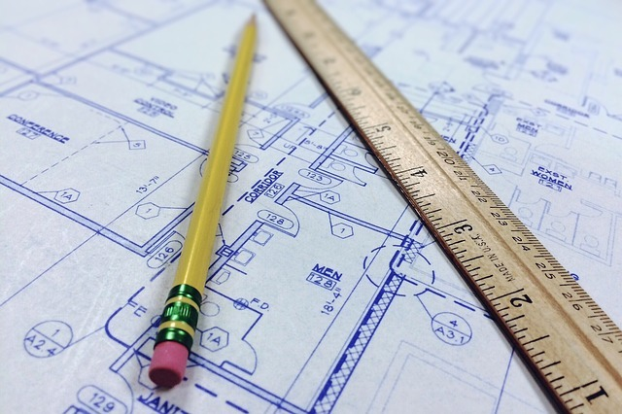
Figure 3.1: The important part is understand when you need to convert units.
Although it seems basic, one of the first steps of becoming a successful engineer is having an intuitive understanding of units and dimensions. Intuitive means that when you see 4 inches or 4 millimeters you can "see" the difference between those two and understand how they are different. Intuitive means that when someone says that they are 6 meters tall, you raise your eyebrows and likely reply "I don't think meters means what you think it means". Unfortunately, it takes practice and time to have an intuitive understanding about anything (that is one of the reasons why we expect engineers to spend 4 years in school!). Therefore, the goal of this chapter is not that you will have an intuitive understanding by the time that you are finished. It is important to understand that the learning process does not end at the completion of each chapter but instead is a life long process. The goal is that by the end of the chapter you will know how to appropriately look things up and that you understand how to be careful when converting units.

In this chapter we will learn a ton! We are going to learn the difference between units and dimensions and how you will be expected to manipulate them as an engineer. We will explore the following:
- The metric system
- Inferior unit systems (aka US Customary Units and why we should switch!)
- How to convert between unit systems
- The fundamental dimensions of the universe! (Grandiose but true!)
- Dimensional homogeneity (fancy way of saying dimensional consistency) and analysis
- How to intuit the difference between precision and accuracy

Motivation - The Gimli Glider
On July 22, 1983, Air Canada flight 143 took off from Montreal to Edmonton. Before takeoff, routine checks showed all systems functional and that everything was ready to go. While cruising at 12,500 meters, an alarm started blaring in the cockpit, warning the pilots that the fuel pressure on the left side of the airplane was low. The pilots silenced the alarm, figuring it was a fuel pump problem, and they knew gravity could handle moving the fuel around until they landed. The fuel gauges were not working correctly (or so it seemed), but the flight computer let the pilots know they had plenty of fuel to make the flight. A few minutes later, the right side fuel pressure alarm went off. Seconds after that, the left engine shut down. The pilots called air traffic control and prepared to land with a single engine in Winnipeg. As they were discussing the plan with air traffic control in Winnipeg, the "all engines down" alarm went off and the cockpit went blank. The pilots consulted the manual and couldn't find a section that told them what to do when all engines fail. Luckily, the pilots managed to safely crash land the plane and no one was hurt.


Figure 3.2: The Gimli Glider before it crashed...duh

Why did it crash?
I hope that you can guess based off the chapter title. The problem was an incorrect unit conversion and a whole host of other errors)! In 1983 when the incident occurred, Canada was in the process of converting the country to the metric system. The new 767 involved in the incident was supposed to be calibrated using metric units, but all other Air Canada aircraft at the time were still operating with Imperial Units. The pilot calculated that the flight required 22,300 kilograms of fuel. A float stick check showed that there was already 7,682 liters of fuel in the tanks. Note that the calculation is in kilograms, a unit of mass, and the float stick indicated a volume, in liters. The crew used an incorrect conversion factor that related mass of a liter of fuel to pounds, an error that went unnoticed by the flight crew. We will explore the specific mathematical errors the crew made later in this chapter. The moral of the story, a flight crew made a bad conversion, that crashed a plane. Luckily, no one died but the story highlights the importance of converting units carefully.

Units vs Dimensions
It is easy to get units and dimensions mixed up. It helps to think of dimensions as fundamental and usually unspoken whereas units are derived from the dimension and quantify the dimension.


Figure 3.3: In basketball, taller is usually better.
As an example, lets say you are recruiting someone to play on your basketball team. You know that in basketball, there are significant advantages for tall players. You might ask a potential Canadian player "How tall are you?" and she might reply "I am 1.8 meters tall". In this case, the dimension we are considering is length (aka "height" in colloquial terms), and the unit we are using to describe the dimension length is meters. However, if you ask an American player who is the exact same height as the Canadian player, she might reply "I am 5 feet 11 inches tall". In this case, the dimension is still length, but now the units being used to describe that dimension, are now feet and inches.

Dimensions
To summarize what you read in the previous section, a dimension describes the measurement of interest, which in the case above was length. There are no other dimensions necessary nor does it even make sense to think about another "dimension to height". On the other hand, the unit meter is used to quantify the dimension and there are multiple different units we can use. Some units are more practical than others as we will see later in this chapter. For now, lets concentrate our mental effort on understanding dimensions.

The Fundamental Dimensions of the Universe
Now that we have an idea of what a dimension is, we can easily list out all of the dimensions needed to describe anything in the universe. Yes, that is a bold statement but it is true. It turns out there are only a few fundamental dimensions of the universe and we can measure every single physical phenomena you can think of using combinations of these dimensions.

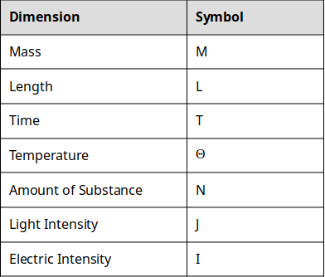
Table 3.4: The fundamental dimensions of the universe and their corresponding symbols.

That is it. That is all the dimensions you need to describe everything in the universe.

Hold on a second, you might say. What about something like volume? Isn't volume a dimension? Well yes, but it is a derived dimension. The dimensions listed above are the fundamental dimensions which we can then combine in different ways to arrive at derived dimensions.

Question 3.1: Fundamental Dimensions and Symbols
Without looking at the table above (because it totally defeats the purpose!) try and match the dimension to the symbol we will use to represent that dimension. Need to add a table

Derived Dimensions
You are already familiar with some of the derived dimensions. For example, it is likely that you already understand that volume is really just length∗length∗length=length³. Similarly, you probably already knew that the dimension area is simply length∗length=length². As we explore more complex concepts in engineering, you can expect the dimensions to get more complex.

A Quick Note on Notation
Now is a good time to put this concept into practice. Before we do, just a quick note on notation. Consider the dimension of velocity. You may have learned in physics class that velocity=distance/time. Now, we remember that distance is really the same thing as the dimension length which is represented by the symbol L. Similarly, we have learned that time is represented by the symbol T. Therefore, the dimensions of velocity is TL=L/T=LT⁻¹
As you can see, all of the ways of writing out the notation are equally as valid. However, the LT⁻¹ is the most space efficient and the form that we will be using for the rest of the chapter. If you need a refresher on the math behind this, click here.

Question 3.2: Quantity to Dimensions
Match the Quantity to the Fundamental Dimensions that describe that quantity. The dimensions will be written in the "negative exponent" notation to indicate division for the sake of saving space. For some of these you may intuit the answer. For others, you may have to do some outside research in order to determine which of the dimensions match the quantity. Need to add a table

Deep Dive Into the Dimensions of Something a Bit More Complex
Now that we have covered some of the simple quantities and your brain muscles are loose, lets take one more look at dimensions and consider the physical concept of work. If you remember what work is from your physics class, great! If not (or even if you do, it is a good video), take a minute to watch the following YouTube clip to familiarize yourself with the concept.

Video courtesy of Khan Academy: A brief introduction to Work and Energy

So what are the dimensions of work? Let's logically follow the steps below:

Step 1) From the video we saw that Work=Force∗Distance. We already know that Distance has dimension of Length, but we don't have any idea about the dimensions of Force. That leaves us here.
(Dimension of Force?)∗L

Step 2) Well, luckily for us, the video also states that Force=Mass∗Acceleration and we know that mass is a fundamental dimension. So we can then expand our analysis.
M∗(Dimension of Acceleration?)∗L

Step 3) We are making progress but now we have another unknown dimension, the dimensions of acceleration. But wait! You should have found above in Question 2 that acceleration has dimensions of LT⁻². Now we just need to put it all together!
M∗L∗T⁻²∗L = M∗L²∗T⁻²
That means our final answer is: ML²T⁻²

Now try and do this on your own by filling in the blanks to question 3.3:

Question 3.3: Figure out the dimensions
Consider electric potential. Electric potential is defined as the _____________ needed per unit charge to move a test charge between two points. Analyzing the dimensions of electric potential show that it should be _____________.

I tricked you into learning something, surprise! You have just done dimensional analysis! Dimensional analysis is a powerful tool in engineering. It allows us to understand a physical quantity by understanding the underlying fundamental dimensions of the quantity. In fact, if you go to the Wikipedia page for work(physics) you will see they list the dimensions of work as part of the summary.

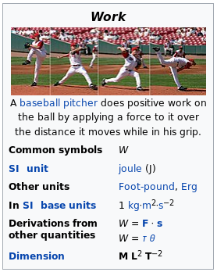
Figure 3.5: Screenshot of Wikipedia page for Work showing the dimensions. I told you it's important

Unit Systems and History
Take another look at figure 3.5 above. Notice how it talks about the "SI unit" used to describe work? You can also see that there is a little section describing "Other units". Wikipedia is following the scientific and international standard of using the SI System. So what is the SI system and why did Canada risk crashing an airplane to switch?

The History of the SI System (aka the Metric System)
SI stands for The International System of Units. It is derived from the french, French Le Système International d’Unités (hence the seemingly backwards abbreviation, SI). The SI system is commonly referred to as the metric system and both metric and SI will be used interchangeably throughout the book. The history of SI is pretty interesting. Watch the following video to get a feel for how SI units came to be.

Video 2: A nice TEDEd video that describes the history of units. Easily worth a watch! You could use a quick little break anyway...

Discussion 2.1: Should America switch to SI?
This post is not anonymous. The professor and participants can see the responses and the author.
Well I will answer the question posed in the title for you. Yes! Lets say that you get elected President of the United States and you make the decision that the US should switch to SI. You make an executive order, and overnight, the US is supposed to switch to the metric system. For this discussion, think of one good consequence, and one potentially disastrous consequence from America switching to metric overnight. Comment on a classmates response and have a discussion.

What Engineers Need to Know About the SI System
It should be clear to you that the SI system has significant advantages over the United States Customary Units (USCU) that are in use in the US today. So what are the units, how were they setup, and why are they so advantageous? There are three main concepts that you need to understand to fully understand the SI system: The Base Units, Derived Units, Metric Prefixes. Once you understand these three concepts you are well on your way to being an SI expert! Do you notice the similarities of "The Base Units" and "Derived Units" to our sections on dimensions?

The Base Units
The SI base units are the building blocks of the whole system. They are analogous to the fundamental dimensions discussed in this chapter earlier. Since the units are simply descriptors of the quantity of a dimension, lets go ahead and pair them up!

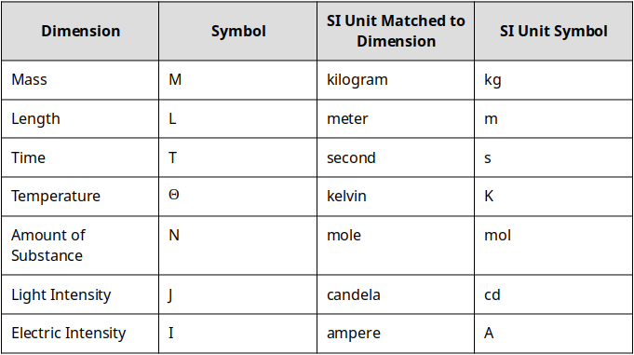
Table 3.6: The fundamental dimensions matched to the SI unit.

So when we want to talk about the height of a basketball player, a scientist (or as we learned from the video, anyone not in the US, Myanmar, or Liberia) would say that Michael Jordan is 1.98 meters tall. The dimension is length and the SI unit for length is the meter. Similarly, in the SI system Michael Jordan is listed as having a mass of 98 kg. The dimension in this case is mass, and the associated SI unit is the kilogram.

The only common exception to this rule is for the dimension of time. If you ask a scientist how old Michael Jordan is it is highly unlikely that they would reply that he is 1767226000 seconds old unless they were really into the SI system. However, for any of the other dimensions listed above, you should use the SI unit for the dimension when you can.

Derived Units
Just like the dimensions, we can then combine different combinations of units to help us quantify more complex physical dimensions.

For example, we discussed the concept of force above. We already determined that the dimensions of force are MLT⁻². Similarly, force has a derived SI unit of Newtons. Remember, unlike dimensions, units are quantities that describe dimensions and the values attributed to them are arbitrary.

What I mean by arbitrary is lets consider a different derived unit, the joule. 1 joule is defined as the amount of work done moving 1 Newton by 1 meter. That is arbitrary. Why isn't 1 joule defined as moving 10 Newtons over 12 meters? Although it seems easier to use the number 1 (it is easier) it doesn't HAVE to be that way. It just is because that's what a bunch of french dudes decided. That being said, they did make some great decisions that make calculations and understanding units much easier as we will see.

Remember: Dimensions are universal concepts but units are not. What I mean by that is if we ever meet aliens, they will know what the dimension of length is and what it refers to, but they will have no idea what a meter is.


Figure 3.7: If we ever meet aliens they WILL know about length, but they WON'T know what a meter is.
Some of the derived units are pretty easy. Consider area. Since the base SI unit for length is the meter, and we know that area=length∗length, it follows that the SI unit for area is simply meter∗meter=meters².

Question 3.4: Derived Units
Following the same logic presented above, match the appropriate derived dimension to the correct SI unit for that dimension. You may have to do a little background work (that is OK because that is a good brain workout!) to remind yourself what each derived dimensions represents.

There are currently 22 derived units with special names. Click here to see the list. You will notice that almost all of the names are the names of famous scientists and engineers who were involved in the discovery of the scientific concept covered by the unit. A table of the most common derived SI units is shown below.

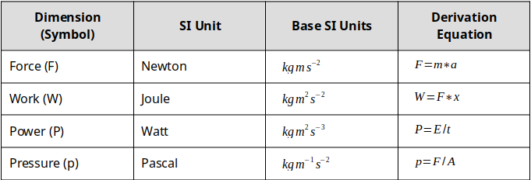
Figure 3.8: A small collection of the derived units.

Metric Prefixes
Up until this point it may seem there is little to no difference between the metric system and USCU and you are right! USCU also has a unit for length (e.g. the inch) and you can also create derived units for area (e.g. the square inch). If you live in the United States or are familiar with the USCU you should know that there are actually multiple different units used for length. In the US they are most commonly, the inch, the foot, the yard, and the mile. You should also know that the mile is used for long distances, the yard for intermediate distances, etc. The different units are designed to allow us to talk about different quantities easily. But converting between inches and yards is NOT straight forward.

The metric system does not have an equivalent confusing structure. There is ONLY the meter for the dimension of length.
The beauty of the metric system is that it does not have an equivalent confusing structure. There is ONLY the meter for the dimension of length. So what happens when we want to talk about different magnitudes of different quantities? That is where the metric prefixes come into play. The prefixes work by changing the magnitude of the dimension. For example, if we are talking about the height of a person, it is likely that it will be described in numbers of meters. However, if we are talking about the circumference of the earth, we would likely talk about kilometers. In this example, the metric prefix is "kilo" which stands for 1000. So instead of saying the circumference of the earth is 40,000,000 meters we would say that is is 40,000 kilometers. Here is a table of the most common metric prefixes, you can find ALL the prefixes here:

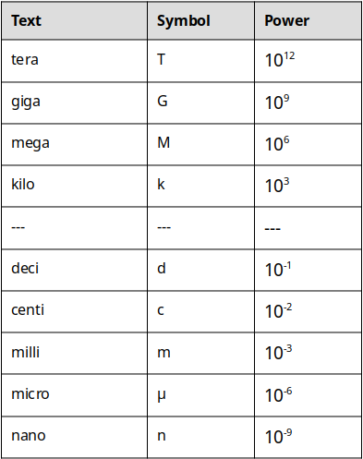
Table 3.9: A small collection of SI prefixes.

Keep in mind that there are more metric prefixes than this. For a complete list, check out this page.

Now we can combine any of the metric prefixes with any of the units to change dimension. For example, lets consider a blink of the eye.


Figure 3.10: In the blink of an eye...
It takes about 0.3 to 0.4 seconds to blink your eye. We could say that it takes 3 to 4 deciseconds because the prefix "deci" corresponds to 10⁻¹.

0.3 seconds = 3 deciseconds = 3∗10⁻¹seconds

However, no one really talks about deciseconds, so instead you might say that an eye blink takes 300 to 400 milliseconds. In this case the prefix "milli" corresponds to 10⁻³ so it is still equivalent (see table 3.4).

Make sure to workout your brain until this concept makes sense to you! You can make up your own problems easily here depending on what you are into. You like swimming? How many centimeters are there in a 100 meter swim? You get the idea.

Question 3.5: Metric Prefix Practice
For this problem, lets consider the dimension of Mass. We know that the SI (or metric) unit for mass is the kilogram. How many grams are in 1 kilogram?

Inferior Unit Systems
The United States Customary System (USCS) units are the system of measurements used in the United States of America. While the history behind them is interesting, they are a burden to use and introduce many complications for the 1st year engineering student. For that reason, this book suggests that you always work in metric units, even if the problem is stated in USCS units. If you would like to read more about USCS units you can find the wikipedia page here.

Proof that USCS is Inferior
1 foot = 12 inches
1 mile = 5280 feet

Try figuring out how many inches are in a mile. Now let's look at the metric equivalent:

1 meter = 100 centimeters
1 kilometer = 1000 meters

Figure out how many centimeters are in a kilometer. I rest my case.

For now, it is simply important to understand that USCS units exist, and that whenever they are encountered, they should be converted to their SI equivalent because USCS units are garbage and way to confusing to be useful.

Converting Units and Conversion Factors
Up until this point you should have a good grasp of what a dimension is, and what a unit is. You should also have gathered that for almost everything that we do in this book, we will use the SI system (again, I will use the term metric and SI interchangeably). Now the question becomes, how can we use all of this knowledge to convert between different units and prefixes? The last piece of the puzzle is going to be conversion factors. The preceding link will take you to a page of conversion factors that are commonly used in engineering. If you can't find the conversion factor you need on that list, google it! We will use conversion factors as a kind of "decoder ring" to help us arrive at the unit of interest. To start, lets begin with some of the conversion factors for the dimension of Length.

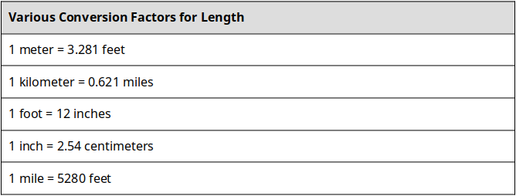
Table 3.11: Some conversion factors for length.
There are a couple of things to notice from the table above. First, the conversion factors can be between USCS and metric (e.g. 1 meter = 3.281 feet) or from USCS to USCS (e.g. 1 foot = 12 inches). The reason you don't see any conversion factors from metric to metric is because we use prefixes instead of different units to describe quantities of different magnitudes. Remember? That is why it is easier.
The way to read the conversion factors is "There are 0.621 miles for every 1 kilometer" or mathematically that can be represented as:
1 km = 0.621mi
It is important to note that since (0.621mi = 1km) that the ratio (1km/0.621mi) is actually a dimensionless 1. Now, time for a quick math problem...

Question 3.6: What do you know about 1?
We all know that 1 is the loneliest number. Maybe it is because of it's unique property when multiplied. What does 1∗1881 equal?

OK, well that was an easy question but the idea is to get you to consider that the ratio of (1km/0.621mi) is the same as (0.621mi/1km) which is the same as the number 1. We also know that we can multiply any number by 1 without changing the number. OK, so why is this useful? Let's look at an example to illustrate.

Marathon Example (Converting Length)
Lets say that we wanted to convert the number of miles in a marathon to kilometers. We know that a marathon is 26.219miles. We know that our conversion factor tells us that 0.621mi=1km. Now all we have to do is multiply our original quantity, 26.219miles by one of the two ratios: (1km/0.621mi) OR (0.621mi/1km). But which one should we use? The trick is to select the ratio such that the unit that is being converted is eliminated, and the unit we are trying to convert to remains.


Figure 3.12: Marathons are hard. 26.219 miles? Running? Ouch

If we try the first ratio we get: 26.219mi∗(0.621mi/1km)=16.282mi²/km which is clearly a completely meaningless answer. What are the units mi²/km and what does that have to do with distance? We acknowledge that technically that answer is correct because the quantity (0.621mi/1km) is just the number 1, but it does not answer our original question.

However, if we try the second ratio we get: 26.219mi∗(1km/0.621mi)=42.221km we can see that the unit mi cancels out algebraically and we are left with km for our answer. So therefore we can say that a marathon is 27.219 mi or 42.221 km.
Putting this altogether we can come up with…

Steps for converting units:
- Determine the appropriate conversion factor(s) to be used.
- Set up a ratio based off the conversion factor that will result in the current unit to be eliminated, and the unit of interest to be preserved.
- Perform multiplication and algebra

Question 3.7: Practice Converting Units
Lets say that you are helping design a phone for a big company that has offices in the USA and in London. The office in London requests that the height of the phone be specified in centimeters. You know that the phone is 6 inches tall. Using the conversion factor (see table 3.5 above) and the process outlined above, what is the height of the phone in centimeters?

Complicated Conversions - Units as Ratios
In the previous example (and a lot of the time in engineering applications), conversions can be completed in one step and with one conversion factor. Sometimes, instances will arise where you need to preform multiple steps and use multiple conversion factors. As long as you understand how to use the steps for converting units, you can apply that logic to more complicated situations.
For example, lets consider converting 55miles/hour to kilometers/second. In this case, we can see that we are going to need to convert miles to kilometers and hours to seconds. Although this seems more complicated, it is almost the exact same conversion process as we have done before. This time though, we need to do 2 conversions. See if you can follow along with the steps we outlined above:

Step 1) Determine the appropriate conversion factors to be used
In this case the conversion factors of interest will be:
1kilometer = 0.621miles AND 1hour = 3600seconds

Step 2) Set up a ratio based off the conversion factor that will result in the current unit to be eliminated, and the unit of interest to be preserved.

(0.621miles/1kilometer) AND (3600seconds/1hour)

We setup the ratios this way so that when we multiply 55miles/hour by those ratios, we can see that miles will be eliminated and kilometers will remain in the numerator AND hour will be eliminated but seconds will remain in the denominator.

Step 3) Perform multiplication and algebra
Multiplying everything and canceling reveals:
(55miles/hour)∗(0.621kilometers/mile)∗(3600seconds/1hour)=0.0246kilometers/second

Question 3.8: Complicated Conversions
Using the same process outlined above, convert 20gal/min to liters/sec.

Complicated Conversions - Units with Exponents
The last thing you need to be aware of when you are performing unit conversions, is when we look at squared, cubed, and other higher power units. For example, lets consider the dimension volume. We know that SI unit for the dimension volume is the cubic meter (m³). The important thing here is the "cubic" part. If we want to convert from cubic meters to say, cubic inches, we can use the conversion factors: 1meter = 3.281feet and 1foot = 12inches in a two part process to eliminate meters and end up with inches. Notice however, that our conversion factors are NOT in powers of three. We have to account for that when we are performing our conversions. All you have to do, is cube the ratios that you develop during Step 2 of our conversion process technique.

To illustrate this, lets convert 12.3m³ to in³. We will follow the same steps we used in the previous examples.

Step 1) Determine the appropriate conversion factors to be used
In this case we already discussed that the conversion factors would be:

1meter = 3.281feet and 1foot = 12inches

Step 2) Set up a ratio based off the conversion factor that will result in the current unit to be eliminated, and the unit of interest to be preserved.

This is where things get tricky. In order for this to work we can tell that we need cubic feet in the numerator for the first multiplication step and cubic meters in the denominator. However, our conversion factors identified do not correspond to the cubic quantities. The solution is simply to cube the appropriate ratio to create a new conversion factor. For this example the two conversion ratios then become:

(1m³/3.281ft)∗(1m³/3.281ft)∗(1m³/3.281ft)=(1m³/35.32ft³)

AND

(1ft/12in)∗(1ft/12in)∗(1ft/12in)=(1ft³/1728in³)

Step 3) Perform multiplication and algebra
Now that we have conversion factors with appropriate units, we can perform the multiplication steps and eliminate unwanted units.

12.3m³∗(1m³/35.32ft³)∗(1ft³/1728in³)=75,0705in³

Question 3.9: Complicated Conversions (Area)
Using the same process outlined above, convert 14.2in³ to m³. Make sure you are giving this a good try and working out your brain!

Question 3.10: The Smoot
Throughout their existence, fraternities have been hazing pledges as a rite of initiation into the fraternity. However, in my opinion, an MIT fraternity prank in 1958 is the most clever, long lasting, and humorous prank in existence. In October 1958, Oliver R. Smoot a pledge to the Lambda Chi Alpha fraternity was required to repeatedly lay down so they could use his height to measure the length of the Harvard Bridge. The bridge's length was measured to be 364.4 smoots plus or minus one ear. You are given that Oliver Smoot was 1.70 meters tall at the time of the prank. Using conversion factors and the steps outlined in this book, what is the length of the Harvard Bridge in feet? (Note: you can ignore the plus or minus one ear) Fun fact: Oliver Smoot became the chairman of the American National Standards Institute!

Ethics
Humans are fantastically complicated and intelligent (sometimes) creatures but we still make mistakes on the occasion. Sometimes the consequences are small (i.e. a typo in a textbook) or sometimes the consequences are huge (i.e. a plane crashes and hundreds of people die).

In engineering, making mistakes can have huge consequences. You can find examples of engineering mistakes killing people all over the place. For example, the Colombia space shuttle disaster resulted from a piece of foam came off of a tank and cut through the wing. An engineer designed a crappy bridge at FIU and it collapsed killing people. The list goes on, and the point is, when engineers make mistakes, disasters happen.

The ethics questions I would like you to consider for this chapter is: who is to blame and how should we punish them?

Ethics: Engineering Disaster
This post is not anonymous. The professor and participants can see the responses and the author.
For this prompt I would like you to consider a disaster, something like the Columbia disaster or any instance where an engineering mistake causes someone to lose their life. I want you to consider what the consequences should be and what should determine the consequences. For example, if I design a roller coaster and someone dies on the roller coaster, what questions should be asked? Do you instantly arrest the engineer? Or did the person that died do something they weren't supposed to do? Think through this and create a discussion post that describes a realistic or made up disaster, what questions need to be answered, and what consequences (if any) the engineer that designed the product should face.

Image 3.1 courtesy of wokandpix under license CCO
Image 3.2 courtesy of Aero Icarus under lincense CC BY-SA 2.0
Image 3.3: courtesy of 12019 under license CCO
Image 3.4: Image courtesy of Samuel Bechara, used with personal permission.
Image 3.5 Image courtesy of Rick Dikeman under license CC BY-SA 3.0
Image 3.6: Image courtesy of Samuel Bechara, used with personal permission
Image 3.7: Image courtesy of kalhh, under license CC0
Image 3.8: Image courtesy of Samuel Bechara, used with personal permission
Image 3.9: Image courtesy of Samuel Bechara, used with personal permission
Image 3.10: Image courtesy of Skitterphoto under license CCO.
Image 3.11: Image courtesy of Samuel Bechara, used with personal permission
Image 3.12: Image courtesy of Skeeze, used with CC0

Chapter 4: Excel Basics

Figure 1: The dreaded spreadsheet

What is data analysis and why is it important?
Unlike some professions which may be more qualitative in nature, most engineering professions are quantitative and consequently, engineers typically deal with a lot of data. As was mentioned in Chapter 1, engineers are in the business of building things that turn ordinary people into super humans. In order to build things in a safe and responsible manner, engineers are obligated to conduct a lot of experiments and to collect a lot of data on those experiments. Engineers then use different statistical tools and methods to analyze the data. We will investigate some of these methods in Chapter 4. For this Chapter we will investigate one of the main tools engineers use to tabulate and interpret data.
Different types of engineers deal with different types of data. For example, a mechanical engineer may have data pertaining to the stress and strain measured in a deforming material. A biomedical engineer may have data on the electrical potential from a electrocardiogram. The list goes on but the one thing that is true is that engineers deal with a lot of data. One tool to analyze and review data is Microsoft Excel.

Most engineering undergraduates have some exposure to Excel, perhaps you had to learn how to use it in high school, you watched your parent's use it to keep track of a budget, or you saw a teacher use it to keep track of grades. Whatever your experience level is with Excel, we will spend the next two chapters investigating the capabilities of Excel and what you as an engineer will be expected to be able to accomplish with the software.

In this chapter we will explore Microsoft Excel and what we will be expected of you as an engineering student. That means learning:
- How spreadsheets work
- Formatting options
- Cell addressing
- Formulas
- Built-in Excel Functions
- Conditional formatting

Before We Begin Excel: How to Learn Software
This is the first chapter in this book where we will learn how to use a computer software package (in subsequent chapters we will learn about MATLAB and other tools). It is assumed that you have access to Microsoft Excel. Luckily for you, most Universities give the entire Microsoft Office suite free to their students. If you do not have Microsoft Excel, you can use a free alternative such as LibreOffice. Most everything will be the same as Microsoft Excel.

Figure 2: Roll up those sleeves and get your hands dirty!

Before we dive into Excel, I think it is necessary to remind you on how I expect you to approach learning this material. The key to learning how to use software is to roll up your sleeves and get your hands dirty (proverbially). What I am trying to say is that just reading about Excel (or any software package really) is insufficient to learning Excel. What you really need to do is open up Microsoft Excel, and follow along with the material as you are reading about it. Reading alone will not be enough to help you learn how to use it. For example, if you are reading about how to enter data into cells in Excel, you need to take a minute to practice that and actually enter data into cells in Excel.
In my opinion, the best way to learn the material on Excel and MATLAB is to have the book opened up in your web browser of choice, and also have the software package of interest opened up beside it (Figure X below). That way you can read and practice simultaneously.

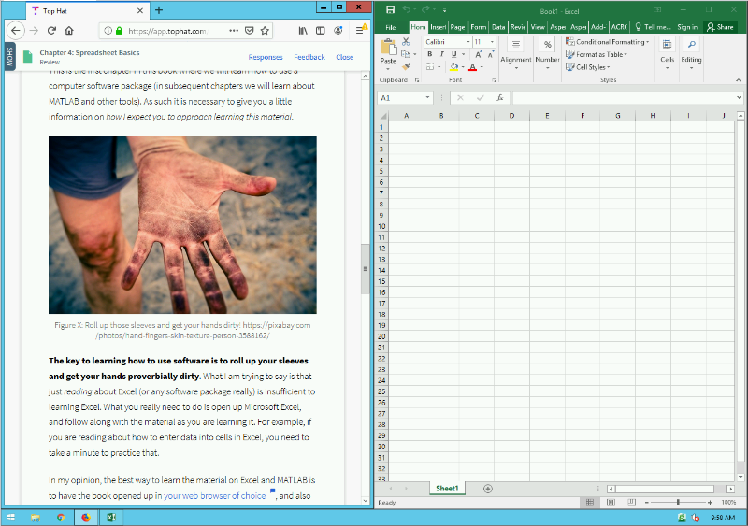
Figure 3: Example of how I expect your desktop to look like when learning about software packages.

Remember, learning is working out your brain muscles. Some of you are stronger than others in certain areas. For example, maybe your Excel brain muscle is very strong because you have worked it out a lot in High School. Then you don't need to put as much time in the mental gym (i.e. practicing Excel) because you are already strong! Others of you have never used Excel and will need to put a LOT of time in the mental gym to get up to speed. That is okay too! The point is, that you need to figure out how much you need to practice so that you are successful. See how all the "you" are bolded in that previous statement? That is because learning is an individual effort and you should never compare yourself to others, just worry about your own learning. Do not skip your brain workouts if you want to build brain muscle!
The last thing I want to mention about learning is that you also need to go beyond this textbook. Spend time playing around with the software package on your own. Find ways to use it for other classes or projects even if it is a little contrived. Watch YouTube videos on Microsoft Excel if you need to. Do whatever it takes so that you learn the material. With all that said, lets jump in...

Open Excel
Go ahead, fire it up! When you first open excel, you are presented with this glorious screen:

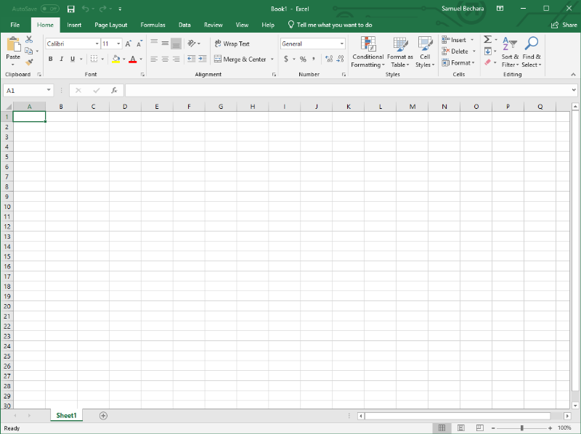
Figure 4: What you are presented with when you open Microsoft Excel

There is a LOT going on here, especially if you are new to Excel. Lets dive in to what all this stuff means, and how we can use it to analyze data.

Cell Addressing
The most basic use case for Excel is to simply use it to organize information into cells.
The cell is the basic storage unit of the spreadsheet.
The cell is the basic storage unit of the spreadsheet. Cells are the little boxes you see above in Figure X and below in Figure X. You can select any of the cells, and begin typing in numbers, letters, or any combination of the two.
Cells are identified by their column (which are identified by letters) and their row (which are identified by sequentially increasing numbers). The combination of the column letter and the row number is called their address.


Figure 5: A cell address is just like your home address.
The analogy of a home address is particularly apt here. Just like your home address is likely identified by a number and name (e.g. 1374 Mulberry Street), the home of each cell in a spreadsheet is identified by a letter and number.

For example, in Figure X below, the cell A3 contains the text Chad Personson. The cell B1 contains the text Night Shift Employees. The cell B4 is currently empty. Etc.
Excel also gives you some advanced formatting tools to make things look nice. For example, you could use it to keep track of employees working different shifts (again, figure X below). In this example, I used the formatting tools (and specifically the "Format as Table" option under the style tab) .

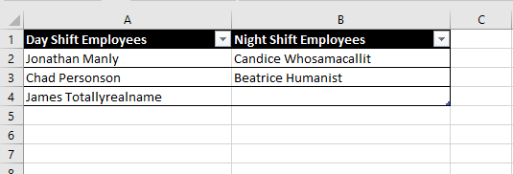
Figure 6: Example of using Excel for simple data entry

The main formatting tools you need to know about are located on the "Home" tab on the main tool banner. The two most important are inside the "Font" box (this is highlighted in red Figure X below) and inside the "Alignment" box on the same tab (highlighted in blue in figure X below).

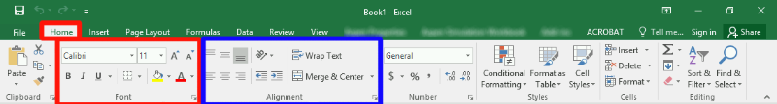
Figure 7: Screenshot and highlights of areas of interest on the "Home" tab of the main tool banner.

Type caption for image (optional)
For now, don't worry about being able to replicate Figure X exactly. Instead, take a second to open up Microsoft Excel and play around with typing text into cells, formatting the text, and playing around with the "Font" and "Alignment" options. If you are already familiar with how to use excel, it still is useful to play around a little bit, click on buttons you haven't before, etc. Do not skip this brain workout! After this, it will be assumed you understand how all these buttons and formatting options work!
Type caption for image (optional)

Question X: Click on Cell
- Version A
- Version B
To show you understand cell addressing, click on cell B2 in the image below.

Formulas (=) and Cell Referencing
Now that we are familiar with cell addressing and how to enter data into cells, we can begin to explore one of the most powerful features of Excel, using cell formulas.
By using formulas, we can have Excel perform a calculation and show the result in the cell that contains the formula. Excel formulas start with an = sign and work essentially like a calculator. For example, if we wanted to calculate the area of a circle (recall area=πr2), with a radius of 0.24 meters, we could simply type the following formula into any cell (let π be approximated by 3.1415):
= 3.1415 * 0.24 ^ 2
Viola! We can then see that the area is 0.18095 meters2. However, we are missing the true power of Excel in this case which is cell referencing.
To see an example of cell referencing in action, let's consider a situation where we need to calculate the areas of a bunch of different circles. To start, recreate the spreadsheet shown in Figure X below (you should be able to recreate this using the formatting tools highlighted in Figure X above).

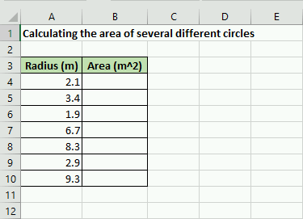
Figure 8: Example spreadsheet we will work on

So now all we need to do is tell Excel to calculate those values and store the corresponding area in the appropriate B cell. To do that, we could just type in an individual formula into each appropriate cell.
For example, you could (but you shouldn't) type the following into B4:
= 3.1415 * 2.1 ^2
Then we could (again, don't do this) type the following into B5:
= 3.1415 * 3.4 ^2
But you can already see this would be exceptionally tedious! Especially if we wanted to calculate hundreds, or even thousands of areas! This is where cell referencing comes into play. The key is to notice that the value 2.1 is stored in cell A4. The power of Excel is that we can actually just reference the cell A4 in the formula.
You should type the following into cell A4:
= 3.1415 * A4 ^2
Once you hit enter, you can see that it uses the data from the cell A4 in the calculation. Now, here is the trick. You can use cell addressing to create formulas and calculate the areas for the other cells automatically! Do do so, select cell B4 by clicking on it. You should notice a little green box (called the "fill handle") in the lower right corner. Click on that, and drag it down so that it fills all the cells in which we would like to calculate an area. This is called copying the cell formula. If you are a little confused on what to do, see video X below.

Video 1: Showing how to use cell addressing to create many different formulas at once.
What you should notice (and can see in Video X to the left) is that Excel automatically creates new formulas that have the correct cell address! That is because when we copied the formulas to the new cells Excel assumed that we wanted it to create a new formula with a cell in the same relative position as A4.

For example, lets think about the new formula in B10. You can see the new formula by double clicking on it. Notice that the new formula is:
= 3.1415 * A10 ^2
Since B4 (the location of the original formula) is 6 cells above B10, when we copied the formula, Excel automatically adjusted the A4 from the original formula to A10 because it is 6 cells lower. That is called relative cell addressing. There are two more types of cell addressing in Excel.
For instance, lets say that instead of typing 3.1415 we wanted to store an approximation of π≅22/7 into a cell and use that in our calculations. To do so, add =22/7 to the cell D4 and format like below.

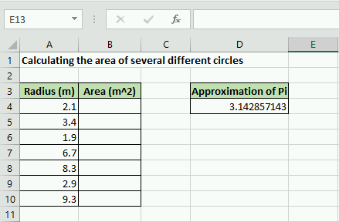
Figure 9: Add 22/7 in cell D4 as an approximation of Pi

Hopefully you can see that relative cell addressing will be a problem in this case. To see what I mean, type =D4*A4^2 into cell B4. Everything should be ok. But when you try to copy the formula down to B10 you should notice that everything is filled with 0. What is going on? If you look at one of the formulas (for example see the new formula in cell B6), you should notice that instead of cell D4 which corresponds to our approximation of π, Excel assumed we wanted to try and use a value in D6 for the calculation. Since there is nothing in D6, the calculation is equal to 0!

matlabmatlab Video 2: A short video showing an example of absolute cell addressing.
What we need to do to fix it, go back to the formula in B4 and create an absolute cell address for D4. To do so, add $ symbols in front of both the D and the 4 like this: $D$4. Now when you try to copy the formula to the cells below, it will use relative cell addressing for the A cells (which is what we want) and it will use absolute cell addressing for the D4 cell!
A short video showing this is shown in Video X to the left.

The last little piece when it comes to cell addressing is there is one more form Excel accepts, mixed addressing. You can fix either the row or the column designation by adding a $ sign. For example, D$4 would only fix the row and would allow the column to change if the formula is copied.
To recap this section, there are three types of cell addressing that you can use in your Excel formulas:
- Absolute Addressing: in this case, Excel will always refer to the exact same cell if the formula is copied to a new location. You create an absolute cell address by adding a $ immediately before both the column and row of the cell of interest (e.g. $B$5)
- Relative Addressing: in this case, Excel will refer to the cell in the same relative position to the cell containing the formula, no matter where the formula is copied in the worksheet. (e.g. B5)
- Mixed Addressing: in this case, either the row or the column is fixed. (e.g. $B5)

Question X: Cell Addressing and Formulas
Consider typing "24" into cell C6 and
=$C$6 + 10
into cell D6. Copy cell D6 down to cell D9. This is an example of

cell addressing. The value

is displayed in cell D9.

Built-in Functions
So far you have learned a good deal about what you need to know as an engineering Excel user. Knowing how to create formulas and use cell addressing to make quick calculations of tabulated data is significant. To expand on these concepts, it is important to introduce some built-in Excel functions.
Part of what makes Excel powerful are the built-in functions that are commonly used in engineering applications as part of Excel formulas. There are hundreds of them ranging from trigonometry, mathematics, statistics, and more.
The functions have very specific names that you must type in exactly to use and they take different numbers of input arguments.

The parts of an Excel Function
Each excel function must be written in a specific but similar way. Just like typing in a formula, you start with = sign. Next you type in the function name, at this point, Excel will often start showing you options and auto-correct suggestions. After the function name, you must include parenthesis and the input arguments to the function inside the parenthesis. In it's generic form an Excel function looks like:
= function_name(input,arguments)
The input arguments in the function can refer to individual cells, a range of cells, or might even be entirely optional. For example, Excel has a function =pi() that takes no input arguments. That doesn't mean that the parenthesis are optional though! All Excel functions must include parenthesis after the function name. For now, open your script you have been using to follow along and replace the cell that contains the approximation of π=22/7 with =pi().

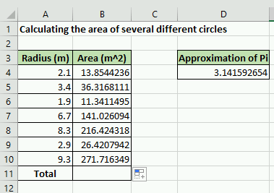
Figure 10: For following along, change D4 to =pi() and add a total row.
To illustrate a use of an Excel function that does require input arguments, lets consider the case that we need to add all of our area calculations in column B. See figure X to the right for what your Excel spreadsheet should look like. As it would be extremely tedious to type in a formula that adds up all the areas, we can use the Excel function sum() to add all of the cells in that range automatically!

To use the sum() function click on cell B11 and type in the following:
= sum(B4:B10)
Notice that Excel automatically adds all of the areas in the column! Neat! You should also notice that when functions require a range of cells (such as sum()) you can specify the cell range using a colon OR by clicking and dragging to select the range of cells of interest. You can see both ways of adding a range of cells in video X below.

Video 3: How to use Excel functions

If you understand how to use the sum() function you are in great shape! Almost all Excel functions work in an identical way. Here is a list of functions that you should be familiar with. You do not have to memorize them, but you should know what they are and how to use them.

Type caption for image (optional)
For your brain workout, I suggest looking at table 4.1 below, and coming up with your own practice problems for each of them. That way you will remember how to use them in the future! For example, add some fake data to 5 cells and use the average() function to calculate the average. You can also find the standard deviation of those numbers using the stdev.p() function. You get the idea.
Type caption for image (optional)

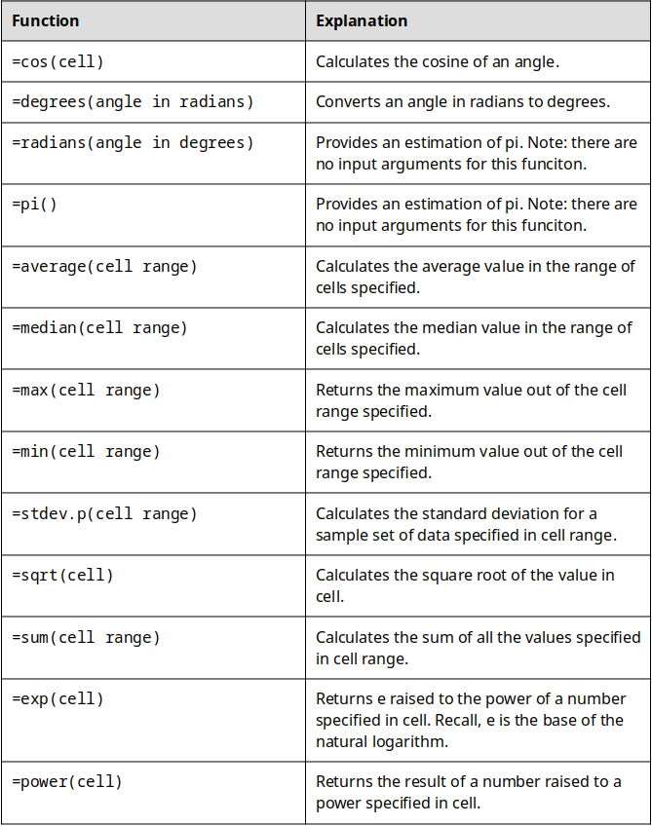
Table 4.11: A non-comprehensive but important list of Excel functions to learn how to use.

Ethics: Rush to Finish
Currently, there is an ongoing "replication crisis" in science. The crisis arises because it has been found that "many scientific studies are difficult or impossible to replicate or produce". This is a huge problem because the scientific method relies on the ability of other scientists to replicate and verify experiments. Although some of the crisis can be attributed to bad actors (i.e. scientists forging data), it was found that 50% of scientists were failing to replicate their own research. A huge part of the problem is the scientific problem with "publish or perish" culture in academia.
Engineering (and other science) faculty have a lot of pressure to publish scientific papers in order to keep their jobs and achieve tenure. Unfortunately, this pressure can lead to engineers taking shortcuts and not adhering to good scientific practices. Similarly, as a professional engineer in the workplace, you may feel like you have an unrealistic deadline and are rushed to finish your work.
Ethics: Being Rushed at Work
This post is not anonymous. The professor and participants can see the responses and the author.
For this prompt I would like you to consider being an employee at an engineering firm (since very few of you will go into academia and most of you will go into industry). Lets imagine that you are given a design task that has significant safety concerns but that your boss gives you an unreasonably short deadline. When you bring it up to your boss, he says "Do your best but the design has to be turned in on time, even if you have to cut some corners". What do you do? Do you go over your bosses head and talk to higher ups? Is there a limit to how dangerous the design has to be before you do that? What if it wouldn't kill anyone but someone might get hurt? Think of some different scenarios that might arise like this, and explain what you would do in your imagined scenario.

End of Chapter Items
Personal Reflection - Chapter 4
This is a completely anonymous submission. The professor will be able to see the responses but the responses will not be attributed to an author. Your participation is required.
What do you think about the content of this chapter? This was the first chapter in which we have discussed a specific program. Did you follow along like you were asked to? Did you find it was useful to have Excel opened up beside the book? Did you make up your own problems like you were asked on the Excel functions? Do a little personal reflection.

Request for Feedback - Chapter 4
This is a completely anonymous submission. The professor will be able to see the responses but the responses will not be attributed to an author. Your participation is required.
What did you think of this chapter? Anything stand out as exceptionally good? Anything that you would like to see differently? Any feedback is appreciated.

Image Citations:
Image 1 courtesy of PhotoMIX-Company via Pixabay, under Pixabay License
Image 2 courtesy Michael Gaida via Pixabay, under Pixabay license
Image 3 - 11 courtesy of Samuel Bechara, used with personal permission.

Chapter Six
This is the beginning of Chapter Six. Use as many chapters as you need. Delete unused chapters, or copy and paste the last sample chapter as needed to add more chapters to your book.
If you have further questions, contact 48HrBooks. Our regular business hours are Mon-Thurs. 8:30 am – 8 pm EST, and Friday 8:30 am – 5 pm. During these hours, you can reach us by phone, email or on-line chat. Outside of these hours, either call and leave a message or email us.
Phone: 800-231-0521
Email: info@48HrBooks.com
On-Line Chat: go to our website, www.48HrBooks.com.

Chapter Seven
This is the beginning of Chapter Seven. Use as many chapters as you need. Delete unused chapters, or copy and paste the last sample chapter as needed to add more chapters to your book.
If you have further questions, contact 48HrBooks. Our regular business hours are Mon-Thurs. 8:30 am – 8 pm EST, and Friday 8:30 am – 5 pm. During these hours, you can reach us by phone, email or on-line chat. Outside of these hours, either call and leave a message or email us.
Phone: 800-231-0521
Email: info@48HrBooks.com
On-Line Chat: go to our website, www.48HrBooks.com.

Chapter Eight
This is the beginning of Chapter Eight. Use as many chapters as you need. Delete unused chapters, or copy and paste the last sample chapter as needed to add more chapters to your book.
If you have further questions, contact 48HrBooks. Our regular business hours are Mon-Thurs. 8:30 am – 8 pm EST, and Friday 8:30 am – 5 pm. During these hours, you can reach us by phone, email or on-line chat. Outside of these hours, either call and leave a message or email us.
Phone: 800-231-0521
Email: info@48HrBooks.com
On-Line Chat: go to our website, www.48HrBooks.com.

Chapter Nine
This is the beginning of Chapter Nine. Use as many chapters as you need. Delete unused chapters, or copy and paste the last sample chapter as needed to add more chapters to your book.
If you have further questions, contact 48HrBooks. Our regular business hours are Mon-Thurs. 8:30 am – 8 pm EST, and Friday 8:30 am – 5 pm. During these hours, you can reach us by phone, email or on-line chat. Outside of these hours, either call and leave a message or email us.
Phone: 800-231-0521
Email: info@48HrBooks.com
On-Line Chat: go to our website, www.48HrBooks.com.

Chapter Ten
This is the beginning of Chapter Ten. Use as many chapters as you need. Delete unused chapters, or copy and paste the last sample chapter as needed to add more chapters to your book.
If you have further questions, contact 48HrBooks. Our regular business hours are Mon-Thurs. 8:30 am – 8 pm EST, and Friday 8:30 am – 5 pm. During these hours, you can reach us by phone, email or on-line chat. Outside of these hours, either call and leave a message or email us.
Phone: 800-231-0521
Email: info@48HrBooks.com
On-Line Chat: go to our website, www.48HrBooks.com.

Chapter Eleven
This is the beginning of Chapter Eleven. Use as many chapters as you need. Delete unused chapters, or copy and paste the last sample chapter as needed to add more chapters to your book.
If you have further questions, contact 48HrBooks. Our regular business hours are Mon-Thurs. 8:30 am – 8 pm EST, and Friday 8:30 am – 5 pm. During these hours, you can reach us by phone, email or on-line chat. Outside of these hours, either call and leave a message or email us.
Phone: 800-231-0521
Email: info@48HrBooks.com
On-Line Chat: go to our website, www.48HrBooks.com.

Chapter Twelve
This is the beginning of Chapter Twelve. Use as many chapters as you need. Delete unused chapters, or copy and paste the last sample chapter as needed to add more chapters to your book.
If you have further questions, contact 48HrBooks. Our regular business hours are Mon-Thurs. 8:30 am – 8 pm EST, and Friday 8:30 am – 5 pm. During these hours, you can reach us by phone, email or on-line chat. Outside of these hours, either call and leave a message or email us.
Phone: 800-231-0521
Email: info@48HrBooks.com
On-Line Chat: go to our website, www.48HrBooks.com.

