Basic summary stats

| **Element_id_3** | | **count** | **mean_elev** | | **max_elev** | | **sd_elev** | | **CV_elev** | |
| --- | --- | --- | --- | --- | --- | --- | --- | --- | --- | --- |
|  |  | |  |  | |  | |  | |  |
| **1** | 8B | | 81 | -1.824630 | | -1.359 | | 0.3997369 | | -21.90784 |
| **2** | 9A | | 53 | -1.747604 | | -1.284 | | 0.4542060 | | -25.99022 |
| **3** | 9B | | 374 | -1.568152 | | -1.142 | | 0.3085549 | | -19.67633 |
| **4** | 10A | | 227 | -1.572480 | | -1.148 | | 0.3236324 | | -20.58102 |
| **5** | 11A | | 74 | -1.603932 | | -1.198 | | 0.4255941 | | -26.53442 |
| **6** | 11B | | 217 | -1.618871 | | -1.198 | | 0.3672609 | | -22.68623 |
| **7** | 15 | | 229 | -1.796419 | | -1.333 | | 0.4687917 | | -26.09589 |
| **8** | 16 | | 283 | -1.708565 | | -1.056 | | 0.3607989 | | -21.11707 |
| **9** | 18 | | 180 | -2.039889 | | -1.300 | | 0.5951644 | | -29.17632 |

How many are over?

| **Element_id_3** | | **count_over** | |
| --- | --- | --- | --- |
|  |  | |  |
| **1** | 9B | | 5 |
| **2** | 10A | | 3 |
| **3** | 11A | | 1 |
| **4** | 11B | | 1 |
| **5** | 16 | | 2 |

How many are under? Looks like some reefs more than 10% are under

| **Element_id_3** | | **count_under** | |
| --- | --- | --- | --- |
|  |  | |  |
| **1** | 8B | | 10 |
| **2** | 9A | | 5 |
| **3** | 9B | | 37 |
| **4** | 10A | | 20 |
| **5** | 11A | | 5 |
| **6** | 11B | | 28 |
| **7** | 15 | | 29 |
| **8** | 16 | | 31 |
| **9** | 18 | | 39 |

How many rocks measured?

| **Element_id_3** | | **num_rocks** | |
| --- | --- | --- | --- |
|  |  | |  |
| **1** | 8B | | 81 |
| **2** | 9A | | 53 |
| **3** | 9B | | 374 |
| **4** | 10A | | 227 |
| **5** | 11A | | 74 |
| **6** | 11B | | 217 |
| **7** | 15 | | 229 |
| **8** | 16 | | 283 |
| **9** | 18 | | 180 |

Histogram of elevations

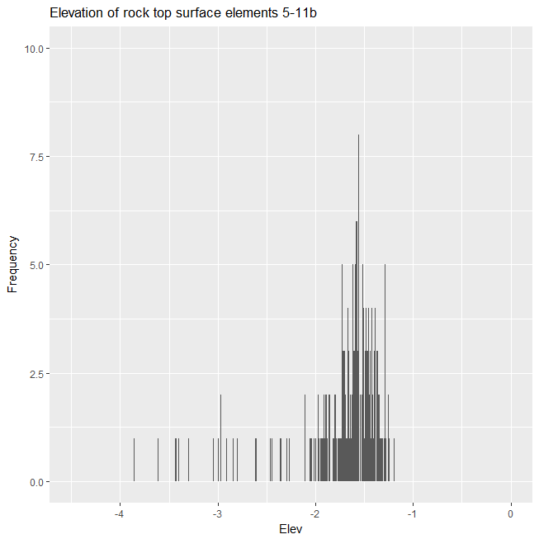

Histogram by reef element with the bounds

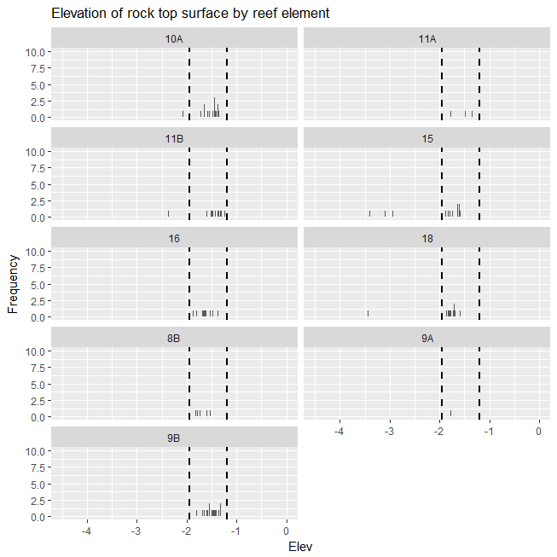

Box plots of elevation by reef element

