

quotation_date
Customer logo
Disclaimer
This document is for discussion purpose only and does not represent a contractual binding agreement of any kind.
© Elektrobit 2026 | Confidential information
Quote for company
quotation_text

Reference: <customer reference number>, <date yyyy-mm-dd>
Elektrobit quote number: quotation_no
Company (in the following company or CUSTOMER):
company
street, zip_code city, country
Contact: first_name last_name
Plant Code: ContinentalPlant; Outlet Code: ContinentalOutlet; ConsUnit/Company Code: ContinentalCU
Your contract partner (in the following Elektrobit):
Elektrobit Automotive GmbH
Am Wolfsmantel 46, 91058 Erlangen, GERMANY
Phone: +49 9131-7701-0, Fax: +49 9131-7701-6333
Managing Directors: Maria Anhalt, Christoph Herzig Commerzbank AG, Branch Nürnberg
Chairperson of Supervisory Board: Nicole Werner IBAN: DE28 760 400 610529 163800
Registered Office: Erlangen, Germany SWIFT/BIC: COBADEFFXXX
Register Court: Fürth HRB 4886 VAT no.: DE132503195
Contact: bid_owner_name

QUOTE quotation_no
© Elektrobit 2026 | Confidential information
Table of contents

01 | Executive summary 3
02 | Commercial overview 4
03 | Offer details 11
04 | Reference documents 20
05 | Get in touch 26



Executive summary

How we understand your needs

Describe in your own words how we understand the request. List the key challenge(s)/pain points the CUSTOMER has and provide a high-level summary of our solution. Describe why the offered Elektrobit product is special/better compared to competitors of Ele

Commercial overview

Commercial summary
Mandatory components – One-time payment:
POs | PRODUCT Item | PRODUCT ITEM Type  Details See PRODUCT item Type Definition | Amount  excl. tax currency | DISCOUNT % | best price  excl. tax currency
qbs_productgroup_SummaryOneTimePaymentMandatory

Total amount: | qbs_productgroup_TotalOneTimePaymentMandatory

Mandatory components – Recurring payment:
POs | PRODUCT Item | PRODUCT ITEM Type  Details See PRODUCT item Type Definition | Payment MODEL | Amount  excl. tax currency | DISCOUNT % | best price  excl. tax currency
qbs_productgroup_SummaryRecurringPaymentMandatory

Optional components – One-time payment:
POs | PRODUCT Item | PRODUCT ITEM Type  Details See PRODUCT item Type Definition | Amount  excl. tax currency | DISCOUNT % | best price  excl. tax currency
qbs_productgroup_SummaryOneTimePaymentOptional

Optional components – Recurring payment:
POs | PRODUCT Item | PRODUCT ITEM Type  Details See PRODUCT item Type Definition | Payment MODEL | Amount  excl. tax currency | DISCOUNT % | best price  excl. tax currency
qbs_productgroup_SummaryRecurringPaymentOptional
Annual subscription:
Yearly ADJUSTMENT RATE of 2,5%, will be added to the following annual subscription invoices. Subscription model solely described in the Elektrobit Terms for Business models (Elektrobit TBM).
Per-unit:
The UNIT pricing mentioned in this QUOTE, is based on the lifetime volume scenario explained on page “Production scenario and UNIT pricing”.

02 | Commercial overview

Product item type definition
PRODUCT ITEM TYPEs referred to in chapter “Summary” and “Products and services” are defined in the table below. The PRODUCT ITEM TYPE definitions and the granted licenses are an integral part of this QUOTE and solely described in the Elektrobit T&C, unless explicitly agreed upon in writing.
Product ITEM TYPE | LICENSE DURATION | MAINTENANCE DURATION | GRANT OF RIGHTS  Details see “Elektrobit T&C” | DESCRIPTION
qbs_productgroup_ItemTypeDefinition
Source Elektrobit Terms and Conditions – Elektrobit T&C (V.1.5, Oct. 2024) / Elektrobit TBM (V.1.0, Feb. 2024) / Elektrobit T&C for Training (V.1.2, July 2023): https://www.elektrobit.com/legal-notice/
02 | Commercial overview

Invoicing and payment terms
POs | PRODUCT Item | PRODUCT ITEM Type  Details See item Type Definition | Payment MODEL | Invoicing date
qbs_productgroup_InvoicingAndPaymentTermsqbs_productgroup_SummaryOneTimePaymentMandatory
Payment terms: Payment is due within 30 days of receipt of the invoice, without deduction.

Offer details

Products and services
POs | PRODUCT Item No. | PRODUCT Item | Short Description  Details see Product description | qty | UNIT PRICE  EXCL. tax currency | Amount  excl. tax currency
qbs_productgroup_ProductsAndServices

03 | Offer details

Production, price per unit model
Conditions to apply in the royalty-, and price per unit payments:
Price level | Annual production volume  From: TO: |  | Discount on Price Level 0
Level 0 | 1 | 50.000 | 0 %
Level 1 | 50.001 | 100.000 | 20 %
Level 2 | 100.001 | 250.000 | 32 %
Level 3 | 250.001 | 500.000 | 42 %
Level 4 | 500.001 | 1.000.000 | 51 %
Level 5 | 1.000.001 | 3.000.000 | 58 %
Level 6 | 3.000.001 | 5.000.000 | 65 %
Level 7 | 5.000.001 | >> | 68 %

- Production volume discounts apply as defined in the table.
- UNIT price (see page “Production scenario and UNIT pricing”) in the price level applies only to the additional volumes higher than the last price level.
- The highest price level reached for annual cumulative volumes will be the
starting price level for the following years.
- MINIMUM PRODUCTION FEE defines the minimum fee for the first year of production (SoP) (see page “Production scenario and UNIT pricing”).
- Monthly UNIT report by CUSTOMER required. Invoicing is done based on actual produced volumes and the MINIMUM PRODUCTION FEE. Per unit model solely described in the Elektrobit Terms for Business models (Elektrobit TBM).

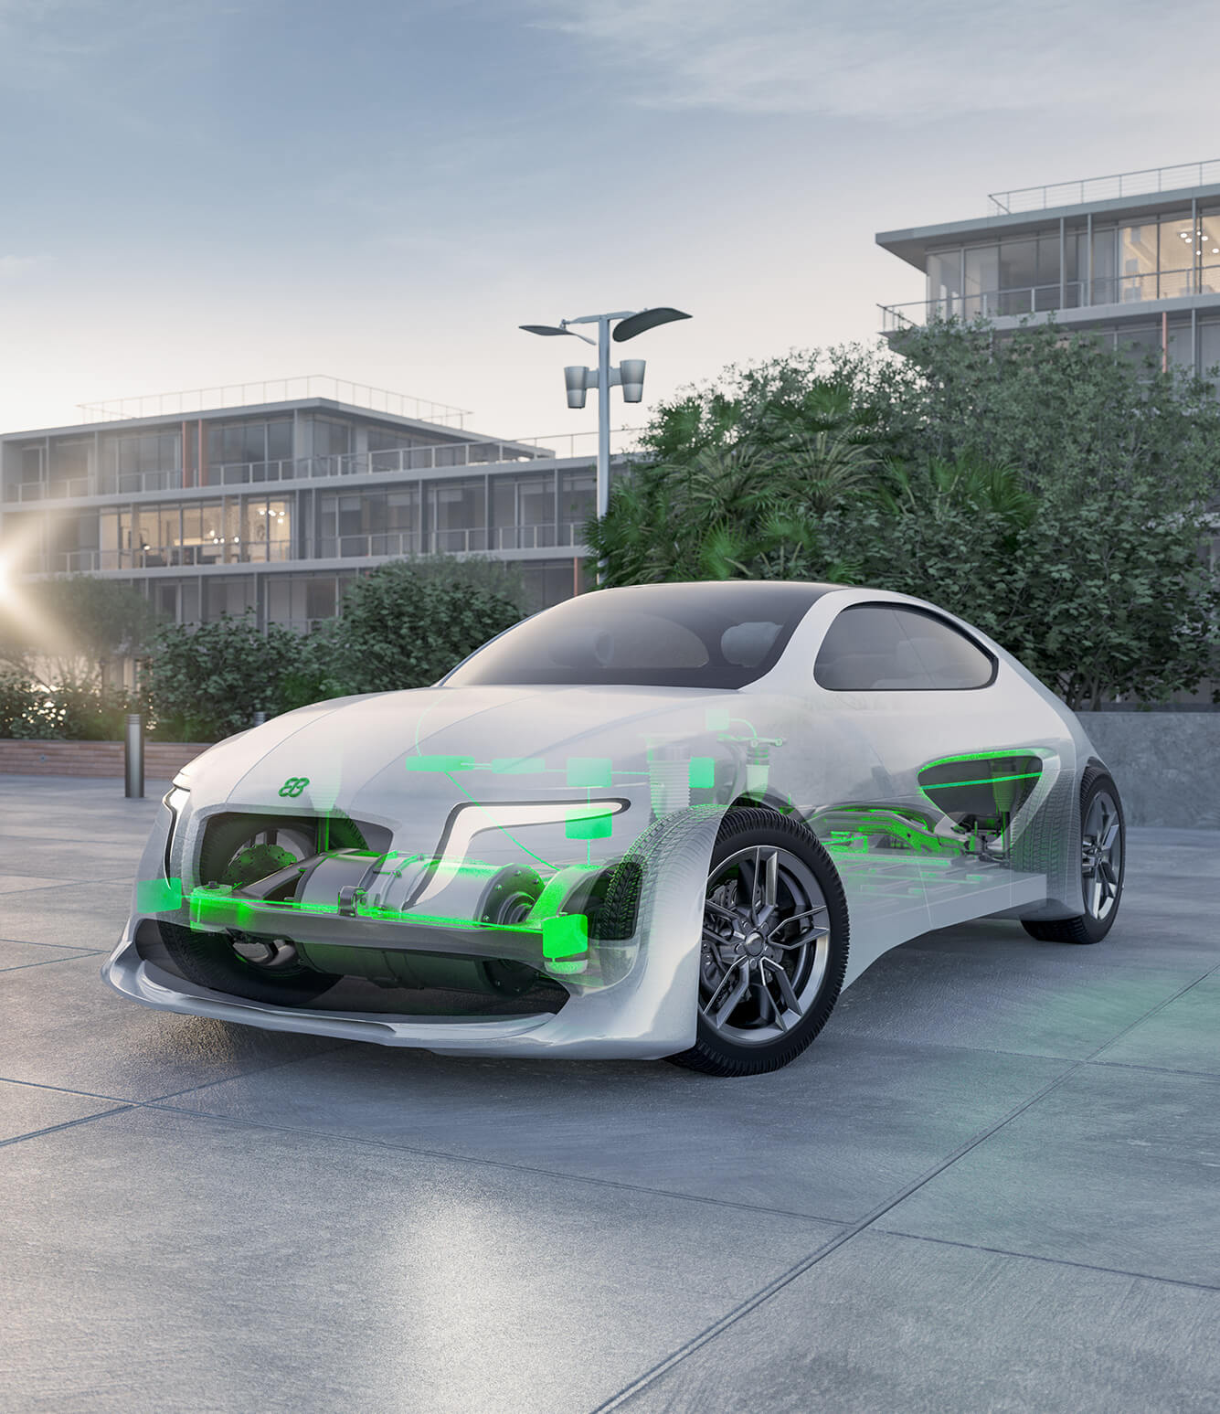
03 | Offer details

Production PRODUCT ITEMS
For “project_title” Elektrobit proposes the following product items:

Product Family | ItemS | qty
qbs_productgroup_PoductItems

03 | Offer details

Production scenario and UNIT pricing
Remove the placeholder picture and replace it with correct customer scenario using the Quotation Excel.

03 | Offer details

Scope of license
The granted license rights shall be limited to the restrictions defined in the following LICENSE PROFILES.
The effected licenses are listed under chapter “Products and services” and refer to one of the following LICENSE PROFILES.
PRODUCT ITEM Type  ProfilE | license_type  License profile 1
Mass production | Yes
CUSTOMER PRODUCT | Battery management system
Vehicle OEM Brand | All brands of Volkswagen Group
Model generation | All
µC derivative | ONE - micro_manufacturer micro_family micro_derivative
Compiler and version | compiler_name / compiler_version
ECU software version | Unlimited
Transceiver hardware | NXP TJA1041T
Tier 1 | ZF

03 | Offer details

Scope of platform services
The platform services shall be limited to the restrictions defined in the following PLATFORM PROFILES. The effected Porting, IP, and QP packages themselves are listed under chapter “Products and services” and refer to one of the following PLATFORM PROFILES.
ProfilE | PLATFORM profile 1
µC derivative | micro_manufacturer micro_family micro_derivative
Compiler type and version | compiler_name / compiler_version
Compiler options | To be defined within Porting Agreement
MCAL vendor and version | mcal_vendor / mcal_version
Transceiver hardware | NXP TJA1041T

03 | Offer details

Delivery timeline
Deliveries can be expected as follows:
POs | PRODUCT Item | PRODUCT ITEM Type  Details See item Type Definition | Expected delivery time
qbs_productgroup_DeliveryTimeline
Delivery schedule “Platform Service”: The CUSTOMER and Elektrobit will agree on a final delivery schedule after FINALIZED PURCHASE PROCESS as part of the Porting Agreement. Any delay can cause a timeline shift.
03 | Offer details

Customer provisions
For timely delivery and successful project execution, the following CUSTOMER PROVISIONS are a prerequisite:
CUSTOMER PROVISION | Quantity | PROVISION Date
Acceptance of Porting Agreement | n/a | After FINALIZED PURCHASE PROCESS
Evaluation board for target µC to be provided | 3 | With PO
Evaluation board with SHE or HSM module (with corresponding SHE+ Firmware) to be provided | 2 | With PO
Device number for existing hardware needs to be provided in case of updates/upgrades | - | With PO
Hardware devices for repair/upgrade need to be sent to Elektrobit Austria at CUSTOMER’s expense (free of charge for Elektrobit)  Shipping address: Elektrobit Austria GmbH, Kaiserstr. 54, 1070 Wien, AUSTRIA | - | After FINALIZED PURCHASE PROCESS
Complete list of training participants (first & last name + email address) to be provided | n/a | With PO
Training participants require a computer with internet access and an up-to-date internet browser to access a virtual desktop for practical exercises.  In case of classroom (on-site) training: CUSTOMER shall provide a room with a projector/screen and wireless internet access for the trainer. | n/a | Training date



03 | Offer details

Travel guidelines
Travel expenses to the CUSTOMERS's place of business in city will not be charged separately.

Travel expenses which are approved in advance by company or which are essential or necessary under the specific circumstances will be invoiced at the end of the month and evidenced on request as follows:
- Travel expenses for car at €0,50/km
- Travel expenses for other means of transport (e.g., for flights) as incurred
- Accommodation expenses as incurred
- Any expenses in accordance with statutory regulations
- Travel time is charged at €130,00/hour



Reference documents

Incorporated documents
The documents listed below are an integral part of this QUOTE and apply in the following order
in case of conflicts:
DOCUMENT (Version/DATE)
This QUOTE document
Product Description EB tresos:
- PD_EB_tresos_Studio_for_ACG8_2024-04-22.pdf
- PD_EB_tresos_Studio_for_ACG9_2025-05-23.pdf
- PD_EB_tresos_ACG8_2025-04-07.pdf
- PD_EB_tresos_ACG_ACL_9_2025-05-31.pdf
- PD_EB_tresos_Embedded_Hypervisor_2024-01-29.pdf
- PD_EB_tresos_AutoCore_OS_6.1_2024-09-16.pdf
- PD_EB_tresos_Safety_RTE_for_ACG-7_2016-12-05.pdf
- PD_EB_tresos_ACG8_Safety_2023-06-30.pdf
- PD_EB_tresos_ACG9_Safety_2024-06-06.pdf
- PD_EB_tresos_Safety_OS_2.0_2024-09-16.pdf
- PD_EB tresos_9_AutoCore_OEM_Extensions_for_Essentials_2025-02_10.pdf
- PD_EB_tresos_9_AutoCore_OEM_Extensions_for_BMW_EES25_2024-02-08.pdf
- PD_EB_tresos_8_AutoCore_OEM_Extensions_for Essentials_2024_10_07.pdf
- PD_EB_tresos_8_AutoCore_OEM_Extensions_for_FCA_2024-02-08.pdf
- PD_EB_tresos_8_AutoCore_OEM_Extensions_for_Ford_2025-01-07.pdf
- PD_EB_tresos_8_AutoCore_OEM_Extensions_for_Honda_2024-09-30.pdf
- PD_EB_tresos_8_AutoCore_OEM_Extensions_for_JLR_2025-07-09.pdf
- PD_EB_tresos_8_AutoCore_OEM_Extensions_for_Renault_Nissan_2023-10-10.pdf
- PD_EB_tresos_8_AutoCore_OEM_Extensions_for_VCC-2024-10-07.pdf
- PD_EB_tresos_8_AutoCore_OEM_Extensions_for_VWAG_2025-02-21.pdf
- PD_EB_tresos_BSP_Platform_ACG8_2023-06-30.pdf
- PD_EB_tresos_BSP_Platform_ACG9_2024-06-06.pdf
- PD_EB_tresos_BSP_MCAL_ACG8_2023-06-30.pdf
- PD_EB_tresos_BSP_MCAL_ACG9_2024-06-06.pdf
- PD_EB_tresos_ACM8_Eep_2023-06-30.pdf
- PD_EB_tresos_ACM9_Eep_2024-06-06.pdf
- PD_EB_tresos_ACM7_RamTst_2014-12-11.pdf
- PD_EB_tresos_Solutions_for_Platforms_2020-02-28.pdf
- RTC_maintenance_and_support_annex_December_2023.pdf
- RTC Maintenance 2025.pdf
- RTC Maintenance 2025_Aumovio.pdf
Product Description EB corbos:  - PD_EB_corbos_Studio_and_AdaptiveCore2_Linux_R19-03_2025_03_07.pdf  - PD_EB_corbos_Studio_and_AdaptiveCore2_Linux_R20-11_2025_03_07.pdf  - PD_EB_corbos_Studio_and_AdaptiveCore2_QNX_R19-03_2025_03_07.pdf  - PD_EB_corbos_Studio_and_AdaptiveCore2_QNX_R20-11_2025_03_07.pdf  - PD_EB_corbos_Hypervisor_2_2023_01_18.pdf  - EB_corbos_maintenance_and_support_annex.pdf  - PD_EB corbos_AdaptiveCore_LTS_support_2022_10_26.pdf  - PD_EB_corbos_Link_R20-11_2025_03_07.pdf  - Limited Use License Agreement  - EB Corbos Linux Supplemental Terms | 2024-08-12  2024-08-12
Product Description EB zentur:
- PD_EB_zentur_CryptoDriver_HW_ACG8_2023-06-30.pdf
- PD_EB_zentur_CryptoDriver_HW_ACG9_2023-10-10.pdf
- PD_EB_zentur_CRYSHE_2021-11-10.pdf
- PD_EB_zentur_HSM_Firmware_v1.16_ACG8_2023-06-30.pdf
- PD_EB_zentur_HSM_Firmware_v1.16_ACG9_2023-10-10.pdf
- RTC_maintenance_and_support_annex_December_2023.pdf
Product Descriptions EB zoneo
- PD_EB_zoneo_SwitchCore_2024_10_21.pdf
- PD_EB_zoneo_VSwitch_2024_02_16.pdf
- PD_EB_zoneo_ACM8_2025_04_10.pdf
- PD_EB_zoneo_GatewayCore_2024_04_16.pdf
- RTC_maintenance_and_support_annex_December_2023.pdf
- Master Software License Agreement (MSLA)  - General Quality Agreement - Software (GQA-SW)  - NON-DISCLOSURE AGREEMENT | 2016-01-01  Revision F/2024-06-30  2023-02-01
<Name of frame contract with customer, if exists> | <version>/<date>
Elektrobit Terms for Business Models (Elektrobit TBM) Global  https://www.elektrobit.com/legal-notice/ | Version 1.0/February 2024
Elektrobit License Terms and Conditions (Elektrobit T&C) Global  https://www.elektrobit.com/legal-notice/ | Version 1.5/October 2024
Additional applicable terms:
- Compliance condition – Business Partner Due Diligence (BPDD), Taxes,
Export control compliance, Glossary: https://www.elektrobit.com/legal-notice/
- Quality assurance, Cybersecurity, Functional safety: https://www.elektrobit.com/about/#iso



04 | Reference documents

Incorporated documents
The documents listed below are an integral part of this QUOTE and apply in the following order
in case of conflicts:
DOCUMENT (Version/DATE)
This QUOTE document
Product Description EB robinos:
- EB_robinos_Predictor_-_Product_description
- EB_robinos_Predictor_EvalKit_v1.9.0_2025.03.28_-_User_guide
- EB_robinos_Predictor_EvalKit_v1.9.0_2025.03.28_-_Release_Notes
- EB_robinos_Provider_ADASISv2_User Guide
- EB_robinos_Provider_ADASISv2_Release_Note
- EB_robinos_Provider_ADASISv3_Release_Note
- ADASISv2_EHR_AUTOSAR_SWC
- EB_robinos_Reconstructor_ADASISv3_Release_Note
- EB robinos Positioning Product Description
Product Description EB Assist busmirror:
- PD_EB_Assist_Busmirror_21.6.0
Product Description EB Assist bus tools hardware:
- Product_description_EB_Assist_hardware_EB_2200_1.1
- Product_description_EB_Assist_hardware_EB_5200_1.2
- Maintenance Agreement for EB Assist bus tools_V1_2023-01-01.pdf
- Agreement on Contract Research and Development Services, VR 18(0) and VR 18 (6)  - Master Software License Agreement (MSLA)  - Delivery Agreement  - General Quality Agreement - Software (GQA-SW) | 2016-01-01  2016-01-01  2016-01-01  Revision F/2024-06-30
- Framework contract (Nr. 0046 – CP/MAC-I) „zur Regelung der Zusammenarbeit in Hardware
und/oder Softwareprojekten“ between Robert BOSCH GmbH and Elektrobit Automotive GmbH (formerly 3SOFT GmbH) from 07.07.2006
- „Beitritts- und Ergänzungsvereinbarung zu dem Rahmenvertrag (Nr. 0046 – CP/MAC-I)“ between Robert BOSCH GmbH and Elektrobit Automotive GmbH (formerly 3SOFT GmbH) from 18.12.2007/14.01./16.01.2008
<Name of frame contract with customer, if exists> | <version>/<date>
Elektrobit Terms for Business Models (Elektrobit TBM) Global  https://www.elektrobit.com/legal-notice/ | Version 1.0/February 2024
Elektrobit License Terms and Conditions (Elektrobit T&C) Global  https://www.elektrobit.com/legal-notice/ | Version 1.5/October 2024
Additional applicable terms:
- Compliance condition – Business Partner Due Diligence (BPDD), Taxes,
Export control compliance, Glossary: https://www.elektrobit.com/legal-notice/
- Quality assurance, Cybersecurity, Functional safety: https://www.elektrobit.com/about/#iso


Get in touch
bid_owner_name

Senior Sales Manager
Phone: bid_owner_fon
Email: bid_owner_email
Office: bid_owner_address
bid_owner_city, quotation_date
_______________________________  authorized_signatory  Title | _______________________________  bid_owner_name  Senior Sales Manager
Elektrobit is committed to this QUOTE for 30 days from the date of issue.
Please refer to QUOTE no. quotation_no and our company Elektrobit Automotive GmbH within your purchase order, as mentioned on the first page. To ensure a fast ordering process, please send all orders by email to ordermanagement@elektrobit.com.

