EEF Overview

World Cup forecasts example

Résumé :

Table of Contents
1 - Introduction 2
1.1 - Meta-Model 2
2 - Create / open a game 3
2.1 - Create 3
2.2 - Open 3
3 - Overview 4
4 - The Master-Detail 4
4.1 - Players management 5
4.2 - Teams management 5
4.3 - Games management 6
5 - Forecast management 7
5.1 - Automatic export 7
5.2 - Forecasts validation 8
6 - Statistics 8

Introduction
World Cup Forecast is a RCP application defined with EEF framework. Based on Ecore mete-model, it aims to introduce the framework possibilities, that is to say advanced properties views in order to edit a model easily.

Meta-Model
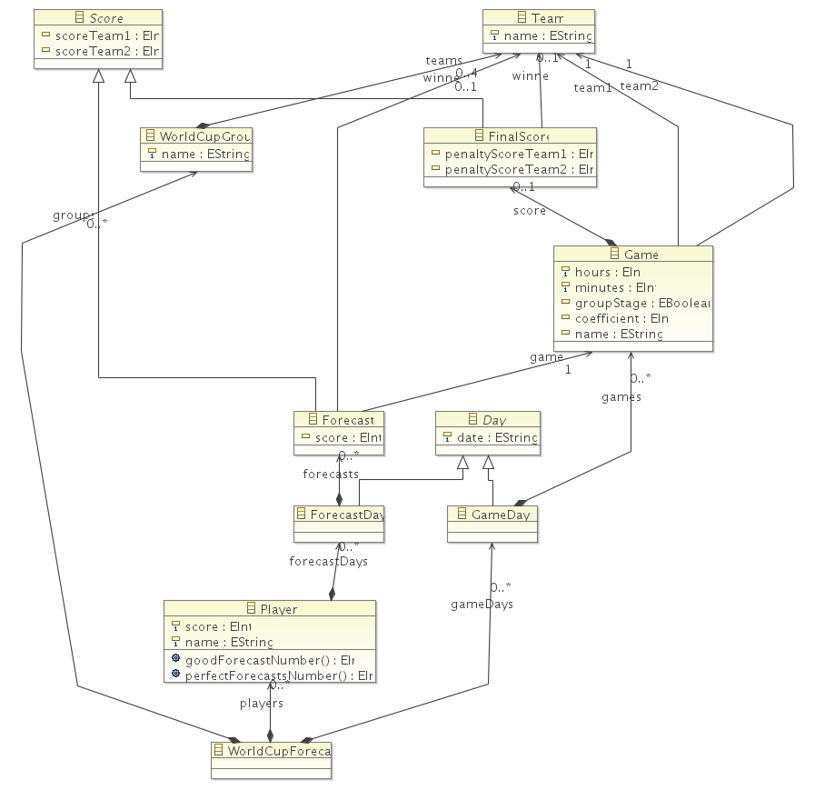Illustration 1: World Cup Forecast meta-model

Create / open a game

Create
To create a new World Cup Forecast game, (i.e. a new instance of worldcupforecast meta-model), go on File menu > New > Worldcupforecast Model.

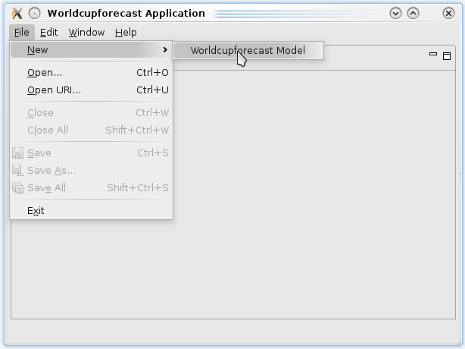
Next, select the place where saving the model (extension *.worldcupforecast) and on “Model Object” field select the model root, World Cup Forecast here.
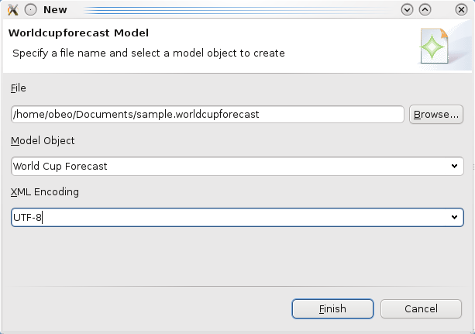

Open
Click on File > Open
Next, select the model to open.

Presentation
By default, EEF generate a tree view from model and advanced properties views for each element.

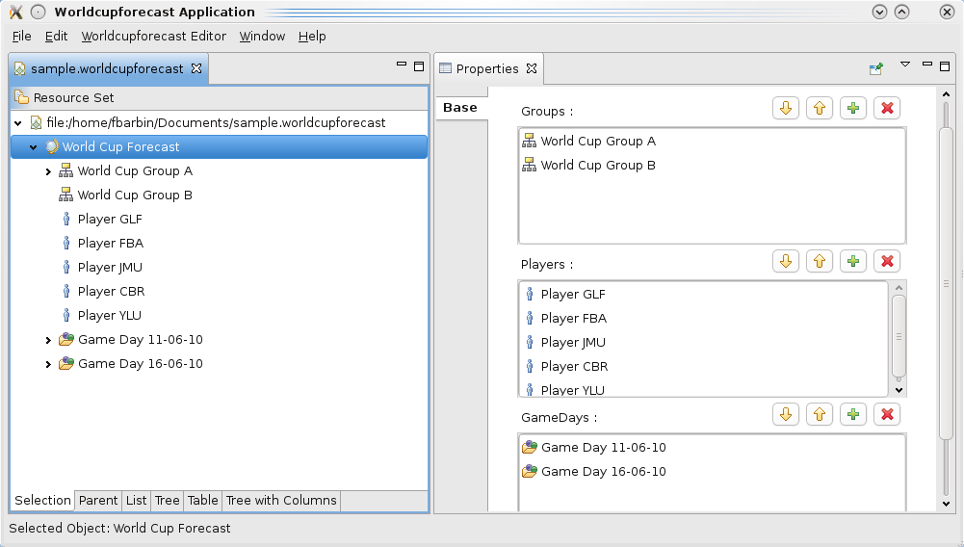Illustration 2: default EEF properties
The goal was to get rid of model tree to only keep customized properties views, more specific to the game problematic.
First, we have modified MultiPageEditorPart type (in file WorldcupForecastEditor from .editor generated by EMF) for FormEditor type which make for us to replace default generated pages by customized pages.

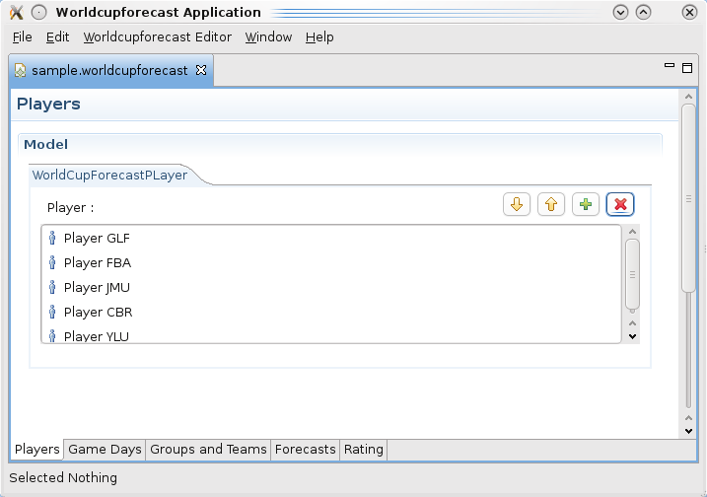Illustration 3: Overview
All pages from application are reachable through tabs at the window bottom.
Tab Players give a players overview (forecasters) listed in the game.
Tab Game Day display and enables editing of football games.
Tab Groups and Teams allows manage teams and their groups.
Tab Forecasts display players forecasts.
Tab Rating display players rank and some statistics.

The Master-Detail
EFF API give an abstract class AbstractEEFMDFormPage which allows to define pages conform with master-detail pattern. EEF provide two implementations of it, EEFPropertiesViewerMDFormPage, and EEFTreeMDFormPage.

Players management
The first tab allows to add / delete players, edit their name and display the player score at forecasts.
The page type is EEFPropertiesViewerMDFormPage. This kind of page is divided follow the Master-Detail pattern : a part displays elements into a list (in this case, players are displayed into AdvancedTableComposition widget) and properties of each element into the other part.

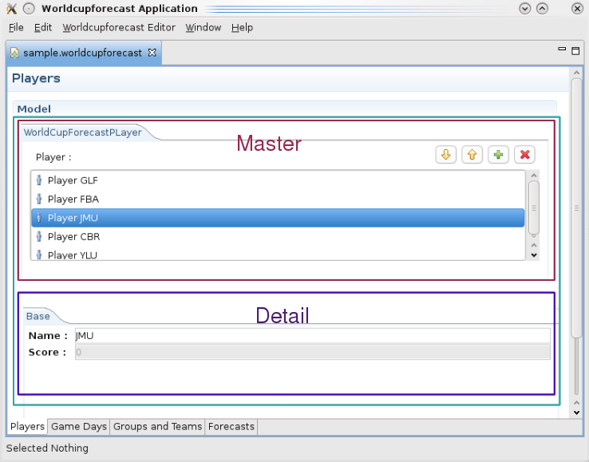Illustration 4: Master-Detail overview

Teams management
The tab “groups and teams” allows to add, edit and delete groups. Each group can contain to four teams.

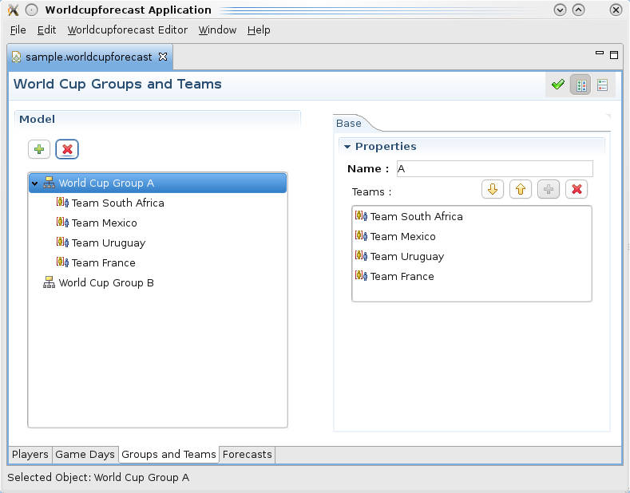Illustration 5: Tree Master-Detail overview

The left part display the tree view and for each group, their teams. EEF give two alternative to edit elements from model : through a wizard with a double-click or with detail view.
The page type is EEFTreeMDFormPage.

Games management
Games are brought together by days. The page is also defined by EEFTreeMDFormPage. As part of forecasts, during the game adding, it's important to specify whether it's about a stage game or not.
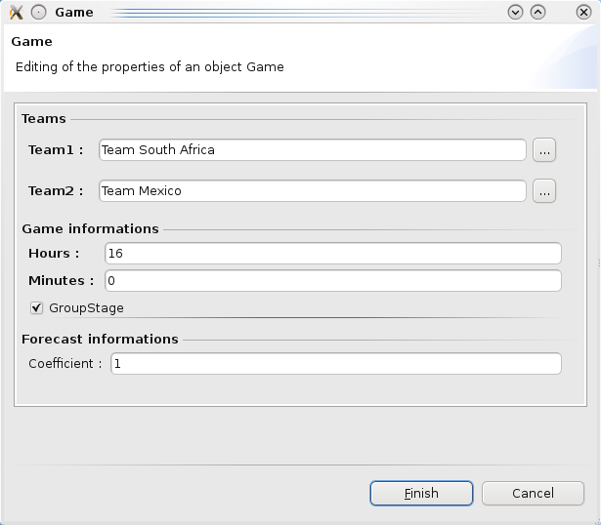Illustration 6: EEF Wizard example : create a game

Forecast management

Automatic export
After the game day is setting up, it's possible to generate the forecast day for each player listed in the game.
To export, perform right-click on the “GameDay” and World Cup Forecast > Generate Forecasts.
Next, you have to select the folder where export the forecast day. Finally, a new folder is created with the date as name and inside him, the external resources of forecast day for each players.
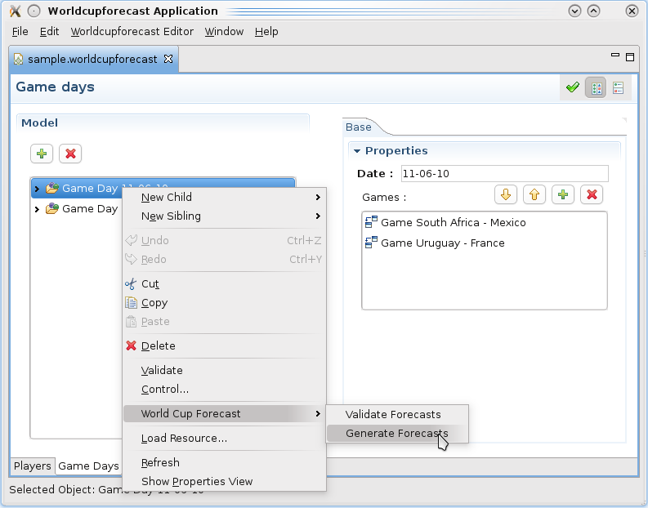

Forecasts validation
The reverse operation consist in validate the forecasts by right-click on the “GameDay” and next, World Cup Forecast > Validate Forecasts.
This operation get back resources into the main resource. Forecasts still also available in other resources but their modification couldn't impact the model.

Statistics
The last tab display some players statistics. This page is similar to “Players” page except that player list is contained in a TableComposition and not in a AdvancedTableComposition. This kind of widget allow us to add additional colons.
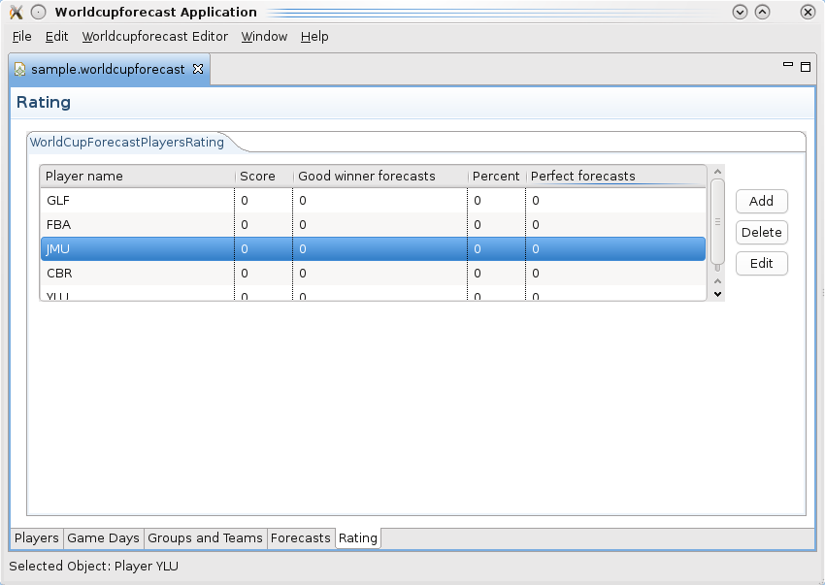Illustration 7: TableComposition overview – Raiting page

