ApexMail — Business Model & Tech Plan
Oct 13, 2026 · @Aaron

For agents: how to apply this doc
This doc is written so an AI agent can execute it end to end. Read this section first, every session. Then read the latest audit of the repo against this plan (Audit · 15 Oct) before choosing a work package.
What each tab is for
- Plan (this tab): the strategy, pricing and MRR model. It explains why; it does not tell you what to change.
- Sales engine: the sales autopilot specification. Work package group F implements it.
- Work packages: the authoritative list of changes. Every change to the repo or to production comes from a work package (WP) there.
- Verification ledger: the evidence for every factual claim. Repo facts are pinned to commit 1987043 (2026-10-13).
Procedure, every session
- Read the invariants below.
- Open the index in Work packages. Take the first WP whose status is Not started and whose dependencies are all Done.
- Before writing code, re-check the WP's "Current state" lines against the repo at HEAD. If a cited file or line has moved, update the ledger row first.
- Do the WP. Meet every acceptance criterion and run every verification command listed.
- Set the WP's status in the index, and record the commit SHA and test names in its Evidence line.
- If a WP needs a human decision (marked Owner), stop at that step, write what you prepared, and move on to another WP.
Invariants (never break these, in any WP)
- EU-only mail fails closed. A message on EU-only routing is held, never sent through SES or any non-EU transport.
- Sales sending is isolated. It never shares a transport account, IP, sending domain or suppression list with customer mail.
- No claim without evidence. Never publish a number, capability or comparison that has no ledger row. Computed numbers come from production data, never from typed constants.
- Prices change only at the source. Edit crates/platform-catalog/src/lib.rs, then regenerate what derives from it. Never hand-edit derived pricing files. tools/validate_pricing_drift.py and tools/check_knowledge_consistency.py must pass.
- Agents draft legal rows; only the owner approves them. Never set approved_by/approved_at on sales_jurisdiction_policies, objection_library or sequence versions.
- Autonomy moves only through the promotion gates in WP F12.
- BYOC stays frozen (WP G1).
- Never delete a test. Move it to another CI lane if needed.
- After WP A1, no CI or test workload runs on the production host.
- Migrations ship forward only. Never edit an applied migration. Migration 252 is the Adyen billing schema; new files continue the sequence after 252, with the header form -- Migration NNN: ... that the validate stage checks.
- Vastly improved scraping, all CAPTCHA-ready

Owner-only decisions. These are never made by an agent:
- approving legal policy rows, the objection library and sequences
- final prices
- signing contracts
- buying domains or IPs
- promoting autonomy
- anything sent under the owner's name for the first time
Generic definition of done. Every WP must meet these on top of its own criteria:
- cargo fmt --check passes.
- cargo clippy --workspace --all-targets -- -D warnings passes.
- New tests are proven to fail before the change and pass after.
- The touched crates' tests pass.
- The validate-stage gates in ci/stages/validate.sh are green, including python3 tools/generate_repo_map.py --check.
- The change lands on main and deploys through the normal pipeline.

Thesis
ApexMail is the email platform built in Europe for anyone who does business in Europe. EU companies are the core market; US companies are welcome and actively won. Most MRR comes from about 100–150 accounts on contract tiers, while self-serve plans and mailbox seats run without the founder.
Why this position works:
- Volume pricing is a race to the bottom. AWS SES sells sending at $0.10 per 1,000 emails, and Resend sells 50,000 emails for $20. An unknown brand cannot win on price per email alone.
- European buyers lean toward local vendors. 61% of Western European CIOs expect geopolitics to deepen their reliance on local or regional cloud providers (Gartner, 2025).
- EU regulation creates budgets. Financial entities under DORA must report every ICT provider in an annual register of information. They pay for vendors who make that easy.
- US companies selling into Europe hit the same questions. Their EU customers ask about residency, the DPA and sub-processors. An EU-based provider with ready answers shortens their sales cycles.
- EU-sovereign buyers get something US-first rivals cannot offer. Their mail never touches a US provider, the proof is signed per message, and the contract sits under EU law with an EU company. One setting turns this on, inside the same product the rest of the world uses.
Segment | Why they buy ApexMail | Lead product line | Where they come from
EU regulated firms (finance, insurance, health, public sector) | EU residency, DORA/NIS2 evidence, audit logs, EU contract and language | Compliance, Enterprise Cloud, Dedicated Tenant | Outbound from regulator registers
EU SaaS and SMEs | European vendor, EU support hours, local language, fair price | Self-serve, Platform, Mailboxes | Self-serve, comparison pages
US SaaS selling into Europe | Passing EU customers' procurement: EU residency, DPA, SCCs, evidence pack | Compliance, Platform | Outbound to US companies with EU customers
US developers and startups | Price, drop-in compatibility with their current provider, developer experience | Self-serve | Comparison pages, compatibility layer, SDKs
Platforms worldwide | Subaccount isolation, white-label domains, usage pricing | Platform | Outbound and partners
ApexMail already has what US-first rivals lack in Europe: an EU legal entity, DSR and audit automation, private-cloud packaging and four EU languages. It also has what EU rivals lack for larger deals: platform subaccounts, dedicated tenants and mailboxes in one account. What is missing is switching ease, SDK reach, provable claims and the evidence pack.
One rule governs every product line, because there is one founder: each line is either fully self-serve, or worth at least €500 a month per account.
This plan has no dates. Work is ordered by dependency, and MRR is modelled as customer mixes, not months.

Product lines and pricing
There are six revenue lines plus add-ons, each priced in both EUR and USD. Self-serve stays cheap and works as the funnel worldwide. Compliance, Platform and Dedicated Tenant carry the MRR, and mailbox seats grow inside those same accounts.
Line | EUR (excl. VAT) | USD | What's included | Main buyers
Self-serve API | Free €0 · Developer €20 (was €29) · Pro €89 · Growth €229 · Business €699 | $0 · $20 · $99 · $249 · $749 | Today's volumes (3k / 50k / 150k / 500k / 2M). EU data residency by default, sending through AWS SES in an EU region | Developers, startups and SMEs worldwide
Compliance | €990/mo, annual | $1,090/mo | 1M emails, EU-only routing included, dedicated IP, DORA/NIS2 evidence pack, GDPR processor pack (DPA, SCCs, sub-processor list), signed routing receipts, 1-year audit log, SSO | EU regulated firms; US SaaS selling into Europe
Enterprise Cloud | €1,750/mo, annual (today's plan) | $1,950/mo | 5M emails, 3 dedicated IPs, legal hold and archive, quarterly evidence refresh, EU-only routing included. 99.9% SLA once the second host is live | Larger regulated senders
Platform | €990/mo base. €0.30 per 1,000 above 1M. €1 per active subaccount above 100 | $1,090 base, $0.35 per 1,000, $1 per subaccount | Subaccounts with isolated reputation, white-label tracking and bounce domains, provisioning API | SaaS companies sending for their own customers, anywhere
Dedicated Tenant | From €4,000/mo, 12-month minimum, €10k–40k setup (already in the catalog) | From $4,500/mo | Single-tenant stack on dedicated hardware, EU region by default, 5M recipients, 2 managed IPs, named owner, monthly review | Banks, government, large platforms
Mailboxes | €6 per seat/mo, 10-seat minimum. Archive and journaling +€2 per seat | $7 per seat, +$2 archive | EU-hosted IMAP/SMTP mailboxes on the existing stack, autoconfig, spam and AV filtering, self-serve import | Staff of existing accounts first
Add-ons | Dedicated IP €49 first, €69 each extra (existing). Inbox placement monitoring €99/mo. EU-only routing on self-serve Pro and up €149/mo | $55, $75, $109, $165 | EU-only routing sends through ApexMail's own EU MTAs, with no third-party transport | Any paid tenant
Price anchors: Resend charges $20 for 50,000 emails, so the $20 Developer plan meets it head-on. mailbox.org charges €4 (Standard) and €12 (Premium) per user, and €6 sits between them.
Since 14 Oct all payments run through Adyen, an EU company: cards in either currency, and SEPA Direct Debit for EU customers. Contract tiers can also pay by bank-transfer invoice through the accounting automation you already have.

MRR model
The three customer mixes produce €45,400, €191,450 and €480,000 MRR. Contract tiers bring in more than half in each one. EU customers carry roughly 70%, and US customers bring the rest. Moving from one mix to the next means adding accounts, not changing the model.
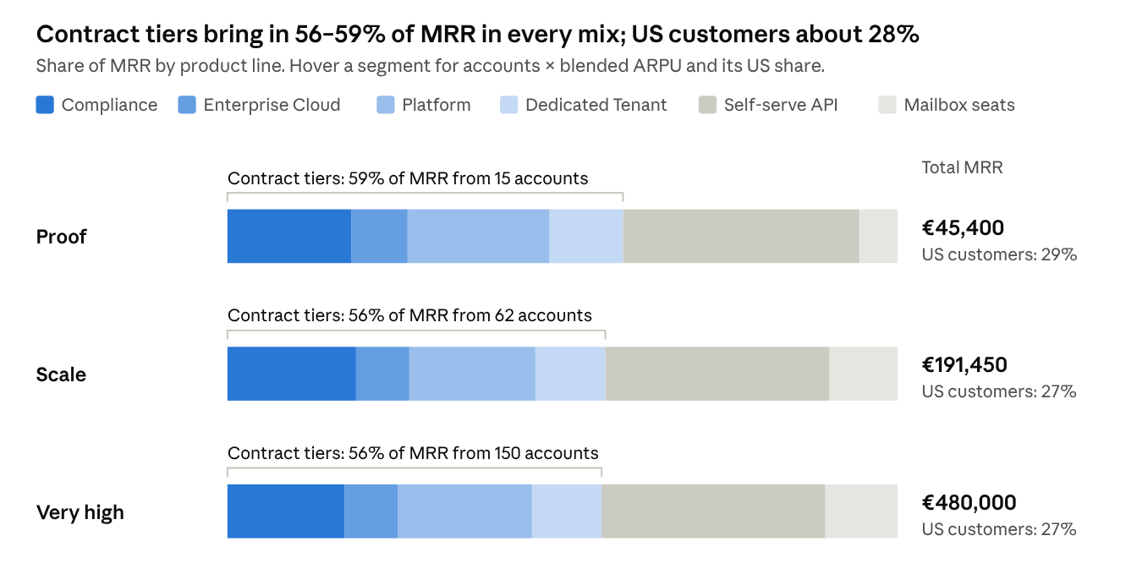
modelled in this doc · 3 customer mixes, no dates · MRR = accounts (or seats) × blended ARPU; US share from the table below
Line | Blended ARPU (basis) | US share | Proof | Scale | Very high
Compliance | €1,050 (€990 plus overage and add-ons) | 25% | 8 | 35 | 80
Enterprise Cloud | €1,900 (€1,750 plus overage and extra IPs) | 15% | 2 | 8 | 20
Platform | €2,400 (€990 base, usage and subaccount fees) | 40% | 4 | 15 | 40
Dedicated Tenant | €5,000 (from €4,000; larger tenants pay more) | 0% | 1 | 4 | 10
Self-serve API | €80 (60% Developer, 28% Pro, 9% Growth, 3% Business, plus add-ons) | 40% | 200 | 800 | 2,000
Mailbox seats | €6.50 per seat (some with archive) | 5% | 400 seats | 3,000 seats | 8,000 seats
The US shares are assumptions. Self-serve and Platform lean toward the US developer market. Compliance includes US SaaS companies that sell into Europe. Dedicated Tenant and mailboxes are EU-led.
The mixes are steady states, not dates. Reaching one depends on win rate and churn. Transactional email churns little once integrated, and contract tiers are annual. The Very high mix (150 contract accounts) needs the contracted help described in the operating model.

Unit economics
Every line clears roughly 80% gross margin, so infrastructure cost does not cap MRR. The binding cost is founder hours (see the operating model). Figures are approximate, except the SES rate, which comes from AWS's price page.
Line | Main cost drivers | Approx. cost per account / month | Approx. gross margin
Self-serve | SES at $0.10 per 1,000 emails, Adyen fees ($0.13 per transaction plus the payment-method fee), share of hosting | Developer (50k emails): about €7 | 65% (Developer) to 85% (Pro and up)
Compliance | Dedicated IP, SES or own-MTA volume, evidence pack (generated, not hand-made) | €80–150 | 85–90%
Enterprise Cloud | 5M emails, 3 IPs, archive storage, own EU MTAs for EU-only routing | €150–300 | 83–90%
Platform | Volume: cost per 1,000 is a fraction of the €0.30 / $0.35 charged | Scales with volume | 80–85%
Dedicated Tenant | 2–3 dedicated servers, offsite backups, IPs. Setup fee covers onboarding hours | €400–800 | 80–90%
Mailboxes | Storage, spam and AV compute | €0.50–1 per seat | About 85%
Fixed costs the plan requires:
- Two production hosts in different Hetzner locations, one CI/build host, offsite backup storage
- ISO/IEC 27001 certification and its yearly surveillance audit, for EU buyers (Lettermint already has it)
- A SOC 2 Type II report once US mid-market deals stall without it; US security reviews expect SOC 2 the way EU ones expect ISO 27001
- Cyber and professional liability insurance that covers US customers
- The Estonian accounting service you already use; ask it to watch US state sales-tax thresholds as US revenue grows
- From the Scale mix on: a contracted on-call engineer and a part-time support contractor
The price cut on Developer (€29 to €20, and $20 in USD) costs little MRR. Self-serve's job is to feed upgrades and to put ApexMail in front of developers on both continents, not to carry the revenue.

Go-to-market engine
Three streams feed one founder-led review:
- outbound to EU regulated firms
- outbound to US SaaS companies that sell into Europe
- developers worldwide who find the product on their own
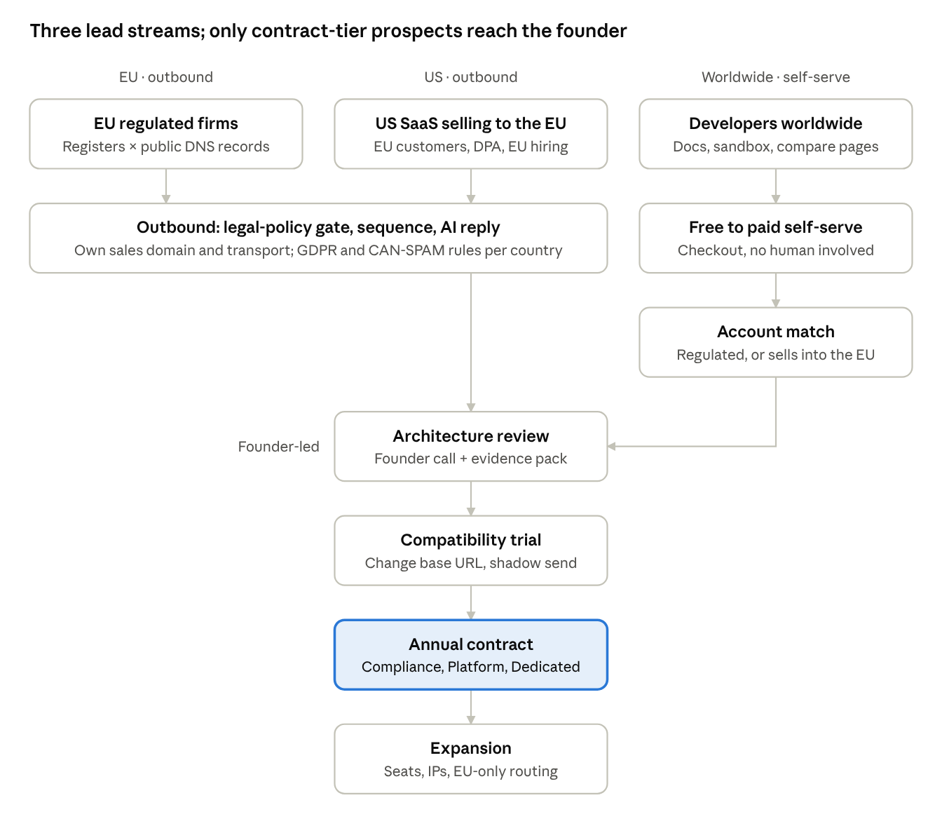
go-to-market flow · 3 lead streams, 1 founder-led review, 4 stages to expansion
Most self-serve accounts never reach the founder. Only those matched as regulated, or as selling into the EU, do.
- EU targets. Take the national registers of licensed payment, e-money, investment and insurance firms. Join them with each firm's public SPF and DKIM records, which name its current email provider. The offer: "Your DORA register lists a US email processor. Switch to EU-only routing by changing one base URL. We supply your register entry and exit plan."
- US targets. Look for US SaaS companies with EU customers: an EU residency or DPA page, EU customer logos, EU job postings, an EU subsidiary. The offer: "Pass your European customers' security reviews. Route their mail EU-only from the same account, and hand them our evidence pack."
- Developers worldwide.
  - Migration pages for SendGrid, Mailgun, Postmark and Resend; the comparison pages already exist.
  - The compatibility layer, so switching is a base-URL change.
  - The TypeScript SDK and the $20 Developer plan.
- Proof before outbound starts.
  - Five design partners, at least one of them in the US, at a discount in exchange for a logo and a case study.
  - Real status history.
  - One published deliverability report for each routing mode.
- Partners. EU DORA and GDPR consultancies, and US advisers who help SaaS companies sell into Europe. Both need the evidence pack more than the email itself.
The full specification is in Sales engine: segments, scoring, hooks, sequences, legal rules per country, infrastructure and guardrails.

Solo-founder operating model
The founder only does work that closes or keeps a contract-tier account. Everything else runs on what the repo already has, or is contracted out.
Function | Handled by | Founder involvement
Prospecting, EU and US | Sales autopilot (discovery, enrichment, legal-policy gate, sequences) on its own domain and transport | Approves target lists and sequences
First response to leads | Instant response already exists: lead, grounded draft, approval, priority-100 send. WP F9 lets low-risk reply classes send without approval | Spot-checks
Demos | Server-driven demo sessions with viewer links (/cp/demos), plus the live API sandbox and grader | Joins only contract-tier calls
Onboarding | Compatibility layer, importer, DNS auto-verify | None on self-serve; one call for contract tiers
Level 1 support, around the clock | Grounded AI chat in console and docs | Reviews escalations
Level 2 support | Founder in CET hours, then a part-time contractor from the Scale mix | Hours per week tracked as a ceiling signal
On-call | Alerting, observability and auto-rollback | Founder first; contracted on-call from the Scale mix
Compliance and security reviews | Evidence packs, routing receipts, SIG/CAIQ answers generated from the claims registry | Signs and does the final review
Accounting, VAT and US sales tax | Accounting automation, the Estonian accounting service, and US sales-tax calculation once WP C2 adds it | None
Dedicated Tenant operations | Same pipeline and images, one host group per tenant | Monthly review per tenant
US time zones. From Tunis (UTC+1), US Eastern business mornings overlap your afternoons. Promise US contract customers support from 9:00 to 13:00 Eastern (15:00 to 19:00 your time). Self-serve users get AI support around the clock, plus next-business-day human replies. Contracted on-call covers nights once the Scale mix is reached.
The realistic solo ceiling is around 60 contract-tier accounts before contracted help is needed. Past that, the business stays founder-owned with contractors, not employees. Top-tier contracts should include source-code escrow and a named backup operator. Both EU and US buyers ask what happens if a single founder is unavailable.

Tech changes
The changes are specified as 41 work packages in Work packages, which is the only authoritative list. This table shows what each group is for.
Group | Purpose | Work packages
A — Risk fixes | Stop CI from endangering production; isolate sales sending; add a second host; make every public claim provable | A1–A6
B — EU-sovereign offer | Routing modes, a hardened EU-only relay, signed receipts, a zero-US subprocessor chain, customer-held keys, the evidence pack | B1–B6
C — US customers | USD prices, US sales tax, a US DPA addendum, SOC 2 | C1–C4
D — Switching | Compatibility endpoints for four providers, importer, SDKs, migration guides | D1–D4
E — Product lines | Catalog price changes, Platform, Dedicated Tenant provisioning, Mailboxes, archive, self-serve signals | E1–E6
F — Sales engine | Legal reach, discovery, signals, hooks, sequences, sending infrastructure, reply automation, contracts, experiments, autonomy | F1–F12
G — Kept surfaces | BYOC freeze, test-only security crates, locale build gate | G1–G3
Everything except BYOC stays and gets a job: IMAP and mailstore power Mailboxes (E4), the AI service powers support and reply automation (F9), ClickHouse feeds the provable public numbers (A4), and the security crates back security-review answers (G2).

Risks and signals
The biggest risk is deliverability on your own IPs. EU-only routing is worthless if Gmail and Microsoft put it in spam. The second is trust: EU-sovereign buyers will doubt a provider that also sends through SES, unless the separation is provable.
Risk | Signal to watch | What changes
Own-IP deliverability | Inbox placement on EU-only routing falls below Global routing on the same content | Slow the warmup, move to cleaner EU IP ranges or a second EU host, keep Global routing as the default for others
Sovereign buyers doubt the separation | Security reviews ask how EU-only and SES traffic are kept apart | Separate IP pools and hosts for EU-only, signed receipts per message, the generated subprocessor list, an exit right in the contract
Hetzner port 25 or IP reputation limits | Unblock request refused, or a range listed on major blocklists | Run the relay on a second EU provider; it already binds source IPs
US deals stall on paperwork | Lost or stuck US deals that cite SOC 2 or the DPA | Bring SOC 2 forward; offer the US-ready DPA addendum
US state sales tax | US revenue crosses state thresholds | Register with the accounting service; compute the tax with WP C2
An EU rival copies the pitch (Lettermint, Scaleway, Brevo) | Lost EU deals naming them | Compete on what they lack: receipts, evidence pack, routing modes per subaccount, mailboxes, Dedicated Tenant, the compatibility layer
US rivals already offer EU regions (Resend, SendGrid, Mailgun; Postmark has none) | Lost deals where "EU region" was enough | Sell what a region cannot give: an EU company, EU law, no US processor, customer-held keys
Founder overload | Level 2 support and on-call together exceed the hours you can sustain | Bring in the contracted on-call and support help earlier
Outreach breaks a country's rules | Complaint or regulator letter | Tighten legal_policy.rs per country (Germany effectively requires prior consent even for B2B email; the US runs on opt-out under CAN-SPAM) and pause that country
Self-serve abuse hurts shared IP reputation | Complaint rate on shared pools rises | Stricter signup scoring, KYC on higher self-serve tiers
The plan holds while contract tiers bring in more than half of MRR. If self-serve ends up carrying most revenue, support load grows faster than one founder can absorb, and prices should move back up.

Sources
- Amazon SES pricing: $0.10 per 1,000 outbound emails
- Resend pricing: Pro $20 for 50,000 emails
- Lettermint pricing: built in the Netherlands, ISO/IEC 27001:2022, from €10/mo
- mailbox.org business plans: €4 and €12 per user
- Gartner survey via ChannelWeb: 61% of Western European CIOs
- AFM: DORA register of information: annual, xBRL-CSV, EBA taxonomy
- The ApexMail repository (sbelakho2/ApexMail): docs/pricing.md, platform-catalog, compliance/src/deployment_products.rs, outbound-mta, enterprise/src/field_encryption.rs, api-server/src/config.rs, sales-autopilot/src/sender_pool.rs, partials/home/hero.html, the commit log, and docs/audit/
Every factual claim in all tabs, with its file and line or its source page, is listed in Verification ledger.

