Anton Maslakou

|  |
| --- |
| , RD Dep. |
| MTN.NIX.05.Zabbix.Basics |

|  |  |  |  |  |  |
| --- | --- | --- | --- | --- | --- |
| REVISION HISTORY | | | | | |
| Ver. | Description of Change | Author | Date | Approved | |
| Name | Effective Date |
| 1.0 | Initial Version | Siarhei Beliakou | 23/May/2017 |  |  |

**Task. Zabbix. Basics**

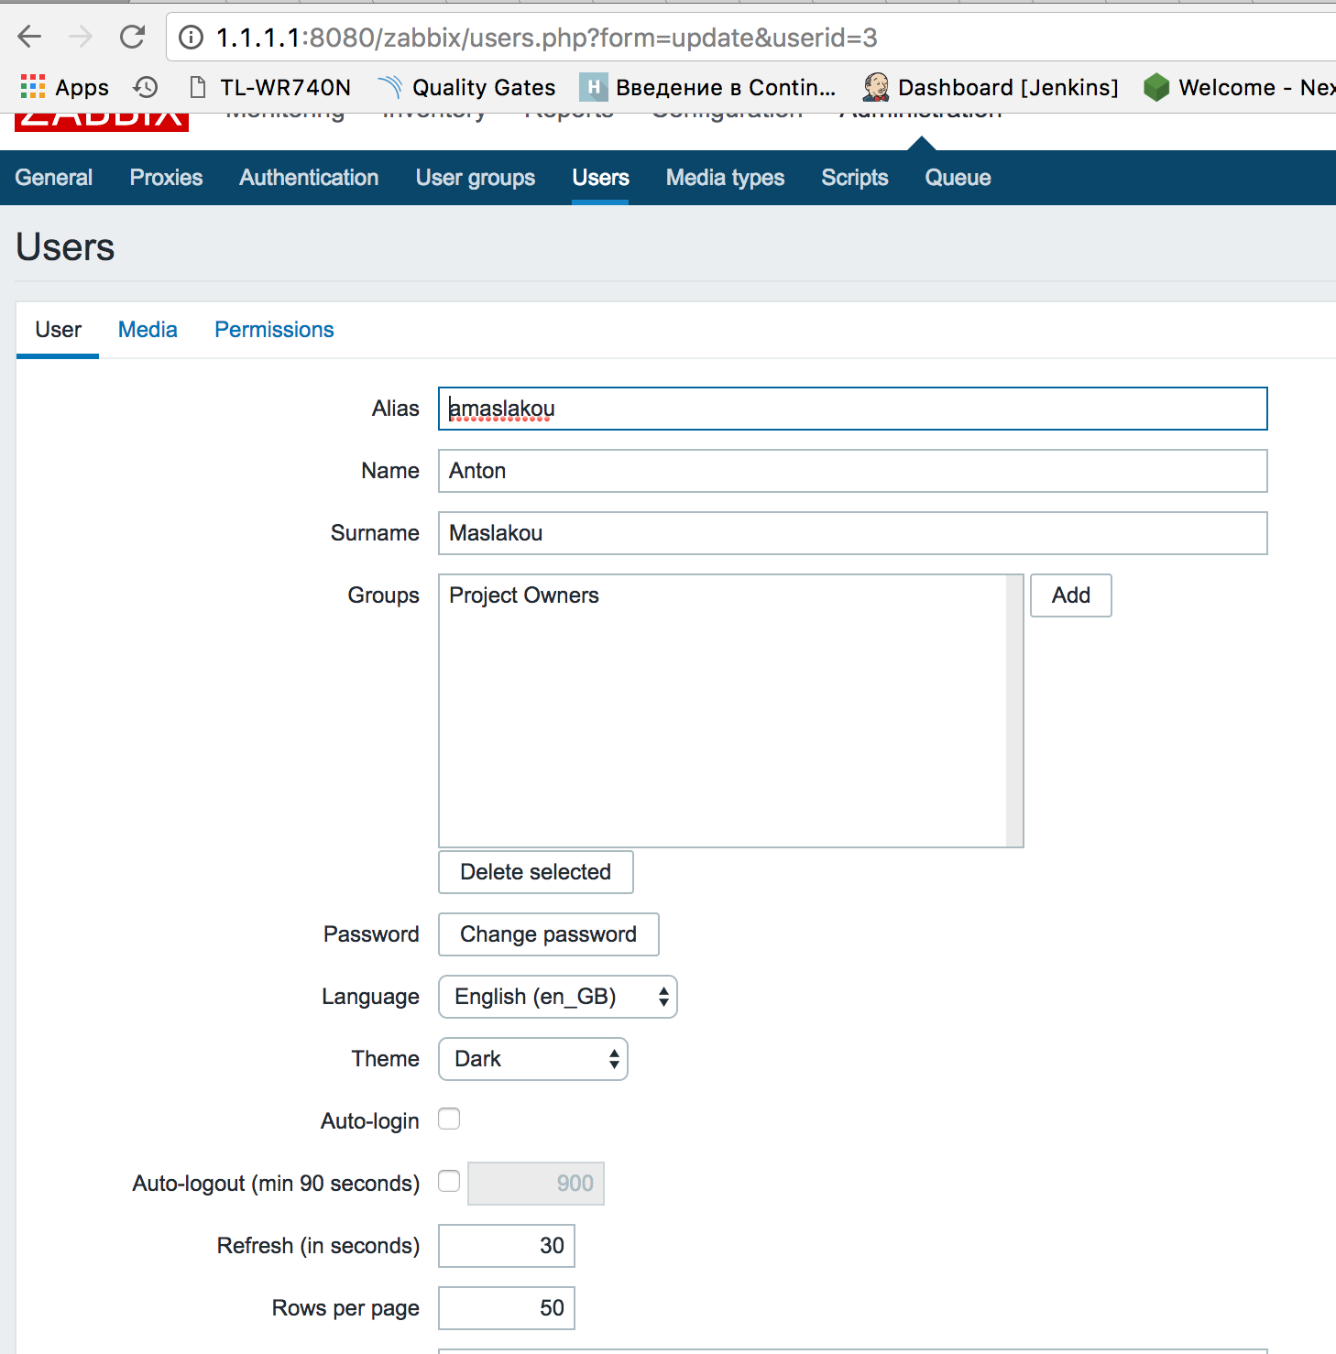

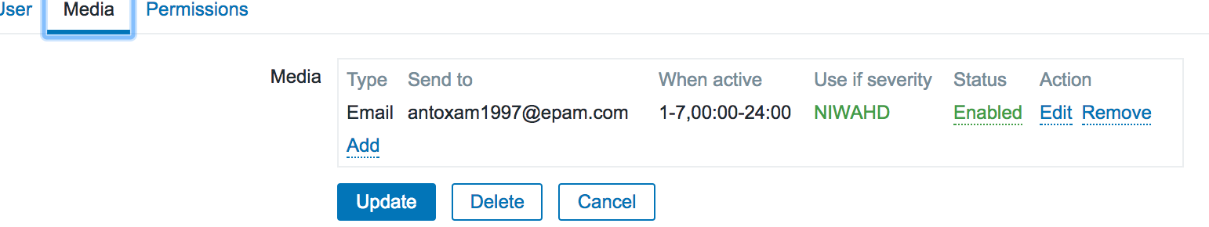

* + Add 2nd VM to zabbix: create Host group (“Project Hosts”), create Host in this group, enable ZABBIX Agent monitoring

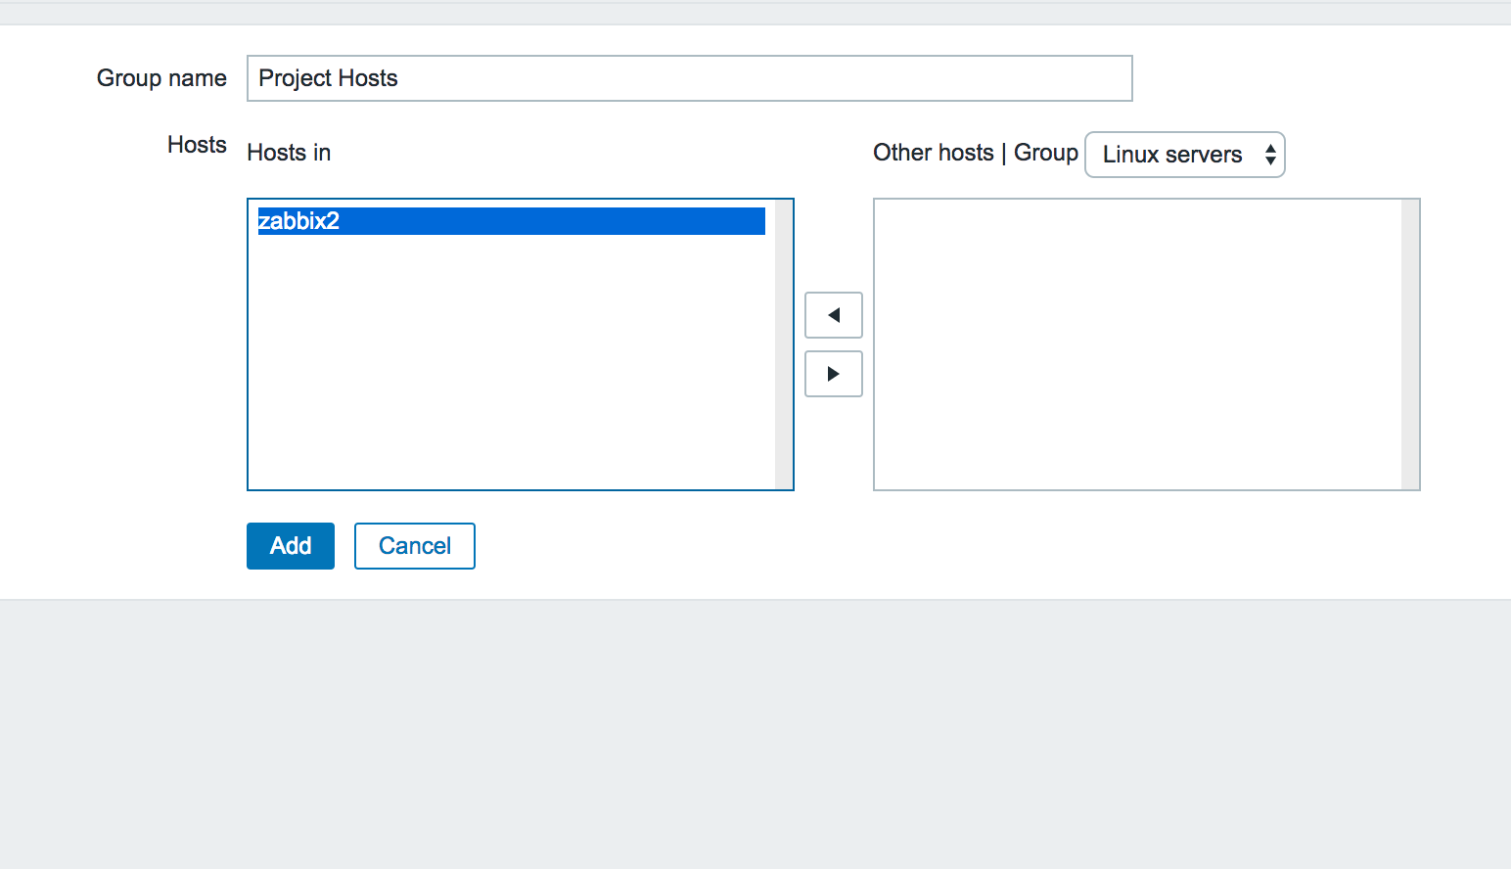

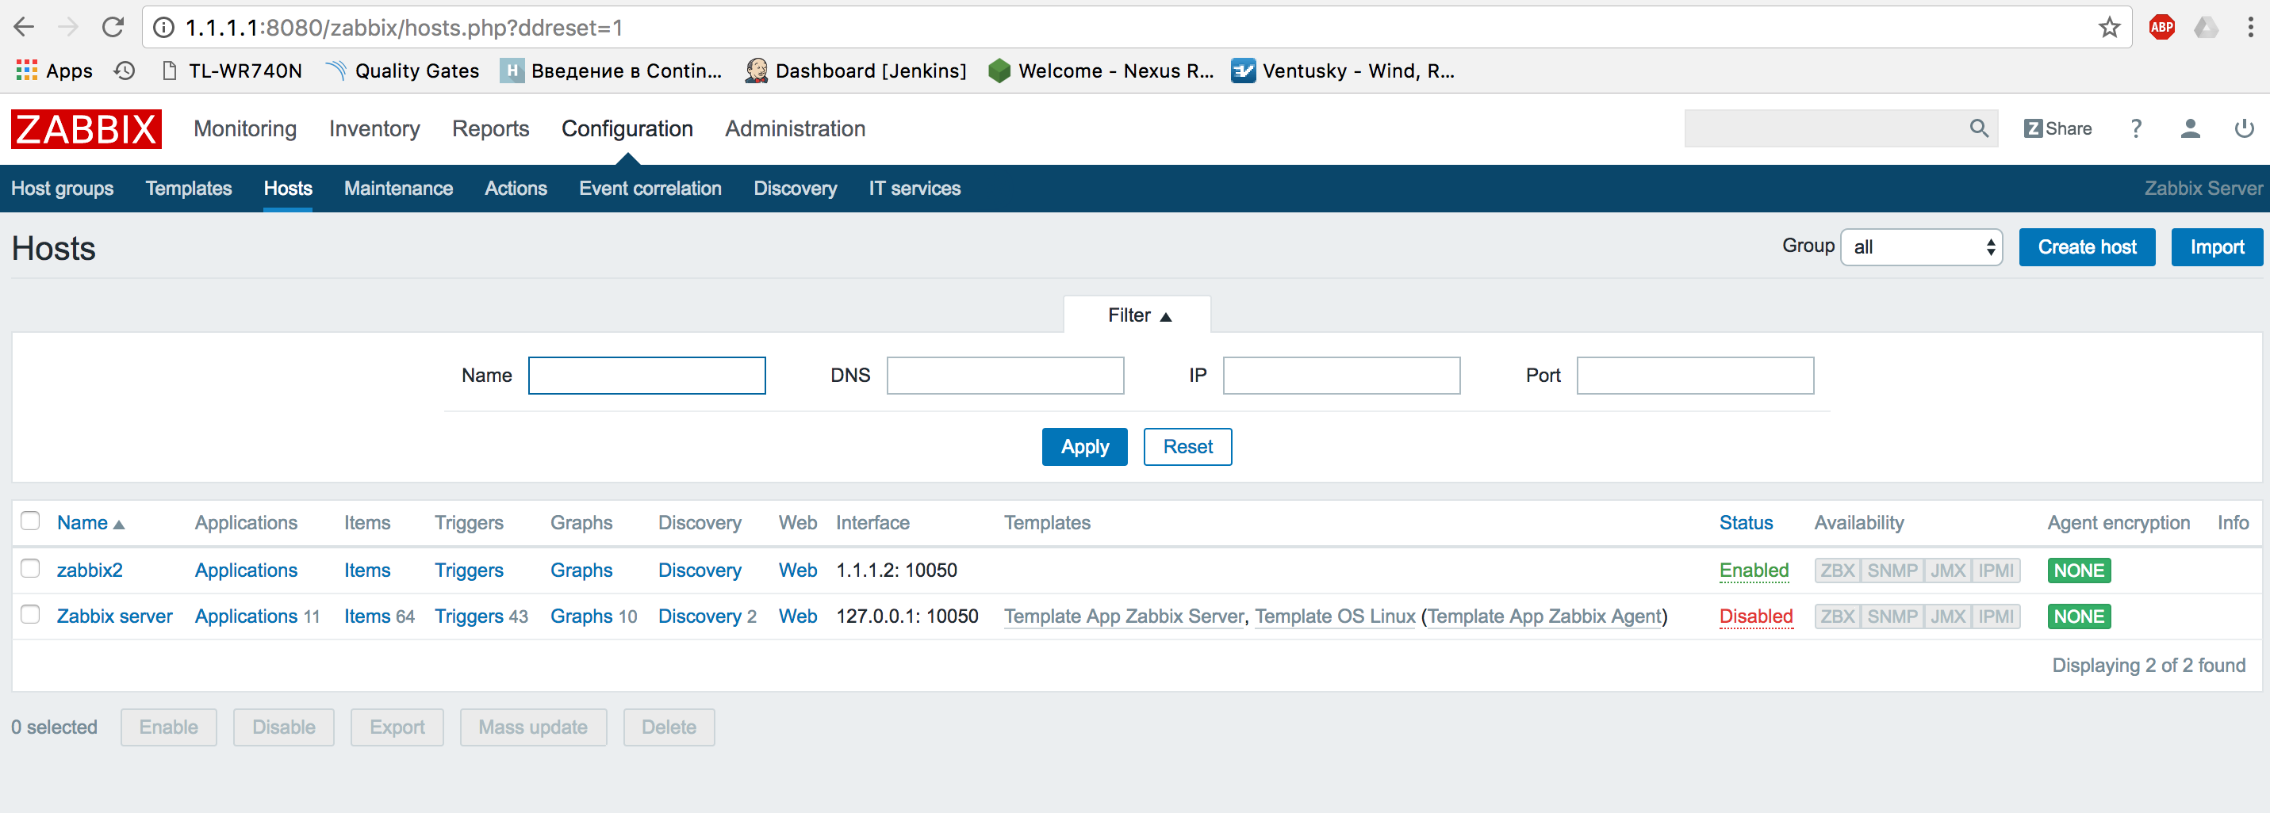

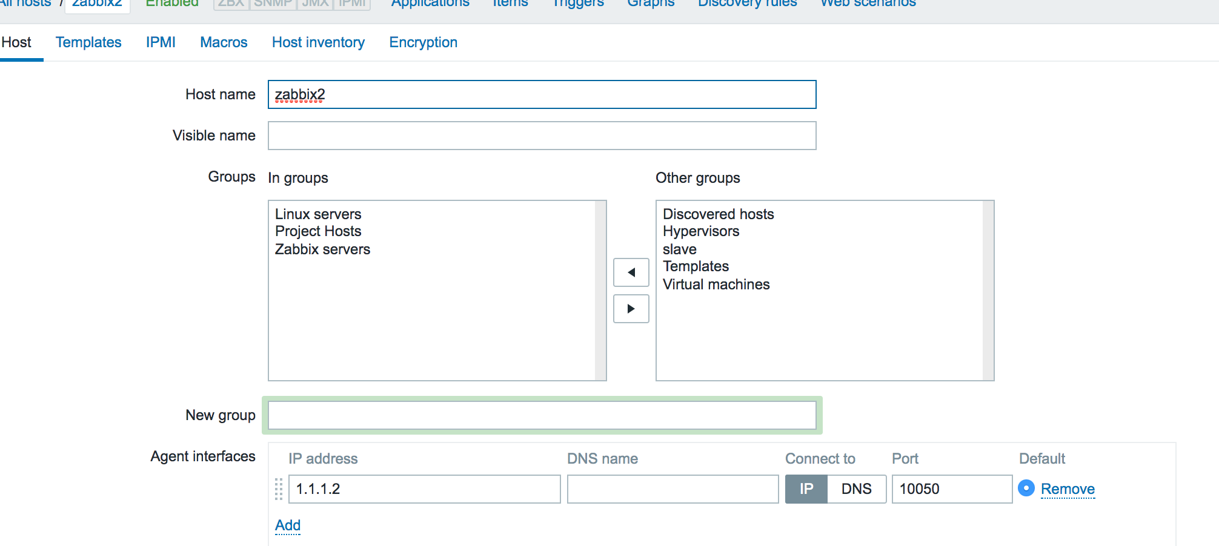

* + Assign to this host template of Linux

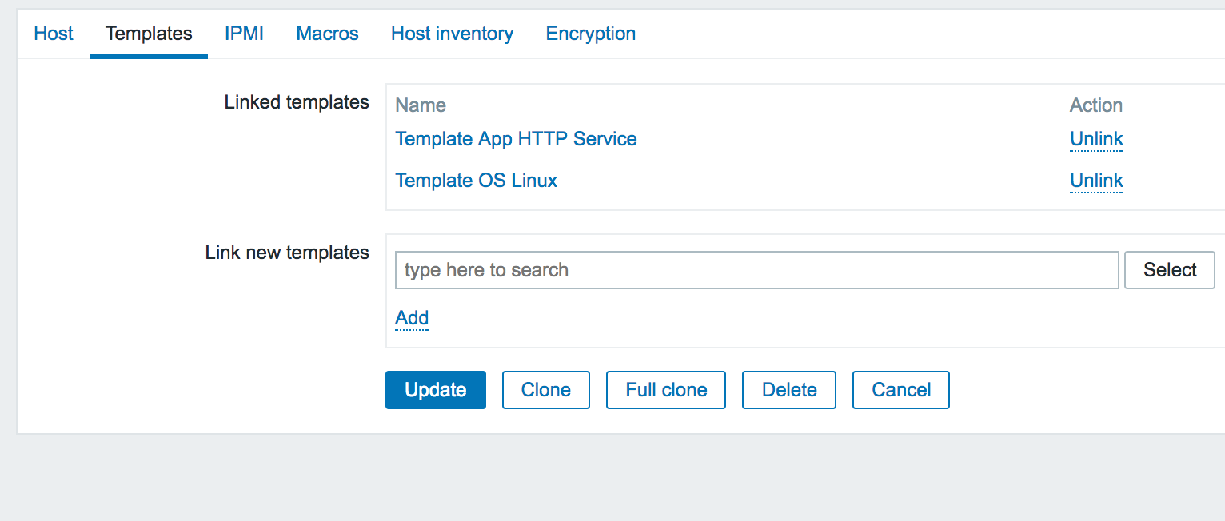



* + Create custom checks (CPU Load, Memory load, Free space on file systems, Network load)

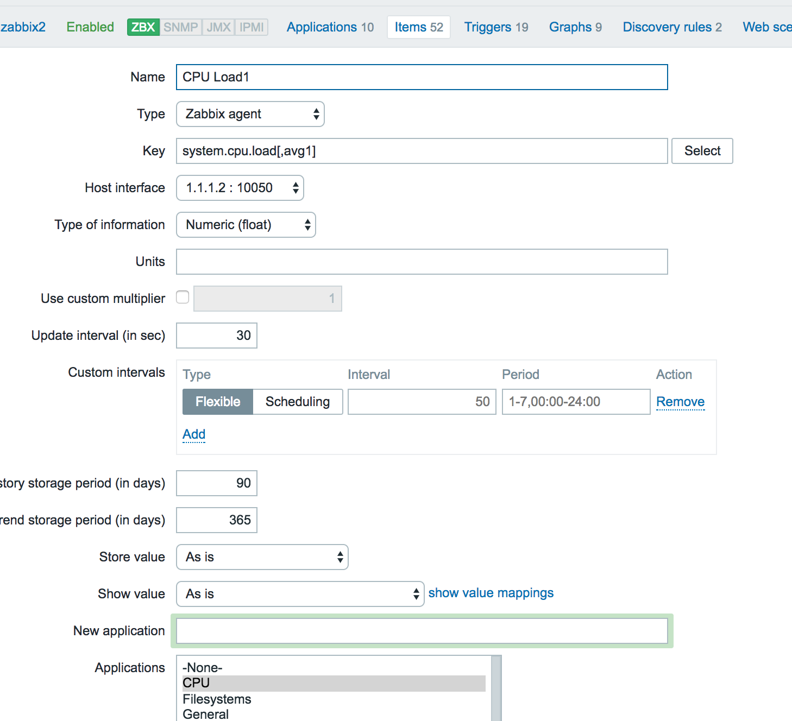

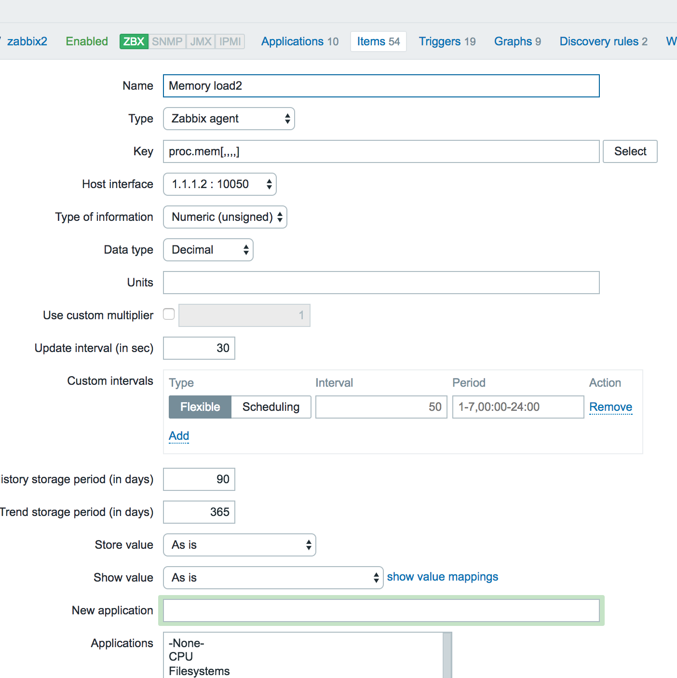

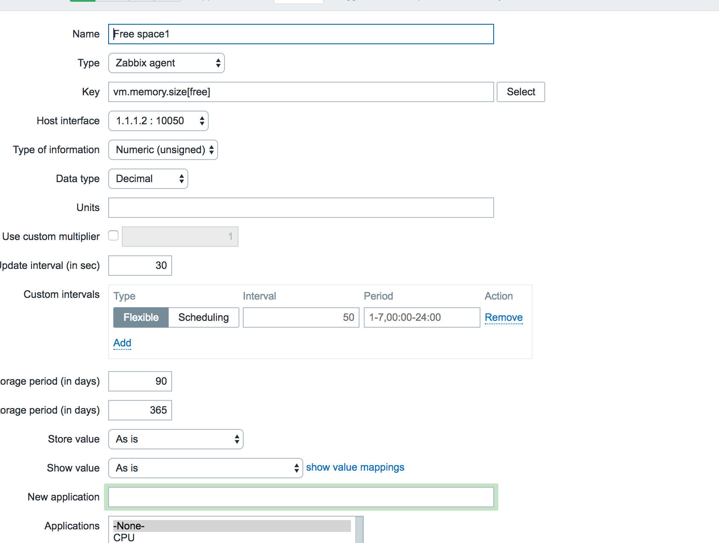

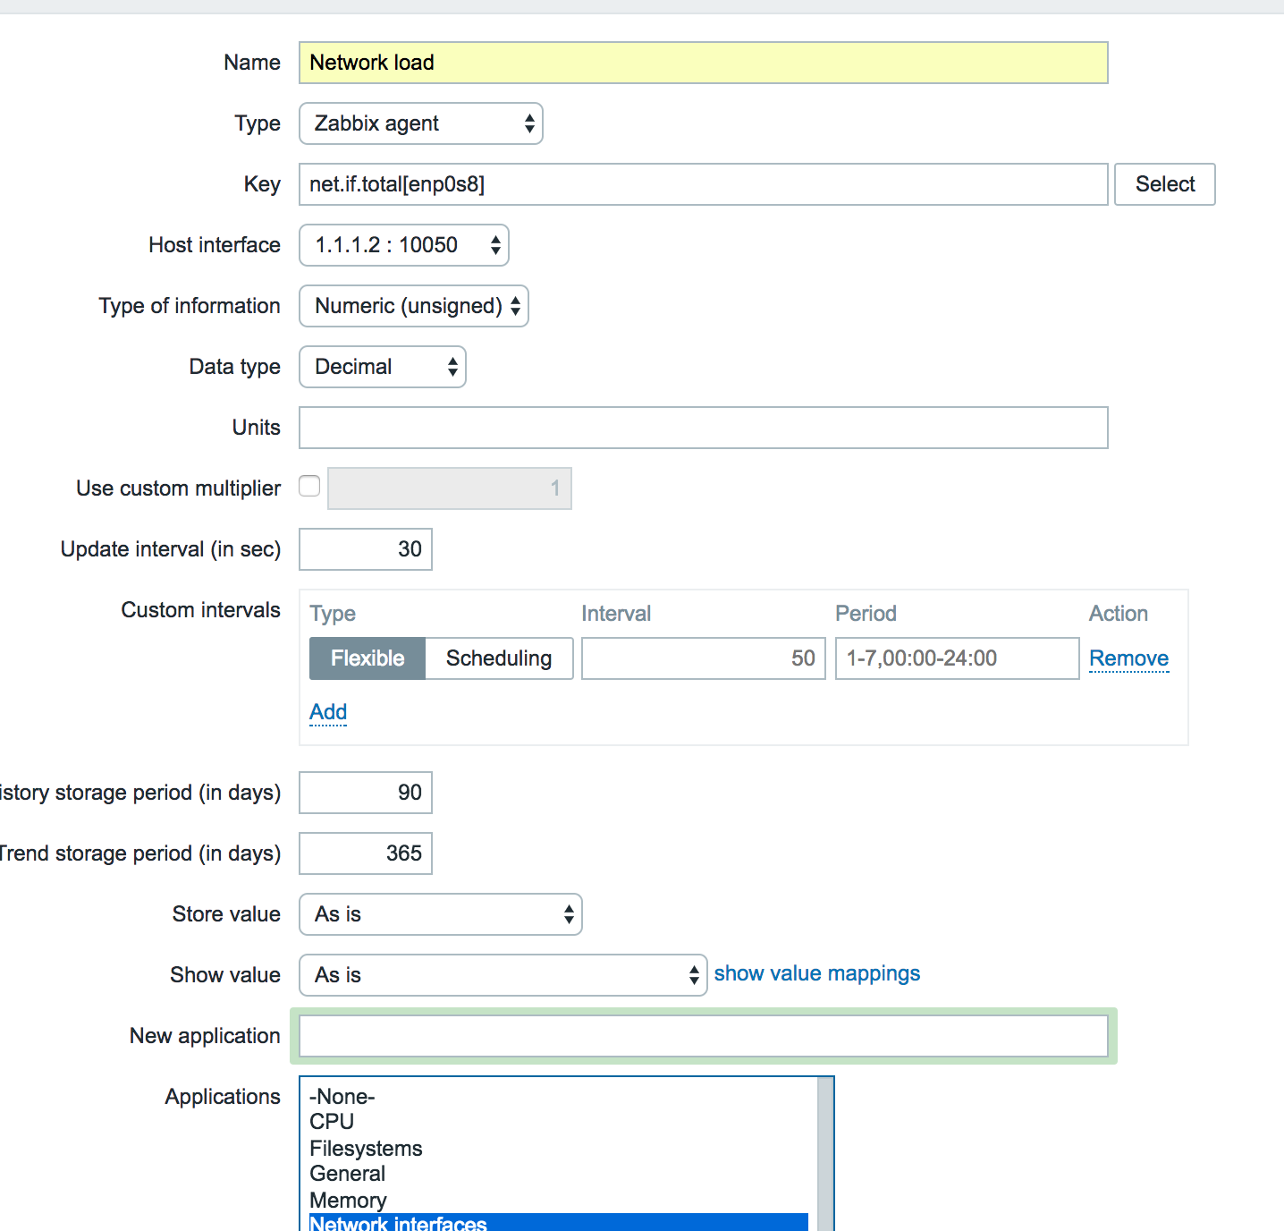

* + Create trigger with Severity HIGH, check if it works (Problem/Recovery)

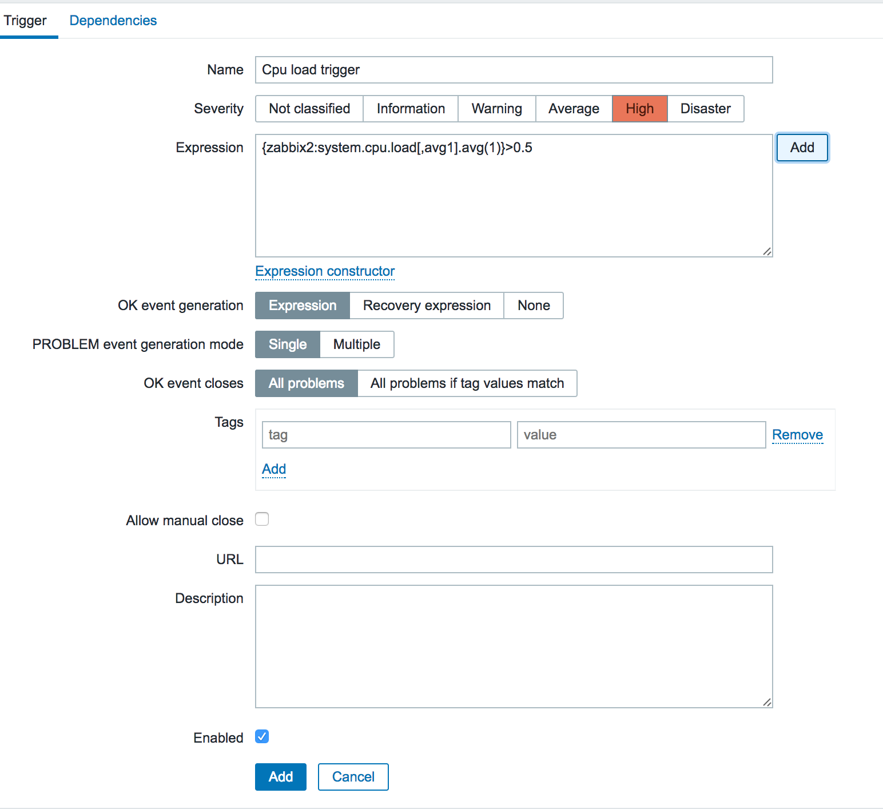



* + Create Action to inform “Project Owners” if HIGH triggers happen

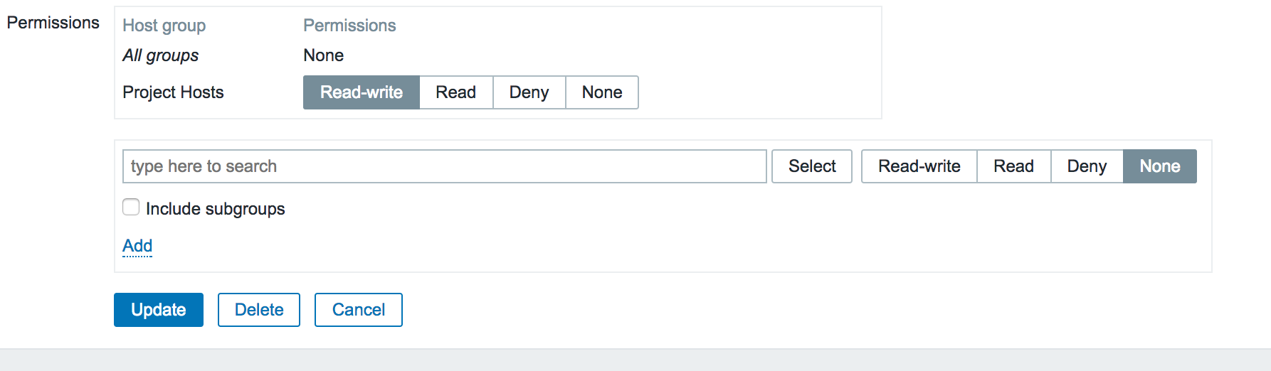

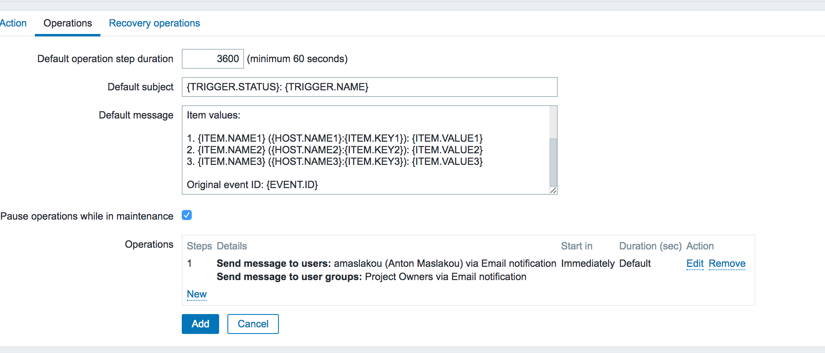

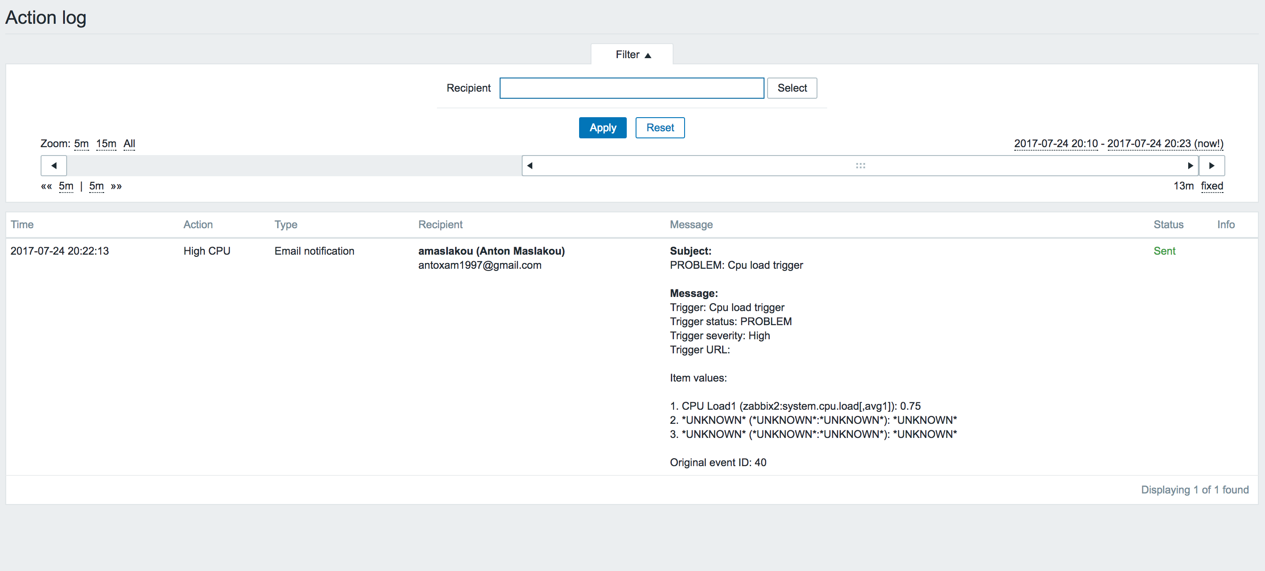

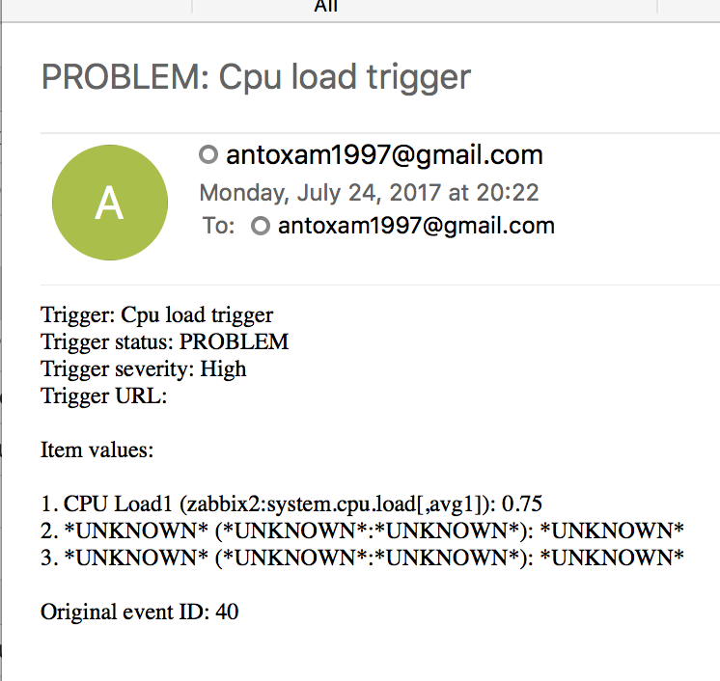

For both VMs use vagrant box “sbeliakou/centos-7.3-x86_64-minimal”

1. **Using Zabbix UI:**
   * Configure “Network discovery” so that, 2nd VM will be joined to Zabbix (group “Project Hosts”, Template “Template OS Linux”)

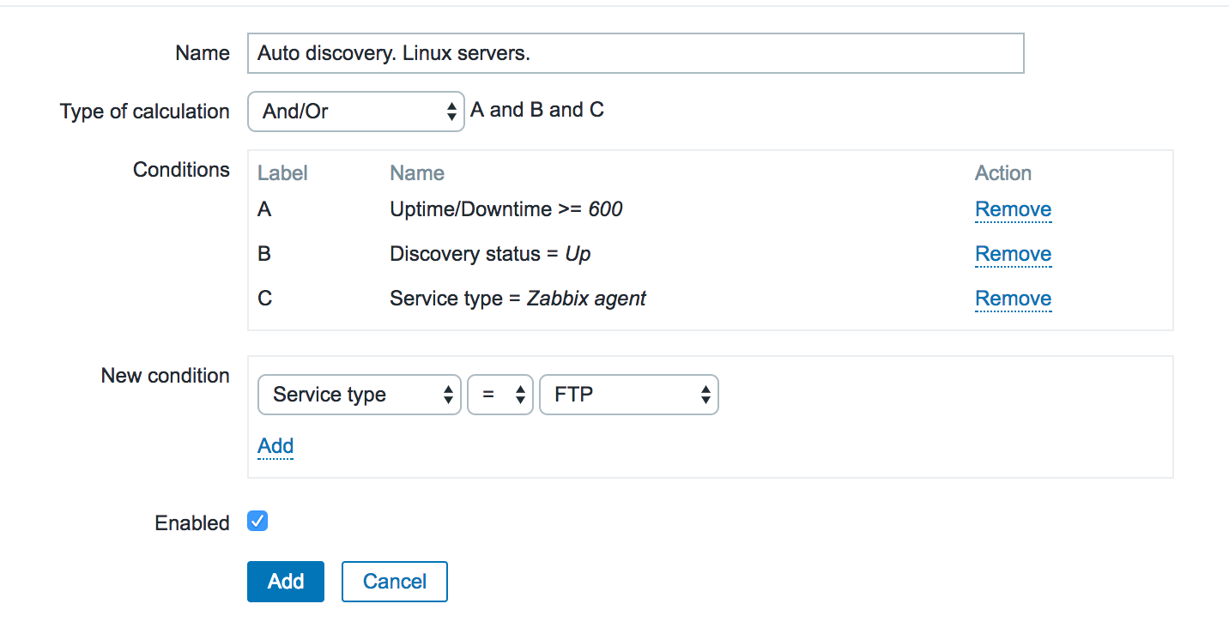

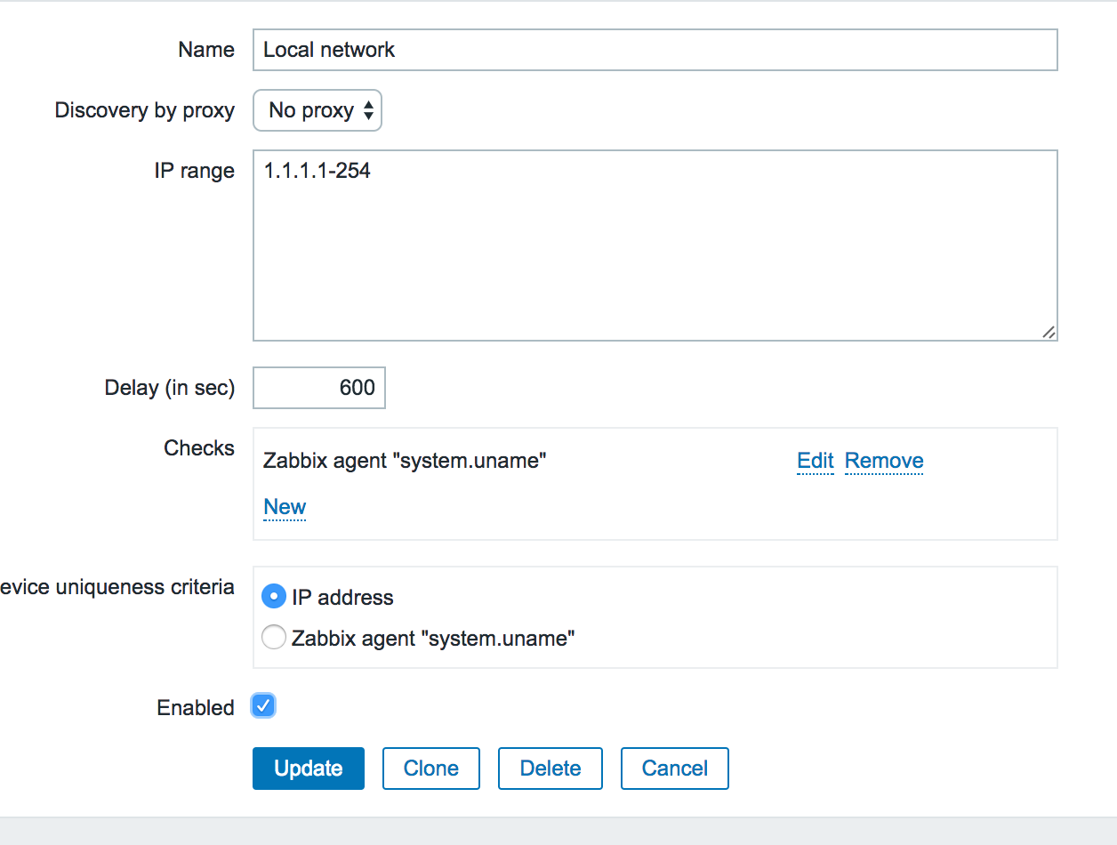

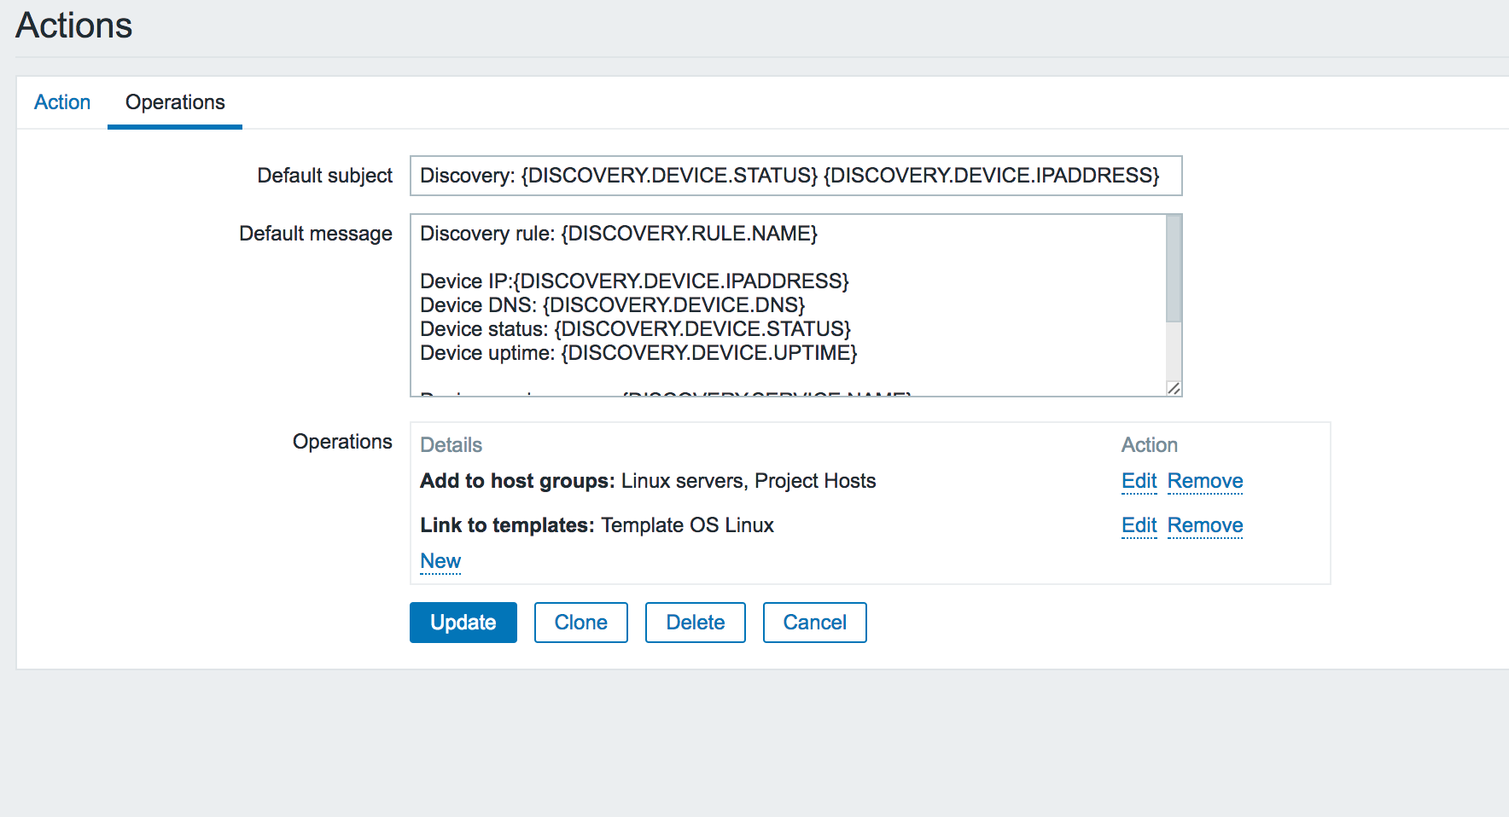

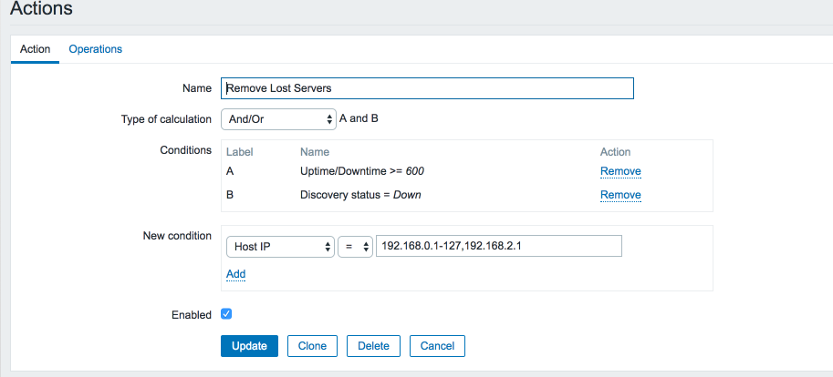

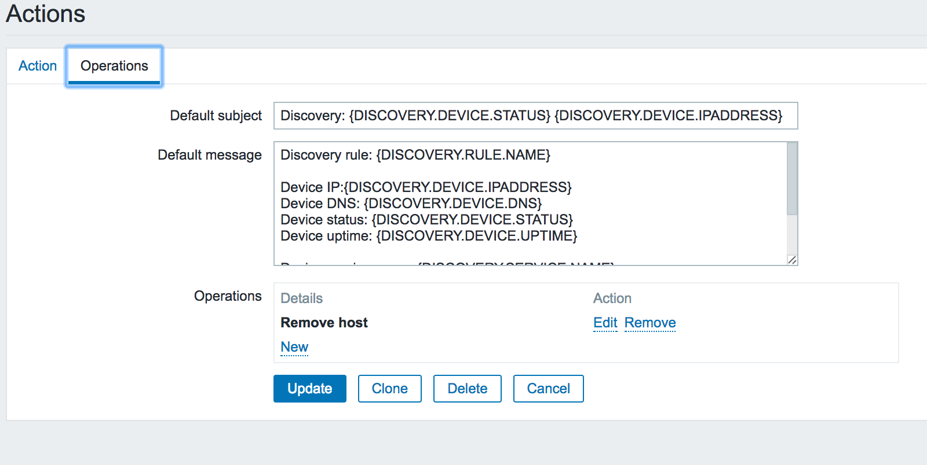

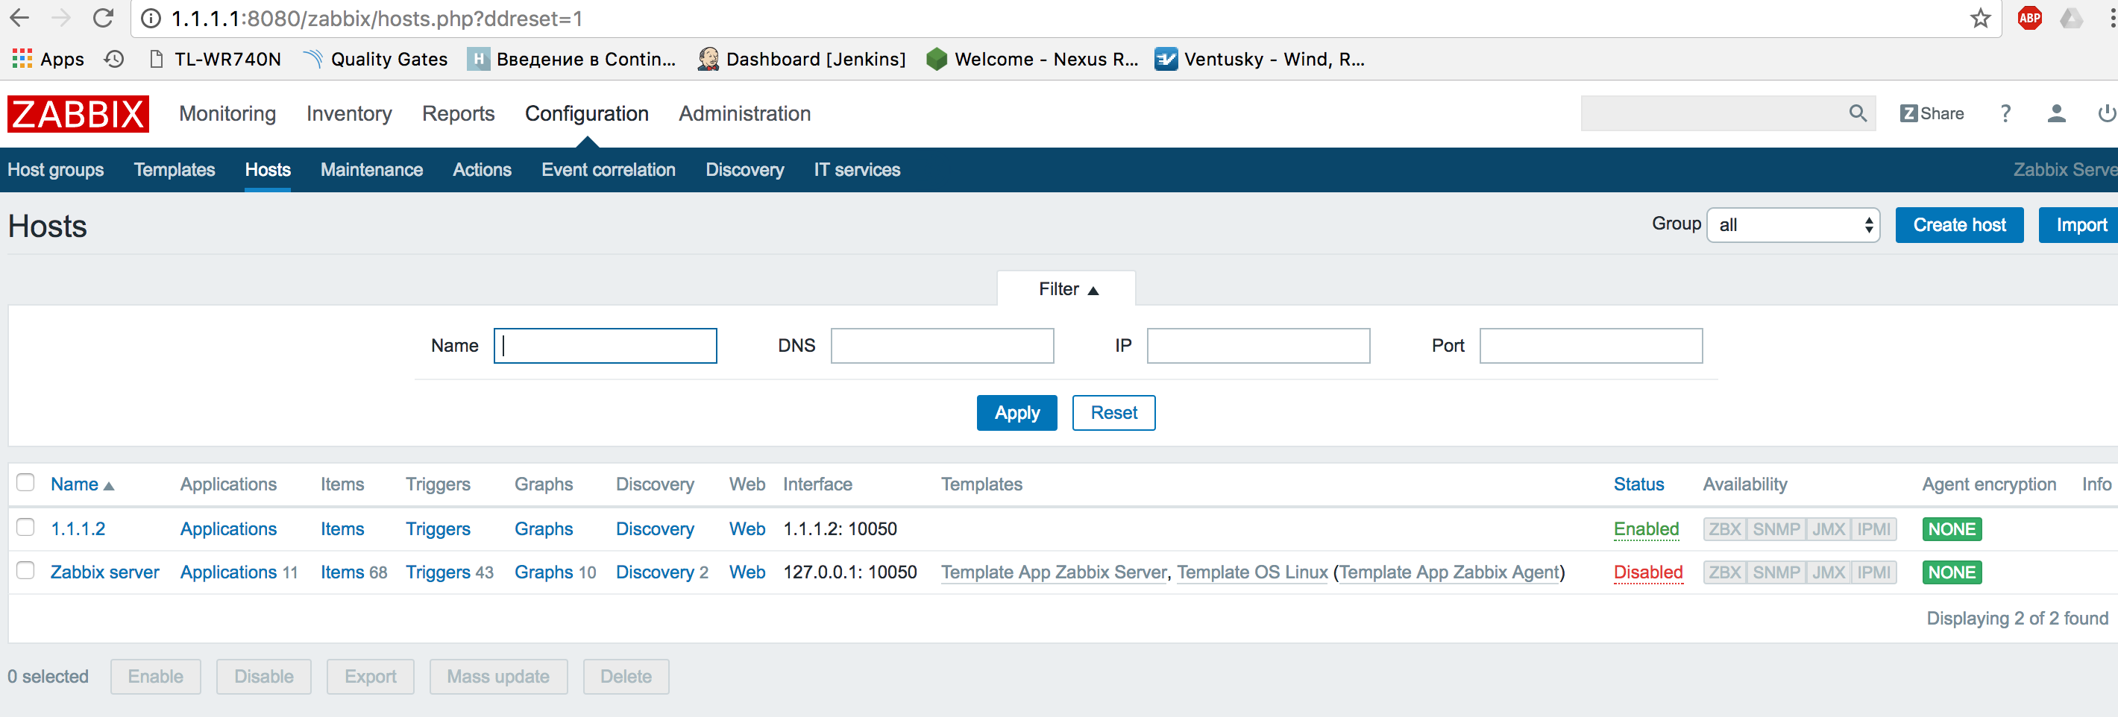

For both VMs use vagrant box “sbeliakou/centos-7.3-x86_64-minimal”

**Task. Zabbix Tools**



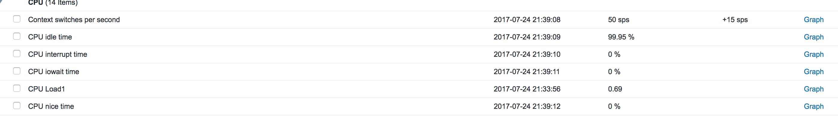

1. Use zabbix_get as data receiver and examine zabbix agent sending’s.

For both VMs use vagrant box “sbeliakou/centos-7.3-x86_64-minimal”

