From MMOS:

“The deliverables we are counting on your contributions for are the following:

- 2.2 Statics of Small Scale Experiments - Deliver statistics on small scale experiment (Yvan + Simon)

- 2.4 Project final report - Final report to be used for dissemination (Greg + Romain)

- 5.3 Platform documentation (Greg + Romain -> sample data sets)

- 5.4 MMOS Platform Game engine and client modules (Greg + Romain -> sample data sets)

- 6.6 Report on small scale experiment (Yvan + Simon)

- 7.1 Dissemination and Communication Report

- 7.3 Report on Project Impact

In this document we are inviting friends/partners/experts and of course consortium members to give a 1-2 page summary/testimonials on what they think about the role of our project in scientific research, what value does it bring, what is the business rationale, how do you see the long term perspectives of such initiatives, what do you expect from such a special setup: science in videogames etc.

Could you please write a couple of paragraphs as persons being very active in citizen science for many years (the deadline would be 15th June)”

+

“In view of the end of GAPARS, I would like to have a short activity report for the final report of the project. This is in addition to the financial report (my email earlier today), to the impact statement (email by Attila last week) and to deliverable.

In the short activity report (1-2 pages), please describe the activities of MNHN in WP6 (small scale experiments). Feel free to add any activity related to the project, even loosely (for instance the relation with CCP or other citizen science activities, outreach, etc..)

Also, Attila will collect all the dissemination, publication, and communication efforts (as a list of items) linked with the project.

I would like to receive these documents by June 20, 2019”

# 2.2 Statics of Small Scale Experiments - Deliver statistics on small scale experiment

The “Galaxy platform” small scale experiment was conducting through 2 different steps: 1. investigate the creation of a game-based user interface to access Galaxy platform “objects” (scientific datasets, tools, workflows) and 2. investigate the use of Galaxy as a massively multi-user online scientific platform

1/ Game-based Galaxy user interface (GGUI)

In order to develop the Game-based Galaxy user interface, 4 high school teachers were included in the construction process of the interface and were the first to test the GGUI (they are teaching to ca. 600 high school students). In the medium term the interface will be deployed in the high school classes participating to the citizen science program Vigie-Nature Ecole (268 schools an c.a. 8000 high school students in 2019) and to all participants of our citizen science programs. In the long term, we will make this interface available to all high schools in France (ca. 6 000 000 high school students).

2/ Galaxy as a massively multi-user online scientific platform

From usegalaxy.eu stats

- The mean is 4285 jobs / day so potentially 4285 MMOS tasks a day, 5 409 912 jobs on this Galaxy instance until now –for more than 300 years combined CPU time

- 9 Millions research datasets

- 6503 registered (possibility to use the platform without registration) data analysis expert users who can be invited to analyse complex tasks from MMOS projects such as genome assembly, differential gene expression between batchs of samples (treated vs non-treated), protein identification on mass spectrometry based data, metabolites identification on mass spectrometry or nuclear magnetic resonance based data, metagenomics sample analysis, ...Globalement nous sommes au dessus en terme de volume pour l'instant si c'est 1-2 pages.

# 6.6 Report on small scale experiment

Task 6.3 Galaxy platform ‘objects’ development for Citizen Science and gamification.

The ‘Galaxy platform’ small scale experiment was conducting through 2 different steps: 1. investigate the creation of a game-based user interface to access Galaxy platform ‘objects’ (scientific datasets, tools, workflows) and 2. investigate the use of Galaxy as a massively multi-user online scientific platform

1. Game-based Galaxy user interface (GGUI ?)

a) A first pure development phase was corresponding to testing the use of the Unity engine to facilitate the creation of game-based graphical user interface to Galaxy scientific platform. We demonstrated the technical possibilities to interact with Galaxy “objects” such as datasets, tools and workflows. Unfortunately, a huge amount of effort will be needed to go further taking into account notably user experience to create a complete new graphical user interface based on this technical Unity-Galaxy bridge. Thus, an important collaboration has to be created with game designer and game developer to propose a full project to create such a Unity-based Galaxy interface. Thanks to the GAPARS project, first connections have been made.

b) During the second phase, we investigated others solutions, with existing complete user interfaces, which can be used in combination with Galaxy and which can provide a relevant solution to improve manners data literacy is taught. To do so, based on an existing French Galaxy for Ecology platform we have already developed, this small-scale experiment allowed us to build an access to scientific data, tools and workflows relevant for teachers and their students and a user friendly interface allowing game style development is in progress.

Four teachers involved in our citizen science programs participated to workshops. We provided data from the programs and they could use all the existing software and platforms to start the analysis. We asked them to propose activities and to give us example of the difficulties they had during the process. Our platform (galaxy-E completed with tools specifically designed for the GGUI) was able to treat all the questions raised during the workshop and has open new possibilities has it will provide access to large amount of data and a powerful tool to analyse data.

We then focused on the user experience to propose an innovative gamified user-friendly interface and scenarios.

The gamified interface and scenarios increase the interest of the participants and lift some of the common constraints linked with data literacy education such as complex tools, long formation of the teachers and stimulate the interest for the students and participant as they can directly interact and ‘play’ with the data. The ease of use allows teachers of fields where the of computer is rare to rapidly adapt and to build bridges between fields. Data collection and input can be done during ecology class and data analysis during mathematics and the output of these analysis can be used again in ecology class.

We investigated different existing solutions in order to test a first version of our platform and reduce the time needed for the development. We compared Scratch, BioBlocks, WAVE, Galaksio and NGPhylogeny.

Scratch is a programming language already used to learn how to code in high schools. Users assemble graphical blocks of code together and form programs such as interactive stories, games or animations. This makes it a good candidate to adapt galaxy-E. As the concept of block of code is already present and the interface is already known by teachers and students. We were able to create an extension and we are now in the development phase to link the API of galaxy and scratch.

We also tried the use of bioBlocks which is based on Scratch but designed to help the preparation of protocols. This solution was abandoned as the project is not supported anymore.

Others solutions we tested were developed for research purpose and already included a link with galaxy and a simplified interface that we can modify toward our GGUI project. The solutions we tested are WAVE, Galaksio and NGPhylogeny.fr. We chose NGPhylogeny.fr as it was the most recent and seemed to be be most flexible in term of interface and tools we can use. We started a collaboration with the development team in the ‘Institut Pasteur’ and deployed our own NGPhylogeny.fr instance.

2. Galaxy as a massively multi-user online scientific platform

Currently, MMOS API is used in 2 main different manners to serve scientific data and analytic tools to different communities: (i) using Games as a front-end to access gamers and (ii) using MOOCS to access learners. Here we want to investigate the use of Galaxy as a massively multi-user online scientific platform. To give access to a multitude of scientific data, tools and workflows, the aim was to create connections between the MMOS system and the Galaxy Platform. Galaxy is a web platform allowing users to execute scientific tools and workflows on shared and/or on their own data with access to high performance computing facilities, without having computing science and/or programming skills. For now, it exists a huge community of contributors and users, and Galaxy instances are deployed and administrated all over the world. Three « main » Galaxy instance are publicly available, the US usegalaxy.org, the European usegalaxy.eu and the Australian usegalaxy.au. From these international main instances, the user can access thousands of tools, hundreds of workflows and To of reference datasets. The French Museum (MNHN) has strong links with the European instance who is now, thanks in part to the GAPARS project, hosting the international Galaxy-E (for Ecology) instance <https://ecology.usegalaxy.eu/>. In this small-scale experiment, connections has been established between our Galaxy-E instance with MMOS using both Galaxy and MMOS API. Tests will be made to create such links between the European usegalaxy.eu instance and MMOS.

Finally, small scale experiment deliverables will consist in the documentations and a « Galaxybricks» POC using our national Galaxy-E instance and/or the European usegalaxy.eu instance.

Pour la Galaxybricks POC, on peut déjà mettre en avant 1/ Galaxy tout court + 2/ un wireframe de ce qu’on va faire avec Scratch + 3/ un wireframe de ce qu’on va faire avec NGPhylogeny….

We propose a simplified activity using our citizen scicence program SPIPoll (Photograhic monitoring of pollinators). In this example, we will import biodiversity data and then climatic data linked to the location of our initial data. We will perform a small data treatement (calculate mean and standart deviation), plot the data and use linear regression to test the relation between to variables.

We give examples of the two interfaces we selected for further development.

1. Wireframe of the future interface using NGPhylogeny.fr

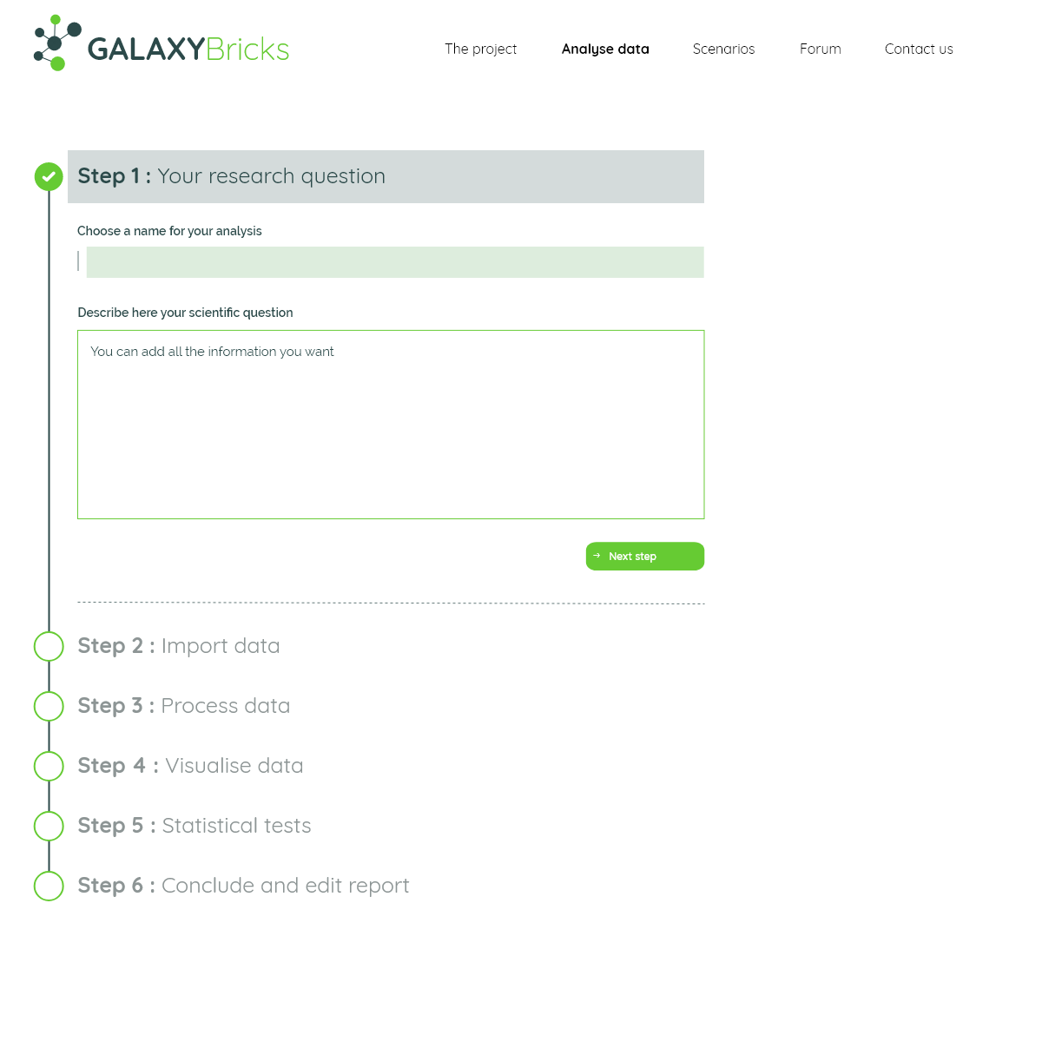

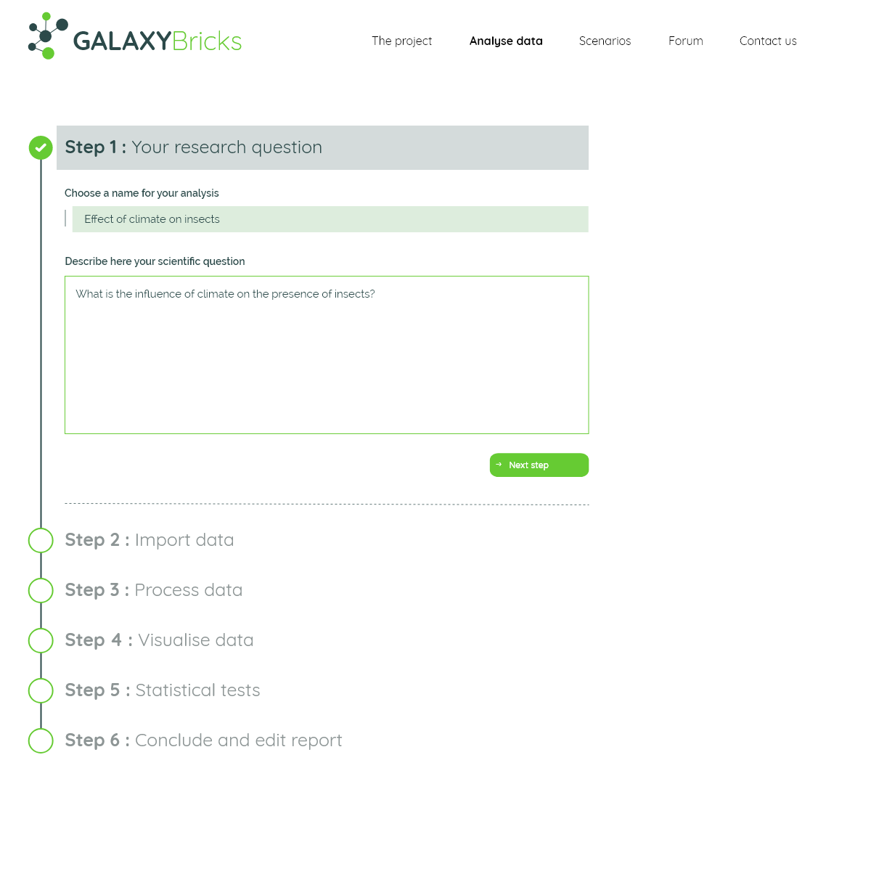

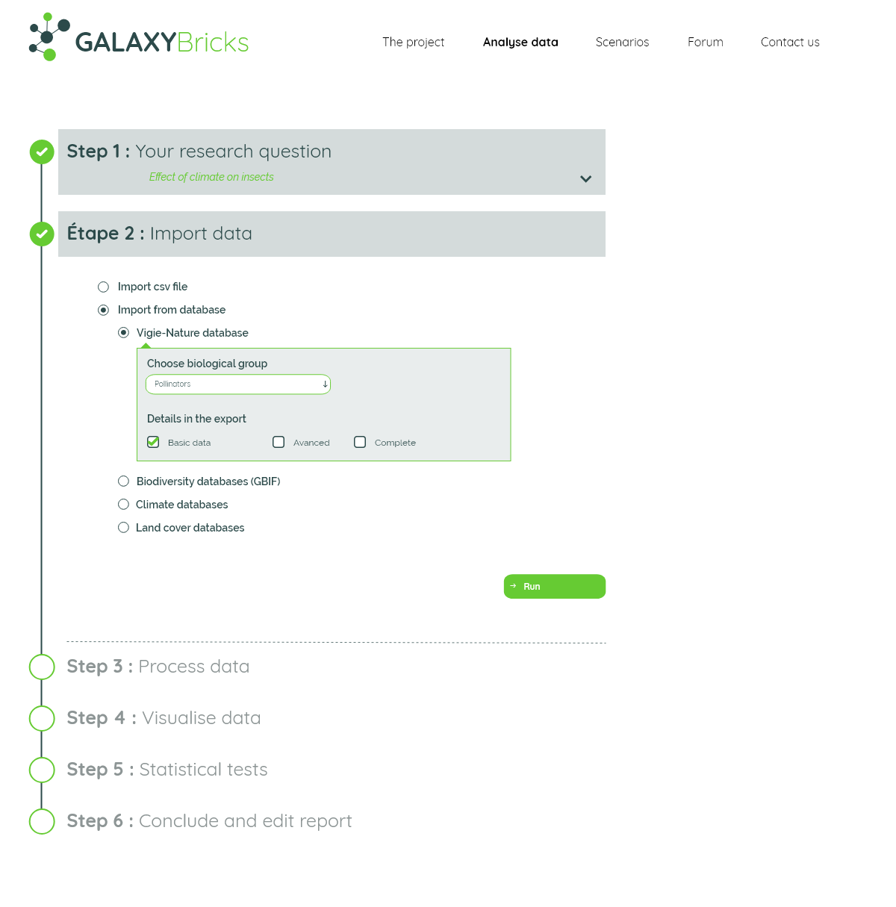

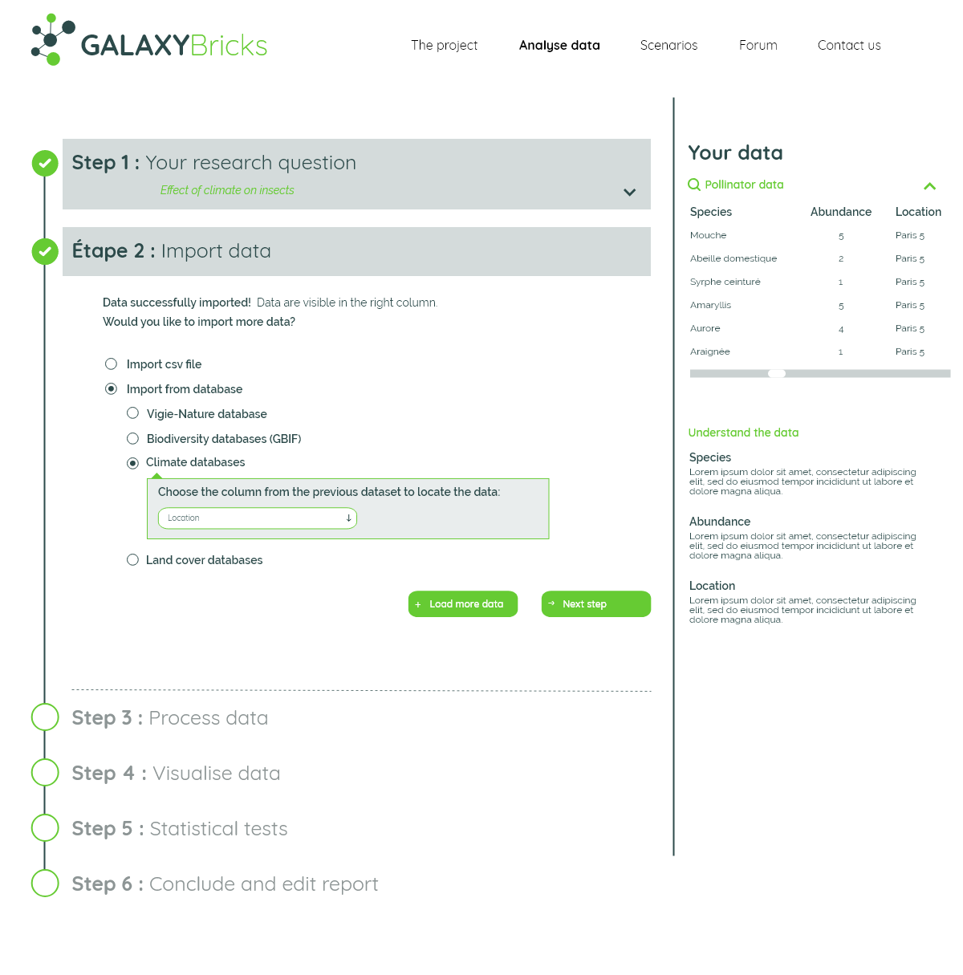

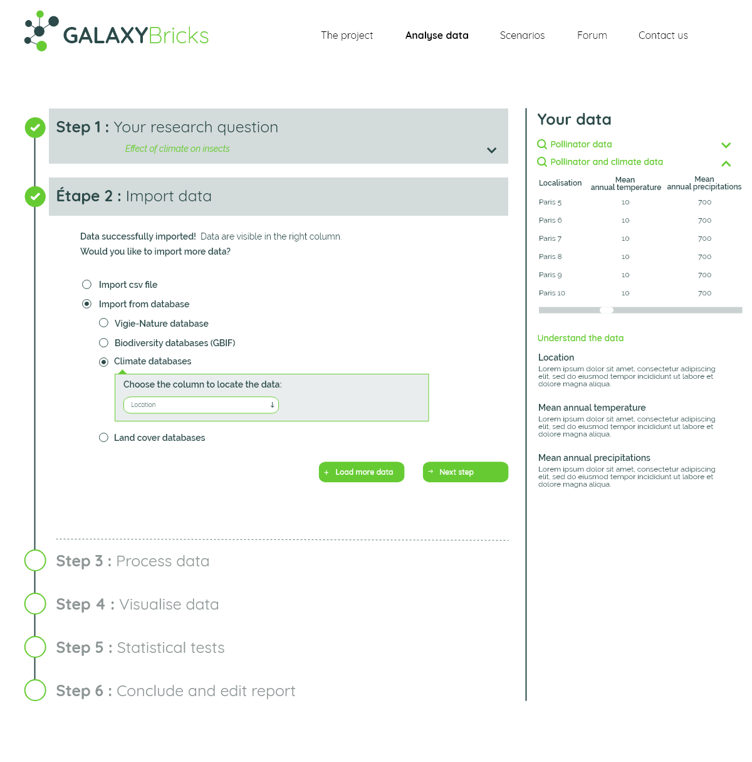

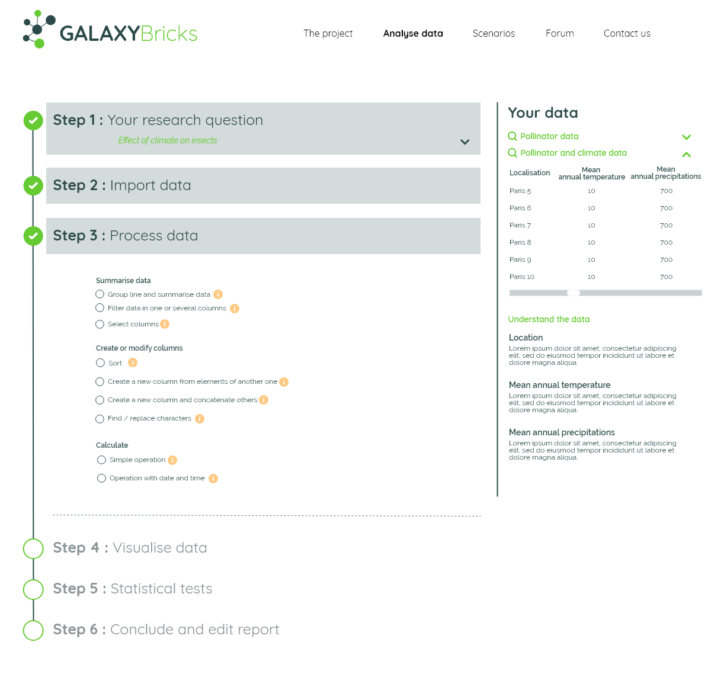

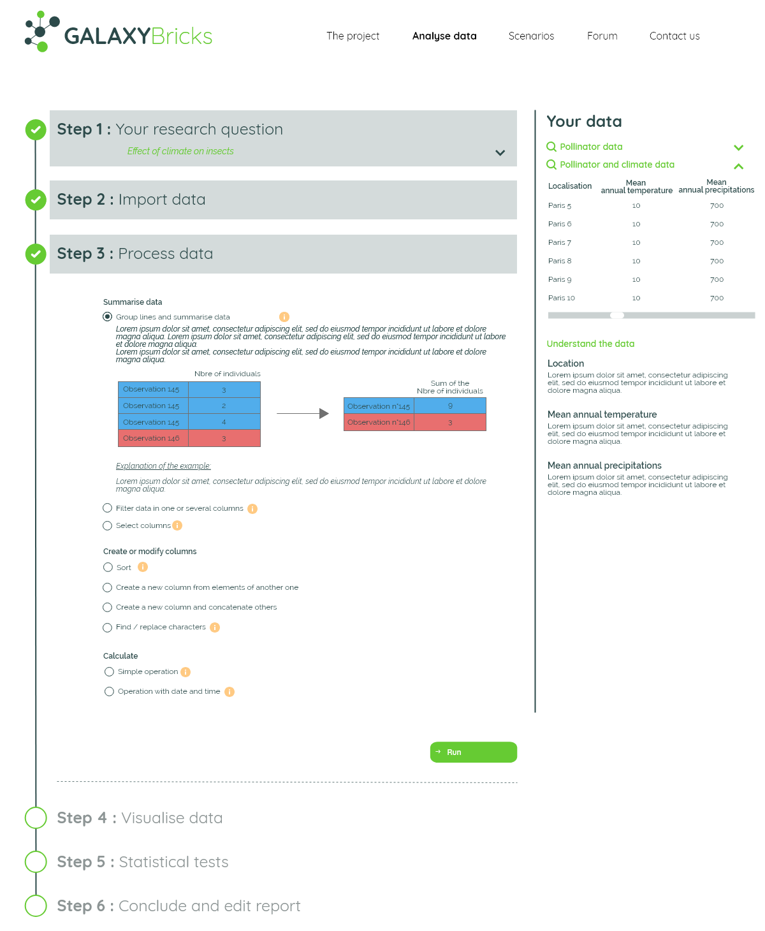

# 

# 

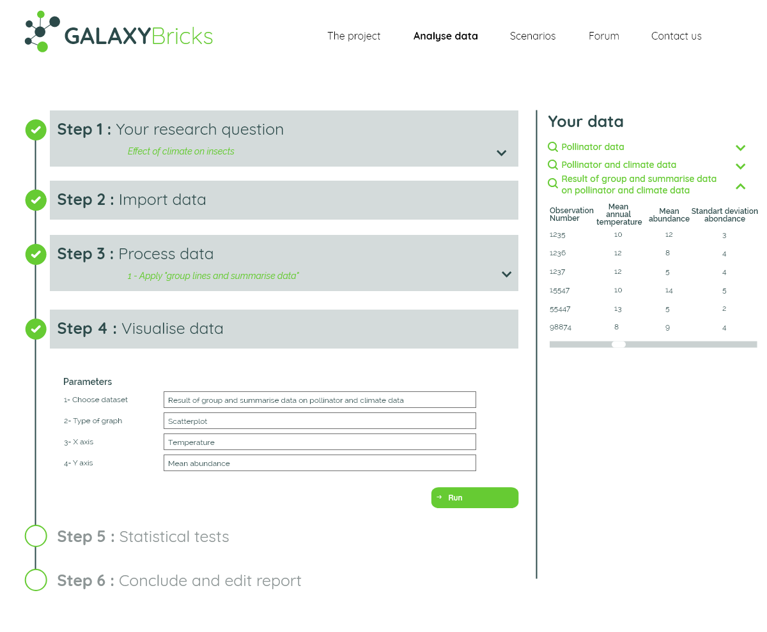

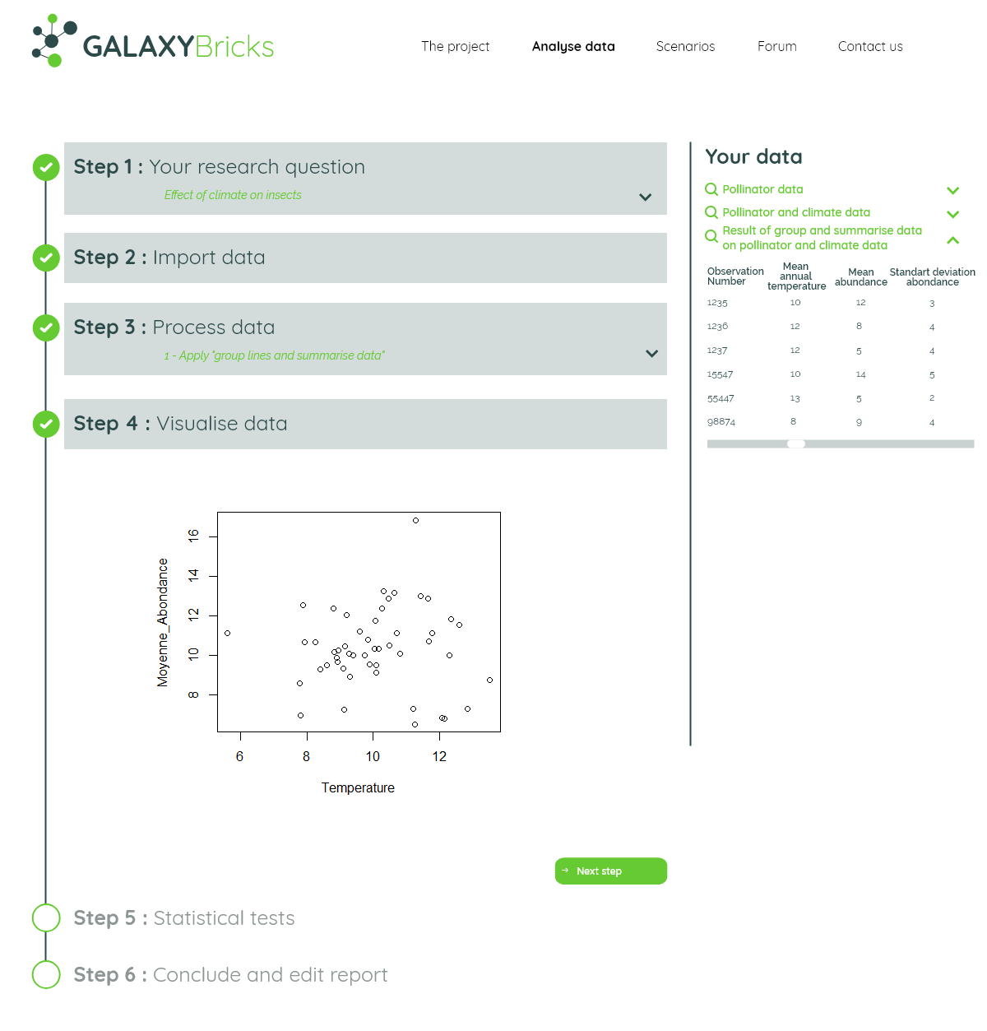

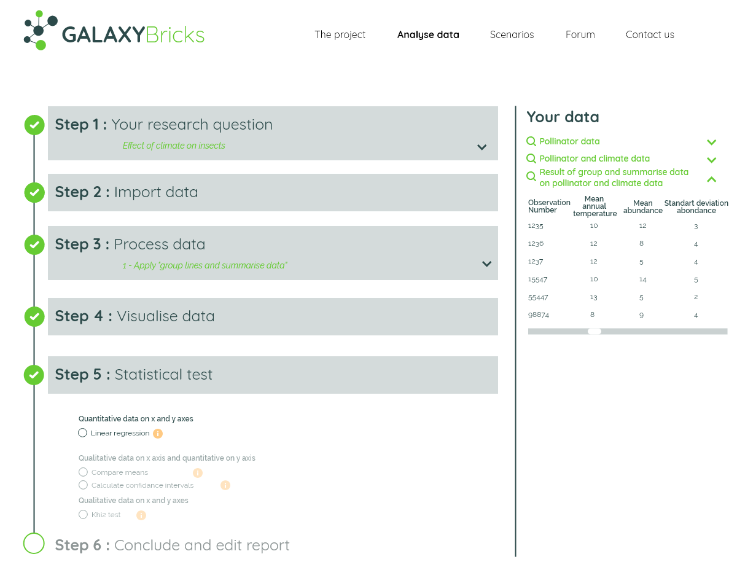



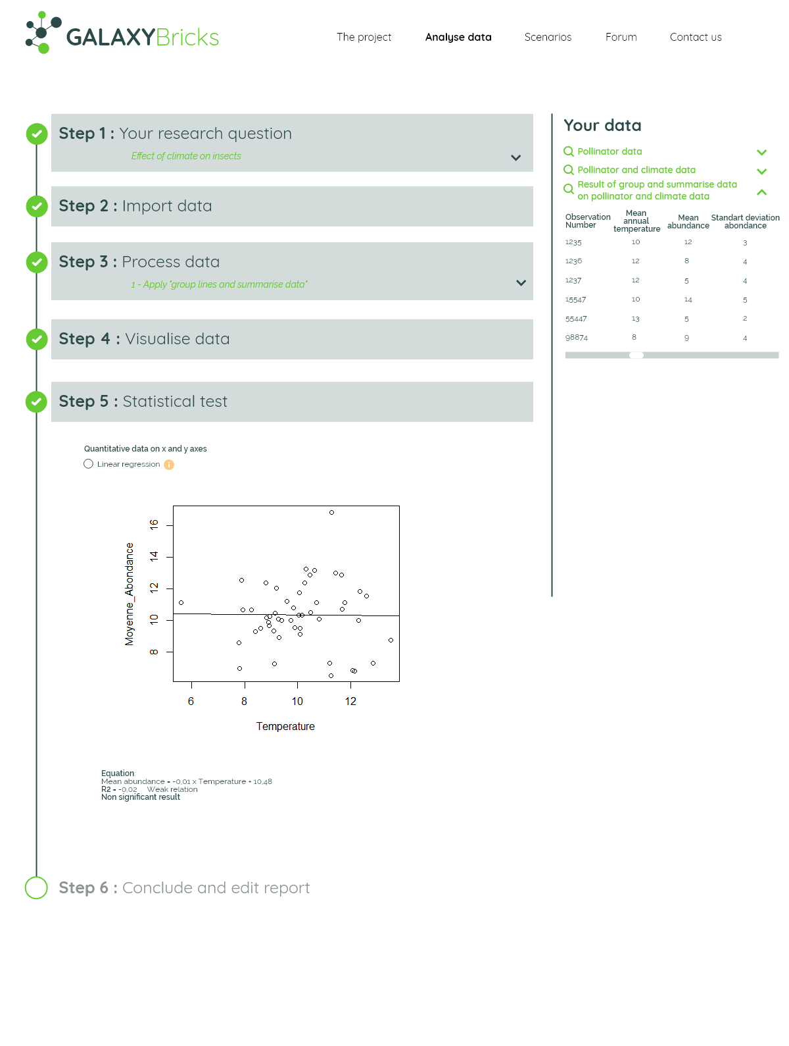

2. Wireframe using Scratch

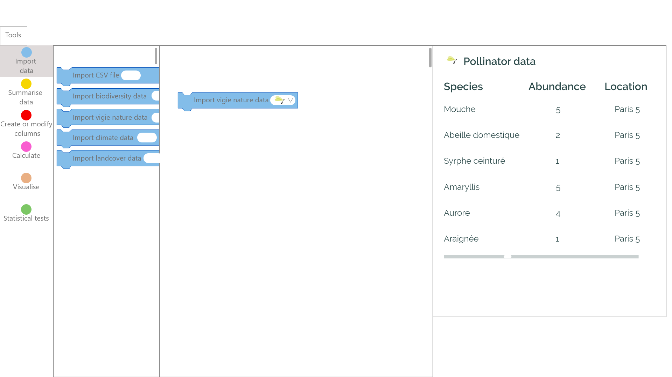

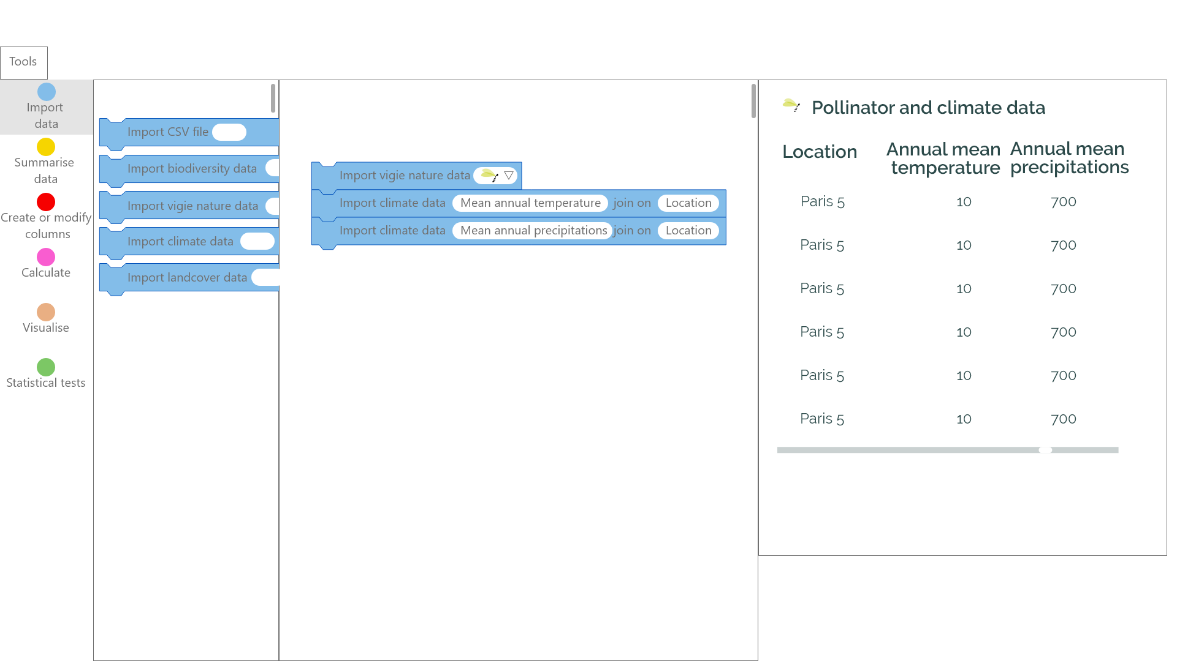

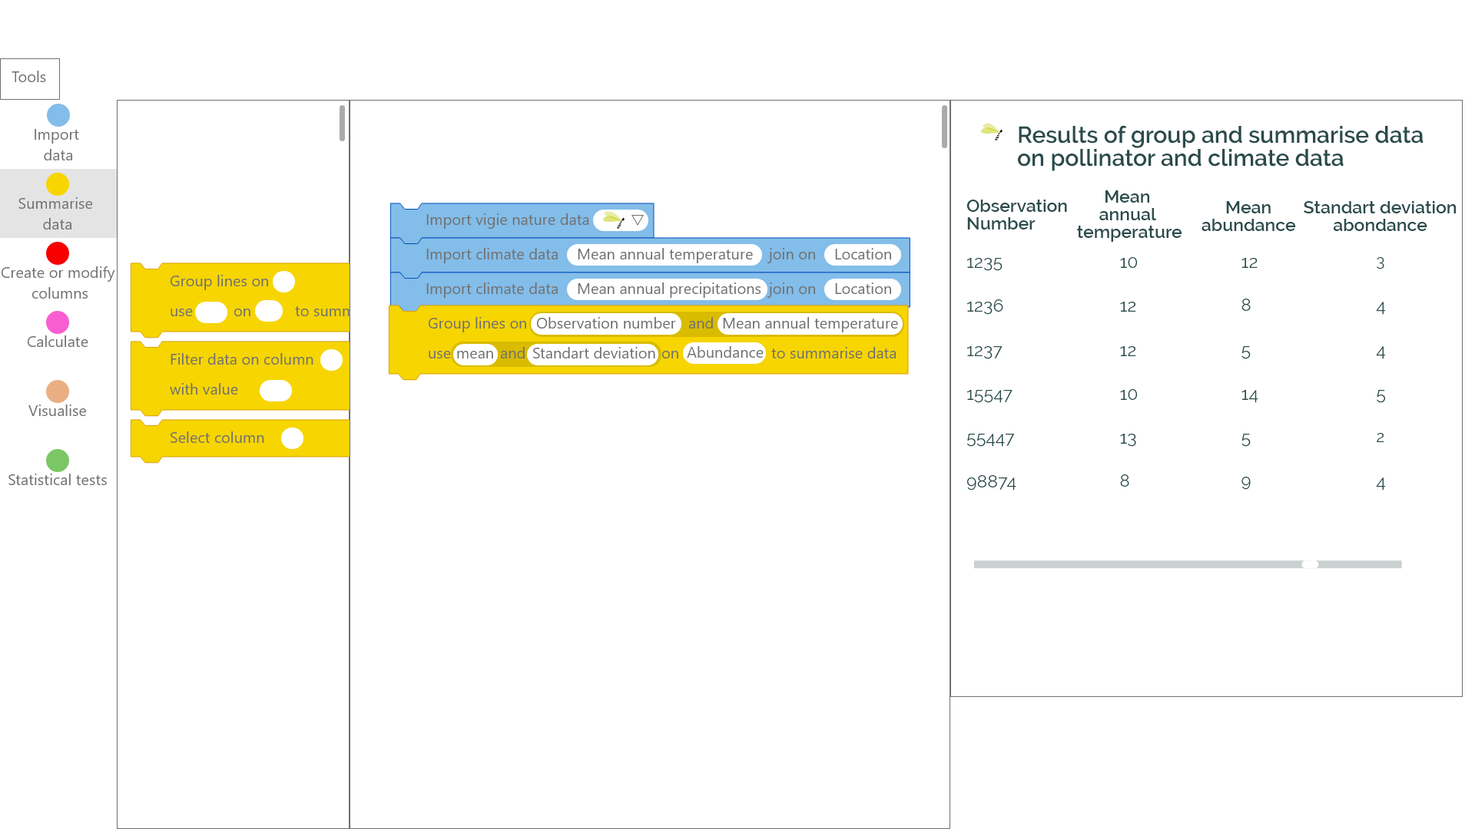

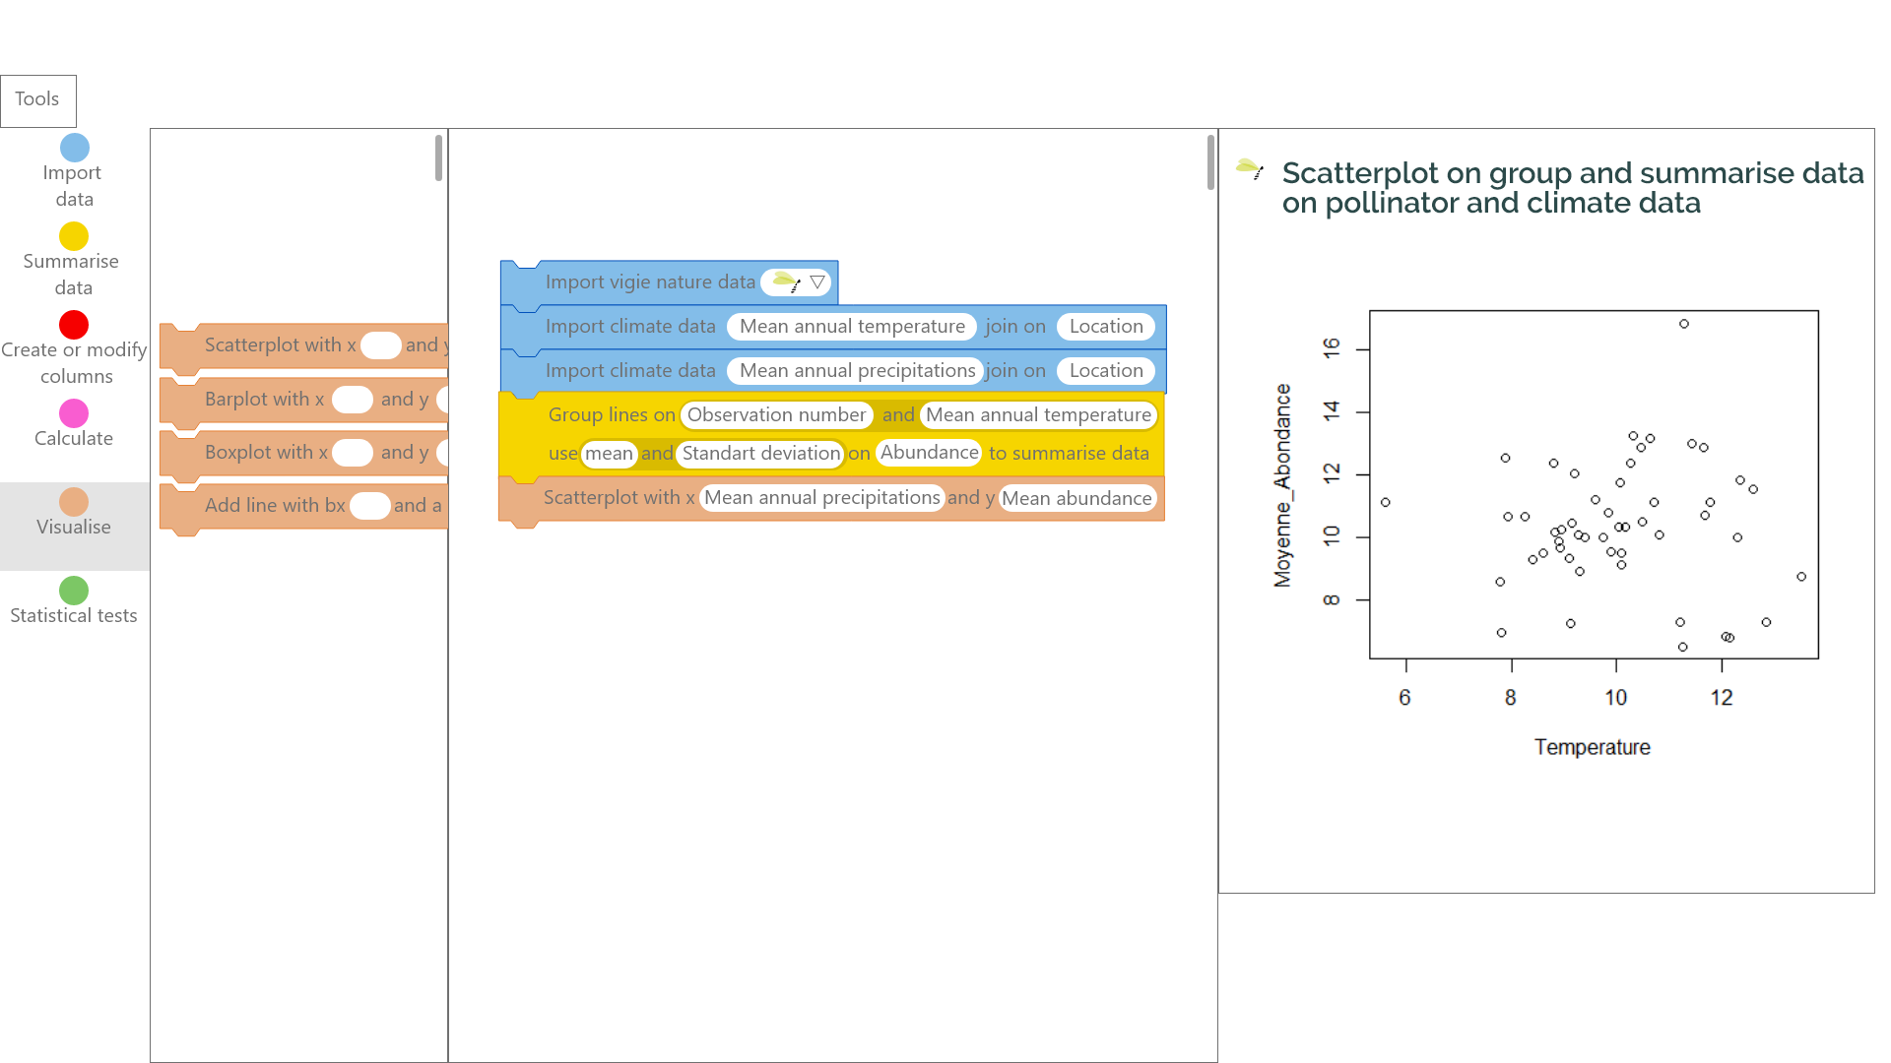

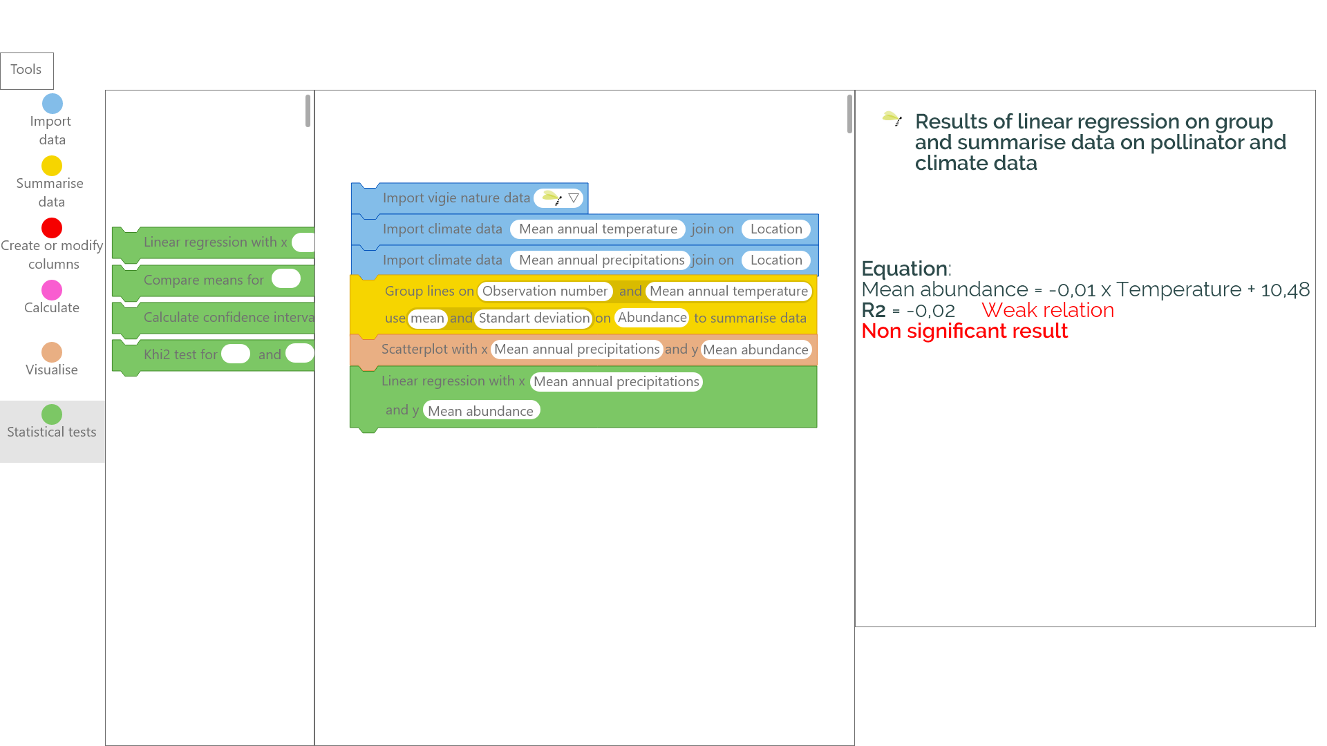

# 7.1 Dissemination and Communication Report

- “From the first amateurs to citizen sciences, breaks and continuities” Vigie-Museum day in Paris, France, April 10th 2019. Simon Bénateau, Sébastien Turpin “Vigie-Nature Ecole and "Galaxy-Bricks", towards an expansion of the objectives of citizen sciences.”

- ELIXIR Galaxy Community – Workshop ([https://docs.google.com/document/d/1cIc920Et6LPnezy8yT1SJyupud0BfZxQ-hofWAu1LB0/edit#](https://docs.google.com/document/d/1cIc920Et6LPnezy8yT1SJyupud0BfZxQ-hofWAu1LB0/edit)) in Roscoff, France, April 26th 2019. Simon Bénateau, Yvan Le Bras – *Galaxy Bricks : Galaxy game style user interface development using Scratch*

- Ecostat (Statistical Ecology <https://sites.google.com/site/gdrecostat/>) annual conference in Avignon, France, May 14th 2019. Simon Bénateau, Yvan Le Bras – *Galaxy-E : an accessible data analysis platform*

- CiSStats (Citizen Science statistics <https://informatique-mia.inra.fr/cisstats/accueil>) annual conference in Avignon, France, May 15th 2019. Simon Bénateau, Yvan Le Bras – *Galaxy Bricks : a collaborative data analysis platform*

- VIGIE NATURE – Website article

<http://www.vigienature.fr/fr/actualites/vous-pourrez-bientot-analyser-vous-memes-donnees-3599>

# 7.3 Report on Project Impact

Thanks to the MMOs project, we have add the possibility to test this idea of using Galaxy more broadly and in a very innovative way. We now have strong ongoing collaboration with teachers network and Vigie-Nature Ecole on one side and with Elixir usegalaxy.eu on the other side. These MMOS activities, as part of the small scale experiment, will pave the way for further biggest scale projects to facilitate data literacy as ecological knowledge at school and analysis of scientific data deluge by crowd so enhancing knowledge of children and in the meantime impact of citizens in the production of knowledge