**Part A:**

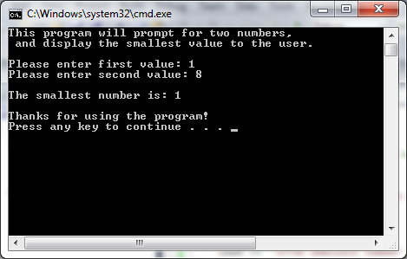

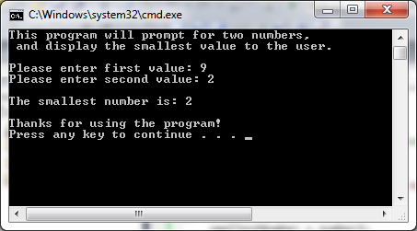

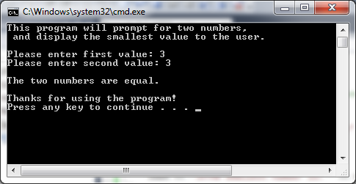

/* Developer: Steven Bennett

Date: March 16, 2013

Assignment: Week 2 Lab Part A "Display Smallest Number" */

#include <iostream>

using namespace std;

int main()

{

//Display welcoming message and purpose of program

cout << "This program will prompt for two numbers,\n and display the smallest value to the user.\n" << endl;

//Prompt user for number1

cout << "Please enter first value: ";

int number1;

cin >> number1;

//Prompt user for number2

cout << "Please enter second value: ";

int number2;

cin >> number2;

//Compare number1 and number2. If numbers are equal display "The two numbers are equal."

int smallestNumber = 0;

if (number1 == number2)

cout << "\nThe two numbers are equal.\n" << endl;

else if (number1 > number2)

{

smallestNumber = number2;

cout << "\nThe smallest number is: " << smallestNumber << "\n" << endl;

}

else

{

smallestNumber = number1;

cout << "\nThe smallest number is: " << smallestNumber << "\n" << endl;

}

//Display termination message.

cout << "Thanks for using the program!" << endl;

return 0;

}

**Part B:**

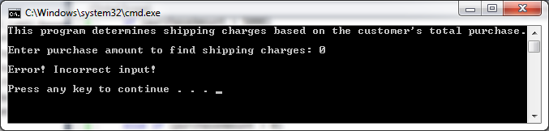

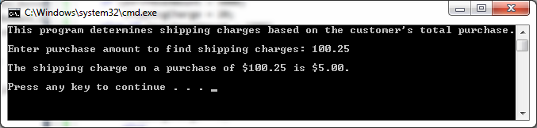

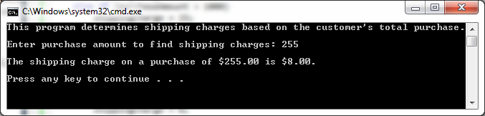

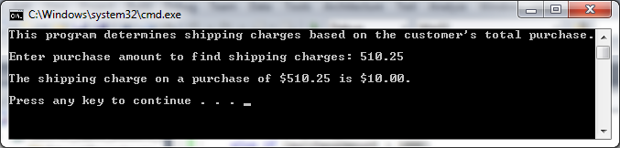

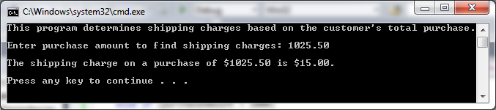

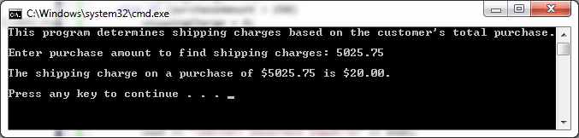

/* Developer: Steven Bennett

Date: March 16, 2013

Assignment: Week 2 Lab 2 Part B Shipping Charges

*/

#include <iostream>

#include <iomanip>

using namespace std;

int main()

{

//Display program information

cout << "This program determines shipping charges based on the customer's total purchase." << endl;

//Prompt user for purchaseAmount

cout << "Enter purchase amount to find shipping charges: ";

double purchaseAmount;

cin >> purchaseAmount;

//Determine shippingCharge

double shippingCharge;

if (purchaseAmount > 5000)

shippingCharge = 20;

else if (purchaseAmount > 1000)

shippingCharge = 15;

else if (purchaseAmount > 500)

shippingCharge = 10;

else if (purchaseAmount > 250)

shippingCharge = 8;

else if (purchaseAmount > 0)

shippingCharge = 5;

else

shippingCharge = 0;

//input validation

if (shippingCharge == 0)

cout << "\nError! Incorrect input!\n" << endl;

else

{

cout << setprecision(2) << fixed;

cout << "\nThe shipping charge on a purchase of $" << purchaseAmount << " is $" << shippingCharge << ".\n" << endl;

}

return 0;

}