I’m honored to be considered for this award as Northwestern ChBE boasts many outstanding researchers whose achievements merit recognition. I feel my work is distinguished by its creative integration of several disciplines and by the broad relevance of its findings. My research falls under the umbrella of quantitative biology. I combine chemical engineering, computer science, and statistics to provide simple explanations for complex biological phenomena by attaching numbers to processes that are notoriously difficult to measure.

The bulk of my efforts are focused on deciphering how cells make reliable decisions during development. Cellular decisions to grow, divide, die, or differentiate are controlled by systems of biochemical reactions called regulatory networks. Elucidating the general principles underlying the structure and function of these networks is vital to understanding all developmental processes, as well as the diseases that arise when they fail.

One of my projects revealed a novel mechanism underlying a specific neuronal differentiation decision in the fruit fly eye. Proteins called transcription factors coordinate the timing and execution of differentiation decisions by binding to target genes and modulating their expression. The prevailing belief was that virtually all such decisions are triggered by changes in the absolute concentration of relevant transcription factors. In most cases, these beliefs were based on qualitative observations as it is difficult to quantify transcription factor dynamics in vivo. Using computer vision and statistical modeling techniques, I extracted quantitative measurements of transcription factor dynamics from microscope images of fruit fly eyes collected by my collaborators. We showed that differentiation is driven by dynamic changes in the ratio between two transcription factors, and is agnostic to changes in their absolute concentrations as long as the ratio remains constant. I developed a general model based on the statistical physics of transcription factor DNA binding to show that this phenomenon is a natural consequence of competition between transcription factors for common binding sites. The study adds a new dimension to our understanding of how transcription factors execute cellular decisions, and showcases the importance of quantification in biology.

Another project addresses the more general question of why many components of regulatory networks appear to serve the same purpose. Networks typically contain multiple negative regulators tasked with attenuating expression of a single transcription factor. Despite serving the same purpose, these redundant regulators are often all essential for normal growth, development, and function of complex organisms. Without them, cells make incorrect decisions and development fails. My collaborators discovered that many essential negative regulators are rendered unnecessary when carbohydrate metabolism is slowed. Their experiments surveyed a broad range of developmental contexts, but offered no insight into the underlying mechanism. I developed a computational framework for probing the molecular behavior responsible for the observed phenomenon. My model suggests the experiments reflect a general principle of dynamic systems; they are more sensitive to perturbation when internal dynamics are fast. In this case, transcription factor activity is more sensitive to changes in regulation when mRNA and protein biosynthesis rates are high. We successfully validated this theory by quantifying transcription factor activity in one of the experimental systems. The findings suggest that redundant negative regulators enable development to proceed more quickly by mitigating erroneous cellular decisions when cells are rapidly metabolizing. As shorter developmental times confer a selective advantage upon organisms, this likely represents a novel evolutionary driving force for increased redundancy in regulatory networks.

Beyond their biological insights, my projects have spawned computational tools that will likely prove valuable to the broader community. My gene network simulation package has already been adopted by two other researchers at Northwestern. I also plan to distribute my transcription factor binding model and computer vision methods, as these resources are broadly applicable to many different biological contexts. By sharing them I hope to promote the adoption of quantitative methods in biology and continue to embrace the spirit of interdisciplinary collaboration that lured me toward this department.

**Project Summary**

Loss of function mutations affecting regulatory mechanisms have been implicated in the emergence of cancer, autoimmune disease, neurological disorders, diabetes, cardiovascular disease, and morphological abnormalities. Understanding when and how regulation fails is vital to controlling its proper function in humans.

During development, gene regulatory programs coordinate cellular decisions by tuning the expression dynamics of relevant genes. A common dynamical form is the transient pulse; gene products are synthesized, used, then detected and degraded. Degradation is often mediated by several negative feedback loops acting in parallel. Perturbing these regulatory features prevents timely attenuation of the regulated signal and increases the frequency of erroneous cellular decisions. Repeated errors yield abnormal morphologies at the organismal scale. Consequently, many regulatory genes have been deemed essential for normal growth, development, and function of complex organisms. Remarkably, recent experiments demonstrate that many of these essential negative regulators are rendered unnecessary when either carbohydrate metabolism or protein biosynthesis rates are slowed. *These observations suggest that redundant regulation enables faster rates of growth and development by mitigating developmental errors when biosynthesis rates are high.*

The proposed study will (1) investigate the biomolecular mechanism behind one instance of this behavior (2) elucidate the general dynamic principles underlying the phenomenon at the level of gene expression and (3) quantitatively predict analogous behavior in an alternate developmental context. First, a mechanistic model of one of the experimental systems will be used to simulate the frequency of developmental errors following removal of negative feedback. Error frequencies will be compared between fast and slow biosynthesis conditions, enabling quantitative prediction of differential regulatory requirements. The model may be validated through comparison with *in vivo* measurements. Second, a phenomenological model describing the regulated expression of a generic gene will be used to determine the conditions under which essential regulators become nonessential. Finally, to investigate the generality of this behavior, a mechanistic model of a different developmental process will be used to quantitatively predict error frequencies following perturbations to the known regulatory structure.

This research promises to elucidate a new role for redundant negative feedback in coupling gene expression programs to physiological conditions. As shorter developmental times confer a selective advantage upon organisms, the anticipated results will reveal a novel evolutionary driving force for increased redundancy in gene regulatory networks. Furthermore, they will advance our understanding of one class of failure mechanisms underlying the emergence of cancer, disease, and developmental defects in humans.

**Specific Aims**

Loss of function mutations affecting regulatory mechanisms have been implicated in the emergence of cancer, autoimmune disease, neurological disorders, diabetes, cardiovascular disease, and morphological abnormalities2–5. Understanding when and how regulation fails is vital to controlling its proper function in humans.

During development, gene regulatory networks coordinate cellular decisions to grow, proliferate, differentiate, or apoptose by tuning the expression of relevant genes. A common dynamical form is the transient pulse: gene products are synthesized, carry out their functions, then are detected and degraded. Regulation is often mediated by several parallel negative feedback loops. Compromising any of these mechanisms prevents timely degradation of the regulated gene, potentially culminating in erroneous decisions. Consequently, many specific regulatory molecules are essential for normal growth, development, and function of complex organisms.

Experiments by the Carthew Lab demonstrate that *Drosophila* *melanogaster* can tolerate losing several, otherwise essential, regulatory mechanisms when carbohydrate metabolism or protein synthesis rates are slowed. Amazingly, even the elimination of all microRNA function can be rescued by slow biosynthesis. These results suggest some regulation is only essential when biosynthesis is fast, motivating a novel hypothesis; redundant negative feedback enables faster growth and development. I propose to investigate the molecular mechanism behind an example of this behavior during eye development (Aim 1), to investigate the general dynamic principles underlying the observed phenotype rescue throughout *Drosophila* (Aim 2), and to assess the generality of this phenomenon by investigating analogous behavior during the yeast mating response (Aim 3).

**Aim 1: Identify role of miR-7 in enabling faster eye development in *Drosophila*.**

*Hypothesis: miR-7 enables differentiation by buffering transient Yan expression when biosynthesis is fast.*

MiR-7 antagonism of Yan translation is normally required for proper retinal patterning in *Drosophila*, but it is rendered unnecessary when biosynthesis is slow. I will develop a kinetic model of the biochemical network that controls photoreceptor recruitment, and use it to simulate neuronal differentiation amongst progenitors. I will quantify the requirement for miR-7 regulation of Yan expression by comparing the extent of differentiation between cell populations with and without proper miR-7 function. The necessity of miR-7 function for proper eye development is expected to diminish when biosynthesis rates are reduced.

**Aim 2: Identify general mechanism by which negative feedback facilitates faster development.**

*Hypothesis: Auxiliary negative feedback attenuates transient gene expression when biosynthesis rates are high.*

Because the experiments simultaneously perturb many developmental systems by eliminating all microRNA functionality, I will develop a general modeling framework for quantifying the role of all negative feedback mechanisms in preventing developmental errors. This approach will emphasize dynamic behavior rather than molecular interactions. Using a control theoretic model of regulated gene expression, I will evaluate the impact of regulatory mechanisms by quantifying the change in simulated expression levels when regulation is removed. I will repeat the simulations following restriction of biosynthesis rates, enabling identification of any feedback mechanisms that are rendered unnecessary when development is slow. By applying this procedure across the relevant parameter space, I will generate phase maps revealing the conditions under which redundant regulation enables faster biosynthesis.

**Aim 3: Identify specific feedback mechanisms that facilitate faster growth in yeast.**

*Hypothesis: Regulatory perturbations incur smaller increases in cell cycle arrest duration if biosynthesis is slow.*

I will develop a detailed kinetic model of the yeast pheromone response pathway in order to simulate cell cycle arrest and re-entry dynamics. Simulations will be repeated under perturbations to feedback mechanisms that attenuate pathway activity. I will predict which regulators are rendered inconsequential upon biosynthesis restriction by quantifying the corresponding changes in arrest durations. The identified regulatory mechanisms will serve as perturbation targets for future experimental validation of the hypothesized mechanism.

My research seeks to elucidate an unexpected role for redundant regulatory features in enabling faster biosynthesis. By quantifying how regulation prevents deleterious cellular decisions when growth and development are fast, the study will inform our ability to intervene when regulation fails in humans. Furthermore, the research promises to identify a new evolutionary incentive for redundant regulation. Understanding how this mechanism drives the evolution of gene regulatory network topologies will improve our ability to infer and control their behavior.

**Research Strategy**

**Significance**

**1. Misregulation of gene expression results in human cancer and disease.** Genome-wide association studies have shown non-coding regulatory DNA variation to be strongly associated with human cancer and disease1. Understanding how regulatory variants give rise to disease states is vital to the development and implementation of novel medical strategies. These functional relationships have been explored for a number of transcriptional, post-transcriptional, and epigenetic regulators, but in most cases the precise molecular details remain elusive2–5. This study proposes both mechanistic and phenomenological frameworks for studying the emergence of developmental errors when regulation fails to attenuate transient signals. By studying how developmental processes fail when regulation is perturbed in *Drosophila* and yeast, the proposed research will advance our understanding of how regulation ensures accurate and timely cellular decisions in all animals.

**2. Mechanistic models of cellular behavior facilitate design of interventions.** The proposed computational framework will quantify the roles of negative feedback mechanisms in preserving normal cellular behavior in response to transient signals. As transient signals and the strategies employed to modulate their dynamics are common throughout biology, an empirical framework is readily extensible to analogous systems in humans6. In the future, model-informed design of engineered repressors could serve as a platform for tuning signaling dynamics in a manner conducive to proper human development and health.

**3. Growth rates shape the evolution of gene regulatory networks.** Robustness is a fundamental organizational principle underlying the evolution of biological systems7. This need for reliability amidst genetic and environmental perturbations is typically assumed to explain the prevalence of redundancy and feedback within gene regulatory networks8. The proposed research poses a complementary explanation for the ubiquity of these regulatory features; redundant negative feedback confers a selective advantage by enabling rapid growth and development. By exploring this hypothesis, the study promises to identify a novel driving force for increased complexity in gene regulatory network topologies.

**Background**

During development, gene regulatory networks coordinate cellular decisions to grow, proliferate, differentiate, or apoptose by tuning the expression of relevant genes9. A common dynamical form is the transient pulse: gene products are synthesized, carry out their functions, then are detected and degraded. Regulation is often mediated by several negative feedback loops acting in parallel. Compromising any of these mechanisms prevents timely degradation of the regulated gene, potentially culminating in erroneous decisions. Consequently, many specific regulatory molecules are essential for normal growth, development, and function of complex organisms.

Experiments by the Carthew Lab demonstrate that *Drosophila* *melanogaster* can tolerate losing some, otherwise essential, regulatory mechanisms when carbohydrate metabolism or protein synthesis rates are slowed. These physiological conditions are enforced through genetic ablation of insulin producing cells and disruption of ribosomal protein synthesis, respectively10,11. The experiments survey a diverse collection of developmental processes and regulatory mechanisms. Amazingly, even the elimination of all microRNA function can be partially rescued by slow biosynthesis. These results suggest some regulation is only essential when biosynthesis is fast.

The prevalence of redundant regulation in gene regulatory networks is often ascribed to a need for robustness against genetic and environmental variability8. These experiments motivate an alternate hypothesis; redundant negative feedback facilitates faster growth and development. While intriguing, the data are limited to fractions of animal populations exhibiting abnormal phenotypes and do not address the underlying mechanism. Any approach toward understanding this phenomenon must bridge the gap between gene expression and phenotypic outcomes with sufficient generality to explain the breadth of surveyed systems. The proposed research plan provides an extension to this hypothesis; *redundant negative feedback facilitates faster growth and development by coupling developmental gene expression programs to physiological cell state.* My hypothesis is predicated on the notion that cells make mistakes when global rates of transcription and translation outpace regulatory networks’ abilities to attenuate transient signals. From this perspective, redundant repressors provide overflow capacity to buffer against increased protein synthesis, ensuring the timely degradation of transiently expressed proteins when growth and development are fast. Together, increased biosynthesis and sufficient negative feedback would enable development to proceed more quickly without incurring additional errors.

**Approach**

I propose to test my hypothesis *in silico* by assessing when and how redundant regulation enables faster biosynthesis. I will investigate the molecular mechanism behind a specific example of this behavior during eye development (Aim 1), as well as the general dynamic principles underlying phenotype rescue throughout *Drosophila* (Aim 2). Furthermore, I will assess the generality of this phenomenon by investigating analogous behavior in the yeast pheromone response pathway (Aim 3).

**Aim 1: Model role of miR-7 in enabling faster eye development in *Drosophila*.**

*Rationale:* Yan is an ETS-domain transcriptional repressor12. A pulse of Yan expression governs recruitment of photoreceptor neurons from a disordered collection of progenitors in the developing *Drosophila* eye13,14. Yan is regulated at the gene, transcript, and protein levels12. The microRNA miR-7 is one such inhibitor of Yan translation15. Yan represses differentiation by competing with the P2 isoform of a concurrently expressed transcriptional activator, *pointed* (Pnt), for occupancy of downstream binding sites13,16. Prolonged Yan expression disrupts timely recruitment of neurons and leads to a roughened eye morphology17. The Carthew Lab has shown that the requirement of miR-7 for successful eye development is relaxed by limiting biosynthesis rates (see Figures 1E, 1F). My hypothesis suggests that this phenomenon occurs because the impact of miR-7 activity on Yan expression and neuronal differentiation diminishes upon restriction of biosynthesis. I will use a kinetic model of the Yan network to investigate these effects.

*Preliminary analysis informing this approach:* I measured Yan expression dynamics *in vivo* by applying segmentation and analysis methods to confocal images of fixed tissues14. The tissues were collected from wildtype and *ΔmiR-7* animals by the Carthew lab. As shown in Figure 1C, the magnitude and duration of Yan expression increase upon mutation of the *miR-7* complementary binding sequence. These results confirm that deleterious effects of restricted miR-7 activity are at least partially mediated through Yan expression.

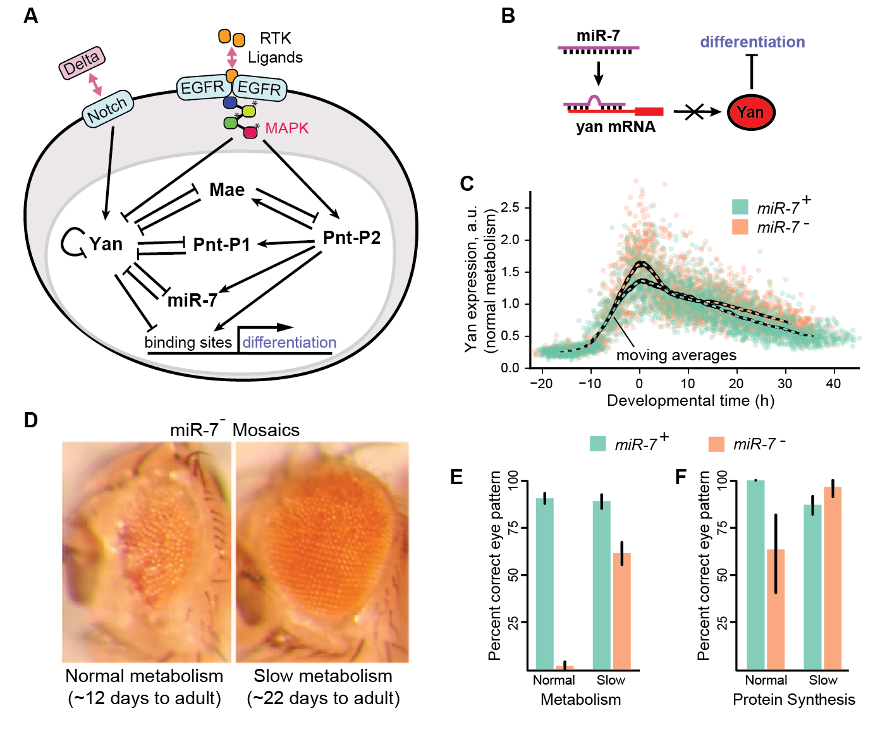**Figure 1: An essential regulator of eye development is rendered unnecessary when biosynthesis is slowed. (A) Biochemical network governing neuronal fate commitment during eye development in *Drosophila melanogaster***. **Signals transduced via the Notch and EGFR pathways drive transient expression of two ETS transcription factors, Yan and Pnt, whose competition for downstream binding sites controls differentiation in progenitors. (B) MiR-7 represses Yan translation by sequestering its mRNA, thus enabling differentiation. (C) Magnitude and duration of Yan expression increase upon mutation of the miR-7 complementary binding sequence. Points are individual progenitors in a fixed tissue**14**. (D) MiR-7 null mosaics exhibit a roughened eye phenotype. (E, F) Phenotype penetrance is reduced when either carbohydrate metabolism or protein biosynthesis are reduced.**

*Analysis Design:* I will develop a kinetic model of the biochemical network that governs neuronal recruitment during eye development. Model scope will begin with Notch-induced Yan expression, and end with competition between Yan and Pnt-P2 for binding site occupancy (see Figure 1A). Possible regulatory mechanisms acting to downregulate Yan expression include transcriptional repression by the Pnt-P1 isoform, post-transcriptional antagonism by miR-7, and post-translational modification by Mae. Rate laws will follow Hill kinetics, with parameters based on available data. I will assign a sensitivity to biosynthesis conditions to each parameter.

Using the model, I will quantify the need for miR-7 in coordinating photoreceptor recruitment. I will use Gillespie’s algorithm to simulate network dynamics amongst independent progenitors following transient Notch activation18. I will then repeat the simulations following reduction of miR-7 binding affinity for the *yan* transcript. In each case, I will quantify the fraction of cells whose Pnt-P2 binding site occupancy exceeds a predefined threshold for differentiation. The decrease in differentiation following restriction of miR-7 activity reflects the importance of miR-7 for proper eye development. MiR-7’s impact will be re-evaluated upon restriction of biosynthesis.

*Anticipated Results:* Simulated Yan expression is expected to recapitulate the pulsatile dynamics measured *in vivo*. Similarly, the magnitude and duration of Yan expression, as well as the fraction of cells that fail to differentiate, should increase upon restriction of miR-7 activity. The necessity of miR-7 activity is expected to diminish upon restriction of biosynthesis rates.

*Potential Pitfalls:* The model is based on molecular interactions governing photoreceptor recruitment in *Drosophila*, but this system is incompletely characterized. Alternate regulatory configurations may be considered should the model fail to recapitulate the anticipated behavior. Model scope could also be narrowed by only evaluating the impact of miR-7 on Yan expression, rather than differentiation. Parameter values may be unavailable for several of the interactions considered. Estimates and sensitivity analyses will be used as needed.

**Aim 2: Identify general mechanism by which negative feedback facilitates faster development.**

*Rationale:* The Carthew Lab’s experiments surveyed a variety of developmental systems in *Drosophila*. Mutations eliminated *miR-7* and *sev,* which regulate Yan expression in the compound eye15,19. They eliminated *miR-9a*, *hairy*, and *Sp,* which regulate Senseless, Achaete/Scute, and Wg expression during bristle formation20–23. Finally, they eliminated post-transcriptional repression throughout the organism by perturbing *dcr-1* and *ago-1*, two components required for biosynthesis of all microRNAs24. Under normal conditions these mutations yield animals with deformed eyes, extraneous bristles, or embryonic lethality. Remarkably, developmental errors are consistently corrected when either carbohydrate energy metabolism or protein biosynthesis are limited.

The breadth of experiments in *Drosophila* points toward a dynamic phenomenon agnostic to the molecular detail of repressors and their targets. To demonstrate the generality of my hypothesis, I propose a coarse-grained framework relating expression of a generic protein to population-wide phenotype distributions that does not depend upon the specifics of each developmental system. My goal is to predict how removal of a negative feedback mechanism causes protein levels within affected cells to differ from their unperturbed counterparts. As nuanced changes in expression yield abnormal morphologies *in vivo*, differences in protein levels manifest as differences in phenotype penetrance25. I aim to quantify both *how different a population of cells behaves* when negative feedback is removed and *how the magnitude of this difference depends upon biosynthesis rates*.

*Preliminary analysis informing this approach:* In each experimental system, a stimulus induces expression of a protein whose activity is brought back to basal levels by multiple negative feedback loops. I modeled this configuration with a control theoretic depiction of the expression and regulation of a generic gene. Control theory provides a natural modeling framework owing to its treatment of complex nonlinear dynamics as linear deviations from steady state. The model incorporates a cascade of events describing the sequential processes of promoter binding, transcription, and translation, with repressors providing proportional feedback at each level (see Figure 2A). It provides a phenomenological description of expression dynamics rather than a detailed depiction of molecular events. This abstraction is a key strength as it enables extension to any pulsatile system. Furthermore, measured expression data may be characterized by a few induction and decay parameters.

I used a Monte Carlo simulation procedure to test the model’s ability to quantify the frequency of errors incurred through loss of a repressor. First, I stochastically simulated protein expression amongst thousands of cells in response to a transient stimulus. I then obtained an additional population of trajectories using a mutant model with some of the feedback removed. I quantified the resultant change in expression by calculating the fraction of mutant protein levels exceeding the 99th percentile of the wildtype distribution. This metric approximates the population-wide phenotype penetrance in that it provides a quantitative estimate of the frequency with which mutant cells, with compromised feedback, exhibit distinctly different behavior than wildtype cells in which feedback is unperturbed25. Figure 2B shows a demonstration of this procedure that qualitatively recapitulates all anticipated behavior, and thus will be used to evaluate error frequencies for each set of model parameters.

*Analysis design:* The modeling framework will permit systematic characterization of differential error rates between fast and slow biosynthesis conditions. Carbohydrate metabolism and protein translation capacity affect the abundance of synthesis and degradation machinery for both transcripts and proteins26,27. Growth laws have been proposed for some organisms, but the exact relationships and any differential sensitivities are unknown28–30. The model will incorporate energy dependence via fold-changes to each rate parameter. For instance, reduced metabolic rate could correspond to reduced ATP production and a consequent reduction of the transcription, translation, and degradation rate constants owing to their intensive ATP consumption. Magnitudes of dependencies will later serve as a basis for sensitivity analysis.

I will apply the framework across the range of biologically relevant model parameters to identify regions of the phase space in which error rates differ considerably between biosynthesis conditions. These are the behavioral regions in which redundant repressors facilitate faster development. The resultant phase map promises to quantify the generality of the observed phenomenon, and will facilitate validation of the proposed mechanism should expression measurements become available for any of the systems surveyed in *Drosophila*.

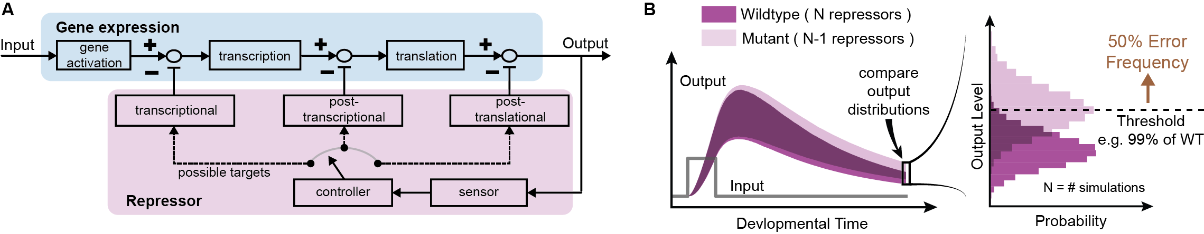

**Figure 2: Computational framework relating gene expression dynamics to phenotypic outcomes. (A) Control theoretic model of gene expression (blue) subject to negative feedback (purple). Blocks represent transfer functions relating input and output variables. (B) Procedure for quantifying repressor importance. Simulations yield distributions of protein levels that depend upon the number and strength of repressors. Shaded regions are 99% confidence bands. The frequency of errors induced upon loss of negative feedback is quantified via the survival function.**

*Anticipated results:* Wildtype and mutant expression are expected to be more similar when biosynthesis is limited. Similarly, if parameters are tuned to recapitulate measured dynamics, simulated error frequencies should reflect the corresponding mutant phenotype penetrance. The framework provides a quantitative description of the functional relationship between regulatory variants and the emergence of disease states. This functionality may inform the design of medical interventions for diseases arising from loss of regulatory function.

Given the broad range of *Drosophila* systems exhibiting reduced developmental error rates under slow growth conditions, much of the parameter space is expected to reflect this trend. If these expectations are met the model will speak toward the evolutionary significance of negative feedback in shaping gene regulatory network topologies. It will also clarify the role fulfilled by the many redundant regulatory motifs found in biological systems.

*Potential pitfalls:* The model employs linear kinetics but developmental systems frequently exhibit complex nonlinear behavior31,32. This study stresses empirical dynamics over mechanistic detail, but model complexity may be increased as necessary should the model fail to recapitulate anticipated behavior. One possibility would be the introduction of enzyme-substrate kinetics through use of Hill functions or a two-state transcription model.

Proportional control is sufficient for restoring basal expression levels if expression is driven by a transient stimulus. This is likely within the context of Yan expression, but other systems could employ integral feedback to attenuate constitutively active stimuli33. The model and simulation procedure may be modified to incorporate constant stimulation and integral feedback should a proportional-only model fail to recapitulate the experimentally observed behavior.

Construction of a detailed phase map across each of the free parameters may incur considerable computational cost as the efficiency of Gillespie’s algorithm suffers when timescale separations arise between rate parameters18. Hybrid tau-leaping offers one solution by aggregating firing events of species whose abundance varies on slower timescales34. Alternatively, the proposed linear model is amenable to analytical solution of the chemical master equation for the time evolution of the statistical moments of protein level distributions35. Moment closure techniques enable a similar approach should nonlinear kinetics be considered36,37. Quasi-random sampling will be used to obtain an efficient survey of the parameter space. Furthermore, simulations are readily parallelizable across the computational clusters at Northwestern University.

**Aim 3: Identify specific negative feedback mechanisms that facilitate faster growth in yeast.**

*Rationale:* The yeast pheromone response is one of the most well characterized signaling processes in eukaryotes38. When haploid cells of the species *Saccharomyces cerevisiae* are exposed to a mating pheromone, the cells arrest at the G1/S checkpoint of the cell cycle, extend morphological projections from their spherical cell surface, and fuse with other haploid cells to make a diploid cell. The pathway is triggered in *MAT***a** genotype cells when G-protein coupled receptors encounter α-Factor peptide secreted by *MAT*α cells. The resultant signal transduction cascade elicits all the described cellular effects (see Figure 3). Cell cycle arrest is mediated by *Far1* following its activation by phosphorylated Fus3, a MAPK protein whose activity is coordinated by multiple negative feedback mechanisms that attenuate signaling throughout the cascade39–42. When pathway activity reaches sufficiently low levels, cells re-enter the cell cycle and resume growth. Perturbations to the feedback structure increase cell cycle arrest duration, sometimes leading to permanent growth restriction.

This pathway provides fertile ground for validating my hypothesis. It constitutes an alternate context in which transient activity of a protein subject to redundant negative feedback mediates a cellular decision. Cells remain in an arrested state for abnormally long times when negative feedback is removed. I hypothesize that the increase in arrest duration will be less severe when biosynthesis is slowed. I propose to use a kinetic model to identify the feedback mechanism whose disruption incurs the largest differential increase in cell cycle arrest duration between biosynthesis rates. This would be an optimal target for experimental perturbation as it would exhibit the largest effect size.

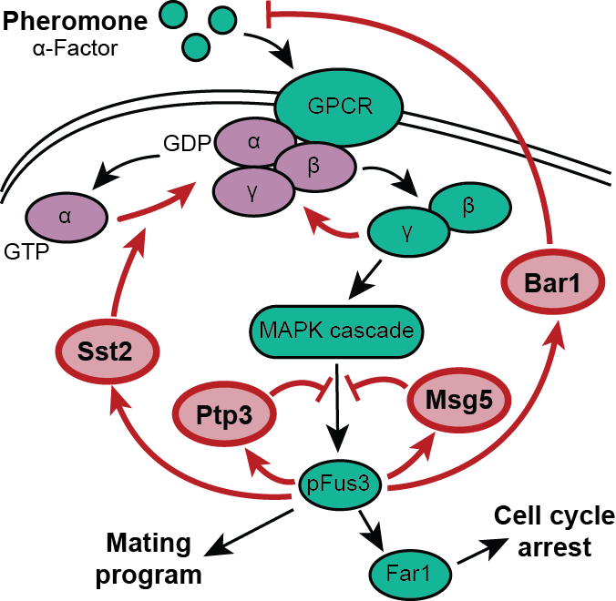

**Figure 3: Pheromone response in *MAT*a yeast. α-Factor binds a tetrameric G-protein coupled receptor causing the Gα subunit to exchange GDP for GTP, liberating the Gβγ subunit for pathway activation. The MAPK pFus3 promotes cell cycle arrest and the mating program. Negative feedback attenuates pathway activity throughout the cascade. Components are excluded for simplicity.**

The pheromone response pathway is attractive for several reasons. All of the components have been identified and their expression dynamics quantified in many cases43–45. Reporters are available for most components allowing future measurement of gene expression *in vivo*. Finally, biosynthesis rates can be manipulated via temperature, the carbon source on which yeast are grown, or by administration of rapamycin46. Together, these features enable quantitative validation of the hypothesized mechanism by which redundant negative feedback enables faster dynamics.

*Preliminary analysis informing this approach:* Dynamic behaviors of the G-protein cycle, MAPK signaling cascade, and Far1-mediated cell cycle arrest have been reproduced *in silico*44,45,47–49. These models include multiple negative feedback loops that attenuate pathway activity at varying points in the cascade. Several of these feedback loops are shown in Figure 3. Pathway activation stimulates expression of Bar1 that degrades extracellular α-Factor, expression of Sst2 that catalyzes re-association of the G-protein heterotrimer, and activation of phosphatases that post-translationally mitigate pFus3 activity. Existing models provide a reference for reactions and rate parameters, and will assist in identifying relevant components for inclusion.

*Analysis design:* My objective is to identify feedback mechanisms that are essential to normal function of the pheromone response pathway but unnecessary when biosynthesis is slow. I will develop a mathematical model relating the signaling cascade, cell cycle control, and biosynthesis conditions. The first step will involve identification of relevant components as the pathway elicits additional cellular responses beyond cell cycle arrest. I will then develop a detailed kinetic model relating the abundance of α-Factor to the activity of Fus3, Far1, and any relevant steps of the cyclin network that controls cell cycle progression. The model will use rate laws and parameters borrowed from the literature. Each parameter will be assigned a sensitivity to biosynthesis conditions.

I will use a Monte Carlo simulation procedure to evaluate the differential requirement for each regulatory mechanism between biosynthesis conditions. I will use Gillespie’s algorithm to simulate pathway-induced cell cycle arrest and re-entry dynamics amongst a population of cells18. I will then repeat the simulations following removal of each feedback mechanism. To quantify the necessity of each perturbed feedback mechanism, I will compare the resultant distributions of arrest durations with those obtained from the simulations in which feedback is unperturbed. I will repeat the procedure upon restriction of biosynthesis, enabling systematic identification of the perturbations imparting the most distinctly different behavior.

*Anticipated results:* Simulations will yield Fus3 and Far1 activity time series for each condition, along with distributions of cell cycle arrest durations. These distributions should shift toward longer arrest durations when negative feedback is removed. I hypothesize that the magnitude of these shifts will decrease upon restriction of biosynthesis due to reduced dependency upon the removed feedback mechanism. Results should vary between regulatory perturbations because each mechanism plays a quantitatively different role in regulating pathway activity. Altogether, simulations should demonstrate that the observed phenomenon is not limited to *Drosophila*. The molecular mechanisms by which essential regulatory motifs are rendered non-essential under conditions of slow biosynthesis will have implications for analogous signaling systems in humans.

*Potential pitfalls:* Studies indicate that substantial crosstalk occurs between the nutrient sensing and mating response pathways50. These interactions have not been extensively characterized, but may complicate the effects of substrate quality and rapamycin upon the synthesis and regulation of all pathway components. Where necessary, I will use informed assumptions and sensitivity analyses to compensate for knowledge gaps.

**Summary and future directions**

Mutant phenotypes are broadly suppressed upon restriction of biosynthesis in *Drosophila*. This study seeks to explain the occurrence of this population-level phenomenon by computationally probing the underlying cause at the level of gene expression. Predictions of analogous behavior in budding yeast will directly inform future experiments designed to validate the hypothesized mechanism.

I will quantitatively predict the dynamic behavior of specific proteins under varied physiological conditions. This research will motivate direct *in vivo* measurement of the corresponding proteins in both *Drosophila* and budding yeast. Quantitative measurements will be used to validate the proposed mechanism while facilitating refinement of model parameters. Increased model fidelity will inspire further experiments designed to probe the boundaries between differing behavioral regimes. Interventions might involve engineering repressors with tunable strength or redundancy. In the long term, model-informed design of repressors could guide medical interventions.

|  |  |  |  |  |  |  |
| --- | --- | --- | --- | --- | --- | --- |
| **Research Plan Timeline** | **Year 1** | | **Year 2** | | **Year 3** | |
| **Months** | 1-6 | 7-12 | 1-6 | 7-12 | 1-6 | 7-12 |
| **Specific Aim 1** |  |  |  |  |  |  |
| * Develop model of Yan network and identify parameters |  |  |  |  |  |  |
| * Develop simulation and analysis procedure |  |  |  |  |  |  |
| * Run Monte Carlo simulations and analysis |  |  |  |  |  |  |
| * Test sensitivity to biosynthesis and model parameters |  |  |  |  |  |  |
| * Prepare and publish manuscript on results |  |  |  |  |  |  |
| **Specific Aim 2** |  |  |  |  |  |  |
| * Develop control theoretic model of gene expression |  |  |  |  |  |  |
| * Develop simulation and analysis procedure |  |  |  |  |  |  |
| * Run Monte Carlo simulations and parameter sweeps |  |  |  |  |  |  |
| * Prepare and publish manuscript on results. |  |  |  |  |  |  |
| **Specific Aim 3** |  |  |  |  |  |  |
| * Develop model of Yeast pheromone response pathway |  |  |  |  |  |  |
| * Develop simulation and analysis procedure |  |  |  |  |  |  |
| * Run Monte Carlo simulations and analysis |  |  |  |  |  |  |
| * Prepare and publish manuscript on results |  |  |  |  |  |  |

My hypothesis suggests both unicellular and multicellular eukaryotic species may increase their fitness by accumulating redundant regulatory mechanisms that allow them to develop faster. Future work may include simulating the evolution of gene regulatory network topologies *in silico*. A population of networks could be subject to repeated cycles of mutation and selection on the basis of developmental errors and resource consumption. The topological trends could be compared against those inferred from literature data. Understanding the driving forces behind the evolution of gene regulatory networks will improve our ability to infer and control their behavior.

If cell-autonomous regulatory interactions stabilize the Pnt-to-Yan ratio, extracellular cues must set the ratio in individual cells recruited for fate commitment. The Notch ligand Delta downregulates the propensity for multipotent cells to differentiate (Mark E. Fortini et al. 1993), whereas the RTK ligands Spitz and Boss upregulate their propensity to differentiate (Freeman 1996). Notch and Ras activities are regulated via cell-cell signals in the eye. Our data suggest relative input via these pathways helps drive cells toward particular Pnt-to-Yan ratios. Notch signaling appears to lower the ratio, while Ras activity raises it. These signals may simultaneously target both proteins to maximize efficacy (Fig. 7A, dashed lines). For example, a single signal could rapidly increase the ratio by increasing Pnt and decreasing Yan, either through regulation of the components themselves or the strength of their actions on each other. Ras post-translationally regulates both Pnt and Yan. By activating MAP kinase, Ras enhances Yan protein turnover, Pnt-P1 expression, and Pnt-P2 potency (O’Neill et al. 1994; Rebay and Rubin 1995). Notch enhances *yan* transcription by activating Su(H) (Rohrbaugh and Ramos 2002). Whether Notch simultaneously inhibits *pnt* transcription is unknown.

While its simplicity is enticing, a model based solely on regulatory interactions suffers several limitations. It is unclear how independent reciprocal regulation could maintain a constant Pnt-to-Yan ratio amidst sustained increases in either Pnt or Yan expression. There is further ambiguity as to whether regulation acts by increasing stimulation or decreasing attenuation of the opposing factor’s expression. These shortcomings limit the predictive utility of the model. In principle they could be overcome by a depiction of the underlying molecular mechanism in which all arrows correspond to a specific set of independent chemical processes. Unfortunately, the complexity of developmental processes often precludes characterization of complete systems. This applies to our system of study. For the sake of discussion we present a hypothetical gene regulatory network motif that recapitulates the observed behavior (Fig. 7B). This motif is based on the concept of antithetic integral feedback(Briat, Gupta, and Khammash 2016), and is capable of maintaining a constant Pnt-to-Yan ratio amidst sustained increases in Pnt or Yan expression (Figs. S8A-D). Notch and Ras could transiently perturb the ratio by modulating Pnt or Yan expression, or set the ratio by modulating the control architecture (Figs. S8E). Pnt is considered a repressor for simplicity, but could instead stimulate an intermediate repressor. Even this unrealistically simple mechanism would require rigorous quantitative characterization in order to make accurate model predictions. Detailed molecular descriptions might also detract from the behavior of interest, as a small subset of molecular events may dictate cellular outcomes under a particular set of conditions.

Instead, we emphasize an empirical description of system dynamics based on control theory (Fig. 7C). In this model, an unknown system of cellular components monitors the relative abundance of Pnt and Yan and takes corrective action when the ratio deviates from a specified reference value. We refer to this strategy as ratio control. This model eschews molecular events in favor of minimizing complexity, but preserves the salient features of a detailed molecular mechanism. Sustained fluctuations in the absolute abundance of one factor are mitigated by compensatory adjustment of the other. Notch or Ras activity could modulate Pnt or Yan protein levels to transiently perturb the Pnt-to-Yan ratio (Fig. 7C, dashed black arrow). These signals could permanently set the ratio by adjusting the reference value (Fig. 7C, dashed red arrow). We prefer this control theoretic representation because it conveys the fundamental strategy underlying system behavior. Furthermore, accurate model predictions would only require a small number of parameters that characterize Pnt-to-Yan ratio dynamics, obviating the need for experimental measurement of reaction rates during R cell specification in *Drosophila*.

We have shown that the Pnt-to-Yan ratio is coupled to cell state. One interpretation is that the ratio determines which state a cell is in. We are unable to test this hypothesis directly because the observed ratio control strategy precludes gene-level manipulation of the ratio. Instead, we acknowledge that our observations are correlative. We cannot discard the possibility that Notch and RTK signaling regulate fate transitions in a manner that is not mediated by relative Pnt and Yan activity. We emphasize, however, that ratio control enforces stability when cells are in one state, which implicates the ratio as an active cell state determinant. Moreover, qualitatively different approaches to manipulate the ratio also affected cell state transitions in a consistent manner. Both Notch inhibition and Ras activation increase the ratio, and cause ectopic R cell fate transitions (Yang and Baker 2006; M E Fortini, Simon, and Rubin 1992). Single-cell dynamical perturbations may ultimately prove necessary to definitively confirm whether elevated ratios mediate differentiation.