**A Novel Role for Redundant Negative Feedback**

**During Development**

**Sebastian Bernasek**

*Department of Chemical and Biological Engineering*

*Northwestern University*

Fall 2017

**Abstract**

Biological systems exhibit a stunning variety of highly reproducible forms and behaviors. These phenotypes are the product of many carefully coordinated cellular decisions to proliferate, differentiate, or apoptose at the correct time and place. During development, gene regulatory programs coordinate cellular decisions by tuning the expression dynamics of relevant genes. A common dynamical form is the transient pulse; gene products are synthesized, used, then detected and degraded. Degradation is often mediated by several negative feedback loops acting in parallel. Perturbing these regulatory features prevents timely attenuation of the regulated signal and increases the frequency of erroneous cellular decisions. Repeated errors yield abnormal morphologies at the organismal scale. Consequently, many regulatory genes have been deemed essential for normal growth, development, and function of complex organisms. Remarkably, recent experiments in *Drosophila melanogaster* demonstrate that many of these essential negative regulators are rendered unnecessary when either carbohydrate metabolism or protein biosynthesis rates are slowed. These observations suggest that redundant regulation enables faster rates of growth and development by mitigating developmental errors when biosynthesis rates are high.

I propose to investigate the biomolecular mechanism behind a specific instance of this behavior in *Drosophila*, elucidate the general dynamic principles underlying the phenomenon at the level of gene expression, and quantitatively predict analogous behavior during pheromone response in budding yeast. My research promises to elucidate a new role for redundant negative feedback in coupling gene expression programs to physiological conditions. As shorter developmental times confer a selective advantage upon organisms, the anticipated results will reveal a novel evolutionary driving force for increased redundancy in gene regulatory networks. Furthermore, loss of function mutations affecting regulatory mechanisms have been implicated in the emergence of cancer, disease, and morphological abnormalities. Understanding when and how regulation fails is vital to controlling its proper function in humans.

Table of Contents

1. Introduction 2

2. Context 3

2.1. Redundant Regulationand Robust Development 3

2.2. Carthew Lab Experiments 4

3. Specific Aims 5

4. Negative Feedback in Drosophila Eye Development 7

4.1. Background: Fate Commitment in the Developing Eye 7

4.2. Data: Experimental Perturbation of MiR-7 Activity 9

4.3. Aim 1A: Quantify the Necessity of MiR-7 for Normal Eye Development 10

4.4. Aim 1B: Validate Model by Predicting Yan Expression Dynamics 13

4.5. Progress and Deliverables 14

5. Negative Feedback in Gene Expression Cascades 15

5.1. Background: Negative Feedback in Developmental Processes 16

5.2. Aim 2A: Model an Intermediate Step in a Gene Expression Cascade 17

5.3. Aim 2B: Quantify the Necessity of Negative Feedback in Expression Cascades 19

5.4. Aim 2C: Assess the Generality of the Experimentally Observed Phenomena 21

5.5. Progress and Deliverables 23

6. Negative Feedback in the Yeast Pheromone Response Pathway 23

6.1. Background: The Yeast Pheromone Response Pathway 23

6.2. Aim 3A: Model Cell Cycle Arrest and Re-entry Dynamics 24

6.3. Aim 3B: Quantify the Necessity of Negative Feedback for Normal Cell Behavior 26

6.4. Aim 3C: Validate Model by Predicting G1 Arrest Durations 27

6.5. Progress and Deliverables 27

7. Summary and Future Directions 28

# Introduction

Biological systems exhibit a stunning variety of highly reproducible forms and behaviors. These phenotypes are the product of many carefully coordinated cellular decisions to proliferate, differentiate, or apoptose at the correct time and place. During development, gene regulatory programs coordinate cellular decisions by tuning the expression dynamics of relevant genes1. A common dynamical form is the transient pulse: gene products are synthesized, carry out their functions, then are detected and degraded. Regulation is often mediated by several negative feedback loops acting in parallel. Compromising any of these mechanisms prevents timely degradation of the regulated gene, potentially culminating in erroneous decisions. Consequently, many specific regulatory molecules are essential for normal growth, development, and function of complex organisms.

Experiments by the Carthew Lab demonstrate that *Drosophila* *melanogaster* can tolerate losing some, otherwise essential, regulatory mechanisms when carbohydrate metabolism or protein synthesis rates are slowed. The experiments survey a diverse collection of developmental processes and regulatory mechanisms. Amazingly, even the elimination of all microRNA function can be substantially rescued by slow biosynthesis. These results suggest some regulation is only essential when biosynthesis is fast.

The prevalence of redundant regulation in gene regulatory networks is often ascribed to a need for robustness against genetic and environmental variability2. The Carthew Lab’s experiments motivate a complementary hypothesis; redundant negative feedback facilitates faster growth and development. While intriguing, the data are limited to fractions of animal populations exhibiting abnormal phenotypes and do not address the underlying mechanism. I propose an extension to this hypothesis; *redundant negative feedback facilitates faster growth and development by coupling developmental gene expression programs to physiological cell state.* My hypothesis is predicated on the notion that cells make mistakes when global rates of transcription and translation outpace regulatory networks’ abilities to attenuate transient expression. From this perspective, redundant repressors provide overflow capacity to buffer against increased protein synthesis, ensuring the timely degradation of transiently expressed proteins when growth and development are fast. Together, increased biosynthesis and sufficient negative feedback would enable development to proceed more quickly without incurring additional errors.

I propose to computationally test my hypothesis by assessing when and how redundant regulation enables faster biosynthesis. I will investigate the molecular mechanism behind an observed instance of this behavior during eye development (Aim 1), as well as the general dynamic principles underlying phenotype rescue throughout *Drosophila* (Aim 2). Furthermore, I will assess the generality of this phenomenon by investigating analogous behavior in the yeast pheromone response pathway (Aim 3).

# Context

## Redundant Regulationand Robust Development

In the early 1940s, C.H. Waddington introduced the canalization of development by noting that “there is scarcely a mutant that is comparable in constancy with the wild type.” Waddington’s remarks stress the tendency of developmental systems to reject perturbations3. His claims are supported by the remarkable consistency of developmental outcomes amidst tolerable levels of genetic and environmental variation, as well as increased variability when severe perturbations are introduced4–7. This robustness against variability was later attributed to the regulatory activities and interactions of genes8–10. Throughout the ensuing decades, progressive advances in genetic, analytic, and computational tools enabled exploration of the regulatory architectures responsible for maintaining consistent phenotypic outcomes9,11–16. A handful of conserved gene network motifs, and the regulatory strategies they implement, are now known to pervade most developmental processes2,17–19. Robustness has thus come to be accepted as a fundamental organizational principle underlying the evolution of all biological systems20. That is, selection for genotypes that confer developmental robustness is widely assumed to shape the evolution of gene regulatory network topologies.

The evolutionary origins of developmental robustness remain an ongoing topic of debate21. Citing phenomenological examples, Waddington attributed canalization to evolutionary selection for optimal traits. More recently, Siegal et al. argued that developmental robustness can arise without stabilizing selection for any particular phenotype22. The authors used a gene interaction network model to demonstrate that robustness is an emergent property of complex networks subject only to selection on the basis of their own functional stability. The same authors used a similar *in silico* evolution approach to show that most genes in developmental networks buffer phenotypic variation, suggesting that robustness is an emergent byproduct of complex network architecture23. More broadly, additional computational studies have questioned the notion that global properties of biological networks are a consequence of adaptive evolution24,25. These results suggest that local properties of genetic circuits can drive the emergence of macroscopic features that ensure robust development.

Redundancy is one of many strategies that confers robustness upon development processes2,26. This seems intuitive; when a gene is absent or fails to perform its function, the simplest contingency is to have another gene ready to compensate. Nowak et al. showed that genetic redundancy is particularly evolutionarily stable in developmental systems27. Using a simple binary outcome simulation procedure, the authors demonstrated that increasing the probability with which each gene in a functionally overlapping pair fails to carry out its function places increasing selection pressure upon both redundant genes. They reasoned that the resultant increase in evolutionary stability explains the prevalence of redundancy in developmental systems, where failure rates are high and erroneous cellular decisions propagate as deleterious phenotypes. Indeed, extensive functional redundancy has been documented in developmental systems throughout the literature20. Redundancy may arise through gene duplication or convergent evolution. A. Wagner argued against the former by associating gene sequence and expression data in yeast, showing that the suppression of phenotypic severity in response to loss of function mutations does not correlate with the presence of functionally similar genes elsewhere in the genome28. He concludes that functional redundancy is not the primary cause of robustness to genetic variation, instead favoring epistatic interactions between otherwise unrelated genes. Combined, these results hint that the prevalence of functional redundancy in biological systems may not solely be the product of direct stabilizing selection for robust development.

My hypothesis poses a complementary explanation for the ubiquity of redundant regulatory mechanisms. By enabling faster biosynthesis, redundant regulation would confer a selective advantage by reducing the time required for organisms to reach reproductive maturity. The prevalence of redundancy within developmental processes would then be a direct consequence of stabilizing selection for shorter generational times.

## Carthew Lab Experiments

The Carthew Lab’s experiments surveyed a variety of developmental systems in *Drosophila melanogaster*. Mutations eliminated *miR-7* and *sev,* which antagonize Yan expression in the compound eye13,29. They eliminated *miR-9a*, *hairy*, and *Sp,* which regulate Senseless, Achaete/Scute, and Wg expression during bristle formation14,30–32. Finally, they eliminated post-transcriptional repression throughout the organism by perturbing *dcr-1* and *ago-1*, two components required for biosynthesis of most microRNA species33. These perturbations target regulatory mechanisms acting at the gene, transcript, and protein levels. Under normal conditions the mutations yield animals with deformed eyes, extraneous bristles, or embryonic lethality. Remarkably, developmental errors are consistently corrected when either carbohydrate energy metabolism or protein biosynthesis are limited. These physiological conditions are enforced through genetic ablation of insulin producing cells and disruption of ribosomal protein synthesis, respectively34,35.

In all experiments, the data are limited to numbers of animals exhibiting mutant and wildtype phenotypes under each set of genetic and biosynthesis conditions. Any approach toward understanding this phenomenon must bridge the gap between gene expression and phenotypic outcomes with sufficient generality to explain the breadth of surveyed systems.

The genetic perturbations target regulatory mechanisms whose activities of interest occur during intermediate stages of development. Consequently, experimental measurement of single-cell expression dynamics is technically infeasible in most cases. An existing pipeline enables inference of spatially-aggregate Yan expression dynamics from confocal microscope images of fixed eye imaginal discs36. This method will be explored as an avenue for hypothesis and model validation.

The Carthew Lab are also developing an experimental protocol for a series of analogous experiments in *Saccharomyces cerevisiae*. Haploid yeast cells arrest at the G1/S checkpoint of the cell cycle upon stimulation of pheromone response pathway activity following exposure to the appropriate pheromone. Multiple redundant regulatory mechanisms attenuate pathway activity at multiple points in the signaling cascade, allowing growth-arrested cells to re-enter the cell cycle. An overview of the interactions governing cell cycle arrest and re-entry dynamics in response to pheromone-induced signaling is shown in Figure 9.

The experiments will quantify changes in the fraction of cells that remain in an arrested state following genetic elimination of specific regulatory mechanisms. In particular, the initial experiments will eliminate *sst2*, a gene whose protein product attenuates pathway activity by antagonizing signaling at the level of cell-surface receptors. The requirement for *sst2* in restoring normal cell cycle progression will be assessed under normal conditions, as well as when biosynthesis rates are limited. Biosynthesis rates will be controlled by temperature, by the carbon source on which cells are grown, and by administration of rapamycin. Cell populations will be annotated using automated image segmentation and classification software such as Ilastik or CellSort. Various reporter assays will be used to monitor the activity of gene products of interest, such as those mediating arrest and re-entry decisions37.

# Specific Aims

The literature presents a diverse collection of theories that seek to explain the prevalence of redundant regulation within developmental gene regulatory networks. In light of the Carthew Lab’s experiments in *Drosophila*, I propose a complementary explanation: redundancy is conserved because it enables faster growth and development by mitigating erroneous cellular decisions when biosynthesis rates are high. Testing this hypothesis requires knowledge of gene expression dynamics, but the experimental data are limited to population-level measurements of adult phenotype penetrance and do not survey the underlying biomolecular processes. As precise measurement of all the corresponding systems is technically infeasible, I propose to investigate their behavior *in silico*. I will interrogate the role of redundant negative feedback in three developmental contexts. In particular, I will identify the biomolecular mechanism by which miR-7 facilitates faster eye development (Aim 1), explore the general dynamic principles by which negative feedback enables faster development throughout *Drosophila* (Aim 2), and assess the generality of this phenomenon by investigating analogous behavior during the yeast mating response (Aim 3).

**Aim 1: Identify role of miR-7 in enabling faster eye development in *Drosophila*.**

MiR-7 antagonism of Yan translation is normally required for retinal patterning in *Drosophila*, but it is rendered unnecessary when biosynthesis is slowed. I will develop a kinetic model of the biochemical network that controls photoreceptor recruitment, and use it to simulate neuronal differentiation amongst multipotent cells. I will quantify the requirement for miR-7 regulation of Yan expression by comparing the extent of differentiation between cell populations with and without miR-7 function. I hypothesize that miR-7 enables differentiation by buffering excessive Yan expression when biosynthesis rates are high. Consequently, I expect the necessity of miR-7 function for error-free eye development to diminish when biosynthesis rates are reduced. I will then develop an analysis framework for experimental validation of model predictions.

**Aim 2: Identify the role of redundant negative feedback in gene expression cascades.**

The Carthew Lab’s experiments simultaneously perturb many developmental systems by eliminating most microRNA functionality. I propose a computational approach of similar scope. I will develop a general modeling framework for quantifying the role of all negative feedback mechanisms in preventing a broad class of developmental errors. This approach will emphasize dynamic behavior rather than molecular interactions. Using a control theoretic model of an intermediate step in a gene expression cascade, I will evaluate the impact of feedback mechanisms by quantifying the change in signal intensity when regulation is removed. I will repeat the simulations following restriction of biosynthesis rates, enabling identification of any feedback mechanisms that are rendered unnecessary when development is slow. By applying this procedure across the relevant parameter space, I will generate phase maps revealing the conditions under which redundant regulation enables faster biosynthesis. I hypothesize that auxiliary negative feedback serves to attenuate excessive expression when biosynthesis rates are high. As microRNAs participate in a wide variety of genetic programs and expression cascades throughout development, I expect this result to persist across the biologically relevant parameter space.

**Aim 3: Identify role of negative feedback mechanisms in facilitating faster growth in yeast.**

I will develop a detailed kinetic model of the yeast pheromone response pathway in order to simulate cell cycle arrest and re-entry dynamics. Simulations will be repeated under perturbations to feedback mechanisms that attenuate pathway activity. I will predict which regulators are rendered inconsequential upon biosynthesis restriction by quantifying the corresponding changes in arrest durations. I hypothesize that specific regulatory perturbations will incur smaller increases in cell cycle arrest duration when biosynthesis rates are slow. I will validate the model by comparing its predictions with experimental data.

# Negative Feedback in Drosophila Eye Development

Under normal biosynthesis conditions, miR-7 function is required for proper eye development in *Drosophila*. In particular, *ΔmiR-7* mutants exhibit a roughened eye phenotype following erroneous fate commitment decisions in the eye imaginal disc. The Carthew Lab has shown that the requirement of miR-7 for successful eye development is relaxed by limiting biosynthesis rates. My hypothesis suggests that this phenomenon occurs because the impact of miR-7 activity diminishes upon restriction of biosynthesis.

I will use a computational model of the eye development process to quantitatively investigate the role of miR-7 during compound eye development. My methodology will employ a mathematical model of the processes governing eye formation. As not all of the biomolecular species and interactions are known, I will first introduce the key processes informing model design. I will then propose a plan to (1) simulate the emergence of developmental phenotypes under varied genetic and biosynthesis conditions and (2) experimentally validate the model.

## Background: Fate Commitment in the Developing Eye

During the third larval instar, a wave of differentiation progresses across a disordered pool of multipotent cells in the eye imaginal disc38,39. Differentiating cells propagate this morphogenetic furrow by sending extracellular cues to downstream cells40. How cells interpret these signals and commit to a particular fate remains an open question for most neuronal types. Prior studies have identified two ETS-domain transcription factors, Yan and Pointed (Pnt), as key regulators of differentiation41,42. Yan and Pnt repress and activate transcription, respectively. Until recently, the two proteins were predominantly believed to comprise a bistable switch enforced by mutual inhibition43. My collaborators recently showed that Yan and Pnt are co-expressed during eye development, and Yan exhibits transient dynamic behavior36,44. These observations refute the existing model, motivating further investigation of the Yan and Pnt network.

Together with the authors of Peleaz et al. (2014), I showed that Pnt is also transiently expressed during eye development by simultaneously measuring Pnt and Yan expression dynamics *in vivo*. These measurements were inferred from confocal images of fixed tissues using image segmentation and analysis methods36. As shown in Figure 1, multipotent cells exhibit two distinct peaks of Pnt-GFP expression before relaxing to basal levels. Additional data confirm that the two peaks predominantly correspond to the Pnt-P1 and Pnt-P2 isoforms, respectively (data not shown). These data further refute the theory that Yan and Pnt comprise a bistable switch that governs neuronal fate commitment.

Figure 1: Pnt-GFP is transiently expressed in the developing eye. (A) Anti-Yan (magenta) and Pnt-GFP (green) activity in the developing eye. Images are maximum intensity projections across 60 regularly spaced layers of a confocal fluorescence microscope image. As the furrow progresses at an approximately constant rate of one column per two hours, cells spatial positions along the posterior-anterior axis can be uniquely mapped to developmental time. (B, C) Dynamics of Anti-Yan and Pnt-GFP expression amongst multipotent cells in the developing eye disc. Grey points are individual cells, black line is a moving average with a window size of 250 cells. The shaded beige regions correspond to the first and second zones of fate commitment. Photoreceptors R8, R2/R5, and R3/R4 are first identified during the first window, R1/R6 and R7 are first identified during the second window.

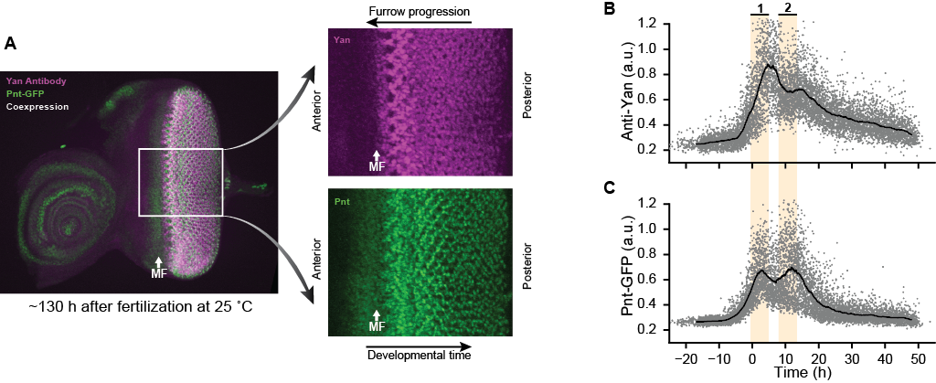

We also showed that neuronal fate commitment is governed by the Pnt to Yan Ratio, rather than the absolute abundance of either protein. My collaborators manually labeled each of the segmented cells with their respective cell type. These labels allowed us to independently analyze Yan and Pnt expression dynamics before, during, and after fate commitment (see Figure 2A-F). I considered the period during differentiation by comparing the first ten identified neurons of each cell type against concomitant multipotent cells. These comparisons reveal that neurons are recruited from multipotent cells with elevated Pnt to Yan ratios, rather than cells with only low Yan or high Pnt abundance (see Figure 2G-I). We further demonstrated that, while absolute levels change, Pnt to Yan ratios remain constant when Pnt gene dosage is varied (data not shown). The compensatory changes in Yan expression suggest that multipotent cells actively control their Pnt to Yan ratios.

Together, these results indicate that tightly coordinated competition between Yan and Pnt lies at the heart of neuronal fate commitment. These observations are consistent with the notion that Yan and Pnt compete for occupancy of shared binding sites in the promoter region of downstream effectors of neuronal differentiation45,46. Consequently, altering the expression dynamics of either protein is expected to increase the frequency of erroneous fate commitment, and subsequently increase the likelihood of a roughened eye phenotype.

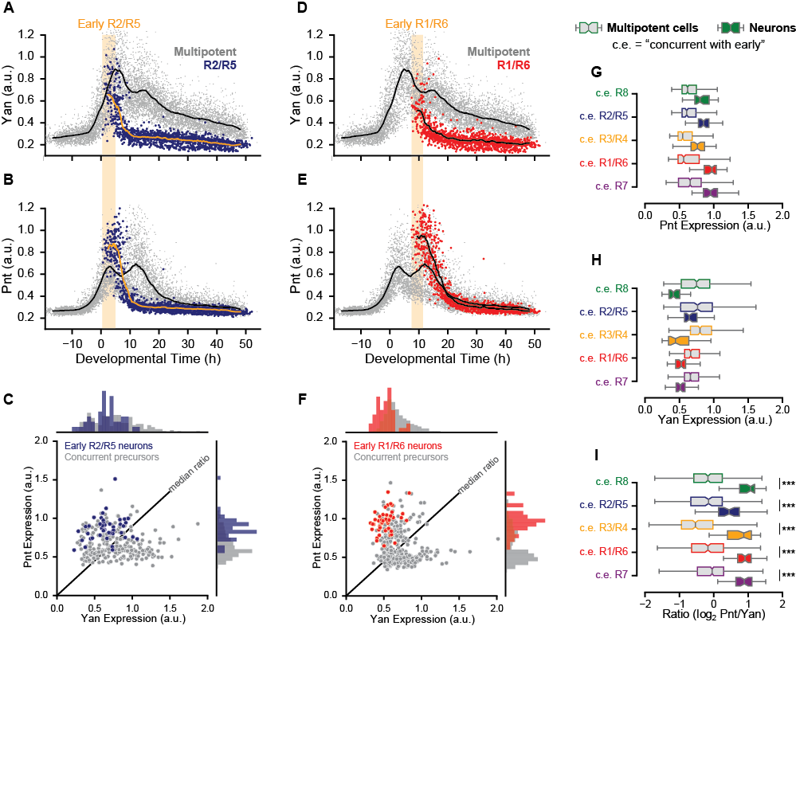

Figure 2: Photoreceptor neurons are recruited from multipotent cells with elevated Pnt to Yan expression ratios. (A-F) Pnt-GFP and anti-Yan expression dynamics in annotated R2/R5 (A-C, blue) and R1/R6 (D-F, red) neurons. Precursors are grey. Solid lines are smoothed moving averages across 250 and 50 samples for multipotent and neuronal cells. Yellow shading indicates time spanned by the first ten neurons in each disc. Joint distributions for (C) R2/R5 and (F) R1/R6 expression levels consist of cells spanning the early neuron regions. (G-I) Distributions of Pnt-GFP, anti-Yan, and log2-transformed ratio levels amongst early neurons (color fill) and concurrent multipotent (grey fill) cells. Two sample KS-tests indicate significant differences in all pairwise comparisons between neurons and their concurrent population of multipotent cells.

## Data: Experimental Perturbation of MiR-7 Activity

Normal eye development is contingent upon both Yan and Pnt expression dynamics. Yan is regulated at the gene, transcript, and protein levels41. The microRNA miR-7 inhibits Yan translation through complementary binding of its transcripts29. As shown in Figure 3B, the magnitude and duration of Yan expression appear to increase upon mutation of the *miR-7* complementary binding sequence. Prolonged Yan expression disrupts timely recruitment of neurons and leads to a roughened eye morphology42. The Carthew Lab’s experiments demonstrate that *miR-7* is largely dispensable when carbohydrate metabolism or protein biosynthesis rates are reduced (see Figure 3C-D).

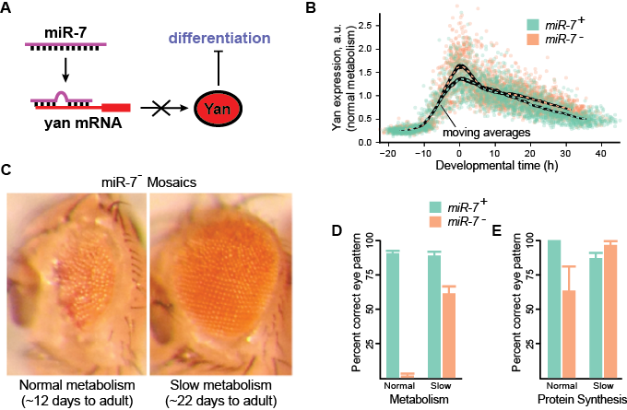

Figure 3: MiR-7 is rendered unnecessary when biosynthesis is slowed. (A) MiR-7 represses Yan translation by sequestering its mRNA, thus enabling differentiation. (B) Magnitude and duration of Yan expression increase upon mutation of the miR-7 complementary binding sequence. Points are individual progenitors compiled from several fixed tissue samples36. It is difficult to discern differences between the two populations from 10 h onward due to the high variability between biological replicates. (C) MiR-7 null mosaics exhibit a roughened eye phenotype. (D, E) Phenotype penetrance is reduced when either carbohydrate metabolism or protein biosynthesis are reduced.

## Aim 1A: Quantify the Necessity of MiR-7 for Normal Eye Development

I propose to computationally investigate the differential requirement for *miR-7* between biosynthesis conditions. Specifically, I will predict the frequency of fate commitment errors induced by restriction of miR-7 function under both normal and slowed biosynthesis conditions. I hypothesize that the frequency of fate commitment errors will diminish upon restriction of biosynthesis rates.

My approach necessitates a computational framework relating miR-7 function, global biosynthesis conditions, and fate commitment decisions. An overview of the proposed framework is presented in Figure 4. In my initial approach, I will consider an identical population of cells divorced from any spatiotemporal signaling context. Each cell will contain modular components representing the cellular processes leading to a fate commitment decision. I will develop a kinetic model of the biochemical network that governs neuronal recruitment during eye development. Model scope will begin with Notch-induced Yan expression, and end with Yan and Pnt-P2 activity. These activity time series will be passed through a competitive binding model in order to evaluate the Pnt-P2 binding site occupancy. I will evaluate the frequency of erroneous fate commitment decisions using an occupancy threshold model whose decision window is set by the transient activity of a distinct molecular signaling pathway. Combined, this modular framework enables quantitative prediction of developmental error frequencies upon restriction of miR-7 function.

The biochemical network governing Yan and Pnt expression dynamics has not been quantitatively characterized, but many of the qualitative interactions are known. Possible regulatory mechanisms acting to downregulate Yan expression include transcriptional repression by the Pnt-P1 isoform, post-transcriptional antagonism by miR-7, and post-translational modification by Mae (see Figure 4B). In the model, enzymatic rate laws will follow Hill kinetics, with parameters based on any available data and estimated where necessary. I will assign a sensitivity to biosynthesis conditions to each parameter. Sensitivity to each of these parameters will be explored through parameter sweeps.

Competition between Yan and Pnt for binding site occupancy will follow a simple competitive binding model based on mass-action kinetics:

 







where *Y* and *P* represent Yan and Pointed, and *YS* and *PS* represent their association with downstream binding sites, *S*. An analytical solution to this model was used to construct the occupancy spectrum in Figure 4C47. Consistent with the experimental system, binding site occupancy is more sensitive to changes in Pnt to Yan ratio than the absolute abundance of either species. In-vitro experiments in the literature provide quantitative estimates of the two species respective affinities for ETS binding domains, with Yan having almost two orders of magnitude greater binding strength.

A threshold model will relate Pnt-P2 binding site occupancy to the success or failure of fate commitment in each cell. The decision window will be set by the activity of a signaling pathway distinct from that which drives Yan activity. Threshold models have been used in many other contexts, most notably in demonstrating that genetic variation can lead to partial penetrance of developmental phenotypes48. In my initial approach, intrinsic noise will provide the only source of variability between cells. Should this fail to explain the experimental observations, extrinsic sources of variation may be introduced by sampling signaling dynamics from predefined distributions.

Using these models, I will quantify the necessity for miR-7 in coordinating photoreceptor recruitment. I will use Gillespie’s algorithm to simulate network dynamics amongst independent cells following transient activation of the upstream signaling pathways49. I will then repeat the simulations following reduction of miR-7 binding affinity for the *yan* transcript. In each case, I will quantify the fraction of cells that successfully achieve fate commitment. The decrease in successful fate commitment decisions following restriction of miR-7 activity reflects the requirement of miR-7 for proper eye development. MiR-7’s necessity will be re-evaluated upon restriction of biosynthesis rates. Simulations are expected to demonstrate that the frequency of erroneous fate commitment decisions increases upon elimination of miR-7. This requirement for miR-7 is expected to diminish upon restriction of biosynthesis rates.

Figure 4: Proposed approach for modeling penetrance of roughened eye phenotype following perturbation of miR-7. (A) Modular view of a multipotent cell. Cells integrate multiple parallel signals in order to render a fate commitment decision. These signals may be common to (pink) or distinct from (green) Yan activity (yellow and blue modules). Perturbing Yan activity desynchronizes the common and distinct signaling inputs to the fate commitment decision (purple). (B) Signals transduced via the Notch and EGFR pathways drive transient expression of Yan and Pnt, who compete for downstream binding sites. (C) Theoretical site occupancy in a two-species competitive binding model. Saturated conditions and equivalent binding affinities were used for illustrative purposes. Proportional increases in absolute abundance of each species have minimal impact on Pnt occupancy, while varying ratio confers maximal change. (D) Illustration of decision mechanism in which variability in gene expression underlies impartial penetrance of erroneous fate commitment. Figure is based on the work of Raj et al.48. Spatiotemporal integration of signals distinct from the Yan-Pnt network (panel A, green line) set a decision window during which Pnt binding site occupancy must exceed a predefined threshold to execute the correct decision. Genetic elimination of miR-7 is expected to incur an increase in the frequency of erroneous decisions.

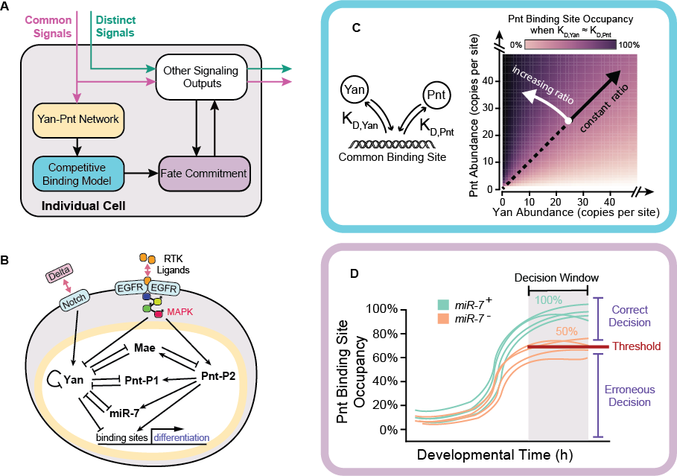

The model is based on molecular interactions governing photoreceptor recruitment in Drosophila, but this system is incompletely characterized. Alternate regulatory configurations may be considered should the model fail to recapitulate the anticipated behavior. Model scope could also be narrowed by only evaluating the impact of miR-7 on Yan expression, rather than differentiation. Parameter values may be unavailable for several of the interactions considered. Estimates and sensitivity analyses will be used as needed. Furthermore, cell populations could be embedded in a spatiotemporal context where adjacent cells’ incident signals are coupled by juxtacrine and paracrine signaling. This approach would enable multiscale simulation of retinal patterning similar to the work of Lubensky et al., but will be reserved for future work unless the present approach fails to recapitulate the hypothesized behavior40.

## Aim 1B: Validate Model by Predicting Yan Expression Dynamics

The computational framework will yield quantitative predictions surrounding Yan expression levels. Simulations are expected to recapitulate the pulsatile dynamics measured *in vivo*. Similarly, the magnitude and duration of Yan expression should increase upon elimination of *miR-7*. I hypothesize that these effects will diminish when biosynthesis is limited. These predictions may be validated through statistical comparison with experimental measurements. In particular, I will assemble aggregate time series of predicted and measured expression dynamics for each condition, then evaluate the cross correlation of their moving averages. I will generate confidence intervals for the correlation coefficient by bootstrap resampling the annotated cells used to construct each composite time series.

Accurately quantifying in vivo Yan expression dynamics is a non-trivial exercise. While the method developed by Pelaez et al. has proven invaluable for exploring the role of Yan and Pnt in coordinating neuronal fate commitment, Figure 3B suggests that the existing analysis pipeline lacks the precision and resolution required to definitively compare Yan-YFP expression dynamics between wildtype and ΔmiR-7 samples. I will use mathematical methods to surmount several of the challenges that prevent discernment of subtle differences between tissues obtained under different genetic backgrounds.

First, the existing analytical protocol relies upon manual alignment of expression time series. This was the case for biological replicates used to construct composite time series, as well as comparisons between experimental conditions. Manual alignment forces arbitrary prioritization of certain dynamic features over others, particularly when dynamics qualitatively differ between samples. I will develop an automated method for consistent, reproducible alignment of expression time series that equally considers the entire time course. In particular, I plan to align pairs of time series by maximizing the cross-correlation of their moving averages, *X(t)* and *Y(t)*:



where *dt* is a time delay. This procedure can be applied combinatorially between biological replicates, or pairwise between experimental conditions. The use of moving averages will desensitize alignment to measurement noise. Furthermore, the maximized cross-correlation provides a metric for similarity between time series. Cross correlation may fail to achieve adequate alignment when expression profiles qualitatively differ between conditions, in which case dynamic time warping might prove to be more appropriate.

Second, the existing pipeline identifies individual cells by image segmentation, then maps their spatial positions to developmental time under the assumption that developmental signaling progresses along the anterior-posterior axis of the imaginal disc with constant velocity. This assumption fails when significant three dimensional curvature and soft tissue deformation occur, as relative positions within the tissue are not conserved when cells’ Euclidean coordinates are projected onto 2-D space. I will first attempt to resolve this problem by computationally smoothing the segmented tissues. In particular, I will apply a Lloyd relaxation to a 2-D projection of annotated R8 neuron positions, then map the relaxed coordinates to developmental time. Multipotent cells’ positions will be interpolated from those of their differentiated neighbors. The relaxation maximizes the entropy of R8 positions, implicitly assuming regular spacing of adjacent columns of cells. This assumption is consistent with the known processes of retinal patterning which proceed in columnar fashion. I will evaluate the success of my approach by quantifying the quality of expression time series alignment between biological replicates using the aforementioned cross-correlation procedure. Improved alignment between biological replicates is indicative of increased measurement precision. Should Lloyd relaxation of R8 positions fail to improve measurement precision, two entirely different approaches are possible. First, I could map R8 positions to a regular lattice by formulating an integer linear programming problem in which I seek to minimize the distance and bond-angles between adjacent cells within the lattice, as well as the frequency of empty lattice sites. Alternatively, I could extend to the pipeline to include three-dimensional segmentation of cells, enabling projection of R8 coordinates onto a parameterized 2-D surface intersecting each of the R8 nuclei. Appropriate algorithms are available within the literature, but necessitate the development of a null model for validating 3-D segmentation performance.

Finally, the existing pipeline does not delineate multipotent cells by their local signaling context. I will develop analytical tools that enable quantitative comparison of spatiotemporal expression patterns. For instance, Yan expression may differ considerably between cells adjacent to R8 neurons and those that are far away, and this difference could be sensitive to genetic context. In this instance, binning cells by distance and relative orientation from their nearest R8 neighbor would facilitate detection of differences in expression between genetic conditions that are not apparent when only aggregate dynamics are considered.

## Progress and Deliverables

I view this aim as a mechanistic extension of the phenomenological work described in Aim 2, and feel that it could justify independent publication. Aim 1A represents an entirely new research avenue, and no progress has been made to date. Considerable progress has been made on Aim 1B. I have successfully built and deployed the proposed time series alignment methodology, and have made considerable progress on the platform for spatiotemporal analysis of expression dynamics. I have implemented several of the approaches toward digital smoothing of imaginal discs, but am yet to establish their efficacy.

Figure 5: Potential modifications to an existing pipeline for inference of protein expression dynamics from fixed eye imaginal discs36. (A) Given R8 neuron positions in 2-D space, inter-column distances (ICD) are proportionally mapped to developmental time assuming ommatidia are formed at a constant rate of one column per two hours. ICD are obtained from the x-component of Delaunay ridges oriented between 30° and 60° from the axis of furrow progression (solid orange line). (B) Curvature and soft tissue defects yield asymmetric compression and stretching of developmental time upon projection from 3-D to 2-D space. Green dots are 3-D coordinates of annotated R8 neurons, black dots are their corresponding 2-D projections. Delaunay triangulation in 3-D yields approximate tissue structure and orientation (green surface). Delaunay triangulation of 2-D projection is colored according to the ICD of each edge (red, blue lines). In this tissue, developmental time is stretched toward the anterior side of the disc. (C, D) Lloyd relaxation of projected R8 coordinates mitigates the effect of 3-D structure upon ICD. Black dots and lines are a Voronoi tessellation of projected R8 positions. The distribution of ICD narrows following Lloyd relaxation with reflective boundary conditions. Color scale is the same as in panel B. (E) Two samples (dots) are aligned by maximizing the cross correlation of their moving averages (solid lines).

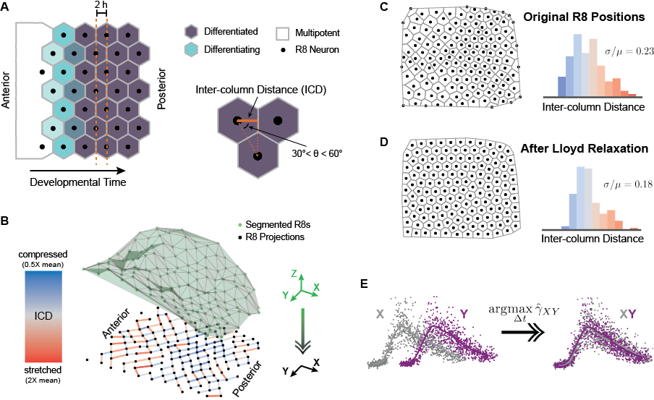

# Negative Feedback in Gene Expression Cascades

The breadth of experiments in *Drosophila* points toward a dynamic phenomenon agnostic to the molecular detail of repressors and their targets. To demonstrate the generality of my hypothesis, I propose a coarse-grained framework relating expression of a generic protein to population-wide phenotype distributions that does not depend upon the specifics of each developmental system. My goal is to predict how removal of a negative feedback mechanism causes protein levels within affected cells to differ from their unperturbed counterparts. As nuanced changes in expression yield abnormal morphologies *in vivo*, differences in protein levels manifest as differences in phenotype penetrance48. I aim to quantify both *how different a population of cells behaves* when negative feedback is removed and *how the magnitude of this difference depends upon biosynthesis rates*.

## Background: Negative Feedback in Developmental Processes

Negative feedback mechanisms serve many varied roles in developmental systems18. From an engineering perspective, the obvious application of negative feedback is in controlling cellular states – that is, rejecting exogenous disturbances and driving cells toward a desired set point. Computational studies have long demonstrated the biological advantages of various implementations of negative feedback, including adaptation to sustained disturbances17,50,51. However, the advent of advanced genetic tools and gene expression assays with high temporal and cellular resolution have recently shed light on the diverse functions of negative feedback *in vivo*.

In human engineered electrical systems, proportional feedback is known to linearize input-output relationships, thus improving information transmission by expanding dynamic range52. The same behavior has been reported in developmental signaling cascades11,37,53–55. Yi et al. used a FRET-based reporter of the Gα-subunit to demonstrate dose-response alignment of G-protein signaling activity at the highest level of the yeast pheromone response signaling cascade55. Yu et al. quantified pFus3 activity following pathway activation to demonstrate that pFus3-mediated negative feedback further increases signaling fidelity through dose-response alignment of subsequent stages of the pathway37. Paulsen et al. showed that a synexpressed negative regulator expands the dynamic range of BMP4 signaling in HEK293 cells11. The authors also demonstrated that feedback suppresses transduction of correlated extrinsic noise, further improving signal fidelity. Notably, in all of these cases computational models were used to demonstrate the dynamic principles underlying each of the experimental observations.

Paulsen et al. also report increased variation in *Xenopus* gene expression and morphology upon elimination of synexpressed negative feedback, suggesting that negative feedback can suppress phenotypic variation. Experiments in *Drosophila* point toward a similar role for microRNAs in buffering developmental processes against both environmental and genetic variability13–15. Li et al. qualitatively investigated the effects of temperature fluctuations on sensory organ development under perturbations to miR-7 activity13. The authors concluded that miR-7 stabilizes both gene expression and fate commitment decisions against environmental fluctuations during sensory organ development. Using directional selection to quantify the heritability of increased scutellar bristle formation, Cassidy et al. demonstrated that miR-9a canalizes development by suppressing the effects of genetic variants that promote bristle formation14. The same group later showed that miR-9a does not universally suppress the penetrance of genetic variants, as no measurable increase in heritability of decreased bristle formation was detected in the absence of miR-9a function15. The authors did, however, conclude that miR-9 directly suppresses the phenotypic penetrance of genetic variants deleterious to organismal fitness by measuring viability at elevated temperatures. Together, these studies implicate negative feedback mechanisms, particularly microRNAs in *Drosophila*, in promoting canalization. It remains unclear, however, precisely how this effect is achieved.

## Aim 2A: Model an Intermediate Step in a Gene Expression Cascade

In each experimental system, a stimulus induces expression of a protein whose activity is brought back to basal levels by multiple negative feedback loops. I modeled this configuration with a control theoretic depiction of the expression and regulation of an intermediate in a generic gene expression cascade (see Figure 6). Control theory provides a natural modeling framework owing to its treatment of complex nonlinear dynamics as linear deviations from steady state. The model incorporates a cascade of events describing the sequential processes of promoter binding, transcription, and translation, with repressors providing proportional feedback at each level. In particular, a linear time invariant system describes the time evolution of activated DNA (*D*), mRNA (*R*), and protein (*P*) state variables in response to a disturbance (*I*) inducing gene activation. These discrete state variables describe the extent of gene expression at any point in time. Transitions between each of the variables’ states are governed by a set of linear reaction propensities (Table 1). Rather than explicitly defined regulatory mechanisms, I abstract all modes of regulation as independent linear feedback terms:

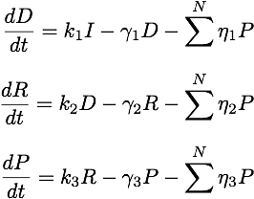

where *ki* are activation, transcription, or translation rate constants, *γi* are degradation constants, *ηi* are feedback strengths, and each species may be subject to *N* independent repressors. State variables are linearized about a steady state of zero stimulus and expressed in the Laplace frequency domain:





resulting in three algebraic equations relating deviations in input to deviations in protein:

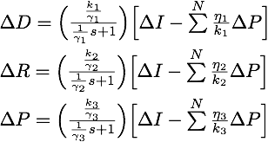

In control terminology, protein level is maintained at a basal steady state by proportional feedback in response to an upstream disturbance. The disturbance induces activation of a gene, which induces transcription of mRNAs, which proceed to induce translation of protein. This corresponds to three sequential first-order transfer functions with interspersed feedback relating deviations in the input to deviations in output protein level. The model provides a phenomenological description of expression dynamics rather than a detailed depiction of molecular events. This abstraction is a key strength as it enables extension to any pulsatile system. Furthermore, measured expression data may be characterized by a few induction and decay parameters.

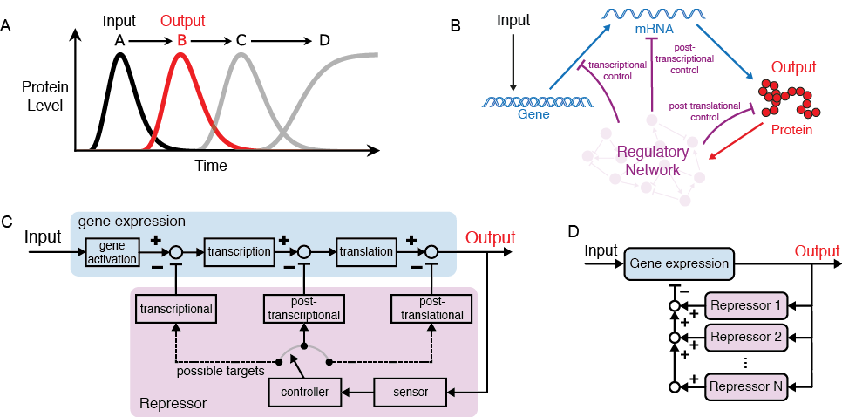

Figure 6: Modeling a generic gene within a developmental gene expression cascade. (A) Model scope focuses on the transient expression of a single gene within a cascade of developmental events culminating in cell fate commitment. (B) Input signal drives the expression (blue) of a protein output (red) subject to negative feedback (purple). (C) Control theoretic representation of a single feedback loop as depicted in panel B. Boxes contain transfer functions, open circles indicate summation points, and closed circles indicate exclusive switches for each repressor. (D) Gene expression may be subject to redundant repressors.

**Table 1: State transition propensity functions for the linear model**

|  |  |  |  |
| --- | --- | --- | --- |
| Reaction | State Transition | Propensity | Parameter Value [min­-1] |
| gene activation | ΔD 🡪 ΔD + 1 | k1 ΔI | 1 |
| transcription | ΔR 🡪 ΔR + 1 | k2 ΔD | 1 |
| translation | ΔP 🡪 ΔP + 1 | k3 ΔR | 1 |
| gene deactivation | ΔD 🡪 ΔD – 1 | γ1 ΔD | 1 |
| transcript decay | ΔR 🡪 ΔR – 1 | γ2 ΔR | 1 x 10-2 |
| protein decay | ΔP 🡪 ΔP – 1 | γ3 ΔP | 1 x 10-3 |
| transcriptional feedback | ΔD 🡪 ΔD – 1 | η1 ΔP | 1.25 x 10-4 |
| post-transcriptional feedback | ΔR 🡪 ΔR – 1 | η2 ΔP | 4.5 x 10-5 |
| post-translational feedback | ΔP 🡪 ΔP – 1 | η3 ΔP | 2.55 x 10-4 |

Gene activation, deactivation, transcription, transcript decay, translation, protein decay, and all modes of regulation are described by linear rate laws. While protein synthesis and gene-product decay are typically modeled as linear processes, transcriptional and regulatory kinetics are frequently described by nonlinear propensities56,57. I have also considered more complex modeling frameworks. First, the number of active sites firing transcription within a cell is limited by gene copy number, but the activated-DNA state in my simple linear model is unbounded. To test whether model results qualitatively persist when an upper bound on gene activity is introduced, I considered a two-state transcription model:

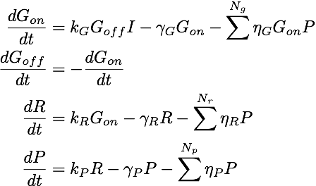

where *Gon*and *Goff* are the on- and off- states of a gene; *I*, *R* and *P* are the input, transcript, and protein levels; *ki*, *γi*, and *ηi* are the synthesis, decay, and feedback rate constants for species *i*; and *Ng*, *Nr*, and *Np* are the number of transcriptional, post-transcriptional, and post-translational repressors, respectively. Similarly, gene expression models frequently utilize cooperative binding kinetics in order to capture the nonlinearities and thresholds encountered in transcriptional regulation. To test whether simulation results qualitatively persist when nonlinear thresholds are introduced, I also reformulated my gene expression model in terms of Hill kinetics:

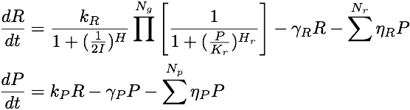

where *I*, *R*, and *P* are the input, transcript, and protein levels; *ki*, *γi*, and *ηi* are the synthesis, decay, and linear feedback rate constants for species *i*; *Nr*, and *Np* are the number of post-transcriptional, and post-translational linear repressors; *H* is a transcriptional Hill coefficient; and *Kr* and *Hr* are the half-maximal occupancy level and Hill coefficient of each of the *Ng* transcriptional repressors. The stimulus level corresponding to half-maximal transcription rate was fixed at 0.5 because I only considered a binary input signal. Rate parameters were scaled with biosynthesis conditions in a manner analogous to the linear model. The half-maximal occupancy level and Hill coefficients of transcriptional repressors were assumed to be independent of biosynthesis rates.

## Aim 2B: Quantify the Necessity of Negative Feedback in Expression Cascades

I used a Monte Carlo simulation procedure to quantify the frequency of developmental errors incurred through loss of a redundant repressor. First, I simulated state trajectories both with (redundant) and without (non-redundant) a second repressor. I set a default threshold at 30% of the maximum mean redundant output protein level distribution achieved throughout the time course. I defined a decision window, or commitment time, as the time elapsed when 99% of redundant simulations reached this threshold. Consequently, all redundant simulations exhibit a 1% error frequency by definition. I quantified the necessity of the removed repressor by evaluating the survival function of a normal fit to the non-redundant distribution at the commitment time. This metric approximates the population-wide phenotype penetrance in that it provides a quantitative estimate of the frequency with which cells with compromised feedback exhibit distinctly different behavior than cells in which feedback is unperturbed48. Figure 7 shows a demonstration of this procedure for a twofold reduction in post-translational feedback strength.

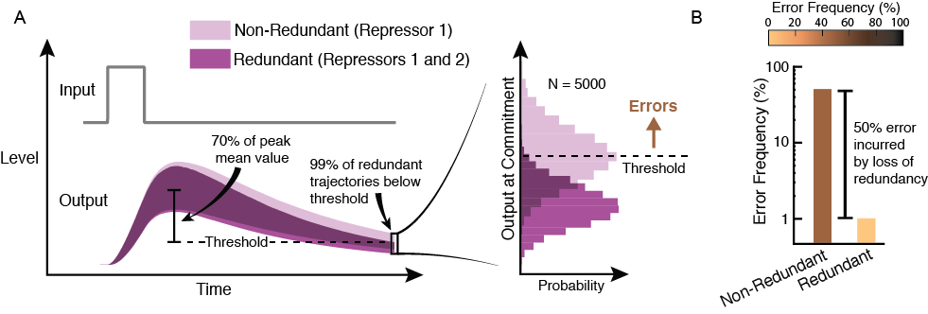

Figure 7: Quantifying the necessity of a generic repressor. (A, B) Example simulation: Loss of one of two post-translational repressors incurs 50% error. Error frequency is determined following stochastic simulation of output protein levels in response to a transient input signal, both with two repressors in place (control, dark purple) and with one repressor removed (light purple). Shaded regions correspond to 98% confidence band. Error frequency is taken to be the fraction of output levels in excess of a threshold defined by the 99th percentile of the control distribution. The comparison is made when the 99th percentile of the control distribution first falls below 30% of the control’s maximum mean value.

Default parameters were based on approximate transcript and protein synthesis and turnover rates for animal cells reported in the literature, while gene activation and decay rates were arbitrarily set to a significantly faster timescale. Default feedback strengths were chosen such that ~50% of simulations fail to reach the threshold when one of two identical repressors were removed. These values are shown in Table 1. Dynamic state distributions were reconstructed from 5000 approximate solutions of the chemical master equation in response to a three-hour transient step input to the gene activation rate. Solutions were obtained via a hybrid SSA/tau-leaping algorithm58,59. The algorithm constrains solutions to the set of discrete positive values, consistent with linearization about a basal level of zero gene activity. This simplifying assumption is based on the near-zero basal activities expected in the experimental systems, but is not required to support the conclusions of the model. Relaxing this assumption by simulating absolute gene expression levels in response to a transient step fold-change to a finite basal stimulus, the resultant trajectories can be expressed as deviations from the population-wide mean basal level, yielding qualitatively similar results.

## Aim 2C: Assess the Generality of the Experimentally Observed Phenomena

The modeling framework permits systematic characterization of differential error rates between fast and slow biosynthesis conditions. Carbohydrate metabolism and protein translation capacity affect the abundance of synthesis and degradation machinery for both transcripts and proteins60,61. Growth laws have been proposed for some organisms, but the exact relationships and any differential sensitivities are unknown62–64. The model incorporates energy dependence via fold-changes to each rate parameter. Reductions in cell metabolism and protein synthesis are incorporated as changes to the model’s rate parameters (Table 2). Transcription, translation, and protein degradation are taken to be ATP-dependent and are consequently halved under conditions of reduced metabolism. Under conditions of reduced protein synthesis, only the translation rate is assumed to be affected. In both cases, feedback strengths are reduced in order to account for the intermediate processes abstracted by each feedback element. Magnitudes of dependencies will later serve as a basis for sensitivity analysis.

**Table 2: Default model parameter dependence upon metabolic and protein synthesis rates**

|  |  |  |  |
| --- | --- | --- | --- |
| Parameter | Normal Growth | Slow Metabolism | Slow Translation |
| transcription rate constant | k2 | k2 | k2 |
| translation rate constant | k3 | k3 | k3 |
| protein decay rate constant | γ3 | γ3 | γ3 |
| transcriptional feedback strength | η1 | η1 | η1 |
| post-transcriptional feedback strength | η2 | η2 | η2 |
| post-translational feedback strength | η3 | η3 | η3 |

I systematically applied the framework across an order of magnitude variation in each of the model parameters to identify regions of the phase space in which error rates differ considerably between biosynthesis conditions. These are the behavioral regions in which redundant negative feedback facilitates faster development. Strikingly, the resultant phase maps reveal the universality of the experimentally observed phenomenon (available upon request). In nearly all scenarios considered, the frequency of errors induced by loss of negative feedback diminishes upon restriction of carbohydrate metabolism and biosynthesis rates. This is the case for repressors acting at the gene, transcript, and protein levels, or any combination thereof. It persists when the success threshold for success is varied, stimulus duration is scaled with biosynthesis rates, and when a non-zero basal stimulus is applied. The results also persist when the two-state transcription model or cooperative binding kinetics are used in place of the linear model. For brevity, I have only included a small sample of the results here. Figure 8 shows that error frequencies induced by removal of repressors acting at the gene, transcript, and protein levels are broadly suppressed when biosynthesis is limited.

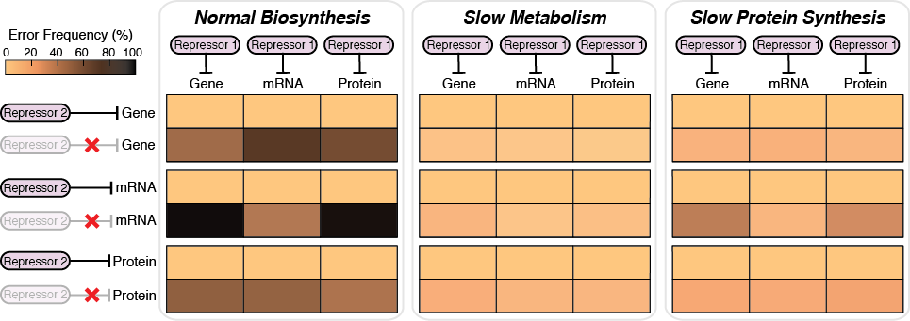

Figure 8: The necessity for redundant regulation diminished upon limitation of biosynthesis rates. The model predicts increased frequency of developmental error when only one repressor is present (left panel). Developmental accuracy recovers when carbohydrate metabolism and protein biosynthesis parameter values are reduced by 50% (middle, right panels).

Together, the simulations suggest that requirements for redundant regulation are relaxed upon limitation of biosynthesis rates. This is consistent with the broad range of *Drosophila* systems exhibiting reduced developmental error rates under slow growth conditions. Furthermore, it provides a plausible explanation for the surprising observation that microRNAs are almost entirely dispensable when biosynthesis rates are slow. By demonstrating the expected generality of this phenomenon, the model speaks toward the evolutionary significance of negative feedback in shaping gene regulatory network topologies. It also clarifies the role fulfilled by the many redundant regulatory motifs found in biological systems.

As it stands, the implied mechanism through which developmental errors are broadly suppressed upon restriction of biosynthesis lacks experimental validation. Unfortunately, because the model presents an abstract view of many incompletely characterized developmental systems, simultaneous experimental measurement of relevant genes is technically infeasible. I propose to use a validation experiment of limited developmental scope, such as that described in Aim 1B, to validate the more general model proposed here.

I do not contend that all systems using pulsatile expression to realize cellular decisions elicit the described behavior. The transient stimulus, proportional feedback, and threshold-based decision mechanism modeled here represent one of many possible configurations that may exist *in vivo*. It is also likely that some systems respond qualitatively differently to changes in biosynthesis rates than others. Rather, I propose that the dynamic behavior described by my abstract model is sufficiently common that it provides a non-negligible driving force for increased redundancy in gene regulatory networks.

## Progress and Deliverables

Excluding validation, this aim is complete in its proposed form. I have co-authored a manuscript that will report the described results in conjunction with the accompanying experiments. The manuscript is currently under preparation for submission, pending the completion of a validation experiment akin to Aim 1B.

# Negative Feedback in the Yeast Pheromone Response Pathway

## Background: The Yeast Pheromone Response Pathway

The yeast pheromone response is one of the most well characterized signaling processes in eukaryotes65. When haploid cells of the species *Saccharomyces cerevisiae* are exposed to a mating pheromone, the cells arrest at the G1/S checkpoint of the cell cycle, extend morphological projections from their spherical cell surface, and fuse with other haploid cells to make a diploid cell. The pathway is triggered in *MAT***a** genotype cells when G-protein coupled receptors encounter α-Factor peptide secreted by *MAT*α cells. The resultant signal transduction cascade elicits all the described cellular effects (see Figure 9). Cell cycle arrest is mediated by *Far1* following its activation by phosphorylated Fus3, a MAPK protein whose activity is coordinated by multiple negative feedback mechanisms that attenuate signaling throughout the cascade37,66–68. Notably, these feedback mechanisms confer adaptation; they restore pathway activity to basal levels even in the sustained presence of mating pheromone. When pathway activity reaches sufficiently low levels, cells re-enter the cell cycle and resume normal growth. Perturbations to the feedback structure increase cell cycle arrest duration, sometimes leading to permanent growth restriction.

The pathway provides fertile ground for testing my hypothesis. It constitutes an alternate context in which transient activity of a protein subject to redundant negative feedback mediates a cellular decision. Cells remain in an arrested state for abnormally long times when negative feedback is removed. I hypothesize that increases in arrest durations will be less severe when biosynthesis is slowed. I propose to develop a computational framework for independently testing this hypothesis for each of the relevant negative feedback mechanisms. Specifically, I will (1) develop a kinetic model of cell cycle arrest and re-entry dynamics in response to pathway stimulation, (2) identify feedback mechanisms whose utility diminishes upon restriction of biosynthesis rates, and (3) make quantitative predictions that will be compared against *in vivo* measurements made by my experimental collaborators.

## Aim 3A: Model Cell Cycle Arrest and Re-entry Dynamics

I propose to build a kinetic model of the pheromone response pathway in order to quantify the contribution of each known regulatory mechanism toward restoring normal cell growth following stimulation of pathway activity. My efforts will rely upon prior work known to the field. All of the pathway components have been identified and their expression dynamics quantified in many cases55,69,70. Dynamic behaviors of the G-protein cycle, MAPK signaling cascade, and Far1-mediated cell cycle arrest have also been reproduced *in silico*55,70–73. Existing models provide a reference for reactions and rate parameters, and will assist in identifying relevant components for inclusion.

Existing models include a broad variety of negative feedback loops that attenuate pathway activity at varying points in the cascade37,55,70–75. My initial model will consider the four feedback loops shown in Figure 9. I chose these particular feedback mechanisms because, while they all confer adaptation to persistent pheromone stimulation, they act in both qualitatively different ways and on quantitatively different timescales. Pathway activation stimulates the expression and translocation of a diffusible protein, Bar1, that degrades extracellular α-Factor65. This mechanism confers feedback inhibition by decreasing the rate of upstream pathway activation. The pathway also stimulates expression of Sst2, a protein that catalytically increases the rate of re-association of the G-protein heterotrimer by approximately two orders of magnitude76–78. This feedback mechanism attenuates pathway activity by increasing the rate of upstream pathway deactivation. Each of these negative feedback mechanisms are driven by the active MAPK, pFus3, that stimulates the mating program. The active MAPK also phosphorylates Ptp3, a phosphatase that reciprocally dephosphorylates pFus3 in the cytoplasm. This mechanism attenuates signaling by direct feedback deactivation on a relatively fast time scale. Finally, pFus3 activity transcriptionally upregulates expression of Msg5, a phosphatase that dephosphorylates pFus3 in the nucleus79. This mechanism attenuates signaling by indirect feedback deactivation on a relatively slow time scale, as the transcription and translation of Msg5 introduce non-negligible time delays. Combined, these four negative feedback loops provide a qualitatively diverse survey of the regulatory mechanisms that confer adaptation to sustained pathway stimulation.

The exact mechanism by which pathway components coordinate G1 arrest has not been completely characterized. Cell cycle arrest is partially mediated by Far1, a downstream effector of pFus3 activity. Prior studies have established that pathway-induced G1 arrest requires Fus3-mediated phosphorylation of Far180. Phosphorylated Far1 has been shown to associate with the cyclin-dependent kinase Cdc2867. As Cdc28 is a master regulator of the yeast cell cycle, its association with Far1 prevents induction of the G1 cyclins, thus inhibiting cell cycle progression65. Pathway activation has also been shown to inhibit the induction of G1 cyclins by a mechanism that circumvents Far1. Namely, pFus3 inhibits the activation of G1 cyclins by Cdc2866. More recently, FRET-based quantification of Fus3 activity in individual cells confirmed that Fus3 activity and Far1-mediated cell cycle arrest are mutually coupled75. These results present several possible options for relating pathway activity to G1 arrest and re-entry within the proposed model. In either case, I will represent the cellular decision using a threshold model. Thresholds will initially be placed on Far1 activity, but could similarly be moved up- or downstream within the signaling network topology.

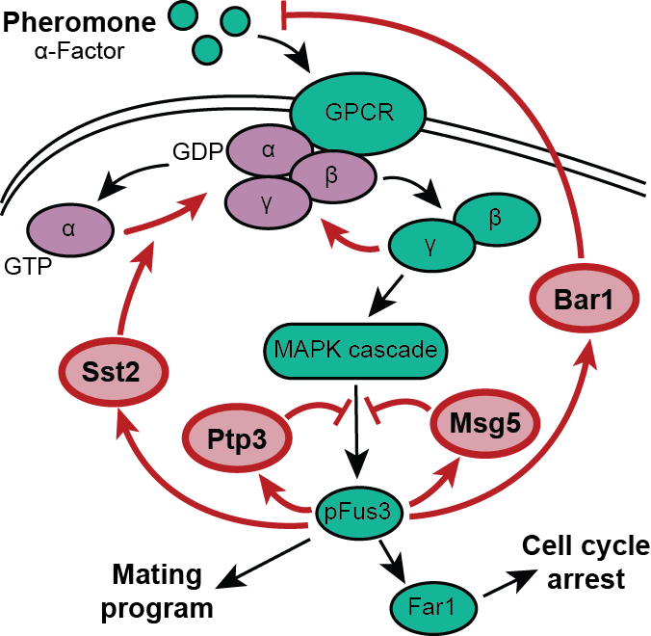

Figure 9: Pheromone response in *MAT*a yeast. α-Factor binds a tetrameric G-protein coupled receptor causing the Gα subunit to exchange GDP for GTP, liberating the Gβγ subunit for pathway activation. The MAPK pFus3 promotes cell cycle arrest and the mating program. Negative feedback attenuates pathway activity throughout the cascade. Components are excluded for simplicity.

The model will consist of many coupled ordinary differential equations describing the induction, decay, and interaction of each molecular species. Reactions will follow Hill kinetics, and each parameter will be assigned an appropriate sensitivity to biosynthesis conditions.

Yeast biosynthesis rates can be manipulated via temperature, the carbon source on which cells are grown, or by administration of rapamycin81. In the model, temperature will globally influence all elementary reaction rates in accordance with Arrhenius law. Carbohydrate growth substrates will influence transcription, translation, and degradation rates in accordance with their anticipated effects on cell energy metabolism82r. Administration of rapamycin inhibits the activities of TOR protein kinases, whose global effects on cell physiology are far reaching. In general, these kinases regulate the balance between protein production and turnover, and thus will strongly affect the biosynthesis rate constants83. Combined, these model dependencies upon physiological conditions will facilitate comparison of differential requirements for negative feedback between biosynthesis conditions.

Prior studies indicate that substantial crosstalk occurs between the nutrient sensing and mating response pathways84. These interactions have not been extensively characterized, but may complicate the effects of substrate quality and rapamycin upon the synthesis and regulation of all pathway components. Where necessary, I will use informed assumptions and sensitivity analyses to compensate for knowledge gaps.

## Aim 3B: Quantify the Necessity of Negative Feedback for Normal Cell Behavior

My goal is to predict differential requirements for each regulatory mechanism between biosynthesis conditions. To this end, I will develop a Monte Carlo simulation procedure to quantify the necessity of a given negative feedback mechanism. Using the previously described model, I will stochastically simulate pathway-induced cell cycle arrest and re-entry dynamics amongst a population of independent cells subject to a sustained pheromone stimulus49. I will then repeat the simulations following removal of each feedback mechanism. To quantify the necessity of each perturbed feedback mechanism, I will compare the resultant distributions of G1 arrest durations with those obtained from the simulations in which feedback is unperturbed. I will repeat the procedure upon restriction of biosynthesis rates, enabling systematic identification of the perturbations imparting the most distinctly different behavior between physiological conditions.

Simulations will yield Fus3 and Far1 activity time series for each condition, along with distributions of cell cycle arrest durations. These distributions should shift toward longer arrest durations when negative feedback is removed. I hypothesize that the magnitude of these shifts will decrease upon restriction of biosynthesis due to reduced dependency upon the removed feedback mechanism. Results should vary between regulatory perturbations because each mechanism plays a quantitatively different role in regulating pathway activity. Altogether, I expect the simulations to qualitatively recapitulate the phenotype-rescue phenomenon observed in *Drosophila*.

Simulation results are expected to depend upon model parameter values. While these parameters will be based upon experimental data where possible, considerable uncertainty will remain for many aspects of the model. This uncertainty will pervade the reaction rate constants, the pFus3 or pFar1 thresholds for cell-cycle arrest and re-entry, and the relative sensitivities of synthesis and turnover rates to physiological conditions. I will explore the sensitivity of model results to parameter values by constructing detailed phase maps across the parameter space. This approach will require many repeated simulations, and may incur considerable computational cost because the efficiency of Gillespie’s algorithm suffers when timescale separations arise between rate parameters49. Hybrid tau-leaping offers one solution by aggregating firing events of species whose abundance varies on slower timescales58. Alternatively, analytical solution of the chemical master equation for the time evolution of the statistical moments of Fus3 and Far1 level distributions would eliminate the need for repeated simulations, while preserving intrinsic variability85. Moment closure techniques will be necessary as the proposed model will utilize nonlinear kinetics86,87. Quasi-random sampling will also be used to obtain an efficient survey of the parameter space.

## Aim 3C: Validate Model by Predicting G1 Arrest Durations

The pheromone response pathway is particularly amenable to experimental validation of model predictions. Biosynthesis rates are readily manipulated by temperature control, substituting the carbon substrate on which cells are grown, or by administration of rapamycin. The phenotype of interest, growth arrest, is quantifiable for large numbers of cells through either manual or automated annotation of microscope images. In addition, halo assays facilitate efficient screening for mutations and biosynthesis conditions that substantially affect cell cycle arrest dynamics88. Reporters are available for key model components, such as Fus3, allowing measurement of gene expression dynamics with single-cell resolution75. Together, these features facilitate quantitative validation of model predictions.

The framework I have proposed will enable prediction of several measurable quantities. As my research seeks to explain the emergence of macroscopic phenotype distributions from microscopic expression dynamics, my predictions must address both scales. At the highest level, I will qualitatively predict which feedback mechanisms will be rendered unnecessary under each manipulation of biosynthesis rates. Next, for each condition I will predict the duration of G1 arrest in response to saturating levels of pheromone for a large population of cells. I will compare these G1 arrest duration distributions against their experimentally measured counterparts using the Kolmogorov-Smirnov two sample test. I have chosen this nonparametric statistical test because it makes no assumptions regarding the properties of each distribution. If excessive uncertainty in model parameter values prevents accurate prediction of cell cycle arrest durations, I may instead focus on predicting relative changes in arrest durations upon removal of a feedback mechanism. For instance, I may predict the fraction of perturbed cells whose arrest durations exceed the 99th percentile of the corresponding distribution for unperturbed cells (see Figure 10). At the lowest level, I will predict 95% confidence bands for Fus3 expression time series. These may be approximately compared with corresponding single-cell measurement of pFus3 activity by evaluating the cross-correlation of their moving averages. Confidence intervals may be constructed by bootstrap resampling. Combined, these approaches facilitate quantitative validation of the proposed simulation framework.

## Progress and Deliverables

Minimal progress has been made on this aim. As a proof of concept, I have successfully reproduced the work of Yi et al. in modeling G-protein cycle dynamics55. Once complete, this aim would justify publication of a single manuscript in conjunction with the accompanying experiments.

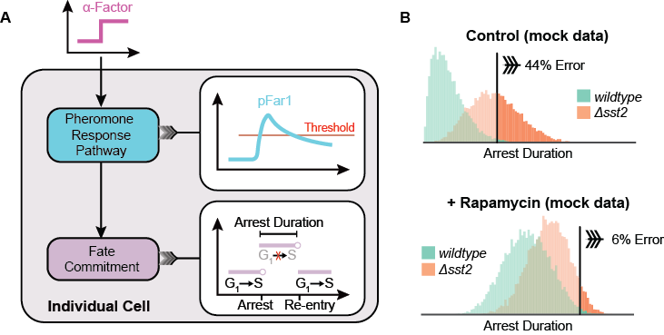

Figure 10: Quantifying the necessity of a negative feedback mechanism acting upon pheromone response pathway activity. (A) Schematic of simulation procedure within an individual cell. A kinetic model followed by a threshold-based fate commitment decision relates a step change in α-Factor abundance to G1 arrest duration. (B) Demonstration of potential analysis procedure using mock data. Repeated stochastic simulations amongst a population of independent cells yield distributions of G1 arrest durations. For each condition, developmental error is taken to be the fraction of mutant cells whose arrest durations exceed the 99th percentile of the wildtype distribution.

# Summary and Future Directions

My research seeks to elucidate, characterize, and assess the generality of an unexpected role for redundant regulatory features in enabling faster growth and development. My computational study will build upon existing experimental evidence by investigating the underlying biomolecular processes that are experimentally inaccessible in most cases. By testing hypotheses at the single-cell resolution *in silico*, I will generate population-aggregate predictions amenable to experimental validation. For each system, I will quantitatively predict the dynamic behavior of specific proteins under varied physiological conditions. My research will motivate direct *in vivo* measurement of the corresponding proteins in both *Drosophila* and budding yeast. Quantitative measurements will be used to validate the proposed mechanism while facilitating refinement of model parameters. Increased model fidelity will inspire further experiments designed to probe the boundaries between differing behavioral regimes. In this sense, my computational models will serve as a hypothesis generation device. Proposed experimental interventions might involve engineering repressors with tunable strength or redundancy.

Aim 2 describes a generalized framework for assessing the extent to which proportional feedback control within transient gene expression cascades enables faster growth and development. Proportional control is sufficient for restoring basal expression levels when expression is driven by a transient stimulus. This is likely within most developmental contexts, but other systems could employ integral feedback to attenuate constitutively active stimuli51. Future work could involve extending the model and simulation procedure to incorporate constant stimulation and integral feedback. This approach would further assess the generality of my hypothesis by expanding the scope of developmental systems considered.

My hypothesis suggests both unicellular and multicellular eukaryotic species may increase their fitness by accumulating redundant regulatory mechanisms that allow them to develop faster. Future work may include simulating the evolution of gene regulatory network topologies *in silico*. A population of networks could be subject to repeated cycles of mutation and selection on the basis of developmental errors and resource consumption. The topological trends could be compared against those inferred from literature data. Understanding the driving forces behind the evolution of gene regulatory networks will improve our ability to infer and control their behavior.

**References**

1. Bor, G., Zsi, B., Van Oudenaarden, A. & Collins, J. J. Cellular Decision Making and Biological Noise: From Microbes to Mammals. *Cell* **144,** 910–925 (2011).

2. Hartman, J. L. I. V, Garvik, B. & Hartwell, L. Principles for the Buffering of Genetic Variation. *Science (80-. ).* **1001,** 1–5 (2001).

3. Waddington, C. H. Canalization of Development and the Inheritance of Acquired Characters. *Nature* **150,** 563–565 (1942).

4. Scharloo, W. Canalization: genetic and developmental aspects. *Annu. Rev. Ecol. Syst.* **22,** 65–93 (1991).

5. Bateman, K. G. The genetic assimilation of four venation phenocopies. *J. Genet.* **56,** 443–474 (1959).

6. Rendel, J. M., Sheldon, B. L. & Finlay, D. E. Selection for Canalization of the Scute Phenotype. II. *Am. Nat.* **100,** 13–31 (1966).

7. Rendel, J. M. Canalisation of the scute phenotype of Drosophila. *Evolution (N. Y).* **13,** 425–439 (1959).

8. Dun, R. B. & Fraser, A. S. Selection for an Invariant Character - ‘Vibrissa Number’ - in the House Mouse. *Nature* **182,** 1638–1640 (1958).

9. Rutherford, S. L. & Lindquist, S. Hsp90 as a capacitor for morphological evolution. *Nature* **396,** 336–342 (1998).

10. Gibson, G. & Hogness, D. S. Effect of Polymorphism in the Drosophila Regulatory Gene Ultrabithorax on Homeotic Stability. *Science (80-. ).* **271,** 200–203 (1996).

11. Paulsen, M., Legewie, S., Eils, R., Karaulanov, E. & Niehrs, C. Negative feedback in the bone morphogenetic protein 4 (BMP4) synexpression group governs its dynamic signaling range and canalizes development. *Proc. Natl. Acad. Sci.* **108,** 10202–10207 (2011).

12. Denby, C. M., Im, J. H., Yu, R. C., Pesce, C. G. & Brem, R. B. Negative feedback confers mutational robustness in yeast transcription factor regulation. *Proc. Natl. Acad. Sci.* **109,** 3874–3878 (2012).

13. Li, X., Cassidy, J. J., Reinke, C. A., Fischboeck, S. & Carthew, R. W. A MicroRNA Imparts Robustness against Environmental Fluctuation during Development. *Cell* **137,** 273–282 (2009).

14. Cassidy, J. J. *et al.* MiR-9a minimizes the phenotypic impact of genomic diversity by buffering a transcription factor. *Cell* **155,** 1556–1567 (2013).

15. Cassidy, J. J., Straughan, A. J. & Carthew, R. W. Differential masking of natural genetic variation by miR-9a in Drosophila. *Genetics* **202,** 675–687 (2016).

16. Eldar, A. *et al.* Robustness of the BMP morphogen gradient in Drosophila embryonic patterning. *Nature* **419,** 304–308 (2002).

17. Alon, U. Network motifs: theory and experimental approaches. *Nat. Rev. Genet.* **8,** 450–61 (2007).

18. Freeman, M. Feedback control of intercellular signalling in development. *Nature* **408,** 313–319 (2000).

19. Marciano, D. C. *et al.* Negative Feedback in Genetic Circuits Confers Evolutionary Resilience and Capacitance. *Cell Rep.* **7,** 1789–1795 (2014).

20. Kitano, H. Biological Robustness. *Nat. Rev. Genet.* **837,** 826–837 (2004).

21. Siegal, M. L. & Leu, J.-Y. On the Nature and Evolutionary Impact of Phenotypic Robustness Mechanisms. *Annu. Rev. Ecol. Evol. Syst.* **45,** 495–517 (2014).

22. Siegal, M. L. & Bergman, A. Waddington’s canalization revisited: developmental stability and evolution. *Proc. Natl. Acad. Sci. U. S. A.* **99,** 10528–10532 (2002).

23. Bergman, A. & Siegal, M. L. Evolutionary capacitance as a general feature of complex gene networks. *Nature* **424,** 549–552 (2003).

24. Wagner, A. How the global structure of protein interaction networks evolves. *Proc. Biol. Sci.* **270,** 457–66 (2003).

25. Lynch, M. The evolution of genetic networks by non-adaptive processes. *Nat. Rev. Genet.* **8,** 803–13 (2007).

26. McAdams, H. H. & Arkin, A. It’s a noisy business! Genetic regulation at the nanomolar scale. *Trends in Genetics* **15,** 65–69 (1999).

27. Nowak, M. A., Boerlijst, M. C., Cooke, J. & Maynard Smith, J. Evolution of genetic redundancy. *Nature* **388,** 167–71 (1997).

28. Wagner, A. Robustness against mutations in genetic networks of yeast. *Nat. Genet.* **24,** 355–61 (2000).

29. Li, X. & Carthew, R. W. A microRNA mediates EGF receptor signaling and promotes photoreceptor differentiation in the Drosophila eye. *Cell* **123,** 1267–1277 (2005).

30. Neumann, C. J. & Cohen, S. M. Sternopleural is a regulatory mutation of wingless with both dominant and recessive effects on larval development of Drosophila melanogaster. *Genetics* **142,** 1147–1155 (1996).

31. Van Doren, M., Bailey, A. M., Esnayra, J., Ede, K. & Posakony, J. W. Negative regulation of proneural gene activity: Hairy is a direct transcriptional repressor of achaete. *Genes Dev.* **8,** 2729–2742 (1994).

32. Li, Y., Wang, F., Lee, J. A. & Gao, F. B. MicroRNA-9a ensures the precise specification of sensory organ precursors in Drosophila. *Genes Dev.* **20,** 2793–2805 (2006).

33. Carthew, R. W. & Sontheimer, E. J. Origins and Mechanisms of miRNAs and siRNAs. *Cell* **136,** 642–655 (2009).

34. Rulifson, E. J., Kim, S. K. & Nusse, R. Ablation of insulin-producing neurons in flies: growth and diabetic phenotypes. *Science* **296,** 1118–20 (2002).

35. Sæbøe-Larssen, S., Lyamouri, M., Merriam, J., Oksvold, M. P. & Lambertsson, A. Ribosomal protein insufficiency and the minute syndrome in drosophila: A dose-response relationship. *Genetics* **148,** 1215–1224 (1998).

36. Peláez, N. *et al.* Dynamics and heterogeneity of a fate determinant during transition towards cell differentiation. *Elife* **4,** e08924 (2015).

37. Yu, R. C. *et al.* Negative feedback that improves information transmission in yeast signalling. *Nature* **456,** 755–61 (2008).

38. Ready, D. F., Hanson, T. E. & Benzer, S. Development of the Drosophila retina, a neurocrystalline lattice. *Dev. Biol.* **53,** 217–240 (1976).

39. Tomlinson, A. & Ready, D. F. Neuronal differentiation in the Drosophila ommatidium. *Dev. Biol.* **120,** 366–376 (1987).

40. Lubensky, D. K., Pennington, M. W., Shraiman, B. I. & Baker, N. E. A dynamical model of ommatidial crystal formation. *Proc. Natl. Acad. Sci.* **108,** 11145–11150 (2011).

41. Rebay, I. & Rubin, G. M. Yan Functions as a General Inhibitor of Differentiation and Is Negatively Regulated by Activation of the Rasl/MAPK Pathway. *Cell* **81,** 857–866 (1995).

42. Lai, Z.-C. & Rubin, G. M. Negative Control of Photoreceptor Development in Drosophila by the Product of the yan Gene, an ETS Domain Protein. *Cell* **70,** (1992).

43. Graham, T. G. W., Tabei, S. M. A., Dinner, A. R. & Rebay, I. Modeling bistable cell-fate choices in the Drosophila eye: qualitative and quantitative perspectives. *Development* **137,** 2265–78 (2010).

44. Boisclair Lachance, J.-F. *et al.* A comparative study of Pointed and Yan expression reveals new complexity to the transcriptional networks downstream of receptor tyrosine kinase signaling. *Dev. Biol.* **385,** 263–278 (2014).

45. O’Neill, E. M., Rebay, I., Tjian, R. & Rubin, G. The Activities of Two Ets-Related Transcription Factors Required for Drosophila Eye Development Are Modulated by the Ras/MAPK Pathway. *Cell* **78,** 137–147 (1994).

46. Gabay, L. *et al.* EGF receptor signaling induces pointed P1 transcription and inactivates Yan protein in the Drosophila embryonic ventral ectoderm. *Development* **122,** 3355–3362 (1996).

47. Wang, Z. X. An exact mathematical expression for describing competitive binding of two different ligands to a protein molecule. *FEBS Lett.* **360,** 111–114 (1995).

48. Raj, A., Rifkin, S. A., Andersen, E. & van Oudenaarden, A. Variability in gene expression underlies incomplete penetrance. *Nature* **463,** 913–8 (2010).

49. Gillespie, D. T. Exact Stochastic Simulation of Coupled Chemical Reactions. *J. Phys. Chem.* **81,** 2340–2361 (1977).

50. Behar, M., Hao, N., Dohlman, H. G. & Elston, T. C. Mathematical and computational analysis of adaptation via feedback inhibition in signal transduction pathways. *Biophys. J.* **93,** 806–21 (2007).

51. Yi, T. M., Huang, Y., Simon, M. I. & Doyle, J. Robust perfect adaptation in bacterial chemotaxis through integral feedback control. *Proc. Natl. Acad. Sci.* **97,** 4649–53 (2000).

52. Black, H. S. & Aiee, M. Stabilized Feed-Back Amplifiers.

53. Cheong, R., Rhee, A., Wang, C. J., Nemenman, I. & Levchenko, A. Information Transduction Capacity of Noisy Biochemical Signaling Networks. *Science (80-. ).* **334,** 354–358 (2011).

54. Bhalla, U. S., Ram, P. T. & Iyengar, R. MAP Kinase Phosphatase As a Locus of Flexibility in a Mitogen-Activated Protein Kinase Signaling Network. *Science (80-. ).* **297,** 1018–1023 (2002).

55. Yi, T.-M., Kitano, H. & Simon, M. I. A quantitative characterization of the yeast heterotrimeric G protein cycle. *Proc. Natl. Acad. Sci. U. S. A.* **100,** 10764–9 (2003).

56. Bhalla, U. S. & Iyengar, R. Emergent Properties of Networks of Biological Signaling Pathways. *Sci. Bioinorg. Chem. Chem. Biol. Nat. Beechem Biophys. J. Proc. Natl. Acad. Sci. U.S.A. J. Phys. Chem* **381,** 1247–12759 (1999).

57. Weng, G., Bhalla, U. S. & Iyengar, R. Complexity in biological signaling systems. *Science* **284,** 92–96 (1999).

58. Cao, Y., Gillespie, D. T. & Petzold, L. R. Avoiding negative populations in explicit Poisson tau-leaping. *J. Chem. Phys.* **123,** 54104 (2005).

59. Cao, Y. & Samuels, D. C. in 115–140 (2009). doi:10.1016/S0076-6879(08)03805-6

60. Klumpp, S., Zhang, Z. & Hwa, T. Growth Rate-Dependent Global Effects on Gene Expression in Bacteria. *Cell* **139,** 1366–1375 (2009).

61. Klumpp, S. & Hwa, T. Bacterial growth: Global effects on gene expression, growth feedback and proteome partition. *Current Opinion in Biotechnology* **28,** (2014).

62. Scott, M. & Hwa, T. Bacterial growth laws and their applications. *Curr. Opin. Biotechnol.* (2011). doi:10.1016/j.copbio.2011.04.014

63. Scott, M., Klumpp, S., Mateescu, E. & Hwa, T. Emergence of robust growth laws from optimal regulation of ribosome synthesis. *Mol. Syst. Biol.* **10,** (2014).

64. Maitra, A. & Dill, K. A. Bacterial growth laws reflect the evolutionary importance of energy efficiency. *Proc. Natl. Acad. Sci.* **112,** 406–411 (2015).

65. Bardwell, L. A walk-through of the yeast mating pheromone response pathway. *Peptides* **26,** 339–50 (2005).

66. Cherkasova, V., Lyons, D. M. & Elion, E. A. Fus3p and Kss1p Control G1 Arrest in Saccharomyces cerevisiae Through a Balance of Distinct Arrest and Proliferative Functions That Operate in Parallel With Far1p. *Genetics* **151,** 989–1004 (1999).

67. Tyers, M. & Futcher, B. Far1 and Fus3 link the mating pheromone signal transduction pathway to three G1-phase Cdc28 kinase complexes. *Mol. Cell. Biol.* **13,** 5659–69 (1993).

68. Peter, M., Gartner, A., Horecka, J., Ammerer, G. & Herskowitz, I. Far1 links the signal transduction pathway to the cell cycle machinery. *Cell* **78,** 747–760 (1993).

69. Kofahl, B. & Klipp, E. Modelling the dynamics of the yeast pheromone pathway. *Yeast* **21,** 831–850 (2004).

70. Shao, D., Zheng, W., Qiu, W., Ouyang, Q. & Tang, C. Dynamic Studies of Scaffold-Dependent Mating Pathway in Yeast. *Biophys. J.* **91,** 3986–4001 (2006).

71. Hao, N., Behar, M., Elston, T. & Dohlman, H. Systems biology analysis of G protein and MAP kinase signaling in yeast. *Oncogene* **26,** 3254–3266 (2007).

72. Li, W., Yi, M. & Zou, X. Mathematical modeling reveals the mechanisms of feedforward regulation in cell fate decisions in budding yeast. *Quant. Biol.* **3,** 55–68 (2015).

73. Dyjack, N., Azeredo-Tseng, C. & Yildirim, N. Mathematical modeling reveals differential regulation of MAPK activity by phosphatase proteins in the yeast pheromone response pathway. *Mol. BioSyst. Mol. BioSyst* **13,** 1323–1335 (2017).

74. Dohlman, H. G. & Thorner, J. W. REGULATION OF G PROTEIN–INITIATED SIGNAL TRANSDUCTION IN YEAST: Paradigms and Principles. *Annu. Rev. Biochem* **70,** 703–54 (2001).

75. Conlon, P., Gelin-Licht, R., Ganesan, A., Zhang, J. & Levchenko, A. Single-cell dynamics and variability of MAPK activity in a yeast differentiation pathway. *Proc. Natl. Acad. Sci.* 201610081 (2016). doi:10.1073/pnas.1610081113

76. Hao, N., Yildirim, N., Wang, Y., Elston, T. C. & Dohlman, H. G. Regulators of G protein signaling and transient activation of signaling: Experimental and computational analysis reveals negative and positive feedback controls on G protein activity. *J. Biol. Chem.* **278,** 46506–46515 (2003).

77. Apanovitch, D. M., Slep, K. C., Sigler, P. B. & Dohlman, H. G. Sst2 is a GTPase-activating protein for Gpa1: Purification and characterization of a cognate RGS-Gα protein pair in yeast. *Biochemistry* **37,** 4815–4822 (1998).

78. Dohlman, H. G., Apaniesk, D., Chen, Y., Song, J. & Nusskern, D. Inhibition of G-protein signaling by dominant gain-of-function mutations in Sst2p, a pheromone desensitization factor in Saccharomyces cerevisiae. *Mol. Cell. Biol.* **15,** 3635–3643 (1995).

79. Roberts, C. J. *et al.* Signaling and circuitry of multiple MAPK pathways revealed by a matrix of global gene expression profiles. *Science* **287,** 873–880 (2000).

80. Gartner, A. *et al.* Pheromone-dependent G1 cell cycle arrest requires Far1 phosphorylation, but may not involve inhibition of Cdc28-Cln2 kinase, in vivo. *Mol. Cell. Biol.* **18,** 3681–91 (1998).

81. Schmelzle, T. & Hall, M. N. TOR, a central controller of cell growth. *Cell* **103,** 253–262 (2000).

82. Slavov, N. & Botstein, D. Coupling among growth rate response, metabolic cycle, and cell division cycle in yeast. *Mol. Biol. Cell* **22,** 1997–2009 (2011).

83. Raught, B., Gingras, A.-C. & Sonenberg, N. The target of rapamycin (TOR) proteins.

84. Schmidt, M. C. Signaling Crosstalk: Integrating Nutrient Availability and Sex. *Sci. Signal.* **6,** pe28-pe28 (2013).

85. Sotiropoulos, V. & Kaznessis, Y. N. Analytical derivation of moment equations in stochastic chemical kinetics. *Chem. Eng. Sci.* **66,** 268–277 (2011).

86. Singh, A. & Hespanha, J. P. Approximate moment dynamics for chemically reacting systems. *IEEE Trans. Automat. Contr.* **56,** 414–418 (2011).

87. Lee, C. H., Kim, K.-H. & Kim, P. A moment closure method for stochastic reaction networks. *J. Chem. Phys.* **130,** 134107 (2009).

88. Sprague, G. F. Assay of yeast mating reaction. *Methods Enzymol.* **194,** 77–93 (1991).