**CMSC203 Assignment 5 Implementation (Documentation)**

Class: CMSC203 CRN 47501

 Program: Assignment #5

Instructor: Professor Grinberg

 Summary of Description: Calculate the Holiday Bonus for Disney Stores

 Due Date: 07/24/2022

 Integrity Pledge: I pledge that I have completed the programming assignment independently.

 I have not copied the code from a student or any source.

**Part1: Pseudo Code:** Here is a pseudo code for Assignment 5 program:

Get Average

Get Column Total

Get highest in array

Get highest in column

Get highest in column index

Get highest in row

Get highest in row index

Get lowest in array

Get lowest in column

Get lowest in column index

Get lowest in row

Get lowest in row index

Get row total

Get total

Read File

Write to file

Calculate holiday bonus

Calculate total holiday bonus

**Part2: Comprehensive Test Plan**

A good test plan should be comprehensive. This means you should have a few test cases that test when the input is in and out of range, division by 0, incorrect Data type, etc. (Provide valid and invalid input)

|  |  |  |  |  |
| --- | --- | --- | --- | --- |
| Cases | Input | Expected Output | Actual Output | Did Test Pass? |
| Case 1 | dataset1 | The proper output | The proper output | Y |
| Case 2 | dataset2 | The proper output | The proper output | Y |
| Case 3 | dataset3 | The proper output | The proper output | Y |
| Case 4 | dataset4 | The proper output | The proper output | Y |

**Part3: Screenshots related to the Test Plan:**

**Case 1**

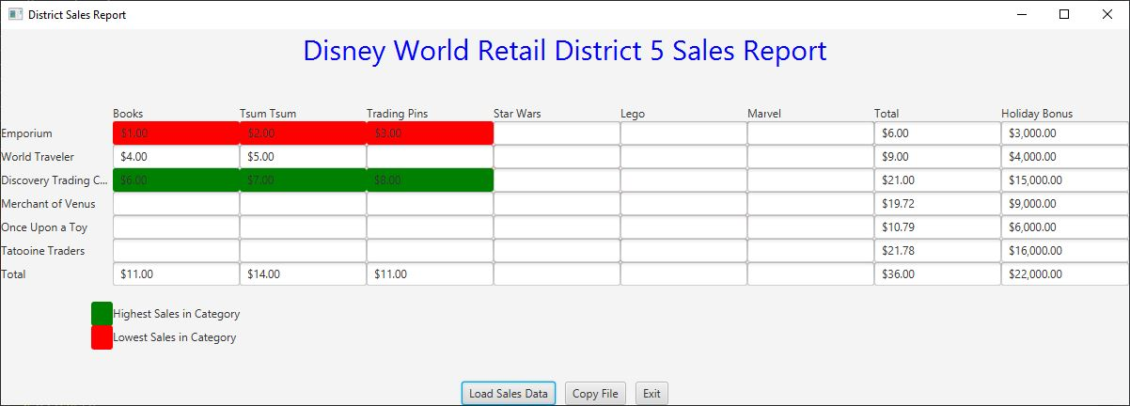

**Case 2**

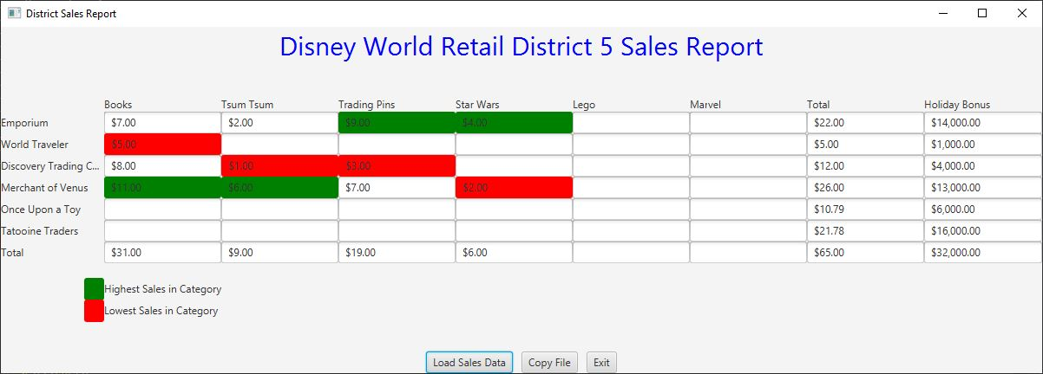

**Case 3**

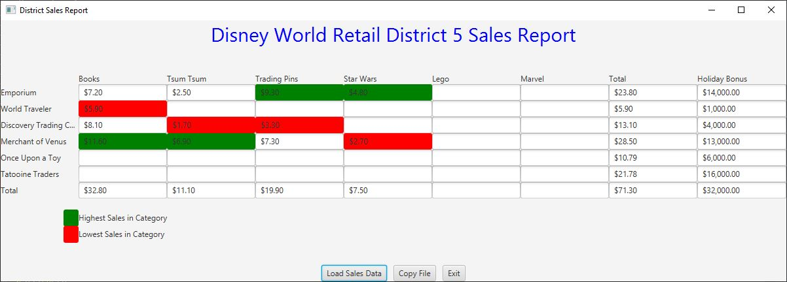

**Case 4**

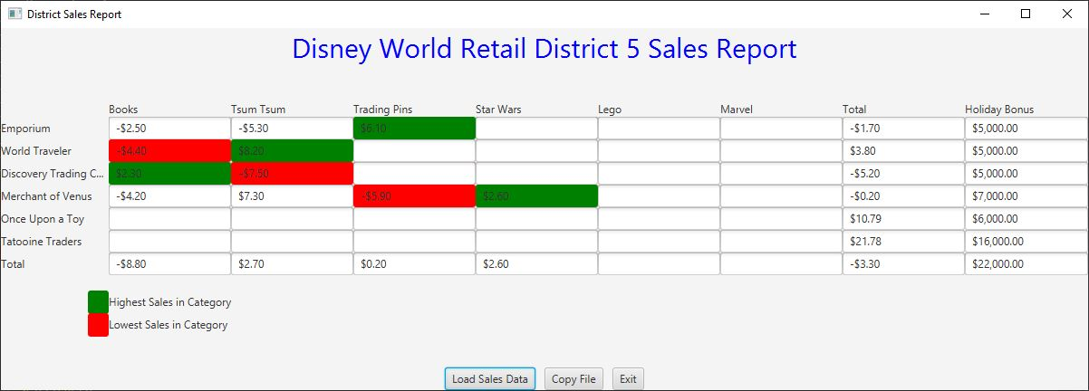

**Lessons Learned** <Provide answers to the questions listed above>**:**

Write about your Learning Experience, highlighting your lessons learned and learning experience from working on this project.

What have you learned? I learned how to utilize files with my code

What did you struggle with? I had trouble setting up my javafx on my new computer

What would you do differently on your next project? Give myself a longer period of time to work on it

What parts of this assignment were you successful with, and what parts (if any) were you not successful with? I was successful with the coding aspect, I also think I did a good job with the UML tool

Provide any additional resources/links/videos you used to while working on this assignment/project.

**Check List:** <Provide answers to the column Y/N or N/A >**:**

|  |  |  |  |
| --- | --- | --- | --- |
| **#** |  | **Y/N** | **Comments** |
|  | **Assignment files:** |  |  |
|  | * FirstInitialLastName_ Assignment#_Moss.zip | **Yes or No** | **Y** |
|  | * FirstInitialLastName_Assignment#.docx/.pdf | **Yes or No** | **Y** |
|  | * Source java files | **Yes or No** |  |
|  | **Program compiles** | **Yes or No** | **Y** |
|  | **Program runs with desired outputs related to a Test Plan** | **Yes or No** | **Y** |
|  | **Documentation file:** |  |  |
|  | * Comprehensive Test Plan | **Yes or No** | **Y** |
|  | * Screenshots related to the Test Plan | **Yes or No** | **Y** |
|  | * Screenshots of your GitHub account with submitted Assignment# (if required) | **Yes or No or N/A** | **Y** |
|  | * UML Diagram (if required) | **Yes or No or N/A** | **Y** |
|  | * Algorithms/Pseudocode (if required) | **Yes or No or N/A** | **Y** |
|  | * Flowchart (if required) | **Yes or No or N/A** | **N/A** |
|  | * Lessons Learned | **Yes or No** | **Y** |
|  | * Checklist is completed and included in the Documentation | **Yes or No** | Y |