MediBook — Running the Clinic from the Dashboard
Every job the clinic does in the MediBook dashboard, in the order a working day needs them — with a screenshot of each screen and the rules that sit behind it.
About these screenshots — Screenshots were taken from a running MediBook dashboard signed in as a clinic admin, one screen at a time. This is a development environment seeded with demo data, so the clinic name, dentists, patients and figures are sample values — the screens, buttons and rules are the real ones. Two screens show empty states because the demo clinic has no data of that kind yet; each is called out where it appears.

Who can do what
- Front desk (staff) — the daily work: the queue, walk-ins, callbacks, appointment status, treatment payments, day close.
- Admin (owner or manager) — everything above, plus dentists, branches, schedules, holidays, staff accounts, settings and the QR code. Actions marked Admin only are refused for other roles.
- Every change that matters is written to the audit log with who did it, when, and from where (Section 18).

Part A · The daily round

1. Overview — the screen the day starts on
WHO: Front desk HOW OFTEN: Continuously, all day
The landing tab leads with today’s queue and a + Walk-in button, because roughly half of an Indian clinic’s footfall walks in without an appointment. Below it sits Waiting for a call — patients the bot could not book because nothing was free, who asked to be rung back. Clearing that list is front-desk work, which is why it is not locked behind the owner’s login: gate it and it never gets cleared, and then nobody trusts it.

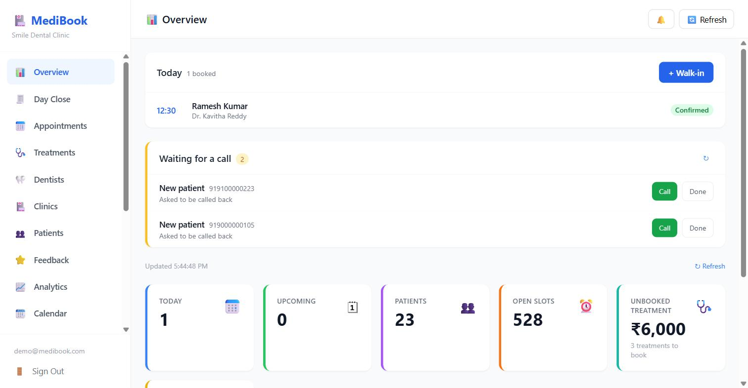
Figure 1 — Overview — today’s queue, callback requests, and the stat row
What you do here:
- Read today’s list — time, patient, dentist, status.
- + Walk-in — book someone standing at the desk (Section 2).
- Call — ring a patient who asked for a callback; Done — clear the request once handled.
- Watch the stat row: today, upcoming, patients, open slots, and treatment advised but not yet booked.
Note — Only ONE open callback request is kept per patient per kind. Somebody who taps "call me" on three different days is one person wanting one appointment, not three jobs on the list.

2. Booking a walk-in
WHO: Front desk HOW OFTEN: Many times a day
The same form opens from the Overview and from the Appointments tab — one shared modal, so the two can never prefill differently. Phone is the only required patient field; the name is optional because a queue does not wait for spelling.

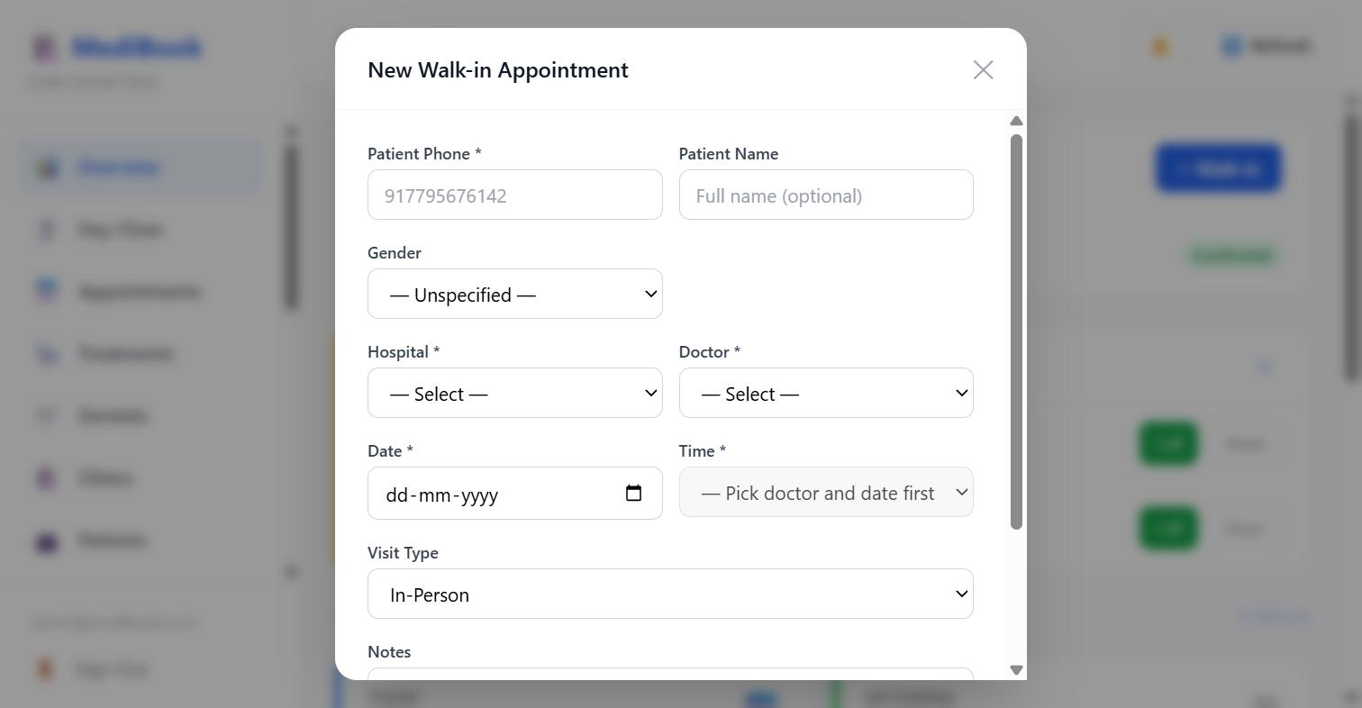
Figure 2 — New Walk-in Appointment — phone, name, gender, branch, dentist, date, time, visit type, notes
Fields, in the order they are asked:
- Patient Phone (required) — this is the patient’s identity everywhere in MediBook.
- Patient Name, Gender — optional.
- Hospital and Doctor (required) — the time list stays disabled until both are chosen.
- Date and Time (required) — times come from that dentist’s live slot grid, so a walk-in cannot double-book.
- Visit Type — In-Person or the alternatives your clinic uses.
- Notes — anything the dentist should see.
Note — A walk-in booked here goes through exactly the same slot lock and monthly quota check as a booking made by the patient on WhatsApp. There is no back door.

3. Appointments — the working list
WHO: Front desk HOW OFTEN: Continuously
Every appointment the clinic holds, filterable by date and status. This is where a visit is marked done, a patient is marked absent, and a receipt or a note is attached.

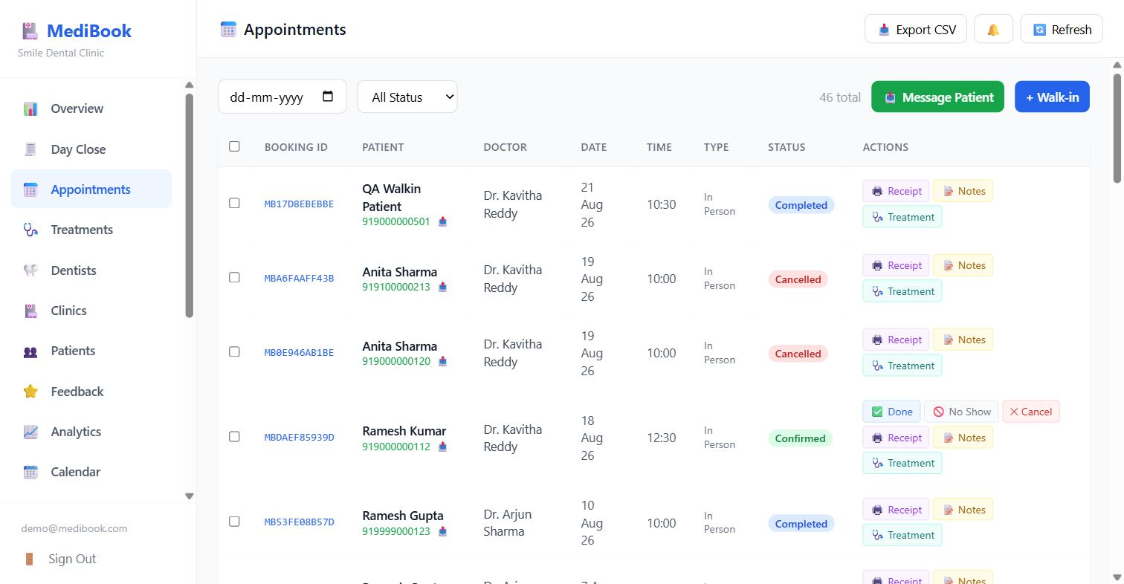
Figure 3 — Appointments — filters, per-row actions, and bulk selection
Per-row actions:
- Done — mark the visit completed. This is also the moment MediBook creates the six-month check-up recall.
- No Show — record that the patient did not arrive. It triggers the softer "that’s alright, it happens" message, not a telling-off.
- Cancel — cancel the booking and release the slot.
- Receipt — the payment slip for the consultation fee.
- Notes — clinical or desk notes against the visit.
- Treatment — start a multi-visit treatment plan from this appointment (Section 5).
Screen-level actions:
- Date filter and All Status dropdown.
- Message Patient — send a WhatsApp message by hand. It only works for numbers already known to this clinic.
- + Walk-in, and Export CSV for the whole filtered list.
- The checkbox column selects several rows for a bulk status change.
Note — Status changes are not free-form: an appointment can only move along allowed transitions, and the same rule is enforced whether you change one row or fifty.

4. Calendar — the month at a glance
WHO: Front desk / Admin HOW OFTEN: Daily, and when planning ahead
The month view is how you spot the Tuesday that is over-booked and the Thursday that is empty, before either becomes a problem.

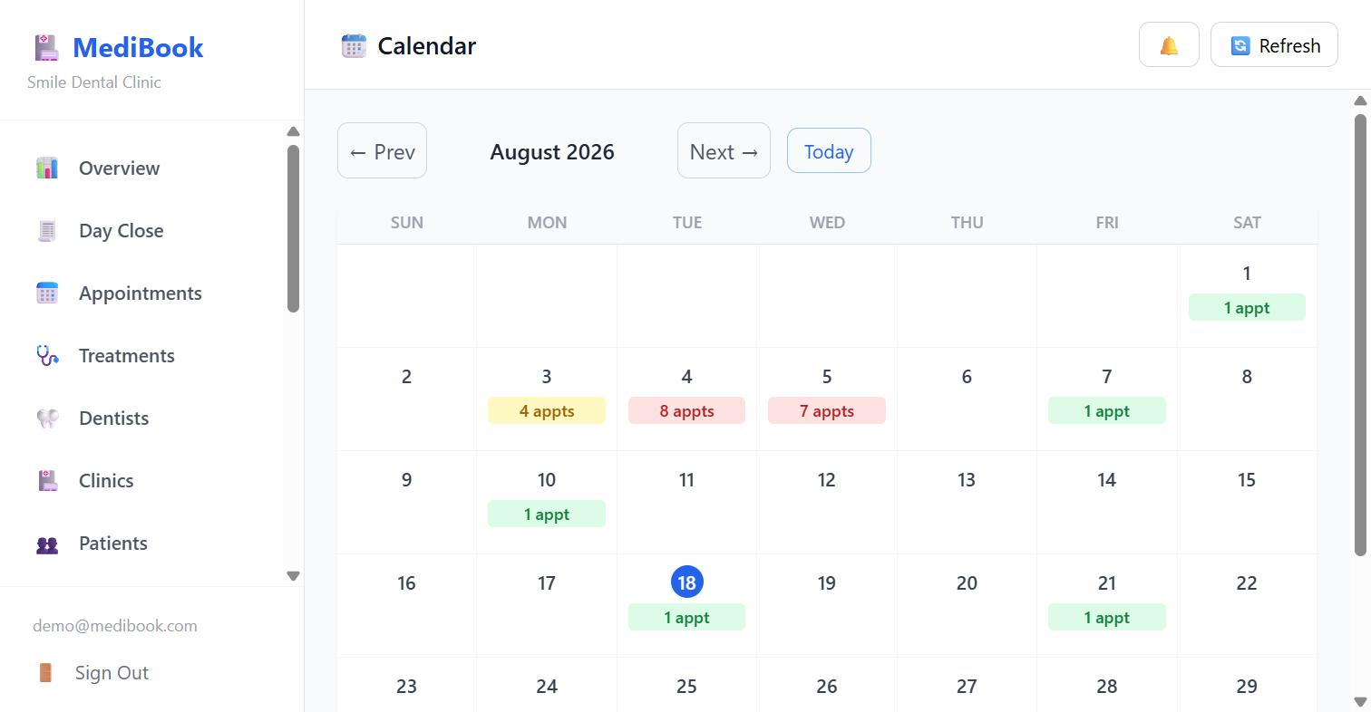
Figure 4 — Calendar — appointment counts per day, colour-coded by load

5. Treatments — courses that run over several visits
WHO: Dentist / Front desk HOW OFTEN: Whenever a treatment is advised, and when chasing what is unbooked
A root canal is two or three sittings; braces are eighteen to twenty-four. This tab is the whole course as one record: what was advised, who is rendering it, how many sittings are done and how many are still unbooked.

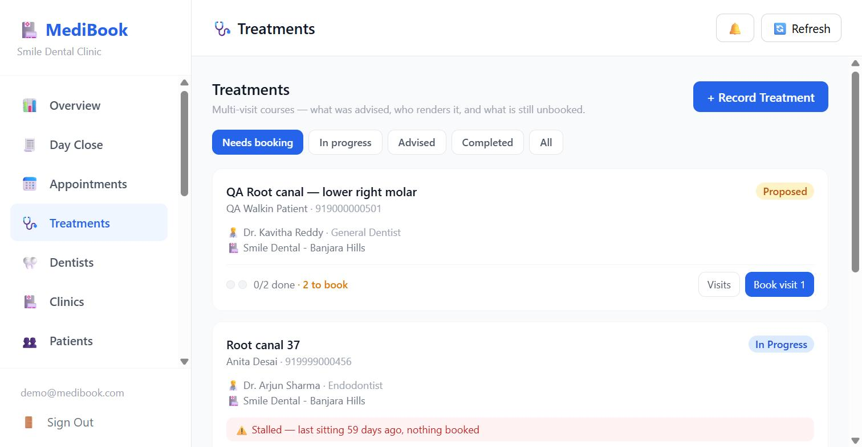
Figure 5 — Treatments — status filters, progress per course, and the stalled warning
The filters ARE the work queue:
- Needs booking — advised, nothing in the diary. This is the money the clinic has already won but not yet earned.
- In progress — started, more sittings to come.
- Advised — proposed but not begun.
- Completed / All.
What you do here:
- + Record Treatment — write up what the dentist advised: title, number of visits, treating dentist, branch, cost.
- Book visit N — put the next sitting in the diary. It takes the plan lock first, then the slot lock, so a receptionist and the patient booking on WhatsApp at the same moment cannot both take it.
- Visits — see every sitting of the course.
- Record a payment against the course, which sends the patient a WhatsApp slip automatically.
Note — Progress is derived from the appointments, never stored as a counter. Cancel a sitting and the course goes straight back onto the "needs booking" queue — a stored count would quietly get that wrong. A course shows Stalled when work has started, nothing is booked, and the last sitting was 30+ days ago; that is usually the case with money outstanding.

6. Day Close — counting the drawer
WHO: Front desk HOW OFTEN: Once, at the end of every day
One end-of-day total, broken down by method so the cash in the drawer can be counted against the cash line.

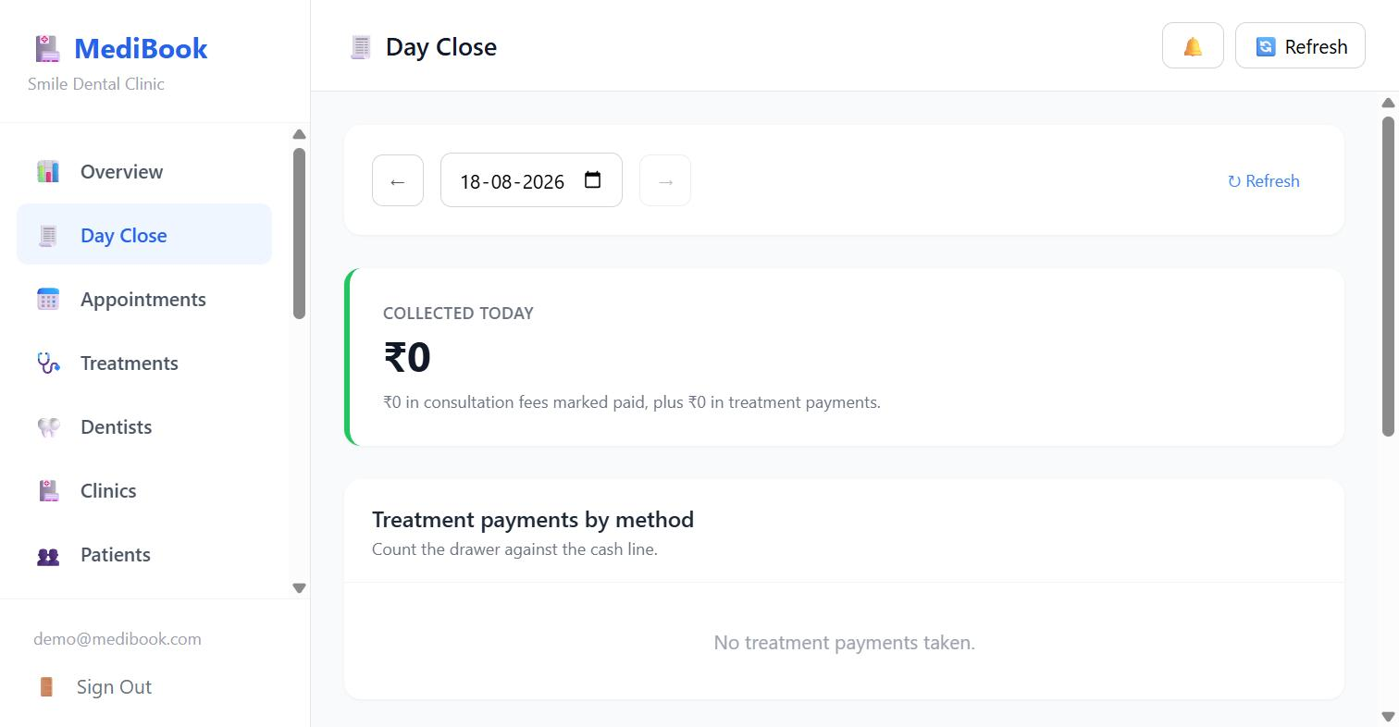
Figure 6 — Day Close — collected total and the breakdown by payment method
Note — Consultation fees and treatment payments are counted SEPARATELY and then added once. Conflating them double-counts revenue. Everything is computed in IST, so a clinic closing at 21:00 does not see yesterday’s figures. In the screenshot the demo clinic has taken no payments, so both lines read ₹0.

7. Patients
WHO: Front desk HOW OFTEN: As needed
One row per patient, searchable by name, phone or email. Phone is the identity — it is what the WhatsApp bot matches on.

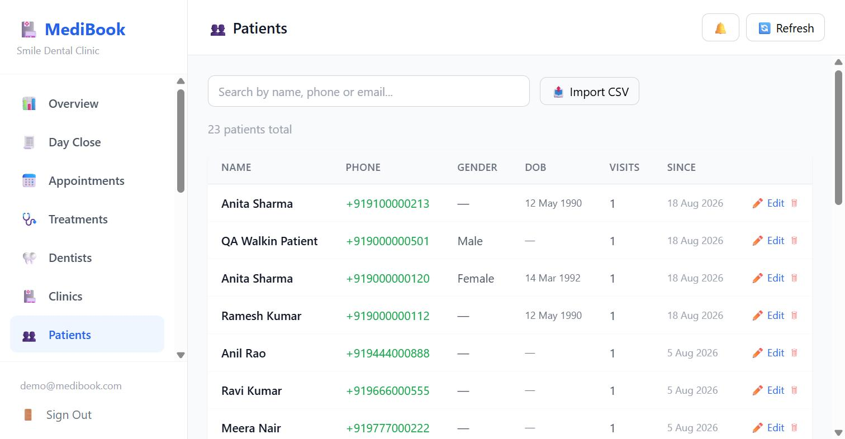
Figure 7 — Patients — search, visit counts, and per-row edit
What you do here:
- Search by name, phone or email.
- Edit — correct a name, gender or date of birth.
- Delete — a soft delete; the record stops appearing but history is not destroyed.
- Import CSV — bring an existing patient list across when a clinic joins.

8. Feedback
WHO: Owner / Admin HOW OFTEN: Weekly
Ratings patients sent back over WhatsApp, with the average and the distribution.

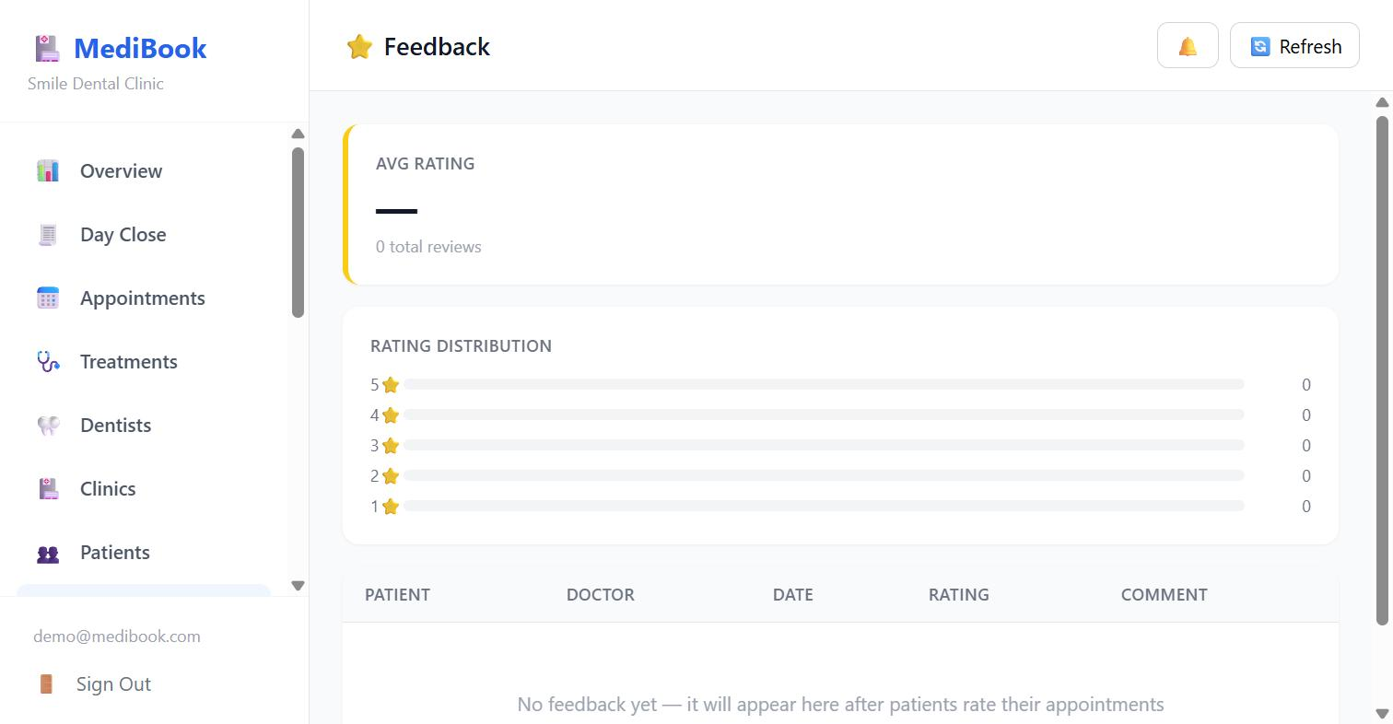
Figure 8 — Feedback — average rating, distribution, and the individual responses
Note — A rating is requested at most once a MONTH per patient, not once per visit — three sittings in a month used to mean three requests. The patient is told plainly that the answer goes only to the clinic and is published nowhere. The demo clinic has no ratings yet, so the screen shows its empty state.

Part B · Setting the clinic up

9. Dentists
WHO: Admin only HOW OFTEN: When someone joins, leaves, or changes their hours
Each card carries the dentist’s specialty, qualification, home branch, consultation fee, slot length and their current appointment and open-slot counts.

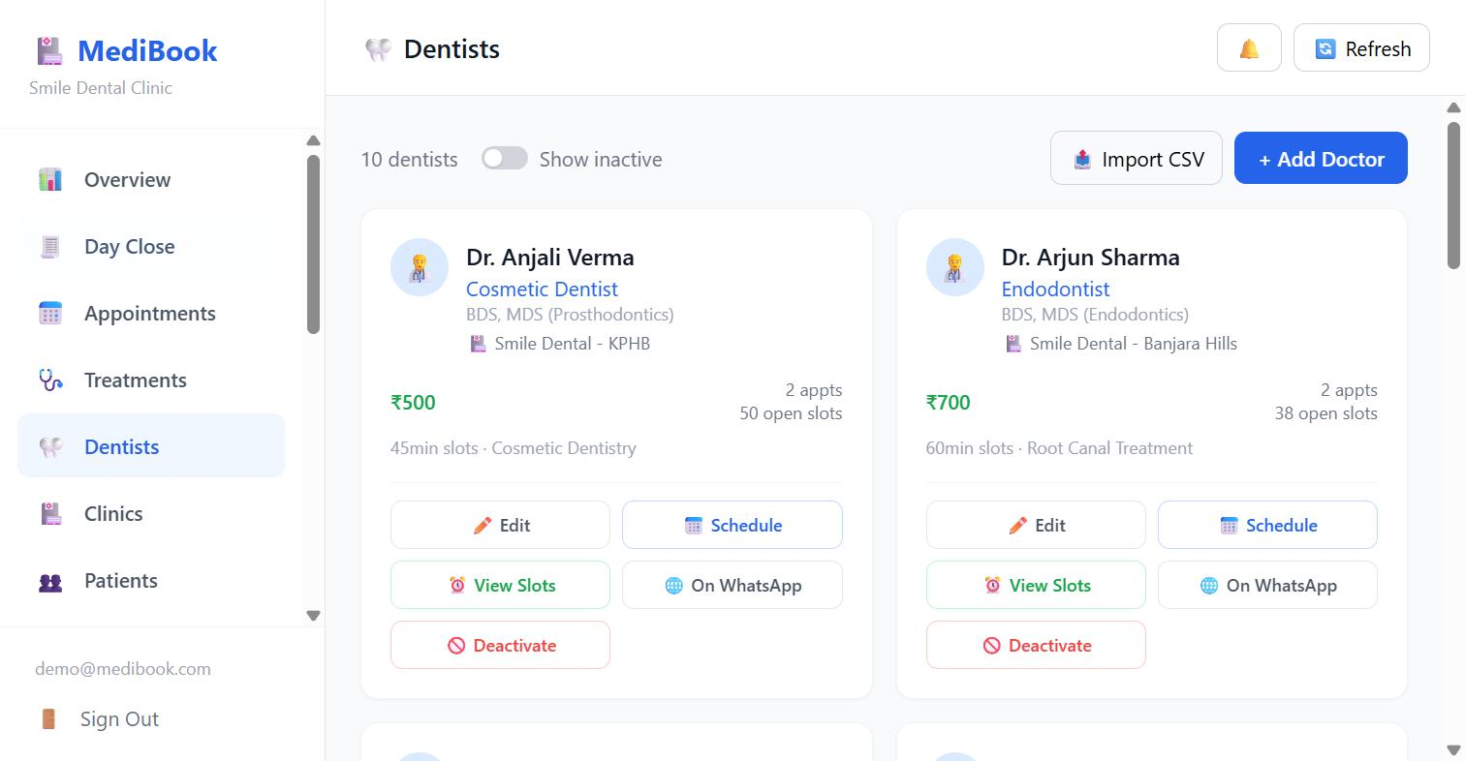
Figure 9 — Dentists — one card per dentist with edit, schedule, slots and deactivate
What you do here:
- + Add Doctor — name, specialty, qualification, fee, slot length, branch, treatments.
- Import CSV — add a whole list at once.
- Edit — change any of the above.
- Schedule — set working days and sessions (Section 10).
- View Slots — the generated bookable grid.
- On WhatsApp — whether patients may pick this dentist in the bot.
- Deactivate — they stop appearing everywhere.
- Show inactive — bring former staff back into view.
Note — "Active" and "bookable on WhatsApp" are DIFFERENT questions. A visiting orthodontist is very much active and takes referred cases, but an owner may not want them picked off a menu by someone with toothache. The bot only ever lists dentists marked bookable; the dashboard deliberately lists everyone, so the desk can still book anybody.

10. A dentist’s working week
WHO: Admin only HOW OFTEN: On joining, and whenever hours change
A working day is a LIST of sessions, not a single span. An Indian dentist routinely does 10–1 at one clinic and 5–9 at another on the same day.

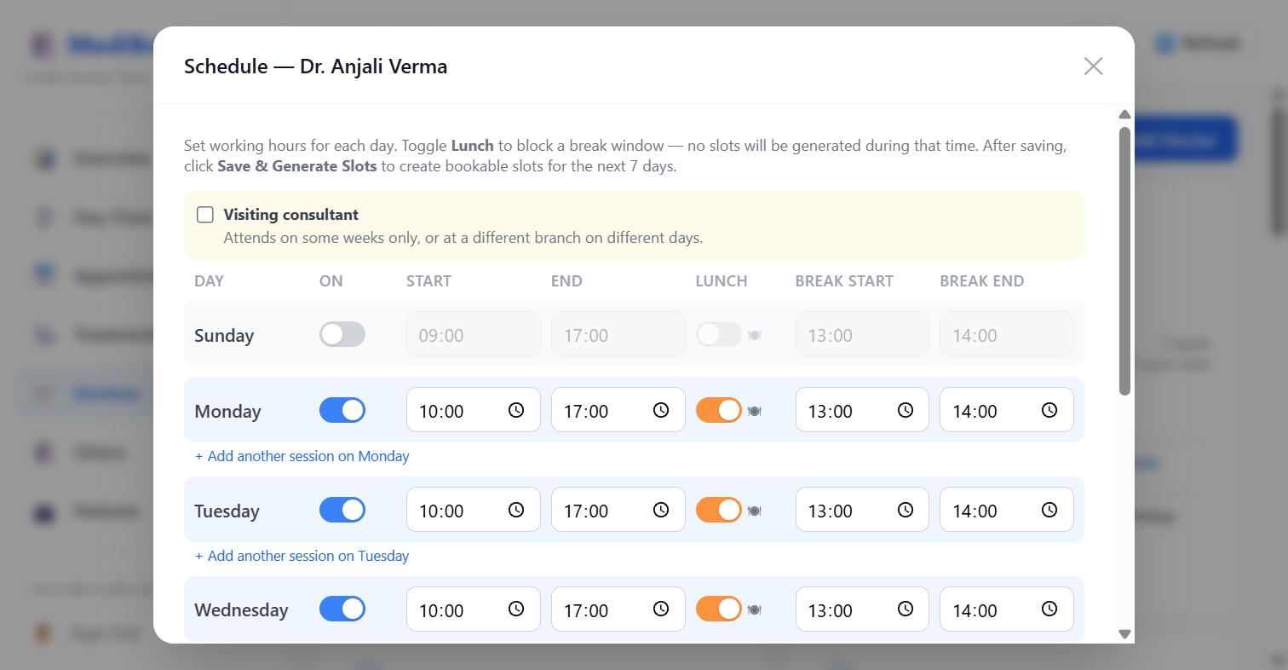
Figure 10 — Schedule — per-day on/off, start and end, and a lunch break that blocks slot generation
Per day you set:
- On / off for that weekday.
- Start and End time.
- Lunch on/off, with a break start and end — no slots are generated inside it.
- + Add another session on that day — for a dentist working a morning here and an evening elsewhere.
Ticking Visiting consultant opens the two extra controls that make a visiting specialist work:
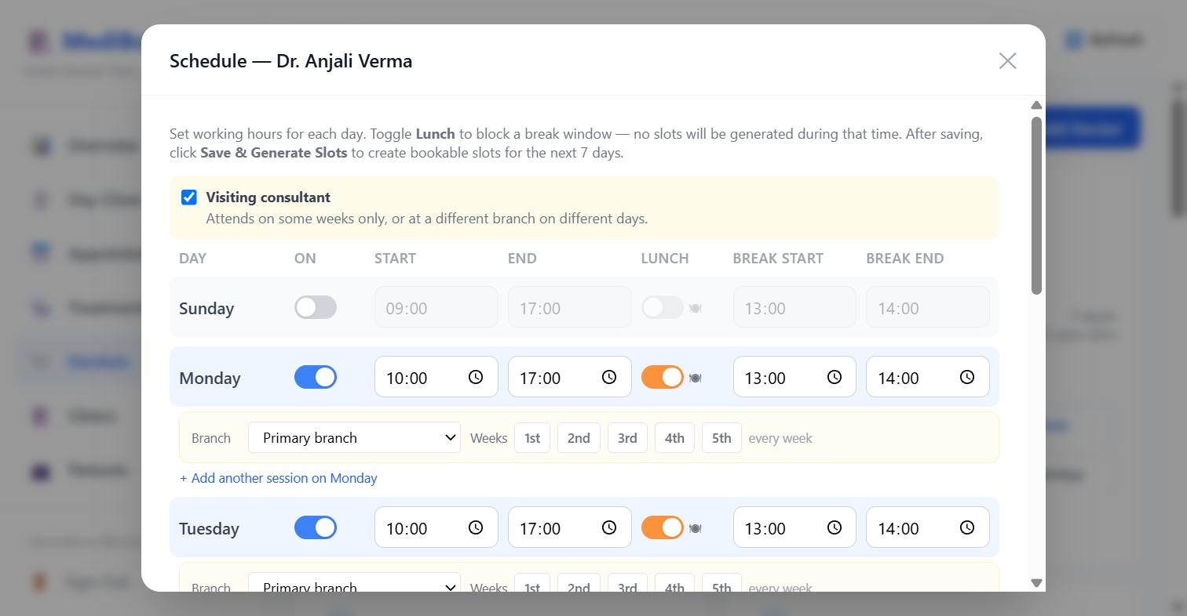
Figure 11 — Schedule — visiting consultant mode adds a branch and a week-of-month pattern per session
Visiting consultant controls:
- Branch — which clinic that particular session belongs to, so Tuesdays can be one branch and Thursdays another.
- Weeks 1st / 2nd / 3rd / 4th / 5th — the cadence. Pick 1st and 3rd for a fortnightly visit; pick none and it means every week.
Note — Saving REPLACES that day’s sessions rather than adding to them, so a session you delete really goes. Overlapping sessions are rejected outright — left alone they generate slots that silently collide. After saving, use Save & Generate Slots to create the bookable grid.

11. Slots — the bookable grid
WHO: Front desk / Admin HOW OFTEN: When checking or freeing up a day
What the patient actually sees. Pick a dentist and a date to see every slot and its state.

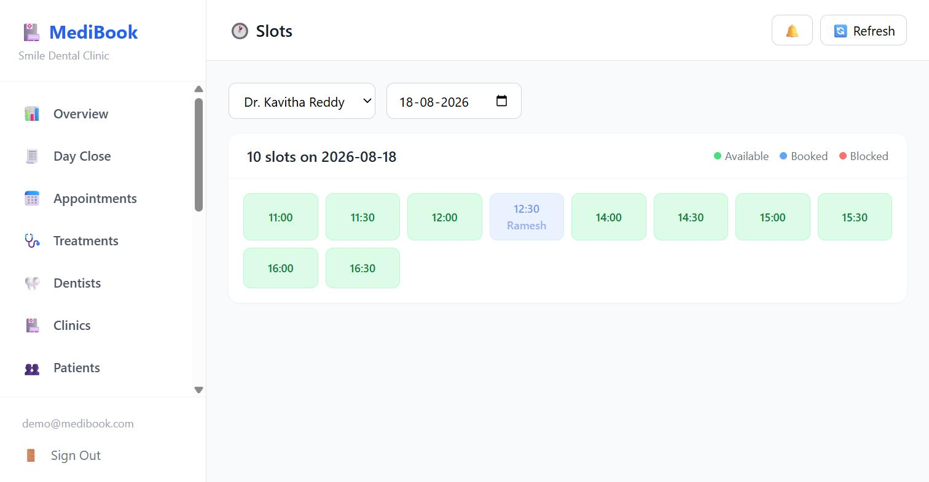
Figure 12 — Slots — the grid for one dentist on one day, with the available / booked / blocked legend
Note — Slots are generated nightly and whenever a schedule is saved. Generation always skips dentist leaves and clinic holidays. The window starts TODAY and keeps only times later than the current moment, so a dentist added this morning still has same-day availability.

12. Dentist Leaves
WHO: Admin only HOW OFTEN: When a dentist books time off
Pick the dentist, then record the leave. Slots inside a leave are blocked rather than deleted, and removing the leave releases exactly those slots again — nothing else is disturbed.

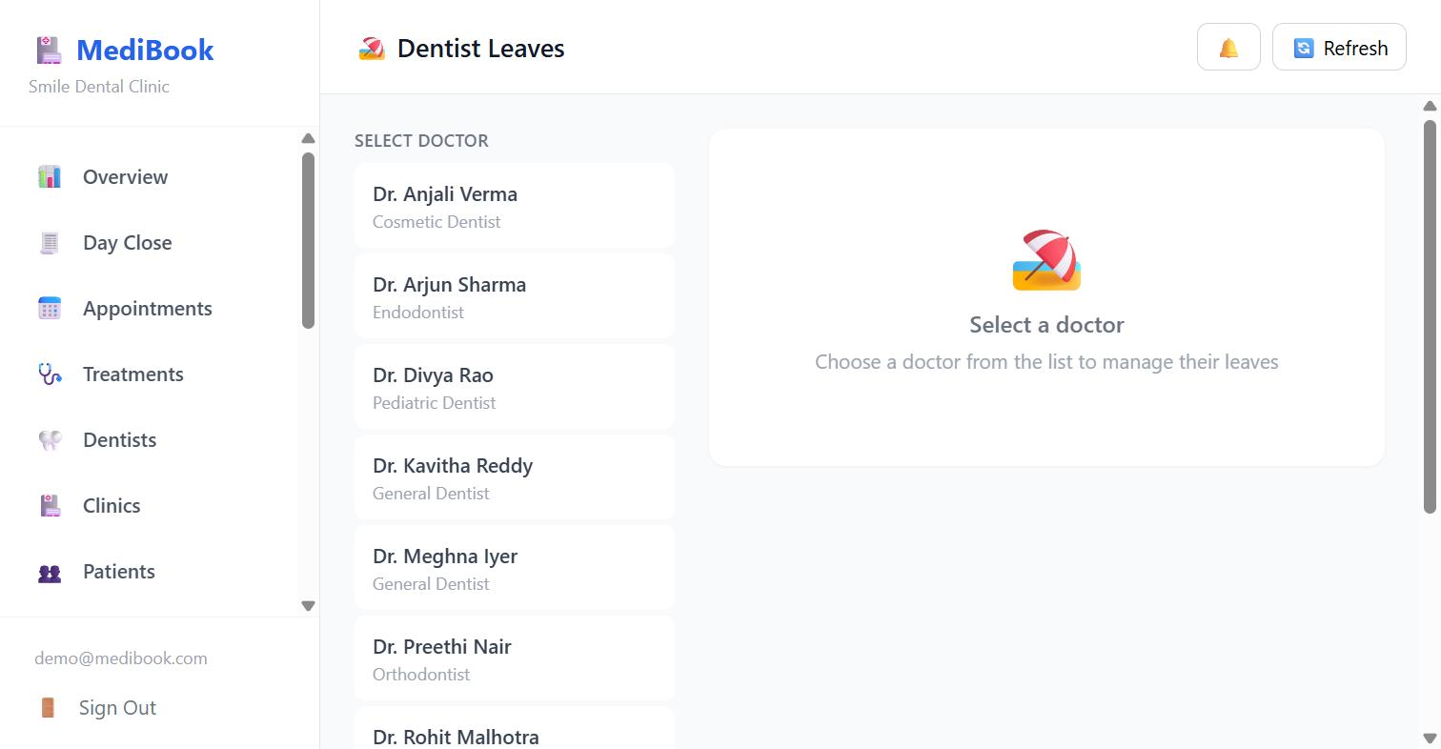
Figure 13 — Dentist Leaves — choose a dentist to manage their time off

13. Holidays and clinic closures
WHO: Admin only HOW OFTEN: Once at the start of the year, then as needed
Diwali, Republic Day, a renovation. Can be set for one branch or all of them — a holiday at one branch must not close the day a visiting dentist spends at the other.

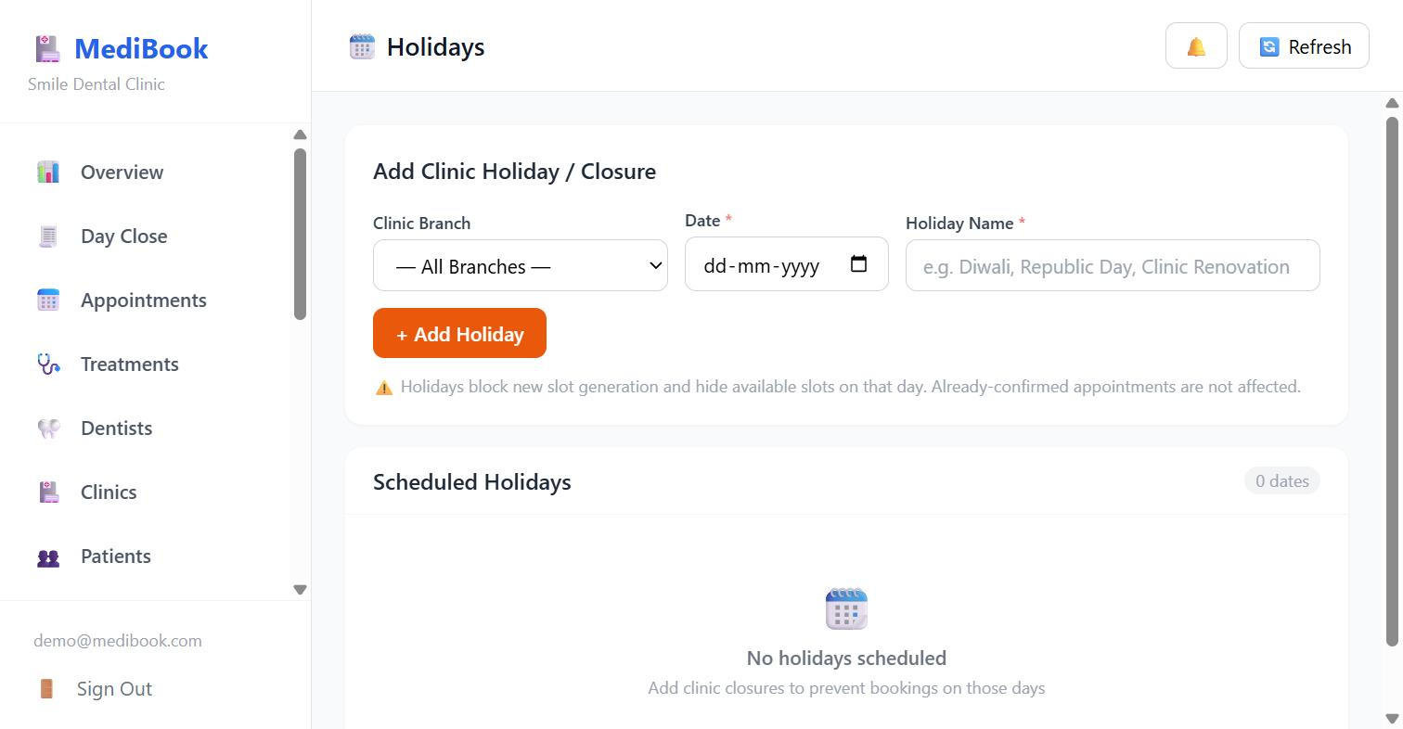
Figure 14 — Holidays — add a closure for one branch or all, and the list of scheduled dates
Note — Holidays block new slot generation and hide available slots on the day. Appointments already confirmed are NOT touched — the clinic decides what to do about those.

14. Clinics and departments
WHO: Admin only HOW OFTEN: On setup, and when a branch opens or changes
Each branch carries its own address and phone number. The phone number matters more than it looks: it is what the bot gives out whenever it tells a patient to call.

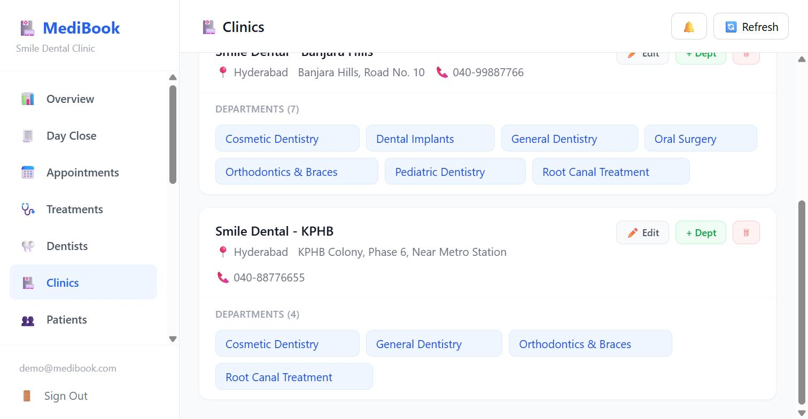
Figure 15 — Clinics — branches with their addresses, phone numbers and departments
What you do here:
- + Add Hospital — a new branch.
- Edit — name, city, address, phone.
- + Dept — add a treatment category to that branch. Departments are per-branch.
- Delete a branch.

15. Services catalogue
WHO: Admin only HOW OFTEN: On setup
The treatments the clinic offers and what they cost — used when writing up a treatment plan.

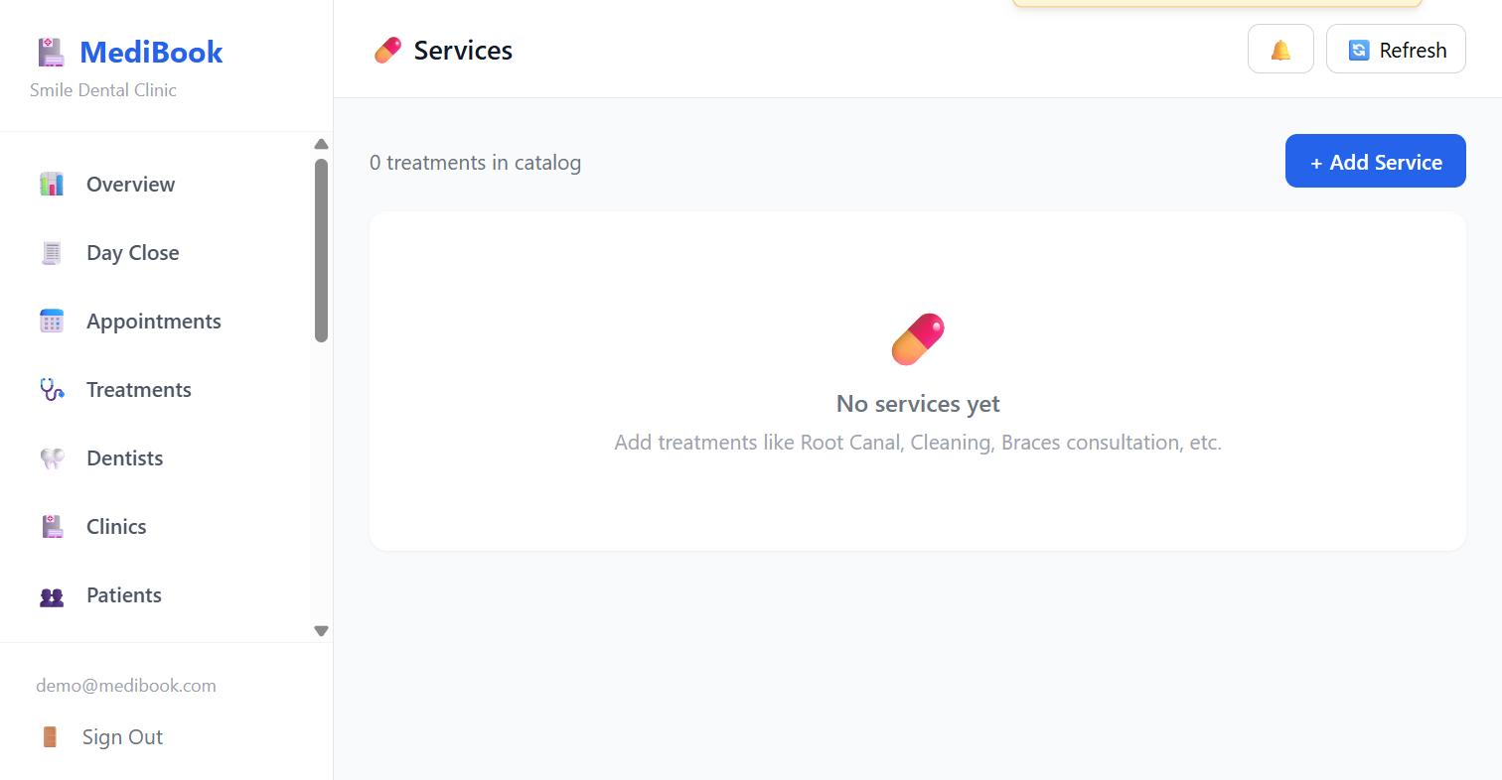
Figure 16 — Services — the treatment catalogue (empty in the demo clinic)

16. Staff accounts
WHO: Admin only HOW OFTEN: When someone joins or leaves
Dashboard logins, separate from dentists. A dentist is someone patients book; a staff member is someone who signs in.

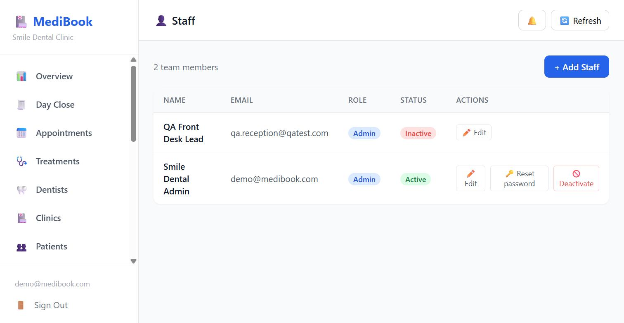
Figure 17 — Staff — team members with role, status, and the password reset action
What you do here:
- + Add Staff — name, email (this is the login), role.
- Edit — change name or role.
- Reset password — issues a new password shown ONCE, for a human to hand over, and signs that user out everywhere.
- Deactivate — they can no longer sign in; their history stays.
Note — You cannot reset your OWN password here — that is what Change Password is for, and it asks for the current one. Allowing self-reset would turn a hijacked session into a permanent takeover. Password reset is audited. This exists so a clinic is never waiting on the vendor on a Saturday morning to get the front desk back in.

Part C · The clinic’s own settings

17. Settings — and the QR code that is the way in
WHO: Admin only HOW OFTEN: Once on setup; the QR when posters are reprinted
The QR panel leads this tab for a reason: it is the ONLY way a patient can reach this clinic on WhatsApp. There is no clinic search and no directory. A clinic whose QR is printed nowhere is unreachable.

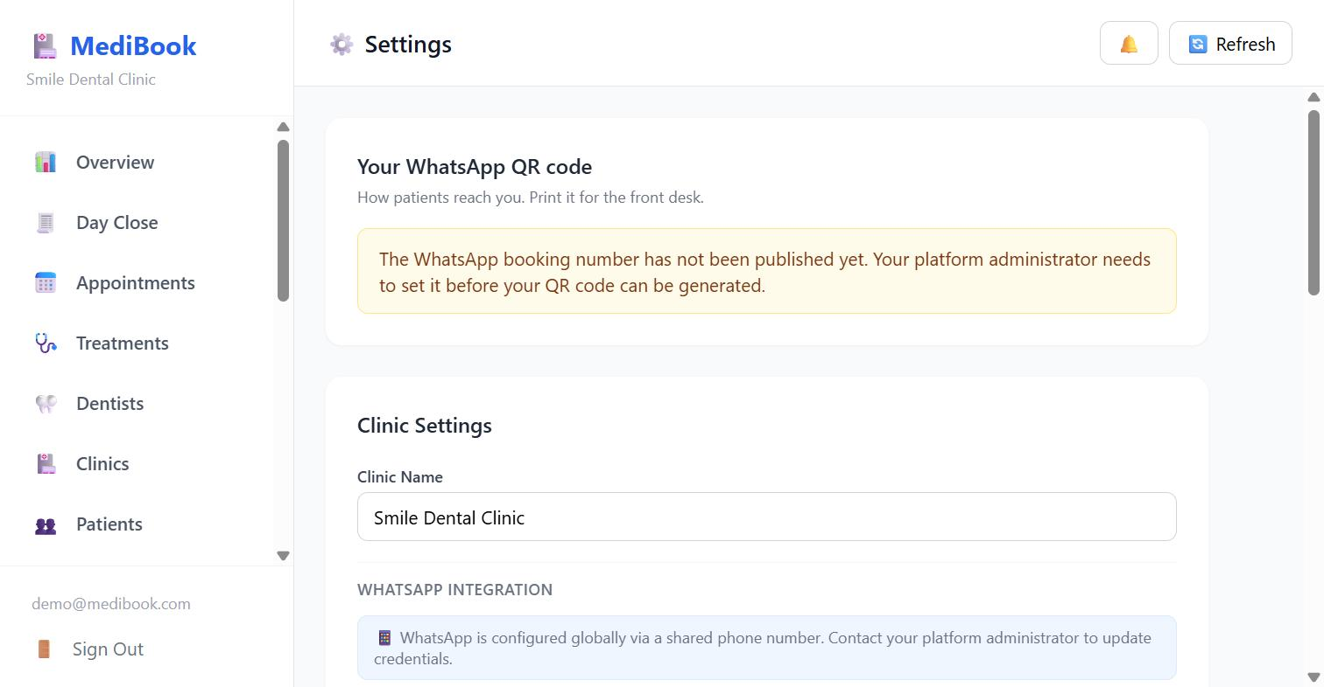
Figure 18 — Settings — the WhatsApp QR panel and clinic name
Note — In the screenshot the panel reports that the platform’s WhatsApp booking number has not been published in this development environment, so no QR can be drawn. On a live clinic this panel shows the QR image, the booking deep link, and buttons to print a counter card, copy the link or download the PNG.

What you do with the QR:
- Print it for the front desk, and put the link on the website, the Google listing and the Instagram bio.
- Issue a new code — only if the old one has been misused. It is destructive in the physical world: every card and poster already carrying the old code stops working, and the clinic finds out when patients stop arriving. The action is admin-only and audited.
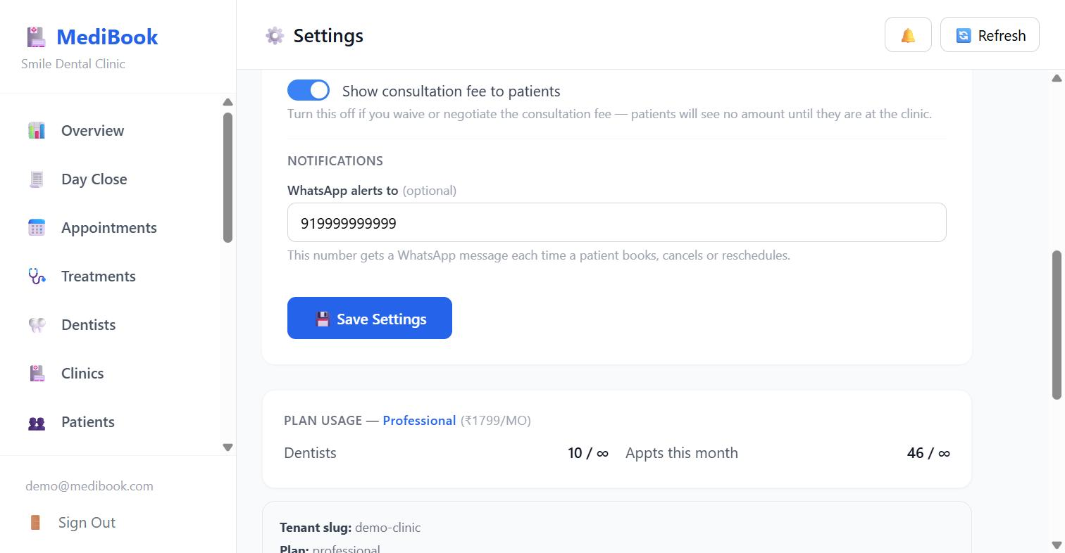
Figure 19 — Settings — fee display, WhatsApp alert number, and plan usage
The rest of the tab:
- Show consultation fee to patients — turn it OFF if you waive or negotiate the fee. A firm number shown in WhatsApp and then not charged at the desk is an argument the receptionist has to have. The dentist picker and the booking confirmation both read this one switch, so they can never disagree.
- WhatsApp alerts to — the staff number that gets a message on every booking, cancellation and reschedule, plus the Monday morning weekly summary.
- Plan usage — dentists and appointments used this month against your plan.

18. Analytics and exports
WHO: Owner / Admin HOW OFTEN: Weekly or monthly
Appointments by status, busiest dentists, daily volume, revenue and treatment breakdowns.

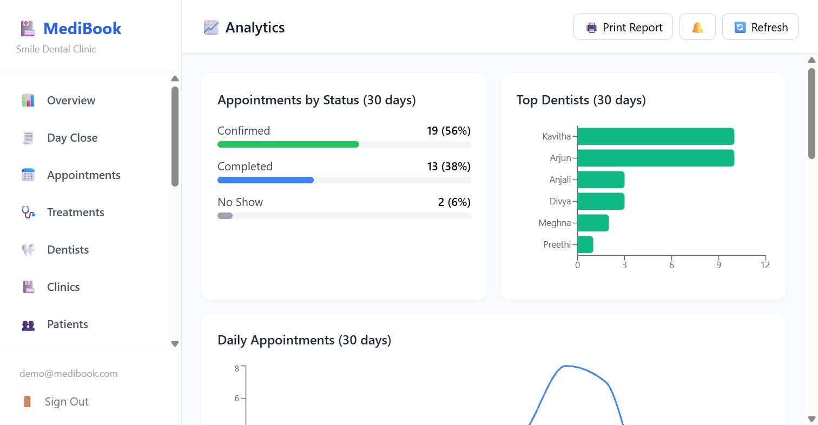
Figure 20 — Analytics — status split, top dentists, and daily appointment volume
Note — Print Report gives a shareable summary. Exports of patients, appointments and treatments are also available — deliberately, so that nobody is ever trapped in the system: a clinic can always take its own data out.

19. Bot Tester
WHO: Admin only HOW OFTEN: When checking a change, or reproducing a patient’s complaint
Runs a message through the real WhatsApp bot without needing a real WhatsApp connection — the replies are intercepted and shown on screen.

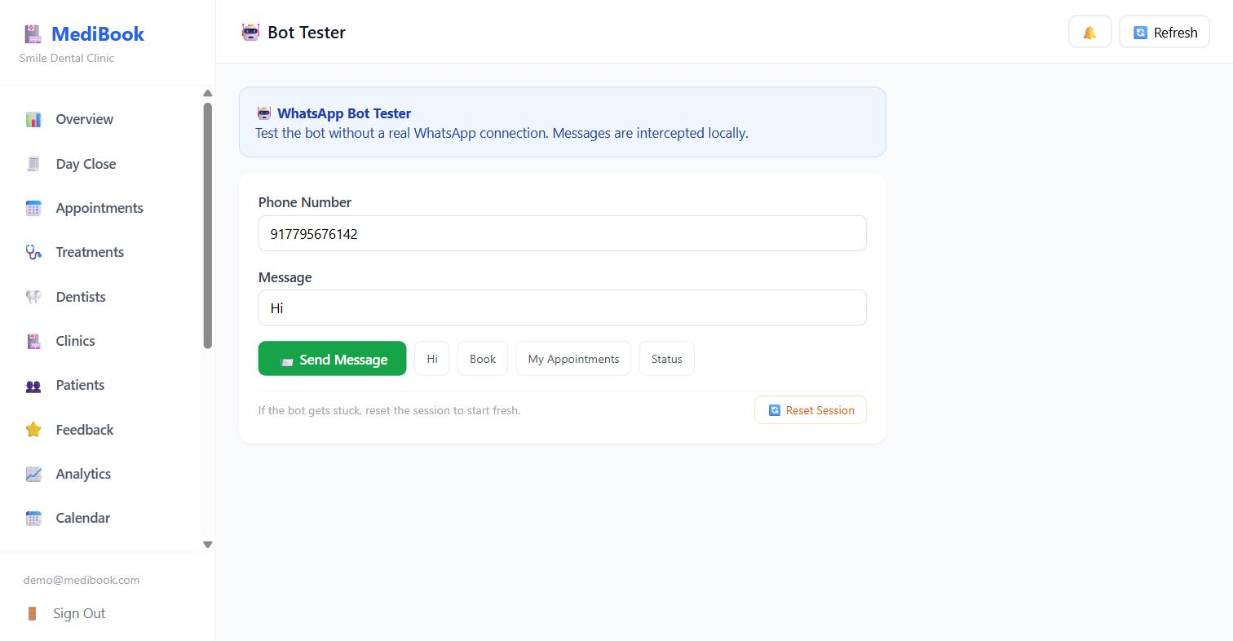
Figure 21 — Bot Tester — send any message as any phone number and see what the bot would reply
What you do here:
- Type a phone number and a message, then Send Message.
- Shortcut buttons for Hi, Book, My Appointments and Status.
- Reset Session — if a patient says the bot is stuck, this puts their conversation back to the start.

20. Audit Logs
WHO: Admin only HOW OFTEN: When something needs explaining
Who did what, to which record, when, and from which address. Filterable by date range and action.

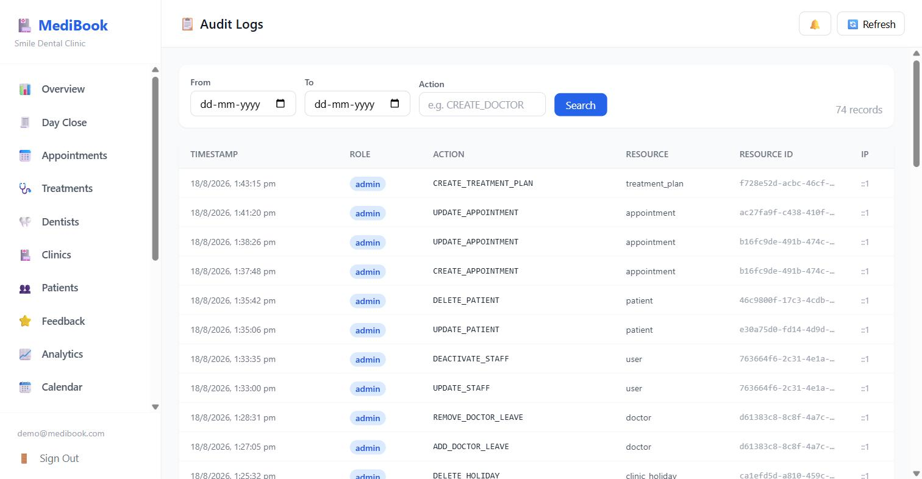
Figure 22 — Audit Logs — every consequential action with actor, resource and timestamp
Note — Recorded here: appointment creation and status changes, patient edits and deletions, staff changes and password resets, doctor leaves, holidays, treatment plans, consent records, deleted payments and QR regeneration. Timestamps are IST, so filtering a single day returns that day as the clinic lived it.

Appendix · A duty checklist
When | Who | What
Every morning | Front desk | Open Overview; read today’s queue; clear any callback requests
Through the day | Front desk | Book walk-ins; mark Done / No Show; take payments; add notes
When treatment is advised | Dentist / desk | Record Treatment; book the first sitting
End of day | Front desk | Day Close; count the drawer against the cash line
Weekly | Owner | Treatments → Needs booking; Feedback; Analytics
When hours change | Admin | Dentists → Schedule → Save & Generate Slots
When a dentist is away | Admin | Dentist Leaves
Before a festival | Admin | Holidays — per branch or all
When staff join or leave | Admin | Staff — add, or deactivate and reset
When posters are reprinted | Admin | Settings — print the QR; reissue only if misused
If something looks wrong | Admin | Audit Logs; Bot Tester to reproduce

