Untitled
library(here)
here() starts at /Users/samharper/git/bhet-report
#| echo: FALSE
#| fig-cap-location: top
#| label: fig-afig-mi
#| fig-cap: Kernal density plots showing distribution of multiply-imputed values for body mass index (kg/m^2^), waist circumference (cm), and indoor PM~2.5~ (µg/m^3^) (red lines) and observed values (heavy black line).
#| fig-width: 6
#| fig-subcap:
#| - ""
#| - ""
#| - ""
#| layout-nrow: 2
#| fig-pos: H
knitr::include_graphics(here("images",
"MI_BMI_density.png"))
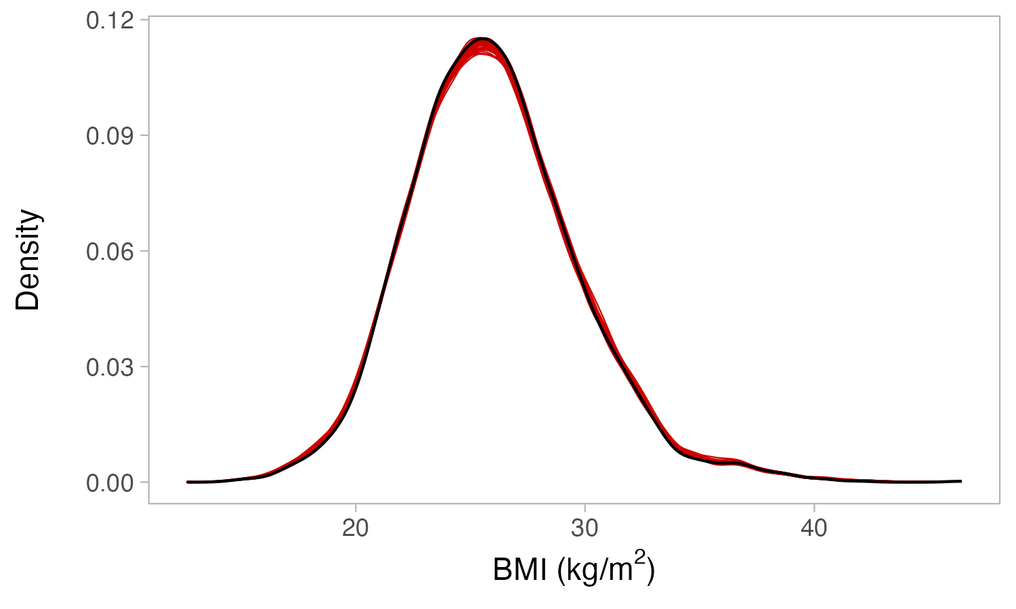
knitr::include_graphics(here("images",
"MI_waist_circ_density.png"))
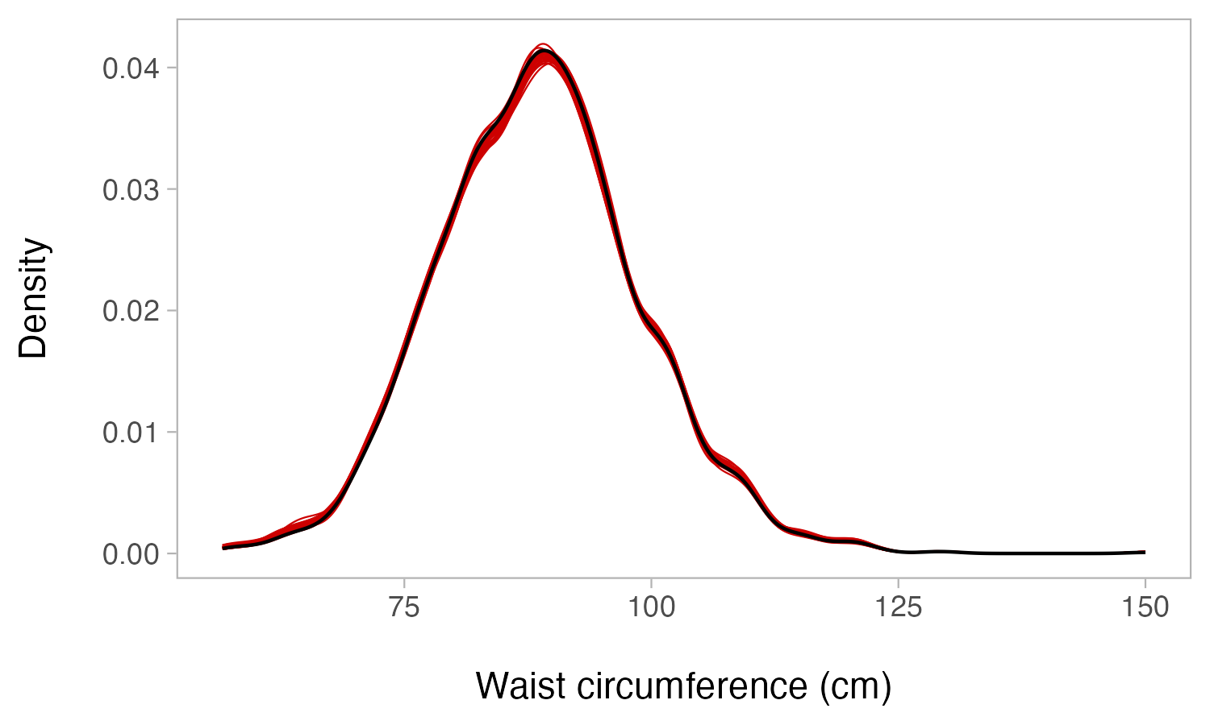
knitr::include_graphics(here("images",
"MI_indoorPM_density.png"))
