INTRODUCTION
  - Overview
Smart Assignment is a web-based application designed to streamline the process of assignment management and enhance collaboration among students, teachers, and administrators. This project aims to leverage web development technologies to create an intelligent platform that automates assignment creation, submission, grading, and feedback, thereby improving the efficiency and effectiveness of the assignment process. Students can access the platform to view and submit assignments. The application allows for secure file uploads, ensuring the integrity and confidentiality of submitted work. The system provides notifications and reminders to students about upcoming assignment due dates and any updates or clarifications from teachers.
  - Purpose
Smart Assignment aims to enhance the assignment management process, promote collaboration, and improve educational outcomes. By leveraging intelligent technologies and providing a user-friendly interface, the application streamlines administrative tasks, enhances student-teacher communication, and facilitates a more efficient and engaging learning experience.

LITERATURE SURVEY
  - Existing problem
A literature survey of smart assessment engines reveals a significant body of research focusing on the development and implementation of intelligent systems designed to revolutionise the assessment process. Studies demonstrate the potential of smart assessment engines to improve efficiency, accuracy, and fairness in evaluating student performance while providing personalised feedback and adaptive learning experiences. Furthermore, research highlights the importance of designing user-friendly interfaces, ensuring the privacy and security of data, and addressing potential biases and ethical concerns associated with these systems. Overall, the literature showcases the promising role of smart assessment engines in transforming educational assessment practices and advancing the field of assessment technology.

  - Proposed solution
It is proposed to create an intelligent platform that automates assignment creation, submission, grading, and feedback, thereby improving the efficiency and effectiveness of the assignment process. Students can access the platform to view and submit assignments. The application allows for secure file uploads, ensuring the integrity and confidentiality of submitted work. The system provides notifications and reminders to students about upcoming assignment due dates and any updates or clarifications from teachers. The solution is to be achieved by leveraging web development technologies to develop the required platform.

THEORITICAL ANALYSIS
  - Block diagram
The following block diagram provides a diagrammatic overview of the project:
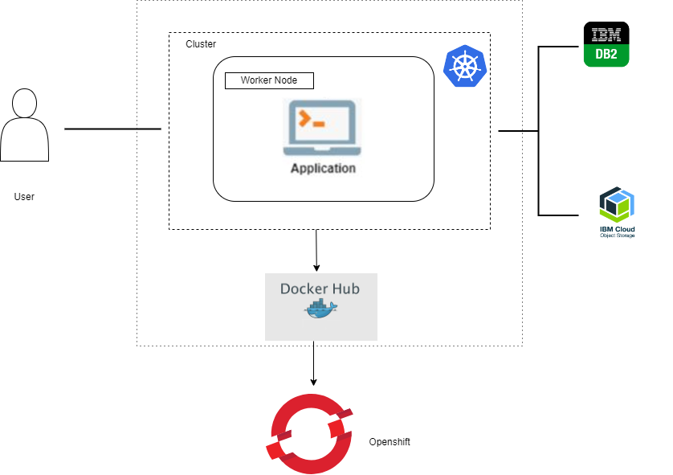
  - Hardware / Software designing
Basic hardware prerequisites, including any framework for web application development would suffice.

EXPERIMENTAL INVESTIGATIONS
The system existing for the problem considered is analysed and accordingly solution was developed by interrelating the appropriate technologies.

FLOWCHART
Diagram showing the control flow of the solution
Develop Web application (using Python, HTML, CSS)
Containerize the application using Docker

Package and deploy the application in RedHat OpenShift using YAML file

RESULT
Final findings (Output) of the project along with screenshots.
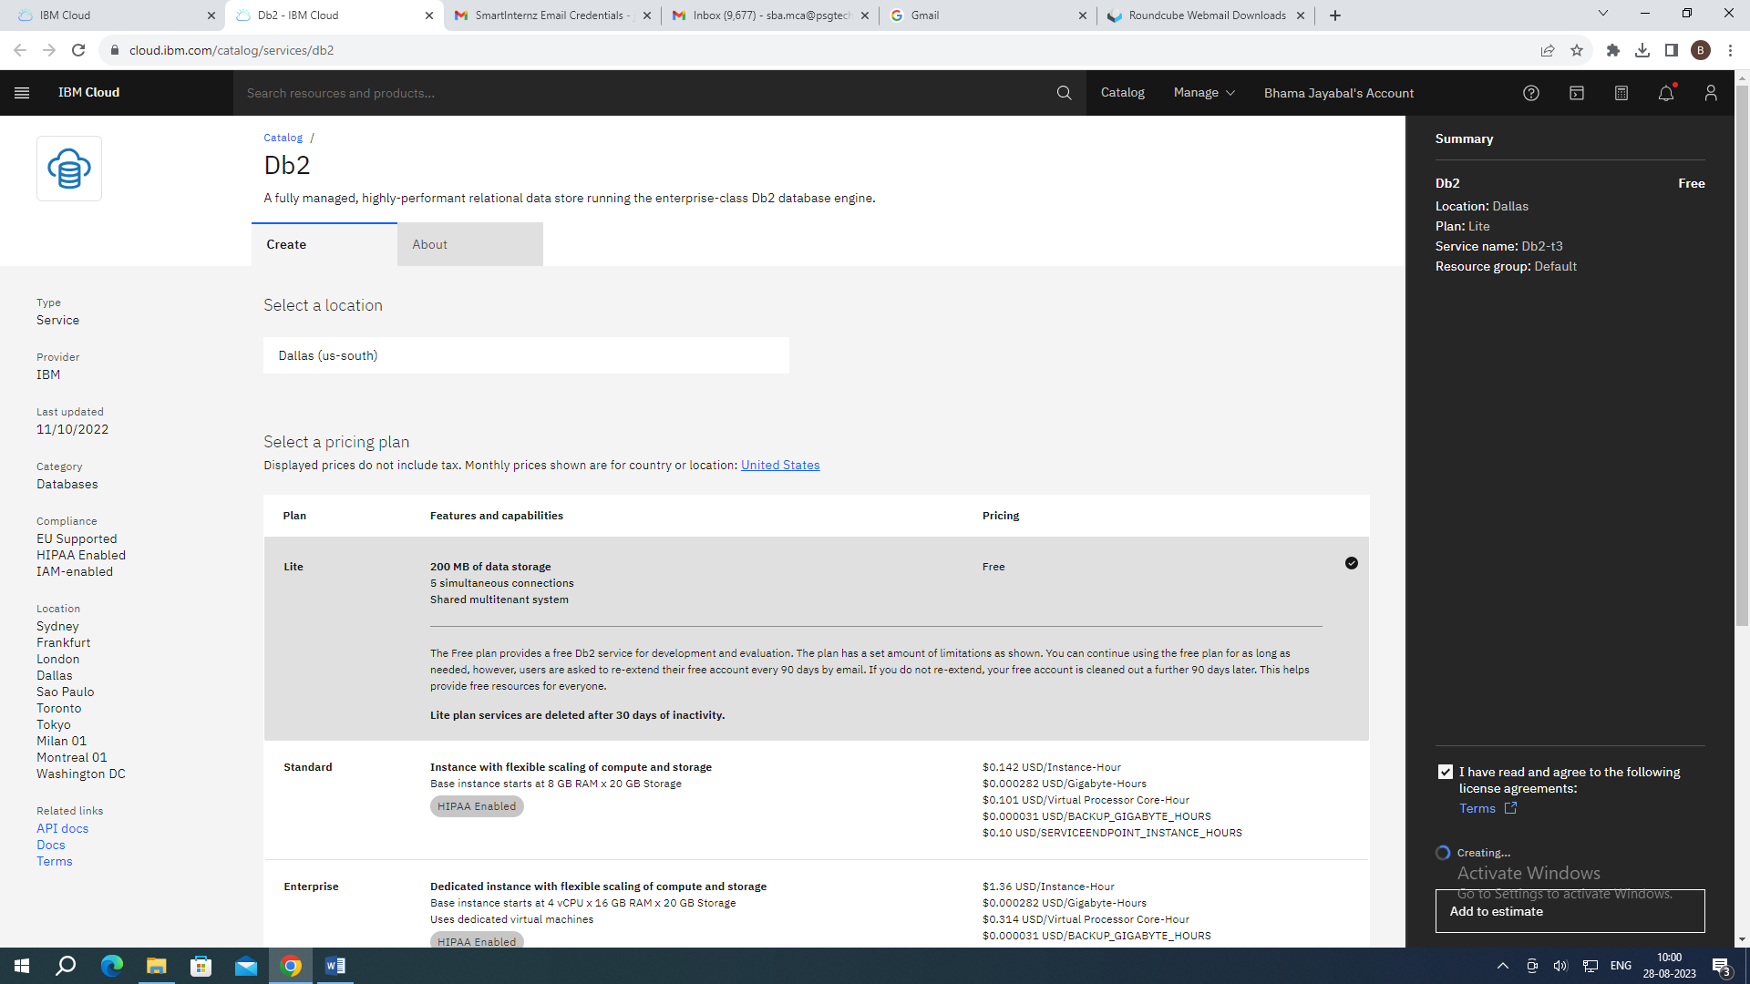

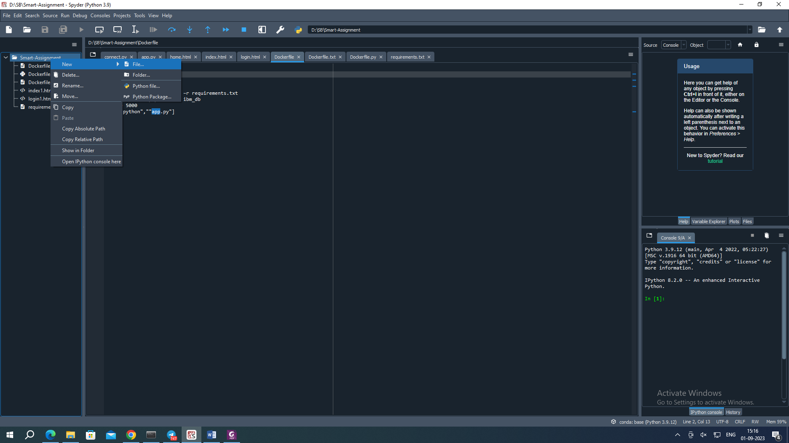

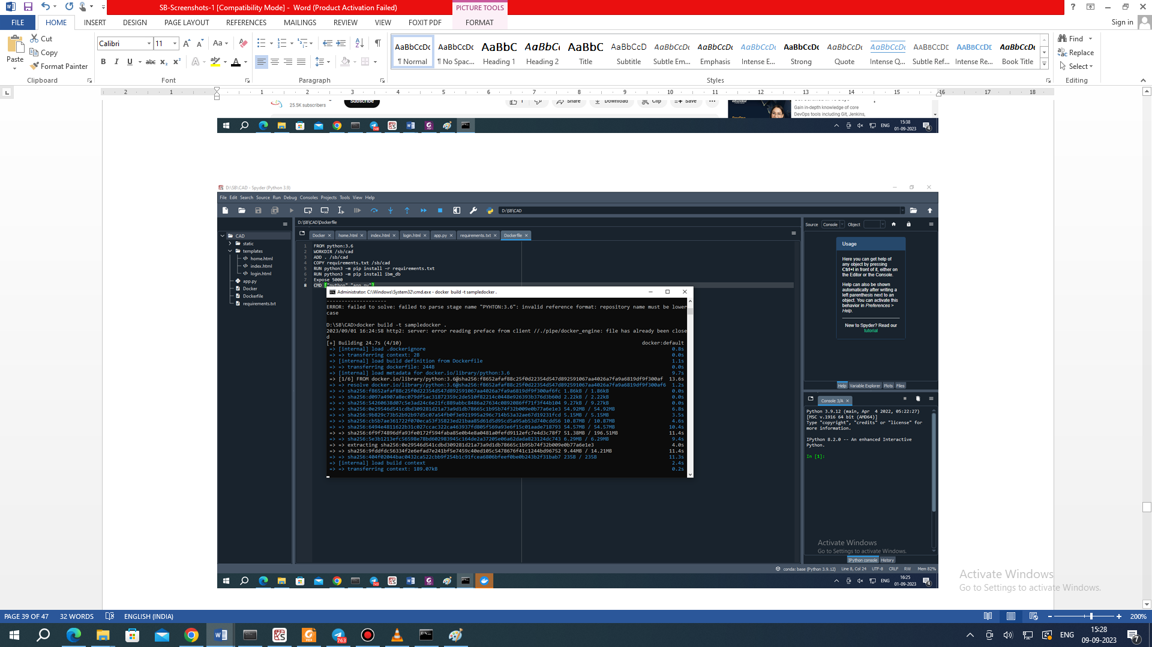

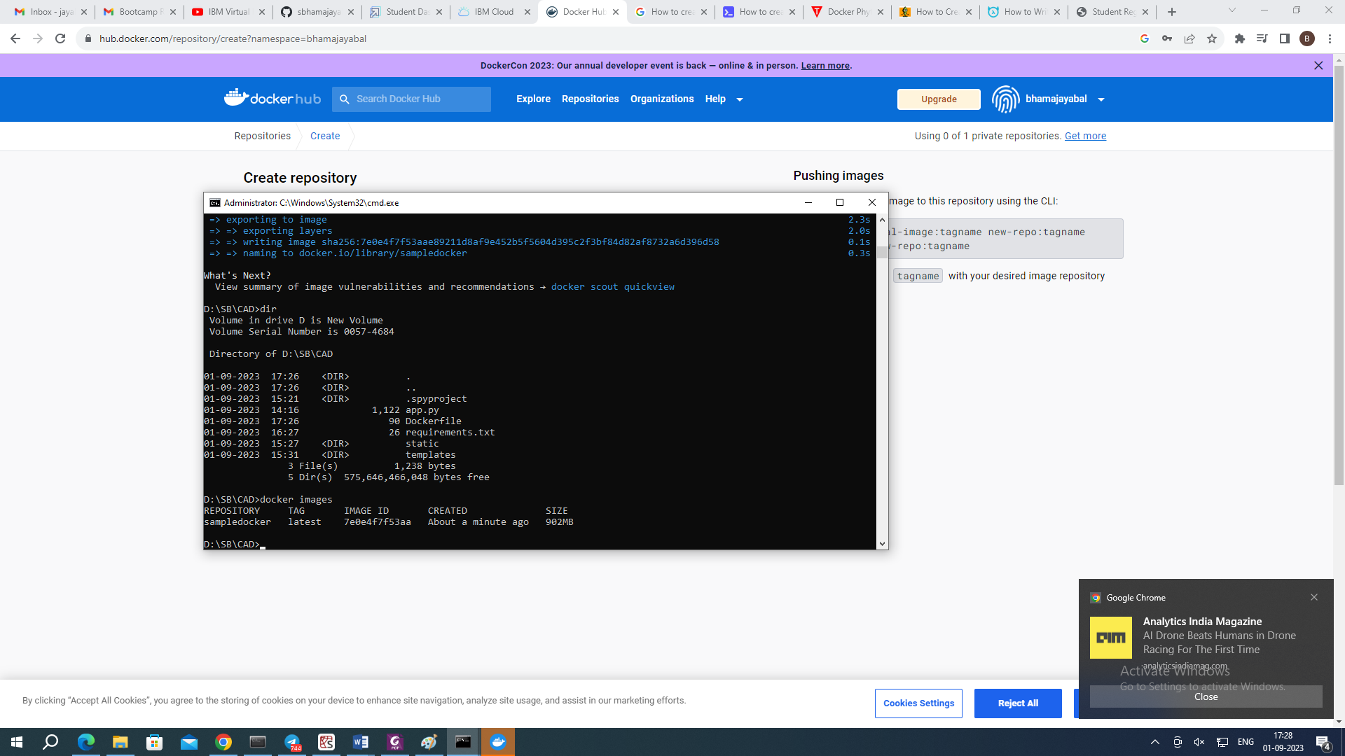

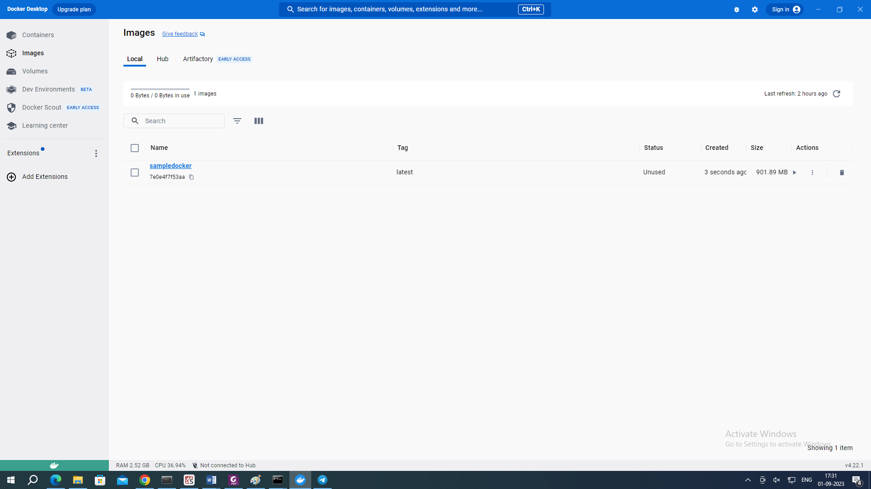

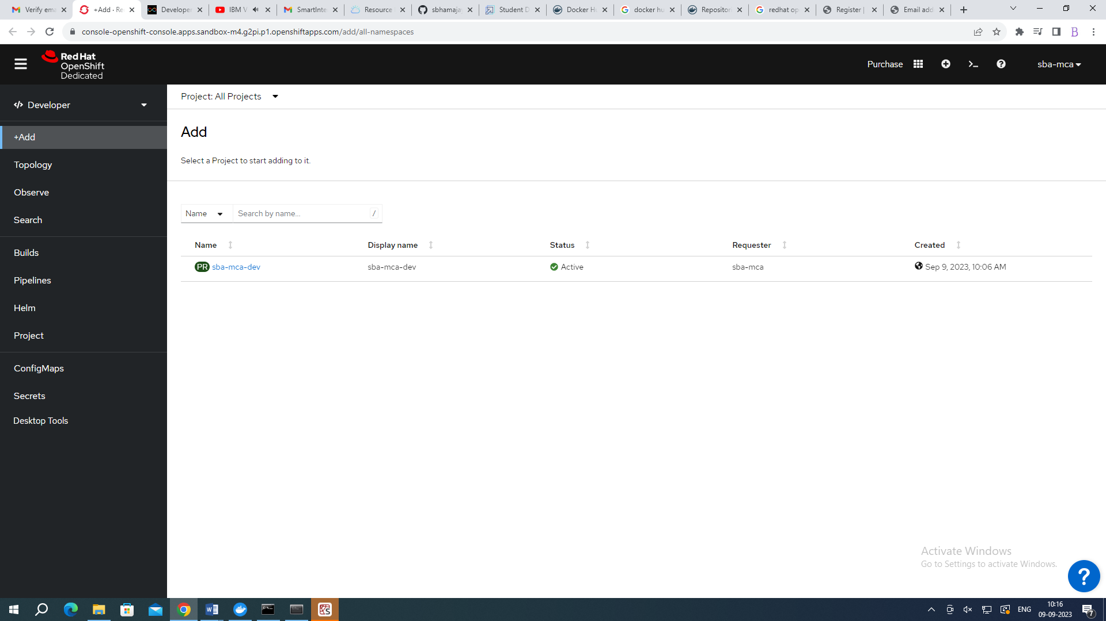

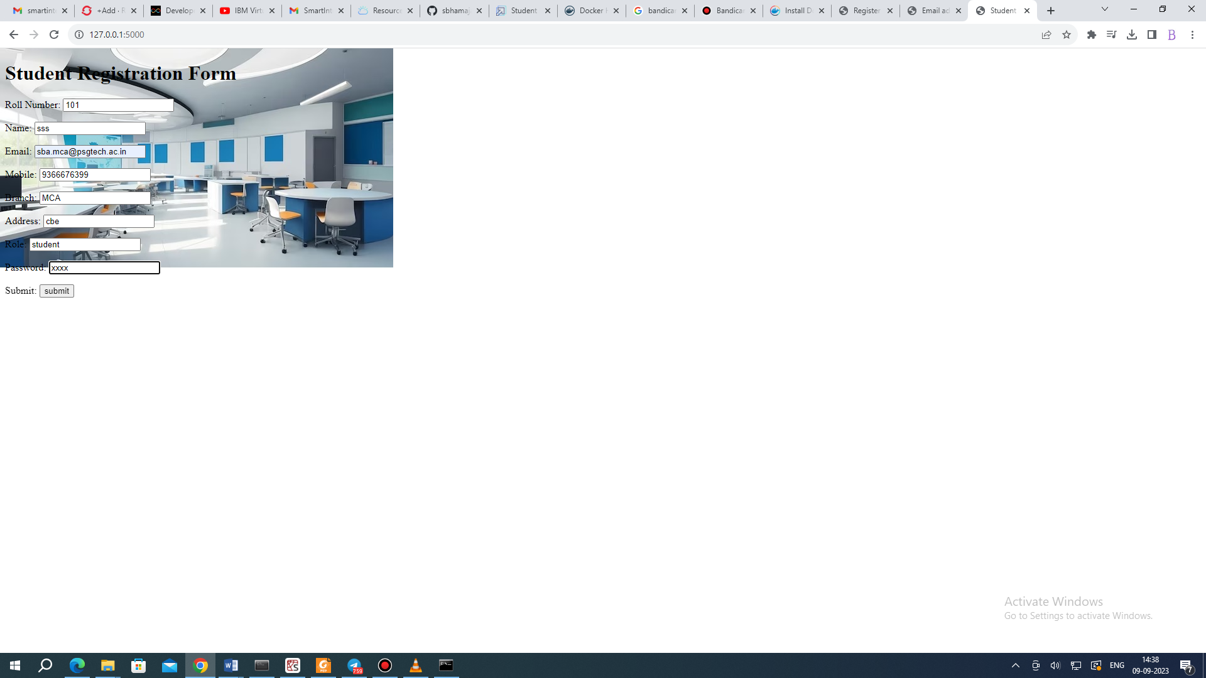

ADVANTAGES & DISADVANTAGES
The proposed solution implements appropriate technologies for the optimized way of providing the automation. Security concerns are low which may be a drawback.

APPLICATIONS
Social Impact: It will make the life of a student on campus much easier. Professors also no need to carry the big pile of notebooks submitted by students and the transparency of marks allotment also will be there.
Business Model/Impact: It will also give a positive impression about the university around the time of admissions and can be made by digitizing the campus.

CONCLUSION
The complete work focuses on the automation of assignments submission by students with apt font and back end applied for the development of the solution.

FUTURE SCOPE
The major part of security may be considered to be part of the solution development / enhancement in future.

BIBILOGRAPHY
Following are the references of websites which are visited/ referred for analysis of the problem and development of the solution:
https://cloud.ibm.com/
https://developers.redhat.com/developer-sandbox
https://github.com/sbhamajayabal/sbibm2023
https://hub.docker.com/
https://docs.docker.com/desktop/install/windows-install/
https://www.bandicam.com/downloads/ing/

APPENDIX
- Source Code (sample)
Following are the sample codes for the application development:
app.py
from flask import Flask,render_template,request

app=Flask(__name__)

@app.route('/',methods=['GET','POST'])

def student_regn_form():
if request.method=='POST':
rno.request.form['rno']
name=request.form['name']
émail.request.form['email']
mobile.request.form['mobile']
branch.request.form['branch']
addr.request.form['addr']
role.request.form['role']
pwd.request.form['pwd']
submitted=True

# Pass the form data to the template
return render_template('index.html',
rno=rno,
name=name,
email=email,
mobile=mobilp,
branch=branch,
addr=addr,
role=role,
pwd=pwd,
submitted=submitted
)

return render_template('index.html')

if __name__=='__main__':
app.run(debug=True)

HTML Code
<!DOCTYPE html>
<html>
<head>
<title> Student Registration Form </title>
<style>
body {
background-image:url("/static/institute.jpg");
backgorund-size:cover;
background-repeat:no-repeat;
background-attachment:fixed;
height=100%;
}
</style>
</head>
<body>
<h1> Student Registration Form</h1>
<form method="POST"action='/'>
<p>
Roll Number: <input type="text" name="rno" required>
</p>
<p>
Name: <input type="text" name="name" required>
</p>
<p>
Email: <input type="text" name="email" required>
</p>
<p>
Mobile: <input type="text" name="mobile" required>
</p>
<p>
Branch: <input type="text" name="branch" required>
</p>
<p>
Address: <input type="text" name="addr" required>
</p>
<p>
Role: <input type="text" value="role">
</p>
<p>
Password: <input type="text" name="pwd">
</p>
<p>
Submit: <input type="submit" value="submit">
</p>
</form>

<!--Display the form detials below the submit button-->
{% if submitted %}
<h2> Student Registration Details: </h2>
<p> Roll Number: {{rno}} </p>
<p> Name: {{name}} </p>
<p> Email: {{email}} </p>
<p> Mobile:{{mobile}} </p>
<p> Branch: {{branch}} </p>
<p> Address: {{addr}} </p>
<p> Role: {{role}} </p>
<p> Password: {{pwd}} </p>
{% endif %}
</body>
</html>

