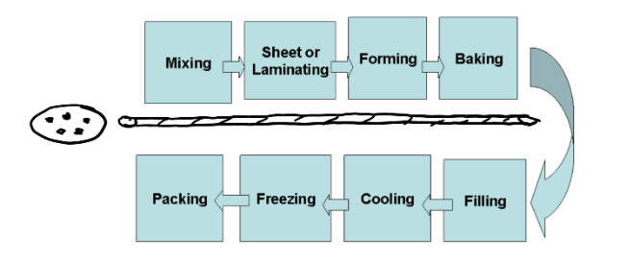

I want to compare this to implementation

Stage 1:

Plan: we should plan a project and track every mile inside it.

Tools used: JIRA, ServiceNow

Stage 2:

Develop and Integrate: In this stage we need to develop code according to the requirement

Tools Used: GIT and Jenkins

Stage 3:

Build: This phase is where the project or source code gets built/compiled

Tools Used: Maven, Gradle, Ant

Stage 4:

Package: the artifacts are necessary for deployment and deployable packages are stored in repository.

Tools Used: Artifactory,DockerHub

Stage 5:

TEST: Testing of Application is ensured before pushing the application onto prod environment

Tools Used: cucumber, SE

Stage 6 and 7:

Release and configuration:

Tools Used: Ansible, CloudFormation, Kubernetes

Stage 8:

Monitor: Setting up specialized counters like response times, memory & CPU utilization, etc. can provide a lot of insight into the end-user experience.

Tools Used: New Relic, Nagios