<Surrogate City Finder Tool>

Software Requirements Specification

<Version 1>

<Date>

<Team 46: Akanksha, Arushi Vashisht, Ayush Tripathi, Dhruv Das, Siddharth Bhatore >

Revision History

Date | Description | Author | Comments
<date> | <Version 1> | <Your Name> | <First Revision>

Document Approval

The following Software Requirements Specification has been accepted and approved by the following:
Signature | Printed Name | Title | Date
 | <Your Name> | Lead Software Eng.
 | A. David McKinnon | Instructor, CptS 322

Table of Contents

Revision History ii
Document Approval ii
1. Introduction 1
1.1 Purpose 1
1.2 Scope 1
1.3 Definitions, Acronyms, and Abbreviations 1
1.4 References 1
1.5 Overview 1
2. General Description 2
2.1 Product Perspective 2
2.2 Product Functions 2
2.3 User Characteristics 2
2.4 General Constraints 2
2.5 Assumptions and Dependencies 2
3. Specific Requirements 2
3.1 External Interface Requirements 3
3.1.1 User Interfaces 3
3.1.2 Hardware Interfaces 3
3.1.3 Software Interfaces 3
3.1.4 Communications Interfaces 3
3.2 Functional Requirements 3
3.2.1 <Functional Requirement or Feature #1> 3
3.2.2 <Functional Requirement or Feature #2> 3
3.3 Use Cases 3
3.3.1 Use Case #1 3
3.3.2 Use Case #2 3
3.4 Classes / Objects 3
3.4.1 <Class / Object #1> 3
3.4.2 <Class / Object #2> 3
3.5 Non-Functional Requirements 4
3.5.1 Performance 4
3.5.2 Reliability 4
3.5.3 Availability 4
3.5.4 Security 4
3.5.5 Maintainability 4
3.5.6 Portability 4
3.6 Inverse Requirements 4
3.7 Design Constraints 4
3.8 Logical Database Requirements 4
3.9 Other Requirements 4
4. Analysis Models 4
4.1 Sequence Diagrams 5
4.3 Data Flow Diagrams (DFD) 5
4.2 State-Transition Diagrams (STD) 5
5. Change Management Process 5
A. Appendices 5
A.1 Appendix 1 5
A.2 Appendix 2 5

1. Introduction

This section gives a scope description and overview of everything included in this SRS document. Also, the purpose for this document is described and a list of abbreviations and definitions is provided.

1.1 Purpose
The purpose of this document is to give a detailed description of the requirements for the “Surrogate City Finder Tool (SCFT). It will illustrate the purpose and complete declaration for the development of system. It will also explain system constraints, interface and interactions with other external applications. This document is primarily intended to be proposed to the client for their approval of our understanding and implementation of the project as well as a reference for developing the first version of the system for the development team.

1.2 Scope

Energy Plus Weather data files (.epw) contain exhaustive weather data for a city which utilized in simulations of the weather of a city for planning constructions and architectural modelling. Currently these files exist only for some cities of the world and (67 in India, to be precise).

To facilitate the application of this model for the cities for whom weather data files have not yet been developed, we will make the 'Surrogate City Finder Tool' which finds weather data files of those cities around the world whose weather is the closest match to the city in the question.
The matching is done on the basis of parameters which induce similar weather conditions like Altitude , Latitude and Yearly Temperature Profile.
The tool will display weather data files on a map of the world and the user will be able to make queries about specific cities and the tool will display the result on the map. The user will have an option of mailing results to their registered email Ids.

We will be using Ruby on Rails web framework to develop a deployable web application and HTML, CSS and Java scripting to provide a professional look to our WebApp.

1.3 Definitions, Acronyms, and Abbreviations
This subsection should provide the definitions of all terms, acronyms, and abbreviations required to properly interpret the SRS. This information may be provided by reference to one or more appendixes in the SRS or by reference to other documents.
Definitions:
Term | Definitions
User | Someone who interacts with the application
Admin/Administrator | System administrator who is given specific permission for managing and  controlling the system
Web App/Tool | The tool that is developed to find surrogate cities

1.4 References
This subsection should:
(1) Provide a complete list of all documents referenced elsewhere in the SRS, or in a separate, specified document.
(2) Identify each document by title, report number - if applicable - date, and publishing organization.
(3) Specify the sources from which the references can be obtained.
This information may be provided by reference to an appendix or to another document.

1.5 Overview
This subsection should:
(1) Describe what the rest of the SRS contains
(2) Explain how the SRS is organized.

2. General Description
This section will give an overview of the whole system. The system will be explained in its context to show how the system interacts with other systems and introduce the basic functionality of it. It will also describe what type of stakeholders that will use the
system and what functionality is available for each type. At last, the constraints and assumptions for the system will be presented.

2.1 Product Perspective
This subsection of the SRS puts the product into perspective with other related products or
projects. (See the IEEE Guide to SRS for more details).

2.2 Product Functions
This subsection of the SRS should provide a summary of the functions that the software will perform.

2.3 User Characteristics
Earthquake Engineering Professionals –Professionals who may want to use this tool to help them in weather assessment and modeling.
Weather Broadcast Companies–
Meteorology experts and Researchers – They know the domain best and will be the ones who will extensively use the City Finder tool.
Common man – They have the least knowledge about the domain, and also the software system. The user interface needs to be simple and appealing to this user.

2.4 General Constraints
This subsection of the SRS should provide a general description of any other items that will
limit the developer’s options for designing the system. (See the IEEE Guide to SRS for a partial list of possible general constraints).

2.5 Assumptions and Dependencies
This subsection of the SRS should list each of the factors that affect the requirements stated in the SRS. These factors are not design constraints on the software but are, rather, any changes to them that can affect the requirements in the SRS. For example, an assumption might be that a specific operating system will be available on the hardware designated for the software product. If, in fact, the operating system is not available, the SRS would then have to change accordingly.

3. Specific Requirements
This section contains all of the functional and quality requirements of the system. It gives a detai
led description of the system and all its features.

This will be the largest and most important section of the SRS. The customer requirements will be embodied within Section 2, but this section will give the D-requirements that are used to guide the project’s software design, implementation, and testing.

Each requirement in this section should be:
- Correct
- Traceable (both forward and backward to prior/future artifacts)
- Unambiguous
- Verifiable (i.e., testable)
- Prioritized (with respect to importance and/or stability)
- Complete
- Consistent
- Uniquely identifiable (usually via numbering like 3.4.5.6)

Attention should be paid to the carefully organize the requirements presented in this section so that they may easily accessed and understood. Furthermore, this SRS is not the software design document, therefore one should avoid the tendency to over-constrain (and therefore design) the software project within this SRS.

3.1 External Interface Requirements
This section provides a detailed description of all inputs into and outputs from the system. It also gives a description of the hardware, software and communication interfaces and provides basic prototypes of the user interface.

3.1.1 User interfaces
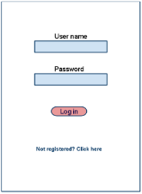 Login Page

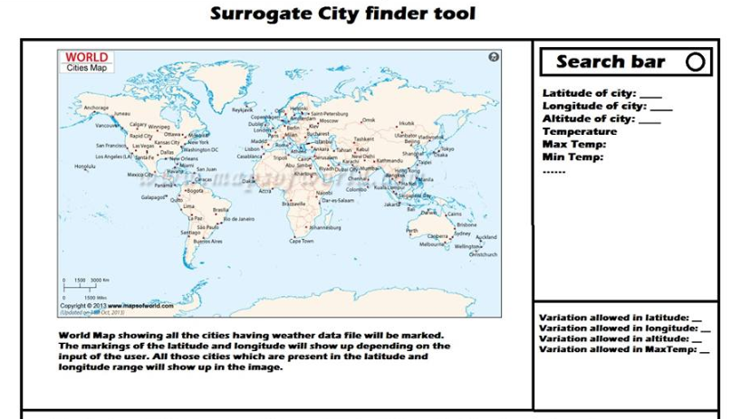

3.1.2 Hardware Interfaces
Since neither the mobile application nor the web portal have any designated hardware, it does not have any direct hardware interfaces. This is a normal Web Application which will be hosted on a server and the database is picked directly from the Energy Plus databases.

3.1.3 Software Interfaces
The tool interacts with the Energy Plus Database for weather data files. It retrieves the data files from the Database and displays the files on the map on the tool accordingly. The tool also uses the Google Map API for displaying an interactive world map within the tool and also uses the Google Map GeoCode API for locating places according to address on the map.

3.1.4 Communications Interfaces
The communication between the different parts of the system is important since they de
pend on each other. However, in what way the communication is achieved is not important for the system and is therefore handled by the underlying operating systems for the web application and the database and AP services.

Programming Languages – Ruby, Bash, JavaScript, Jquery, AJAX, Python
Web Framework(MVC) - Ruby on Rails
Development platform – VIM editor, Sublime Text 2, Linux Ubuntu 13.04/14.04
Collaboration and Version Control –Git
Project Documentation tools – LibreOffice, Creately.com (for USE CASE diagrams), Google Drive, Google Docs

3.2 Functional Requirements
This section includes the requirements that specify all the fundamental actions of the software system.

3.2.1 <Functional Requirement or Feature #1>
3.2.1.1 Introduction
3.2.1.2 Inputs
3.2.1.3 Processing
3.2.1.4 Outputs
3.2.1.5 Error Handling

Use Case No. | Use Case Name | Brief Description
1. | User login | A Login page will be implemented which will ask user for Email-Id and Password/Re-Type Password. The input will be validated with the information stored in the database and the user will directed to the main page.
2. | User Registration | Create a database which will hold user information. The user information will have the following fields:  a) Full Name  b) Industry  c) Job Title  d) Email address  e) Password  f) Company Name
3. | Profile View/Edit | User can view his profile which will show him his account details. It can be edited as per user’s wish.
4. | Display existing weather data files | An option will be present for the user to take a look at all the existing weather data files of cities.
5. | Query data for a city | User will give a city name as input. Database will search weather data files for the input city. Result will show the weather details of the city if its file exists.
6. | Parametric range input | The user will input the range for the latitude, altitude and temperature matching which it permits for matching cities to their surrogates
7. | Obtain Surrogate cities and save result | The tool calculates result, displays the range band on the map and highlights the matching cities. The user has an option to save the result for the particular query.
8. | E-mail the result | The result page can be emailed to the user’s registered Email Id.
9. | Manage weather data files | The admin has options to manage the database of the weather data files and update it as more and more files become available.
10. | Manage User accounts | The admin had CRUD options on User accounts.

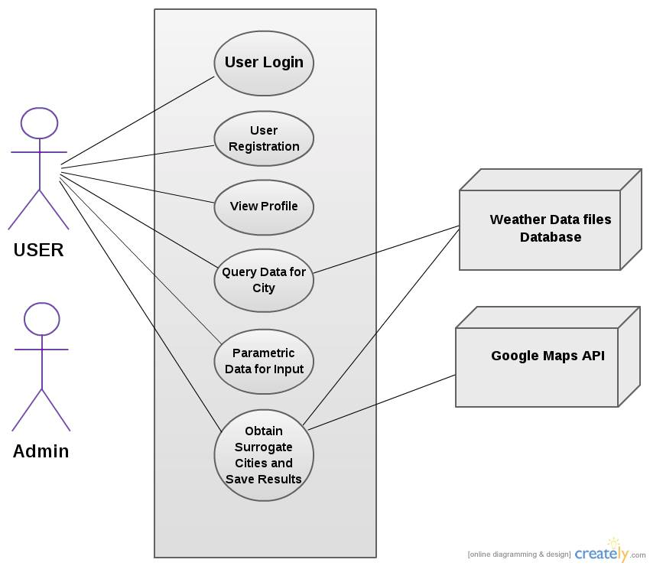

3.3 Use Cases

3.3.1 Use Case #1

3.3.2 Use Case #2
…

3.4 Classes / Objects

3.4.1 <Class / Object #1>

3.4.1.1 Attributes
3.4.1.2 Functions
<Reference to functional requirements and/or use cases>

3.4.2 <Class / Object #2>
…

3.5 Non-Functional Requirements
Non-functional requirements may exist for the following attributes. Often these requirements must be achieved at a system-wide level rather than at a unit level. State the requirements in the following sections in measurable terms (e.g., 95% of transaction shall be processed in less than a second, system downtime may not exceed 1 minute per day, > 30 day MTBF value, etc).

3.5.1 Performance

3.5.2 Reliability

3.5.3 Availability

3.5.4 Security

3.5.5 Maintainability

3.5.6 Portability

3.6 Inverse Requirements
State any *useful* inverse requirements.

3.7 Design Constraints
Specify design constrains imposed by other standards, company policies, hardware limitation, etc. that will impact this software project.

3.8 Logical Database Requirements
Will a database be used? If so, what logical requirements exist for data formats, storage capabilities, data retention, data integrity, etc.

3.9 Other Requirements
Catchall section for any additional requirements.

4. Analysis Models
List all analysis models used in developing specific requirements previously given in this SRS. Each model should include an introduction and a narrative description. Furthermore, each model should be traceable the SRS’s requirements.

4.1 Sequence Diagrams

4.3 Data Flow Diagrams (DFD)

4.2 State-Transition Diagrams (STD)

5. Change Management Process
Identify and describe the process that will be used to update the SRS, as needed, when project scope or requirements change. Who can submit changes and by what means, and how will these changes be approved.

A. Appendices
Appendices may be used to provide additional (and hopefully helpful) information. If present, the SRS should explicitly state whether the information contained within an appendix is to be considered as a part of the SRS’s overall set of requirements.

Example Appendices could include (initial) conceptual documents for the software project, marketing materials, minutes of meetings with the customer(s), etc.

A.1 Appendix 1

A.2 Appendix 2

