Practical-31

Write a program which asks the user to enter their age in years (Assume that the user always enters an integer) and based on the following conditions, prints the output exactly as in the following format (as highlighted in yellow):

When age is less than or equal to 0, your program should print

UNBORN

When age is greater than 0 and less than or equal to 150, your program should print

ALIVE

When age is greater than 150, your program should print

VAMPIRE

Note that your printed output should be in capital letters and there should be no extra spaces.

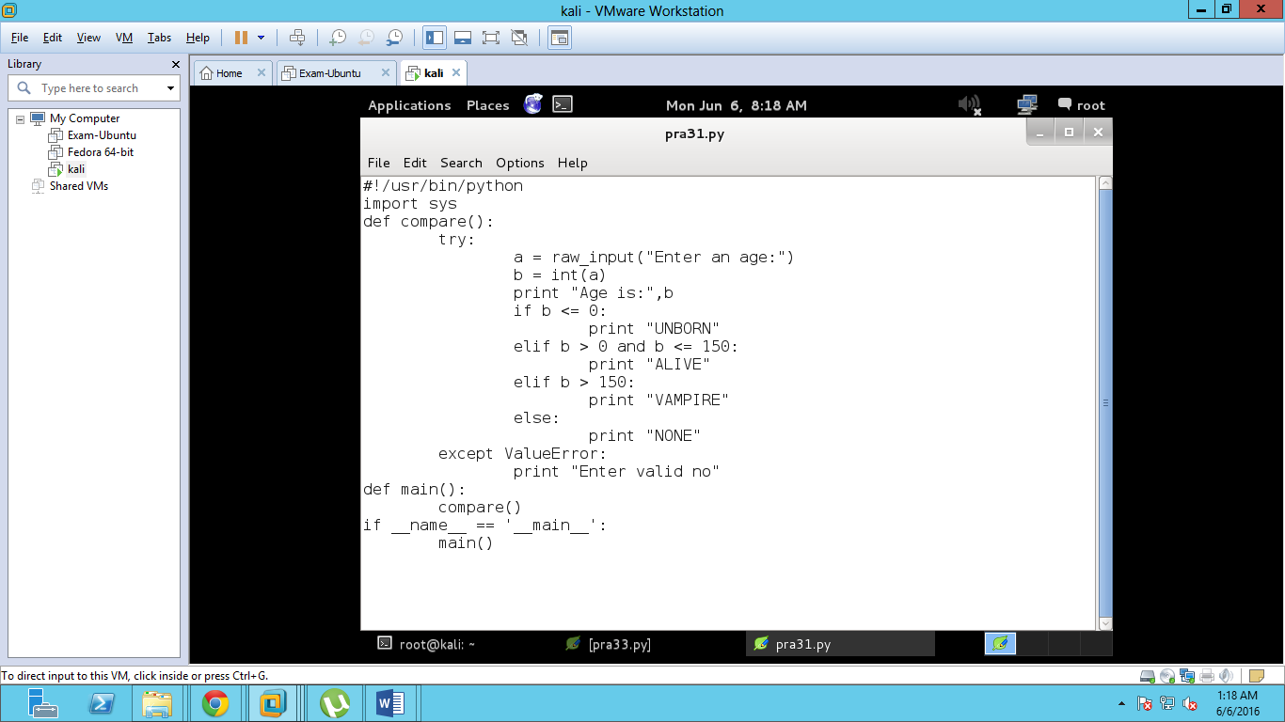

Output

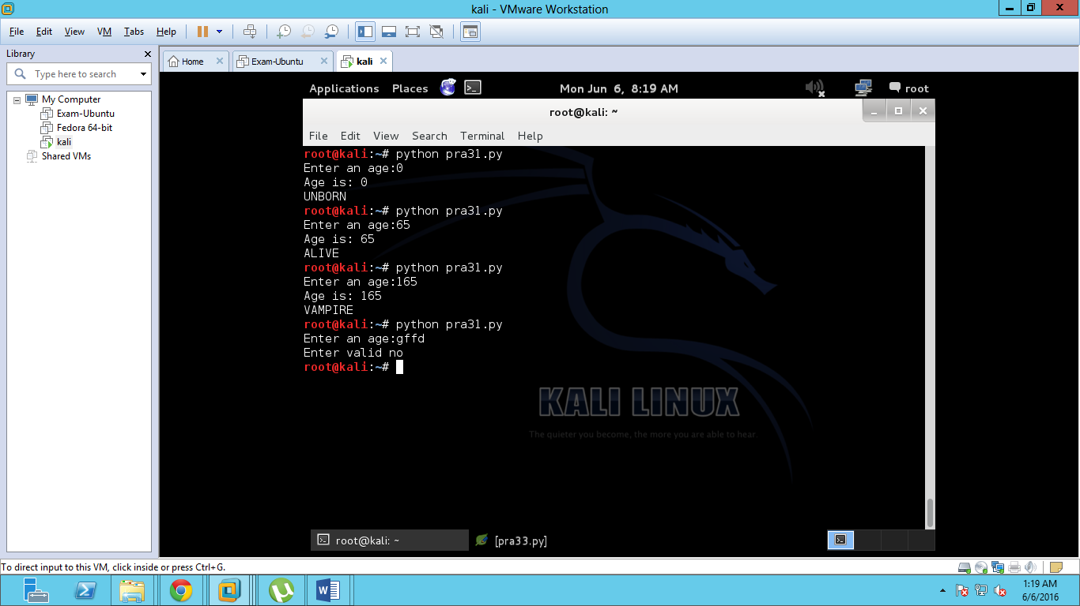

Practical -33

Write a program which asks the user to enter a positive integer 'n' (Assume that the user always enters a positive integer) and based on the following conditions, prints the appropriate results exactly as shown in the following format (as highlighted in yellow).

when 'n' is divisible by both 2 and 3 (for example 12), then your program should print

BOTH

when 'n' is divisible by only one of the numbers i.e divisible by 2 but not divisible by 3 (for example 8), or divisible by 3 but not divisible by 2 (for example 9), your program should print

ONE

when 'n' is neither divisible by 2 nor divisible by 3 (for example 25), your program should print

NEITHER

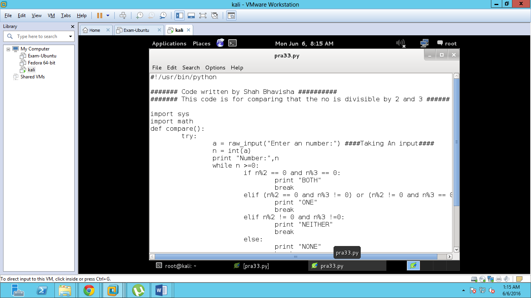

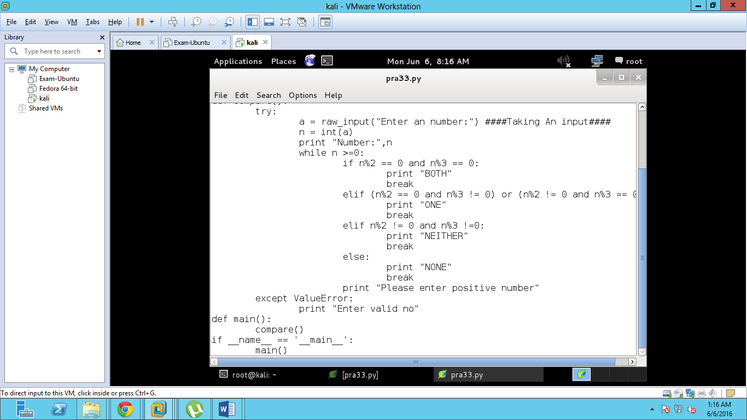

Output

