**BIRLA INSTITUTE OF TECHNOLOGY AND SCIENCE, PILANI**

Batch No. :

**DEPARTMENT OF COMPUTER SCIENCE AND INFORMATION SYSTEMS**

**Artificial Intelligence (BITS F444/ CS F407)**

**I Semester 2019-20**

**Programming Assignment-2**

**Coding Details**

**(September 27, 2019)**

*Instruction: Type the details precisely and neatly*

1. ID: **2019H1020023P**

Name: **SUBHASHIS DHAR**

1. Mention the names of Submitted files :
   1. **Ana.png**
   2. **Graph.py**
   3. **Main.py**
   4. **Minesweeper.png**
   5. **Next.png**
   6. **Start.png**
   7. **State.py**
   8. **Stop.png**
2. Total number of submitted files: **8**
3. Name of the folder : **2019H1030023P_CSF407_PA_1**
4. Have you checked that all the files you are submitting have your name in the top? **Yes**
5. Have you checked that all the files you are submitting are in the folder as specified in 4 (and no subfolder exists)? **Yes**

1. Problem formulation
   1. State representation:

**State is represented by 2 2D matrices corresponding to actual game matrix, and another visited matrix which keeps track of which squares are visible to the user. Also current value of X,Y are stored to show click event. And previous values of X,Y are also stored in the case of Random restart to detect 3 successive attempts resulting in the same state. After we get same state 3 times, we restart at random point.**

* 1. How is the Initial state generated?

**Initial state is generated by making a 2D matrix of order row*column and initializing it to 0. Also I am representing the location of mines as 9 as max neighboring nodes can reach only up to 8 as there can be at max 8 neighbors for each square. After that I am taking input the number of mines from user. And placing those many mines randomly on the board. After that calculating the numbers 0-8 for each square on the board. Visited matrix is initially 0 as none of the squares are visible to user at start.**

* 1. What is the goal state?

**Goal state is defined as number of unseen squares = number of mines. So I have formed the problem as a minimization problem where from initial row*col unseen squares, we need to reach unseen squares equal to number of mines. This means we have identified all the mines on the board.**

* 1. Are there more than one goal states? If yes, then describe all the goal states.

**No**

* 1. Do you view the goal state as a state reaching its optimal heuristic value in a search landscape? Give details.

**Yes. Goal state has unseen squares equal to number of mines. As per my heuristic function1, this denotes that probability of finding a mine in all remaining squares is 1. This is the global optimal value of the goal state as per this heuristic.**

* 1. State representation in Python (name the construct and give one small example of a state)

State comprises of:

-----------------------

row  
col   
board = [[0 for i in range(col)] for j in range(row)]  
visited = [[0 for i in range(col)] for j in range(row)]

curX

curY

prevX

prevY

Example:

-------------

Board:

[1, 9, 1, 0, 0, 0, 0, 0, 1, 9, 1, 0]

[1, 1, 1, 0, 0, 1, 1, 1, 1, 1, 1, 0]

[0, 0, 0, 1, 1, 2, 9, 1, 1, 1, 2, 1]

[0, 0, 0, 1, 9, 2, 1, 1, 1, 9, 2, 9]

[0, 0, 0, 2, 3, 3, 1, 0, 2, 2, 3, 1]

[0, 0, 0, 1, 9, 9, 1, 0, 1, 9, 1, 0]

[0, 0, 0, 1, 3, 3, 2, 0, 1, 1, 1, 0]

[0, 0, 0, 0, 1, 9, 1, 0, 0, 0, 0, 0]

[0, 0, 0, 0, 1, 1, 1, 0, 0, 0, 0, 0]

Visiting X: 8 Y:6 on first click

Visited:

[0, 0, 0, 0, 0, 0, 0, 0, 0, 0, 0, 0]

[0, 0, 0, 0, 0, 0, 0, 0, 0, 0, 0, 0]

[0, 0, 0, 0, 0, 0, 0, 0, 0, 0, 0, 0]

[0, 0, 0, 0, 0, 0, 0, 0, 0, 0, 0, 0]

[0, 0, 0, 0, 0, 0, 0, 0, 0, 0, 0, 0]

[0, 0, 0, 0, 0, 0, 0, 0, 0, 0, 0, 0]

[0, 0, 0, 0, 0, 0, 0, 0, 0, 0, 0, 0]

[0, 0, 0, 0, 0, 0, 0, 0, 0, 0, 0, 0]

[0, 0, 0, 0, 0, 0, 1, 0, 0, 0, 0, 0]

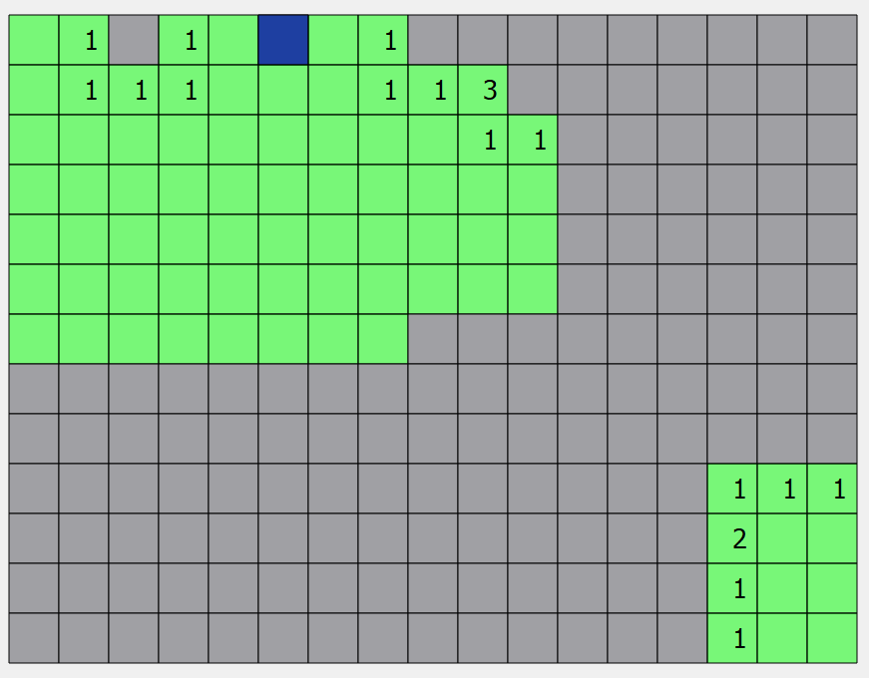

1. NextState() function description

**Next state function calculates what portion of the board will be visible to the user after clicking on a square. Thus the board remains same. Only the visited matrix is changed. A convex region is opened up on a click on a square bordered by possible mines. This new visited matrix is updated in the GUI**

1. Heuristic functions
   1. Is the heuristic function applied on a cell or on a state?

**Heuristic function is applied on a cell in my program. Each cell will have its own probability of being a mine. The program chooses next cells whose probability of being a mine is smallest.**

* 1. Define and explain the heuristics (in words) used in your program. Specify the input and output to each function in detail
     1. h1 : **Probability of Mine: each cell is given a heuristic value in this function. The next cell to be clicked is chosen as the least probable mine, or whose probability value is lowest.**
     2. h2 : **N/A**
  2. Compute (manually) the heuristic values for the following three states state 1, 2 and goal state as given in the following three figures 1,2 and 3 respectively. Write the values below appropriately.

State1 : h1 = all cells with 1 has lower prob h2 = **N/A**

State2 : h1 = all cells with 1 has lower prob h2 = **N/A**

State3 : h1 = all cells with 1 has lower prob h2 = **N/A**

Goal state : h1 = all unseen cells as 1 h2 = **N/A**

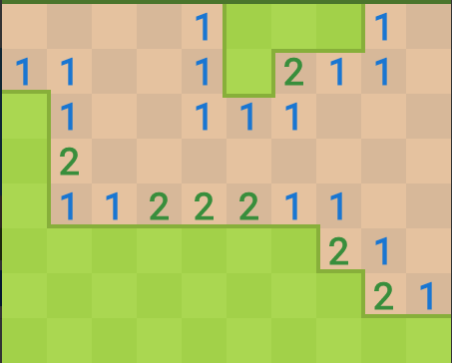

Fig 1

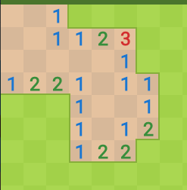

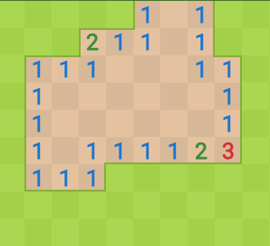

state 1 (your state should not have concavity as is here)

state 2 (convex shape of open area)

state 3 (convex shape of open area)

1. Hill Climbing (T1) technique
   1. Code status : **Implemented Fully**
   2. Write the sequence of steps followed by you:

(choose words from - First click, next state, all next states, compute heuristic value, cell, state, open area, closed area, mine etc.)

**First click computes x,y randomly**

**A convex area is opened up showing cell values. User can click on mine at first click.**

**Then heuristic values of all shown nodes are computed**

**Cell with minimum value is chosen as next x,y**

**This process continues until a mine is hit or number of unseen cells is equal to number of mines**

* 1. Print the pre-computed values

R1 = 679 R2 = 15.622 R3 = Varies with run R4 = 23 R5 = N/A R6 = 13 R7 = 31 R8 = N/A R9 = 29 R10 = N/A

* 1. Cut and paste the images of graphs G1, G2, G3 and G4 below

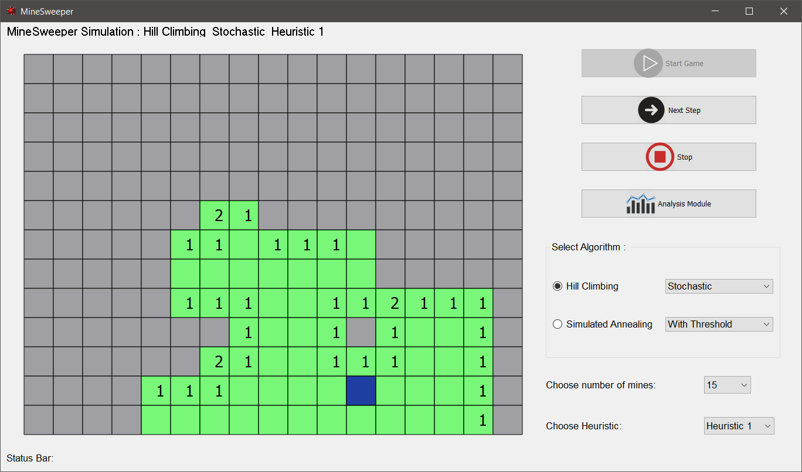

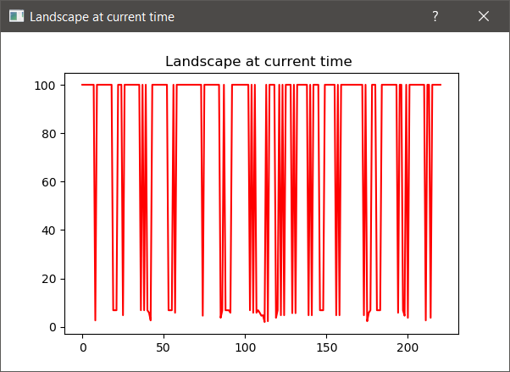

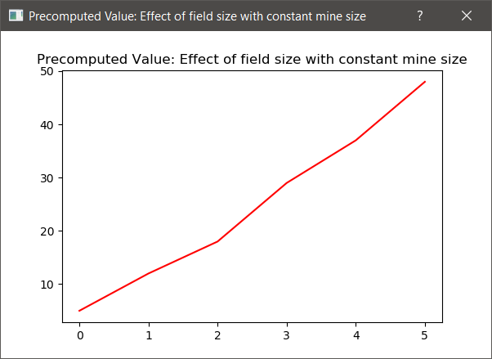

* 1. Are you posing the problem as maximization problem or minimization problem? Discuss why.

**As per the heuristic I have chosen, I need to minimize the number of unseen nodes till it becomes equal to the number of mines initially set by the player.**

* 1. Discuss how you view the changing values of heuristics as you proceed.

**As more and more nodes are opened up, the number of hidden nodes decreases. Hence the probability of finding a mine increases gradually as the game goes on. The heuristic value of each cell increases with progress and we choose the lowest probability until there are none such nodes.**

* 1. Discuss the state which represented suboptimal solution? Why?

**Using hill climbing, the algorithm can get stuck at local minima when all the probabilities of discovered nodes are less than previous value. At this stage, the program only chooses nodes that are already seen and gets stuck. It does not go out of this region to click other unseen nodes. To get out of this situation, local beam search and random restart are used.**

1. Simulated annealing (T2) technique
   1. Code: **Not done**
   2. Write the sequence of steps followed by you (choose words from - First click, next state, all next states, compute heuristic value, cell, state, open area, closed area, mine etc.)
   3. Print the pre-computed values

R11 = R12 = R13 = R14 = R15 = R16 =

* 1. Cut and paste the images of graphs G5, G6 and G7 below
  2. Discuss the temperature range used.
  3. Discuss the probability computation.
  4. How are you selecting the bad moves?
  5. Are you posing the problem as maximization problem or minimization problem? Discuss why.
  6. Discuss how you view the changing values of heuristics as you proceed.

1. GUI details
   1. Created the GUI: **Yes**
   2. Have created it according to the specifications? **Yes**
   3. Which module of Python used for creating graphics? **PyQt5**
   4. Is this under the standard Python library/ Matplotlib/ PyQT or not? **Yes**
   5. If not, why?
2. Compilation Details:
   1. Code Compiles (Yes/ No): **Yes**
   2. Mention the .py files that do not compile:**N/A**
   3. Any specific function that does not compile: **N/A**
   4. Ensured the compatibility of your code with the specified Python version? **Yes**
   5. Instructions for compilation of your files mentioning the multi file compilation process used by you (We may use the replica of these for compiling your files while evaluating your code)

**N/A**

1. Driver Details: Does it take care of the options specified earlier(yes/no): **Yes**
2. Execution status (describe in maximum 2 lines)

* **Program can be executed using command : python .\Main.py**
* **The GUI driver application shows all necessary options and variations.Some features are not yet implemented as mentioned in this document.**

1. Any other detail:
   * **User selects the number of mines, heuristic to use and algorithm to be used.**
   * **He clicks on start button.**
   * **To simulate each click of the agent playing minesweeper, next button is clicked. The square selected by the agent is shown in blue color.**
   * **The simulation can be stopped anytime by using stop button**
   * **Top bar shows which algorithm, heuristics are being used.**
   * **Status bar below shows the current heuristic value obtained for X,Y cell**
   * **After simulation is done, user can go to analysis module where performance metrics and graphs are displayed.**
2. Declaration: I, **SUBHASHIS DHAR**  declare that I have put my genuine efforts in creating the python code for the given programming assignment and have submitted only the code developed by me. I have not copied any piece of code from any source. If the code is found plagiarized in any form or degree, I understand that a disciplinary action as per the institute rules will be taken against me and I will accept the penalty as decided by the department of Computer Science and Information Systems, BITS, Pilani.

ID : **2019H103002P** Name: **SUBHASHIS DHAR**

Date: **27TH September 2019**

******************************************************************************* Should not exceed six pages