Indicator calculation definition – Carbon sequestration

The objective of this sheet is to get specifications of indicators for the Eururalis 2 tool in order to:
- implement indicator calculations;
- automate validation of input parameter and calculation result range;
- visualise indicator map;
- collect uniform indicator fact sheet content;
- allow back tracing of calculation (transparency).

Indicator name | Carbon sequestration in LULUCF sector
Short description (max. 3 lines) | Large amounts of CO₂ can be sequestered in the terrestrial ecosystem. This can contribute to climate change mitigation. This indicator represents the amount of carbon that is sequestered in or emitted from land use, land use change and forestry.
Contact person and organization | Nynke Schulp, WUR-SIL, tel. 0317-483716

Indicator data type
Quantitative (please fill in table below)
Units | Ton C/km²
Valid range | 3000 to- +7500
Qualitative or ordinal

Legend (for map display)
Name | Value or range | Colour indication
Very high loss | -3000 to -2000 | Dark red
High loss | -2000 to -1000 | Red
Loss | -1000 to -100 | Light red
No change | -100 to 100 | Grey
Gain | 100 to 2500 | Light blue
High gain | 2500 to 5000 | Medium blue
Very high gain | 5000 to 7500 | Dark blue

Level of map presentation (e.g. 1x1km grid, nuts2, HARM, etc)
Nuts2

Description of causality in calculation method (max. 10 lines)
Different land use types differ in the amount of carbon they sequester or emit in soil and vegetation. Carbon is sequestered in soils of forests, pasture, natural vegetation and emitted by croplands and parts of wetlands. Additionally, in forests large amounts of carbon are stored in vegetation as well. Changes in land use can thus result in changes in carbon emission / sequestration.

Emission / sequestration is defined by an emission factor; this is a country-specific, land use type specific amount of sequestration / emission per km² per year. Thus, the emission for a grid cell is the emission factor. When the land use changes, the emission factor changes to the emission factor of the new land use type. Additionally, deforestation causes loss of carbon from biomass.

Besides land use change, other factors influencing carbon emission and sequestration are the amount of carbon already present in the soil (the higher the soil carbon content, the higher the emission) and the age of certain land use types: when for example a forest is still growing fast, more carbon can be sequestered than in old forests.

Calculation input parameters (name, source and units. Please add whether this comes from Clue, Image, Gtap ,own datasource or other indicator)
Name | Quantity | Source | Description
Land cover | Clue classes (all) | CLUE modelling | Clue AsciiGrid grid 1x1 km. For all scenarios for all timesteps
Soil organic carbon | 0-8 (SOC classes);  9 (peat) | Own data source | Combination of JRC soil organic carbon map and ESB soil map. (we’ll provide it)
Age of land use |  | CLUE modelling | 1x1 km ascii with age of gridcells
Emission factors | Ton C/km² per year | Own data source | We’ll provide a map with emission factor for each land use type as 1x1 km grids (see calculation rules).
Forest biomass content | Ton C/km² | Own data source | We’ll provide a map of forest biomass carbon content per country as 1x1 km grid.

Technical implementation of calculation method (Incl aggregation method)
Flowcharts:
Calc1 to calc5 refer to headings in calculation / decision rules.
2000:

2001 → 2030:

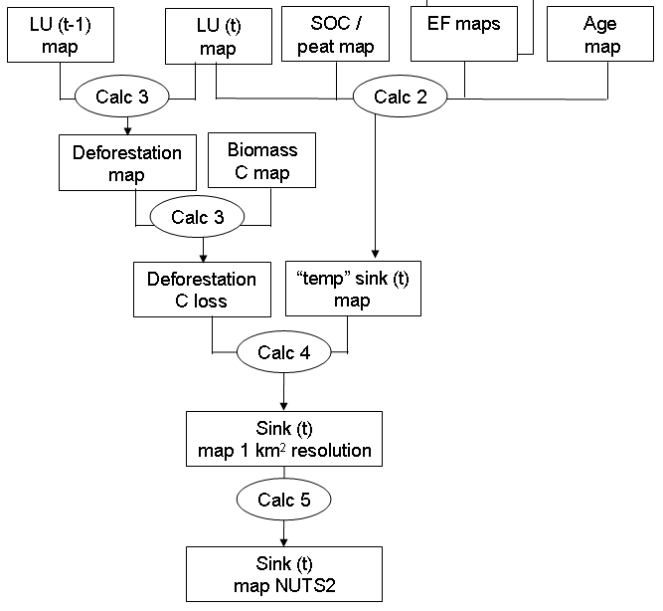
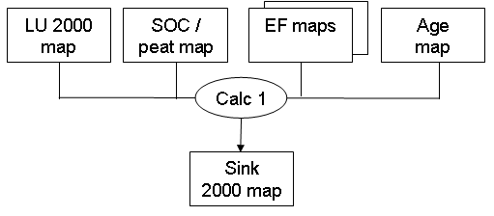

Calculation / decision rules:
[ef…] are maps with emission factors for each land use type;
[biomassC] is map of forest biomass carbon content;
[age] is map of age of land use in each grid cell;
[socpeat] is map with soil organic carbon content classes and peat.

2000
Calc1
If LU=0/5/11/12/13/14, emission=0
If LU=4, emission= [efpeat]
If LU=15, emission=0.15*[efforest]
If LU=3, emission=a*[efforest]
If LU=8, emission=[efpermanentcrops]
If LU=2 and [socpeat]=9, emission=[efpeat], else emission=[efgrass]
If LU=1/6/9 and [socpeat]=1 or 2, emission=0
If LU=1/6/9 and [socpeat]=3, emission=0.2*[efcrop]
If LU=1/6/9 and [socpeat]=4, emission=0.65*[efcrop]
If LU=1/6/9 and [socpeat]=5, emission=1.6*[efcrop]
If LU=1/6/9 and [socpeat]=6, emission=3*[efcrop]
If LU=1/6/9 and [socpeat]=7, emission=5*[efcrop]
If LU=1/6/9 and [socpeat]=8, emission=8*[efcrop]
If LU=1/6/9 and [socpeat]=9, emission=[efpeat]
If LU=10, emission=b*[efforest] (b is age specific; a few different classes)

2001 onwards
Land use change:
Calc2
If LU=0/5/11/12/13/14, emission=0
If LU=4, emission= [efpeat]
If LU=15, emission=[efheath]
If LU=8, emission=[efpermanentcrops]
If LU=10, emission= b*[efforest] (b is age specific; a few different classes)
If LU=2 and [socpeat]=9, emission=[efpeat], else emission=[efgrass]
If LU=1/6/9 and [socpeat]=1 or 2, emission=0
If LU=1/6/9 and [socpeat]=3, emission=0.2*[efcrop]
If LU=1/6/9 and [socpeat]=4, emission=0.65*[efcrop]
If LU=1/6/9 and [socpeat]=5, emission=1.6*[efcrop]
If LU=1/6/9 and [socpeat]=6, emission=3*[efcrop]
If LU=1/6/9 and [socpeat]=7, emission=5*[efcrop]
If LU=1/6/9 and [socpeat]=8, emission=8*[efcrop]
If LU=1/6/9 and [socpeat]=9, emission=[efpeat]
If LU=3 emission=a*[efforest]
If LU=7/16 and m<[age]<n, emission=x*[efforest] (x=age specific, 5? classes)

Deforestation:
Calc3
If LU_{t}<>10 and LU_{t-1}=10, biomassCloss=[biomassC]
The biomass C loss will probably also be age specific

Total:
Calc4
Total=emission_{t} +biomassCloss

Aggregation:
Calc5
Zonal mean for aggregation to NUTS2 region.

