# What is Exception Handling?

There are two types of errors: syntax errors and exceptions. Syntax errors are the common “invalid syntax” errors we receive while running python script with a coding error, such as a colon missing. An exception, on the other hand, is where a statement coding may be correct but an error is detected while running the script. An example of a type of exception would be NameError, and the string printed as the exception type is the name of the built-in exception that occurred. The line then provides details depending on the type of exception and its root cause.

It’s possible to write programs that handle selected exceptions. For example, in a try and except statement, the ‘except’ clause is skipped if no exception occurs and the try statement is completed. If an exception occurs, and the type matches the exception defined after the keyword, the ‘except’ clause is executed. If an exception occurs, and not does not match the exception defined in the ‘except’ clause, then it is passed on to outer try statements. If no handler is found, it is an unhandled exception and the execution stops. A message would appear if a print statement under the ‘except’ clause was inputted.

Handlers only handle exceptions that occur in the corresponding clause, not in other handlers of the same statement. An exception may have an associated value, known as the exception’s argument. If an exception has arguments, they are printed as the last part of the message for unhandled exceptions. The raise statement allows one to force a specified exception to occur. *(Obtained February 26, 2021 from:* [*https://docs.python.org/3/tutorial/errors.html*](https://docs.python.org/3/tutorial/errors.html)*)*

An example of a TypeError:

a = 5

b = ‘Hello’

a + b

TypeError: unsupported operand type (s) for +: ‘int’ and ‘str’. *(Obtained February 26, 2021 from* [*https://www.datacamp.com/community/tutorials/exception-handling-python*](https://www.datacamp.com/community/tutorials/exception-handling-python)*)*

# What is pickling in Python?

Pickling is the process where a Python object hierarchy is converted into a byte stream, and un-pickling would do the inverse operation of converting a byte stream into an object hierarchy. Other terms for pickling is serialization, marshalling or flattening. The pickle module implements binary protocols for pickling and un-pickling a Python object structure.

The data format utilized by the pickle module is specific to Python, which means there are no restrictions imposed by external standards. However, it also means that non-Python programs may not be able to reconstruct the Python objects which have been pickled. *(Obtained February 26, 2021 from* [*https://docs.python.org/3/library/pickle.html*](https://docs.python.org/3/library/pickle.html)*)*

# What are the benefits of using structured error handling?

Exception handling enhances the code and helps prevent potential program failures where the program would stop in an uncontrolled manner. If a code is still in production and it terminates due to an exception, this could cause an issue and it is therefore a better option to handle the exception before production of a code. *(Obtained February 26, 2021 from* [*https://www.datacamp.com/community/tutorials/exception-handling-python*](https://www.datacamp.com/community/tutorials/exception-handling-python)*)*

# What is the difference between a text file and a binary file?

Reading and writing binary file is done by appending b to the mode string. The binary data is represented using special type called bytes which represent a sequence of numbers between 0 and 255. These are not in a human-readable format. Text files can be read as how we would read a sentence or any written text format. *(Obtained February 26, 2021 from* [*https://www.datacamp.com/community/tutorials/exception-handling-python*](https://www.datacamp.com/community/tutorials/exception-handling-python)*)*<https://thepythonguru.com/python-how-to-read-and-write-files/>)

# Assignment 07:

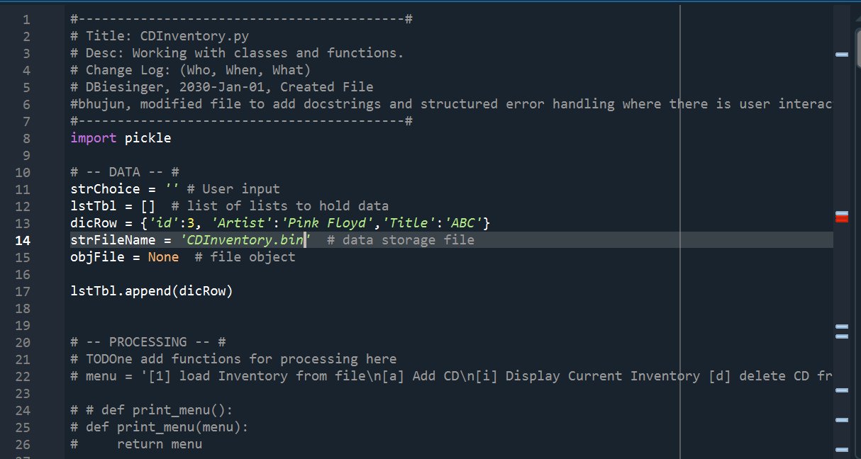

Using the import pickle, we learned to pickle data where we can convert the data into a byte stream. We also applied the Exception handling to call out any errors such as value errors. I ran into challenges with the read section of the binary file. I will follow up on any learnings from this piece. <https://github.com/sbhujun/Assignment07>