**Technology Club**: Requirements Document (version 2.0)

Project: Technology Club Website

Date(s): 01/31/2019 - 05/03/2019

Prepared by: Chad Farrington, Katherine Ruiz, Steve Bien-Aime

Document status: __ Draft __ Proposed __ Validated __ Approved _x_ Final Submission

**1. Introduction**

This document contains the system requirements for the Technology Club Website. These requirements have been derived from several sources, including members of the club and Professor Delgado.

**1.1 Purpose of This Document**

This document is intended to guide development of The Technology Club website.It will go through several stages during the course of the project:

1. **Draft:** The first version, or draft version, is compiled after requirements have been discovered, recorded, classified, and prioritized.
2. **Proposed:** The draft document is then proposed as a potential requirements specification for the project. The proposed document should be reviewed by several parties, who may comment on any requirements and any priorities, either to agree, to disagree, or to identify missing requirements. Readers include end-users, developers, project managers, and any other stakeholders. The document may be amended and re proposed several times before moving to the next stage.
3. **Validated:** Once the various stakeholders have agreed to the requirements in the document, it is considered validated.
4. **Approved:** The validated document is accepted by representatives of each party of stakeholders as an appropriate statement of requirements for the project. The developers then use the requirements document as a guide to implementation and to check the progress of the project as it develops.
5. **Final Submission:** This document will present the finalized document for the Technology Club Website and the final requirements and design the project consist of.

**1.2 How to Use This Document**

We expect that this document will be used by people with different skill sets. This section explains which parts of this document should be reviewed by various types of readers.

**Types of Reader**

This entire document is intended for:

1. Programmers
2. Graphic Designers
3. Front End Web Developers
4. Back End Web Developers
5. End Users
6. Stakeholders

**Technical Background Required**

This document covers general information. An extensive technical background is not necessary to review it.

**1.3 Scope of the Product**

The purpose of this project is to deliver a no more than 8 page user friendly, fully functional and responsive website that allows the Technology Club to deliver relevant news and resources to its members and the public and to maintain a digital archive of currently active membership and active officers.

**1.4 Business Case for the Product**

Every student organization needs a website that promotes its purpose and agenda online. In this digital age, people expect all respectable organizations to have a website in order to take it seriously.

**1.5 Overview of the Requirements Document**

* RSS feed on homepage
* Dashboard for member profile picture
* Office Portal for website maintenance
* Member login feature
* Member/Officers data (database -mysql)
* Picture upload feature
* PHP ( Back End)
* Javascript (Front End)

**2. General Description**

This section will give the reader an overview of the project, including why it was conceived, what it will do when complete, and the types of people we expect will use it. We also list constraints that were faced during development and assumptions we made about how we would proceed.

**2.1 Product Perspective**

The Technology Club Website’s purpose is to convey the club’s mission, provide resources for IT topics and for login members an individual member profile. This site will also serve as a way to attract individuals who are passionate about technology and innovation, and allow existing members to learn new skills and build a professional portfolio. The primary stakeholders are the club’s members. Both club members and prospective members will benefit from the finished product.

**2.2 Product Functions**

1. Display Technology Resources
2. Allow Prospective members to sign up
3. Allow Visitors to Contact the club
4. Provides information about the club
5. Keeps track of members and their profiles
6. Allow Officer to adjust aspects of the website, such as the home page image and mission statement information

**2.3 User Characteristics**

This website is intended to be used by any Miami Dade College student past or present that may have a genuine interest in technology and would like to join the club. There is no technical background or skill required except basic computer knowledge of how to navigate a website.

**2.4 General Constraints**

Time Constraint: The website should be completed by the end of the semester.

Platform Constraints:

1. Linux
2. Apache
3. MySQL
4. PHP

**3. Specific Requirements**

This section of the document lists specific requirements for Technology Club. Requirements are divided into the following sections:

1. User requirements. These are requirements written from the point of view of end users, usually expressed in narrative form.
2. System requirements. These are detailed specifications describing the functions the system must be capable of doing.
3. Interface requirements. These are requirements about the user interface, which may be expressed as a list, as a narrative, or as images of screen mock-ups.

**3.1 User Requirements**

1. Ability to update texts and images on the site without web development knowledge
2. An automatically updated news feed
3. A sign-up page for prospective members

**3.2 System Requirements**

Present Website content using technologies:

1. HTML5
2. CSS
3. JavaScript

Store Club Member information from sign up page using technologies:

1. MySQL
2. PHP

Present latest tech news using technologies:

1. Webhose.io API

**3.3 Interface Requirements**

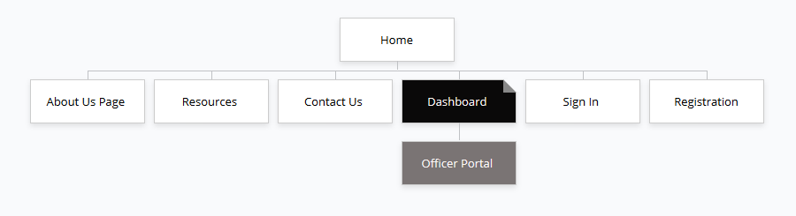

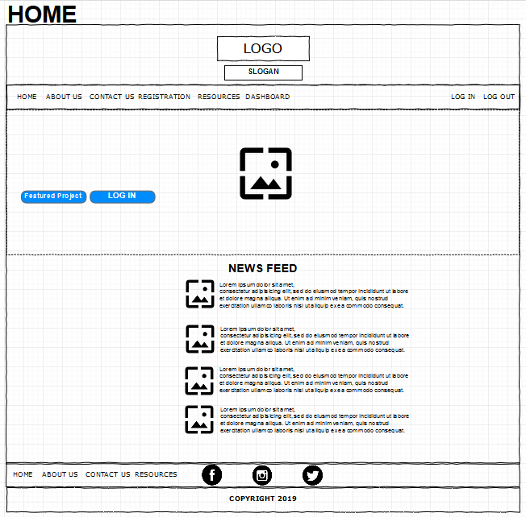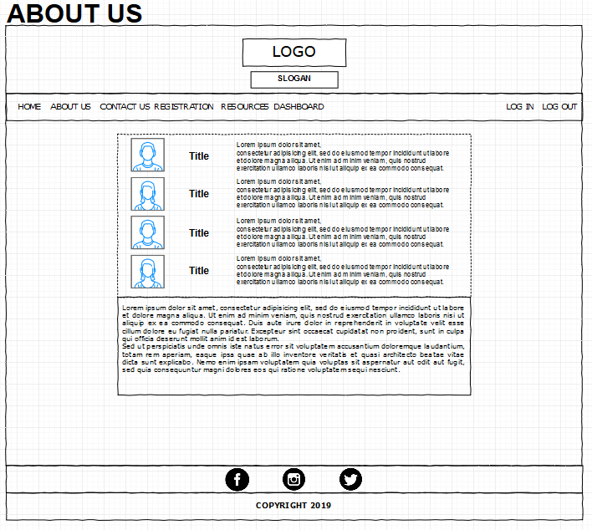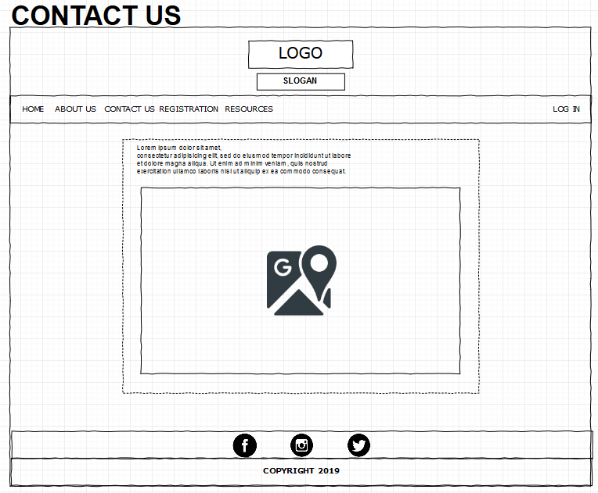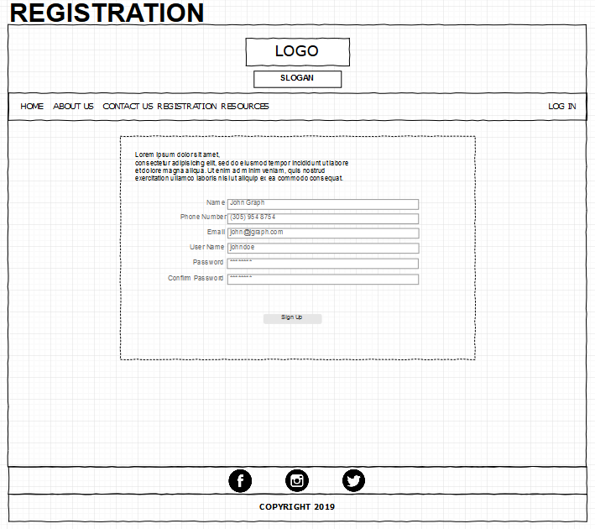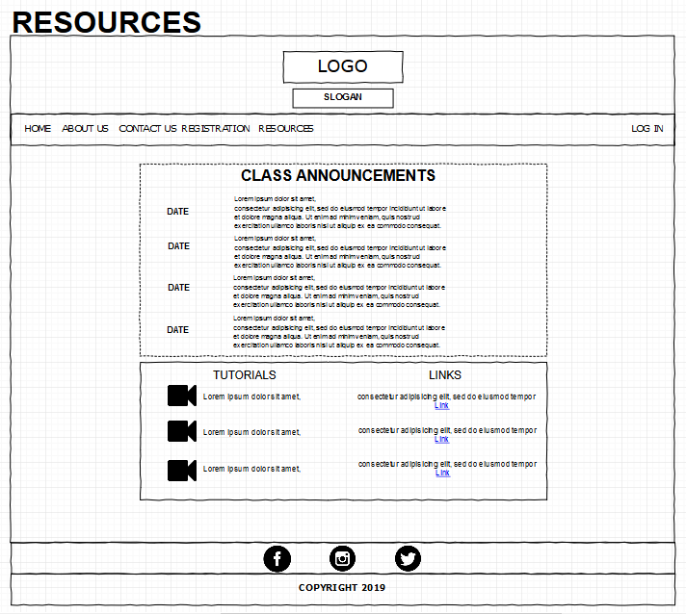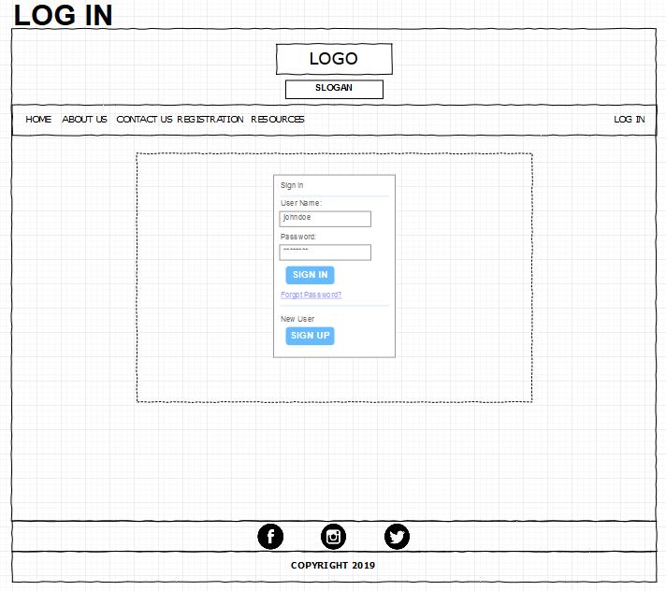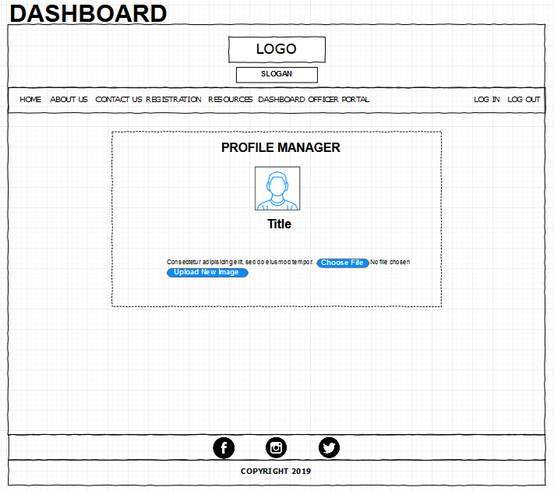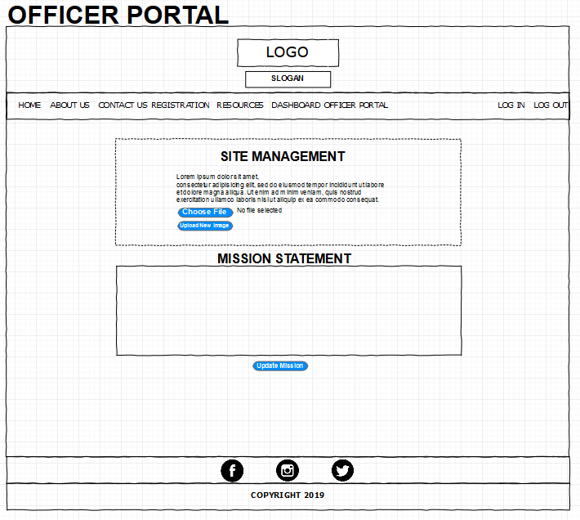

* News Feed
* Front page image
* Sign in page /drop down menu

Our project will boast a very simple and clean interface since its main object is to convey information. Our front page, which is depicted above, will allow you to move to the other pages on the site very easily and seamlessly via links on the navigation bar. The Contact Us page will include the club’s contact information and location. The Resources page will include things like links to important sites that people can use to learn more about technology. The Sign In link will open up a sign in page. Once signed in, an individual will have access to maintain profile image on the Dashboard page. The Office Portal will allow only those with office status to change the home page image and mission statement text. The About Us page will have a table of officers profile pictures and a short description. The simple and clean design approach will be applied across the entire site.

**5. Glossary**

* Webhose.io API: provides access to structured web data feeds across vertical content domains
* PHP (Hypertext Preprocessor): a server-side scripting language designed for web development
* MySQL: an open source relational database management system
* CSS (Cascading Style Sheets): a style sheet language used for describing the presentation of a document written in a markup language like HTML
* JavaScript: the programming language of HTML and the Web
* HTML5: a software solution stack that defines the properties and behaviors of web page content by implementing a markup based pattern to it
* Apache (Apache HTTP Server): a free and open-source cross-platform web server software
* Linux: a family of free and open-source software operating systems based on the Linux kernel
* RSS Feed (Rich Site Summary; Really Simple Syndication): a type of web feed which allows users and applications to access updates to online content in a standardized, computer-readable format

**6. References**

* www.w3Schools.com
* Learning PHP, MySQL & JavaScript, Robin Nixon