**Assignment 3**

Name : Shivani Bimavarapu

UIN: 01025992

**Instructions on how to compile and execute each program:**

I have coded everything in python. You should be able to execute them on putty or any python editor. On putty, to execute the file, type “python filename.py”. for example “python ackley_hillclimb.py” for task1.

**Problem 1 Task 1: Backtracking**

I have implemented Backtracking for this particular task by making use of recursion concept of Python.

For task 1, I haven’t done Forward checking for the dependencies of a particular variable. I have tried to implement it but it was hard to embed Forward check inside the recursion block.

I have also tried to write a separate function for Forward check outside the recursion block but failed to do it for task 1.

Anyway, I have been able to backtrack and get the correct output. So, I thought Forward check is not mandatory because, it only limits the scope of future checks.

**Output of Problem 1 Task 1:**

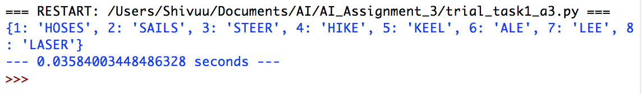

Execution time is 0.03584003448486328 seconds.

And hence, the program took less than 0.04 seconds to give the output.

**Problem 1 Task 2: Larger Puzzle**

I was able to get the correct output for Task 1 without implementing the Forward check functionality for it. It basically worked out because the provided domains in the domain set for the variables in task 1 are very small when compared to the task 1.

Where as coming to the task 2, the domains for 33 variables are very large. So, if Forward check is not embedded in the code written for task 2, it is going to take forever for the program to check all the associated domains of the associated dependencies.

So, I have tried to write the code which implements the forward check functionality. But the forward check function which I coded doesn’t work to the point. It still needs some correction.

Anyway I have submitted the complete task 1 code and code for task 2 in the email. I think if you check my code for task 2, you can see I have implemented everything it needed but there is a small bug which prevents it from getting the exact output.