**Assignment 4**

Name : Shivani Bimavarapu

UIN: 01025992

**Instructions on how to compile and execute the program:**

I have coded everything in python. You should be able to execute the program on putty or any python editor. All the files are submitted in a single zipped folder named AI_Assignment_4.

Submitted files:

1. AI_Assignment4_README
2. Connect4.py

To execute the file, type “python filename.py”. For current program it is “python connect4.py”.

**Steps to execute:**

I have used “Tkinter Package of Python” to implement the Graphical User Interface for the output of the program. So, this is the reason the output of the program can be felt like playing an actual game with all the colors and buttons.

The output at the very beginning gives us the empty board as follows:

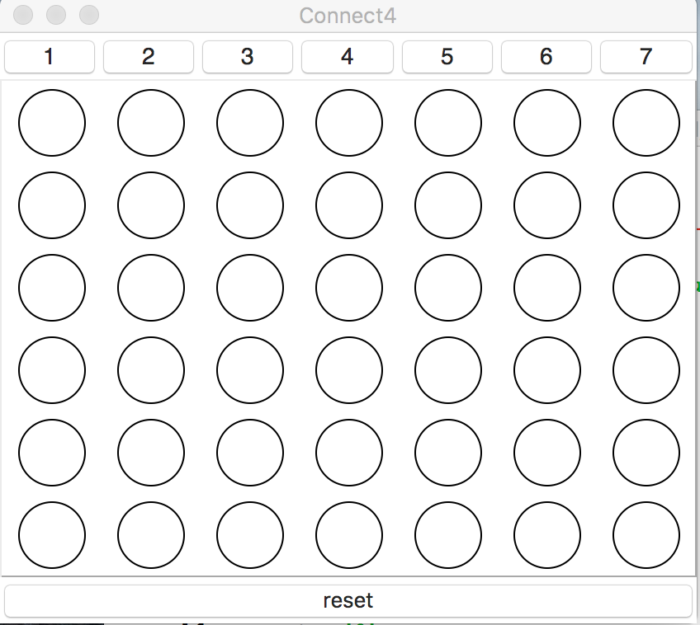

I have trained the program using Minimax algorithm with the extension of Alpha-Beta pruning. But still I was not able to make the Computer make clever moves. I searched a lot on how to train the Program to make the clever moves. Then I came through some more techniques which needs to be encoded into the program to make it work well. The program is also embedded with Horizon, iterative deepening and Transposition table techniques. Transposition table stores the outcome of the evaluation of the state board in a hash table. Horizon limits the time the AI should think by limiting the tree to a look-ahead of four moves.

**GUI:**

Buttons with the numbers on the top of the board are indicated as the columns in which we drop the coins. Clicking the button drops the green coin in that specific column and AI drops the blue coin where ever it thinks will be better. So, the green coin represent the Human Player and blue coin indicates the Computer (AI). When four in a row or column or diagonal are seen the coins are highlighted to represent the winning pattern.

**Design of the Program and Evaluation Function:**

**Output:**



