
External RA Server Interface

2009-04-06

Document History
Version | Date | Name | Comment
1.0 | 2006-01-27 | Philip Vendil | Initial version of this document.
2.0 | 2006-02-10 | Philip Vendil | Added API and Test chapters
2.1 | 2006-02-14 | Philip Vendil | Added authorization section
2.2 | 2006-02-24 | Philip Vendil | Added revocation functionality
2.3 | 2006-07-02 | Philip Vendil | Added edit user functionality
2.4 | 2006-07-31 | Philip Vendil | Changed all se.primekey references to org.ejbca
2.5 | 2006-08-18 | Tomas Gustavsson | Updated with ExtRACardRenewalRequest and response
2.6 | 2007-01-06 | Tomas Gustavsson | Updated with pkcs7 response in ExtRAPKCS10Response
2.7 | 2007-04-19 | Tomas Gustavsson | SCEP RA server
2.8 | 2007-07-11 | Tomas Gustavsson | Updated doc for ExtRATestClient
2.9 | 2007-10-13 | Tomas Gustavsson | Updates to SCEP RA server, authPwd
3.0 | 2008-01-08 | Tomas Gustavsson | Restructure, easier configuration of SCEP RA
3.1 | 2008-11-06 | Tomas Gustavsson | Added information about signed and enc messages for ScepRA
3.2 | 2009-02-18 | Tomas Gustavsson | CA service as clusterable EJBCA service supporting multiple RAs

Table of Contents
1 Document History 2
2 Introduction/Scope 4
3 The Request Process 4
3.1End Entity Request Process 5
3.2ExtRA CA Service Process 5
3.3End Entity Response Process 5
4 Using the Ext RA API 6
4.1Configuring the Ext RA CA Service on the CA server 6
4.1.1Enabling the Ext RA CA Service on the CA server 7
4.1.2Configuring multiple External RAs 8
4.1.3Running multiple CA nodes 9
4.1.4Security options 9
4.1.5A word about Authorization 9
4.1.6Managing your configuration and private modifications 10
4.2Using the RA API 10
4.3Configuring Hibernate 10
4.4Using Signing and Encryption of Messages 11
4.5API-Examples 12
4.5.1Example 1: Adding a new request 12
4.5.2Example 2: Checking if a request is ready 12
5 Using the Scep RA Server 14
5.1Configuring the Scep RA Server on the external RA host 14
5.2Security options 15
6 Design of Message API 16
6.1DB related Classes 16
6.1.1MessageHome 16
6.1.2Message 17
6.2Request Classes 17
6.2.1SubMessages 18
6.2.2ISubMessage 18
6.2.3ExtRARequest 18
6.2.4PKCS10Request 18
6.2.5PKCS12Request 18
6.2.6EditUserRequest 19
6.2.7KeyRecoveryRequest 19
6.2.8RevocationRequest 19
6.2.9CardRenewalRequest 19
6.2.10ExtRAResponse 19
6.2.11PKCS10Response 20
6.2.12PKCS12Response 20
6.2.13CardRenewalResponse 20
6.3Developing new messages 21
7 Testing 21
7.1Automatic Junit Tests 21
7.2Automatic Junit Tests for Web services 21
7.3Ext RA Test Client 22
7.4Manual Tests 22
8 References 23

Introduction/Scope
This document describes the design suggestions regarding the interface between EJBCA and the external RA Server.

For security reasons is it preferable to deny all inbound traffic to the CA and instead let the CA periodically fetch and process information from external trusted data sources. For an overview of the intended solution see illustration 1.

This document will emphasize on describing the API used between the developers of the RA server and the EJBCA Service.

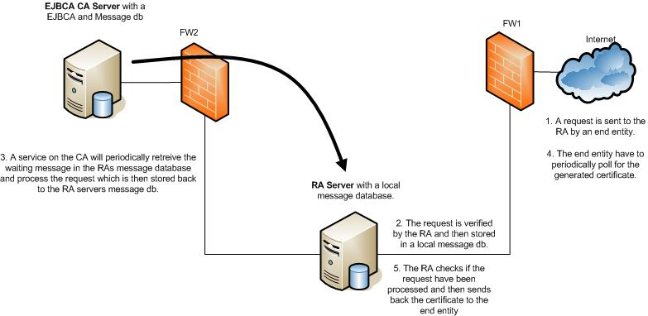
Illustration 1: Overview of solution

The Request Process
The processing of a end entity request is described in the sequence diagram in illustration 2. It defines three sub-processes: End Entity Request Process, ExtRA CA Service Process and End Entity Response Process.

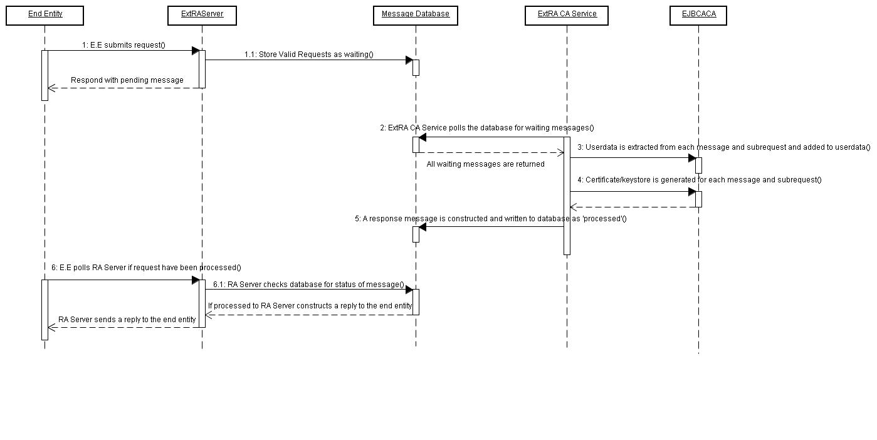Illustration 2: Sequence Diagram over Issuing process

End Entity Request Process
This process (point 1 in diagram) shows what happens when an end entity submits a request for certificates to the RA server. The RA server will review and verify the contents of the and create a 'Message' in a local database. This message contains information about the end entities requests like subjectDN, certificate type and expected response (Certificate, PKCS12, key recovered PKCS12) and so on. One message can contain several requests for each user, i.e both signature and authentication/encryption certificates can exist in one message to the CA server.

In this process should RA server respond with some form of 'request pending' message to the end entity.

ExtRA CA Service Process
This is a process run on the EJBCA server. (Point 2-5) It will periodically check for waiting messages on the RA server, fetch them and generate the appropriate responses for each user and store the message back to the RA server with status 'processed'.

End Entity Response Process
The last sub-process is when the end entity polls the RA server to see if the request have been generated. Here should the RA server check the database if the users message have status 'processed' and the generate an appropriate response back to the end entity. It the message is still in state 'waiting' or 'in process' should another 'request pending' message be returned.

Using the Ext RA API

Configuring the Ext RA CA Service on the CA server

The Ext RA CA Service is the module installed on the EJBCA CA server. This module fetches and processes messages from the external RA.
The default configuration of ExtRA is built for MySQL database, if you are using another database new mappings in src/db/Message.hbm.xml is needed. Some others may be provided in that directory.

The first step to do before installing and using the Ext RA API on the RA host is to deploy EJBCA with the RA CAService on the CA host.

Step 1. Install and configure EJBCA on the CA host first, better take one step at a time. After youe have done this, continue with step 2.

Step 2. If the RA messages should be signed and/or encrypted then two key stores need to be generated using one of the CAs in the EJBCA installation,one for the RA server and one for the RA-CAService. In the examples we use AdminCA1 to issue these keystores. If encryption should be used, must the RA-CAService keystore's certificate also be downloaded separately, to be used by the RA server. This can be done in the page 'View Certificate' in the adminweb. Important, it must be the same CA issuing the RA and CAService keystores.

The RA-CAServer keystore must be in named extrakeystore.p12 and be in the keystore subdirectory. The RA server key store can have any name.

Note, this is for protecting the messages between the RA and the CA, it is not related to other keystores used by the RA such as a Scep keystore used by the Scep RA to cummunicate with Scep clients.

Step 3. Configure the RAMessageDS data source in JBoss by editing the file extra/src/appserver/jboss/ramessage1-ds.xml. This datasource points to the database that is on the External RA.

Step 4. Configure the RACAService by editing the file extra/conf/externalra-caservice.properties.
The following options could be configured. If you are unsure of any values the default (don't configure anything) is usually good enough.
externalra-caservice.encryption.required (true|false)
externalra-caservice.signature.required (recommended if supported by RA client)
externalra-caservice.keystore.path (full path to keystore used to sign and encrypt messages, if signing and encryption is required.
externalra-caservice.keystore.pwd (password to the above configured keystore)
externalra-caservice.raissuer (CA Name of the CA issuing RA Certificates, used to check the validity of RA signatures.)

Step 5. If the RA message should be signed, deploy the RA-CAService keystore on the CA host by using (in extra deirectory): ant deploy-keystore

Step 6. Configure EJBCA on the CA host to include the RA CA Service by configuring the path to the extra packge in ejbca/conf/externalra.properties.

Step 7. Redeploy EJBCA on the CA host using the command (in ejbca directory): ant clean and ant deploy
Make sure a database JDBC connector jar is installed in JBoss. If you have installed EJBCA before on the CA host, this is probably already done. You must use the same database, for example MySQL on both the CA host and external RA host.

Step 8. Check the server logs that everything seems fine by checking file APPSRV_HOME/server/default/log/server.log

Enabling the Ext RA CA Service on the CA server
Enabling the finalizing configuration of the service is done in the admin-GUI of EJBCA.

Step 1. Go to Edit Services and add a new service called ExternalRA1, or similar.

Step 2. Edit the service:
- Select Worker: Custom worker
- Custom Worker Class Path: org.ejbca.extra.caservice.ExtRACAServiceWorker
- Custom Worker Properties: optionally you can configure all properties here. See conf/externalra-caservice.properties for information.

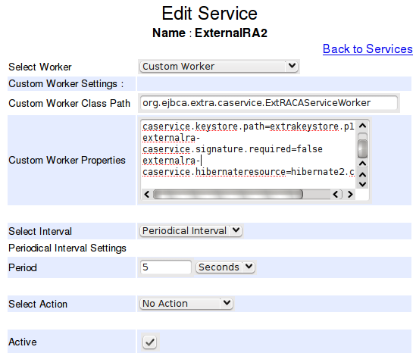

Configuring multiple External RAs
To be able to use multiple External RAs you need to configure multiple data sources for RA CA services to poll from. This is easy to do:

Step 1. Copy src/db/hibernate1.cfg.xml to src/db/hibernate2.cfg.xml. Change RAMessageSessionFactory1 to RAMessageSessionFactory2, and change RAMessageDS1 to RAMessageDS2.

Step 2. Copy src/appserver/jboss/ramessage1-ds.xml to src/appserver/jboss/ramessage2-ds.xml. Change RAMessageDS1 to RAMessageDS2 and configure the database connection settings to the second external RA database.

Step 3. Re-build and re-deploy EJBCA.

Step 4. Add a new worker and add property:
- externalra-caservice.hibernateresource=hibernate2.cfg.xml

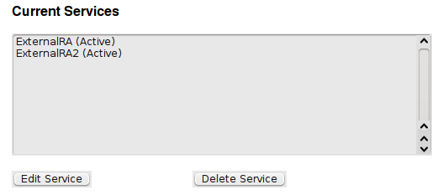

Running multiple CA nodes
When running EJBCA in a cluster so you have multiple CA nodes running simultaneously there is not thing important. You must use a transactional database. For example on MySQL you should use the InnoDB engine and not the MyISAM enging.

Security options

It is strongly recommended to at least use signing of messages sent between RA and CA. If the messages are signed will the RAs certificate be used for authorization internally. This makes it possible to trace which RA that approved the information certified and possible to control which kind of information that the RA can approve, by defining End Entity Profiles.

For signing and encryption the client that uses the API on the RA must support these options. The ScepRA does not support signing and encryption.

For signing is the SHA-256 digest algorithm used and for encryption is AES256 used.

A word about Authorization

If message signing is used, must the RA servers certificate (used to sign the message) be an administrator i EJBCA.
The administrator must have access rights to the following´:
- Have the administrator flag marked in the user data.
- Belong to and administrator group with the following access rules
- At least have the role as RA administrator.
- View/Create/Edit/Key Recovery/Revocation Rights.
- Access to the End Entity Profiles used by the RA.
- Access to the CAs used.

If data sent isn't signed will the service run as an 'internal user' where anything goes (Super Administrator).

Managing your configuration and private modifications
There is an easy way to manage your configuration outside of the external RA distribution directory. In the same way as ejbca-custom works for EJBCA (see EJBCA User Guide), extra-custom works for external RA.
If you have the directory extra_3_9_0 in your file system you can create another directory extra-custom on the same level. If you put your configuration, such as src/db/hibernate0.cfg.xml there, it will be copied to extra_3_9_0/src/db when extra is built.
This gives a very easy way to upgrade the external RA without having to keep track of which files you have modified and configured. Your modifications are always in the extra-custom directory and is automatically used by a new release of the external RA.

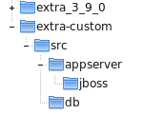

Using the RA API

After running ant is the API libraries generated in the directory dist/client-jars it contains all the jars necessary to use the API.

Configuring Hibernate

Before using the API Hibernate must be configured in the code. This can be done by a hibernate configuration file or directly in the code. Example:

static {
CertTools.installBCProvider();
Properties props = new Properties();
try {
props.load(ExtRATestClient.class.getResourceAsStream("/log4j.properties"));
PropertyConfigurator.configure(props);

} catch (IOException e) {
e.printStackTrace();
}
Configuration dbconfig = new Configuration().
setProperty("hibernate.dialect", "org.hibernate.dialect.MySQLDialect").
setProperty("hibernate.connection.driver_class", "com.mysql.jdbc.Driver").
setProperty("hibernate.connection.url", "jdbc:mysql://localhost/messages").
setProperty("hibernate.connection.username", "test").
setProperty("hibernate.connection.password", "foo123").
setProperty("hibernate.connection.autocommit", "true").
setProperty("hibernate.cache.provider_class", "org.hibernate.cache.HashtableCacheProvider").
setProperty("hibernate.hbm2ddl.auto", "update").
// setProperty("hibernate.show_sql", "true")
addInputStream(ExtRATestClient.class.getResourceAsStream("/Message.hbm.xml"));

HibernateUtil.setSessionFactory(HibernateUtil.SESSIONFACTORY_RAMESSAGE, dbconfig.buildSessionFactory(), true);

}

A hibernate configuration file could look like:

<?xml version="1.0" encoding="UTF-8"?>
<!DOCTYPE hibernate-configuration PUBLIC
"-//Hibernate/Hibernate Configuration DTD 3.0//EN"
"http://hibernate.sourceforge.net/hibernate-configuration-3.0.dtd">
<hibernate-configuration>
<session-factory name="java:/RAMessageSessionFactory">
<property name="hibernate.connection.driver_class">com.mysql.jdbc.Driver</property>
<!--
org.postgresql.Driver
-->
<property name="hibernate.connection.password">foo123</property>
<property name="hibernate.connection.username">test</property>
<property name="hibernate.connection.url">jdbc:mysql://localhost/messages</property>
<!--
jdbc:postgresql://127.0.0.1/messages
-->
<property name="hibernate.dialect">org.hibernate.dialect.MySQLDialect</property>
<!--
org.hibernate.dialect.PostgreSQLDialect
-->
<property name="hbm2ddl.auto">create</property>
<!-- JDBC connection pool (use the built-in) -->
<property name="connection.pool_size">1</property>

<!-- Enable Hibernate's automatic session context management -->
<property name="current_session_context_class">thread</property>

<!-- Disable the second-level cache -->
<property name="cache.provider_class">org.hibernate.cache.NoCacheProvider</property>

<mapping resource="Message.hbm.xml" />
</session-factory>
</hibernate-configuration>

If placing the hibernate.cfg.xml file in the root of your classpath, for example in WEB-INF/classes in a web application, you can configure hibernate in you code with:

SessionFactory sessionFactory = new Configuration().configure().buildSessionFactory();
HibernateUtil.setSessionFactory(HibernateUtil.SESSIONFACTORY_RAMESSAGE, sessionFactory,false);

Using Signing and Encryption of Messages
If signing or encryption of messages is used, then should the RA have a key store and the RA CAService certificate. These are used in the constructor
SubMessages(X509Certificate userCert, PrivateKey userKey, X509Certificate encCert)
and the method in Message
getSubMessages( PrivateKey userKey, Collection cACertChain, Collection crls)
To disable CRL checking send null as parameter. CACertChain is the CA chain that signed the RA and CAService keystore.

If no security should be applied to the messages use 'null' for all the parameters.

API-Examples
This section provides a couple of examples of how the API could work from the RA server developers point of view.

More information about using the API can be found in the junit scripts and the test client se/primeKey/rasrv/ra/ExtRATestClient.java

Example 1: Adding a new request

MessageHome msgHome = new MessageHome(MessageHome.MESSAGETYPE_EXTRA);

SubMessages subMessages = new SubMessages();

subMessages.addSubMessage(new ExtRAPKCS10Request(requestId1, username, subjectDN, subjectAltName, email, endEntityProfileName, certificateProfileName, cANAme, pkcs10));

subMessages.addSubMessage(new ExtRAPKCS12Request(requestId2, username, subjectDN, subjectAltName, email, endEntityProfileName, certificateProfileName, cANAme, password, ExtRAPKCS12Request.KEYALG_RSA, 1024, storeKeys));

try {
msgHome.create(messageId, subMessages);
}catch(RuntimeException e){
// Problems with database
}

Example 2: Checking if a request is ready
Try{

Message msg = msgHome.findByMessageId(messageId);
if(msg != null){
if(msg.getStatus == Message.STATUS_PROCESSED){
// Message is ready to use. In example 5.1 we requested a pkcs10 and a pkcs12 so that
// what we will get in the response if all i ok
Iterator iter = msg.getSubMessages().getSubMessages().iterator;
while(iter.hasNext()){
ExtRAResponse resp = (ExtRAResponse) iter.next();
if(!resp.getSuccessful()){
// Request Failed report using resp.getFailInfo();
}
if(resp instanceof ExtRAPKCS10Response){
req1cert = ((ExtRAPKCS10Response) resp).getCertificate();
}
if(resp instanceof ExtRAPKCS12Response){
req1keystore = ((ExtRAPKCS12Response) resp).getPKCS12();
}
}

}else{
// Respons with still pending.
}
}else{
// Respond with user doesn't exist.
}
}catch(RuntimeException e){
// Problems with database
}

Using the Scep RA Server
EJBCA supports the SCEP 'polling' RA model using the External RA API. Using this a SCEP client can send a request to the External RA, and then wait, polling the RA for updates. When the request is processed by the CA, which fetches the pkcs10 request from the External RA, the certificate is sent back to the External RA. When the certificate is complete on the External RA, the RA sends back the SCEP certificate response the next time the SCEP client polls the RA. This feature is very useful to securely insulate the CA from the SCEP clients throughout the network.

Configuring the Scep RA Server on the external RA host

The Scep RA Server is the module installed on the External RA. This module receives scep requests from a scep client and uses the Ext RA API to get the CA to process the scep requests. The Scep RA Server is thus a user of the Ext RA API on the External RA.

Step 1. Set up a 'messages' database on the External RA.
> mysqladmin -u root -p create messages
> mysql -u root -p
mysql> grant all in messages.* to ejbca identified by 'ejbca';

Step 2. Configure and install the RA CA Service as described in 4.1.
Note that the Scep RA does not currently support signing and encrypting the messages between the RA and the CA.

Step 3. Configure the JBoss datasource in src/appserver/jboss/ramessage1-ds.xml. This datasource points to the database that is on the External RA (localhost in this case). If using another database then MySQL you must also configure src/db/Message.hbm.xml.

Step 4. Create a pkcs12 keystore for the SCEP RA in EJBCA. This certificate will be the RA certificate used by the SCEP client to encrypt messages to the RA, it should have key usage 'digital signature' and 'key encipherment'. The certificate must be issued by your SCEP CA, which is the CA you wish your SCEP server to issue from.
Put the generated RA keystore in the file 'keystore/sceprakeystore.p12'.

Step 5. Configure the SCEP RA Server in conf/scep.properties. Configure the certificate profile, end entity profile and CA settings to match the CA and profiles you will use for your SCEP certificates. Also configure the keyStorePassword to match the password on your sceprakeystore.p12 created before.
You can optionally configure the authPwd property if you want to authenticate SCEP messages based on a password in the request.

Step 6. Make sure a database JDBC connector jar is installed in JBoss for your database. It should be in the APPSRV_HOME/server/default/lib directory.

Step 7. Deploy the SCEP RA Server with 'ant deployscepraserver'. Check the server logs that everything seems fine by checking file APPSRV_HOME/server/default/log/server.log. You need to have an EJBCA package available on the External RA at $EJBCA_HOME for the build process to work. This EJBCA package does not need to have any specific configuration though.

Security options

Using the External RA, the CA trusts all messages that comes from the RA. This means that if a SCEP client sends a request to the RA, the CA will create the user and issue a certificate as soon as it picks up the message from the RA.

To make a more secure setup, one of the two following ways are recommended:
- Each SCEP request can contain a password. Set authPwd in conf/scep.properties to another value then none. This will require a correct password to be sent in the SCEP request.
- Configure Approvals on the CA(s) issuing SCEP certificates.
The two ways can also be combined and both used.

When approvals are activated, a Scep request will result in an approval request beeing created in the CA. The approval request will be for adding or editing a user. An administrator can then view the approval request and approve or reject the new request from the scep client. The scep client will continue to poll the RA until the request is approved, then a certificate is returned, or the request is rejected, then a failure message is returned.
Approvals are activated in EJBCA using the Admin GUI:
- Edit Certificate Authorities
- Select a CA and click Edit
- Select 'Add/Edit End Entity' for 'Approval Settings'
- Click 'Save'

If an approval request is rejected, because the router administrator mistyped something for example, you will have to wait 30 minutes before a new request can be done, because the RA will remember the rejection for 30 minutes.

An approval request will be valid for one hour. After one hour a new request will be created.

The normal work-flow using approvals will be the following:
- A router admin creates a SCEP request to the RA
- The router admin calls up a EJBCA admin and asks to get approval of the request.
- The EJBCA admin approves the request and the router gets the certificate, or
- The EJBCA admin rejects the request and the router gets a failure message.

Design of Message API

DB related Classes
The database related API will mainly consist of two classes, MessageHome which is used to manipulate messages with the database and the Message class representing an actual message.

Illustration 3: The Message DB Interface

MessageHome
In this class will the RA server mainly use two methods:
'create' that adds a message to the database, if a message already exists with the status 'waiting' or 'processed' it will overwrite the old message.

findByMessageId() will find a existing message given the unique messageId (could be username).

Both methods throws RuntimeException if database problems occur.

MessageHome will internally use the framework Hibernate to connect to the database.

Message
Class representing the columns in the message table.

Column | Comment
User | Unique messageId owning the request message, used as Primary Key, called User for historic reasons.
CreateTime | Time when the message was created
ModifyTime | Time when the message was last modified
SubMessage | String representation of a ExtRASubMessages
Status | Integer having the value, Waiting, Inprocess or Processed

The 'Message' table design in MySQL:

+------------+--------------+------+-----+---------+-------+
| Field | Type | Null | Key | Default | Extra |
+------------+--------------+------+-----+---------+-------+
| uniqueId | varchar(250) | NO | PRI | | |
| user | varchar(255) | YES | | NULL | |
| type | int(11) | NO | | | |
| status | int(11) | NO | | | |
| createtime | bigint(20) | NO | | | |
| modifytime | bigint(20) | NO | | | |
| message | longtext | YES | | NULL | |
+------------+--------------+------+-----+---------+-------+

Request Classes

Basically there are four different requests: PKCS10 request assuming a certificate as response, PKCS12 and KeyRecovery requests assuming a PKCS12 key store in return and Revocation Requests used to revoke a generated certificate. Illustration 4 shows these classes and how they relate to each other. Illustration 5 shows more detailed content of these classes.
Illustration 4: RA Request Hierarchy

SubMessages
Illustration 5: ExtRA Request Hierarchy
The SubMessages class is in charge of collection sub-messages (request or responses) and serializing them into String format.

The submessage data can be signed and encrypted using CMS envelopes (PKCS7). For this it is required for both the CA Service and RA server to have a PKCS12 keystore generated by a CA in the EJBCA instance. More information about the security is found in the Section 5.1.2.

ISubMessage
Empty interface that connects request and response messages.

ExtRARequest
Abstract base class containing request information about the user like dn, certificatetype ...
Also contains a requestId used to match the request with the given response.

PKCS10Request
Class containing a PKCS10 request.

PKCS12Request
Class containing a password used to lock the key-store, a key size and key algorithm.

EditUserRequest
Class containing userdata used to add or edit a user. Mostly used with hard token issuing.

KeyRecoveryRequest
Class containing serial number of certificate with associated key to recover. It is possible to request a new certificate with the original keys, or the original certificate, depending on the constructor used.

RevocationRequest
Request to use to revoke a generate certificate. Contains the IssuerDN, certificate SN and revocation reason (One of the ExtRARevocationRequest.REVOKATION_REASON_ constants).
Optionally you can request revocation of the user in EJBCA, so the user can not get a new certificate, when revoking the user, all the users certificates are revoked. This is requested by setting the parameter revokeuser to true. You can also optionally request revocation of all the users certificates, but without revoking the user itself, do this by setting revokall to true.

CardRenewalRequest
Request to use to renew certificates on an EID smart card. The request is currently tailored against EID card with one authentication certificate and one signature certificate. The certificates and two pkcs10 requests are used as input. When the request is processed the following validations are performed:

When certificate renewal is requested the following steps are done:

- The two certificates are verified against the CA certificate
- The signatures on the requests are verified again the certificates (so the whole chain is verified)
- The certificate profile and caid for each certificate is taken from the hard token profile of the user, if there is a hard token profile defined for the user, otherwise it is taken from the users registration info.There is also a possibility to override the profile values in the request, this possibility is not used however.
- When the certificates have been created they are returned to in an ExtRACardRenewalResponse.
- The old certificates are not revoked, they can still be used to validate old signatures etc.

ExtRAResponse
Base class for all ext RA responses. Contains the requestId, a flag if operation was successful and a failure message if not. A basic ExtRAResponse will be returned from a ExtRARevokationRequest.

PKCS10Response
Response to a ExtRAPKCS10Request, contains a certificate if operation was successful. The response also contains the same certificate in a PKCS7 file. The PKCS7 file is signed by the CA and contains the full certificate chain of the issued certificate.

PKCS12Response
Response to a ExtRAPKCS12Request and ExtRAKeyRecoveryRequest, contains a Java Key Store of type PKCS12 containing the certificate and private key if the operation was successful.

CardRenewalResponse
Response to an ExtRACardRenewalRequest. The response contains two certificates that can be used to replace the old certificates on an EID smart card.
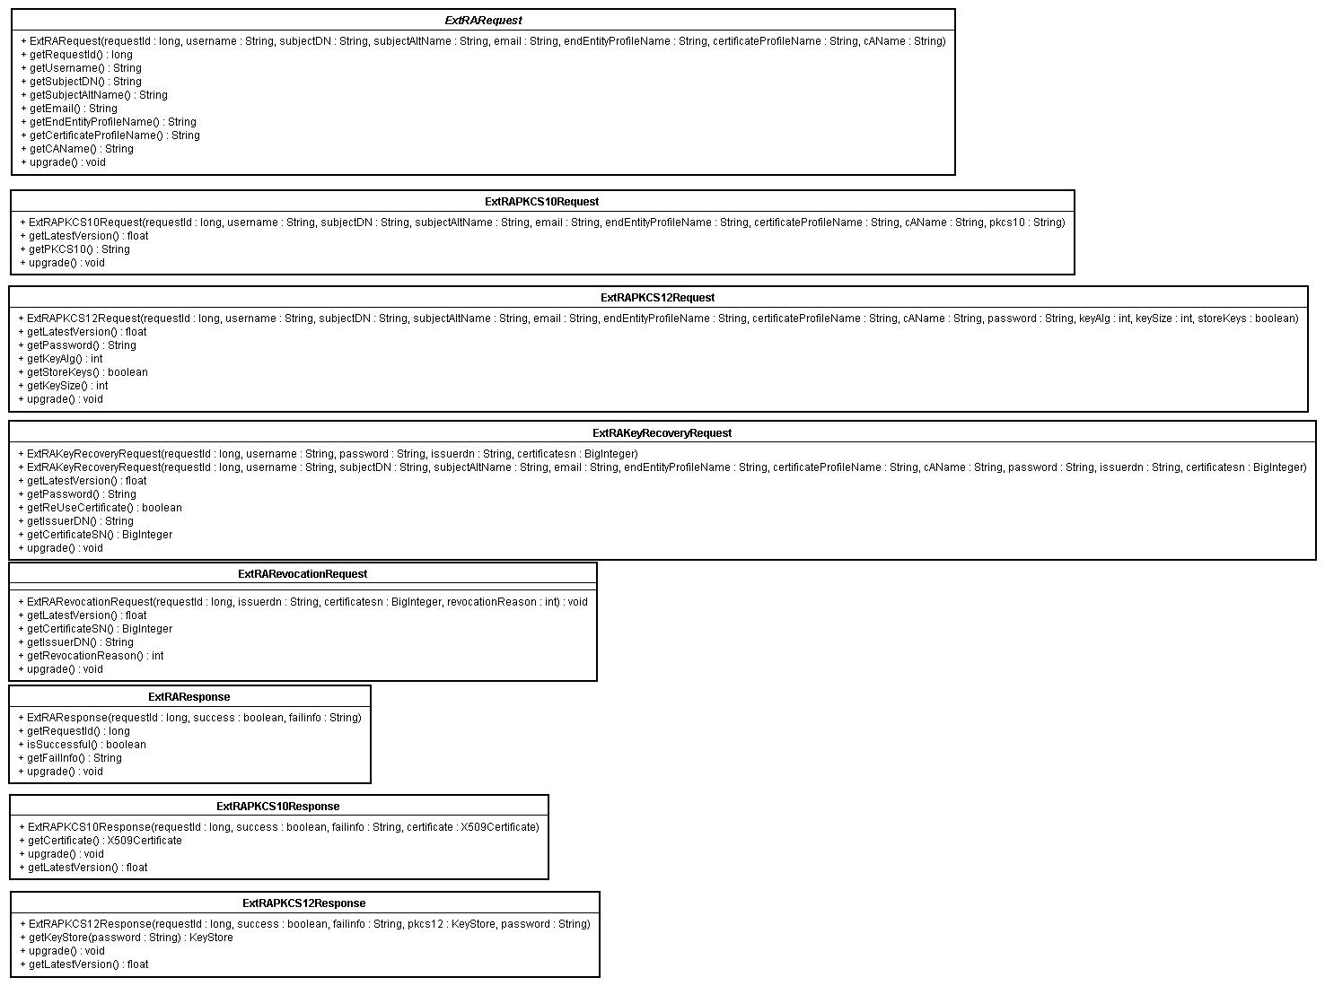Illustration 6: Class diagram of RA Request and Responses

Developing new messages
To develop and add new messages is easy.

- Create a new request message class called org.ejbca.extra.db.MyRequest where My is your name of choice.
- Create new message processor class org.ejbca.extra.caservice.processor.MyRequestProcessor.
- Done.

It is this easy because the dispatching of messages to a processing class is done in MessageProcessor and this class uses java reflection to automatically instantiate the correct processor for a message. It is important that the java class names are correct. The processor class must be called the same as the request class with Processor added in the end.

Testing
The following tests have been done.

Automatic Junit Tests
Automatic Junit tests lies in the directory 'src/tests'. The test can be run with the command 'ant test:run'.

The following must be done before running the tests.
- Setup a mysql database on localhost and create a 'messages' database and user 'test' with password 'foo123'.
- Deploy the RA CA Service without any requirements on signature and encryption.
- Enable Key Recovery in EJBCA System Configuration.

The following tests are performed:
TestExtRAMsgHelper: Performs test related to encryption/signature of messages.
TestExtRAMessages: Makes sure that request and response classes are serialized properly
TestMessageHome: Makes basic database functionality tests.
TestRAAPI: Makes a full scale tests of sending PKCS10 and PKCS12 request to the CA and waits for proper responses. May take some time and check the server log for errors. It also test to revoke some of the generated certificates.

Automatic Junit Tests for Web services
Automatic Junit web tests lies in the directory 'src/tests'. The test can be run with the command 'ant test:runweb'.

The following must be done before running the tests.
- Setup a mysql database on localhost and create a 'messages' database and user 'test' with password 'foo123'.
- Deploy the RA CA Service without any requirements on signature and encryption.
- Deploy the SCEP RA server

The following tests are performed:
ProtocolScepHttpTest: Performs test related to the SCEP polling RA mode.

Ext RA Test Client
To simply load and performance tests have a test client been implemented that generates request from x concurrent RAs. Using this client it's possible to figure out expected response times for the different types of requests.

The test client is in the jar dist/client-jars/ext-raclient.jar and executed by the command.
java -jar dist/client-jars/ext-raclient.jar.

The following parameters can be set:
<CERT | KEYSTORE> : Type of test, CERT creates single PKCS10 requests, KEYSTORE creates one PKCS10
and one PKCS12 request for each message
<dbhost> : Hostname of database.
<KeyStorePath> : The path to the keystore used to sign/encrypt messages. Use NOKEYSTORE for
unencrypted security level.
<KeyStorePwd> : Password to unlock the keystore,. Use NOPWD for unencrypted security level. <EncCert> : Path to certificate (DER) used to encrypt messages,. Use NOCERT for unencrypted
security level.
<SecurityLevel> : Security Level, Valid values are UNSECURED, SIGNED, ENCRYPTED, SIGNEDENCRYPTED <RequestsPerMin> : Requests to generate every minute per concurrent RA.
<ConcurrentRAs> : Number of concurrent RAs that will create requests.
<WaitTime> : Number of seconds to wait for answer before exception is thrown.

Examples : Simple test sending unsecured requests every 5 s in one thread expecting an answer within 60 s :
java -jar ext-raclient.jar CERT localhost NOKEYSTORE NOPWD NOCERT UNSECURED 12 1 60

Advanced test using encrypted and signed requests for pkcs10 cert and a pkcs12 keystore
every 1 min in two threads, expecting an answer within 60 s :");
java -jar ext-raclient.jar KEYSTORE localhost rakeystore.p12 foo123 enccert.cer SIGNEDENCRYPTED 1 2 60

Important, if signing is used must the RA server key store be configured as an Super Administrator in EJBCA.

The test client have the same requirements on the database as the junit tests.

Manual Tests

The following test have been done verified.

- RA and CAService keystores generated by a Root CA.
- RA and CAService keystores generated by a SubCA.
- Unsigned messages isn't accepted if signing is set as required.
- Unencrypted messages isn't accepted if encryption is set as required.
- If RA certificate is revoked the wont any more messages be accepted.
- If CA certificates (Either Root or Sub) is revoked wont the any more message be accepted
- Check that if all certificates are revoked, then is also the user status set to 'Revoked'.
- Authorization tests of signed messages:
- The administrator flag isn't set
- The administrator haven't access to the CA specified in request.
- The administrator haven't access to the End Entity Profile specified in request.
- The administrator haven't create rights
- The administrator haven't got edit rights
- The administrator haven't got key recovery rights

References
Hibernate, http://www.hibernate.org/

