Insert Oracle 12c CD on CD drive and click on set up button and following these steps:-

1. Uncheck security update checkbox.

## C:\Users\Dinesh Panwar\Desktop\Personal\Technology\database\Oracle 12c installation steps\Step1.PNG

1. Click on yes button.

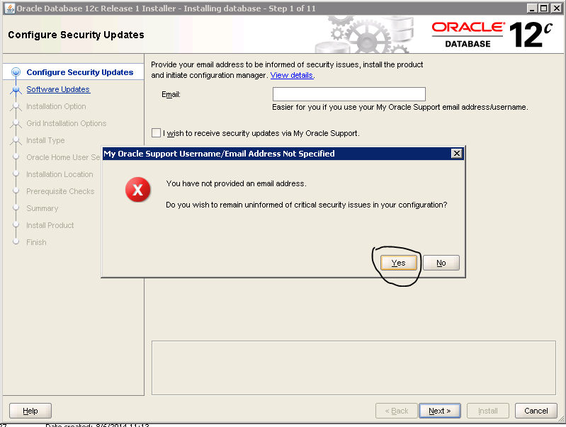

1. Choose skip software update option.

## C:\Users\Dinesh Panwar\Desktop\Personal\Technology\database\Oracle 12c installation steps\Step3.PNG

1. Only install database software.

## C:\Users\Dinesh Panwar\Desktop\Personal\Technology\database\Oracle 12c installation steps\Step4.PNG

1. Choose single instance option.

## C:\Users\Dinesh Panwar\Desktop\Personal\Technology\database\Oracle 12c installation steps\Step5.1.PNG

1. Select the language (default English).

## C:\Users\Dinesh Panwar\Desktop\Personal\Technology\database\Oracle 12c installation steps\Step5.2.PNG

1. Select Enterprise Edition.

## C:\Users\Dinesh Panwar\Desktop\Personal\Technology\database\Oracle 12c installation steps\Step6.PNG

1. Select Windows Built-in Account.

## C:\Users\Dinesh Panwar\Desktop\Personal\Technology\database\Oracle 12c installation steps\Step7.PNG

1. Click on yes button.

## C:\Users\Dinesh Panwar\Desktop\Personal\Technology\database\Oracle 12c installation steps\Step8.PNG

1. Click on next button.

## C:\Users\Dinesh Panwar\Desktop\Personal\Technology\database\Oracle 12c installation steps\Step9.PNG

1. Showing progress bar.

## C:\Users\Dinesh Panwar\Desktop\Personal\Technology\database\Oracle 12c installation steps\Step10.PNG

1. Click the install button.

