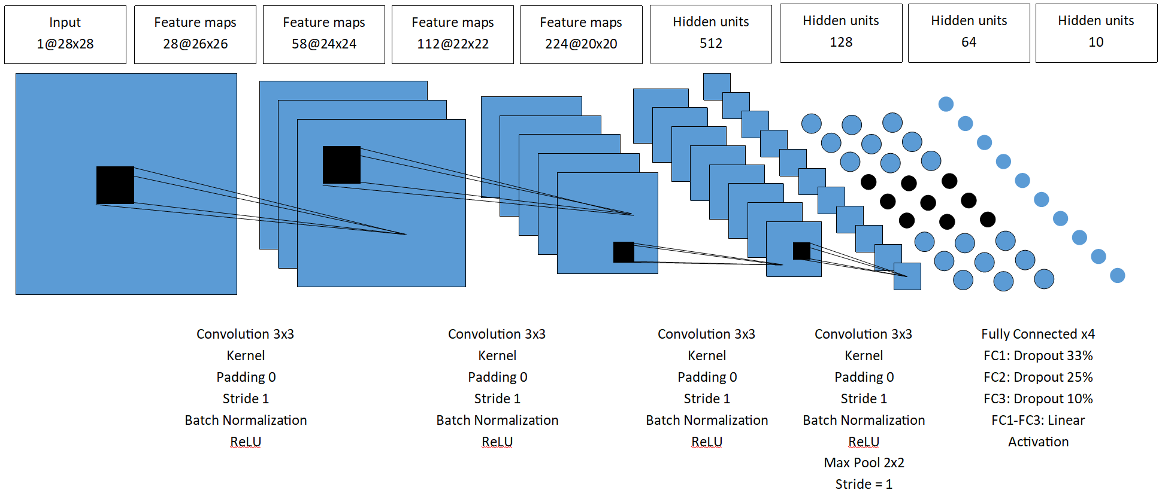

|  |  |  |  |  |
| --- | --- | --- | --- | --- |
| Conv1 | Conv2 | Conv3 | Conv4 | Test Accuracy (%) |
| 0 | 0 | 0 | 0 | 91.580 |
| 0 | 0 | 0 | 1 | 92.660 |
| 0 | 0 | 1 | 0 | 91.760 |
| 0 | 0 | 1 | 1 | 92.840 |
| 0 | 1 | 0 | 0 | 92.560 |
| 0 | 1 | 0 | 1 | 93.110 |
| 0 | 1 | 1 | 0 | 92.100 |
| 0 | 1 | 1 | 1 | 92.650 |
| 1 | 0 | 0 | 0 | 91.890 |
| 1 | 0 | 0 | 1 | 92.590 |
| 1 | 0 | 1 | 0 | 92.270 |
| 1 | 0 | 1 | 1 | 92.860 |
| 1 | 1 | 0 | 0 | 92.210 |
| 1 | 1 | 0 | 1 | 92.710 |
| 1 | 1 | 1 | 0 | 92.780 |
| 1 | 1 | 1 | 1 | 92.700 |