We will then add an image or logo and the h3 heading, in the header section with the class as “top”.

Let us style the image and heading with some CSS-

img {

margin: auto;

display: block;

width: 34px;

}

h3 {

text-align: center;

font-family: 'Segoe UI', Tahoma, Geneva, Verdana, sans-serif;

margin: 0px;

}

By inspecting both the elements in the Chrome browser, we see that the **image**is an *inline*element and the **h3 heading** is the *block*element. Our objective is to bring all the elements to the center of the webpage. We can achieve it by adjusting the **width** of the block element i.e. the heading. The respective code of the following is-

header {

border: 2px solid red;

margin: auto;

width: 1200px;

}

The display of “img” is inline and therefore, to make it come to center, we have to set the property *display* as *block* as follows-

img {

margin: auto;

display: block;

width: 34px;

}

Copy

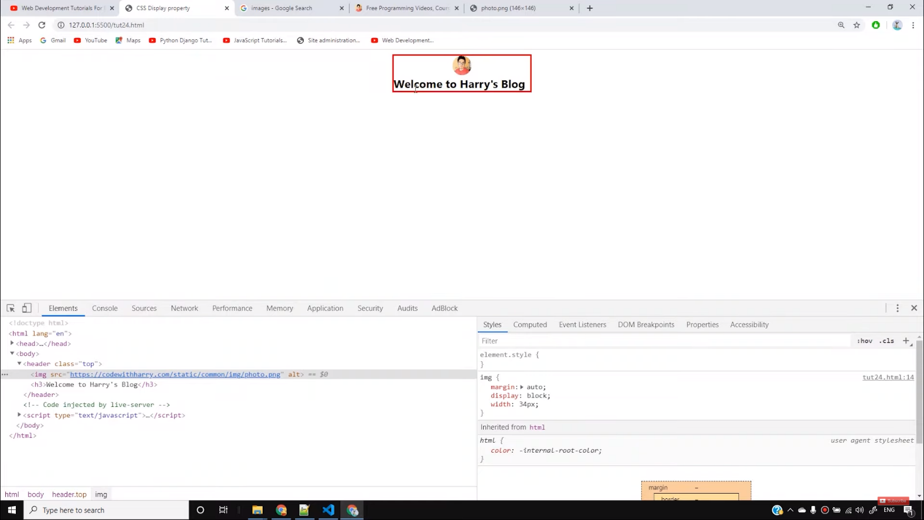

The next problem which arises is that when we stretch the full width of the page, the text in the heading moves towards left. So to move it towards the center, we can set the property of **text-alignment** as center.  
***Display inline*** means it will take the space according to the size of the element. ***Display block*** means we can set its width and by margin manually.

Now suppose we want to make an element inline as well as customize its width too, then in that case we can use ***inline-block***. To understand it, first we will add three *divs* with some texts in it and then style it. To appear those as a box, we can take the help of *container*and *box class.* We can style the box element as

.box {

border: 4px solid black;

background-color: grey;

margin: 4px 0px;

padding: 23px;

width: 33%;

box-sizing: border-box;

display: inline-block;

}

The *inline-block*property here allows us to change the width of inline elements also. To ensure that all the three blocks come in a single line, we can use the property **box-sizing.**It ensure that the width we provide is not changed including padding and margin.

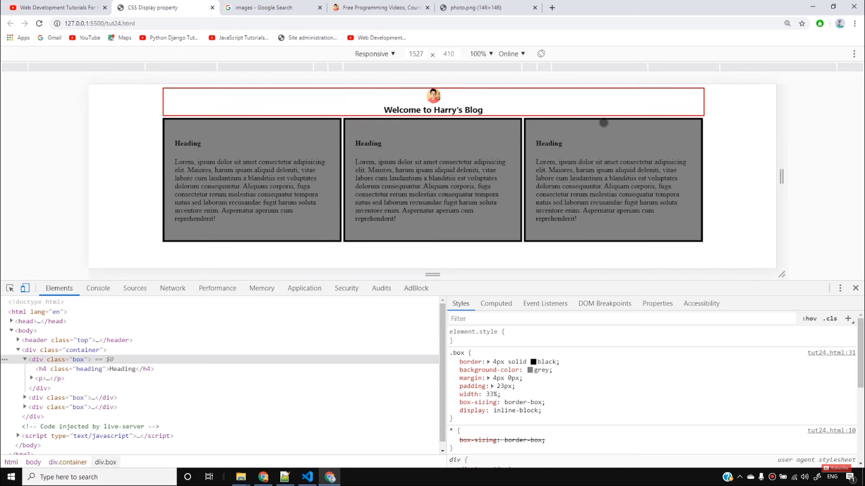

So I believe, you must have clearly understood the concept CSS Display Property. Stay with the tutorials to build more attractive websites in the future. Till then, keep practicing.

<!DOCTYPE html>

<html lang="en">

<head>

<meta charset="UTF-8">

<meta name="viewport" content="width=device-width, initial-scale=1.0">

<meta http-equiv="X-UA-Compatible" content="ie=edge">

<title>CSS Display property</title>

<style>

*{

box-sizing: border-box;

}

header {

border: 2px solid red;

margin: auto;

width: 1200px;

}

img {

margin: auto;

display: block;

width: 34px;

}