Supplementary Material for RAPID

Supplementary Note 1. Status of the CATH Benchmark Refresh
The main manuscript uses the current 23-target CATH artifact benchmark as component-level evidence for AF2-budgeted surrogate-triage design choices rather than as the final corrected-chain benchmark. That benchmark was generated before the final chain-selection fixes and is retained because it provides paired SoluProt and pLDDT records for surrogate and acquisition analyses. A corrected-chain refresh manifest has been generated at public_release/data/benchmark/results/rapid_target_manifest.csv. The manifest selects 40 CATH targets for re-screening and 8 targets for the four-arm structural-context ablation. The selected structural-context arms are the original target backbone, target plus BioEmu ensemble, selected RFD3 backbone, and RFD3 plus BioEmu ensemble.

Supplementary Note 2. Current CATH Artifact Corpus
The pre-refresh CATH archive contains 73 completed CATH run directories. Twenty-three runs passed the QC rule requiring all three conservation tiers, at least 100 valid non-fallback amino-acid design sequences, and at least 100 positive pLDDT records. The included subset contains 2,737 paired SoluProt/pLDDT design rows. Excluded records are treated as input-compatibility or fallback-design artifacts under the previous pipeline contract, not as valid low-quality biological designs.
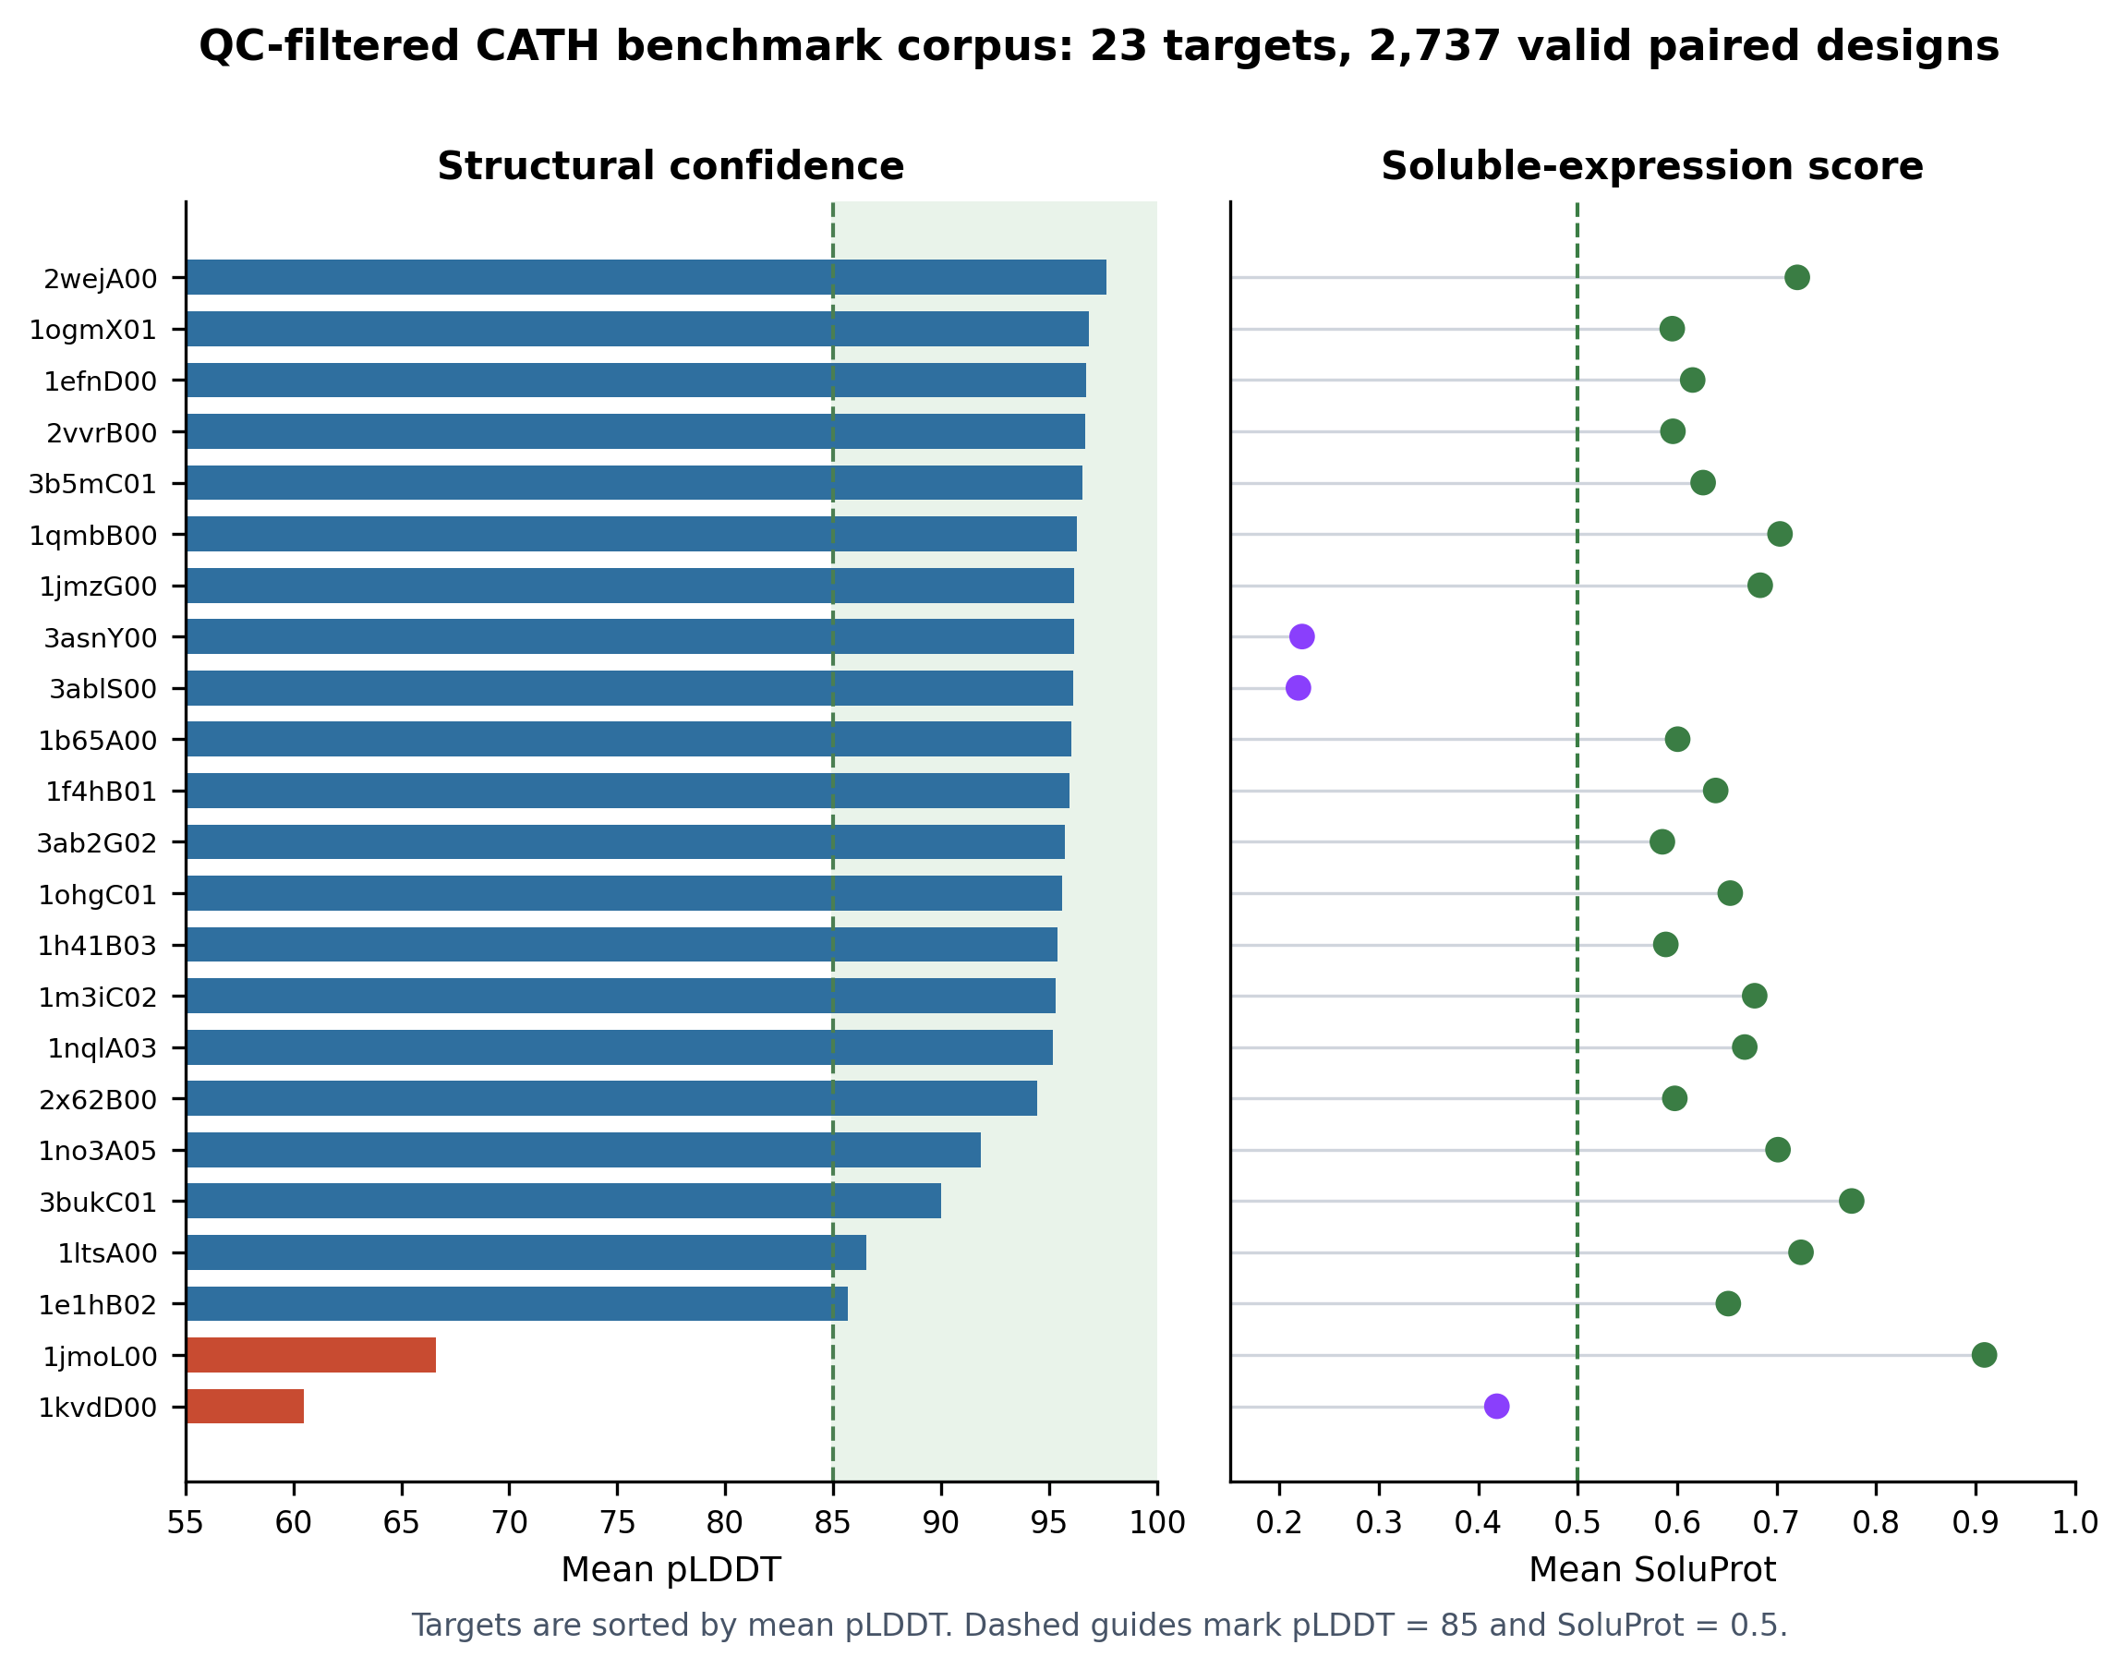
QC-filtered CATH artifact corpus
Supplementary Figure S1. Target-level summary of the pre-refresh CATH artifact corpus. The figure shows target-level pLDDT and SoluProt heterogeneity after excluding fallback or input-incompatible outputs.
Metric | Value
Completed CATH runs parsed | 73
QC-included targets | 23
QC-excluded runs | 50
Valid paired design rows | 2,737
Positive pLDDT records | 2,737
SoluProt records | 2,737
Mean pLDDT | 91.91
Maximum pLDDT | 97.89
Mean SoluProt | 0.615
Maximum SoluProt | 0.971

Supplementary Note 3. Training-Set Selection
The Random Forest selection-size ablation shows that K-means is most useful when AF2 labels are scarce. The K-means advantage is largest at N = 5 and N = 10 and becomes small near the production default N = 30. This supports using K-means as a cold-start safeguard rather than as a claim that K-means always dominates random selection at larger training budgets.
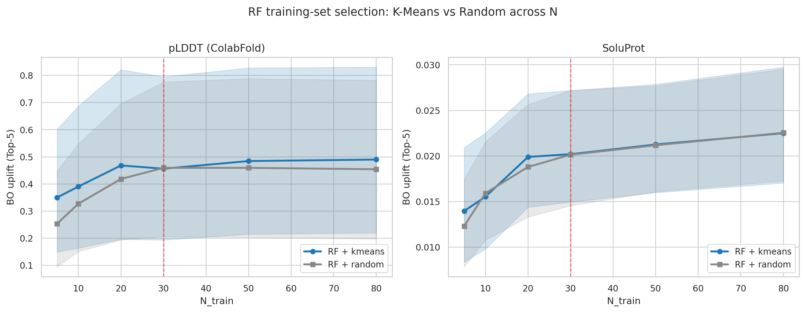
Selection-size ablation
Supplementary Figure S2. Random Forest BO uplift Top-5 as a function of the number of AF2-labelled training examples. K-means selection provides its largest benefit in the low-label regime and converges with random selection near N = 30.
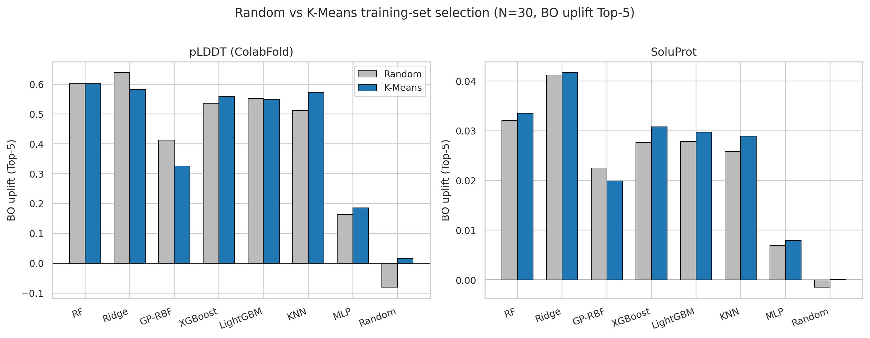
Selection by surrogate family
Supplementary Figure S3. Effect of K-means versus random training-set selection at fixed N = 30 across surrogate families. The smaller differences at N = 30 support using K-means primarily as a bootstrap safeguard rather than as a universal advantage at all training sizes.
N | Random RF pLDDT BO uplift Top-5 | K-means RF pLDDT BO uplift Top-5 | Delta
5 | 0.254 | 0.350 | +0.097 (+38%)
10 | 0.327 | 0.390 | +0.063 (+19%)
20 | 0.418 | 0.468 | +0.050 (+12%)
30 | 0.459 | 0.456 | -0.003 (-1%)
50 | 0.459 | 0.484 | +0.025 (+5%)
80 | 0.454 | 0.490 | +0.036 (+8%)

Supplementary Note 4. Surrogate Model Comparison
At K-means N = 30, Random Forest gives the highest mean pLDDT BO uplift Top-5, while Ridge remains strongest for SoluProt ranking and recall-oriented metrics. The production recommendation is therefore score-specific: Random Forest is the conservative pLDDT acquisition default, and Ridge is retained when the operator prioritises SoluProt-related ranking or recall. The aggregate visualization is shown once in the main manuscript as Figure 3; the supplementary material reports the numerical model-level comparison to avoid duplicating the same figure.
Model | pLDDT BO uplift Top-5 | Delta vs RF | Holm-adjusted p vs RF | Cliff’s delta
RF | 0.602 | - | - | -
Ridge | 0.583 | -0.019 | 0.71 | +0.04
KNN | 0.572 | -0.030 | 0.51 | +0.05
XGBoost | 0.558 | -0.044 | 0.51 | +0.07
LightGBM | 0.549 | -0.053 | 0.046 | +0.05
GP-RBF | 0.326 | -0.276 | 0.00022 | +0.20
MLP | 0.185 | -0.417 | 1.6e-13 | +0.49
Random | 0.016 | -0.586 | 1.1e-11 | +0.47

Supplementary Note 5. Sample-Size Operating Point
The N-ablation places N = 30 on a cost-efficient plateau. Increasing RF training labels from 30 to 80 requires approximately 2.7 times more AF2-labelled training examples but gives a modest additional pLDDT BO-uplift gain. The N = 30 default is therefore a conservative operating point for the bootstrap round.
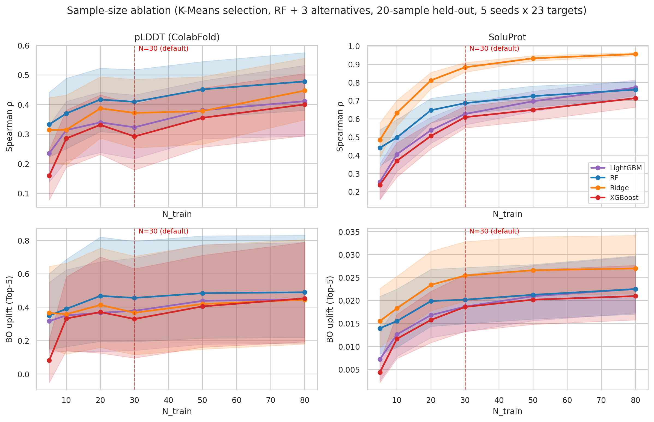
Sample-size ablation
Supplementary Figure S5. Sample-size ablation for production-supported surrogate families. The vertical reference at N = 30 marks the operating point used in RAPID. The curves show diminishing returns beyond roughly 20-30 AF2-labelled examples, supporting N = 30 as a conservative default rather than an arbitrary setting.
N_train | RF pLDDT BO uplift Top-5 | Percent of N = 80 | RF SoluProt BO uplift Top-5 | Percent of N = 80
5 | 0.350 | 71.4% | 0.0140 | 62.1%
10 | 0.390 | 79.7% | 0.0155 | 69.1%
20 | 0.468 | 95.6% | 0.0199 | 88.5%
30 | 0.456 | 93.1% | 0.0202 | 89.8%
50 | 0.484 | 98.9% | 0.0213 | 94.5%
80 | 0.490 | 100.0% | 0.0225 | 100.0%

Supplementary Note 6. Acquisition Bias and Diversity
K-means training selection does not by itself remove acquisition bias. In the current artifact benchmark, RF-selected Top-K sets are more internally similar than the true Top-K sets, even when the bootstrap training set is selected by K-means. This means diversity control belongs at acquisition time if sequence diversity is an explicit design objective.
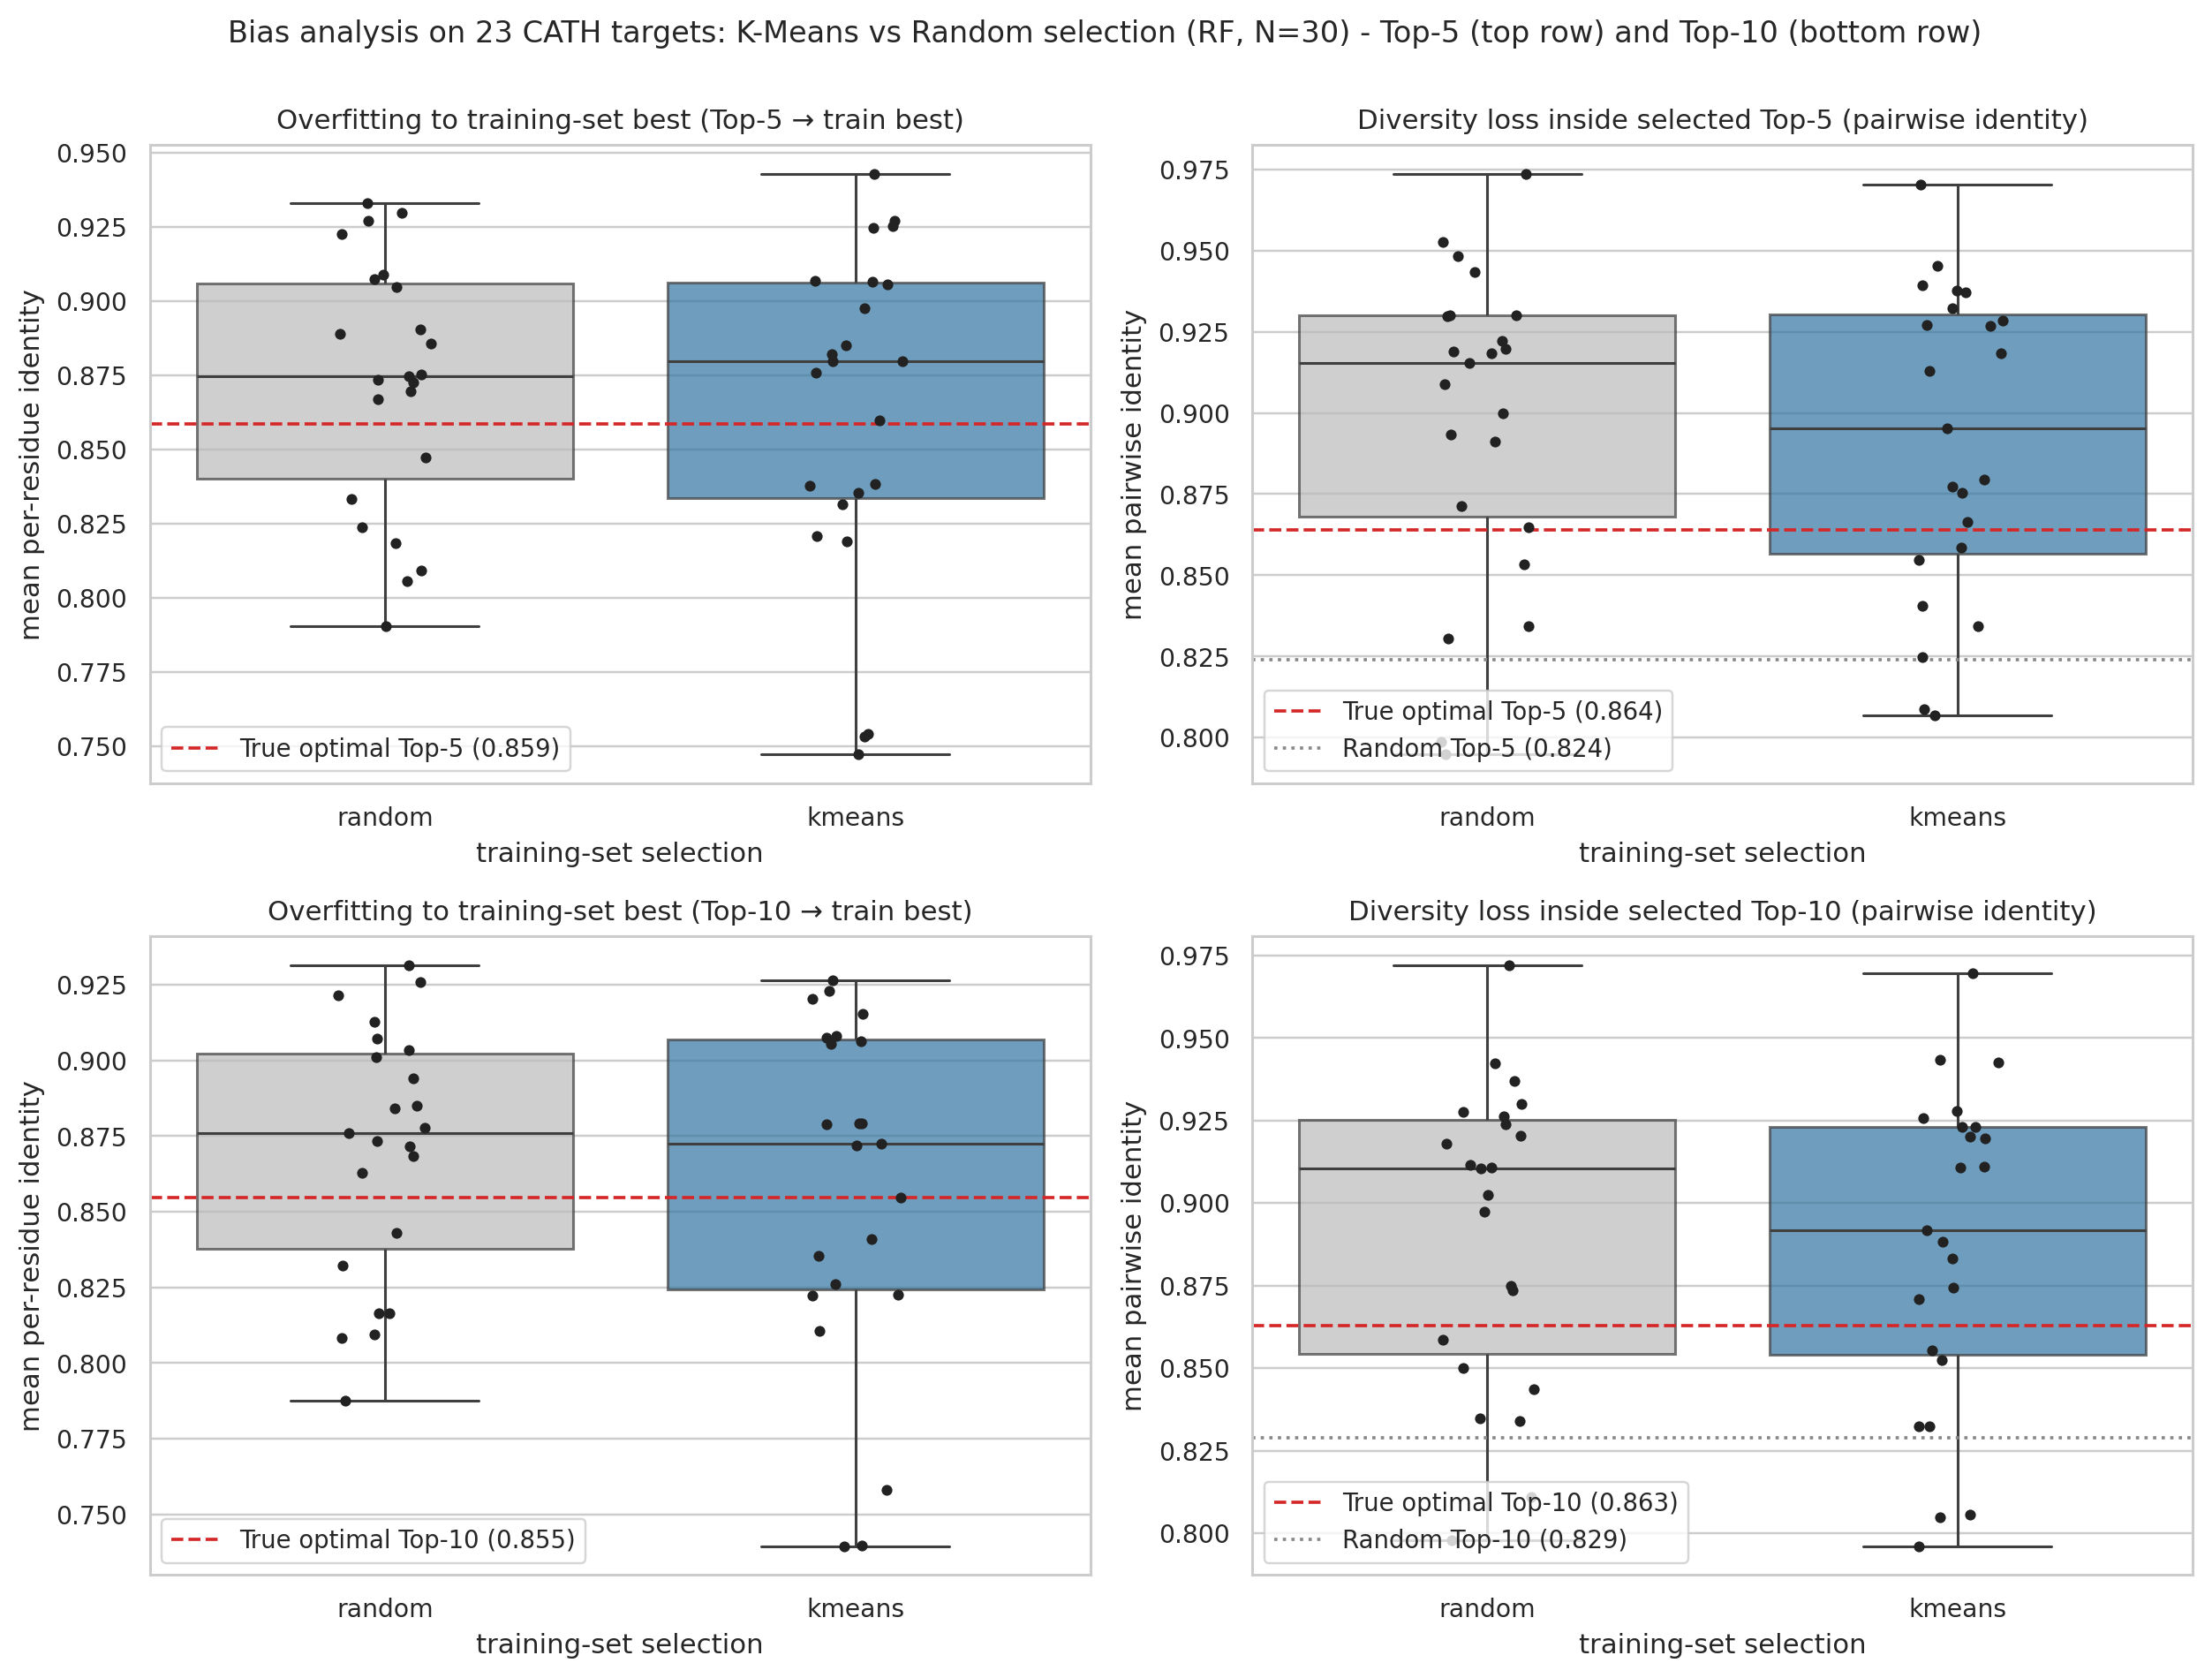
Acquisition-bias analysis
Supplementary Figure S6. Acquisition-bias analysis for RF at N = 30. K-means reduces identity to the best training sequence relative to random bootstrap selection, but surrogate-selected Top-K sets remain more internally similar than the true Top-K sets.
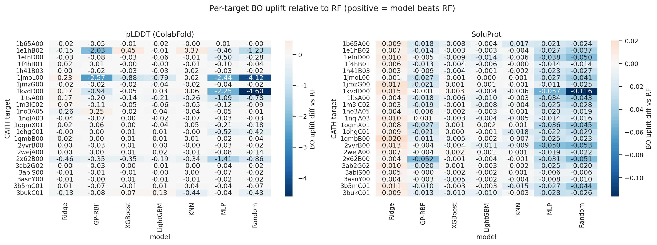
Per-target surrogate heatmap
Supplementary Figure S7. Per-target BO uplift difference relative to Random Forest. The heatmap shows target-level winner switching that is obscured by aggregate means, supporting a configurable surrogate layer rather than a hard-coded single-model policy.
Metric | Random training | K-means training | True optimal | Random Top-K
Top-5 overfit identity | 0.872 | 0.862 | 0.860 | -
Top-5 internal identity | 0.898 | 0.891 | 0.866 | 0.828
Top-5 mean pLDDT | 92.51 | 92.51 | 93.09 | 91.95
Top-10 overfit identity | 0.870 | 0.859 | 0.854 | -
Top-10 internal identity | 0.892 | 0.887 | 0.864 | 0.831
Top-10 mean pLDDT | 92.47 | 92.45 | 92.89 | 91.91

Supplementary Note 7. Rank-Mean Ensemble
A rank-mean ensemble over RF, Ridge, LightGBM, and XGBoost gives the highest mean pLDDT BO uplift in the current artifact benchmark, but the gain over RF is small and does not remove acquisition diversity collapse. Rank-mean is therefore retained as an optional robustness layer rather than as the default surrogate. In the RAPID interface, selecting multiple surrogate families uses this rank-mean rule on the same AF2-labelled bootstrap set, so the number of AF2/ColabFold calls remains N_train + Top-K rather than increasing with the number of selected models.
Combination rule | pLDDT BO uplift Top-5 | SoluProt BO uplift Top-5 | Top-10 internal identity
rank-mean ensemble | 0.622 | 0.0370 | 0.883
score-mean ensemble | 0.611 | 0.0377 | 0.881
RF | 0.602 | 0.0335 | 0.887
top-5 vote ensemble | 0.600 | 0.0363 | 0.880
Ridge | 0.583 | 0.0418 | 0.865
XGBoost | 0.558 | 0.0308 | 0.873
LightGBM | 0.549 | 0.0297 | 0.877

Supplementary Note 8. Representative Surrogate-Budget Runs
Two representative historical in-silico runs verify the implemented computational surrogate path but are not treated as a paired biological benchmark. They used AF2/pLDDT as a computational label source and therefore support the software and budget path, not experimental enrichment. The current paper-run script for claim 2 is scripts/paper_runs/03_launch_surrogate_triage_budget.py, which runs the standard pipeline with evolution_mode=False, surrogate_triage_enabled=True, RFD3/BioEmu/Relax disabled, and default N_train = 30, Top-K = 20.
Target | Run ID | SoluProt-gated candidates | AF2 records | AF2 reduction vs folding all gated candidates | Top-K setting | Best phase | Best SoluProt | Best pLDDT | Best relax score
3RGK | pys74631_kribb.re.kr_ev_3rgk | 8,000 | 94 | 98.8% | 20 | R1 train | 0.794 | 97.05 | -3.13
1LVM | admin_20260430_064926_afb67369 | 8,000 | 49 | 99.4% | 5 | R3 top-k | 0.734 | 89.52 | -3.15
The Top-K default of 20 is an operating budget rather than a fitted hyperparameter. It pairs with the N = 30 bootstrap setting to give 50 AF2 calls per target-tier decision point when the SoluProt-passing pool exceeds the budget. N = 30 is supported by the sample-size ablation, where additional labels beyond 30 provide diminishing returns in the current artifact benchmark; Top-K = 20 keeps enough candidates for manual review while making the AF2/ColabFold cost visible before a run is launched.

Supplementary Note 9. Structural-Context Pilot
The completed structural-context pilot compares the original target backbone, one selected RFD3 backbone, and a three-backbone RFD3 ensemble across three CATH targets. It shows target-dependent tradeoffs and motivates the four-arm RAPID refresh, but it is not powered to claim a universal structural-generator advantage. The pilot visualization is shown once in the main manuscript as Figure 5; the supplementary material retains the numeric summary and protocol context rather than repeating the same image.
Arm | Designs per target | AF2 records per target | Top-5 pLDDT | Top-5 SoluProt
Single target backbone | 120 | 30 | 84.76 | 0.756
RFD3 selected backbone | 120 | 30 | 87.58 | 0.725
RFD3 ensemble, 3 backbones | 117 | 30 | 85.58 | 0.759

Supplementary Note 10. BioEmu Target-RMSD Gate QC
BioEmu-containing structural-context arms were required to satisfy the same 2.0 Å target-RMSD gate used in the primary four-arm refresh. This gate is part of the artifact contract: a BioEmu arm is quantitatively evaluable only when the requested near-target conformers are recovered. Initial BioEmu runs for four targets did not recover three accepted conformers within the 10-attempt budget. These cases are therefore treated as not evaluable for BioEmu-based score comparison, rather than as zero-valued design outcomes. A sensitivity rerun increases the BioEmu sampling and maximum-attempt budgets to 30 while preserving the 2.0 Å acceptance gate.
Target | BioEmu accepted/attempted | BioEmu min RMSD (Å) | RFD3+BioEmu accepted/attempted | RFD3+BioEmu min RMSD (Å) | Primary handling
1h6wA03 | 0/10 | 22.664 | 0/10 | 22.664 | Not evaluable
2auaB01 | 0/10 | 8.051 | 0/10 | 8.051 | Not evaluable
3jvoG00 | 0/10 | 2.887 | 0/10 | 3.219 | Not evaluable
3twkA01 | 0/10 | 4.976 | 0/10 | 4.976 | Not evaluable
Supplementary Table S8. BioEmu target-RMSD gate failures in the initial four-arm structural-context refresh. The table reports the initial 10-attempt BioEmu runs only. The sensitivity rerun changes the sampling budget but keeps the acceptance gate fixed, avoiding post-hoc relaxation of the structural-quality criterion.

Supplementary Note 11. Execution Environment and RunPod Images
The public release records Docker image tags for the RunPod-backed model stages, while endpoint IDs and API keys are excluded from the repository. Endpoint IDs are deployment-specific secrets and should be supplied through .env or server environment variables. For manuscript reproduction, image tags should be pinned for each benchmark run, and any image tagged as latest should be accompanied by a digest or release note before final archival.
Pipeline stage | Environment variable | Docker image
MMseqs2 MSA/search | MMSEQS_ENDPOINT_ID | mimikyou0607/mmseqs-runpod:latest
ProteinMPNN sequence generation | PROTEINMPNN_ENDPOINT_ID | mimikyou0607/proteinmpnn-runpod:latest
ColabFold/AF2 structure prediction | COLABFOLD_ENDPOINT_ID or AF2_ENDPOINT_ID | mimikyou0607/colabfold-runpod:20260304_4
RFdiffusion3 backbone generation | RFD3_ENDPOINT_ID | mimikyou0607/rfd3-runpod:260408-3
BioEmu ensemble sampling | BIOEMU_ENDPOINT_ID | mimikyou0607/bioemu-runpod:latest
Rosetta Relax post-processing | RUNPOD_RELAX_ENDPOINT_ID | mimikyou0607/relax_runpod:260428_1

Supplementary Note 12. Software Interface and Deployment Scope
RAPID is distributed with a static browser interface served by the backend API. The interface is not treated as a separate scientific contribution in the main manuscript; its role is to make the run-scoped artifact contract accessible during local or server-based operation. Basic mode exposes the default solubility-aware multiple-mutant redesign workflow with a compact set of output-size and threshold controls. Advanced mode exposes start and stop points, optional RFD3 and BioEmu stages, masking controls, AF2/ColabFold budget parameters, provider choices, surrogate-triage mode, and experimental-feedback evolution records. These controls map to the same request fields stored in each run directory, so analyses can be reproduced from the resulting artifacts without depending on the browser state.
The intended deployment model is local or server-side execution by the user, including GPU-backed RunPod endpoints configured through environment variables. Runtime .env files, endpoint identifiers, API keys, and raw logs are excluded from the public release. The browser interface therefore documents and exposes the reproducibility contract, but the manuscript’s empirical claims are based on stored artifacts and benchmark scripts rather than on user-interface behaviour.

