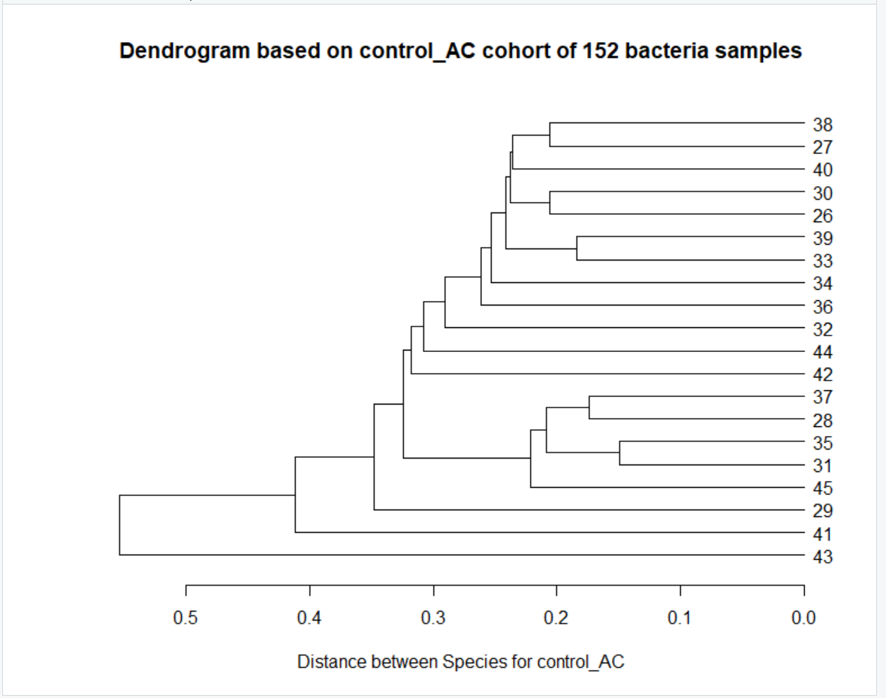  
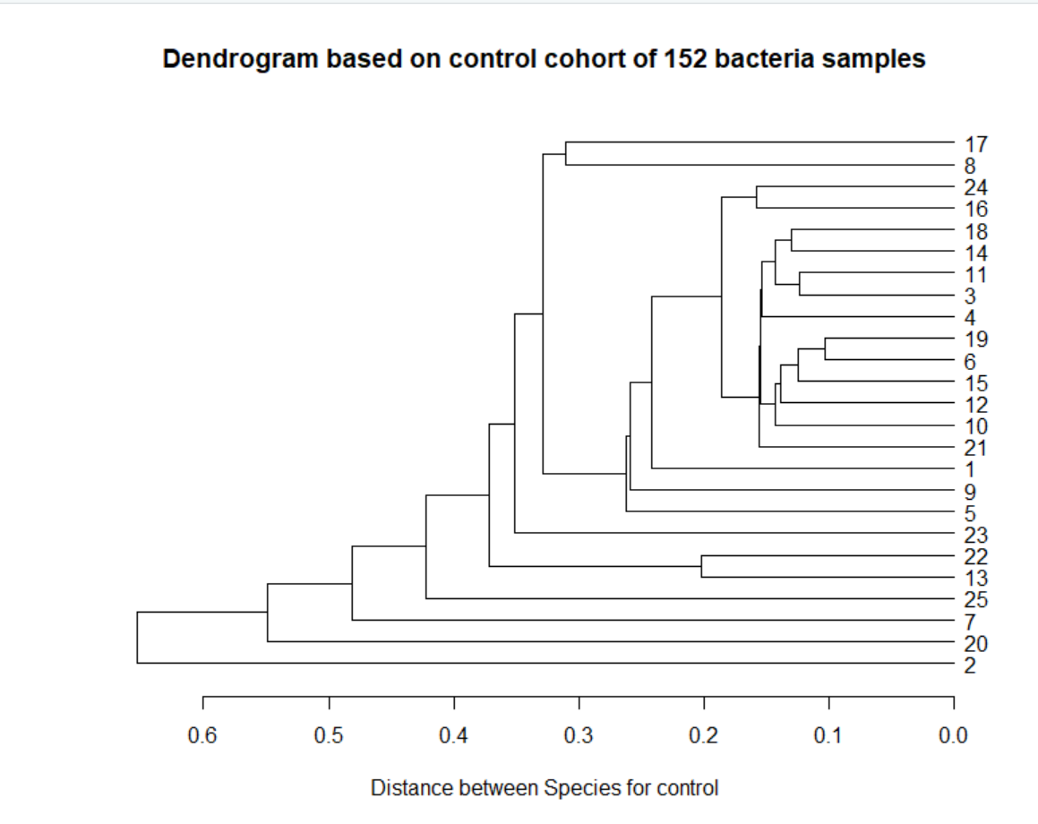

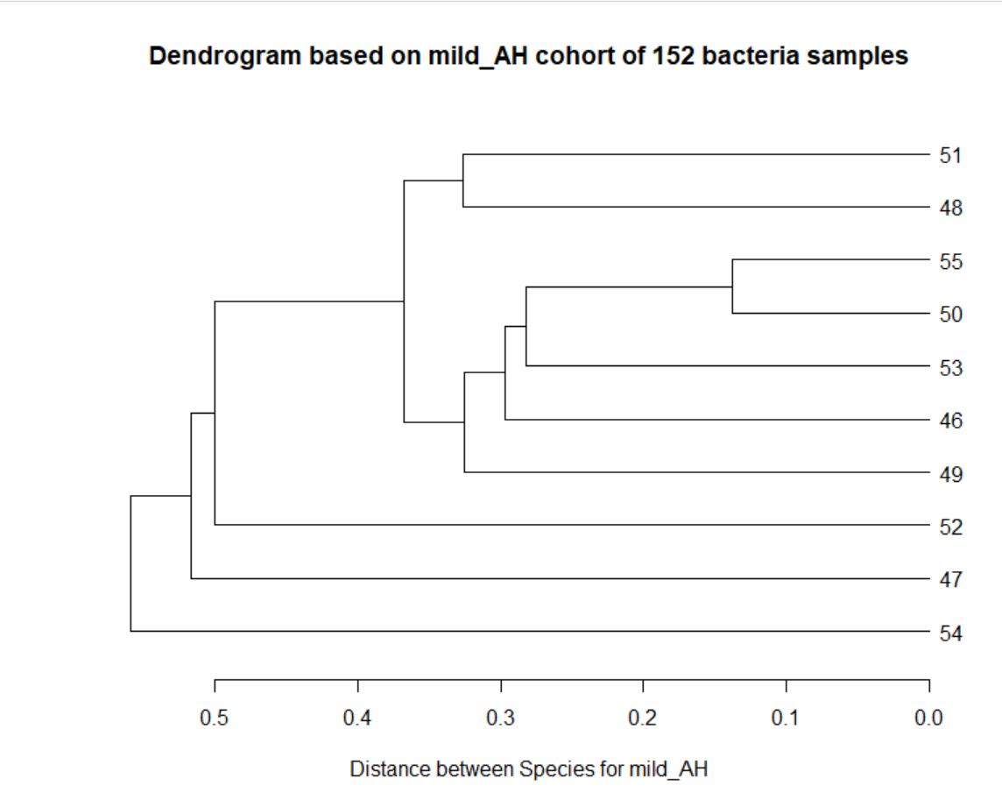

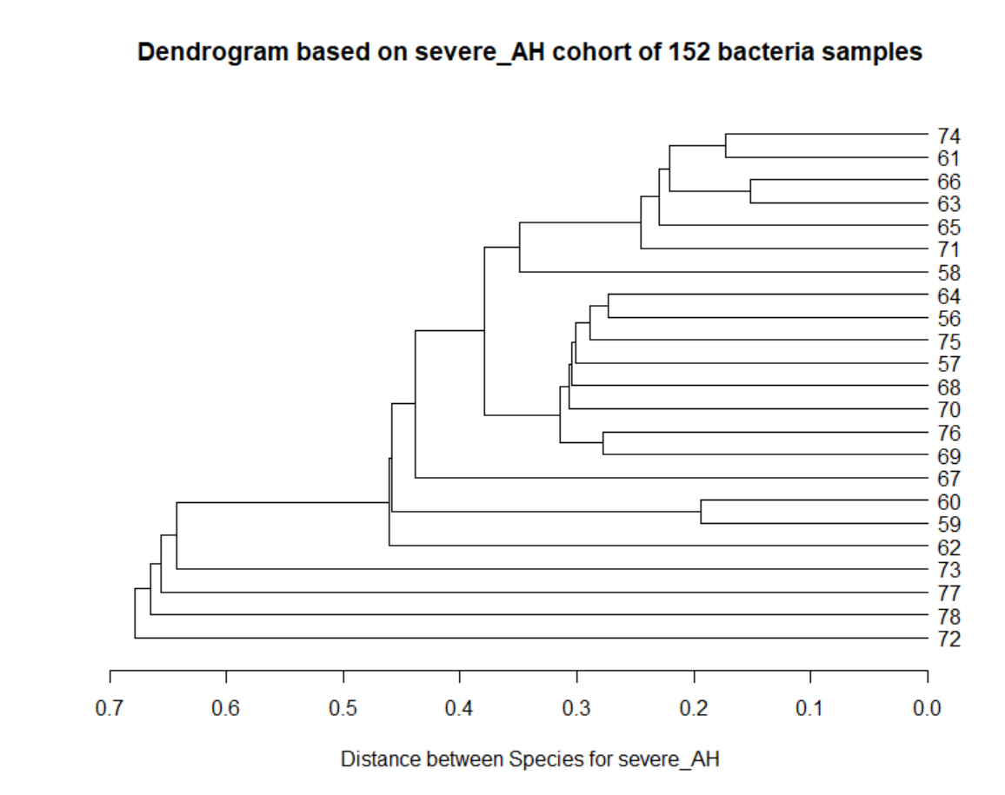

setwd("/Users/Lauren/Desktop/")

ALD <- read.csv("Ordered Team4-ALD_4cohort_dataset.csv")

ALD

control <- ALD[1:25, 3:152]

control

options(max.print = 99999)

control

control_AC <- ALD[26:45, 3:152]

options(max.print = 99999)

control_AC

mild_AH <- ALD[46:55, 3:152]

options(max.print = 99999)

mild_AH

severe_AH <- ALD[56:78, 3:152]

options(max.print = 99999)

severe_AH

ALD_matrix <- as.matrix(read.csv("Ordered Team4-ALD_4cohort_dataset.csv"))

ALD_matrix

cov_ALD_matrix <- cov(ALD_matrix)

cohort_vs_species <- read.csv("cohorts_species.csv")

dist.cohort_vs_species <- dist(cohort_vs_species, method="euclidean")

dist.cohort_vs_species

dist.control_AC <- dist(control_AC, method="euclidean")

dist.control_AC

dist.mild_AH <- dist(mild_AH, method="euclidean")

dist.mild_AH

dist.severe_AH <- dist(severe_AH, method="euclidean")

dist.severe_AH

dist.control <- dist(control, method="euclidean")

dist.control

clustcontrol_AC <- hclust(dist.control_AC, method="single")

plot(as.dendrogram(clustcontrol_AC), horiz = TRUE, xlab="Distance between Species for control_AC", main="Dendrogram based on control_AC cohort of 152 bacteria samples")

clustcontrol <- hclust(dist.control, method="single")

plot(as.dendrogram(clustcontrol), horiz = TRUE, xlab="Distance between Species for control", main="Dendrogram based on control cohort of 152 bacteria samples")

clustmild_AH <- hclust(dist.mild_AH, method="single")

plot(as.dendrogram(clustmild_AH), horiz = TRUE, xlab="Distance between Species for mild_AH", main="Dendrogram based on mild_AH cohort of 152 bacteria samples")

dist.severe_AH <- dist(severe_AH, method="euclidean")

dist.severe_AH

clustsevere_AH <- hclust(dist.severe_AH, method="single")

plot(as.dendrogram(clustsevere_AH), horiz = TRUE, xlab="Distance between Species for severe_AH", main="Dendrogram based on severe_AH cohort of 152 bacteria samples")