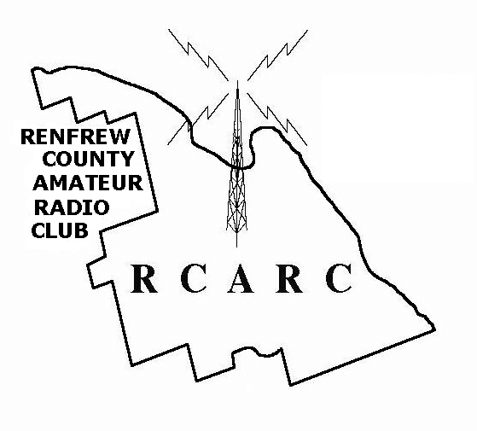

Configuration of Outpost

Ver. 1.4, Mar 27, 2014



Configuration of Outpost

Run Outpost to bring up the Station Identification Screen. | 
Note that as of V2.7, the startup Profile name is shown.  Under Legal, the User Call Sign and User Name should be modified to show the current operator.  If the User call sign is changed, (a new operator taking over), the signature will also have to be changed.  See Message Settings, New Messages.  Under Tactical , select Use Tactical Call, and set the Tactical Call Sign to reflect the current operating location from the list in Appendix A. In this case for demo purposes, we are using the MEOC. Fill in the Additional ID Text, and set the Tactical ID to 3 characters for that location.  Select OK to continue to the Outpost Packet Message Manager. | 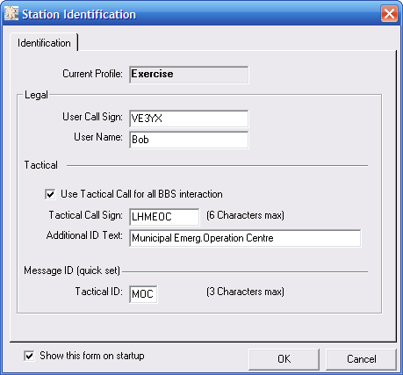
In the Outpost Packet Message Manager, click Setup to bring up the setup dropdown menu:  Select the first option TNC from that dropdown menu.  (Note the new Profile dropdown menu for selecting a profile.) | 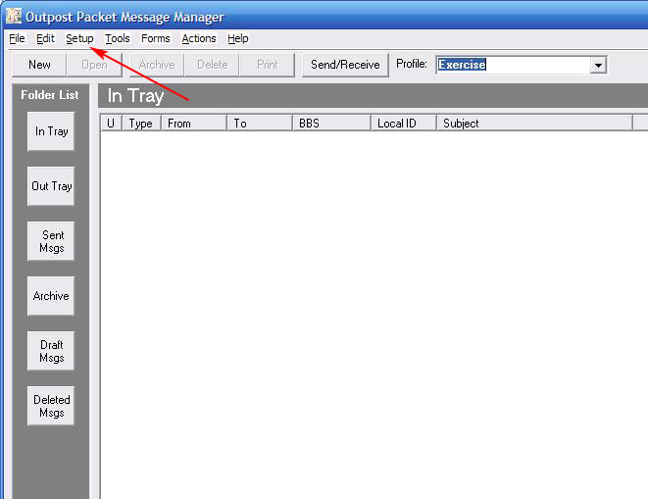
The following screen appears. Review the information under the Interface Type Tab. If the Device Type is not shown as TNC, consult the installation guide for instructions on the use of configuration files at installation time.  The Device Name and Description should reflect the hardware in use.  Select Apply to preserve any changes. | 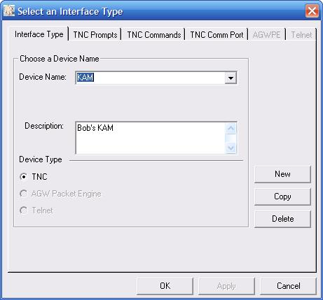
Select the TNC Comm Port Tab.  From the dropdown menu beside Comm Port select the port used. This may require some trial and error if you are not sure which port the TNC is connected to.  Select Apply to preserve any changes, then OK to continue. | 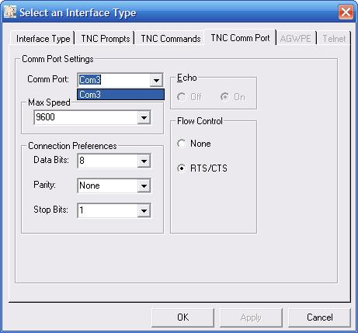
Back in the Outpost Packet Message Manager, click Setup and click on BBS from that dropdown menu.  The following Select a BBS screen will appear. Select the BBS Name Tab.  From the dropdown menu beside BBS Name, select RBW DIRECT if you can reach RBW from your location. If you can only reach PEM, select RBW THRU PEM.  Select Let Outpost Determine the BBS and set up the prompts.  Select Apply to preserve any changes. | 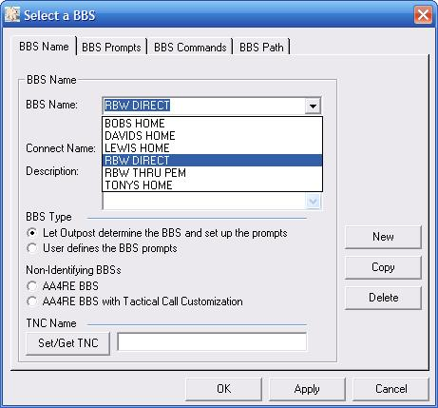
If you need to set up a new path using digipeaters to get to RBW:  Under the BBS Path Tab select Via digipeater(s) and enter the call signs in the box.  See Appendix C for additional info about BBSs. | 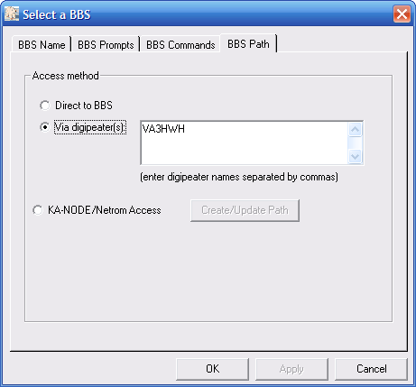
In some instances you may not be able to connect to RBW directly and will have to connect Via node(s). In the example aside, VE3NRR-7 is being used for a node. This will likely be the situation for the Red Cross.  After filling in the Names, description and local TNC, click on the BBS Path tab. | 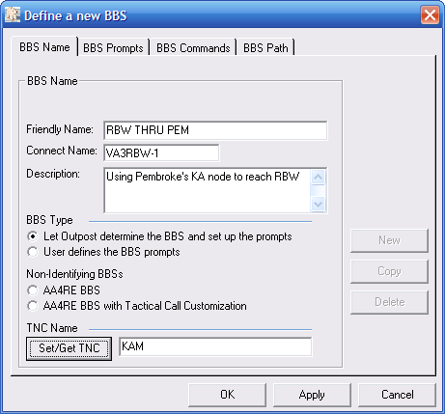
Click on the KA-Node button, then on Create/Update Path. | 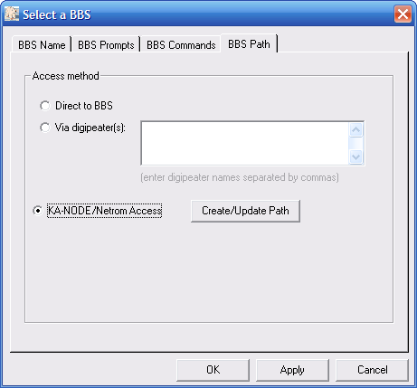
Here we are using the KA-node VE3NRR-7. The remaining fields are appropriate for a KA-node. If the node in use is not a KA type, then the remaining fields will have to be set differently. See:  http://www.outpostpm.org/docs/Appnote-1001-node-setup.pdf  Click OK, Apply, OK. | 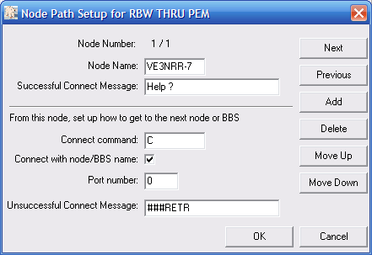
From the Outpost Packet Message Manager, select Tools, Send/Receive Settings. | 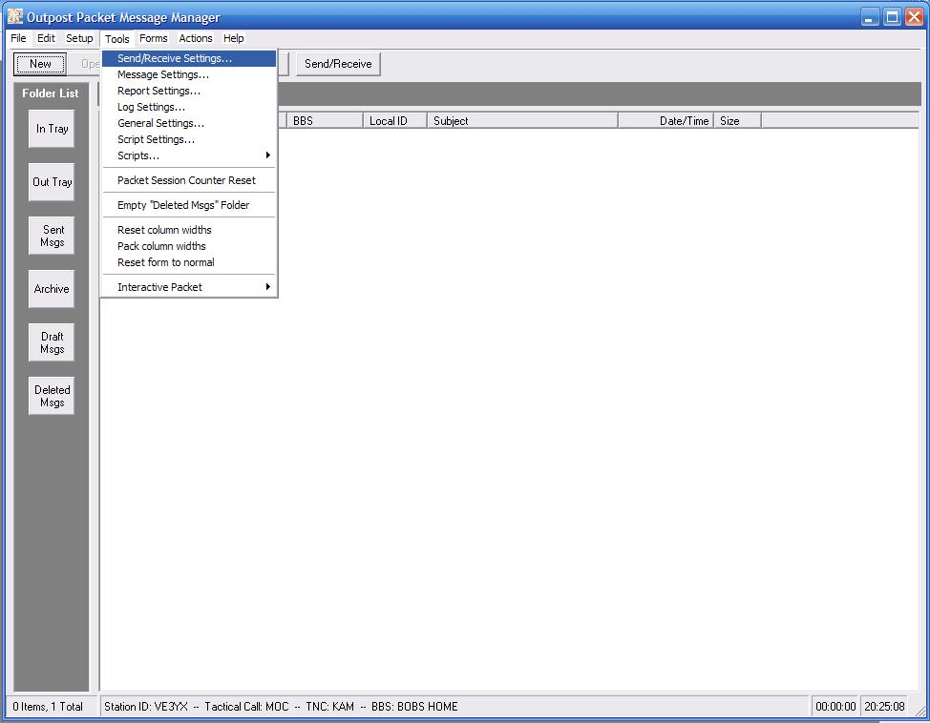
Under the Automation Tab,  Schedule a send/receive event every 6 minutes. Select Send a message immediately when it is complete.  Select Apply to preserve any changes. | 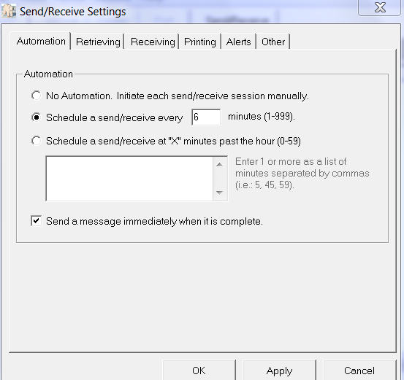
Under the Retrieving Tab, Select Retrieve Private Messages,  and Retrieve New Bulletins, and Skip(do not retrieve)NTS Messages I send to the BBS and Skip(do not retrieve) Bulletins I send to the BBS.  Select Apply to preserve any changes. | 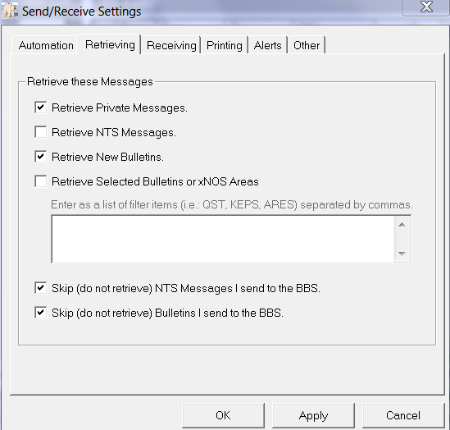
Under the Receiving Tab, select Play this sound on arrival: incoming.wav.  Select Apply to preserve any changes. | 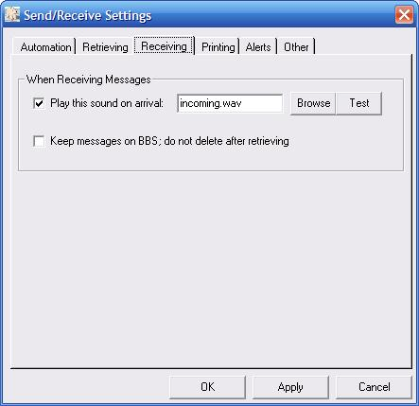
Under the Printing tab, select Print received message (2)  and Print send messages (2). Select Print message headers.  One copy goes to centre staff.  One copy is for our records.  Select Apply to preserve any changes. | 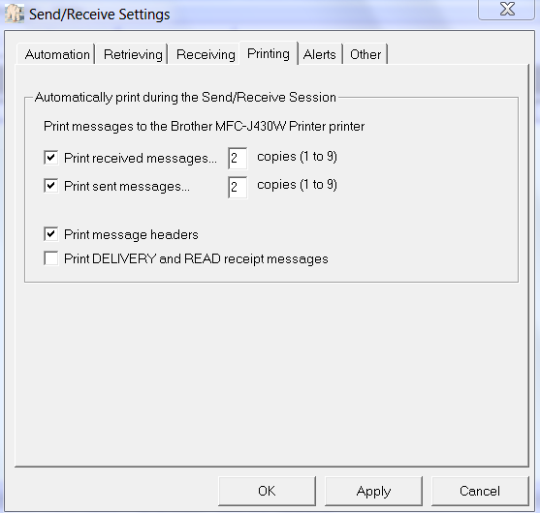
Under the Other tab, select Show the TNC Session Window during Send/Receive.  Select Apply to preserve any changes. | 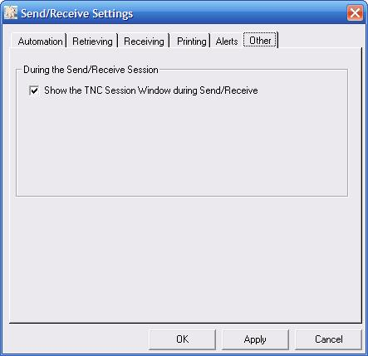
From the Outpost Packet Message Manager select Tools, Message Settings. | 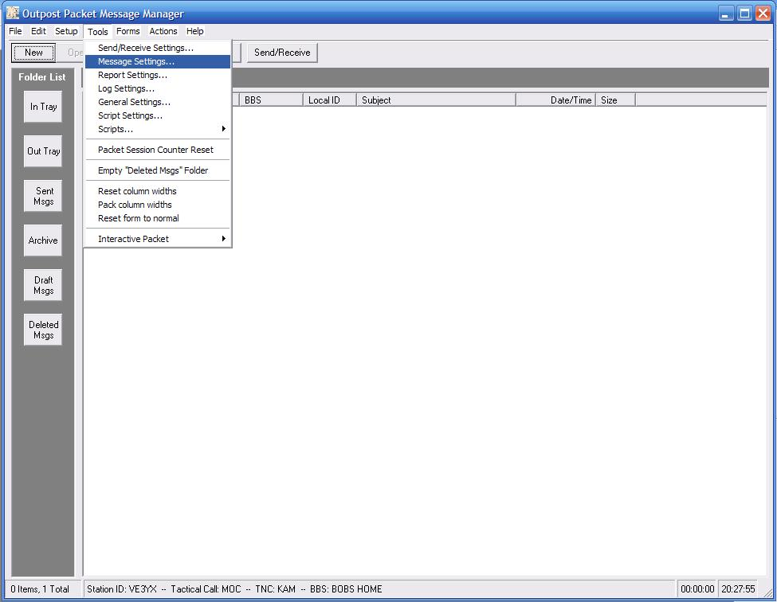
Under the New Messages tab, select Set default to PRIVATE.  Select Insert a signature for call sign in all messages.  In the message window, insert words indicating that This is an exercise message. (This example is tailored for the MEOC)  (The signature is specific for the call sign. If the call sign on the Ident Page (Setup, Identification) is changed, a new signature is required).  Select Apply to preserve any changes.  See Appendix D for new notes about signatures. | 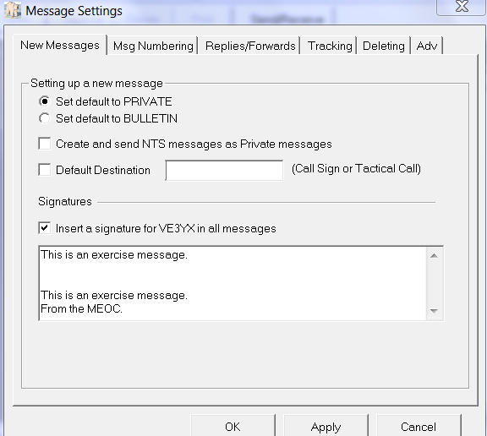
Under Msg Numbering tab, select Add message number...  and without hyphenation.  Select Apply to preserve any changes. | 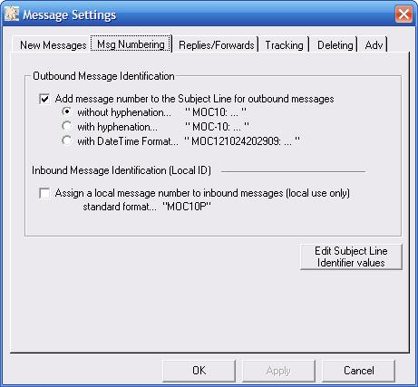
Under Replies/Forwards tab select Set default to Private for replies or forwards and Close original message on reply or forward.  Select Apply to preserve any changes. | 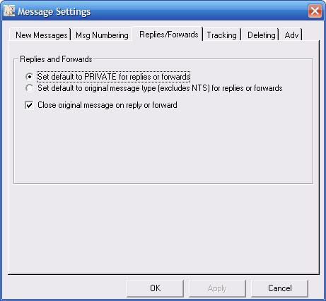
Under Tracking tab, select Always request a Read Receipt.  Select Apply to preserve any changes. Click OK if the station is not going to be used for ICS-213 Messages.  Note that for Outpost to recognize that a message has been read and to send a Read Receipt, the message must be opened in a window. i.e.  Double click on the message in the In Tray window. | 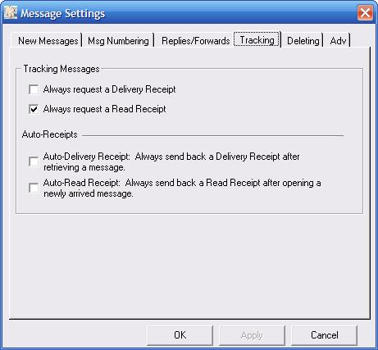
If this station is going to be used for ICS-213 messages:  Under Adv tab, select Automatically start the Opdirect...  and Never open in its native program in the two places it appears.  Select Apply to preserve any changes  and OK to close the window. | 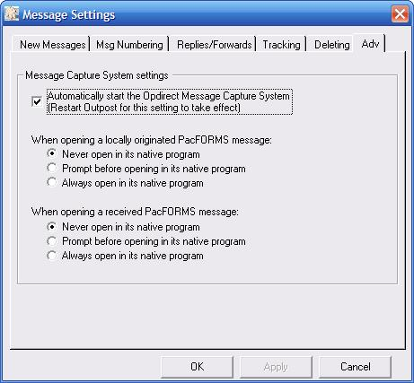
When the Opdirect Message System is set to automatically start (as configured in the previous step), this message with appear when Outpost is restarted and Opdirect will appear in the task bar. | 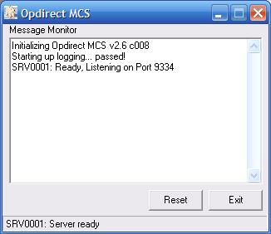

Sending an Outpost Message

Under the Outpost Packet Message Manger, select New to create a new Packet Message.  The New Packet Message window appears, with fields BBS and From completed, with the signature text in the message field. By default, the message will be private (Pvt). If you want to create an urgent message, which will appear in red, select Urg at the top of the New Packet Message window. To send a bulletin, select Bul. In the case of Bul, you can simply use your own tactical call in the To field. See Appendix B for instructions on deleting a bulletin from the BBS.  Note the To is highlighted. Click on To to bring up the Select address book entries window. Double click on one or more addresses to select message destination. | 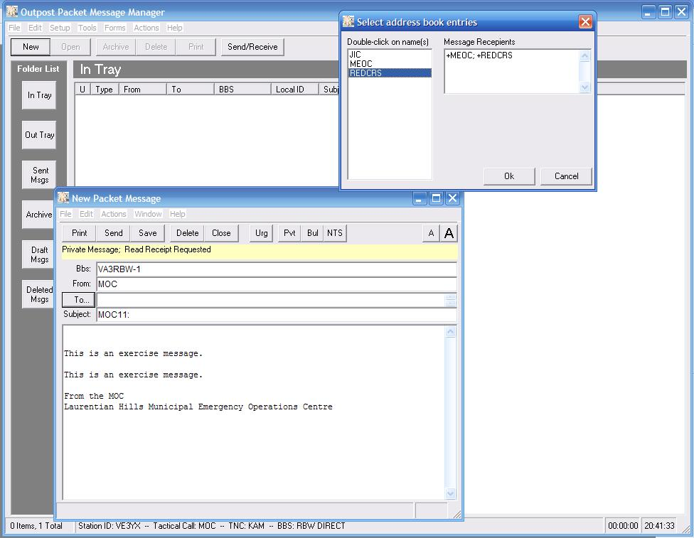
Fill in the subject field and the message text between the exercise notifications.  Select Send to put the message in the Out Tray.  The message will go immediately, because we have configured Outpost to send when the message is complete. (refer page 7, bottom screen)  The TNC session window will show the progress of the send.  Also two copies of the outgoing message will be printed. | 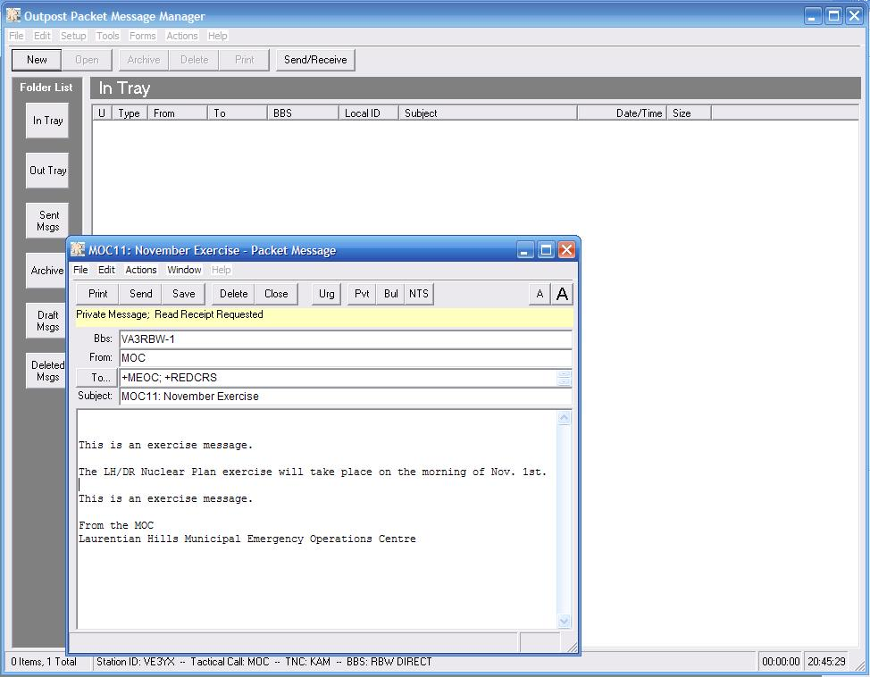
At the end of the exercise or at the end of day, in the Outpost Packet Message Manager, select Forms and then ICS 309 Communications Log. | 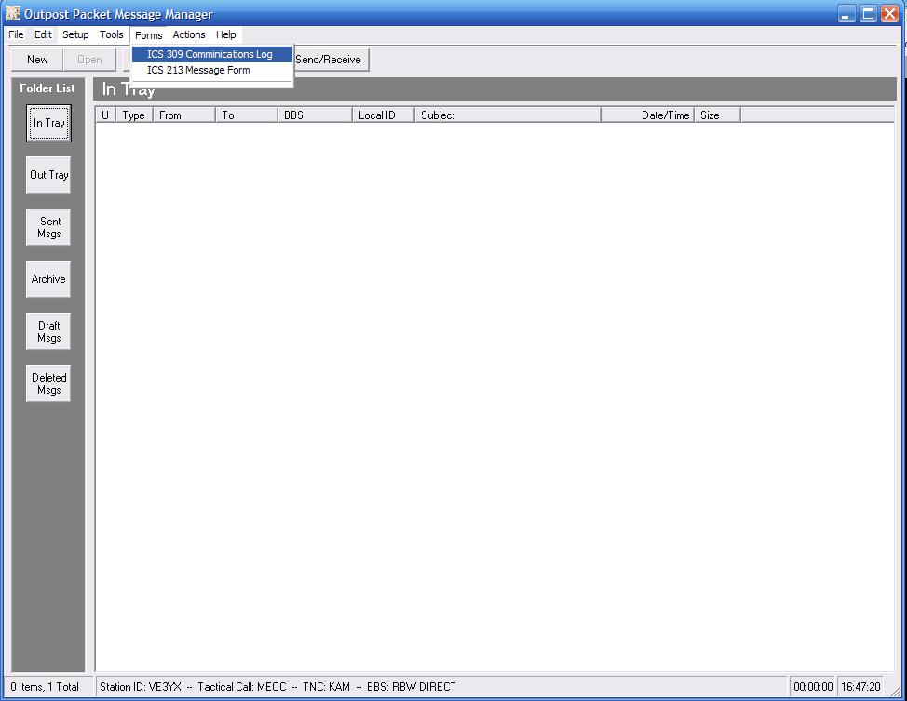
In the ICS 309 Comm Log Builder window, select Reporting Period Today.  Select Build Data Set at the upper left of the window.  Select Print to print the resulting data set.  At the end of the event, our records will include this data set printout, and our copies of all sent and received messages. This documentation should be handed to the EC. | 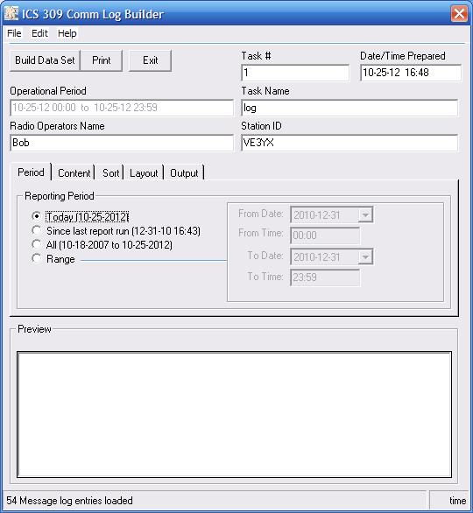

Appendix A

Centre Name | Tactical Call Sign | Tactical ID (for message #s)
Municipal Emerg. Operation Centre | LHMEOC | MOC
LH/DR NP Joint Information Centre | LHJIC | JIC
LH/DR NP Joint Traffic Control Centre | LHJTCC | JTC
Red Cross Pembroke | RCPEMB | RDP
Red Cross Ottawa | RCOTWA | RCO
LH/DR NP Reception Centre | DRRECP | REC
LH/DR NP Evacuation Centre | DREVAC | EVA
Laurentian Valley EOC | LVEOC | LVE
Petawawa EOC | PETEOC | PTE
Deep River EOC | DREOC | DRE
Renfrew County | RNCNTY | RNC

Appendix B

Deleting a Bulletin you have sent

A bulletin can only be deleted by the sender. To delete a bulletin you must select Tools, Send/Receive Settings, Retrieving from the Outpost Packet Message Manager.  Uncheck Skip(do not retrieve) Bulletins I send to the BBS.  Select Apply to save changes made and OK to exit the screen. | 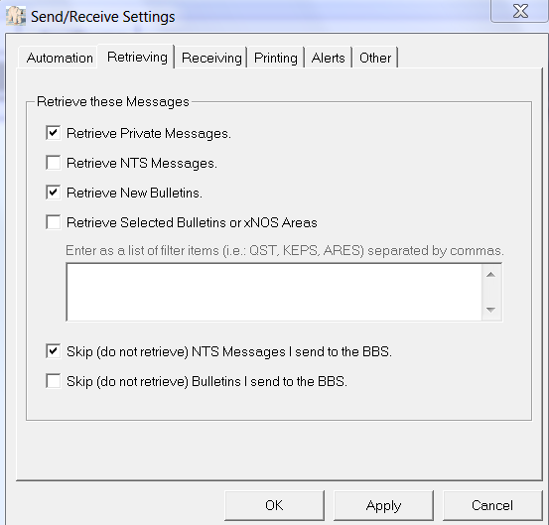
Select Send/Receive to deliver the Bulletin you wish to delete.  When the Bulletin message is delivered, select Expire on the Bulletin.  After deleting the Bulletin, you may want to change the Retrieving Settings back.  Follow with a Send/Receive to execute the delete command on the BBS. | 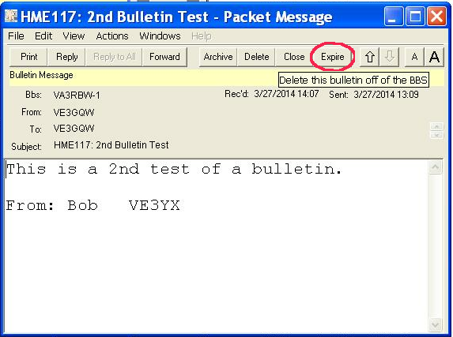

Appendix C

Additional info on BBSs

VA3RBW and VE3NRR use the KPC3 plus for their TNCs. The big advantage of this TNC is that it is the only TNC that allows multiple connects at once. This means that when Outpost connects to RBW or NRR’s TNC to send or receive messages, and someone else is already connected, Outpost won’t receive a “Busy” response causing it to disconnect and wait for the next Send/Receive session to try again. That would cause a serious slowdown in the message rate.

RBW is designated as the primary BBS while NRR is the secondary. A script has been written that will do a Send/Receive with both BBSs, but it shouldn’t normally be necessary.

Most of the other TNCs we are using are KAMs, for example, the Red Cross station, the MEOC station and some of the personal stations. If RBW or NRR was not available for some reason, we can switch to a different station for the central BBS, but we would then have to deal with the “Busy” issue. The preferred alternate station would be one of the KAMs.

In order to access a different BBS, the Setup, BBS, window has to be accessed and the BBS selected from the drop down menu. If that BBS is not directly accessible from your station, you will have to set up a Path using some station you can get to as a node or Digi to bridge the gap.
For complete info on setting up node access, see the Application Note:
http://www.outpostpm.org/docs/Appnote-1001-node-setup.pdf

Appendix D

Additional info on Signatures

In order to encourage better formatting of messages, the signature can contain the headers for the parts of the message. The operator whose call sign appears on the Ident screen is responsible for creating the signature for his call sign. (See page 10, bottom). Here is a suggestion for a signature:

To:
Posn:

From:
Posn:

Time of Origin:

Message:

This is an exercise.

This is an exercise.

Signature:

To: and From: is a person’s name and Posn: is their job title and perhaps physical location.
The Time of Origin: is the time shown on the originator’s message form if there is one.
The message text is placed between the “This is an exercise.” lines, assuming it is an exercise.
The Signature: would likely not be the originator’s. In some sites such as EOCs, the centre manager vets the messages and signs them before passing to the radio ops. The signature would be the name of the manager.

A separate signature is stored by Outpost for every call sign that has been entered on the Ident page. They could be created in advance or made the responsibility of each operator when they put their call on the ident page for the first time.

For messages that don’t require such a formal format, just delete the entries when they appear on the NEW message form.

Change History

Date | Change
Oct 31, 2012 | Draft 1.0 created YA and RH
Oct 31, 2012 | Draft 1.1 - Bulletin and Urgent Messages described and Appendix B added YA
Nov 02 2012 | Added notes about Call Sign and signature
Nov 02 2012 | Corrections to bulletin deletions, appendix B
Nov 21 2012 | Added Appendix C; notes about BBSs
Mar 10 2013 | Added info about Profiles – introduced with V 2.7
May 20 2013 | Added info about NRR’s KPC3+, and the use of nodes. Now 1.3
Oct 17 2013 | Corrected Path NRR’s node. Added note about read receipts.  Now Ver. 1.4
Mar 27 2014 | Added Appendix D – Message form in signature

