ICOM T2A Cheat Sheet

To toggle between VFO and memory modes, push the 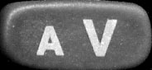 button.
When in Memory mode,  will show in the display.

To enter a frequency – in VFO mode, key in the 6 digit frequency.
If * is pushed first, only the last 3 digits have to be entered.

To enter Set Mode - push for 1 sec. (See Mode Info below).

To set a subaudible tone – Enter Set Mode.
Push  one or more times until RP appears. Push 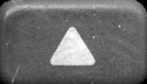 or 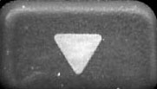 to select the desired tone frequency.
Push to save the tone and exit the set mode.

Program a memory channel – Select VFO mode if necessary by pushing the button.
Set Duplex by pushing the  button for +, - or none.
Set the tone frequency as above and the tone mode by pushing the 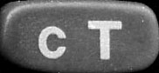 button to select the mode.
Enter the frequency as above.
Push the 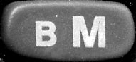 button and use the or buttons to select a memory channel.
Push the button for 1 sec. to program the channel and return to VFO mode.

To start or stop memory channel scanning - select memory mode and push .

To set a Skip channel for scanning – in memory mode, push or to select the channel to skip. Push for 1 sec. to toggle skip on or off.

Mode Info – After entering Set mode, the button cycles through the modes, and the or buttons cycle through the settings for that mode. The modes are:
FR – frequency (info only)
tS – Tuning step
oF – Duplex setting
oW – Transmit frequency offset
to – Tone setting (off, tone, tone squelch)
Ct – Tone squelch frequency
Rp – Tone encode frequency
To Exit Set mode – push .

Turn Power Saver ON or OFF - Enter Initial Set Mode:
With power OFF, push 8 and O and turn power ON.
Push the button to get to PS, then the or buttons to select.
Turn Power OFF, then back ON.

