Steven Bluen
Image Stitching Project

prog5 uses Renuka's showkeys program to annotate matching points on the images. The numbers written are their order in terms of key strength. 2 examples are shown below.

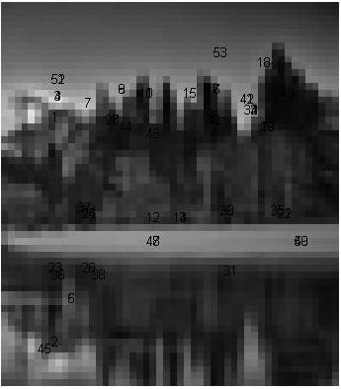
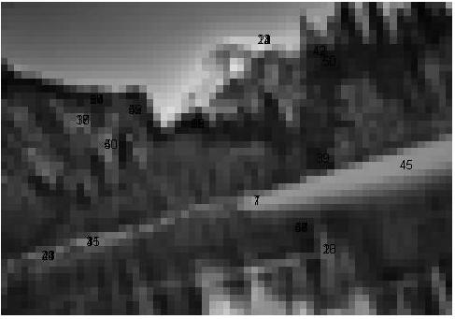

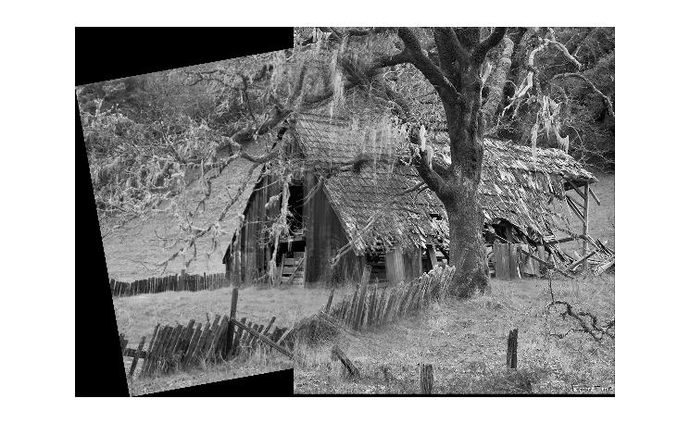
prog6 is uses Lowe's invariant keypoint matching as part of its algorithm to stitch images together. It also requires a cropping function sourced from Alec Jacobson.

The results are below:

c1 and c2:

m1 and m2:
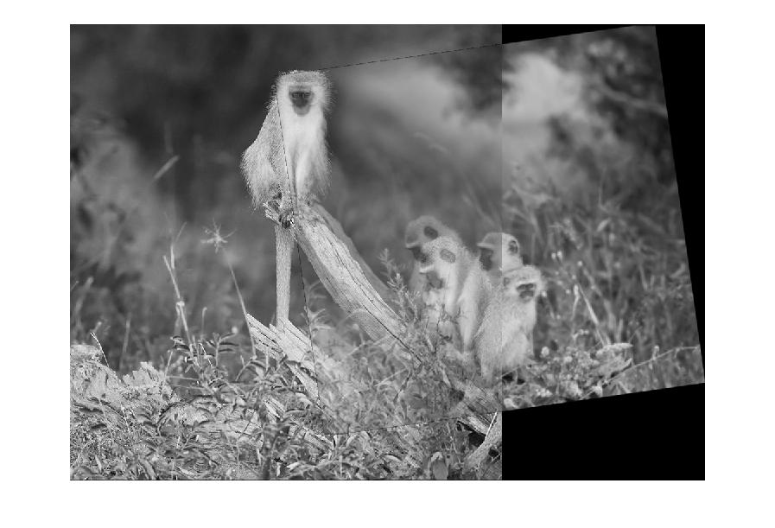

y1 and y2:

