Loan Operating System

Below is the GIT Hub path for source code.

* Backend (Rest Service) Code: <https://github.com/sbm111/LOAN>
* UI (Angular) Code: <https://github.com/sbm111/lps_ui>

Database Design:

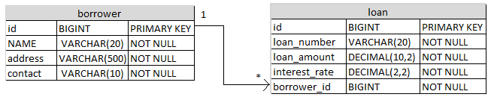

Rest API (POST URI): <http://localhost:8080/loan/borrower/createloan>

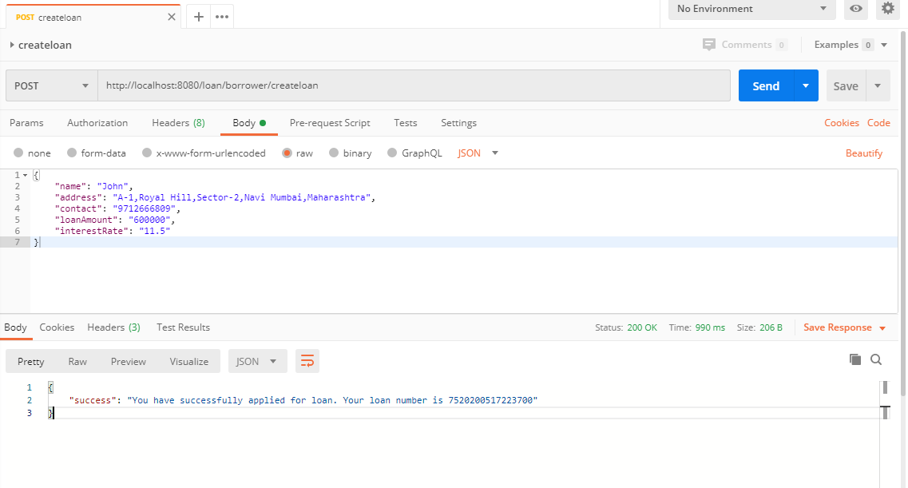

Angular UI:

Submit button will enable once all field will be validated correctly.

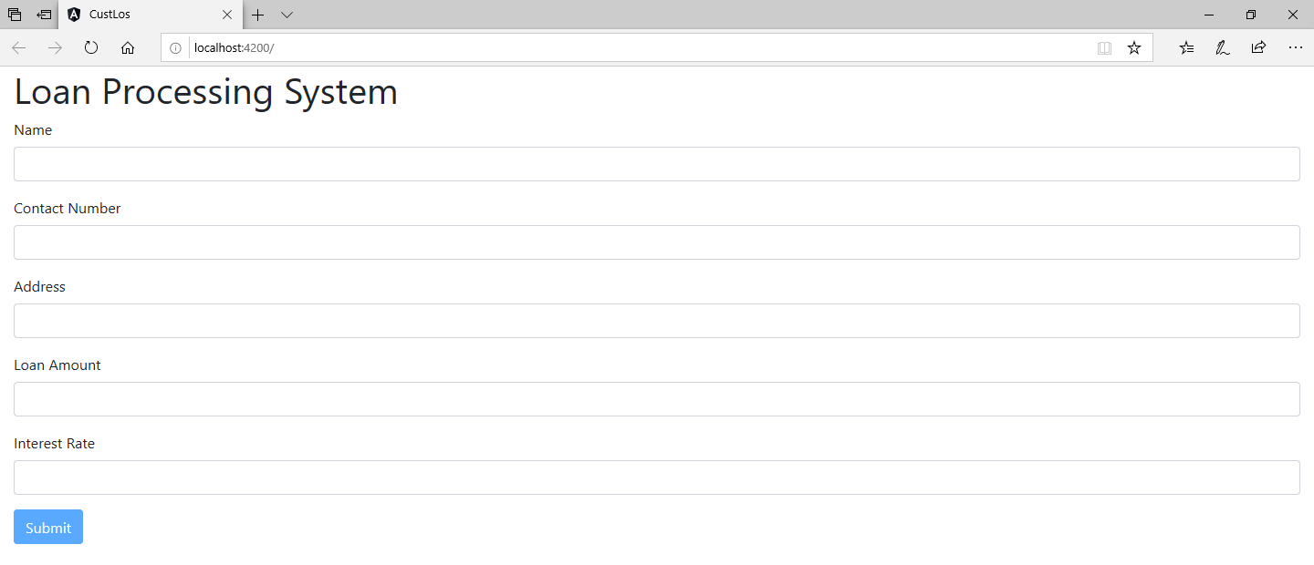

Field Validation:

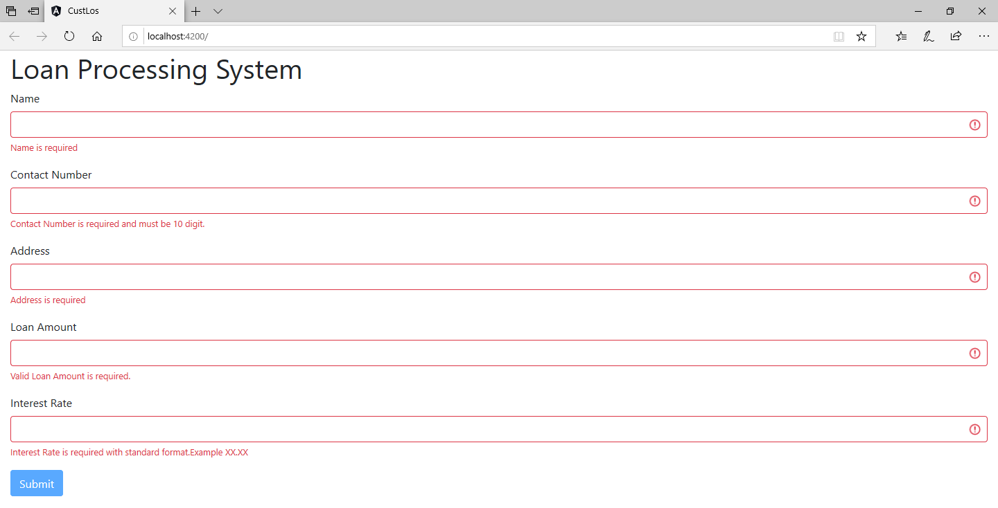

Borrower Loan submission:

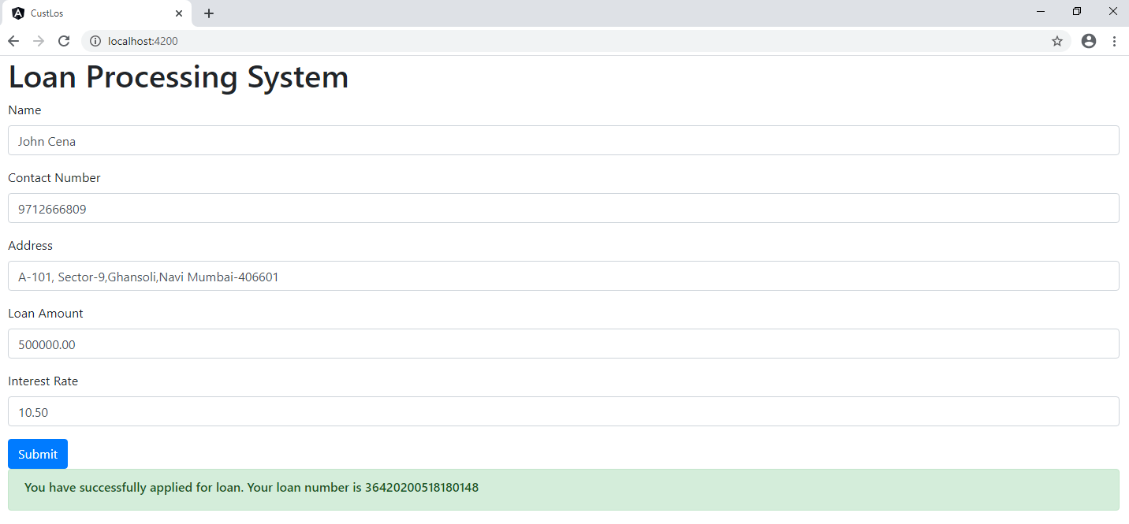

Thank You