
4 MATLAB

User’s manual

Sarah M Keating

Science and Technology Research Institute
University of Hertfordshire
Hatfield, AL10 9AB
United Kingdom

http://www.sbml.org
mailto:sbml-team@caltech.edu

Contents

1. Introduction 4
2. Installation 4
2.1 Downloads 4
2.2 Windows 4
2.3 Linux 5
3. Importing and exporting SBML 6
4. Access model 7
4.2 Getting information from reaction functions 8
4.3 Deriving information functions 9
4.4 Overview of model functions 11
5. Access to symbols 12
5.1 Getting symbols functions 12
5.2 Deriving information functions 14
5.3 Overview of model functions 15
5.4 General functions 17
6. Convenience functions 19
6.1 Checking information functions 19
6.2 Other functions 19
7.1 Parameter subfolder 22
8. Simulation 23
8.1 Simulation functions 24
8.2 MathML functions 25
8.3 Other functions 26
9. Storing models in MATLAB 27
9.1 Saving and loading functions 27
9.2 Data file functions 28
9.3 Graphical user functions 29
10. Validate_MATLAB_SBML_Structures 31
10.1 isSBML_Model 31
10.2 isSBML_XXX 32
11. Viewing models in MATLAB 35

1. Introduction

The SBMLToolbox provides a set of functions that allow an SBML model to be imported into MATLAB and stored as a structure within the MATLAB environment. At present the toolbox includes functions to translate a sbml document into a MATLAB_SBML structure, save and load these structures to/from a MATLAB data file, validate each structure (e.g. reaction structure), view the structures using a set of GUIs and to convert elements of the MATLAB_SBML structure into symbolic form and thus allow access to MATLAB’s Symbolic Toolbox.

The toolbox is not intended to be a complete Systems Biology toolbox for MATLAB but a platform which facilitates the import/export of SBML and from which a user can develop their own functionality.

2. Installation

2.1 Downloads

There are two downloads available

1) SBMLToolbox-setup.exe - windows setup program that will install the SBMLToolbox with prebuilt executables and all necessary library files

2) SBMLToolbox_src.zip – a zip file containing all the code for the SBMLToolbox; suitable for use with any operating system

2.2 Windows

At the command prompt change to directory 'SBMLToolbox/toolbox' and type ‘make’

This will start Matlab and run a script that performs the following

- Adds this folder (SBMLToolbox/toolbox) and all its subdirectories to the Matlab path

- Checks whether the appropriate libraries are on the system PATH and if not adds these libraries to the MATLABROOT\bin\win32 directory which is on the PATH

- Prompts for whether to exit Matlab

The installation process described above can also be performed from within the MATLAB environment by changing to directory SBMLToolbox/toolbox and typing ‘install’.

2.3 Linux

In order to use the SBMLToolbox on linux you must have downloaded and installed libSBML (see http://sbml.org/software/libsbml/) prior to the installation.

Assuming libSBML is installed; to build SBMLToolbox:

- Change to the directory 'SBMLToolbox/toolbox.

- Ensure that Matlab's mex compiler is in your PATH.

You can verify this by typing 'mex' or 'which mex' at the command-prompt (The mex executable is located in Matlab's bin directory).

- Ensure the CFLAGS and LDFLAGS point to the directories containing the libsbml header and library files.

For example, if you installed libsbml in /usr/local:

In sh or Bash:

export CFLAGS=-I/usr/local/include
export LDLAGS=-L/usr/local/lib

In csh or tcsh:

setenv CFLAGS -I/usr/local/include
setenv LDLAGS -L/usr/local/lib

- Type 'make'

This should build TranslateSBML.mexglx
OutputSBML.mexglx.
ReadAndValidateSBML.mexglx.

To run:

Ensure the directory containing these files and the all the toolbox subdirectories are in your Matlab path. For example, at the Matlab prompt:

>> addpath('SBMLToolbox/toolbox);
>> addpath('SBMLToolbox/toolbox/StoreModels');
etc…

You may wish to add these commands to your Matlab startup script in
${HOME}/matlab/startup.m

3. Importing and exporting SBML

The functions to import and export SBML use MATLAB’s mexFunction and therefore must be compiled prior to use. The windows-setup download of the toolbox provides the necessary dlls and therefore no compilation is necessary.

In order to import a sbml model into MATLAB type

>> Model = TranslateSBML
or >> Model = TranslateSBML(‘../path/filename.xml’)

If no filename is supplied this will open a browse window. If a filename is supplied the file to be opened must be in the MATLAB’s current directory or the full pathname must be supplied as the argument.

Alternatively if the version of libSBML being used has been built with the Xerces-c XML library (as is the case with the prebuilt windows installation) the alternative function ReadAndValidateSBML can be used. This performs validation and consistency checking on the sbml document being imported and reports possible problems prior to import.

Both these functions return a MATLAB_SBML structure named Model within the MATLAB environment (Figure 1). The MATLAB_SBML structure is defined in full in the document MATLAB_SBML_Structure.pdf which is also part of the SBMLToolbox download.

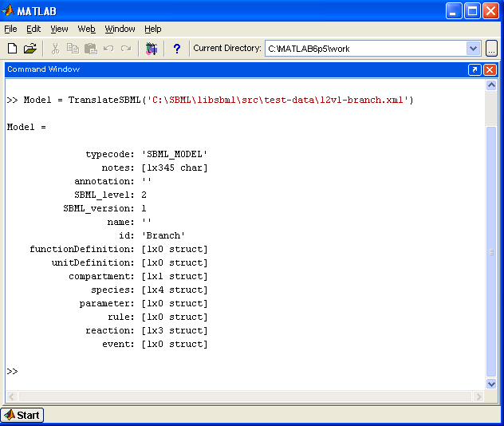

Figure 1: Screenshot of the command ‘Model = TranslateSBML(‘../branch.xml’)’ and the resulting MATLAB_SBML structure returned

The structure returned can then be passed as an argument to other functions within the SBMLToolbox or functions developed by the user.

To export SBML from MATLAB type

>> OutputSBML(Model)

where ‘Model’ is the MATLAB_SBML structure.

A browse window is opened to allow the user to specify the name and location of the output file which will be saved as an .xml document.

4. Access model

The AccessModel folder contains a number of functions that derive information from the MATLAB_SBML structure.

The functions in the AccessModel folder are listed in Table 1.

Table 1: Functions and their type in folder AccessModel
Type of function | Function name
MATLAB help | Contents.m
Getting information | GetAllParameters.m
from model | GetAllParametersUnique.m  GetCompartments.m
 | GetGlobalParameters.m
 | GetSpecies.m
Getting information | GetParameterFromReaction.m
from reaction | GetParameterFromReactionUnique.m
Deriving information | DetermineSpeciesRoleInReaction.m  GetRateLawsFromReactions.m  GetRateLawsFromRules.m  GetSpeciesAlgebraicRules.m  GetSpeciesAssignmentRules.m  GetStoichiometryMatrix.m
Overview of model | CheckValues.fig
 | CheckValues.m

4.1 Getting information from model functions

All the functions in this category have the same format.

Format | >> [names, values] = GetAllParameters(model)
Argument(s) | model | MATLAB_SBML_Model structure
Returns | names | array of the character string representation of the names¹ of elements
 | values | array of the values of each element

NOTE: the function GetAllParametersUnique appends the reaction name to the names of any parameter local to that reaction (Figure 2).

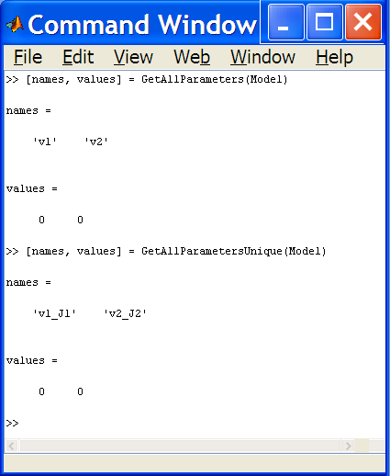

Figure 2: Using the GetAllParameters and the GetAllParametersUnique functions

4.2 Getting information from reaction functions

All the functions in this category have the same format.

Format | >> [names, values] = GetParameterFromReaction(reaction)
Argument(s) | reaction | MATLAB_SBML_Reaction structure
Returns | names | array of the character string representation of the names¹ of elements
 | values | array of the values of each element

¹When the name of an element is returned this will refer to the ‘name’ field in SBML level 1 models and the ‘id’ field in SBML level 2 models.

4.3 Deriving information functions

4.3.1 DetermineSpeciesRoleInReaction

Format | >> y = DetermineSpeciesRoleInReaction(species, reaction)
Argument(s) | species | MATLAB_SBML_Species structure
 | reaction | MATLAB_SBML_Reaction structure
Returns | y = 0 | If species is NOT part of reaction
 | y = [isProduct, isReactant, isModifier, positionInProductList, posInReactantList]
indicating whether the species is a product/reactant/modifier and its position
in the relevant List within the reaction
EXAMPLE: y = DetermineSpeciesRoleInReaction(s, r)
= 0 s is not in r
= [1, 0, 0, 2, 0] s is product no 2 in r
= [0, 1, 0, 0, 1] s is reactant no 1 in r
= [0, 0, 1, 0, 0] s is a modifier in r

4.3.2 GetRateLawsFrom…

Format | >> [species, rateLaws] = GetRateLawsFromReactions(model)
Argument(s) | model | MATLAB_SBML_Model structure
Returns | species | array of the character string representation of all species
 | rateLaws | array of the character representation of the rate laws from reactions  (for each species in order of species array)
Format | >> [species, rateLaws] = GetRateLawsFromRules (model)
Argument(s) | model | MATLAB_SBML_Model structure
Returns | species | array of the character string representation of all species
 | rateLaws | array of the character representation of the rate laws from rules  (for each species in order of species array)
4.3.3 GetSpecies…Rules

Format | >> [species, rules] = GetSpeciesAlgebraicRules (model)
Argument(s) | model | MATLAB_SBML_Model structure
Returns | species | array of the character string representation of all species
 | rules | an array of the character representation of each algebraic rule the species appears in

Format | >> [species, rules] = GetSpeciesAssignmentRules (model)
Argument(s) | model | MATLAB_SBML_Model structure
Returns | species | array of the character string representation of all species
 | rules | an array of the character representation of the assignment rule used to assign value to each species

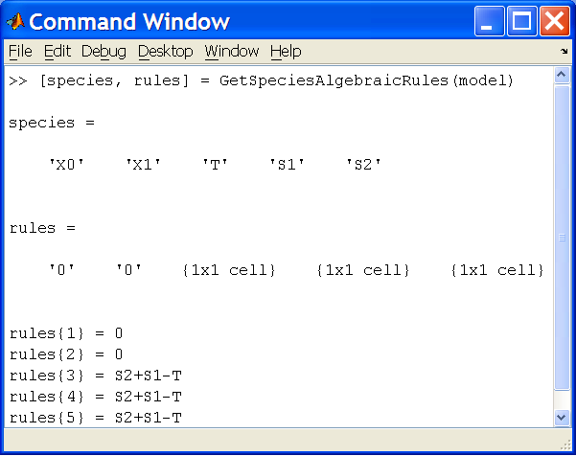

Figure 3: Typical output from GetSpeciesAlgebraicRule

4.3.4 GetStoichiometryMatrix

Format | >> [matrix, species] = GetStoichiometryMatrix (model)
Argument(s) | model | MATLAB_SBML_Model structure
Returns | matrix | stoichiometry matrix for the species and reactions in the model
 | species | array of the character string representation of all species in the order in which the stoichiometry matrix deals with them

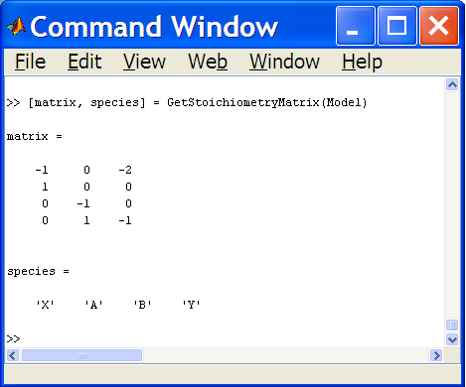

Figure 4: Typical output from GetStoichiometryMatrix

4.4 Overview of model functions

Format | >> [speciesValues, parameterValues] = CheckValues (model)
Argument(s) | model | MATLAB_SBML_Model structure
Returns | speciesValues | array of values for the initial amount/concentration of the species
 | parameterValues | array of values for the parameters
Displays | a GUI that allows the user to check that the values for the parameters and the initial amounts/concentrations of the species are as expected and edit as appropriate.

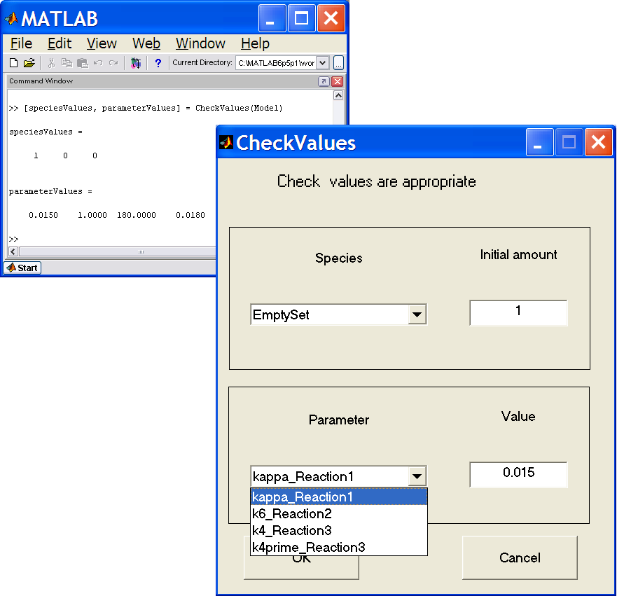
NOTE: parameter names used are the unique names with reaction names appended

Figure 5: Typical output from CheckValues function

5. Access to symbols

The AccessToSymbols folder contains a number of functions that take elements of the MATLAB_SBML model and convert them to a symbolic form for use with the MATLAB Symbolic Toolbox.

The functions in the AccessToSymbols folder are listed in Table 2.

Table 2: Functions and their type in folder AccessToSymbols
Type of function | Function name
MATLAB help | Contents.m
Getting symbols | GetAllParameterSymbols.m
GetAllParameterSymbolsUnique.m
GetCompartmentSymbols.m
 | GetGlobalParameterSymbols.m
 | GetParameterSymbolsFromReaction.m
 | GetParameterSymbolsFromReactionUnique.m
 | GetSpeciesSymbols.m
Deriving information | AnalyseSpeciesSymbolic.m  GetEquilibrium.m
 | GetStoichiometryMatrixSyms.m
GetSymbolicRateLawsFromReactions.m
GetSymbolicRateLawsFromRules.m
GetSymbolicSpeciesAlgebraicRules.m
GetSymbolicSpeciesAssignmentRules.m
Overview of model | PlotTimeCourse.m
 | PlotSelectedTimeCourse.m
General | charFormula2sym.m
 | CreateSymArray.m
 | GetDegree.m

NOTE: The majority of the functions in the AccessToSymbols folder mimic functions explained elsewhere in this manual. Thus explanation will be kept to a minimum.

5.1 Getting symbols functions

All the functions in this category have the same format.

Format | [symbols, values, names] = GetAllParametersSymbols (model)
Argument(s) | model | MATLAB_SBML_Model structure
Returns | symbols | array of symbols representing of the names¹ of elements
 | values | array of the values of each element
 | names | array of the character string representation of the names¹ of elements
¹When the name of an element is returned this will refer to the ‘name’ field in SBML level 1 models and the ‘id’ field in SBML level 2 models.
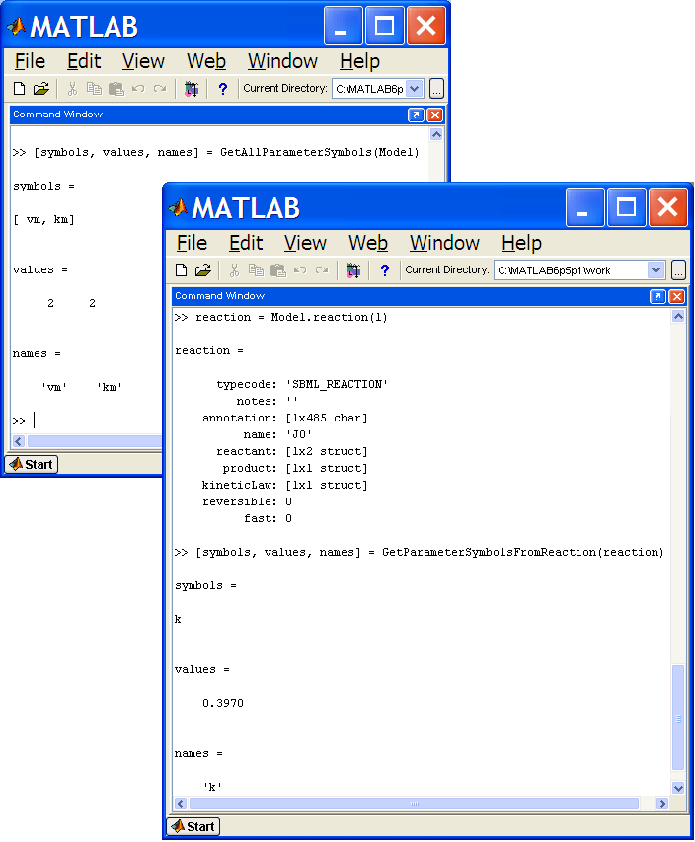
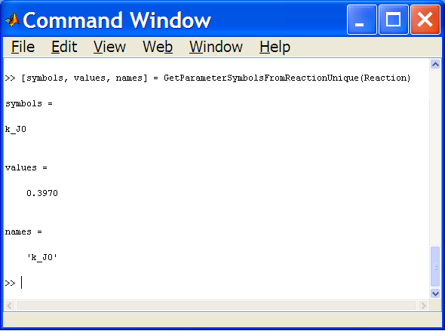

Figure 6: Examples of output from Getting Symbols functions

5.2 Deriving information functions

5.2.1 GetEquilibrium

Format | >> [values, info] = GetEquilibrium (model)
Argument(s) | model | MATLAB_SBML_Model structure
Returns | values | array of the equilibrium values of each species
 | info | structure detailing the equilibrium
 | .species |  | array of symbolic representation of the species
 | .initialValues |  | array of the initial amounts used
 | .equilValues |  | array of the equilibrium values  (= 0 if equilibrium not reached)
 | .timeValues |  | array of the amount of each species at the time shown  (equal to equilValues if equilibrium was reached)
 | .Time |  | elapsed time
 | .delta_t |  | time step used in calculations
 | .tolerance |  | difference value at which equilibrium was  considered to be reached

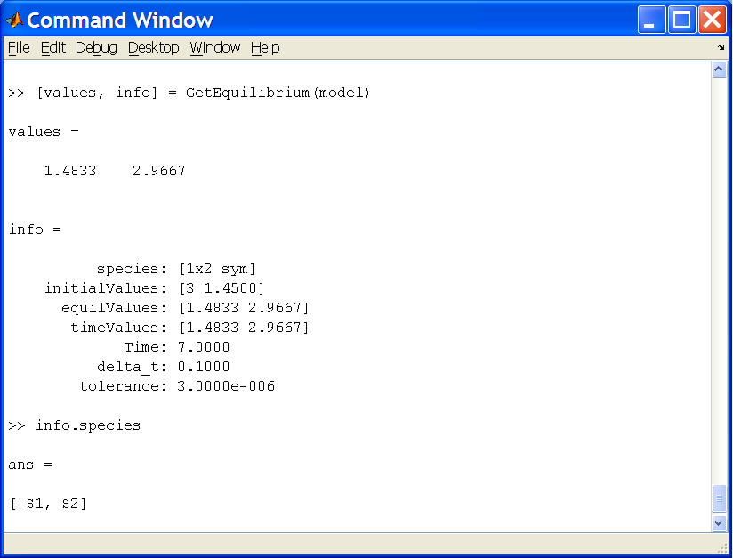

Figure 7: Typical output from the GetEquilibrium function.
The algorithm used to calculate the equilibrium involves using the rate equations to produce a set of functions for the change in the amount of each species for a corresponding change in time.

Example:

Reaction A -> B with kinetic law formula k * B

The rate equations are
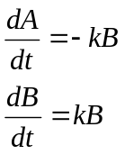
Rewriting these, the change in amount of A and B for each change in time becomes

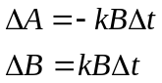

An appropriate time step, time limit and tolerance are calculated from the initial values of the species amounts and parameters involved. The procedure then iterative calculates the new species amounts using the derived functions until either the required tolerance (difference between newly calculated figure and previously calculated figure) has been achieved or the time limit has been reached. If the time limit is reached it is assumed that equilibrium is unlikely to be achieved and the function terminates and reports the values calculated within the info structure returned.

5.3 Overview of model functions

5.3.1 PlotTimeCourse

Format | >> [values] = PlotTimeCourse (model, variableArgs)
Argument(s) | model | MATLAB_SBML_Model structure
optional | limit | time limit for calculations
 | steps | number of time steps to consider
 | flag | indicate whether to output data as a comma separated variable file
Returns | values | array of species amounts at the end of the plot time  (either at equilibrium or time limit if this has been specified)
Displays | plot of the time course for each of the species within the model as separate graphs

5.3.2 PlotSelectedTimeCourse

Format | >> [values] = PlotSelectedTimeCourse (model, variableArgs)
Argument(s) | model | MATLAB_SBML_Model structure
optional | limit | time limit for calculations
 | steps | number of time steps to consider
Returns | values | array of species amounts at the end of the plot time  (either at equilibrium or time limit if this has been specified)
Displays | plot of the time course for each of the species selected on a single graph

NOTE: PlotTimeCourse/PlotSelectedTimeCourse uses the same algorithm as GetEquilibrium.
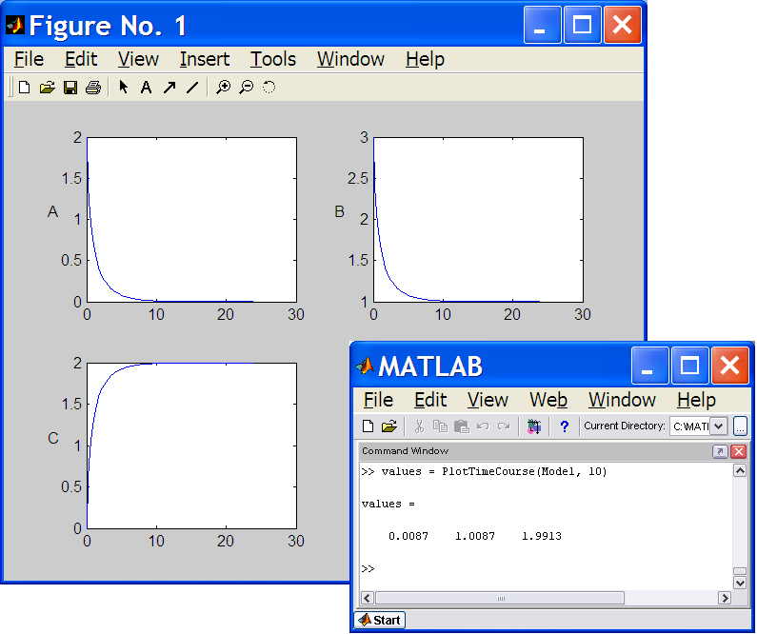

Figure 8: Examples of the output from PlotTimeCourse function

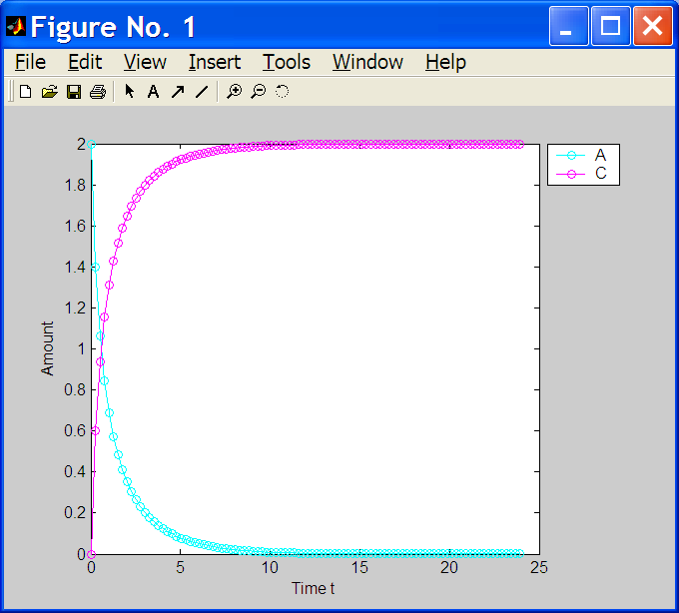

Figure 9:Output from PlotSelectedTimeCourse function

5.4 General functions

5.4.1 charFormula2sym

Format | >> [symFormula, symbols] = charFormula2sym(charFormula)
Argument(s) | charFormula | character respresentation of a mathematical formula
Returns | symFormula | symbolic representation of charFormula
 | symbols | array of the symbols used in the formula

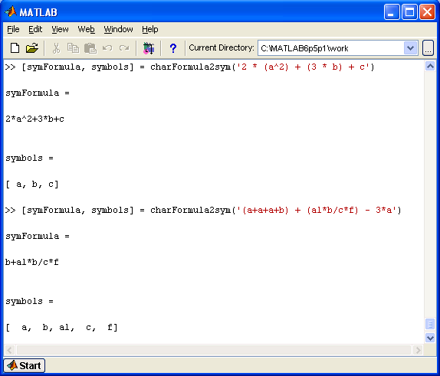

Figure 10: Sample outputs from charFormula2sym function

5.4.2 CreateSymArray

Format | >> [symbols] = CreateSymArray (symFormula)
Argument(s) | symFormula | symbolic respresentation of a mathematical formula
Returns | symbols | array of the symbols used in the formula

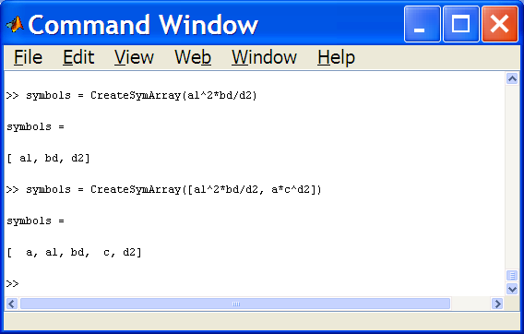

Figure 11: Output from CreateSymArray function

5.4.3 GetDegree

Format | >> degree = GetDegree (symPolynomial, symVariable)
Argument(s) | symPolynomial | symbolic respresentation of a polynomial
 | symVariable | single symbol
Returns | degree | the degree of the single symbol in the polynomial

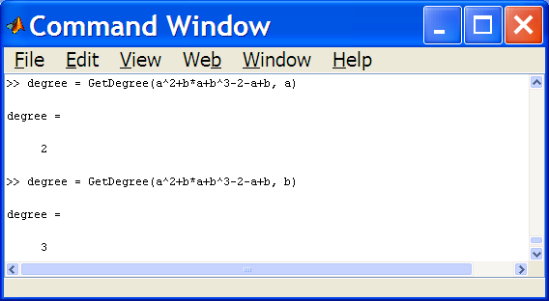

Figure 12: Output from GetDegree function

6. Convenience functions

The Convenience folder contains a number of convenience functions.

The functions in the AccessModel folder are listed in Table 3.

Table 3: Functions and their type in folder Convenience
Type of function | Function name
MATLAB help | Contents.m
Checking information | isIntegralNumber.m
 | isValidUnitKind.m
Other | LoseWhiteSpace.m
 | PairBrackets.m
 | RemoveDuplicates.m
 | SubstituteFunction.m

6.1 Checking information functions

6.1.1 isIntegralNumber

Format | >> y = isIntegralNumber(number)
Argument(s) | number | any number
Returns | y = 1 | if number is an integrer
 | y = 0 | otherwise

NOTE: MATLAB's 'isinteger' function only returns true if the number has been declared as an int; whereas the default type for numbers in MATLAB is double. Thus isIntegralNumber will return true for a number of type double that is can be represented as an integer.

6.1.2 isValidUnitKind

Format | >> y = isValidUnitKind(kind)
Argument(s) | kind | a string representation of a unit kind
Returns | y = 1 | if kind is a valid SBML unit kind
 | y = 0 | otherwise

6.2 Other functions

6.2.1 LoseWhiteSpace

Format | >> array = LoseWhiteSpace(charArray)
Argument(s) | charArray | an array of characters
Returns | array | the array of characters with any white space removed

6.2.2 PairBrackets

Format | >> pairs = PairBrackets(charArray)
Argument(s) | charArray | an array of characters
Returns | pairs | an array of the indices of matching pairs of brackets  (ordered using the opening bracket index)

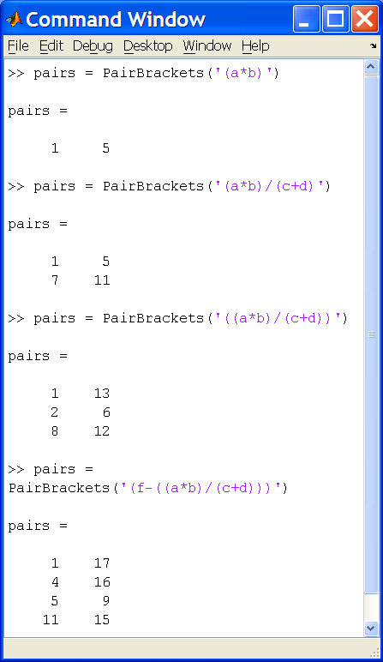

Figure 13: Output from PairBrackets function

6.2.3 RemoveDuplicates

Format | >> array = RemoveDuplicates(anyArray)
Argument(s) | anyArray | any array
Returns | array | the array with any duplicates removed

EXAMPLE: array = RemoveDuplicates(‘abcacsdab’)
array = ‘abcsd’

array = RemoveDuplicates([1,3,2,1,4,3,2,5,1,2])
array = [1,3,2,4,5]

6.2.4 SubstituteFunction

Format | >> formula = SubstituteFunction(charFormula, functionDefinition)
Argument(s) | charFormula | character respresentation of a mathematical formula
 | functionDefinition | MATLAB_SBML_FunctionDefinition structure
Returns | formula | charFormula with the functionDefinition substituted

NOTE: charFormula must contain the ‘id’ of the functionDefinition

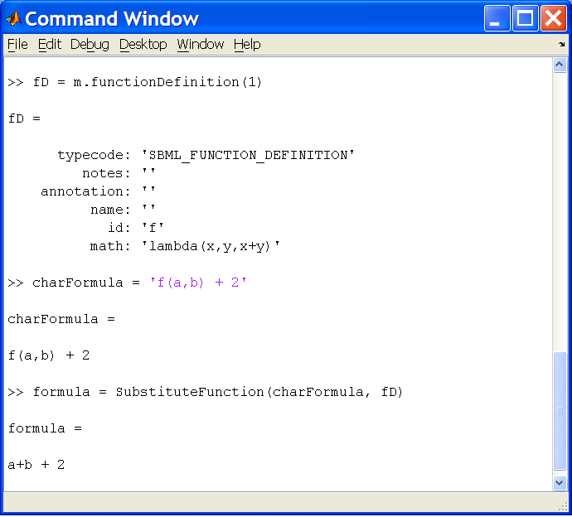

Figure 14: Output from SubstituteFunction function

7. MATLAB_SBML Structure functions

The MATLAB_SBML_Structure_functions folder contains a number of functions that mimic the functions contained in the libSBML C API.

The folder contains subfolders named after the elements of an SBML model e.g. Model, Species, Parameter etc. Each of these subfolders then contains a create function, query functions, get functions and set/unset functions as appropriate to the element.

Full details are not given here as the formats of the functions are similar. However the contents of the parameter folder are used as an example.

7.1 Parameter subfolder

The functions in the parameter subfolder are listed in Table 4.

Table 4: Functions and their type in folder
MATLAB_SBML_Structure_functions/Parameter
Type of function | Function name
MATLAB help | Contents.m
create function | Parameter_create.m
query functions | Parameter_isSetId.m
 | Parameter_isSetName.m
 | Parameter_isSetUnits.m
 | Parameter_isSetValue.m
get functions | Parameter_getConstant.m
 | Parameter_getId.m
 | Parameter_getName.m
 | Parameter_getUnits.m
 | Parameter_getValue.m
set functions | Parameter_setConstant.m
 | Parameter_setId.m
 | Parameter_setName.m
 | Parameter_setUnits.m
 | Parameter_setValue.m
unset functions | Parameter_unsetName.m
 | Parameter_unsetUnits.m
 | Parameter_unsetValue.m
Other | Parameter_moveIdToName.m
 | Parameter_moveNameToId.m

7.1.1 create function

Format | >> parameter = Parameter_create(variableArgs)
Argument(s)
optional | SBML_level | SBML_level of parameter structure to create (default = 2)
Returns | parameter | MATLAB_SBML_Parameter structure

7.1.2 query functions

Format | >> y = Parameter_isSetId(parameter)
Argument(s) | parameter | MATLAB_SBML_Parameter structure
Returns | y = 1 | if id field is set
 | y = 0 | if id field is empty

7.1.3 get functions

Format | >> id = Parameter_getId(parameter)
Argument(s) | parameter | MATLAB_SBML_Parameter structure
Returns | id | id field of the parameter as a string

7.1.4 set functions

Format | >> parameter = Parameter_setId(parameter, id)
Argument(s) | parameter | MATLAB_SBML_Parameter structure
 | id | string that is to be set as the parameter id
Returns | parameter | the parameter structure with the id set

7.1.5 unset functions

Format | >> parameter = Parameter_unsetName(parameter)
Argument(s) | parameter | MATLAB_SBML_Parameter structure
Returns | parameter | the parameter structure with the name field empty

7.1.5 other functions

Format | >> parameter = Parameter_moveIdToName(parameter)
Argument(s) | parameter | MATLAB_SBML_Parameter structure
Returns | parameter | the parameter structure with the name field set to the original id – unless the name field was already set

8. Simulation

The Simulation folder contains a number of functions that take a MATLAB_SBML model and convert them files that can be used to simulate the model with MATLABs ode functions.

The functions in the Simulation folder are listed in Table 8.

Table 5: Functions and their type in folder Simulation
Type of function | Function name
MATLAB help | Contents.m
Simulation | AnalyseSpecies.m
 | DisplayODEFunction.m
 | OutputODEFunction.m
 | WriteODEFunction.m
Event handling | WriteEventAssignmentFunction.m
(called as necessary by  WriteODEFunction) | WriteEventHandlerFunction.m
MathML | DealWithPiecewise.m
 | GetArgumentsFromLambdaFunction.m
Other | SelectSpecies.m
 | SelectSpecies.fig

8.1 Simulation functions

8.1.1 AnalyseSpecies

Format | >> [info] = AnalyseSpecies (model)
Argument(s) | model | MATLAB_SBML_Model structure
Returns | info | structure detailing the species and how they are affected by the model
 | .Name |  | character representation of the name of the species
 | .constant |  | flag (1 if constant)
 | .boundaryCondition |  | flag (1 if boundaryCondition)
 | .initialValue |  | initial amount/concentration
 | .isConcentration |  | flag (1 if initialValue is concentration)
 | .compartment |  | compartment containing the species
 | .ChangedByReaction |  | flag (1 if species is in reaction)
 | .KineticLaw |  | KineticLaw formula in which species appears
 | .ChangedByRateRule |  | flag (1 if species is changed by rate rule)
 | .RateRule |  | RateRule formula in which species appears
 | .ChangedByAssignmentRule |  | flag (1 if species is assigned by rule)
 | .AssignmentRule |  | assignment formula for species
 | .InAlgebraicRule |  | flag (1 if species is in an algebraicRule)
 | .ConvertedToAssignRule |  | flag (1 if species is assigned by the algebraic rule)
 | .ConvertedRule |  | algebraicRule converted to assignment for species

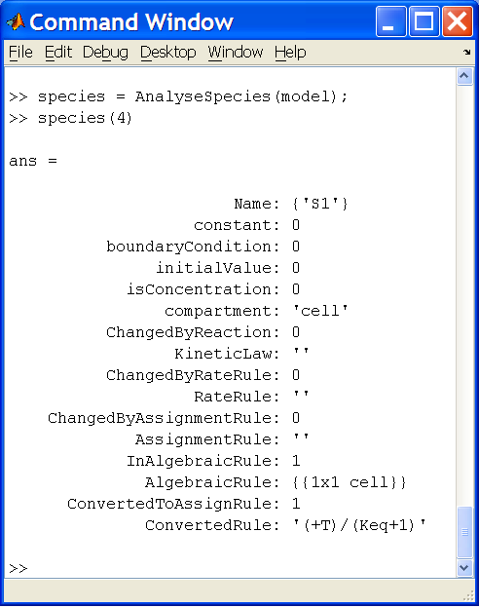

Figure 15: Output from AnalyseSpecies function
8.1.2 WriteODEFunction function

Format | >> WriteODEFunction(model, variableArgs)
Argument(s) | model | MATLAB_SBML_Model structure
optional | filename | name to give to the .m file to use with the ode solvers¹
Outputs |  | file for use with ode solvers
¹ if no name is given the model id/name is used

8.1.3 DisplayODEFunction function

Format | >> DisplayODEFunction(model, variableArgs)
Argument(s) | model | MATLAB_SBML_Model structure
optional | limit | time limit to use in simulation
 | steps | number of steps tp use in the simulation
 | filename | name of the .m file to use with the ode solvers²
Outputs |  | plot of the result of the ode solvers
² if a filename was used with WriteODEFilename this must be supplied

8.1.4 OutputODEFunction function

Format | >> OutputODEFunction(model, variableArgs)
Argument(s) | model | MATLAB_SBML_Model structure
optional | flag | indicate whether to plot output
 | limit | time limit to use in simulation
 | steps | number of steps tp use in the simulation
 | flag | indicate whether to output a csv file
 | filename | name of the .m file to use with the ode solvers²
Outputs |  | plot of the result of the ode solvers
² if a filename was used with WriteODEFilename this must be supplied

8.2 MathML functions

8.2.1 DealWithPiecewise

Format | >> elements = DealWithPiecewise(formula)
Argument(s) | formula | character representation of a formula containing the MathML function ‘piecewise’
Returns | elements | the elements of the piecewise function

8.2.2 GetArgumentsFromLambdaFunction

Format | >> elements = GetArgumentsFromLambdaFunction(formula)
Argument(s) | formula | character representation of a formula containing the MathML function ‘lambda’
Returns | elements | the elements of the lambda function

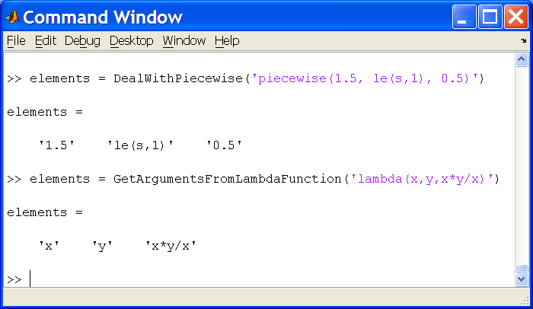

Figure 16: Output from the MathML functions

8.3 Other functions

8.3.1 SelectSpecies

Format | >> [species] = SelectSpecies (model)
Argument(s) | model | MATLAB_SBML_Model structure
Returns | species | array of species selected by users
Displays | a GUI that allows the user to select species from the model

NOTE: this function is called by DisplayODESolver and PlotSelectedTimeCourse to allow the user to output data relating to the selected species only.

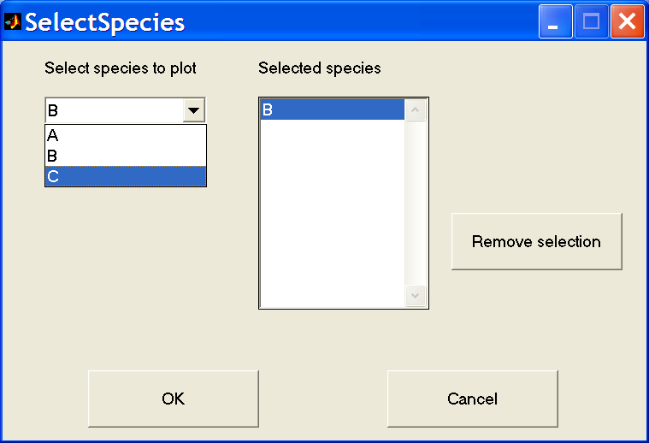
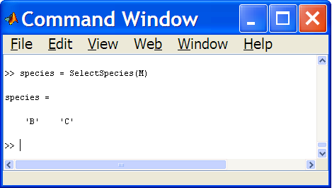

Figure 17: Output from SelectSpecies function

9. Storing models in MATLAB

Once a model has been imported into the MATLAB environment it is convenient to be able to store it there. MATLAB uses data files to store workspace variables and thus the MATLAB_SBML structures can be stored in such a data file. This facilitates the fast retrieval of any imported models.

The first time a model is saved the function creates a data file ‘SBML_Models.mat’. Models are stored within the data file in two arrays; one containing level 1 sbml models, the other level 2 sbml models. Models are added to the appropriate array sequentially.

Functions in the StoreModels folder are listed in Table 6.

Table 6: Functions and their type in folder StoreModels
Type of function | Function name
MATLAB help | Contents.m
Save/Load functions | LoadSBMLModel.m
 | SaveSBMLModel.m
Data file functions | ListSBMLModels.m
 | DeleteSBMLModel.m
Graphical user functions | BrowseSBML_Models.m
 | ViewModel.fig
 | ViewModel.m
Sub-functions | AlreadyExists.fig
 | AlreadyExists.m
 | BrowseModels.fig
 | BrowseModels.m

9.1 Saving and loading functions

9.1.1 SaveSBMLModel

Format | >> SaveSBMLModel(model)
Argument(s) | model | MATLAB_SBML_Model structure

Saves model to the data file SBMLModels.mat

performing the following:
- validates the input structure SBMLModel
- checks whether SBMLModels.mat exists and creates it if not
- checks whether a model with same name/id is already saved and prompts user for permission to add this model as well
- adds the model as the next element of the level 1 or level 2 array
- saves SBMLModels.mat

9.1.2 LoadSBMLModel

Format | >> model = LoadSBMLModel(inputArg, SBMLlevel)
Argument(s) | inputArg | a number representing the index of the model in the data file
 |  | OR
 |  | a string representing the name/id of the model
 | SBMLlevel | SBML level of model to be retrieved
Returns | model | MATLAB_SBML_Model structure of SBMLlevel from data file

Note: if more than one model of the same name exists LoadSBMLModel(name, level) returns the first model that matches the name.

9.2 Data file functions

9.2.1 ListSBMLModel

Format | >> ListSBMLModels

prints a list of the elements in SBMLModels.mat detailing the index number, the sbml level and the name of each model stored in the data file.

Example: NUMBER LEVEL NAME
1 1 Branch
2 1 ODE
1 2 Branch
2 2 Oscillator

Obviously as the number of models stored increases this is not the most productive method for keeping track of the contents of the data file. Thus a graphical user interface that will browse the data file is also available (see BrowseSBML_Models below).

9.2.2 DeleteSBMLModel

Format | >> DeleteSBMLModel(inputArg, SBMLlevel)
Argument(s) | inputArg | a number representing the index of the model in the data file
 |  | OR
 |  | a string representing the name/id of the model
 | SBMLlevel | SBML level of model to be retrieved

deletes a MATLAB_SBMLModel of SBMLlevel from the data file SBMLModels.mat

Note: if more than one model of the same name exists DeleteSBMLModel(name, level) deletes the first model that matches the name.

9.3 Graphical user functions

9.3.1 BrowseSBML_Models

Format |  | >> optionalOutput = BrowseSBML_Models
Returns |  | model | MATLAB_SBML_Model structure
Displays | a GUI that details the contents of the SBMLModels data file

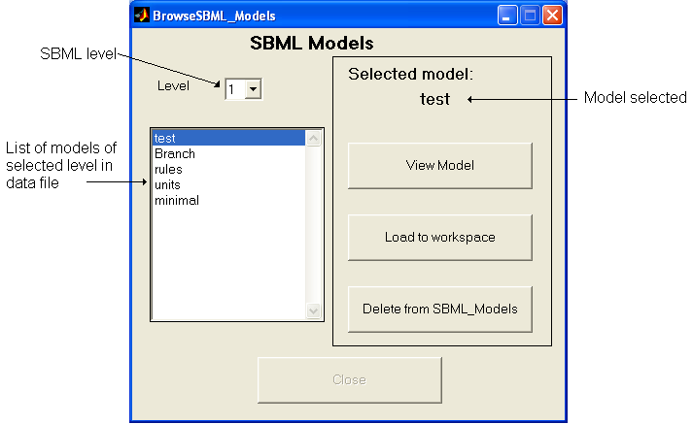

Figure 18: Screenshot of the BrowseSBML_Models GUI.

View Model button activates a further GUI to view details of the model (see ViewModel below).

Load to workspace button is only active if the function has been called with an output argument, otherwise it is greyed out. Once pressed this button loads the selected model to the output argument, becomes inactive and the Close button becomes active.

Delete from SBML_Models button deletes the selected model from the data file.

Close button closes the window and if a model has been loaded returns the model to the workspace as the output argument.

9.3.2 ViewModel

Format |  | >> ViewModel(model)
Argument(s) |  | model | MATLAB_SBML_Model structure
Displays | a GUI that details the model

NOTE: This function is located in this directory as it also provides an alternative means of saving the displayed model to the SBMLModels data file.

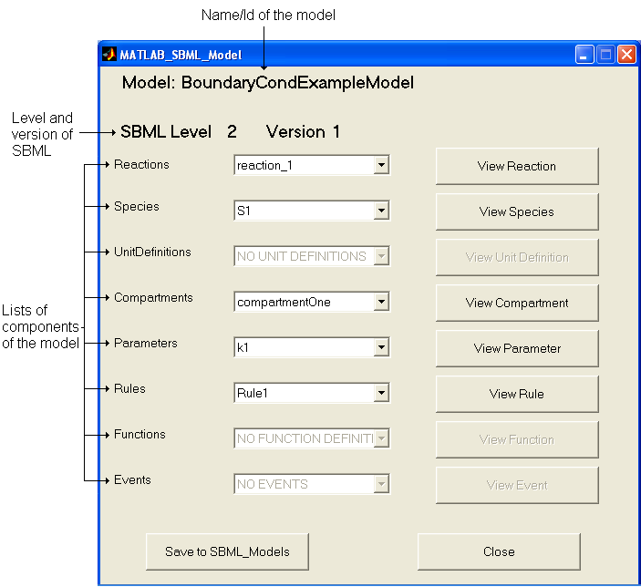

Figure 19: Screenshot of the ViewModel GUI

ViewComponent buttons display further GUIs that detail the component selected. These buttons are greyed if the model does not contain any of the relevant component.

Save to SBML_Models button saves the model to the SBMLModels data file.

Close button closes the window

10. Validate_MATLAB_SBML_Structures

Each of the validation tests checks that the structure supplied as argument is of the appropriate form to represent the intended element of a sbml model.

10.1 isSBML_Model

Format | >> y = isSBML_Model(model)
Argument(s) | model | MATLAB_SBML_Model structure

returns y = 1 if model
- is a MATLAB structure type
- has each of the fields listed in Table 7
(appropriate to the level of SBML)
- any fields that are arrays of structures are of appropriate structure
- has the value ‘SBML_MODEL’ in the typecode field.

returns y = 0 otherwise.

Table 7: MATLAB_SBML Structure for a sbml model
Fieldname | Type
 | C | MATLAB
typecode | char * | mxArray of char
notes | char * | mxArray of char
annotation | char * | mxArray of char
name | char * | mxArray of char
level | unsigned int | mxArray of int32
version | unsigned int | mxArray of int32
unitDefinition | List of structures | array of structures of type  UnitDefinition
compartment | List of structures | array of structures of type  Compartment
species | List of structures | array of structures of type  Species
parameter | List of structures | array of structures of type  Parameter
rule | List of structures | array of structures of type  Rule
reaction | List of structures | array of structures of type  Reaction
Additional for Level 2
id | char * | mxArray of char
functionDefinitions | List of structures | array of structures of type  FunctionDefinition
event | List of structures | array of structures of type  Event

10.2 isSBML_XXX

Format | >> y = isSBML_XXX(structure, SBML_Level)
Argument(s) | structure | MATLAB_SBML_XXX structure
 | SBML_Level | the SBML level of the structure

returns y = 1 if structure
- is a MATLAB structure type
- has each of the fields listed in Table 8 for a elemnt XXX
(appropriate to the level supplied as input argument SBML_Level)
- any fields that are arrays of structures are of appropriate structure
- does not contain any additional fields and
- has the appropriate value in the typecode field (see Table 9)

returns y = 0 otherwise.

Table 8: Fields contained in the MATLAB_SBML structure defining each sbml component
 | Compartment | Event | Event Assignment | Function Definition | Kinetic Law | Modifier Species Reference | Parameter | Reaction | Rule | Species | Species Reference | Unit | Unit Definition
annotation | X | L2 | L2 | L2 | X | L2 | X | X | X | X | X | X | X
boundaryCondition |  |  |  |  |  |  |  |  |  | X
Charge |  |  |  |  |  |  |  |  |  | X
compartment |  |  |  |  |  |  |  |  | X | X
constant | L2 |  |  |  |  |  | L2 |  |  | L2
delay |  | L2
denominator |  |  |  |  |  |  |  |  |  |  | X
eventAssignment |  | L2
exponent |  |  |  |  |  |  |  |  |  |  |  | X
fast |  |  |  |  |  |  |  | X
formula |  |  |  |  | X |  |  |  | X
hasOnlySubstanceUnits |  |  |  |  |  |  |  |  |  | L2
id | L2 | L2 |  | L2 |  |  | L2 | L2 |  | L2 |  |  | L2
initialAmount |  |  |  |  |  |  |  |  |  | X
initialConcentration |  |  |  |  |  |  |  |  |  | L2
isSetCharge |  |  |  |  |  |  |  |  |  | X
isSetFast |  |  |  |  |  |  |  | L2
isSetInitialAmount |  |  |  |  |  |  |  |  |  | X
isSetInitialConcentration |  |  |  |  |  |  |  |  |  | L2
isSetSize | L2
L1 – level 1 ONLY L2 – level 2 ONLY X – both level 1 & 2
isSetValue |  |  |  |  |  |  | X
isSetVolume | X
kind |  |  |  |  |  |  |  |  |  |  |  | X
kineticLaw |  |  |  |  |  |  |  | X
math |  |  | L2 | L2 | L2
modifier |  |  |  |  |  |  |  | L2
multiplier |  |  |  |  |  |  |  |  |  |  |  | L2
name | X | L2 |  | L2 |  |  | X | X | X | X |  |  | X
notes | X | L2 | L2 | L2 | X | L2 | X | X | X | X | X | X | X
offset |  |  |  |  |  |  |  |  |  |  |  | L2
outside | X
parameter |  |  |  |  | X
product |  |  |  |  |  |  |  | X
reactant |  |  |  |  |  |  |  | X
reversible |  |  |  |  |  |  |  | X
scale |  |  |  |  |  |  |  |  |  |  |  | X
size | L2
spatialdimensions | L2
spatialSizeUnits |  |  |  |  |  |  |  |  |  | L2
species |  |  |  |  |  | L2 |  |  | X |  | X
stoichiometry |  |  |  |  |  |  |  |  |  |  | X
stoichiometryMath |  |  |  |  |  |  |  |  |  |  | L2
substanceUnits |  |  |  |  | X |  |  |  |  | L2
timeUnits |  | L2 |  |  | X
trigger |  | L2
typecode | X | L2 | L2 | L2 | X | L2 | X | X | X | X | X | X | X
units | X |  |  |  |  |  | X |  | X | L1 |  |  | X
value |  |  |  |  |  |  | X
variable |  |  | L2 |  |  |  |  |  | X
volume | L1
L1 – level 1 ONLY L2 – level 2 ONLY X – both level 1 & 2

Table 9: Components in sbml model and appropriate typecode value
Component XXX | typecode
Compartment | SBML_COMPARTMENT
Event | SBML_EVENT
EventAssignment | SBML_EVENT_ASSIGNMENT
FunctionDefinition | SBML_FUNCTION_DEFINITION
KineticLaw | SBML_KINETIC_LAW
ModifierSpeciesReference | SBML_MODIFIER_SPECIES_REFERENCE
Parameter | SBML_PARAMETER
Reaction | SBML_REACTION
Rule | SBML_ALGEBRAIC_RULE  SBML_SPECIES_CONCENTRATION_RULE  SBML_COMPARTMENT_VOLUME_RULE  SBML_PARAMETER_RULE  SBML_ASSIGNMENT_RULE  SBML_RATE_RULE
Species | SBML_SPECIES
SpeciesReference | SBML_SPECIES_REFERENCE
Unit | SBML_UNIT
UnitDefinition | SBML_UNIT_DEFINITION

Note: A rule defined by a sbml model may have a number of different types. In order to facilitate the inclusion of rules within the MATLAB_SBML structure any rule structure has the same fields, some of which will be empty depending on the rule type.

11. Viewing models in MATLAB

The SBMLToolbox provides a set of graphics that allow the full definition of the model to be displayed. The ViewModel function was discussed in Section 9.3.2. This GUI (Figure 19) has a range of buttons that allow the sub-structures of the model to be viewed as further GUIs, e.g. the ViewSpecies button brings up a GUI that details the species selected or the ViewRule button brings up a GUI that details the rule selected etc…(Figure 20).

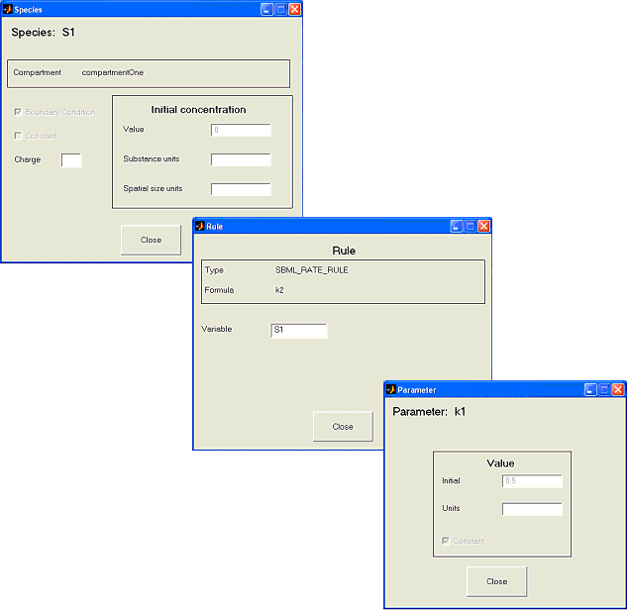

Figure 20: Screenshot of the ViewSpecies, ViewRule & ViewParameter GUIs

Known issues

1. C compilers in windows
The default MATLAB C compiler is lcc. Unfortunately this fails to link to libSBML. You can change the default C compiler used by MATLAB to another C compiler installed on your system by tying ‘mex –setup’ at the MATLAB command prompt and following the instructions.

Using Microsoft VC compilers have proved most reliable.

