
4 MATLAB

User’s manual

Sarah M Keating

Science and Technology Research Institute
University of Hertfordshire
Hatfield, AL10 9AB
United Kingdom

http://www.sbml.org
mailto:sbml-team@caltech.edu

Note: This manual has not been updated for SBMLToolbox-2.0.0-beta release.
All functions contain MATLAB help which can be accessed by typing
‘help function_name’ at the MATLAB prompt.

Contents

1. Introduction 3
2. Installation 3
2.1 Windows 3
2.2 Linux 4
3. Contents of SBMLToolbox download 5
4. Importing and exporting SBML 6
5. Validation tests 7
5.1 isSBML_Model 7
5.2 isSBML_Compartment 8
5.3 isSBML_XXX 10
6. Storing models in MATLAB 11
6.1 Saving and loading functions 11
6.2 SBMLModels data file functions 12
6.3 Graphical user functions 13
7. Viewing models in MATLAB 15
7.1 Viewing individual components 16
8. Access model 17
8.1 Getting information functions 17
8.2 Deriving information functions 19
8.3 Overview of model functions 20
9. Access to symbols 21
9.1 Getting symbols functions 21
9.2 Getting formula functions 24
9.3 Deriving information functions 25
9.4 Overview of model functions 26
9.5 General functions 29
10. Simulation 32

1. Introduction

The SBMLToolbox provides a set of functions that allow an SBML model to be imported into MATLAB and stored as a structure within the MATLAB environment. At present the toolbox includes functions to translate a sbml document into a MATLAB_SBML structure, save and load these structures to/from a MATLAB data file, validate each structure (e.g. reaction structure), view the structures using a set of GUIs and to convert elements of the MATLAB_SBML structure into symbolic form and thus allow access to MATLAB’s Symbolic Toolbox.

The toolbox is under development, development that is primarily driven by the goal of providing a user with a biological model access to MATLAB functionality and other tools that have been developed to function within MATLAB.

2. Installation

2.1 Windows

At the command prompt change to directory 'SBMLToolbox/src' and type ‘make’

This will start Matlab and run a script that performs the following

- Adds this folder (SBMLToolbox/src) and all its subdirectories to the Matlab path

- Checks whether the appropriate libraries are on the system PATH and if not adds these libraries to the MATLABROOT\bin\win32 directory which is on the PATH

- Prompts for whether to exit Matlab

The installation process described above can also be performed from within the MATLAB environment by changing to directory SBMLToolbox/src and typing ‘install’.

Note: The executable TranslateSBML.dll is included with the download and therefore it is not necessary to build it prior to use. However TranslateSBML.dll can be built within MATLAB by typing ‘BuildTranslate_Win32’. Unfortunately some C compilers running through MATLAB fail to link to libsbml and the build will fail. You can change the default C compiler used by MATLAB to any C compiler installed on your system by typing ‘mex –setup’ at the MATLAB command prompt and following the instructions.

2.2 Linux

To build:

- Change to the directory 'SBMLToolbox/src'.

- Ensure that Matlab's mex compiler is in your PATH.

You can verify this by typing 'mex' or 'which mex' at the command-prompt (The mex executable is located in Matlab's bin directory).

- Ensure the CFLAGS and LDFLAGS point to the directories containing the libsbml header and library files.

For example, if you installed libsbml in /usr/local:

In sh or Bash:

export CFLAGS=-I/usr/local/include
export LDLAGS=-L/usr/local/lib

In csh or tcsh:

setenv CFLAGS -I/usr/local/include
setenv LDLAGS -L/usr/local/lib

- Type 'make'

This should build TranslateSBML.mexglx.

To run:

Ensure the directory containing TranslateSBML.mexglx and the
StoreModels, ValidationTexts subdirectories etc…
are in your Matlab path. For example, at the Matlab prompt:

>> addpath('SBMLToolbox/src');
>> addpath('SBMLToolbox/src/StoreModels');
>> addpath('SBMLToolbox/src/ValidationTests');
>> addpath('SBMLToolbox/src/ViewModelComponents');
>> addpath('SBMLToolbox/src/AccessToSymbols');

You may wish to add these commands to your Matlab startup script in
${HOME}/matlab/startup.m

3. Contents of SBMLToolbox download

The SBMLToolbox download includes the following files:

SBMLToolbox
/docs

MATLAB_SBML_Structure.pdf
Manual_SBMLToolbox.pdf

/src

Makefile // Linux installation

make.bat // Windows installation
install.m // Windows installation
BuildTranslate_Win32 // Windows installation
BuildOutput_Win32 // Windows installation

Contents.m // for MATLAB help
TranslateSBML.m // for MATLAB help
OutputSBML.m // for MATLAB help

TranslateSBML.c // source code
OutputSBML.c // source code

/AccessModel // functions that derive information from model

/AccessToSymbols // functions for conversion to symbols

/Simulation // functions for producing files for simulation

/StoreModels // functions for saving/loading models

/ValidationTests // functions for validating structure

/ViewModelComponents // functions for GUIs to view model

4. Importing and exporting SBML

In order to import a sbml model into MATLAB type

>> Model = TranslateSBML or Model = TranslateSBML(‘../path/filename.xml’)

If no filename is supplied this will open a browse window. If a filename is supplied the file to be opened must be in the MATLAB’s current directory or the full pathname must be supplied as the argument.

This returns a MATLAB_SBML structure named Model within the MATLAB environment. This command and the expected MATLAB response are illustrated in Figure 1. The MATLAB_SBML structure is defined in full in the document MATLAB_SBML_Structure.pdf which is also part of the SBMLToolbox download.

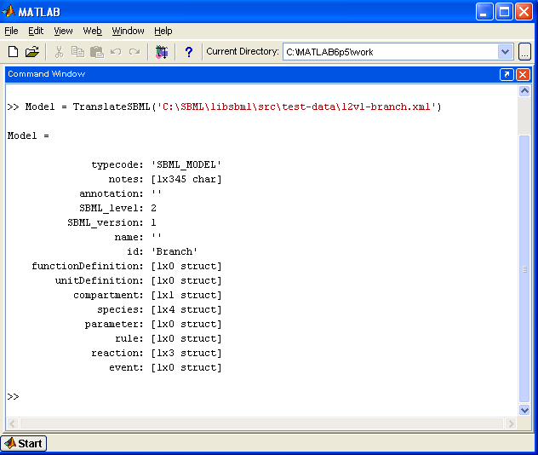

Figure 1: Screenshot of the command ‘Model = TranslateSBML(‘../branch.xml’)’ and the resulting MATLAB_SBML structure returned

The structure returned can then be passed as an argument to other functions within the SBMLToolbox or functions developed by the user.

To export SBML from MATLAB type

>> OutputSBML(Model)

where ‘Model’ is the MATLAB_SBML structure.

A browse window is opened to allow the user to specify the name and location of the output file which will be saved as an .xml document.

5. Validation tests

Each of the validation tests checks that the structure supplied as argument is of the appropriate form to represent the intended element of a sbml model.

5.1 isSBML_Model

y = isSBML_Model(MATLAB_SBMLStructure)

returns y = 1 if the input argument MATLAB_SBMLStructure
- is a MATLAB structure type
- has each of the fields listed in Table 1
(appropriate to the level of SBML)
- any fields that are arrays of structures are of appropriate structure
- does not contain any additional fields and
- has the value ‘SBML_MODEL’ in the typecode field.

returns y = 0 otherwise.

Table 1: MATLAB_SBML Structure for a sbml model
Fieldname | Type
 | C | MATLAB
typecode | char * | mxArray of char
notes | char * | mxArray of char
annotation | char * | mxArray of char
name | char * | mxArray of char
level | unsigned int | mxArray of int32
version | unsigned int | mxArray of int32
unitDefinition | List of structures | array of structures of type  UnitDefinition
compartment | List of structures | array of structures of type  Compartment
species | List of structures | array of structures of type  Species
parameter | List of structures | array of structures of type  Parameter
rule | List of structures | array of structures of type  Rule
reaction | List of structures | array of structures of type  Reaction
Additional for Level 2
id | char * | mxArray of char
functionDefinitions | List of structures | array of structures of type  FunctionDefinition
event | List of structures | array of structures of type  Event

5.2 isSBML_Compartment
y = isSBML_Compartment(MATLAB_SBMLStructure, SBML_Level)
returns y = 1 if the input argument MATLAB_SBMLStructure
- is a MATLAB structure type
- has each of the fields listed in Table 2 for a Compartment
(appropriate to the level supplied as input argument SBML_Level)
- any fields that are arrays of structures are of appropriate structure
- does not contain any additional fields and
- has the value ‘SBML_COMPARTMENT’ in the typecode field.

returns y = 0 otherwise.

Table 2: Fields contained in the MATLAB_SBML structure defining each sbml component
 | Compartment | Event | Event Assignment | Function Definition | Kinetic Law | Modifier Species Reference | Parameter | Reaction | Rule | Species | Species Reference | Unit | Unit Definition
annotation | X | L2 | L2 | L2 | X | L2 | X | X | X | X | X | X | X
boundaryCondition |  |  |  |  |  |  |  |  |  | X
Charge |  |  |  |  |  |  |  |  |  | X
compartment |  |  |  |  |  |  |  |  | X | X
constant | L2 |  |  |  |  |  | L2 |  |  | L2
delay |  | L2
denominator |  |  |  |  |  |  |  |  |  |  | X
eventAssignment |  | L2
exponent |  |  |  |  |  |  |  |  |  |  |  | X
fast |  |  |  |  |  |  |  | X
formula |  |  |  |  | X |  |  |  | X
hasOnlySubstanceUnits |  |  |  |  |  |  |  |  |  | L2
id | L2 | L2 |  | L2 |  |  | L2 | L2 |  | L2 |  |  | L2
initialAmount |  |  |  |  |  |  |  |  |  | X
initialConcentration |  |  |  |  |  |  |  |  |  | L2
isSetCharge |  |  |  |  |  |  |  |  |  | X
isSetFast |  |  |  |  |  |  |  | L2
isSetInitialAmount |  |  |  |  |  |  |  |  |  | X
isSetInitialConcentration |  |  |  |  |  |  |  |  |  | L2
isSetSize | L2
L1 – level 1 ONLY L2 – level 2 ONLY X – both level 1 & 2
isSetValue |  |  |  |  |  |  | X
isSetVolume | X
kind |  |  |  |  |  |  |  |  |  |  |  | X
kineticLaw |  |  |  |  |  |  |  | X
math |  |  | L2 | L2 | L2
modifier |  |  |  |  |  |  |  | L2
multiplier |  |  |  |  |  |  |  |  |  |  |  | L2
name | X | L2 |  | L2 |  |  | X | X | X | X |  |  | X
notes | X | L2 | L2 | L2 | X | L2 | X | X | X | X | X | X | X
offset |  |  |  |  |  |  |  |  |  |  |  | L2
outside | X
parameter |  |  |  |  | X
product |  |  |  |  |  |  |  | X
reactant |  |  |  |  |  |  |  | X
reversible |  |  |  |  |  |  |  | X
scale |  |  |  |  |  |  |  |  |  |  |  | X
size | L2
spatialdimensions | L2
spatialSizeUnits |  |  |  |  |  |  |  |  |  | L2
species |  |  |  |  |  | L2 |  |  | X |  | X
stoichiometry |  |  |  |  |  |  |  |  |  |  | X
stoichiometryMath |  |  |  |  |  |  |  |  |  |  | L2
substanceUnits |  |  |  |  | X |  |  |  |  | L2
timeUnits |  | L2 |  |  | X
trigger |  | L2
typecode | X | L2 | L2 | L2 | X | L2 | X | X | X | X | X | X | X
units | X |  |  |  |  |  | X |  | X | L1 |  |  | X
value |  |  |  |  |  |  | X
variable |  |  | L2 |  |  |  |  |  | X
volume | L1
L1 – level 1 ONLY L2 – level 2 ONLY X – both level 1 & 2

5.3 isSBML_XXX

Validation tests exist for each component of a sbml model.
y = isSBML_XXX(MATLAB_SBMLStructure, SBML_Level)

returns y = 1 if the input argument MATLAB_SBMLStructure
- is a MATLAB structure type
- has each of the fields listed in Table 2 for the component XXX
(appropriate to the level supplied as input argument SBML_Level)
- any fields that are arrays of structures are of appropriate structure
- does not contain any additional fields and
- has the appropriate value in the typecode field (Table 3).

returns y = 0 otherwise.

Table 3: Components in sbml model and appropriate typecode value
Component XXX | typecode
Compartment | SBML_COMPARTMENT
Event | SBML_EVENT
EventAssignment | SBML_EVENT_ASSIGNMENT
FunctionDefinition | SBML_FUNCTION_DEFINITION
KineticLaw | SBML_KINETIC_LAW
ModifierSpeciesReference | SBML_MODIFIER_SPECIES_REFERENCE
Parameter | SBML_PARAMETER
Reaction | SBML_REACTION
Rule | SBML_ALGEBRAIC_RULE  SBML_SPECIES_CONCENTRATION_RULE  SBML_COMPARTMENT_VOLUME_RULE  SBML_PARAMETER_RULE  SBML_ASSIGNMENT_RULE  SBML_RATE_RULE
Species | SBML_SPECIES
SpeciesReference | SBML_SPECIES_REFERENCE
Unit | SBML_UNIT
UnitDefinition | SBML_UNIT_DEFINITION

Note: A rule defined by a sbml model may have a number of different types. In order to facilitate the inclusion of rules within the MATLAB_SBML structure any rule structure has the same fields, some of which will be empty depending on the rule type.

6. Storing models in MATLAB

Once a model has been imported into the MATLAB environment it is convenient to be able to store it there. MATLAB uses data files to store workspace variables and thus the MATLAB_SBML structures can be stored in such a data file. This facilitates the fast retrieval of any imported models.

The first time a model is saved the function creates a data file ‘SBML_Models.mat’. Models are stored within the data file in two arrays; one containing level 1 sbml models, the other level 2 sbml models. Models are added to the appropriate array sequentially.

Functions in the StoreModels folder are listed in Table 4.

Table 4: Functions and their type in folder StoreModels
Type of function | Function name
MATLAB help | Contents.m
Save/Load functions | LoadSBMLModel.m
 | SaveSBMLModel.m
Data file functions | ListSBMLModels.m
 | DeleteSBMLModel.m
Graphical user functions | BrowseSBML_Models.m
 | ViewModel.fig
 | ViewModel.m
Sub-functions | AlreadyExists.fig
 | AlreadyExists.m
 | BrowseModels.fig
 | BrowseModels.m

Contents.m is a standard MATLAB help file which is typed to the command window when the command help is typed followed by a folder name. Thus ‘help StoreModels’ will result in the file Contents.m being displayed

6.1 Saving and loading functions
SaveSBMLModel(SBMLModel)
Saves the SBMLModel to the data file SBMLModels.mat

performing the following:
- validates the input argument SBMLModel
- checks whether SBMLModels.mat exists and creates it if not
- checks whether a model with same name/id is already saved and prompts user for permission to add this model as well
- adds the model as the next element of the level 1 or level 2 array
- saves SBMLModels.mat

SBMLModel = LoadSBMLModel(inputArgument, SBMLlevel)
returns SBMLModel = MATLAB_SBMLModel structure with sbml level SBMLlevel
from the data file SBMLModels.mat
where inputArgument is a number representing the index of the model in the data file
or is a string representing the name/id of the model

Note: if more than one model of the same name exists LoadSBMLModel(name, level) returns the first model that matches the name.

6.2 SBMLModels data file functions
ListSBMLModel

prints a list of the elements in SBMLModels.mat detailing the index number, the sbml level and the name of each model stored in the data file.

Example: NUMBER LEVEL NAME
1 1 Branch
2 1 ODE
1 2 Branch
2 2 Oscillator

Obviously as the number of models stored increases this is not the most productive method for keeping track of the contents of the data file. Thus a graphical user interface that will browse the data file is also available (see BrowseSBML_Models below).

DeleteSBMLModel(inputArgument, SBMLlevel)

deletes a MATLAB_SBMLModel of SBMLlevel from the data file SBMLModels.mat
where inputArgument is a number representing the index of the model in the data file
or is a string representing the name/id of the model

Note: if more than one model of the same name exists DeleteSBMLModel(name, level) deletes the first model that matches the name.

6.3 Graphical user functions
OptionalOutput = BrowseSBML_Models

displays a window that details the contents of the SBMLModels data file (see Figure 2).

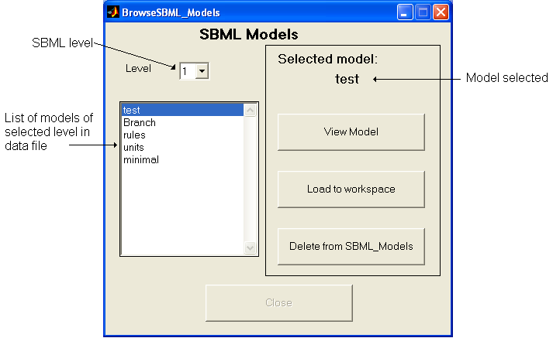

Figure 2: Screenshot of the BrowseSBML_Models GUI.

View Model button activates a further GUI to view details of the model (see ViewModel below).

Load to workspace button is only active if the function has been called with an output argument, otherwise it is greyed out. Once pressed this button loads the selected model to the output argument, becomes inactive and the Close button becomes active.

Delete from SBML_Models button deletes the selected model from the data file.

Close button closes the window and if a model has been loaded returns the model to the workspace as the output argument.

ViewModel(MATLAB_SBMLModel)
displays a window that gives details of the MATLAB_SBMLModel (see Figure 3). This function is located in this directory as it also provides an alternative means of saving the displayed model to the SBMLModels data file.

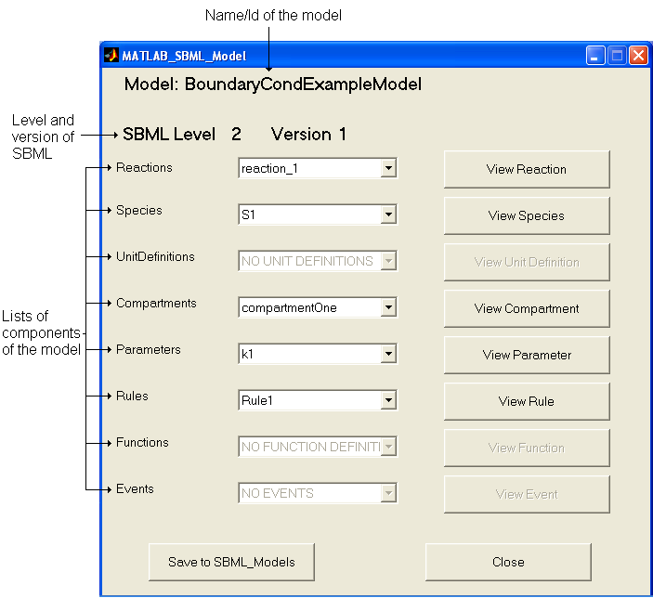

Figure 3: Screenshot of the ViewModel GUI

ViewComponent buttons display further GUIs that detail the component selected. These buttons are greyed if the model does not contain any of the relevant component.

Save to SBML_Models button saves the model to the SBMLModels data file.

Close button closes the window.

7. Viewing models in MATLAB

The SBMLToolbox provides a set of graphics that allow the full definition of the model to be displayed. The ViewModel function was discussed in Section 6.3. This GUI (Figure 3) has a range of buttons that allow the sub-structures of the model to be viewed as further GUIs, e.g. the ViewSpecies button brings up a GUI that details the species selected or the ViewRule button brings up a GUI that details the rule selected etc…(Figure 4).

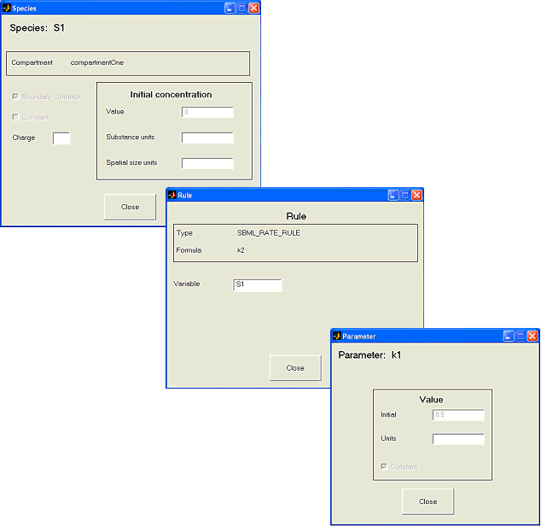

Figure 4: Screenshot of the ViewSpecies, ViewRule & ViewParameter GUIs

7.1 Viewing individual components

The MATLAB_SBML structure is a standard MATLAB structure and thus can be accessed and manipulated in the same way as any structure. Figure 5 shows examples of accessing fields within a MATLAB_SBML Model structure.

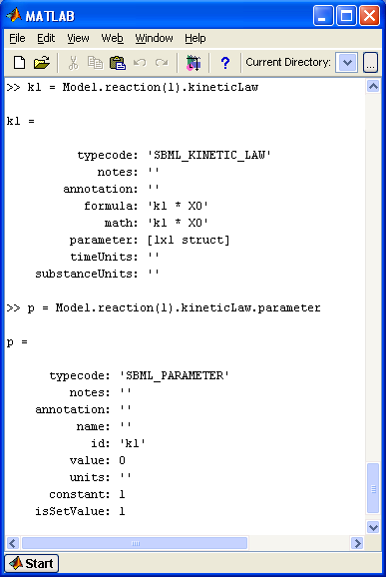
Figure 5: Accessing fields within the MATLAB_SBML Model structure.

Each component of the sbml model can be viewed independently from the ViewModel GUI using the functions in the ViewModelComponents folder. For example ViewKineticLaw(kl) would produce a GUI detailing the kineticLaw structure kl shown in Figure 5.

The variables describing the model cannot be edited using the GUIs as these have initially been developed to facilitate the visualisation of the model. However it would be a short step for a developer to enable the edit boxes should this be a requirement.

8. Access model

The AccessModel folder contains a number of functions that derive information from the MATLAB_SBML structure.

The functions in the AccessModel folder are listed in Table 5.

Table 5: Functions and their type in folder AccessModel
Type of function | Function name
MATLAB help | Contents.m
Getting information | GetAllParameters.m
 | GetAllParametersUnique.m
 | GetGlobalParameter.m
 | GetParameterFromReaction.m
 | GetParameterFromReactionUnique.m
 | GetSpecies.m
Deriving information | GetStoichiometryMatrix.m
Overview of model | CheckValues.fig
 | CheckValues.m

8.1 Getting information functions

[names, values] = GetGlobalParameters(MATLAB_SBMLModel)
returns
names = array of the character string representation of the global parameters
found in MATLAB_SBMLModel i.e. parameters in ListofParameters
(this will be the name field in level 1 SBML models
and the id field in level 2 Models)
values = array of the values of each parameter (if value is not set then -1 is entered in the array)

[names, values] = GetParameterFromReaction(MATLAB_SBMLReaction)
returns
names = array of the character string representation of the parameters
found in MATLAB_SBMLReaction
i.e. parameters in ListofParameters within the kineticLaw of a reaction
values = array of the values of each parameter (if value is not set then -1 is entered in the array)

[names, values] = GetParameterFromReactionUnique(MATLAB_SBMLReaction)
returns
names = array of the character string representation of the parameters
found in MATLAB_SBMLReaction with the name/id of the reaction appended
values = array of the values of each parameter (if value is not set then -1 is entered in the array)

This function allows a user to generate a list of unique identifiers for the parameters within a model.
[names, values] = GetAllParameters(MATLAB_SBMLModel)

returns
names = array of the character string representation of each parameter
values = array of the values of each parameter (if value is not set then -1 is entered in the array)
[names, values] = GetAllParametersUnique(MATLAB_SBMLModel)

returns
names = array of the character string representation of each parameter; with the unique names for
those parameters declared within a reaction
values = array of the values of each parameter (if value is not set then -1 is entered in the array)

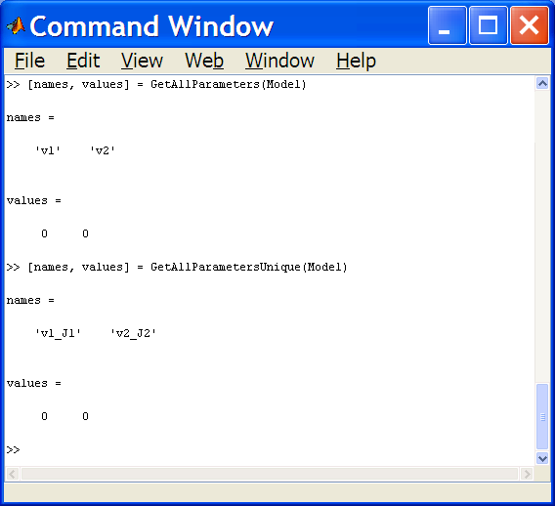

Figure 6: Using the GetAllParameters and the GetAllParametersUnique functions
[names, values] = GetSpecies(MATLAB_SBMLModel)
returns
names = array of the character string representation of all species
found in MATLAB_SBMLModel
values = array of the initial concentration/amount of each species
(if value is not set then -1 is entered in the array)

8.2 Deriving information functions
[matrix, species] = GetStoichiometryMatrix(MATLAB_SBMLModel)
returns
matrix = stoichiometry matrix for the species and reactions in the model
species = array of the character string representation of all species
in the order in which the matrix deals with them

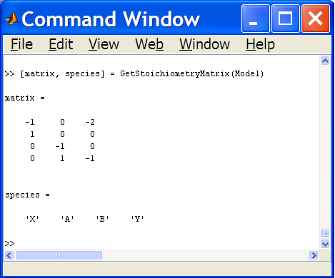

Figure 7: Typical output from GetStoichiometryMatrix

8.3 Overview of model functions
[speciesValues, parameterValues] = CheckValues(MATLAB_SBMLModel)

displays a GUI that allows the user to check that the values for the parameters and the initial amounts of the species are as expected.

returns
speciesValues = array of values for the initial amount of each species
parameterValues = array of values for the parameters

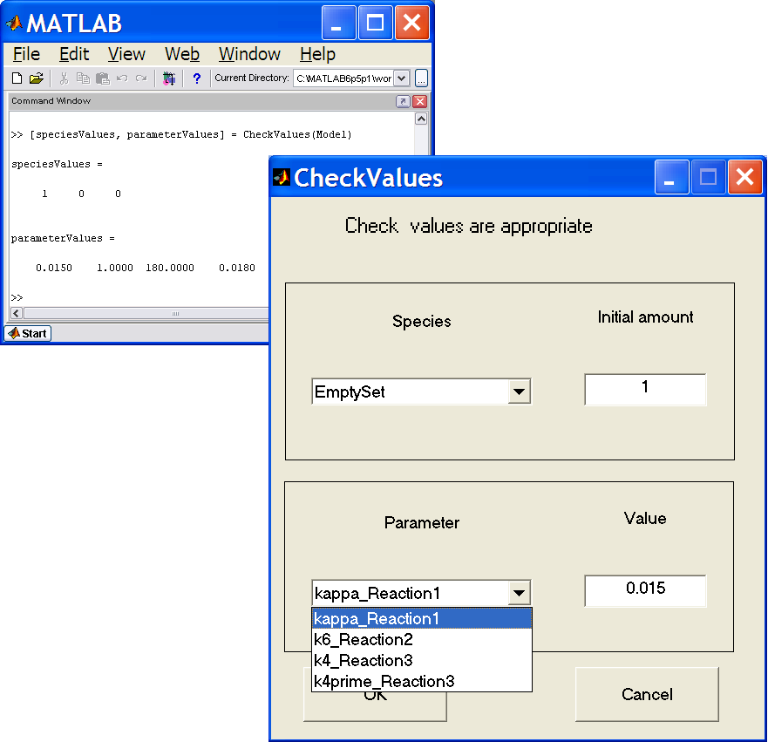
NOTE: parameter names used are the unique names with reaction names appended

Figure 8: Typical output from CheckValues function

9. Access to symbols

The AccessToSymbols folder contains a number of functions that take elements of the MATLAB_SBML model and convert them to a symbolic form for use with the MATLAB Symbolic Toolbox.

The functions in the AccessToSymbols folder are listed in Table 6.

Table 6: Functions and their type in folder AccessToSymbols
Type of function | Function name
MATLAB help | Contents.m
Getting symbols | GetAllParameterSymbols.m
 | GetAllParameterSymbolsUnique.m
 | GetGlobalParameterSymbols.m
 | GetParameterSymbolsFromReaction.m
 | GetParameterSymbolsFromReactionUnique.m
 | GetSpeciesSymbols.m
Getting formulas | GetSpeciesRateLaws.m
 | GetStoichiometryMatrixSyms.m
Deriving information | GetEquilibrium.m
Overview of model | PlotTimeCourse.m
 | PlotSelectedTimeCourse.m
General | charFormula2sym.m
 | CreateSymArray.m
 | GetDegree.m
 | IsSpeciesInReaction.m
 | RemoveDuplicates.m

9.1 Getting symbols functions
[symbols, values, names] = GetAllParameterSymbols(MATLAB_SBMLModel)

returns
symbols = array of the symbolic representation of all parameters found in MATLAB_SBMLModel
values = array of the values of each parameter (if value is not set then -1 is entered in the array)
names = array of the character string representation of each parameter

[symbols, values, names] = GetAllParameterSymbolsUnique(MATLAB_SBMLModel)
returns
symbols = array of the symbolic representation of the unique names of all parameters found in
MATLAB_SBMLModel
values = array of the values of each parameter (if value is not set then -1 is entered in the array)
names = array of the character string representation of each parameter; with the unique names for
those parameters declared within a reaction

[symbols, values, names] = GetGlobalParameterSymbols(MATLAB_SBMLModel)
returns
symbols = array of the symbolic representation of global parameters
found in MATLAB_SBMLModel i.e. parameters in ListofParameters
values = array of the values of each parameter (if value is not set then -1 is entered in the array)
names = array of the character string representation of each parameter

[symbols, values, names] = GetParameterSymbolsFromReaction(MATLAB_SBMLReaction)
returns
symbols = array of the symbolic representation of parameters found in MATLAB_SBMLReaction i.e. parameters in ListofParameters within the kineticLaw of a reaction
values = array of the values of each parameter (if value is not set then -1 is entered in the array)
names = array of the character string representation of each parameter

[symbols, values, names] = GetParameterSymbolsFromReactionUnique(MATLAB_SBMLReaction)
returns
symbols = array of the symbolic representation of parameters found in MATLAB_SBMLReaction with the name/id of the reaction appended
values = array of the values of each parameter (if value is not set then -1 is entered in the array)
names = array of the character string representation of each parameter; with the name/id of the
reaction appended

[symbols, values, names] = GetSpeciesSymbols(MATLAB_SBMLModel)
returns
symbols = array of the symbolic representation of all species found in MATLAB_SBMLModel
values = array of the initial concentration/amount of each species
(if value is not set then -1 is entered in the array)
names = array of the character string representation of each species

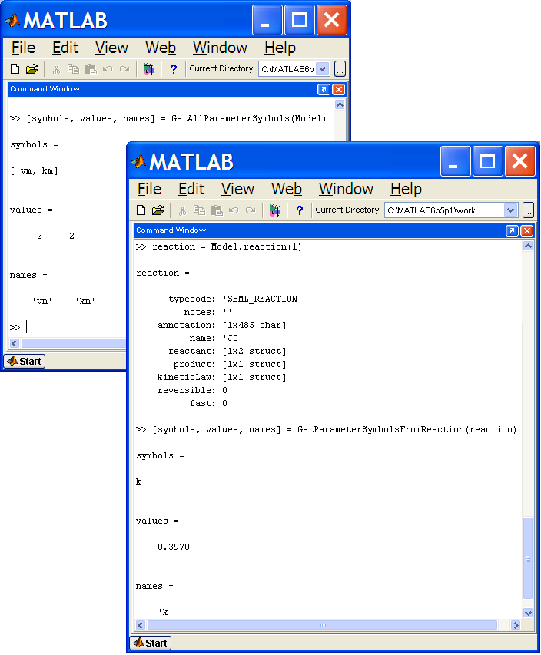
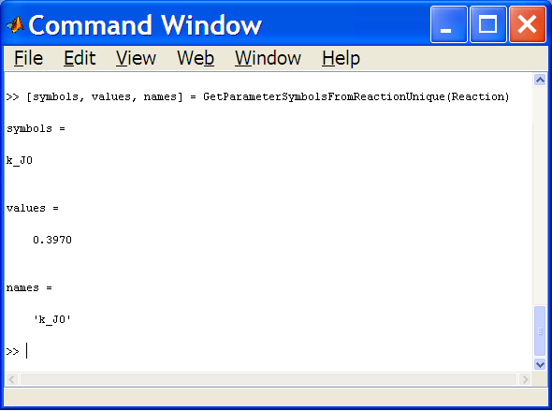

Figure 9: Examples of output from Getting Symbols functions

9.2 Getting formula functions
[symbols, ratelaws] = GetSpeciesRateLaws(MATLAB_SBMLModel)

returns
symbols = array of the symbolic representation of all species found in MATLAB_SBMLModel
ratelaws = array of the symbolic representation for the rate law for each species

NOTE: GetSpeciesRateLaws uses the unique parameter names

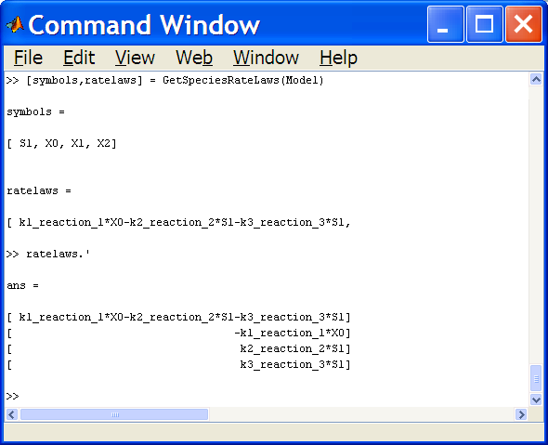

Figure 10: Output from GetSpeciesRateLaws function
[matrix, species] = GetStoichiometryMatrixSyms(MATLAB_SBMLModel)

returns
matrix = stoichiometry matrix for the species and reactions in the model
species = array of the symbolic representation of all species
in the order in which the matrix deals with them

9.3 Deriving information functions
[symbols, values, names] = GetAllParameterSymbols(MATLAB_SBMLModel)

[values, info] = GetEquilibrium(MATLAB_SBMLModel)
returns
values = array of the equilibrium values of each species
info = structure detailing the equilibrium
.species – array of symbolic representation of the species
.initialValues – array of the initial amounts used
.equilValues – array of the equilibrium values
(equal to 0 if equilibrium not reached)
.timeValues – array of the amount of each species at the time shown
(equal to equilValues if equilibrium was reached)
.Time – elapsed time for which the reactions were considered
.delta_t – time step used in the calculations
.tolerance – difference value at which equilibrium was considered to be reached
.Time_limit – length of time reactions would be considered if tolerance not reached

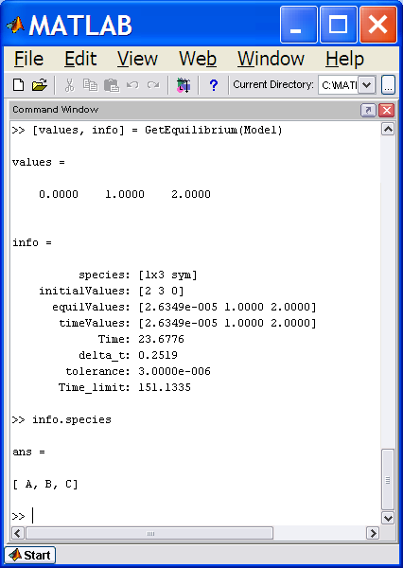

Figure 11: Typical output from the GetEquilibrium function.
The algorithm used to calculate the equilibrium involves using the rate equations to produce a set of functions for the change in the amount of each species for a corresponding change in time.

Example:

Reaction A -> B with kinetic law formula k * B

The rate equations are
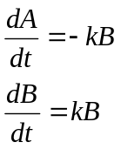
Rewriting these, the change in amount of A and B for each change in time becomes

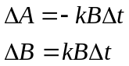

An appropriate time step, time limit and tolerance are calculated from the initial values of the species amounts and parameters involved. The procedure then iterative calculates the new species amounts using the derived functions until either the required tolerance (difference between newly calculated figure and previously calculated figure) has been achieved or the time limit has been reached. If the time limit is reached it is assumed that equilibrium is unlikely to be achieved and the function terminates and reports the values calculated within the info structure returned.

9.4 Overview of model functions
[symbols, values, names] = GetAllParameterSymbols(MATLAB_SBMLModel)

[values] = PlotTimeCourse(MATLAB_SBMLModel, (time_limit))
PlotTimeCourse uses the same algorithm as that used to calculate equilibrium and displays a plot of the time course for each of the species within the model (see Figure 12 overleaf).

Optionally takes a second argument time_limit which limits the length of time the reactions are considered

Returns
values = array of species amounts at the end of the plot time
(either at equilibrium or time_limit if this has been specified)

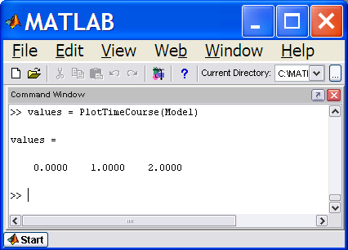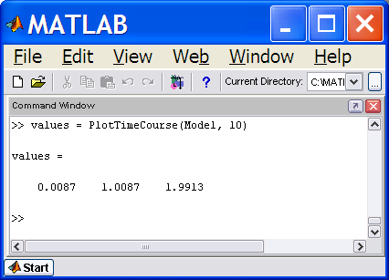

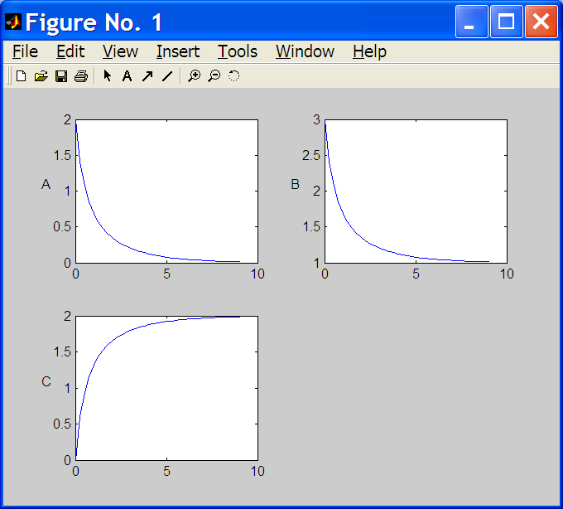

Figure 12: Examples of the output from PlotTimeCourse function

Note: The functions GetEquilibrium, PlotTimeCourse and PlotSelectedTimeCourse all call the CheckValues function (discussed in section 8.3) with additional error trapping for inappropriate zero or negative values.

[values] = PlotSelectedTimeCourse(MATLAB_SBMLModel, (time_limit))
PlotSelectedTimeCourse is a variation on PlotTimeCourse where the user is prompted to select the species for which the time course is to be plotted.

All selected species are plotted using the same axes with up to 14 different line types available (Figure 13).

The arguments and returns are identical to those for PlotTimeCourse.

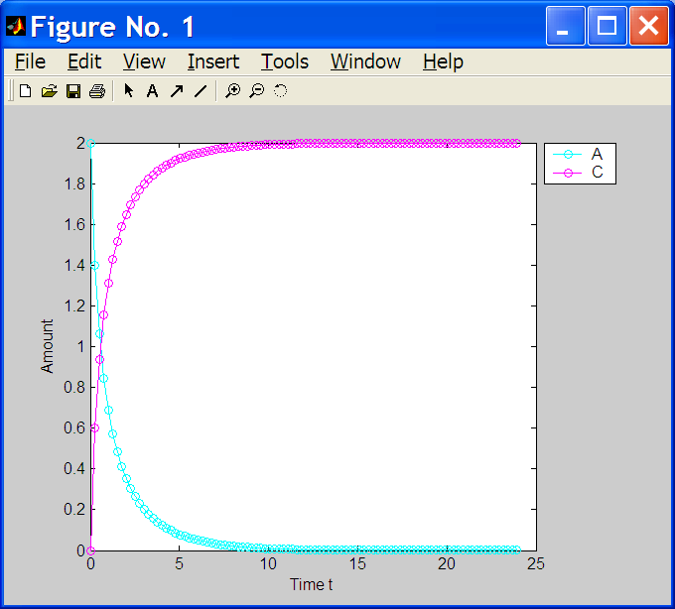

Figure 13:Output from PlotSelectedTimeCourse function

9.5 General functions

[symFormula, symbols] = charFormula2sym(charFormula)
returns
symFormula = symbolic representation of charFormula
symbols = array of the symbols used in the formula

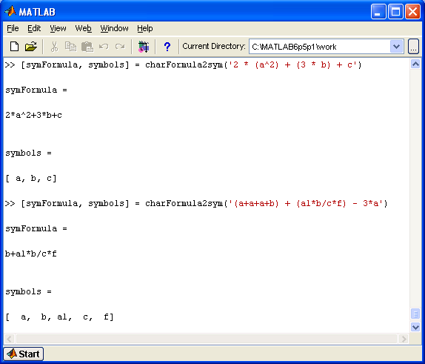

Figure 14: Sample outputs from charFormula2sym function

[symbols] = CreateSymArray(symFormula)
takes a symbolic formula or set of formulas

returns
symbols = array of individual symbols found in symFormula

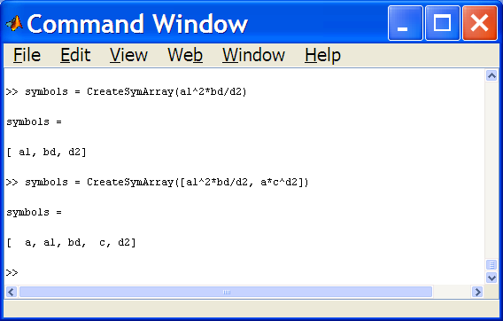

Figure 15: Output from CreateSymArray function
degree = GetDegree(symPolynomial, symVariable)
takes
symPolynomial – a symbolic representation of a polynomial
symVariable – a single symbol

returns
degree = the degree of the single symbol in the polynomial

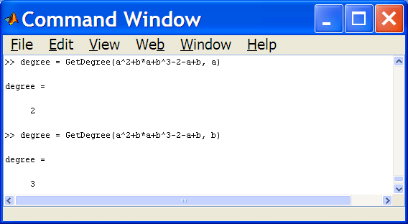

Figure 16: Output from GetDegree function
y = IsSpeciesInReaction(MATLAB_SBMLSpecies, MATLAB_SBMLReaction)
returns
y = 0 if the species given is not in the reaction given
or an array indicting
number of occurrences of species
whether the species is a reactant
stoichiometry if the species is a reactant
whether the species is a product
stoichiometry if the species is a product
whether the species is a modifier

Thus the returned array has the form
[number of occurrence, product_info, reactant_info, modifier]
where product_info or reactant_info may be two numbers if applicable.
Table 7 illustrates some examples.

Table 7: Example outputs from IsSpeciesInReaction function
Output = IsSpeciesInReaction(s, r) | Interpretation
0 | species s is not in reaction r
[1,1,2,0,0] | species s is a reactant with stoichiometry 2  2s +… -> …
[1,0,1,3,0] | species s is a product with stoichiometry 3  … -> 3s +…
[1,0,0,1] | species s is a modifier in reaction r
[2,1,1,1,2,0] | species s is a reactant with stoichiometry 1 and a product with stoichiometry 2  s + … -> 2s + …

set = RemoveDuplicates(full_set)
returns
set = the array full_set with any duplicate members removed

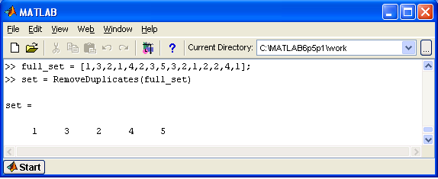

Figure 17: Output from RemoveDuplicates function

10. Simulation

The Simulation folder contains a number of functions that take a MATLAB_SBML model and convert them files that can be used to simulate the model with MATLABs ode functions.

The functions in the Simulation folder are listed in Table 8.

Table 8: Functions and their type in folder Simulation
Type of function | Function name
MATLAB help | Contents.m
Simulation | WriteODEFunction.m
 | DisplayODEFunction.m
General | SelectSpecies.m
 | SelectSpecies.fig

WriteODEFunction(MATLAB_SBMLModel)
takes a sbml model named ‘Test’

and outputs a file named Test.m containing a function Test that can be used with matlabs odeN functions as shown
[t,x] = ode23(@Test, [0, t_end], Test)
where t_end is the end time of the simulation

DisplayODEFunction(MATLAB_SBMLModel)

graphically outputs the solution derived using the ode23 solver.

NOTE: DisplayODEFunction requires the file output by WriteODEFunction.

The xml model shown in Figure 18 is imported into MATLAB and WriteODEFunction is applied. The resulting output is shown in Figure 19. Results of the DisplayODEFunction are illustrated by Figure 20.
<?xml version="1.0" encoding="UTF-8"?>
<sbml level = "1" version = "1" xmlns = "http://www.sbml.org/sbml/level1" xmlns:jd = "http://www.sys-bio.org/sbml">
<model name = "AB_C">
<listOfCompartments>
<compartment name = "compartment" volume = "1"> </compartment>
</listOfCompartments>
<listOfSpecies>
<specie boundaryCondition = "false" compartment = "compartment" initialAmount = "2" name = "A">
</specie>
<specie boundaryCondition = "false" compartment = "compartment" initialAmount = "3" name = "B">
</specie>
</specie>
</listOfSpecies>
<listOfReactions>
<reaction name = "J0" reversible = "false">
<listOfReactants>
<specieReference specie = "A" stoichiometry = "1"/>
<specieReference specie = "B" stoichiometry = "1"/>
</listOfReactants>
<listOfProducts>
<specieReference specie = "C" stoichiometry = "1"/>
</listOfProducts>
<kineticLaw formula = "J0_k*A*B">
<listOfParameters>
<parameter name = "J0_k" value = "0.397"/>
</listOfParameters>
</kineticLaw>
</reaction>
</listOfReactions>
</model>
</sbml>
Figure 18: XML for model of simple reaction A + B -> C

Figure 19: AB_C.m file output using WriteODEFunction
function xdot = AB_to_C(time, x)
% function AB_to_C takes
% either 1) no arguments
% and returns a vector of the initial species concentrations
% or 2) time - the elapsed time since the beginning of the reactions
% x - vector of the current concentrations of the species
% and returns a vector of the rate of change of concentration of each of the species
%
% AB_to_C can be used with matlabs odeN functions as
% [t,x] = ode23(@AB_to_C, [0, t_end], AB_to_C)
% where t_end is the end time of the simulation
%
%The species in this model are related to the output vectors with the following indices
% Index Species name
% 1 A
% 2 B
% 3 C

% output vector
xdot = zeros(3, 1);

% assign parameter values
J0_k = 3.970000e-001;

% calculate concentration values
if (nargin == 0)
% initial concentrations
xdot(1) = 0;
xdot(2) = 0;
xdot(3) = 0;
else
% floating species concentrations
A = x(1);
B = x(2);
C = x(3);
% species concentration equations
xdot(1) = -1 *J0_k*A*B;
xdot(2) = -1 *J0_k*A*B;
xdot(3) = 1 *J0_k*A*B;
end;

Note: At present this function only deals with the kinetic law specified within a reaction and does not consider rules or SBML level 2 events or functions.
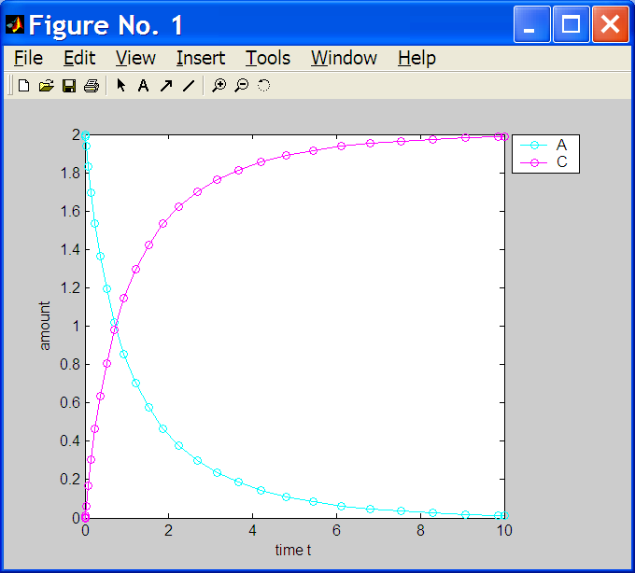

Figure 20: Output from DisplayODEFunction

[species] = SelectSpecies(MATLAB_SBMLModel)
takes a sbml model

returns
species = array of character names of the species selected

NOTE: this function is called by DisplayODESolver and PlotSelectedTimeCourse to allow the user to output data relating to the selected species only.

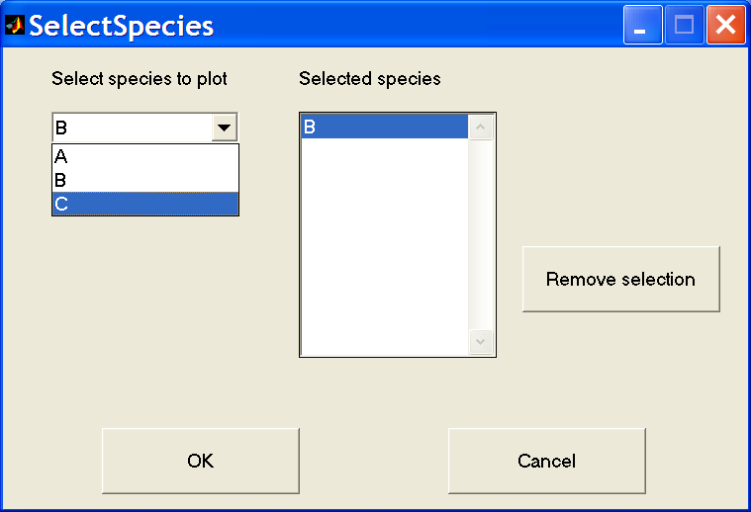
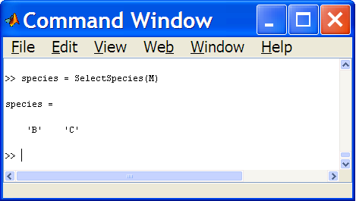

Figure 21: Output from SelectSpecies function

