Extension Document Configuration

Proposal title
Spatial Geometry

Proposal authors
James Schaff

Proposal tracking number
ID: 3137379 (in the SBML issue tracker on Sourceforge.net : https://sourceforge.net/tracker/?group_id=71971&atid=894711).

Version information

Version number and date of public release
Version 0.81 release on 15 August 2012.

URL for this version of the proposal

https://dl.dropbox.com/u/47050439/SBMLSpatialProposal2012_COMBINE_1.doc

URL for the previous version of this proposal
N/A

Introduction and motivation
A set of biochemical process in cellular physiology may be modeled using different choices of spatial and temporal scales depending on the questions to be addressed. SBML Level 3 Core has explicit support for multi-compartmental modeling where cellular organization is approximated by a small set of compartments (e.g. membrane-bound organelles) containing well-stirred populations of molecules. However, the coupling between localized biochemical reactions and diffusive molecular transport within the constraints of cellular geometry often results in important nonuniform molecular distributions. While it is often possible to approximate the influence of spatial organization and localization within a compartmental model using altered parameters and additional species, it is sometimes simpler and always more mechanistic to directly model these spatial processes.
An increasing number of modeling and simulation tools include direct support for modeling with explicitly defined cellular geometry. These models generally include heterogeneous molecular distributions, diffusive transport, and spatially localized reactions. These spatial models generally belong to two different mathematical frameworks, stochastic (where each molecule is tracked in space and time) and deterministic (where time varying species concentration fields are described by partial differential equations).
There are a sufficient number of spatial modeling tools and spatial models to justify the effort of creating a spatial modeling extension of SBML. All such models must describe the cellular geometry, map molecular species to spatial locations, map reactions to spatial locations, and specify molecular transport within geometric compartments and at boundaries of these compartments.
It is the purpose of this SBML Level 3 extension to define a common representation for cellular geometry, spatial mappings of species and reactions, and explicit species transport.

Background

Problems with current SBML approaches
There is no standard way of specifying spatial models in SBML short of introducing an explicit spatial discretization in the form of a large number of compartments with duplicate species and reactions and additional reactions for coupling due to transport. This approach hard-codes the numerical methods which destroys portability and is not practical beyond a few compartments. Tools have been forced to resort to proprietary extensions (e.g. MesoRD custom annotations) to encode geometry.

Past work on this problem or similar topics
There are many standards for the exchange of geometric information of engineered parts in Computer Aided Design and Manufacturing. These formats are designed for geometric shapes which are directly specified by a designer rather than the data driven, freeform biological structures encountered in cell biology.
There also exist standards for the representation of unstructured computational meshes that can encode these freeform biological structures more readily. However, it is important to note that while a computational mesh necessarily encodes an approximation to the shapes of geometric objects, the particular form will be algorithm dependent.
To ensure model interoperability, we must encode the geometric shapes in a way that is independent of the numerical methods and even the mathematical framework. The representation of a spatial model within SBML should be largely invariant of the particular encoding of the geometry definition within that model. For example, a spatial model represented in SBML that encodes geometry as a set of geometric primitives (e.g. spheres, cylinders) should be easily portable to a tool that only supports polygonal surface tessellation. It is expected that a geometry translation library will be very useful for interoperability the same way that libSBML greatly improved model interchange by solving similar implementation problems in a standard way.

Proposed syntax and semantics

Overview of spatial extension
The SBML Compartments, Reactions and Species, and molecular transport mechanisms (spatial::DiffusionCoefficient, spatial::AdvectionCoefficient, spatial:BoundaryCondition) are mapped to geometric domains to describe spatial models within SBML. The primary mechanism to accomplish this mapping is to simply map Compartments to collections of geometric Domains called spatial:DomainTypes. Each Domain is a contiguous patch of volumetric space or a contiguous surface patch that is ultimately described by a single system of equations (whichever mathematical framework is used). In analogy with initial conditions, the mathematical system defined within a domain often needs a definition of what happens at the domain boundary (e.g. boundary conditions) to complete the specification. Because of this, the boundaries between adjacent domains need to be identified so that appropriate boundary conditions can be specified. For compactness of representation, rather than map to each individual Domain, Compartments are mapped to spatial:DomainTypes, along with the corresponding Species and Reactions (with the new compartment attribute).

Geometry
The geometry object within a model is completely modular and does not reference the rest of the model, promoting reuse of the same geometry in different models. The geometry separately defines a coordinate system, a list of domain types, a list of domains and their adjacency relationships, and a list of alternate geometric representations.

Alternative GeometryDefinitions
Modeling and simulation tools will each natively support some subset (often just one) of the possible Geometry Definitions (analytic, sampledField, constructive solid geometry, and parametric shapes ). Interoperability will be enhanced if tools write as many geometry definitions as they are able. Upon reading the model, a tool will typically choose the most convenient geometry definition, i.e. the one that it natively supports. If a tool does not edit the geometry, it has the ability to preserve the alternate representations during model editing (because the mapping of the model to the geometry is not stored in the geometry).
There are two general classes of geometric representation specification, those that explicitly specify surfaces and those that implicitly specify surfaces. For example, a level set is a field where a specific isosurface of the field specifies a geometric surface. A geometry described using constructive solid geometry of geometric primitives (e.g. spheres, cylinders) specifies directly which points are “inside” an object. Alternatively, explicit surface representations explicitly declare the set of points belonging to surfaces (e.g. polygonal tessellations).
4.1.3 Data Types in the Spatial Package
The primitive data types defined in SBML Level 3 core (string, Boolean, int, double, SId, SIdRef, etc) are also valid in the SBML Spatial package (children of spatial:Geometry). The SpId and SpIdRef are data types defined in the Spatial package and are defined like SId and SIdRef in the SBML core respectively [1].
The SpId is the data type for the spatialId attribute for a majority of the components in the spatial:Geometry element in the Spatial package. This data type is derived from the basic XML type string, but imposes restrictions on the permitted characters and their sequences. The definition is similar to the definition of SId in SBML core.
The data type SpIdRef, used for attributes in spatial:Geometry components and for attributes in the Spatial package extension in the SBML core model, refers to identifiers of type SpId in the spatial:Geometry components. The definition and usage rules for the SpIdRef data type are similar to that of SIdRef in SBML core.
4.2 The SBML Container
In order to define a spatial geometry in an SBML model, the SBML container element should declare the namespaces for the Spatial extension package (xmlns:spatial=http://www.sbml.org/sbml/level3/version1/spatial/version1) and the Required Elements extension package (xmlns:req=http://www.sbml.org/sbml/level3/version1/requiredElements/version1) and set the ‘required’ attribute for these two packages to ‘true’.
<sbml xmlns="http://www.sbml.org/sbml/level3/version1/core"
xmlns:req="http://www.sbml.org/sbml/level3/version1/requiredElements/version1"
xmlns:spatial="http://www.sbml.org/sbml/level3/version1/spatial/version1"
level="3" version="1" req:required="true" spatial:required="true">
This Required Elements package is a small package that allows modelers to declare specifically which elements of the SBML model have had their math changed, by which package, and if an alternative math representation is present in the SBML core. This is done by the addition of two optional attributes ‘mathOverridden’ and ‘coreHasAlternateMath’ to Sbase. The mathOverridden attribute is of type String and is set to the prefix of the namespace of the package that redefines the math of the element. The coreHasAlternateMath can take a value of ‘true’ or ‘false’. ‘True’ indicates that the SBML core has an alternate and complete definition for the element’s math (although different results can be expected). A value of ‘false’ for the attribute indicates that core’s version of the element’s math is not adequate.

Model
An overview of the existing SBML Model with the Geometry extension is shown in Figure 1 below. The Geometry element is contained in the Model element in the ‘spatial’ namespace. In order to specify a spatial geometry, some of the existing SBML elements need to be extended (compartment, species, parameter, reaction). These extensions to the SBML elements are discussed in the sections that follow.
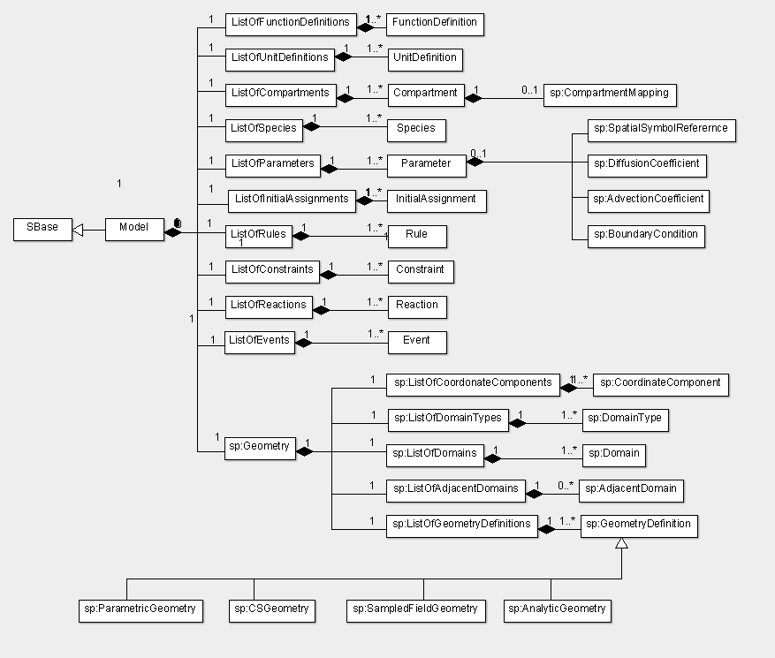
Figure 1 : The SBML Model object with the Geometry object from the Spatial package.
4.4 Compartment
The Compartment in the SBML core is extended while defining a spatial model. An SBML model with spatial geometry defines domain types (classes of domains that are anatomically and physiologically similar). These domain types need to be mapped to a compartment in the SBML model. Compartments are extended to define spatial:CompartmentMappings that map compartments to spatial:DomainTypes such that each corresponding spatial:DomainType is assigned the same biological and mathematical function. Within SBML L3 Core, the compartment Sid refers to the size of that compartment and is specified by the size attribute or may be set by a rule. For spatial models, the compartment size is calculated as the product of the unit size specified in the compartment mapping and the size of the current domain. The definition for the extension of the Compartment element is shown in Figure 2.
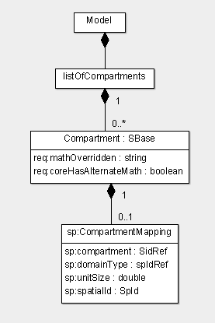
Figure 2 : The definition of the extension to the Compartment element. The SBML core attributes of Compartment are not displayed.
The Compartment element has two additional attributes mathOverridden and coreHasAlternateMath from the RequiredElements package. Each Compartment has an optional spatial:CompartmentMapping which indicates the spatial:DomainType to which the Compartment is mapped. If there is no spatial:CompartmentMapping for a Compartment in a spatial model, then the corresponding Compartment is excluded from the model. In the same way, if a spatial:DomainType is not mapped to one or more Compartments, then the corresponding spatial:Domains in the geometry have no assigned function.
The req:mathOverridden attribute
When a spatial geometry is defined in the SBML model, the Compartment element is being extended for the spatial package. The req:mathOverridden attribute for Compartment is set to the spatial package namespace prefix i.e., “spatial”.
The req:coreHasAlternateMath attribute
The req:coreHasAlternateMath may be set to true if modeling package precalculates the compartment size and stores it in the Compartment size attribute or sets the value using an InitialAssignment. However, due to slight differences in mesh generation between simulators, the domain size actually used within computations may vary slightly from simulator to simulator, and will thus introduce small errors that may break mass conservation.

4.4.1 The CompartmentMapping element
Each Compartment in a model that defines a spatial geometry may contain an optional spatial:CompartmentMappings. spatial:CompartmentMappings are defined as part of the model rather than part of the geometry so that the geometry is modular and may be readily shared between models and. The spatial:CompartmentMapping and its attributes are defined in the ‘spatial’ namespace. spatial:CompartmentMappings map Compartments defined in the model to spatial:DomainTypes defined in the geometry such that each corresponding spatial:DomainType is assigned the same biological and mathematical function described by the set of Compartments that are mapped to that spatial:DomainType.
This mapping need not be one-to-one. In fact, it is common to map er-lumen, er-membrane, and cytosol to the same cell interior volume or 3D spatial:DomainType. The unitSize attribute specifies the relative quantity of each spatial:Compartment that is mapped to the spatial:DomainType.
The value of a spatial:CompartmentMapping is its unitSize attribute, and can be bound to a Parameter by using a spatial:SpatialSymbolReference and the spatialId of the spatial:CompartmentMapping.

The spatialId attribute
The spatialId attribute is a mandatory attribute of type SpId that is used to uniquely identify a spatial:CompartmentMapping in the model. All identifiers of type SpId must be unique within the spatial:Geometry.

The compartment attribute
The mandatory compartment attribute is of type SIdRef that indicates the spatial:Compartment to which the spatial:CompartmentMapping belongs.

The domainType attribute

The mandatory domainType attribute is of type SpIdRef that indicates a spatial:DomainType defined the spatial:Geometry element.

The unitSize attributee
The unitSize attribute is of type double and represents the relative size of the Compartment with respect to the size of the spatial:Domains to which they are mapped. Thus for any infinitesimal subset of the spatial:Domain with size S, there exists an amount of Compartment_{i} of size (S*unitSize_{i}) for i=1..N Compartments mapped to that DomainType. For example, a 3D Compartment (and DomainType) which is mapped to a 3D spatial:DomainType has a unitSize which is a volume fraction of dimensionless unit. All such volume fractions mapped to a particular DomainType should typically sum to one.
4.5 Species
The SBML core Species is extended when a spatial geometry is defined in the model with the addition of three new attributes to Species - mathOverridden, coreHasAlternateMath, and isSpatial. The mathOverridden and coreHasAlternateMath attributes are defined in the RequiredElements package namespace and isSpatial is defined in the Spatial package namespace. If any species in the model is not spatial, the three attributes need not be defined. The extension to the Species element is shown in Figure 3.
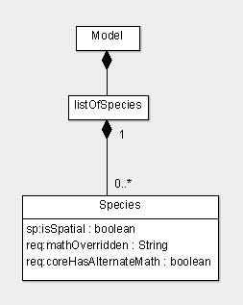
Figure 3 : The extension to the Species element. The attributes of Species from SBML core are not displayed.
The req:mathOverridden attribute
The req:mathOverridden attribute for a Species is set to the spatial package namespace prefix i.e., “spatial”.
The req:coreHasAlternateMath attribute
The req:coreHasAlternateMath attribute of a Species is set to true if model specifies the initialAmount or initialConcentration attributes of the Species or if the initial condition is specified by a Rule or an InitialAssignment.
The spatial:isSpatial attribute
The isSpatial attribute is of data type boolean. If it is set to true, the Species is spatially distributed in a possibly nonhomogeneous manner within the spatial:Domains of the same type as the mapped spatial:DomainType.
For continuous deterministic models (described by partial differential equations), a spatial Species will result in a concentration field described by a partial differential equation which incorporates contributions from Reactions, diffusion (spatial:DiffusionCoefficient) and advection (spatial:AdvectionCoefficient) and are subject to boundary conditions (spatial:BoundaryCondition) and initial conditions (InitialAssignmentRules). All of these quantities can be explicit functions of the spatial coordinates as well as spatial and nonspatial Parameters and Species.
For stochastic models, the Species is represented as a collection of particles that are distributed throughout the spatial:Domains and are subject to reactions, diffusion and advection. Simulation algorithms either track individual particles (e.g. Particle-based methods) or use spatial discretization to track a large number of well stirred pools (e.g. Next-Subvolume Method).
4.6 Parameter
When an SBML model defines a spatial geometry, the SBML core Parameter is extended to define the diffusion coefficient, transport velocity (advection) and boundary conditions for species and the coordinate components defined in the spatial:Geometry. One Parameter is created for each quantity. The extension involves the addition of two attributes mathOverridden and coreHasAlternateMath (in the RequiredElements package namespace) to Parameter and one of the following objects : spatial:SpatialSymbolReference, spatial:DiffusionCoefficient, spatial:AdvectionCoefficient, spatial:BoundaryCondition (in the Spatial package namespace). A Parameter that has been extended for the Spatial package can have only one of the above listed objects. For example, if a Parameter is extended to represent the diffusion coefficient of a species, the existing attributes of the Parameter (id, name, value, units, constant) are defined according to SBML core specifications, along with the extension attributes (mathOverridden, coreHasAlternateMath) and the spatial:DiffusionCoefficient object that contains the information about the species it represents. Figure 4 represents the extension to the Parameter element.
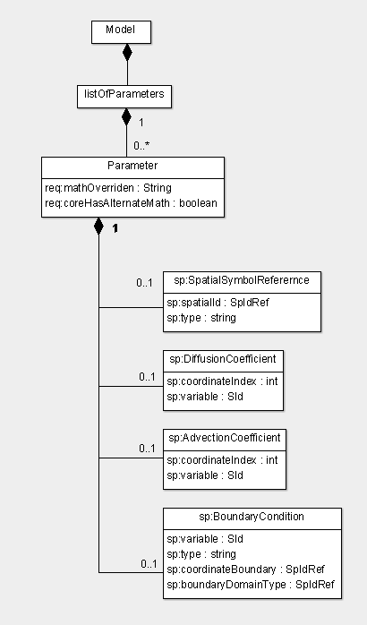
Figure 4 : The Parameter element extension for spatial package. The SBML core attributes for Parameter are not displayed in this figure.
The req:mathOverridden attribute
The req:mathOverridden attribute for a Parameter is set to the spatial package namespace prefix i.e., “spatial”.
The req:coreHasAlternateMath attribute
The req:coreHasAlternateMath is set to true if model specifies the value of the Parameter or if the Parameter is specified by a Rule.
    - The SpatialSymbolReference element
A Parameter is extended with a spatial:SpatialSymbolReference element, defined in the Spatial package namespace, when a symbol from the defined spatial geometry (spatialId of any element contained in Geometry) is required to be used in the SBML core model. Typically, the spatial:SpatialSymbolReference is used to represent the coordinate components defined in the spatial:Geometry’s listOfCoordinateComponents. For example, if the Geometry is defined in a 2-dimensional Cartesian coordinate system with X and Y defined as coordinate components, two Parameters (one each for spatial:CoordinateComponents X and Y) are created in the model. The value of the parameter is not required to be set. For each of these parameters, a spatial:SpatialSymbolReference object is created.
The spatialId attribute
The spatialId attribute of spatial:SpatialSymbolReference, defined in the Spatial package namespace, is of type SpIdRef and refers to the spatialId of any element defined in the Geometry of the model.
4.6.2. The DiffusionCoefficient element
When a species in a spatial model has a diffusion rate constant, a Parameter for this diffusion constant is created in the SBML model. The value of the Parameter is set to the value of the diffusion constant of the species. If the diffusion constant is a numeric value, the Parameter’s value attribute is set with this value. If the diffusion is an expression, an AssignmentRule is created for the Parameter and the constant attribute of the Parameter is set to false. Units are needed for diffusion rate constant which is dimensionally (Length)²(Time)⁻¹ (typically cm²s⁻¹ or um²s⁻¹). Furthermore, the Parameter is extended with the spatial:DiffusionCoefficient element, defined in the Spatial package namespace. The spatial:DiffusionCoefficient is used to identify the Species whose diffusion rate the Parameter represents.
The variable attribute
The variable attribute of spatial:DiffusionCoefficient is of type SIdRef and is the id of the Species in the model whose diffusion coefficient is being set.
The coordinateIndex attribute
The coordinateIndex is of type integer and represents the index attribute of the spatial:CoordinateComponent (e.g. 0 for x, 1 for y, 2 for z), for specifying the diffusion coefficient for flux in the coordinateIndex direction due to a gradient in the coordinateIndex direction (diagonal term of the diffusion tensor). If the coordinateIndex is missing, the diffusion is considered to be Isotropic.
    - The AdvectionCoefficient element
The spatial:AdvectionCoefficient is the extension to Parameter in SBML core that is used to represent transport velocity of a species, if it exists. spatial:AdvectionCoefficient is defined in the Spatial package namespace. The transport velocity for the species is defined in a manner similar to the diffusion constant with a unit of length/time. A Parameter is created in SBML code for the velocity; its value is set to the value of the velocity (an AssignmentRule is created if the velocity is not numeric but an expression). A spatial:AdvectionCoefficient element is created for the Parameter. This element is used to identify the species whose velocity is represented by the Parameter.
The variable attribute
The variable attribute of spatial:AdvectionCoefficient is of type SIdRef and is the id of the Species in the model whose advection coefficient (transport velocity) is being set.
The coordinateIndex attribute
The coordinateIndex is of type integer and represents the coordinate component of the velocity. For example, if the Geometry is defined in the Cartesian coordinate system and is 2-dimensional, the species can have velocity terms in X and Y (assuming that X and Y are the coordinates that define the 2 dimensions of the Geometry). If the Parameter represents the transport velocity of the species in the X-coordinate, the coordinateIndex attribute will take a value of 0, and if it represents the velocity in the Y-coordinate, the attribute will take a value of 1.
    - The BoundaryCondition element
A Species in a spatial model that has a diffusion rate or an advection velocity needs to have specified boundary conditions. A boundary condition is either the concentration of the species or the flux density of the species at a boundary. The boundary refers to either an internal membrane boundary or a face of the box defined by the minimum and maximum coordinates of the geometry (the geometries bounding box).
When creating a spatial SBML model, species boundary conditions are created as parameters, one for each boundary condition. For example, in a 2D geometry for the external boundaries, four parameters are created for each spatial Species (corresponding to the boundary conditions at each of the Xmin, Xmax, Ymin, Ymax limits).
The value attribute of the Parameter is set to the boundary condition value if it is numeric, or an AssignmentRule is created if the value is not numeric and the constant attribute of Parameter is set to false. The Parameter unit is set based on the unit of the boundary condition
The variable attribute
The variable attribute of spatial:BoundaryCondition is of type SIdRef and is the SId of the Species in the model whose boundary condition is being set.
The type attribute
The type attribute is of type string and indicates the type of boundary condition. The boundary condition can be one of two types: flux (Neumann) or value (Dirichlet). The unit of the boundary condition is determined by the type “flux” or “value”, and the unit for density and velocity. For “value”, the unit would be the unit of concentration. For “flux”, the unit would be concentration*length/time.
The coordinateBoundary attribute
The coordinateBoundary attribute is of type SpIdRef and refers to the spatialId of the BoundaryMin or BoundaryMax object of the CoordinateComponent defined in Geometry. This spatialId indicates the boundary condition (minimum or maximum) in the CoordinateComponent. A Parameter that is extended with a BoundaryCondition object can only define the coordinateBoundary attribute or the boundaryDomainType attribute, but not both.
The boundaryDomainType attribute
The boundaryDomainType attribute is of type SpIdRef and refers to the spatialId of the DomainType of the location of the species whose boundary condition is being defined. A Parameter that is extended with a spatial:BoundaryCondition object can only define the coordinateBoundary attribute or the boundaryDomainType attribute, but not both.
4.7 Reaction
The SBML core Reaction is extended when a spatial geometry is defined in the model with the addition of three new attributes to Reaction - mathOverridden, coreHasAlternateMath, and isLocal. Similar to their use in Species, mathOverridden and coreHasAlternateMath attributes are defined in the RequiredElements package namespace and isLocal attribute is defined in the Spatial package namespace. If any reaction in the model is not spatial, the three attributes need not be defined. Figure 5 displays the definition of the extension of the Reaction element.
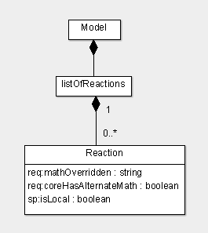
Figure 5 : The extension to the Reaction element. The SBML core atrributes for Reaction are not displayed in the figure.
The req:mathOverridden attribute
The req:mathOverridden attribute for a Reaction is set to the spatial package namespace prefix i.e., “spatial”.
The req:coreHasAlternateMath attribute
The req:coreHasAlternateMath is set to true for a Reaction.
The spatial:isLocal attribute
The isLocal attribute for a Reaction is of type Boolean. The attribute is set to true if the reaction is to be considered a local description of the reaction in terms of concentration/time defined at each point in space rather than substance/time over an entire Compartment or “pool”.

4.8 Geometry
A single geometry must be defined within the model if the spatial extension is to be used. The spatial:Geometry element is defined in the Spatial package namespace (xmlns:spatial=http://www.sbml.org/sbml/level3/version1/spatial/version1). Figure 6 below shows the definition of the spatial:Geometry element.
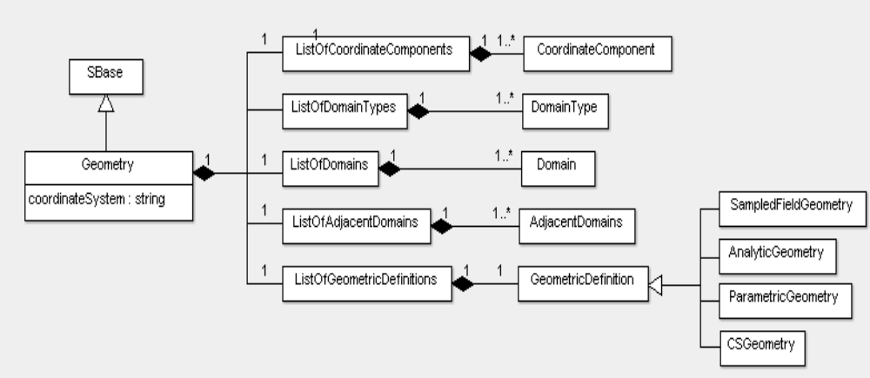

Figure 6 : The definition of the Geometry element. Only one instance of Geometry is present in Model when the spatial package extension is included.

The coordinateSystem attribute
The coordinateSystem attribute is a required attribute and is of type SpId. It represents the coordinate system used by the Geometry. Typically this will be a two or three dimensional cartesian coordinate system, and the coordinate components would correspond to the x, y, and z components. However, there are other coordinate systems in use in biological models, such as spherical and cylindrical symmetry where only the “rho” coordinate component is required and the geometry is one dimensional.

The listOf container classes
The Geometry has listOfCoordinateComponents, listOfDomainTypes, listOfDomains, and listOfAdjacentDomains, and listOfGeometryDefinitions that help define the geometry. The spatial:ListOfCoordinateComponents is a list of spatial:CoordinateComponent objects, the spatial:ListOfDomainTypes is a list of spatial:DomainType objects, the spatial:ListOfDomains is a list of Domain objects, spatial:ListOfAdjacentDomains is a list of spatial:AdjacentDomains objects, and the spatial:ListOfGeometryDefinitions is a list of alternative spatial:GeometryDefinitions (spatial:ParametricGeometry,spatial:CSGeometry, spatial:SampledFieldGeometry, spatial:AnalyticGeometry).

CoordinateComponent
A spatial:CoordinateComponent object explicitly defines a coordinate component of the coordinate axes and gives them names, units, and formally associates them with a coordinate system. The spatial:CoordinateComponent also defines the minimum and maximum values of the coordinate axis it represents. The definition of spatial:CoordinateCompartment is shown in Figure 7.
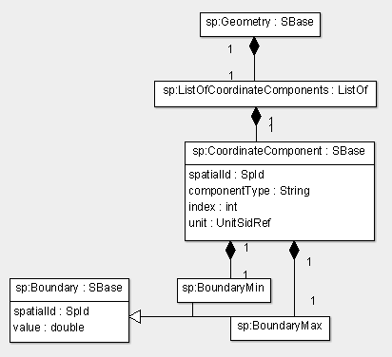

Figure 7 : The CoordinateComponent object definition. One or more instances of CoordinateComponent objects in a ListOfCoordinateComponents can be present in Geometry.

The spatialId attribute
A spatial:CoordinateComponent is identified with the spatialID attribute which is of type SpId. When referenced (for example, via a spatial:SpatialSymbolReference extension of the SBML core Parameter object) and used within a mathematical expression, it represents the coordinate value for this spatial:CoordinateComponent.

The componentType attribute
The componentType attibute of type string represents the type of the coordinate component. For example, if the Geometry is defined in the Cartesian coordinate system, the coordinateType attribute would have values of “cartesianX”, “cartesianY”, “cartesianZ” for the x, y, z, coordinate axes respectively.

The index attribute
The index attribute, of type integer, represents the coordinate index of the spatial:CoordinateComponent. For the Cartesian coordinate system, the coordinateIndex can have a value of 0, 1, or 2 for the x, y, or z coordinate respectively.

The sbmlUnit attribute
The unit of a CoordinateComponent is represented by the sbmlUnit attribute. This attribute is of type UnitSIdRef. A unit needs to be specified for the CoordinateComponent since the length unit from SBML Core is a distance metric and this is not always the same as the unit of each individual coordinate. For example, in Polar coordinates, the coordinate component ‘theta’ may be described in radians while component ‘rho’ may be in microns.

4.8.1.1 The BoundaryMin and BoundaryMax elements
The minimum and the maximum for a spatial:CoordinateComponent represent the bounds in each coordinate. For example, for three dimensional Cartesian coordinate system with x, y, and z coordinates, the minimum and maximum limits for each coordinates define planes orthogonal to each coordinate axis and passing through the minimum or maximum. If max-min is the same for each x,y,z then the bounds on the geometry is a cube. For species defined within volumes adjacent to these surfaces, boundary conditions must be introduced. Independent of the mathematical framework, the boundary conditions can be described as independently specified molecular sources/sinks (molecular flux is given) or as infinite pools of molecules (concentration is given).
The minimum limit of a spatial:CoordinateComponent is represented by the spatial:BoundaryMin object and the mamimum limit is represented by the spatial:BoundaryMax object. Both spatial:BoundaryMin and spatial:BoundaryMax have the following attributes.
4.8.1.1.1 The spatialId attribute
The spatialId attribute of the spatial:BoundaryMin or spatial:BoundaryMax object identifies the object. The attribute is required and is of type SpId. This attribute is used when specifying the spatial:BoundaryCondition for a species as an extension of an SBML core Parameter.
4.8.1.1.1 The value attribute
The value attribute is of type double. In a spatial:BoundaryMin object, it represents the minimum limit of the CoordinateComponent it is defined in. In a spatial:BoundaryMax object, the value attribute represents the maximum limit of the spatial:CoordinateComponent.

4.8.2 DomainType
A spatial:DomainType is a class of domains that are identified as being anatomically and physiologically similar. For example, a spatial:DomainType “cytosol” may be defined in a spatial:Geometry as identifying the structure and function of the cell interior. If there is one cell, then there is one domain, if there are multiple cells, then there are multiple disjoint domains (“cytosol1”,”cytosol2”, etc.) identified with the spatial:DomainType “cytosol”. spatial:ComparmentMappings, defined as an extension to an SBML core Compartment, map compartments to domainTypes such that each corresponding domain is assigned the same biological and mathematical function. Figure 8 shows the spatial:DomainType object.
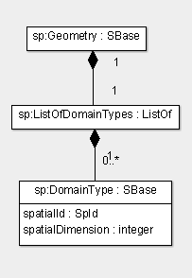
Figure 8 : The DomainType object. One or more instances of DomainType in a ListOfDomainTypes instance can be present in a Geometry object.

The spatialId attribute
Each spatial:DomainType are identified with a spatialID of type SpId. When referenced and used within a mathematical expression, it represents the sum of the sizes of all domains associated with this spatial:DomainType.

The spatialDimension attribute
The spatialDimension attribute of the spatial:DomainType is of type integer and can take on a value of 0, 1, 2, or 3. The spatial dimension is specified for a spatial:DomainType, rather than being repeated for each spatial:Domain that is represented by the spatial:DomainType. The spatial dimension of the spatial:Domains and the corresponding spatial:DomainType must match.
4.8.3 Domain
spatial:Domains represent contiguous regions identified by the same spatial:DomainType. One, two and three dimensional domains are contiguous linear regions, surface regions, and volume regions respectively bounded by the limits of the coordinate system (e.g. min/max of x,y,z) and adjacent domains corresponding to different domain types. Domain is shown in Figure 9.
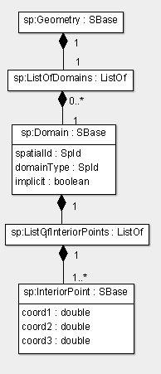
Figure 9 : The definition of the spatial:Domain object. A spatial:ListOfDomains instance in spatial:Geometry can contain one or more spatial:Domain object instances.

The spatialId attribute
A spatial:Domain is identified with a spatialID attribute of type SpId. This spatialId may be used within a spatial:SpatialSymbolReference object that is extended from an SBML core Parameter and can be used in an expression. When referenced, the domain evaluates to the absolute size of that domain as used by the simulator (the meshed size).

The domainType attribute
The domainype attribute refers to the spatialId of the spatial:DomainType that describes the anatomy and physiology of this domain. The attribute is of type SpIdRef. It is through this association that compartments, and hence the whole SBML model, gets mapped to the individual domains.

The implicit attribute [deprecated]
The implicit attribute is really a function of the GeometryDefinitions for a given geometry, and may be “true” for a surface in an AnalyticVolume and at the same time “false” for a ParametricGeometry (surface representation). This quantity is also not essential for geometric understanding.

The InteriorPoint element
Each spatial:Domain can contain a spatial:ListOfInteriorPoints. The list of spatial points for a domain is interior to that domain. This list is optional for a spatial:Domain if it is the only spatial:Domain defined for its spatial:DomainType.
For those geometric descriptions that can describe multiple disjoint domains belonging to the same domainType, these interior points allow unambiguous identification of each domain. Formally, a single point would suffice, but in practice some tools (e.g. Smoldyn) require multiple points to handle non-convex volumes bounded by explicit surfaces. For discontinuous surfaces with the same domainType, the interior point identifies which domain is associated with which surface patch defined in the geometry definition.
Each InteriorPoint has three attributes coord1, coord2, coord3.
The coord1, coord2, coord3 attributes
An InteriorPoint element represents a single point within the defined coordinate system and should be in the interior of the domain that contains it. It has three attributes, coord1, coord2, and coord3, of type double, representing the position along each of the 3 coordinate axes defined by the spatial:CoordinateComponents (with index 1, 2 and 3 respectively for a three dimensional geometry).
In the case of surfaces, interior points are sometimes required to make unambiguous identification of multiple surfaces (e.g multiple plasma membranes for multiple cells present in a geometry). Due to roundoff error and finite word lengths, it is difficult to find a three dimensional point that lies on a surface. In this case, the distance from the surface will be used to provide unambiguous identification.

AdjacentDomains
spatial:AdjacentDomains (or domain adjacencies) captures the topological relationships within the spatial:Geometry. Consider that the spatial:Domains are nodes in a graph. The spatial:AdjacentDomains objects are the edges that specify the spatial connectivity of these nodes. Armed with the topology and the domain sizes, one can readily perform a compartmental approximation. Figure 10 shows the definition of the spatial:AdjacentDomains object.
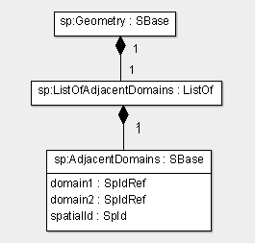
Figure 10 : The spatial:AdjacentDomains object. spatial:Geometry can contain one instance of spatial:ListOfAdjacentDomains that can have one or more instances of spatial:AdjacentDomain objects.

The spatialId attribute
This attribute identifies an spatial:AdjacentDomains object. The attribute is of type SpId.

The domain1 and domain2 attributes
The domain1 and domain2 attributes, of type SpIdRef, are required attributes. They are the spatialIds of two domains that touch each other (spatially adjacent). These are typically surface-volume contacts.
    - GeometryDefinition
A spatial:Geometry can specify a list of spatial:GeometryDefinitions. The spatial:GeometryDefinition is abstract and is the general term for the container which defines the concrete geometric constructs represented by the spatial:Geometry. Four types of spatial:GeometryDefinitions have been identified – spatial:AnalyticGeometry, spatial:SampledFieldGeometry, spatial:ParametricGeometry, spatial:CSGeometry (Constructed Solid Geometry) – and are elaborated in the following sections. The definition of the spatial:GeometryDefinition element is displayed in Figure 11 below.
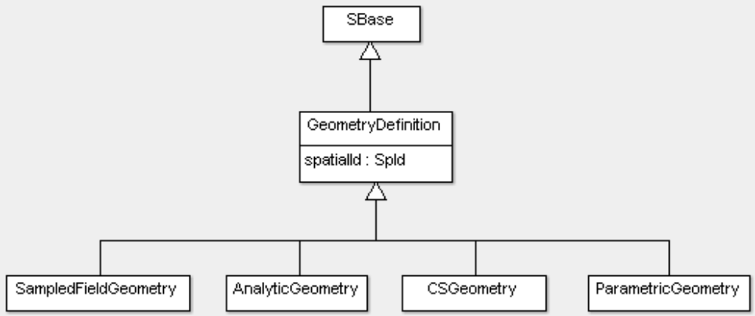
Figure 11 : The GeometryDefinition element. Geometry contains one instance of listOfGeometryDefinitions that can contain one or more instances of GeometryDefinition (one of AnalyticGeometry, SampledFieldGeometry, CSGeometry, ParametricGeometry).

The spatialId attribute
The spatialId attribute that is common to all the GeometryDefinition types is used to uniquely identify the GeometryDefinition. The attribute is of type SpId.
4.8.5.1 AnalyticGeometry
The spatial:AnalyticGeometry is a class of spatial:GeometryDefinition where the geometry of each domain is defined by an analytic expression. An spatial:AnalyticGeometry is defined as a collection of spatial:AnalyticVolumes, one spatial:AnalyticVolume for each volumetric domain in the geometry. In this representation, the surfaces are treated as the boundaries between dissimilar spatial:AnalyticVolumes. The spatial:AnalyticGeometry object contains a spatial:ListOfAnalyticVolumes. Figure 12 shows the definition of the spatial:AnalyticGeometry object.
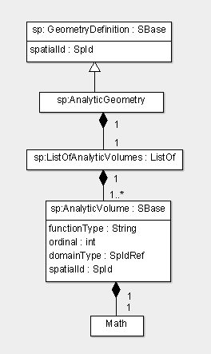
Figure 12 : The definition of the AnalyticGeometry object.

The AnalyticVolume element
The spatial:AnalyticVolume is used to specify the analytic expression of a volumetric (3-dimensional) domain. The analytic expression for the spatial:AnalyticVolume is defined in the Math element.
The spatialId attribute
The spatialId attribute uniquely identifies the spatial:AnalyticVolume. The attribute is required and is of type SpId.
The functionType attribute
The functionType attribute is of type string and is currently limited to “layered” (to be renamed), or “R-function”. A “layered” function type implies that the Math child element contains an inequality in the spatial dimensions (e.g. x,y,z) such that evaluation to “true” indicates that the point (x,y,z) is within that shape, and “false” indicates that it is not covered by that shape. The “R-function” functionType indicates that the shape is represented by a real-valued function whose sign indicates coverage by the shape.
The domainType attribute
The domainType attribute of type SpIdRef is a required attribute. It represents the spatialId of the spatial:DomainType of the spatial:Domain that is represented by this spatial:AnalyticVolume.

The ordinal attribute
The ordinal attribute of type int is an optional attribute. It is used to represent the order of the spatial:AnalyticVolume. The ordinal is useful while reconstructing the geometry in the specific software tool – it represents the order in which the spatial:AnalyticVolumes representing geometric domains have to be evaluated.
Rather than struggle with the task of preventing overlapping regions of space from different spatial:AnalyticVolumes, the spatial:AnalyticVolumes are to be considered to be evaluated in the reverse order of their ordinals. In this way, any spatial:AnalyticVolumes that have already been processed will cover those with a smaller ordinal, thus resolving any ambiguities and removing the constraint that all spatial:AnalyticVolumes be disjoint and cover the entire geometric domain. The spatial:AnalyticVolume with ordinal 0 can be the “background” layer (typically the extracellular space).
4.8.5.1.2 The Math element
The Math element is a required element for an spatial:AnalyticVolume. The Math element contains a MathML expression that defines the analytic expression for the spatial:AnalyticVolume referencing the coordinate components that are specified in the spatial:ListOfCoordinateComponents in the spatial:Geometry.

4.8.5.2. SampledFieldGeometry
SampledFieldGeometry is a type of GeometryDefinition that defines a sampled image-based geometry or a geometry based on samples from a level set. SampledFieldGeometry is defined using a SampledField that specifies the sampled image and a list of SampledVolumes that represent the volumetric domains as sampled image regions. Figure 13 shows the definition of the SampledFieldGeometry object.
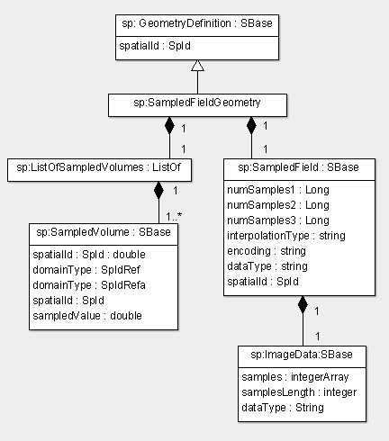
Figure 13 : The definition of the SampledFieldGeometry object.
4.8.5.2.1 The SampledVolume element
A SampledVolume represents an interval of the sampled field that constitutes one or more contiguous regions. A SampledVolume is defined for each volumetric (3-dimensional) Domain in the Geometry. It has the following attributes.

The spatialId attribute
The spatialId attribute identifies a SampledVolume object. The attribute is of type SpId and is required when specifying a SampledVolume.

The domainType attribute
The domainType attribute is a required attribute of type SpIdRef. It is the spatialId of the DomainType that represents this class of anatomical features. If there are more than one contiguous regions, then more than one domains will be defined corresponding to each SampledVolume.

The sampledValue attribute
The sampledValue attribute is a required attribute of type double. It represents the pixel value of a SampledVolume.

The minValue attribute
The minValue attribute is of type double and is optional. It represents the minimum of the pixel value (sampledValued) range.

The maxValue attribute
The maxValue attribute is of type double and is optional. It represents the maximum of the pixel value (sampledValued) range.

4.8.5.2.2 The SampledField element
A SampledField defined in a SampledFieldGeometry is a sampled scalar field such as an image or samples from a level set. Currently, the attributes of SampledField represent the specification of an image dataset (the number of samples in x, y, z coordinates, data type of the image representation, etc.) and the ImageData element of the SampledField specifies the actual image as integer sampled data.
The spatialId attribute
The spatialId attribute identifies a SampledField. It is of type SpId and is a required attribute.
The numSamples1, numSamples2, numSamples3 attributes
The numSamples1, numSamples2, and numSamples3 attributes represent the number of samples in each of the coordinate components. (e.g. numX, numY, numZ) in an image dataset. These attributes are of type long and are required to specify the SampledField. The samples are assumed to be uniformly sampled.
The dataType attribute
This attribute represents the data type of each sample (e.g. int32). The attribute is of type string and is optional.
The interpolationType attribute
The interpolationType attribute is an optional attribute of type string and represents the interpolation type of the sampled data and is defined as “constant” for zeroth order, “linear” for first order, etc.
The encoding attribute
The encoding attribute is an optional attribute of type string. It is used to specify text encoding and compression.
          - The ImageData element
The ImageData element represents the actual image data of the image-based geometry as encoded samples defined by the encoding and the data type. The ImageData element has the following attributes.
The samples attribute
The samples attribute is an integer array of values representing the image pixel values as an integer array. This attribute is required.
The samplesLength attribute
The samplesLength attribute is of type integer and is required. It represents the array length of the samples attribute (number of values in the image data array).
The dataType attribute
The dataType attribute is of type String and is required. Presently, this attribute indicates if the image data is ‘compressed’ or ‘uncompressed’. (this attribute and the encoding attribute of SampledField have to be revisited).
      - CSGeometry
CSGeometry (Constructed Solid Geometry) is a type of GeometryDefinition that defines a combined, solid, volumetric object from a number of primitive solid volumes by the application of set operations such as union, intersection and difference and affine transformations such as rotation, scaling, translation, etc. The CSGeometry element is defined by a listOfCSGObjects element that contains a collection of CSGObjects. Figure 14 shows the definition of the CSGeometry object.
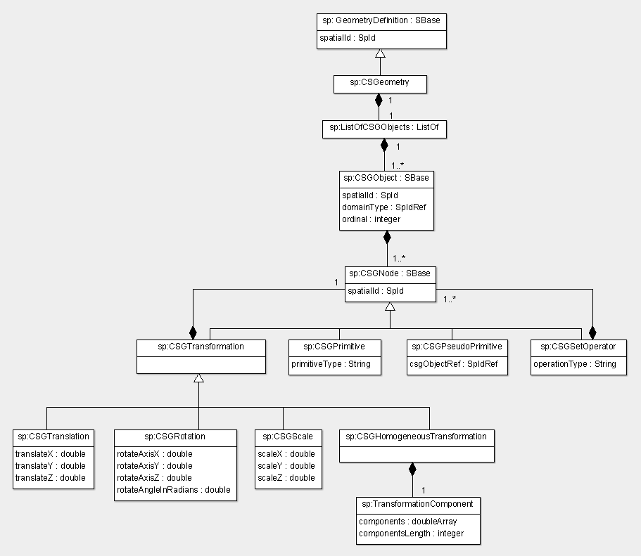
Figure 14 : The definition of the CSGeometry object.

The CSGObject element
Each CSGObject is a scene graph representing a particular geometric object using constructed solid geometry. A node in a tree (scene graph) is made up of CSGPrimitives, CSGSetOperators, and CSGTransformations. Note that the CSGPrimitives are always leaves in this tree. The CSGObject is analogous to an AnalyticVolume element in the sense that it is a constructed geometry (from primitives) used to specify a volumetric (3-dimensional) domain. The CSGObject element has three attributes : spatialId, domain and ordinal. The definition of the CSGobject is completed by defining a CSGNode which is the root of the CSGObject scene graph.

The spatialId attribute
The spatialId attribute uniquely identifies the CSGObject element. The attribute is required and is of type SpId.

The domain attribute
The domain attribute is of type SpIdRef and is a required attribute. It is a reference to the spatialId of the domain that this CSGObject represents.

The ordinal attribute
The ordinal attribute of type int is an optional attribute. It is used to represent the order of the CSGObject. The ordinal is useful while reconstructing the geometry in the specific software tool – it represents the order in which the CSGObjects representing geometric domains have to be placed.

The CSGNode element
The operators and operands used to construct a constructed solid geometry are generalized as a CSGNode. The CSGNode can be one of the following : CSGSetOperator, CSGTransformation (operators) or CSGPrimitive, CSGPseudoPrimitive (operands). The CSGNode has one attribute : spatialId. The CSGObject contains a CSGNode object which is the root of the CSObject scene graph (representing one constructed solid geometry domain).

The spatialId attribute
The spatialId attribute uniquely identifies the CSGNode element. The attribute is required and is of type SpId.

The CSGPrimitive element
CSGPrimitive element represents the primitive geometric shapes that can be represented by the CSGeometry. Some of the primitive shapes that can be used are “sphere”, “cylinder”, “cube”, “cone”, etc. These shapes are defined with a predefined orientation and fitting within the unit cube (+/- 1 in x, y, and z). This element has one required attribute : primitiveType of type string.

The primitiveType attribute
The primitiveType attribute is a required attribute that is of type string. It represents one of the predefined primitive shapes.

The CSGPseudoPrimitive element
CSGPseudoPrimitive element is used to reference a pre-defined CSGObject object while defining a CSGObject (geometric domain). This allows the re-use of constructed CSGObject in another. It has one attribute of type SpIdRef.

The csgObjectRef attribute
The csgObjectRef attribute identifies a pre-defined CSGObject in the CSGeometry The attribute is required and is of type SpId.

The CSGSetOperator element
The CSGSetOperator element represents the set operations (union, intersection, difference) that can be performed on a set of primitive geometric shapes (CSGPrimitives) or on a set of CSGNodes (a transformation or set operation on one or a set of CSGPrimitves). This element has one attribute of type string. It also contains a list of CSGNodes ListOfCSGNodes that represent the set of nodes on which the set operation is performed.

The operationType attribute
The operationType attribute is of type string and represents an operation that can be performed on a set of CSGNodes. The possible values that the operationType attribute can take are “union”, “intersection” or “difference”.

The CSGTransformation element
The CSGTransformation represents a generalization for the type of transformation that can be performed on a primitive geometric shape (CSGPrimitive) or on a CSGNode (a transformation or set operation on one or a set of CSGPrimitves). The types of possible transformations are ‘rotation’, ‘translation’, ‘scaling’, and ‘homogeneous transformation’, defined below. The CSGTransformation element contains a CSGNode element upon which the transformation is performed. It also has one attribute : transformationType of type string.

The transformationType attribute
The transformationType attribute is of type string and is a required attribute. It represents the type of transformation (‘rotation’, ‘translation’, ‘scaling’, and ‘homogeneous transformation’).
            - The CSGTranslation element
The CSGTranslation element represents a translation transformation on a CSGNode (a transformation or set operation on one or a set of CSGPrimitves) or a CSGPrimitive along the axes defined in the Geometry. This element has 3 attributes:

The translateX attribute
The translateX attribute is of type double. It represents the translation of the CSGNode along the x-axis (or first CoordinateComponent defined in Geometry).

The translateY attribute
The translateY attribute is of type double. It represents the translation of the CSGNode along the y-axis (or second CoordinateComponent defined in Geometry).

The translateZ attribute
The translateZ attribute is of type double. It represents the translation of the CSGNode along the z-axis (or third CoordinateComponent defined in Geometry).
            - The CSGRotation element
The CSGRotation element represents a rotation transformation on a CSGNode (a transformation or set operation on one or a set of CSGPrimitves) or a CSGPrimitive about the axes defined in the Geometry. This element has 4 attributes:

The rotateX attribute
The rotateX attribute is of type double. It represents the rotation of the CSGNode along the x-axis (or first CoordinateComponent defined in Geometry).

The rotateY attribute
The rotateY attribute is of type double. It represents the rotation of the CSGNode along the y-axis (or second CoordinateComponent defined in Geometry).

The rotateZ attribute
The rotateZ attribute is of type double. It represents the rotation of the CSGNode along the z-axis (or third CoordinateComponent defined in Geometry).

The rotationAngleInRadians attribute
The rotationAngleInRadians attribute is of type double. It represents the rotation angle of the CSGNode, in radians, along the defined axis.
            - The CSGScale element
The CSGScale element represents a scale transformation on a CSGNode (a transformation or set operation on one or a set of CSGPrimitves) or a CSGPrimitive along the axes defined in the Geometry. This element has 3 attributes:

The scaleX attribute
The scaleX attribute is of type double. It represents the amount of scaling of the CSGNode along the x-axis (or first CoordinateComponent defined in Geometry).

The scaleY attribute
The scaleY attribute is of type double. It represents the amount of scaling of the CSGNode along the y-axis (or second CoordinateComponent defined in Geometry).

The scaleZ attribute
The scaleZ attribute is of type double. It represents the amount of scaling of the CSGNode along the z-axis (or third CoordinateComponent defined in Geometry).
            - The CSGHomogeneousTransformation element
The CSGHomogeneousTransformation element represents a homogeneous transformation on a CSGNode (a transformation or set operation on one or a set of CSGPrimitves) or a CSGPrimitive. This element contains two TransformationComponent elements : a ForwardTransformation and a ReverseTrasnformation.
            - The TransformationComponent element
The TransformationComponent element represents an affine transformation that can be applied to a CSGNode. This element has the following two attributes:
The components attribute
The components attribute is an double array of values representing the affine transformation. This attribute is required.
The componentsLength attribute
The componentsLength attribute is of type integer and is required. It represents the array length of the components attribute (number of values in the components array).
4.8.5.4 ParametricGeometry
ParametricGeometry is a type of GeometryDefinition that parametrically defines geometric strucutures/domains. The ParametricGeometry element is defined with a listOfObjects that is a collection of ParametricObjects and a listOfSpatialPoints that is a collection of SpatialPoints. Figure 15 shows the definition of the ParametricGeometry object.
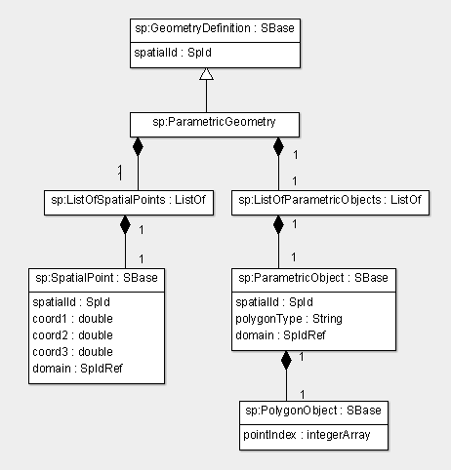
Figure 15 : The definition of the ParametricGeometry object.
        - The ParametricObject element
The ParametricObject element represents a parametric geometry object.
The spatialId attribute
The spatialId attribute is a required attribute of type SpId. It uniquely identifies the ParametricObject element.
The polygonType attribute
The polygonType attribute is of type string and is a required attribute. It represents the type of polygon that describes the ParametricObject.
The domain attribute
The domain attribute is of type SpIdRef and is a required attribute. It is a reference to the spatialId of the domain that this ParametricObject represents.
          - The PolyObject element
The polyObject represents an ordered list of indices that refer to elements in the SpatialPoints array and are interpreted by considering the polygonType attribute of the ParametricObject. For reference, we could consider using the VTK polydata convensions for shapes and vertex orderings.
The pointIndex attribute
The pointIndex attribute is an array of integers holding the indices of the points in the SpatialPoints array.
        - The SpatialPoint element
The SpatialPoint element represents a point used as a vertex in the ParametricGeometry.
The spatialId attribute
The spatialId element uniquely identifies a SpatialPoint element. It is a required attribute and is of type SpId.
The coord1, coord2, coord3 attributes
The coord1, coord2, coord3 attributes are of type double. They represent the 3-dimensional coordinate of the SpatialPoint. Depending on the dimension of the Geometry, one, two or all the three attributes are required.
The domain attribute
The domain attribute is of type SpIdRef and is a required attribute. It is a reference to the spatialId of the domain which contains this SpatialPoint.

Package dependencies
There are no package dependencies. However, if the current proposal is decomposed into two packages (a geometry package and a spatial modeling package), then the spatial modeling package would require a geometry package.

Use-cases and examples

Prototype implementations
Virtual Cell 5.3 includes
The sourceforge repository has a spatial plugin directory with source to the spatial extension using libSbml 5.5.0. The C++ libraries have been built and Java bindings have been created using SWIG.
The current VCell Test site (5.3) uses this modified libSbml 5.5.0-req-spatial libraries and supports export and import of analytic, image-based and constructed solid geometries to/from VCell spatial models as well as the discussed CompartmentMappings and a SBML compatable unit handling system.

Translation to SBML Level 2
There is no counterpart of explicit spatial modeling in SBML Level 2. One may automatically generate a well-stirred compartmental approximation which in turn could be translated to SBML Level 2. However that would result in a different model.

Unresolved issues

Alternative Reaction Kinetics descriptions (local, lumped)
Having alternate kinetic descriptions for chemical reactions may become more necessary as SBML expands to other domains of modeling. One approach is to attempt to describe the reaction kinetics in a domain-specific language that is independent of the mathematical framework to be applied. In this case, the formula is omitted but can be inferred for a particular mathematical framework from the SBO annotation of the KineticLaw and the LocalParameters. The other approach would be to provide one or more KineticLaws that are each fully defined for a single mathematical framework. In this case, to remove ambiguity, the use of the Reaction Sid within mathematical expressions to reflect the reaction velocity would be removed … and the SID of the alternate KineticLaws would be used in its place … with the well-defined units appropriate for that mathematical framework.

ParametricGeometry as a separate extension
ParametricGeometry is the least mature GeometryDescription in this proposal, and the most controversial. A simple version based on the VTK format would provide an existing high quality library and mature specification for flexible handling of polyhedral meshes.

(domainType or compartment) and isSpatial for Parameter
In SBML core, Parameters can be the target of rate rules such that they become dynamical variables described by ordinary differential equations. In the Spatial extension, should Parameters can be the targets of spatial:DiffusionCoefficients, spatial:AdvectionCoefficients, spatial:BoundaryConditions, and spatially varying InitialAssignmentRules. For RateRules, the complete mathematical form is specified, and the analogous Rule for spatial could be a ReactionDiffusionAdvectionRule which explicitly includes For the spatial-determinstic mathematical framework of partial differential equations.

References
[1] SBML Level 3 Core specification

Appendix

