Requirement Specifications For Level-2 Parameters Required Stored or Derived by
The Near Earth Asteroid Rendezvous (NEAR) Gamma-Ray Spectrometer (GRS) Ground System

Irina Mikheeva (UA) and Tim McClanahan (GSFC)

Revision 1.5: May 25, 2001

Table of Contents

- Introduction and Purpose..................................................................................................................…..1

- The UA-LPL Ground Processing Environment....................................................................................2

- Description of NEAR GRS Data File Standards...............................................................................….3

- Fractional Footprint Accounting............................................................................................................4

- Listings of Parameters for GRS Level-2 Integral Records...............................................................…5
E.1-E.7. NEAR GRS Spectra...................................................................................................................5
E.8. NEAR GRS Science Housekeeping (SCI HK) Parameters........................................................5
E.9. NEAR GRS Engineering Housekeeping (ENG HK) Parameters...............................................6
E.10. NEAR GRS Derived Engineering (DER ENG) Parameters.....................................................10
E.11. NEAR GRS Spatial (SPATIAL) Parameters............................................................................10

- Listings of Parameters for GRS Level-2 Summary Record............................................................…11
F.1-F.7. NEAR GRS Summarized Spectra............................................................................................11
F.8. NEAR GRS Summarized Engineering (ENG) Parameters.......................................................11
F.9. NEAR GRS Summarized Spatial (SPATIAL) Parameters.......................................................12

- Listings of Parameters for GRS Fractional Footprint Accounting System.................................…12

- Numerical Specifications for GRS Level-2 Integral Records............................................................12
H.1-H.7. NEAR GRS Spectra.................................................................................................................12
H.8. NEAR GRS Science Housekeeping (SCI HK) Parameters......................................................13
H.9. NEAR GRS Engineering Housekeeping (ENG HK) Parameters.............................................13
H.10. NEAR GRS Derived Engineering (DER ENG) Parameters.....................................................13
H.11. NEAR GRS Spatial (SPATIAL) Parameters............................................................................14

- Numerical Specifications for GRS Level-2 Summary Record...........................................................22
I.1-I.7. NEAR GRS Summarized Spectra......................................................................................…...22
I.8. NEAR GRS Summarized Engineering (ENG) Parameters.......................................................23
I.9. NEAR GRS Summarized Spatial (SPATIAL) Parameters.......................................................24

- Numerical Specifications for GRS Fractional Footprint Accounting System.................................27

APPENDIX 1. Definitions for: Instr_Angular_Response_Fct_YYMeV
(where YY can be 0.3, 0.6, 1.0, 3.0 or 6.0); NC_Angular_Fct;
NC_Geom_Weight_YYMeV; NC_Weight_YYMeV;
NR_Geom_Weight_YYMeV; NR_Weight_YYMeV.....................................................30

APPENDIX 2. Approximations for: Instr_Angular_Response_Fct_YYMeV,
(where YY can be 0.3, 0.6, 1.0, 3.0 or 6.0); NC_Angular_Fct...................................…32

APPENDIX 3 Location of GRS Level-2 Parameters in the U of A Database....................................36

NEAR GRS Requirements Specs Revision Notes................................................................................…47

NEAR GRS Glossary and Acronym List..................................................................................................49

Introduction and Purpose

The following document will act as one part of a two part requirement specification for all Level-2 parameters required to be stored or derived by the Near Earth Asteroid Rendezvous (NEAR) X-ray and Gamma-Ray spectrometer ground system (XGRS). It will relate specifically to the Gamma-Ray spectrometer (GRS) requirements. The document will act as a primary common reference for both NEAR X-ray and Gamma-ray spectrometer (XGRS) science team members, systems development staff and future users of these data. The goal is to assist in the development and understanding of parameters defined as key to the NEAR XGRS Science objectives.

A primary data server residing at the University of Arizona, Lunar and Planetary Laboratory (UA-LPL) is designated with the function of deriving and serving mission critical parameters during cruise and encounter phases of the NEAR mission scheduled from February 1996 through February 2001. The intent of the first level product is to include all NEAR XGRS mission critical information needed for asteroid mapping, health of instrument, control, and science analysis systems.

Level -1 products will include integral spectral data in either raw or instrument calibrated format. Bundled with the spectral data products will be scientific housekeeping and engineering housekeeping data sampled by the XGRS instrumentation at the same time as the integral spectra onboard the spacecraft. This information is then telemetered through NASA’s Deep Network (DSN) managed by the Jet Propulsion Laboratory in Pasadena, California, and NEAR related telemetry is forwarded to the Applied Physics Laboratory (APL). The Level-0 XGRS raw spectral and engineering data is then broken out of the NEAR mission specific data stream and stored online at the APL Science Data Center (SDC). These data are stored in the Hierarchical Data Format (HDF) file standard. These files are then picked up by the automated (UA-LPL) data processing ingest system.

Figure 1.0 NEAR XGRS OPERATIONAL FLOW OF INFORMATION
NEAR
SPACECRAFT
MAX PLANCK
INSTITUTE FOR CHEMISTRY
DEEP SPACE NETWORK (DSN)

JET PROPULSION LABORATORY
NEAR Telemetry
Flow MAX PLANCK
APL Meteorite Libraries
Serve HDF Science Analysis
APPLIED PHYSICS LABORATORY
Serve SPICE
Validate SC MACROS
UA-LPL
NEAR XGRS Data Server
Level 1 Processing
NASA GODDARD SPACE FLIGHT CENTER
UNIVERSITY OF ARIZONA LUNAR AND PLANETARY
LABORATORY

Science Analysis
Raw Spectral Data Products

Calibration and Quicklook Info
GSFC
Instrument MACROS
CORNELL UNIVERSITY XGRS health of mission
Coverage Mapping Spacecraft Pointing
CORNELL
UNIVERSITY
Instrument Pointing Plan Science Analysis

- The UA-LPL Ground Processing Environment

The core of the UA-LPL data processing system (Figure 2.0) consists of a Sybase Relational Database (UA-RDBMS) that stores tables of NEAR XGRS raw spectral, science housekeeping, engineering housekeeping, derived engineering and spatial data products. XRS and GRS data processing systems are logically partitioned into separate processing environments on the UA-LPL server. A scientific data processing system has been developed around the UA-RDBMS to provide automated data ingest and science team interaction. Critical spatial and derived engineering data products are generated either at ingest time or query time. Core query time processing options include calibration and summation processing, compression and bundling of query results for return to the scientific user community over the Internet file transfer protocol (FTP).

Figure 2.0 NEAR XGRS Ground Processing System at the UA-LPL

Ingest Proc
Spatial Process
Calibration
User Comm
Bundling
Summation
WWW Interface
UA-LPL
RDBMS
NASA Goddard
Calibrate
Quicklook
Inst. Health

UA-LPL database ingest systems automatically monitor the APL SDC for new and updated postings of XGRS data sets. These file sets are recovered via the file transfer protocol (FTP) to the UA-LPL data system. Raw spectral and engineering data products are then loaded into XGRS RDBMS tables with Mission Elapsed Time (MET) acting as the primary key for database access. Mission Elapsed Time is used with spacecraft ephemeris data SPICE system, APL Science Data Center and JPL/NASA Ancillary Information Facility) to derive spatial data products. Spacecraft navigation and pointing information is converted to SPICE data for the NEAR XGRS ground system and will be generated by participating scientists at APL/SDC. These products will then be maintained within the UA-RDBMS database system.

At Goddard Space Flight Center participating scientists will be charged with monitoring instrument health, calibration, and bad data flagging systems. These data are then forwarded to on-line ingest processes at the UA-RDBMS. The calibration system will be used to convert spectral data products to a common energy standard specified at query time. Calibration processing is optionally selected at query time. Bad flagging information is generated during instrument health checks as a function of identification of problem (MET) record sets. These (MET)’s are forwarded to the UA-LPL RDBMS for tagging.

Query time summation processes will be used to sum multiple integral record sets into a single output record. This record will include one spectrum per spectral classification and selected engineering products. Summed output will generally be specific to regional coverage and science analysis. The primary motivation for summation processing is to limit large volume network transfers incurred in this distributed processing environment. Results are then accumulated in the Xternal Data Representation (XDR) binary file standard (Sun Microsystems) then compressed, bundled and forwarded to the query initiator.

C. Description of NEAR GRS Data File Standards

In the NEAR GRS data processing system there are 3 data file standards possible for output. These different file standards reflect the different UA-LPL ground processes selectable at query time. Output format type is selected at query time through the UA-LPL WWW query interface. Integral raw GRS products will be used primarily in the calibration, instrument health and mission planning activities. Calibrated data will be used primarily in the science analysis activity. Formats for the three record standards are as follows.

Figure 3.0
FORMAT 1: GRS Integral Raw:
NAI BGO ANTICO NAI1ESC BGO1ESC NAI2ESC BGO2ESC SCI HK ENG HK DER ENG SPATIAL SPARE

Description:
- NAI 1024 R*4 Sodium Iodide (NaI) raw spectrum E.1., H.1.
- BGO 1024 R*4 Bismuth Germanate (BGO) raw spectrum E.2., H.2.
- ANTICO 1024 R*4 AntiCoincidence raw spectrum E.3., H.3.
- NAI1ESC 1024 R*4 NaI single escape raw spectrum E.4., H.4.
- BGO1ESC 21 R*4 BGO single escape raw spectrum E.5., H.5.
- NAI2ESC 1024 R*4 NaI double escape raw spectrum E.6., H.6.
- BGO2ESC 21 R*4 BGO double escape raw spectrum E.7., H.7
- SCI HK 31 I*4 Science Housekeeping sampled at integration time E.8., H.8.
- ENG HK 152 R*4 Engineering Housekeeping sampled at integration time E.9., H.9.
- DER ENG 17 R*4 Derived Engineering: only live times, galactic cosmic E.10., H.10.
ray (GCR) flux, real gain zero** estimates and position
of escape windows are valid ELSE Default value
5 I*4 1 longword for BadFlag and 4 longwords for QueryID
- SPATIAL 1 I*4 Mission Elapsed Time (MET) E.11., H.11.
32 R*4 Spatial derivations, positional and pointing information
- SPARE 25 R*4 To Be Decided (TBD)

FORMAT 2: GRS Integral Calibrated:
NAI BGO ANTICO NAI1ESC BGO1ESC NAI2ESC BGO2ESC SCI HK ENG HK DER ENG SPATIAL SPARE

Description:
- NAI 1024 R*4 Sodium Iodide (NaI) calibrated spectrum E.1., H.1.
- BGO 1024 R*4 Bismuth Germanate (BGO) calibrated spectrum E.2., H.2.
- ANTICO 1024 R*4 AntiCoincidence calibrated spectrum E.3., H.3.
- NAI1ESC 1024 R*4 NaI single escape calibrated spectrum E.4., H.4.
- BGO1ESC 21 R*4 BGO single escape raw spectrum E.5., H.5.
- NAI2ESC 1024 R*4 NaI double escape calibrated spectrum E.6., H.6.
- BGO2ESC 21 R*4 BGO double escape raw spectrum E.7., H.7.
- SCI HK 31 I*4 Science Housekeeping sampled at integration time E.8., H.8.
- ENG HK 152 R*4 Engineering Housekeeping sampled at integration time E.9., H.9.
- DER ENG 17 R*4 Derived Engineering: All information is valid E.10., H.10.
5 I*4 1 longword for BadFlag and 4 longwords for QueryID
- SPATIAL 1 I*4 Mission Elapsed Time (MET) E.11., H.11.
32 R*4 Spatial derivations, positional and pointing information
- SPARE 25 R*4 To Be Decided (TBD)

Nomenclature for GRS integral data products: FORMATS 1 and 2 (Calibrated and Raw)
g(yyyy)(ddd)(hh)(mm)(ss).xdr Example: g1998234010159.xdr

NEAR GRS Summation Processing: (Format 3)
The NEAR XGRS data processing ground system is a distributed system that currently spans institutions in the United States and Europe. The summation processing system has been specified to render the possibly very large volumes of data (> Gbytes) returned from a single query down to a single summary record. The intention of summation processing will be to minimize the per query network data transfer size (bytes), by rendering a single summed spectrum from a relationally defined set. Correlated parameters will be bundled with this summed set. The summation ground processing step will be supported only on calibrated spectral data products.

FORMAT 3: GRS Summed:
NAI BGO ANTICO NAI1ESC BGO1ESC NAI2ESC BGO2ESC ENG SPATIAL

Description:
- NAI 1024 R*4 Sodium Iodide (NaI) calibrated summed spectrum F.1., I.1.
- BGO 1024 R*4 Bismuth Germanate (BGO) calibrated summed spectrum F.2., I.2.
- ANTICO 1024 R*4 AntiCoincidence calibrated summed spectrum F.3., I.3.
- NAI1ESC 1024 R*4 NaI single escape calibrated summed spectrum F.4., I.4.
- BGO1ESC 21 R*4 BGO single escape raw summed spectrum F.5., I.5.
- NAI2ESC 1024 R*4 NaI double escape calibrated summed spectrum F.6., I.6.
- BGO2ESC 21 R*4 BGO double escape raw summed spectrum F.7., I.7
- ENG 13 R*4 Engineering and Derived Eng F.8., I.8.
- SPATIAL 13 R*4 Averaged Spatial parameters F.9., I.9.

Nomenclature for GRS integral data products: FORMATS 3 (Summed)
h(yyyy)(ddd)(hh)(mm)(ss).xdr Example: h1998234010159.xdr

Summation processing will be query specific and all derived engineering tracking is done internal to each query process. All (XDR) file sets returned from the query will be run through the summation processing system. Integral calibrated spectra will be summed into single GRS specific output sets. Selected engineering and spatial parameters are also averaged into values representative of the parameter over the range of output (MET) records and specific to each query. Parameter rendering algorithms are listed in the numerical specifications (Section I).

Fractional Footprint Accounting

The 433Eros asteroid is highly irregular in shape and deviates significantly from a spherical geometry. A system was developed by NEAR XGRS staff to partition a virtual representation of the 433Eros asteroid into surface regions (bins) of roughly equal surface area, not based on spherical geometry. The bin system is internal to the UA-RDBMS ground processing system.

Individual spectral accumulations will most likely span multiple asteroid surface bins. This system will be used to discriminate and identify the applicability of integral footprints, based on their fractional coverage of the asteroid surface bin being queried. During UA-RDBMS ingest processing each integral footprint will be broken down into a set of records, one bin record for each bin subtended by the footprint. The current plan does not include the possibility of using the fractional footprint as a weighting function when automatically summing spectral data at query time. The fractional footprint accounting will be used as a query time threshold criteria for inclusion of the integral MET to summation processing.

Figure 3.0
FOOTPRINT BIN MET = Single Integration Mission Elapsed Time (MET)

Fractional Footprint Accounting (MET in Spatial Bins)
A B

C D
BIN A BIN B BIN C BIN D

MET 0.2 MET 0.1 MET 0.4 MET 0.3

1 Integral Footprint at MET
Fraction totals = 1.0
4 total records generated Asteroid Spatial Bins A,B,C,D

A query time specification requesting all integrations (MET records) from Bin C with a fractional footprint area
>= 0.4 would return the example integration and others whose fractional coverage are at least 0.4.
Information related to the bin processing is included in sections G and J.

Listings of Parameters for GRS level–2 Integral Records

FORMATS 1,2 - List of RDBMS parameters for Single Raw and Calibrated GRS Level-2 record (output)

E.1. – E.7. NEAR GRS Spectra: 4 spectra*1024 channels*(Real*4), 1 spectrum*21 channels(Real*4), 1 spectrum*1024 channels*(Real*4), 1 spectrum*21 channels(Real*4)

0 – 1023 Sodium Iodide (NAI) spectrum
0 – 1023 Bismuth Germanate (BGO) spectrum
0 – 1023 Anti-Coincidence (ANTICO) spectrum
0 – 1023 Sodium Iodide (NAI1ESC) single escape spectrum
0 – 20 Bismuth Germanate (BGO1ESC) single escape spectrum
0 – 1023 Sodium Iodide (NAI2ESC) double escape spectrum
0 – 20 Bismuth Germanate (BGO2ESC) double escape spectrum

E.8. NEAR GRS Science Housekeeping (SCI HK) Parameters: 31*(Integer*4)

The following parameters are described in detail in the NEAR XGRS DPU Software Requirements Specification JHU/APL Version 7 7358-9002. Version 7 of the software was uploaded in May 1999.

- MET
- UTC
- DQI * Data Quality Index

TIME_TAG
- INTEGRATION_TIME
- BGO_PROTON_FLARE_FLG
- BGO_LEVEL_1_SAFE_FLG Version 7
- BGO_LEVEL_2_SAFE_FLG
- NAI_LEVEL_1_SAFE_FLG
- NAI_LEVEL_2_SAFE_FLG
- NAI_INT_OVERFLOW_FLG
- BGO_INT_OVERFLOW_FLG
- NAI_ANTICOINCID_OVFL_FLG
- NAI_SINGLE_ESCP_OVFL_FLG
- NAI_DOUBLE_ESCP_OVFL_FLG
- BGO_SINGLE_ESCP_OVFL_FLG
- BGO_DOUBLE_ESCP_OVFL_FLG
- NAI_RAW_EVENT_RATE
- BGO_RAW_EVENT_RATE
- COINCIDENCE_COUNTER Version 7
- COMMAND_COUNTER Version 7
- PROBLEM_COUNTER Version 7
- PROBLEM_CODE Version 7
- NUM_NAI_ANTICOINCID_EVENTS
- NUM_NAI_VALID_EVENTS
- NUM_BGO_VALID_EVENTS
- NAI_DC_OFFSET Downlinked value. No conversion to energy
bins is performed. ( no devision by 2 as required by NEAR XFRS DPU Software Requirements Specifications JHU/APL 7358-9002 Version 7)
- BGO_DC_OFFSET - “ -
- NAI_STAND_DEV - “ -
- BGO_STAND_DEV - “ -

30 GRAY_DATA_QUALITY_BIT Version 7

E.9. NEAR GRS Engineering Housekeeping (ENG HK) Parameters: 152*(REAL*4)

The following parameters are described in detail in the NEAR XGRS DPU Software Requirements Specification JHU/APL Version 7 7358-9002. Version 7 of the software was uploaded in May 1999.

ENG_HK Parameters 0:137 are common to XRS and GRS. Parameters are sampled at XRS and GRS

Resolutions.

- DETECTOR_ELECTR_CURR
- XRAY_PIN_DIODE_FET_BIAS
- HVCE_TEMPERATURE
- UNF_XRAY_HVPS_VOLT
- MG_XRAY_HVPS_VOLT
- AL_XRAY_HVPS_VOLT
- XRAY_GAS_HVPS_VOLT
- XRAY_PIN_HVPS_VOLT
- NAI_HVPS_VOLT
- BGO_HVPS_VOLT
- DPU_DC_DC_TEMP
- XGRS_DC_DC_TEMP
- UNF_XRAY_HVPS_TEMP
- MG_XRAY_HVPS_TEMP
- AL_XRAY_HVPS_TEMP
- XRAY_GAS_HVPS_TEMP
- XRAY_PIN_HVPS_TEMP
- NAI_HVPS_TEMP
- BGO_HVPS_TEMP
- TEC_CURRENT
- NAI_HVPS_VOLT_CMD
- BGO_HVPS_VOLT_CMD
- UNF_HVPS_VOLT_CMD
- MG_HVPS_VOLT_CMD
- AL_HVPS_VOLT_CMD
- HVPS_POWER_ON_OFF
- XRAY_CALIB_HOME_FLG
- XRAY_CALIB_MOTOR_ON_OFF
- XRAY_CALIB_MOTOR_ENABLE
- GAS_HVPS_VOLT_CMD
- PIN_HVPS_VOLT_CMD
- GAMMA_RAY_HEATER_CURR
- spare0
- XRAY_CALIB_MOTOR_DIR
- XRAY_CALIB_MOTOR_CURR
- XRAY_CALIB_MOTOR_GOAL
- XRAY_CALIB_MOTOR_POS
- XRAY_CALIB_MOTOR_FID_SENS
- XRAY_CALIB_MOTOR_FID_BRIT
- XRAY_MOTOR_IN_CALIB_POSITION
- XRAY_MOTOR_IN_NORM_POSITION
- ACTIVE_SOLAR_TOGGLE_MODE
- XRAY_CALIB_MAX_STEPS
- Spare
- TEC_ENABLE
- XRAY_CALIB_CUM_MOTOR_STPS
- GRAY_BURST_THRESH_VAL
- XRAY_SAFING_THRESH
- XRAY_CALIB_MOTOR_DIAG
- TEC_POWER_ON_OFF
- TEC_MODE
- TEC_COOL_HEAT_FLG
- TEC_TEMPERATURE
- TEC_COOL_MODE_TEMP_UP_LMT
- TEC_COOL_MODE_TEMP_LOW_LMT
- TEC_HEAT_MODE_TEMP_UP_LMT
- TEC_HEAT_MODE_TEMP_LOW_LMT
- GAMMA_RAY_TEMP_HYSTERESIS
- GAMMA_RAY_HEAT_TEMP_LOW_LMT
- FULL_GAMMA_RAY_SCIENCE_MODE
- FULL_XRAY_SCIENCE_MODE
- SUMM_GRAY_XRAY_SCIENCE_MODE
- GRAY_BURST_SCI_REC_MODE
- HVCE_TEMP_SET_POINT
- CMDED_END_XRAY_INTEG_PER
- CMDED_GAMMA_RAY_INTEG_PER
- BGO_PROTON_FLARE_FLG
- GAMMA_RAY_BIN_OVER_FLG_CMD
- UNF_XRAY_BIN_OVER_FLG_CMD
- MG_BIN_OVER_FLG_CMD
- AL_BIN_OVER_FLG_CMD
- ACT_BIN_OVER_FLG_CMD
- NAI_BIN_OVERFLOW_FLG
- BGO_BIN_OVERFLOW_FLG
- NAI_ANTICOIN_OVERFLOW_FLG
- NAI_SING_ESC_OVERFLOW_FLG
- NAI_DOUB_ESC_OVERFLOW_FLG
- BGO_SING_ESC_OVERFLOW_FLG
- BGO_DOUB_ESC_OVERFLOW_FLG
- UNF_XRAY_BIN_OVERFLOW_FLG
- MG_BIN_OVERFLOW_FLG
- AL_BIN_OVERFLOW_FLG
- ACT_BIN_OVERFLOW_FLG
- GAMMA_RAY_HEAT_ON_OFF
- GAMMA_RAY_HEAT_MODE
- BGO_LEVEL_1_SAFING_FLG
- BGO_LEVEL_2_SAFING_FLG
- Spare
- XRAY_INTEGR_TIME
- HVPS_ON_OFF
- PIN_SENSOR_MASK_FLG
- GAS_SENSOR_MASK_FLG
- AL_SENSOR_MASK_FLG
- MG_SENSOR_MASK_FLG
- UNF_SENSOR_MASK_FLG
- BGO_SENSOR_MASK_FLG
- NAI_SENSOR_MASK_FLG
- UNF_XRAY_RISE_TIME_THRESH
- MG_RISE_TIME_THRESH
- AL_RISE_TIME_THRESH
- GAS_RISE_TIME_THRESH
- UNF_RISE_TIME_VALID_THRESH Downlinked value. No ground conversion
specified in NEAR XFRS DPU Software Requirements Specifications JHU/APL 7358-9002 Version 7 is performed.
- MG_RISE_TIME_VALID_THRESH - “ -
- AL_RISE_TIME_VALID_THRESH - “ -
- GAS_RISE_TIME_VALID_THRESH - “ -
- GAMMA_RAY_INTEGR_TIME
- GAMMA_SING_ESC_WIND_CENTER - “ -
- GAMMA_SING_ESC_WIND_WIDTH
- GAMMA_DOUB_ESC_WIND_CENTER - “ -
- GAMMA_DOUB_ESC_WIND_WIDTH
- NAI_LOW_LEVEL_AMPL_THRESH Ground conversion is: (downlinked value * 3.413 +
3.0), which is different from specified in NEAR XFRS DPU Software Requirements Specifications JHU/APL 7358-9002 Version 7
- BGO_LOW_LEVEL_AMPL_THRESH - “ -
- UNF_LOW_LEVEL_AMPL_THRESH
- MG_LOW_LEVEL_AMPL_THRESH
- AL_LOW_LEVEL_AMPL_THRESH
- GAS_LOW_LEVEL_AMPL_THRESH
- PIN_LOW_LEVEL_AMPL_THRESH
- GAMMA_RAY_SENSOR_TEMP
- NAI_LEVEL_1_SAFING_FLG
- UNF_LEVEL_1_SAFING_FLG
- MG_LEVEL_1_SAFING_FLG
- AL_LEVEL_1_SAFING_FLG
- GAS_LEVEL_1_SAFING_FLG
- PIN_LEVEL_1_SAFING_FLG
- NAI_LEVEL_2_SAFING_FLG
- UNF_LEVEL_2_SAFING_FLG
- MG_LEVEL_2_SAFING_FLG
- AL_LEVEL_2_SAFING_FLG
- GAS_LEVEL_2_SAFING_FLG
- PIN_LEVEL_2_SAFING_FLG
- XRAY_SENS_SAFING_REST_LEVEL
- GAMMA_SENS_SAFING_REST_LEVEL
- XRAY_SAFING_REST_MAX_RETRY
- GAMMA_SAFING_REST_MAX_RETRY
- GAMMA_HEATER_DUTY_CYCLE
- GAMMA_SENS_SAFING_THRESH
- HVPS_CURRENT
- BGO_PROTON_FLARE_THRESH
- VERSION_NUMBER Version 7
- NAI_SPECTRUM_0 Version 7
- HW_NAI_RAW Version 7
- NAI_HIGH_ENERGY Version 7
- BGO_SPECTRUM_0 Version 7
- HW_BG Version 7
- BGO_HIGH_ENERGY Version 7
- NAI_ANTICOIN_SPECTRUM_0 Version 7
- HW_NAI_ANTICOIN Version 7
- NAI_ANTICOIN_HIGH_ENERGY Version 7
- SINGLE_ESC_SPECTRUM_0 Version 7
- SINGLE_ESC_HIGH_ENERGY Version 7
- DOUBLE_ESC_SPECTRUM_0 Version 7
- DOUBLE_ESC_HIGH_ENERGY Version 7

E.10. NEAR GRS Derived Engineering (DER ENG) Parameters: 17*(Real*4), 1*(Integer*4), 1*(4*Integer*4)

These parameters are not stored in the University of Arizona RDBMS but derived at a query time.

“Not valid” – is designated as = -1

0 GAIN_STANDARD_BGO
1 GAIN_STANDARD_NAI
2 ZERO_STANDARD_BGO
3 ZERO_STANDARD_NAI
4 REAL_GAIN_BGO
5 REAL_GAIN_NAI
6 REAL_ZERO_BGO
7 REAL_ZERO_NAI
8 LIVE_TIME_BGO
9 LIVE_TIME_NAI
10 BGO_VALID_CHANNEL_HI
11 NAI_VALID_CHANNEL_HI
12 BGO_VALID_CHANNEL_LOW
13 NAI_VALID_CHANNEL_LOW
14 Pos_ESC_1
15 Pos_ESC_2
16 GCR_FLUX
17 Bad_Flag
18 Query_ID

E.11. NEAR GRS Spatial (SPATIAL) Parameters: 1*(Integer*4), 32*(Real*4)

These parameters are derived in the University of Arizona at the ingest phase.

“Not valid” – is designated as = -1

MET

PLATEID_BORESITE_INTERSECT NOT VALID IF FOV_STATUS=0

BINID_BORESIGHT_INTERSECT NOT VALID IF FOV_STATUS=0

SC_POSITION, X

SC_POSITION, Y

SC_POSITION, Z

BS_VECTOR, X

BS_VECTOR, Y

BS_VECTOR, Z

FOV_STATUS

DOWNLINK_STATUS

AVERAGE_SC_DISTANCE NOT VALID IF FOV_STATUS=0

AVERAGE_EMISSION_ANGLE NOT VALID IF FOV_STATUS=0

TOTAL_EFF_SOLID_ANGLE =0 IF FOV_STATUS=0

TOTAL_AREA_FOOTPRINT NOT VALID

TOTAL_VISIBLE_AREA =0 IF FOV_STATUS=0

NC_WEIGHT_0.3MEV =0 IF FOV_STATUS=0

NR_WEIGHT_0.6MEV =0 IF FOV_STATUS=0

NC_WEIGHT_0.6MEV =0 IF FOV_STATUS=0

NR_WEIGHT_1.0MEV =0 IF FOV_STATUS=0

NC_WEIGHT_1.0MEV =0 IF FOV_STATUS=0

NR_WEIGHT_3.0MEV =0 IF FOV_STATUS=0

NC_WEIGHT_3.0MEV =0 IF FOV_STATUS=0

NC_WEIGHT_6.0MEV =0 IF FOV_STATUS=0

BORESIGHT_INTERSECT_LAT NOT VALID IF FOV STATUS = 0

BORESIGHT_INTERSECT_LON NOT VALID IF FOV STATUS = 0

BORESIGHT_INTERSECT_R NOT VALID IF FOV STATUS = 0

SPICE_KERNEL_ID

PLATE_MODEL_ID

PROCESSING_SOFTWARE_ID

DATABASE_VERSION_ID

F. Listings of Parameters for GRS Level–2 Summary Record

FORMAT 3 - List of RDBMS parameters for Summarized GRS Level-2 record (output)

F.1. – F.7. NEAR GRS Summarized Spectra: 4 spectra*1024 channels*(Real*4), 1 spectrum*21 channels(Real*4), 1 spectrum*1024 channels*(Real*4), 1 spectrum*21 channels(Real*4)

0 – 1023 Sodium Iodide (NAI) spectrum
0 – 1023 Bismuth Germanate (BGO) spectrum
0 – 1023 Anti-Coincidence (ANTICO) spectrum
0 – 1023 Sodium Iodide (NAI1ESC) single escape spectrum
0 – 20 Bismuth Germanate (BGO1ESC) single escape spectrum
0 – 1023 Sodium Iodide (NAI2ESC) double escape spectrum
0 – 20 Bismuth Germanate (BGO2ESC) double escape spectrum

F.8. NEAR GRS Summarized Engineering (ENG) Parameters: 13*(Real*4)

- GAIN_STANDARD_BGO
- GAIN_STANDARD_NAI
- ZERO_STANDARD_BGO
- ZERO_STANDARD_NAI
- TOTAL_INTEG_TIME
- TOTAL_LIVE_TIME_BGO
- TOTAL_LIVE_TIME_NAI
- BGO_VALID_CHANNEL_HI
- NAI_VALID_CHANNEL_HI
- BGO_VALID_CHANNEL_LOW
- NAI_VALID_CHANNEL_LOW
- AVG_GCR_FLUX
- NUMBER_MET

F.9. NEAR GRS Summarized Spatial (SPATIAL) Parameters: 13*(Real*4)

“Not valid” – is designated as = -1

- AVG_SC_DISTANCE NOT VALID IF FOV_STATUS=0
- AVG_EMI_ANGLE NOT VALID IF FOV_STATUS=0
- AVG_TOTAL_EFF_SOLID_ANGLE =0 IF FOV_STATUS=0
- NR_WEIGHT_0.3MEV =0 IF FOV_STATUS=0
- NC_WEIGHT_0.3MEV =0 IF FOV_STATUS=0
- NR_WEIGHT_0.6MEV =0 IF FOV_STATUS=0
- NC_WEIGHT_0.6MEV =0 IF FOV_STATUS=0
- NR_WEIGHT_1.0MEV =0 IF FOV_STATUS=0
- NC_WEIGHT_1.0MEV =0 IF FOV_STATUS=0
- NR_WEIGHT_3.0MEV =0 IF FOV_STATUS=0
- NC_WEIGHT_3.0MEV =0 IF FOV_STATUS=0
11 NC_WEIGHT_6.0MEV =0 IF FOV_STATUS=0
12 ESTIMATED_COVERED_AREA =0 IF FOV_STATUS=0

G. Listing of Parameters for GRS Fractional Footprint Accounting System

Internal to the University of Arizona RDBMS information for accounting purposes only. This information will not be output at the query time.

- MET INTEGER*4
- FOOTPRINT_BIN_TOTAL_AREA REAL*4 NOT VALID
- FOOTPRINT_BIN_VISIBLE_AREA REAL*4
- TOTAL_EFF_SOLID_ANGLE_FRACTION REAL*4

NR_SPECTRUM_FRACTION REAL*4
- NC_SPECTRUM_FRACTION REAL*4
- BINID REAL*4

Numerical Specifications for GRS level–2 Integral Records

FORMATS 1,2 – Numerical specifications for Single Raw and Calibrated GRS Level-2 record (output)

H.1. – H.7. NEAR GRS Spectra: 4 spectra*1024 channels*(Real*4), 1 spectrum*21 channels(Real*4), 1 spectrum*1024 channels*(Real*4), 1 spectrum*21 channels(Real*4)

The following parameters are described in detail in the NEAR XGRS DPU Software Requirements Specification JHU/APL Version 7 7358-9002. Version 7 of the software was uploaded in May 1999.

H.8. NEAR GRS Science Housekeeping (SCI HK) Parameters: 31*(Integer*4)

The following parameters are described in detail in the NEAR XGRS DPU Software Requirements Specification JHU/APL Version 7 7358-9002. Version 7 of the software was uploaded in May 1999.

H.9. NEAR GRS Engineering Housekeeping (ENG HK) Parameters: 152*(REAL*4)

The following parameters are described in detail in the NEAR XGRS DPU Software Requirements Specification JHU/APL Version 7 7358-9002. Version 7 of the software was uploaded in May 1999.

H.10. NEAR GRS Derived Engineering (DER ENG) Parameters: 17*(Real*4), 1*(Integer*4), 1*(4*Integer*4)

PARAMETER NAME UNITS

0 GAIN_STANDARD_BGO keV/channel
1 GAIN_STANDARD_NAI keV/channel
2 ZERO_STANDARD_BGO keV
3 ZERO_STANDARD_NAI keV
4 REAL_GAIN_BGO keV/channel a1+a2*x+a3*x^2+a4*x^3+...,
where x is day since launch,
a1..an are derived coefficients,
provided by GSFC.
5 REAL_GAIN_NAI keV/channel - “ -
6 REAL_ZERO_BGO keV - “ -
7 REAL_ZERO_NAI keV - “ -

8 LIVE_TIME_BGO Unitless

LIVE_TIME_BGO =
NUM_BGO_VALID_EVENTS(SCI_HK:25)/(BGO_RAW_EVENT_RATE(SCI_HK:18) –
0.5*BGO_HIGH_ENERGY(ENG_HK:144))

9 LIVE_TIME_NAI Unitless

LIVE_TIME_NAI =
NUM_NAI_VALID_EVENTS(SCI_HK:24) / (NAI_RAW_EVENT_RATE(SCI_HK:17) -
0.2*NAI_HIGH_ENERGY(ENG_HK:141))

10 BGO_VALID_CHANNEL_HI Channel Highest channel of the spectrum
in new (after calibration) energy scale.
=N(1021), if N(1021)<=1023
=1023, if N(1021)>1023,
N(1021): channel number in the
new energy scale, corresponding
to 1021 channel of the original spectrum.

11 NAI_VALID_CHANNEL_HI Channel - “ -
12 BGO_VALID_CHANNEL_LOW Channel Lowest channel of the spectrum
in new (after calibration) energy scale.
=N(LLD), if N(LLD)>=0
=0, if N(LLD)<0,
N(LLD): channel number in the
new energy scale, corresponding
to low level discriminator setting of the
original spectrum N(LLD_0)=
BGO_LOW_LEVEL_AMPL_THRESH
(Eng_HK:111) or 10, whatever is higher.
- NAI_VALID_CHANNEL_LOW Channel - “ - N(LLD_0)=
NAI_LOW_LEVEL_AMPL_THRESH
(Eng_HK:110)
14 Pos_ESC_1 keV Energy, corresponding to the
middle of 1-st escape window
(Eng_HK:106)

15 Pos_ESC_2 keV Energy, corresponding to the
middle of 2-nd escape window
(Eng_HK:108)
16 GCR_Flux Counts/Seconds Parameter reflects changes in
galactic cosmic ray flux.
Updated after calibration
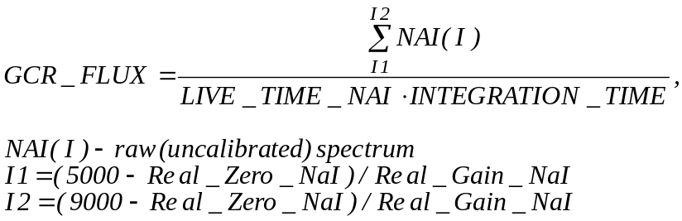

17 Bad_Flag
18 Query_ID

H.11. NEAR GRS Spatial (SPATIAL) Parameters: 1*(Integer*4), 32*(Real*4)

All spatial derivations, unless specified differently, are made for the middle of integration period.
* ET – ephemeris time corresponding to clock fixed Mission Elapsed Time in the middle of the integration
period. Measuring units are seconds before January 1, 2000.

PARAMETER NAME UNITS

0 MET Seconds Mission Elapsed Time at start of integration
1 PlateID_Boresite_Intersect Plate Index ID of the plate that boresight intersects
in the middle of integration period
2 BinID_Boresite_Intersect Bin Index ID of the plate that boresight intersects
in the middle of integration period
3 SC_Position, X Coord X, km Position of spacecraft (ET*) in Eros fixed
4 SC_Position, Y Coord Y, km coord. system (ET*)
5 SC_Position, Z Coord Z, km

6 BS_Vector, X Vector X, normal Boresight vector of GRS (ET*) in Erosfixed
7 BS_Vector, Y Vector Y, normal coord. system (ET*)
8 BS_Vector, Z Vector Z, normal

9 FOV_Status Status value = 0: Field of view (FOV) is completely
off the asteroid (if there are no
plates in the field of view).
= 1: Field of view is on the asteroid
(totally or partially).

10 Downlink_Status Status Value = 0: No downlink
= 1: Yes downlink (The angle between
antenna direction and vector
spacecraft(ET*)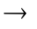Earth(ET*)
is less than 2 degrees)

11 Average_SC_Distance Kilometers Average distance from the spacecraft
to the surface of the asteroid
in the middle of integration period.

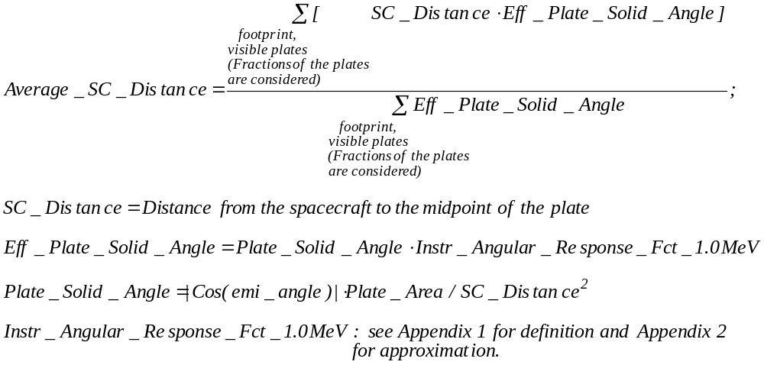

12 Avg_Emission_Angle Degrees Average emission angle

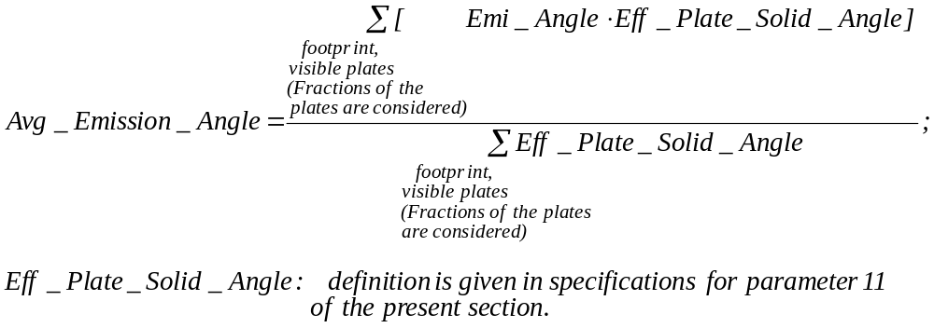

13 Total_Eff_Solid_Angle Steradians Overall solid angle of all plates
in the footprint weighted by the instrument angular response function for the 1 MeV radiation.
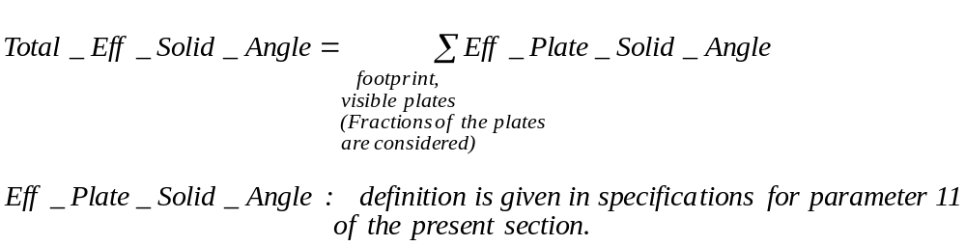

14 Total_Area_Footprint Sq. Kilometers NOT VALID

15 Total_Visible_Area Sq. Kilometers Total area of plates in the
footprint visible from the spacecraft

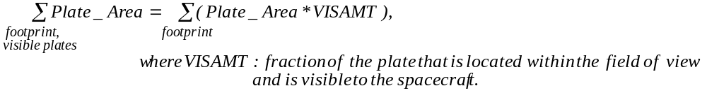

16 Footprint_Solid_Angle Steradians Overall solid angle of all plates in the
footprint as seen from the spacecraft.

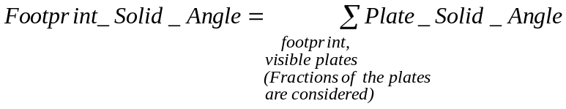

17 NR_Geom_Weight_0.3MeV Steradians Normalization coefficient. It relates the
gamma-ray flux at the detector and the intensity of gamma-ray radiation from the asteroid surface in the direction normal to the surface (for 0.3 MeV natural radioactivity radiation).
For complete definition see Appendix 1.

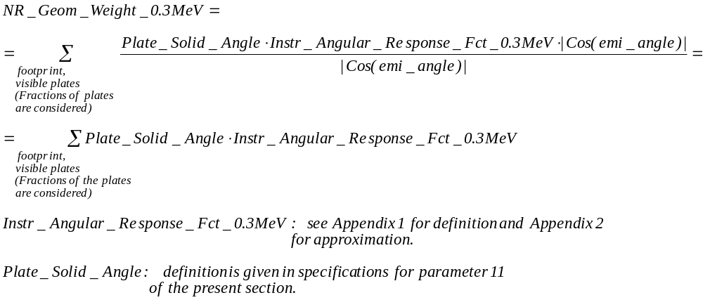

18 NC_Geom_Weight_0.3MeV Steradians Normalization coefficient. It relates the
gamma-ray flux at the detector and the intensity of gamma-ray radiation from the asteroid surface in the direction normal to the surface (for 0.3 MeV non-elastic scattering and thermal neutron capture radiation).
For complete definition see Appendix 1.

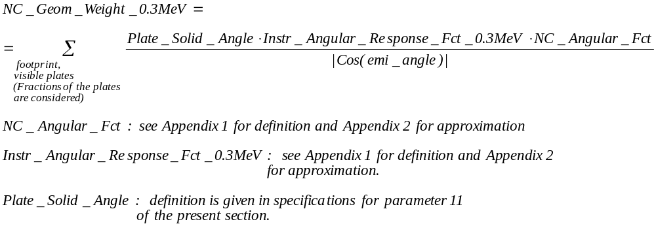

19 NR_Geom_Weight_0.6MeV Steradians Normalization coefficient. It relates the
gamma-ray flux at the detector and the intensity of gamma-ray radiation from the asteroid surface in the direction normal to the surface (for 0.6 MeV natural radioactivity radiation).
For complete definition see Appendix 1.

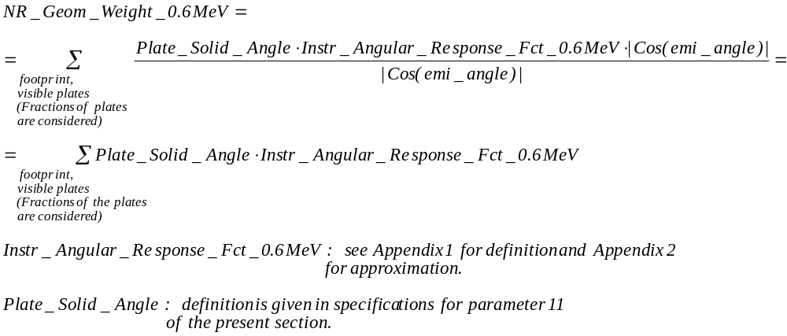

20 NC_Geom_Weight_0.6MeV Steradians Normalization coefficient. It relates the
gamma-ray flux at the detector and the intensity of gamma-ray radiation from the asteroid surface in the direction normal to the surface (for 0.6 MeV non-elastic scattering and thermal neutron capture radiation).
For complete definition see Appendix 1.

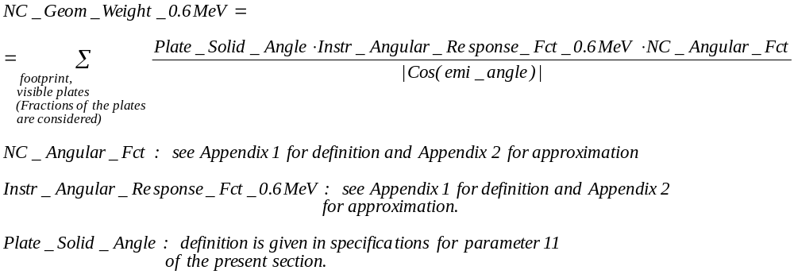

21 NR_Geom_Weight_1.0MeV Steradians Normalization coefficient. It relates the
gamma-ray flux at the detector and the intensity of gamma-ray radiation from the asteroid surface in the direction normal to the surface (for 1.0 MeV natural radioactivity radiation).
For complete definition see Appendix 1.

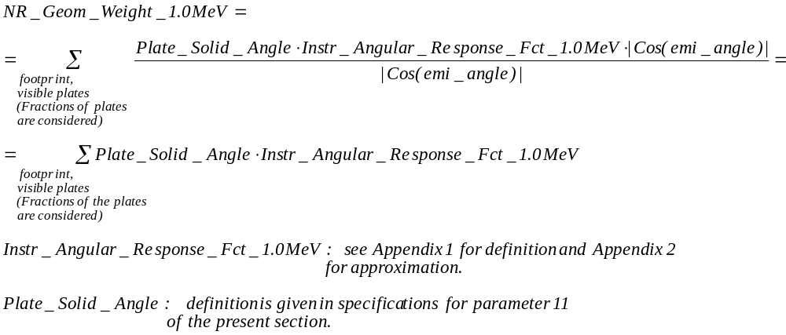

22 NC_Geom_Weight_1.0MeV Steradians Normalization coefficient. It relates the
gamma-ray flux at the detector and the intensity of gamma-ray radiation from the asteroid surface in the direction normal to the surface (for 1.0 MeV non-elastic scattering and thermal neutron capture radiation).
For complete definition see Appendix 1.

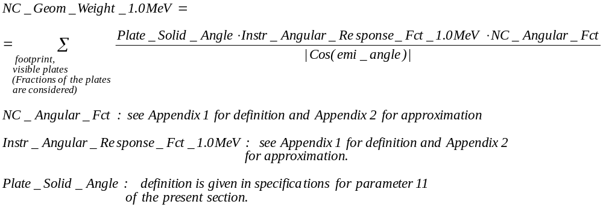

23 NR_Geom_Weight_3.0MeV Steradians Normalization coefficient. It relates the
gamma-ray flux at the detector and the intensity of gamma-ray radiation from the asteroid surface in the direction normal to the surface (for 3.0 MeV natural radioactivity radiation).
For complete definition see Appendix 1.

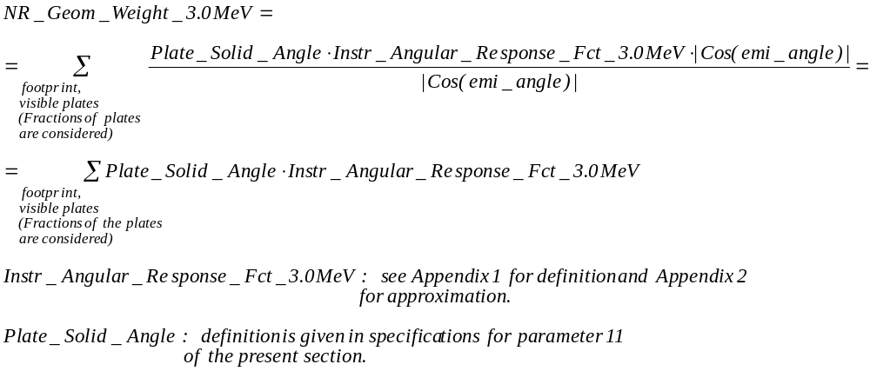

24 NC_Geom_Weight_3.0MeV Steradians Normalization coefficient. It relates the
gamma-ray flux at the detector and the intensity of gamma-ray radiation from the asteroid surface in the direction normal to the surface (for 3.0 MeV non-elastic scattering and thermal neutron capture radiation).
For complete definition see Appendix 1.

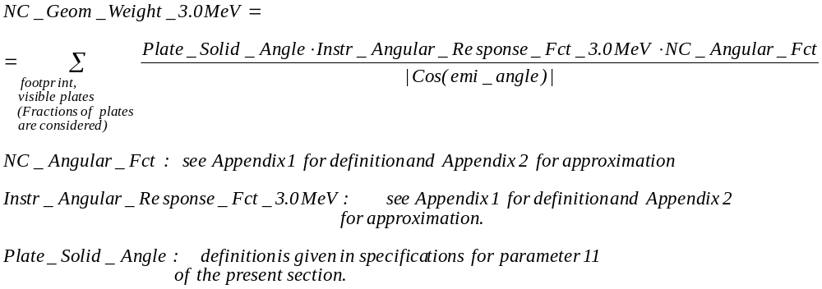

25 NC_Geom_Weight_6.0MeV Steradians Normalization coefficient. It relates the
gamma-ray flux at the detector and the intensity of gamma-ray radiation from the asteroid surface in the direction normal to the surface (for 6.0 MeV non-elastic scattering and thermal neutron capture radiation).
For complete definition see Appendix 1.
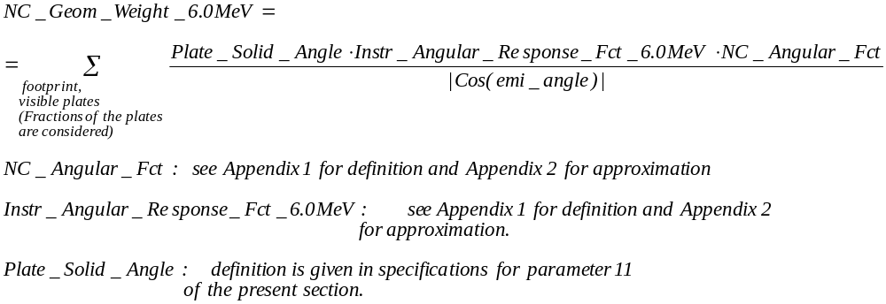

26 Boresight_Intersect_Lat Degrees Latitude of boresight intersection
in the middle of integration period

Coordinate transformation Asteroid Body Fixed, Cartesian to
Asteroid Body Fixed, Spherical. Intersection point (x,y,z) of
boresight with asteroid surface converted to Latitude.

LAT = Degrees(ARC_SIN(Z/R)) (R solved for in eqn 28)

27 Boresight_Intersect_Lon Degrees Longitude of boresight intersection
in the middle of integration period

Coordinate transformation Asteroid Body Fixed, Cartesian to
Asteroid Body Fixed, Spherical. Intersection point (x,y,z) of
boresight with asteroid surface converted to Longitude.

1. LON = -1.*Degrees(ARC_TAN(Y/X))
2. LON = 270 for x = 0 AND y > 0
3. LON = 90 for x = 0 AND y < 0

28 Boresight_Intersect_R Kilometers Radius-vector of boresight intersection
in the middle of integration period

Coordinate transformation Asteroid Body Fixed, Cartesian to
Asteroid Body Fixed, Spherical. Intersection point (x,y,z) of
boresight with asteroid surface converted to Radius from
center of asteroid mass.

R = SQRT( X^2 + Y^2 + Z^2) (R is needed in sol’n 26)

29 SPICE_Kernel_ID Version Number Specified by NAIF
30 Plate_Model_ID Version Number
31 Processing_Software_ID Version Number
32 DataBase_Version_ID Version Number

I. Numerical Specifications for GRS Level–2 Summary Record

FORMAT 3 : Numerical specifications for summarized GRS Level-2 record (output)

I.1. – I.7. NEAR GRS Summarized Spectra: 4 spectra*1024 channels*(Real*4), 1 spectrum*21 channels(Real*4), 1 spectrum*1024 channels*(Real*4), 1 spectrum*21 channels(Real*4)

Measuring units: Counts/Channel

Sodium Iodide summed spectrum: 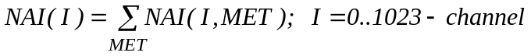

Bismuth Germanate summed spectrum: 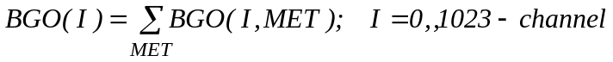

Anti-Coincidence summed spectrum:

Sodium Iodide single escape summed spectrum:

Bismuth Germanate single escape summed spectrum:
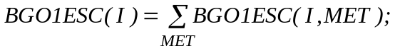 I – channel, 0-20

Sodium Iodide double escape summed spectrum:

Bismuth Germanate double escape summed spectrum:
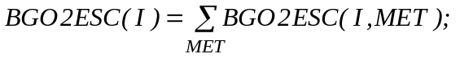 I – channel, 0-20

I.8. NEAR GRS Summarized Engineering (ENG) Parameters: 13*(Real*4)

PARAMETER NAME UNITS

0 GAIN_STANDARD_BGO keV/Channel User specified or default
1 GAIN_STANDARD_NAI keV/Channel - “ -
2 ZERO_STANDARD_BGO keV - “ -
3 ZERO_STANDARD_NAI keV - “ -
4 TOTAL_INTEG_TIME Seconds 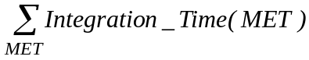
5 TOTAL_LIVE_TIME_BGO Seconds

6 TOTAL_LIVE_TIME_NAI Seconds

7 BGO_VALID_CHANNEL_HI Channel Highest channel of summed spectrum
uncorrupted by energy scale adjustments.
Lowest BGO_VALID_CHANNEL_HI among all MET records in a sum.
8 NAI_VALID_CHANNEL_HI Channel - “ –
Lowest NAI_VALID_CHANNEL_HI
among all MET records in a sum
9 BGO_VALID_CHANNEL_LOW Channel Lowest channel of summed spectrum
uncorrupted by energy scale adjustments.
Highest BGO_VALID_CHANNEL_LOW among all MET records in a sum.
10 NAI_VALID_CHANNEL_LOW Channel - “ –
Highest NAI_VALID_CHANNEL_LOW
among all MET records in a sum.

11 Avg_GCR_FLUX Counts/Second Characteristics of average galactic cosmic
ray flux

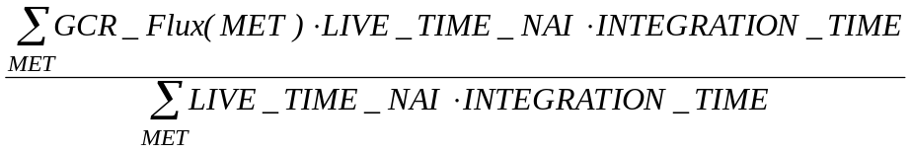

12 Number_MET Number of MET records in a query

I.9. NEAR GRS Summarized Spatial (SPATIAL) Parameters: 13*(Real*4)

PARAMETER NAME UNITS

0 AVG_SC_DISTANCE Kilometers Distance from the spacecraft to the surface
of the asteroid averaged over MET records in a sum.

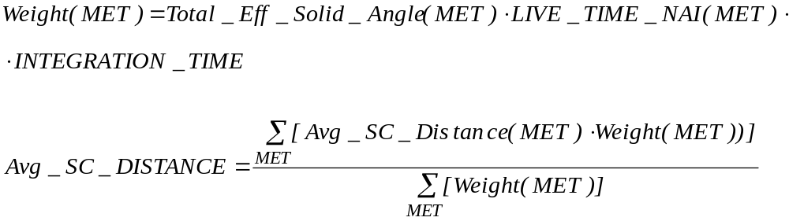

1 AVG_EMI_ANGLE Degrees Emission angle averaged over MET records
in a sum.

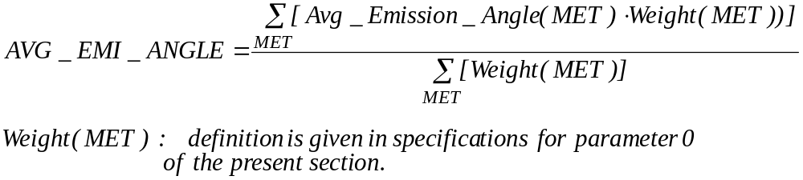

2 AVG_TOTAL_EFF_SOLID_ANGLE Steradians Total effective solid angle averaged over
MET records in a sum.

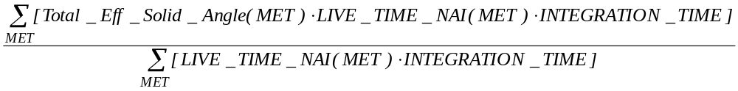

3 NR_Weight_0.3MeV Steradians*Seconds Normalization coefficient. It relates the
number of counts in summed spectrum gamma-line to the intensity of gamma-ray radiation of corresponding energy from the asteroid surface in the direction normal to the surface (for natural radioactivity radiation and energy range < 0.45 MeV).
For complete definition see Appendix 1.

4 NC_Weight_0.3MeV Steradians*Counts Normalization coefficient. It relates the
number of counts in summed spectrum gamma-line to the intensity of gamma-ray radiation of corresponding energy from the asteroid surface in the direction normal to the surface normalized for GCR flux = 1 proton/(s*cm²) (for non-elastic scattering and thermal neutron capture radiation and energy range < 0.45 MeV).
For complete definition see Appendix 1.

5 NR_Weight_0.6MeV Steradians*Seconds Normalization coefficient. It relates the
number of counts in summed spectrum gamma-line to the intensity of gamma-ray radiation of corresponding energy from the asteroid surface in the direction normal to the surface (for natural radioactivity radiation and energy range 0.45..0.8 MeV).
For complete definition see Appendix 1.

6 NC_Weight_0.6MeV Steradians*Counts Normalization coefficient. It relates the
number of counts in summed spectrum gamma-line to the intensity of gamma-ray radiation of corresponding energy from the asteroid surface in the direction normal to the surface normalized for GCR flux = 1 proton/(s*cm²) (for non-elastic scattering and thermal neutron capture radiation and energy range 0.45..0.8 MeV).
For complete definition see Appendix 1.

7 NR_Weight_1.0MeV Steradians*Seconds Normalization coefficient. It relates the
number of counts in summed spectrum gamma-line to the intensity of gamma-ray radiation of corresponding energy from the asteroid surface in the direction normal to the surface (for natural radioactivity radiation and energy range 0.8..2.0 MeV).
For complete definition see Appendix 1.

8 NC_Weight_1.0MeV Steradians*Counts Normalization coefficient. It relates the
number of counts in summed spectrum gamma-line to the intensity of gamma-ray radiation of corresponding energy from the asteroid surface in the direction normal to the surface normalized for GCR flux = 1 proton/(s*cm²) (for non-elastic scattering and thermal neutron capture radiation and energy range 0.8..2.0 MeV).
For complete definition see Appendix 1.

9 NR_Weight_3.0MeV Steradians*Seconds Normalization coefficient. It relates the
number of counts in summed spectrum gamma-line to the intensity of gamma-ray radiation of corresponding energy from the asteroid surface in the direction normal to the surface (for natural radioactivity radiation and energy range 2.0..4.5 MeV).
For complete definition see Appendix 1.

10 NC_Weight_3.0MeV Steradians*Counts Normalization coefficient. It relates the
number of counts in summed spectrum gamma-line to the intensity of gamma-ray radiation of corresponding energy from the asteroid surface in the direction normal to the surface normalized for GCR flux = 1 proton/(s*cm²) (for non-elastic scattering and thermal neutron capture radiation and energy range 2.0..4.5 MeV).
For complete definition see Appendix 1.

11 NC_Weight_6.0MeV Steradians*Counts Normalization coefficient. It relates the
number of counts in summed spectrum gamma-line to the intensity of gamma-ray radiation of corresponding energy from the asteroid surface in the direction normal to the surface normalized for GCR flux = 1 proton/(s*cm²) (for non-elastic scattering and thermal neutron capture radiation and energy range > 4.5 MeV).
For complete definition.. see Appendix 1.

12 ESTIMATED_COVERED_AREA Sq. Kilometers Estimated area of the asteroid surface
covered by MET records in a sum

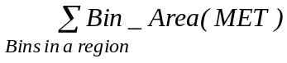 For a spatial query
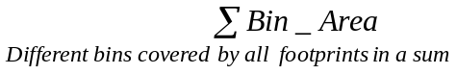 For a temporal query

J. Numerical Specifications for GRS Fractional Footprint Accounting System

PARAMETER NAME UNITS

0 MET Seconds Mission Elapsed Time at start of integartion.
1 Footprint_Bin_Total_Area Sq. Kilometers NOT VALID
2 Footprint_Bin_Visible_Area Sq. Kilometers Total area of all plates in the
footprint that belong to the bin, visible from the spacecraft.

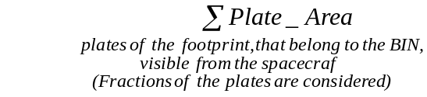 Fractions are considered as in H11 param.15

3 Total_Eff_Solid_Angle_Fraction Unitless Fraction of the total effective
solid angle that can be attributed to the bin.

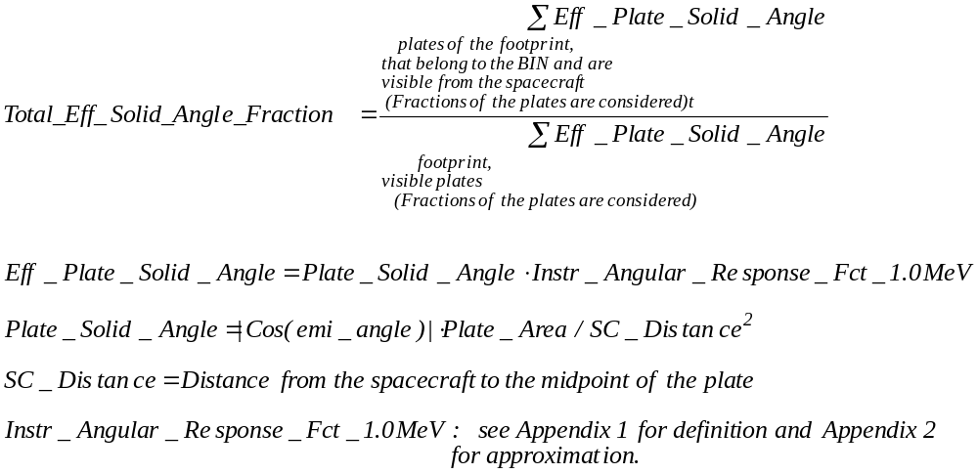

4 NR_Spectrum_Fraction Unitless Fraction of the spectrum that can
be attributed to the bin
(for natural radioactivity radiation).

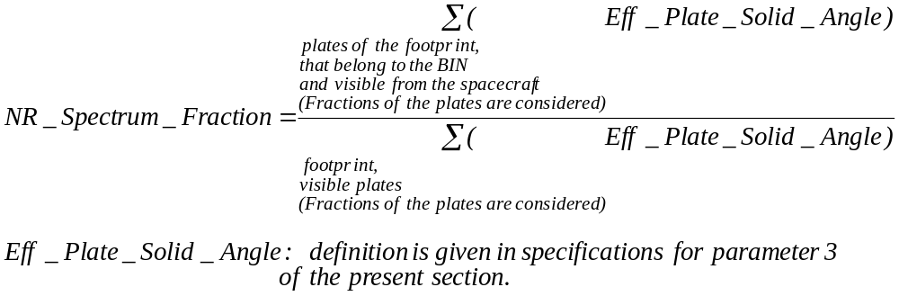

5 NC_Spectrum_Fraction Unitless Fraction of the spectrum that can
be attributed to the bin
(for non-elastic scattering and thermal neutron capture radiation).

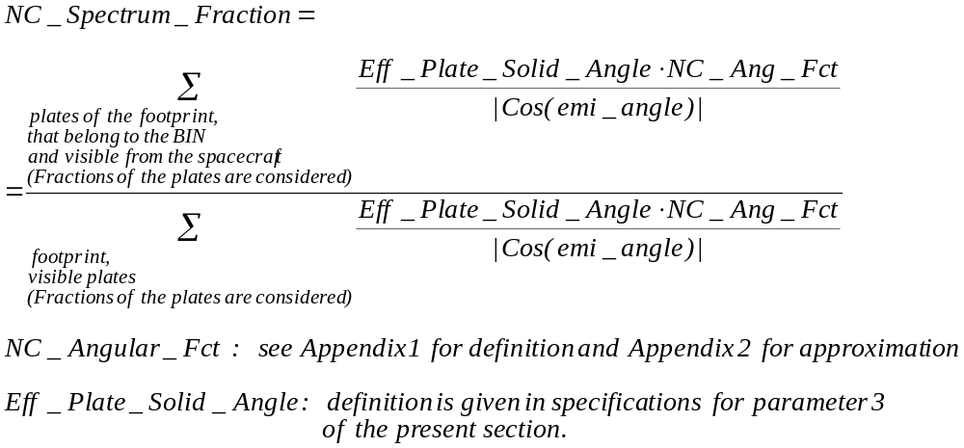

6 Binid Value Bin identifier generated by the Bin
generation system

APPENDIX 1 Definitions for:
Instr_Angular_Response_Fct_YYMeV,
where YY can be 0.3, 0.6, 1.0, 3.0 or 6.0;
NC_Angular_Fct;
NC_Geom_Weight_YYMeV;
NC_Weight_YYMeV;
NR_Geom_Weight_YYMeV;
NR_Weight_YYMeV

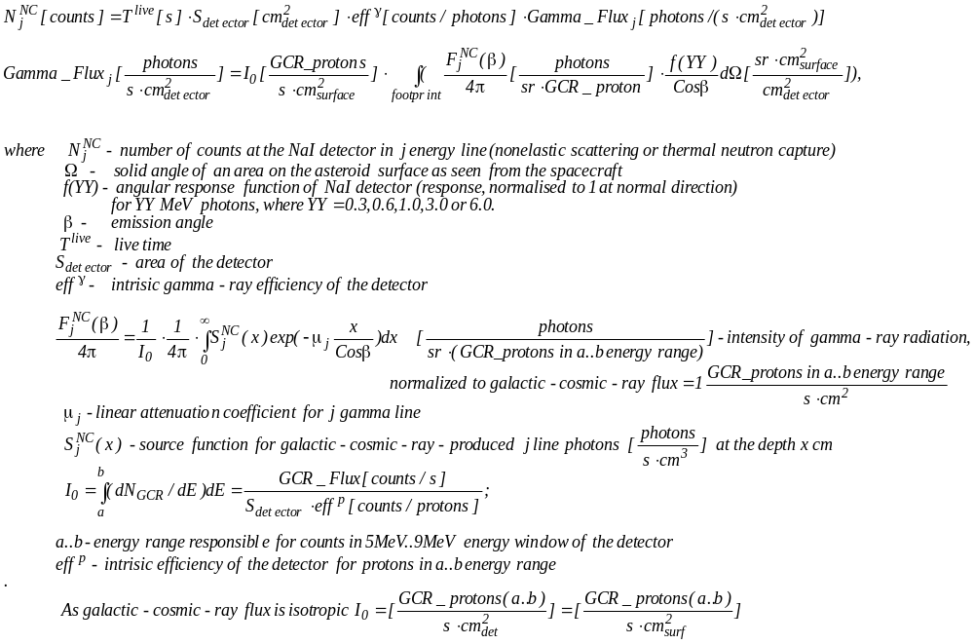

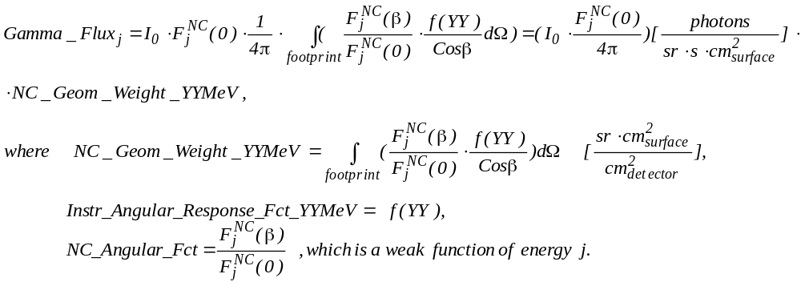

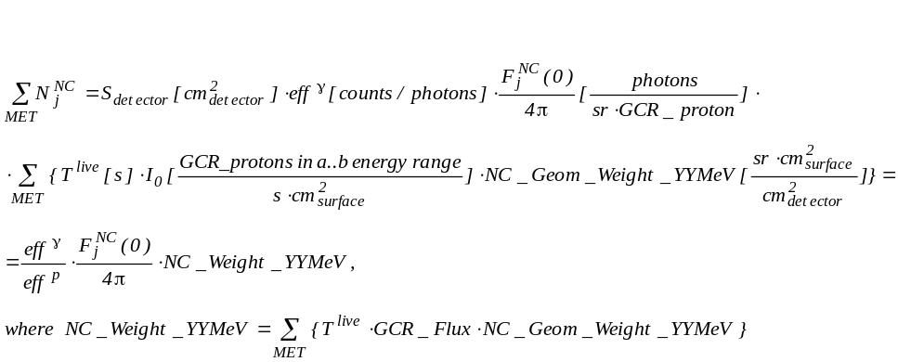

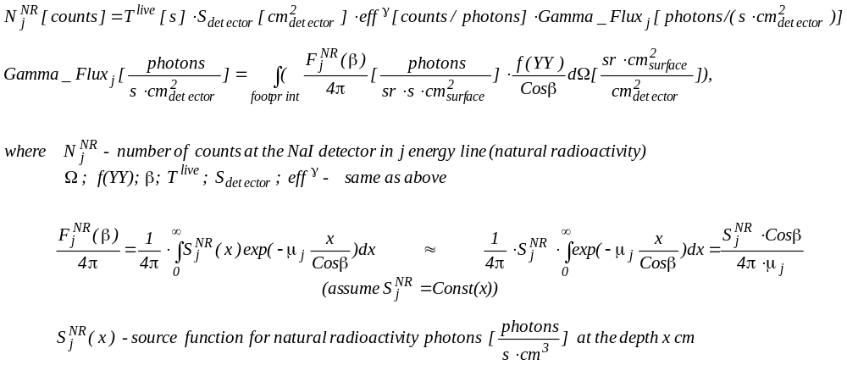
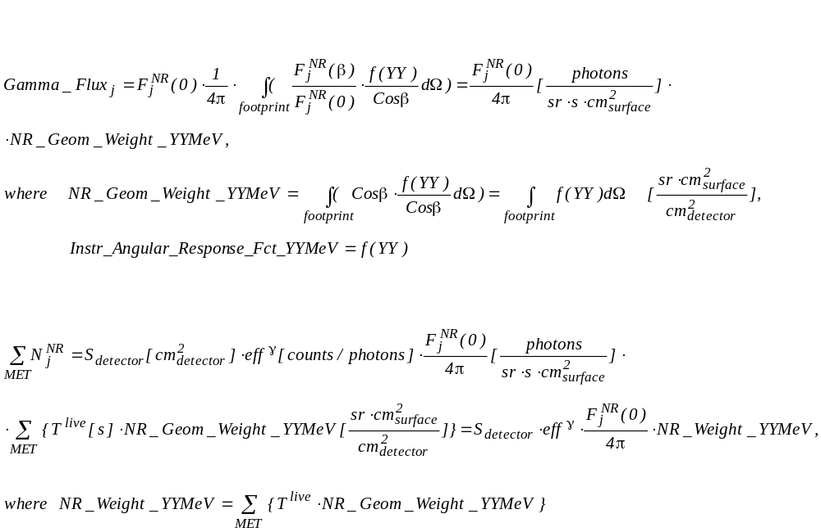
APPENDIX 2 Approximations for:
Instr_Angular_Response_Fct_YYMeV,
where YY can be 0.3, 0.6, 1.0, 3.0 or 6.0;
NC_Angular_Fct

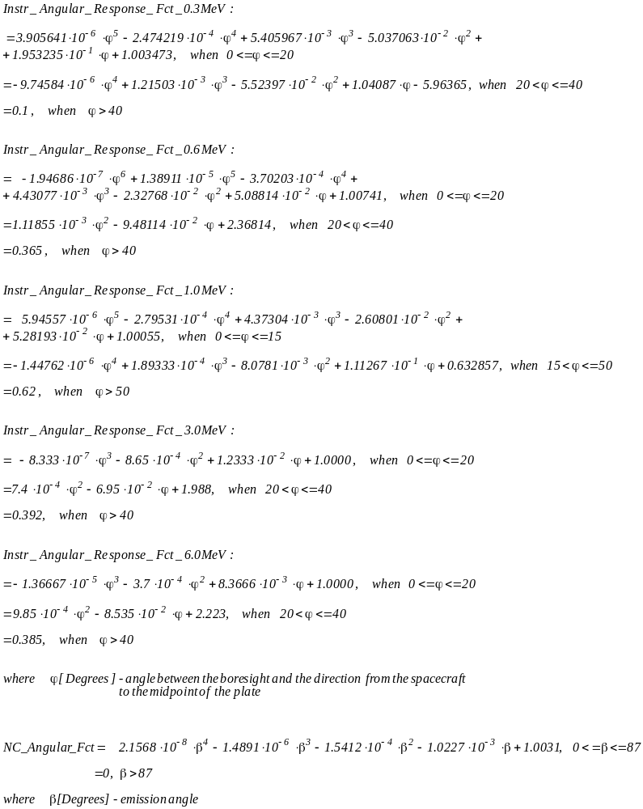

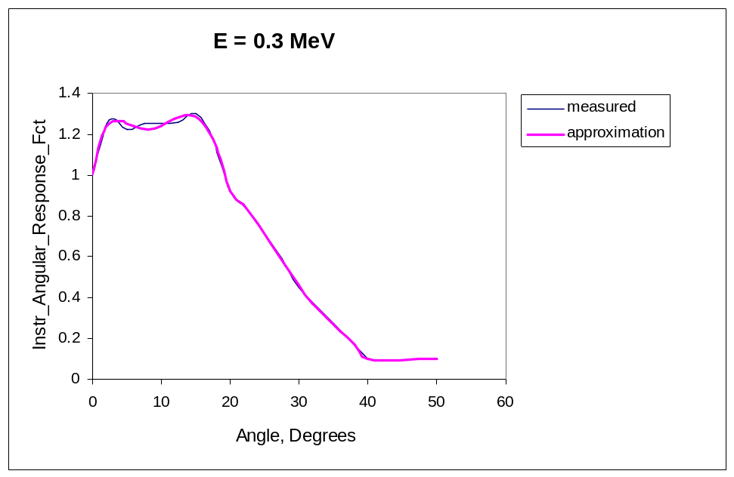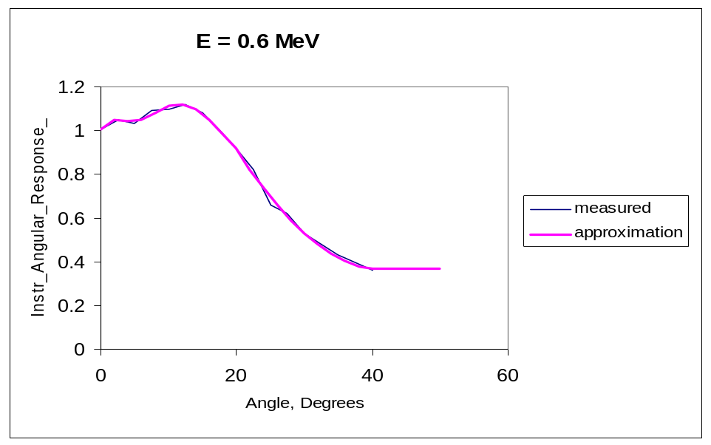
Figure 1. GRS angular response function for radiation 0.3 MeV

Figure 2. GRS angular response function for radiation 0.6 MeV

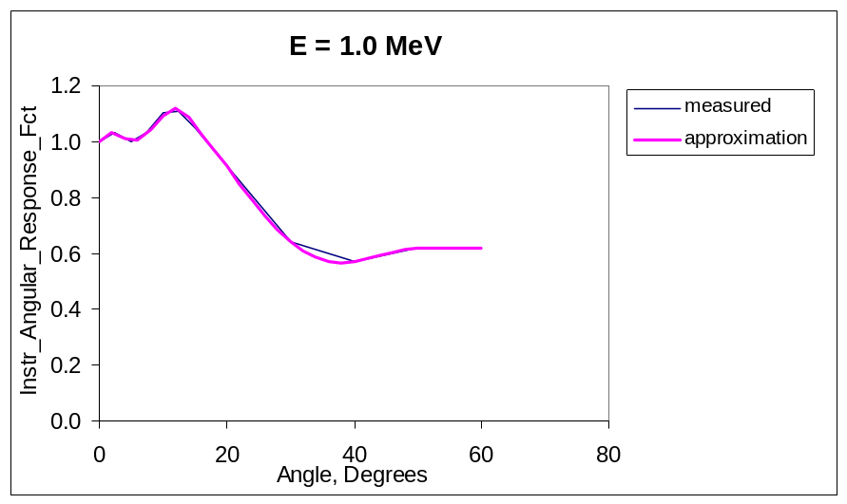

Figure 3. GRS angular response function for radiation 1.0 MeV

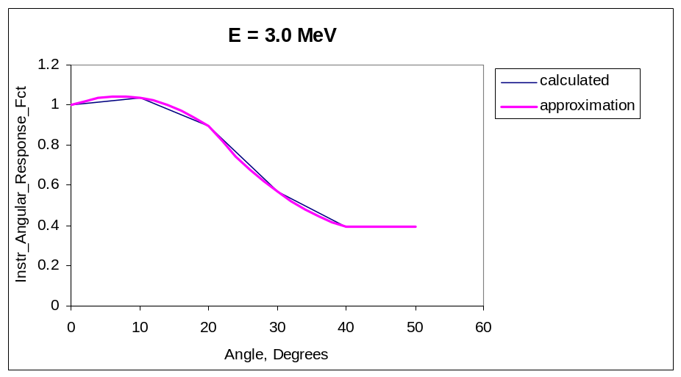

Figure 4. GRS angular response function for radiation 3.0 MeV

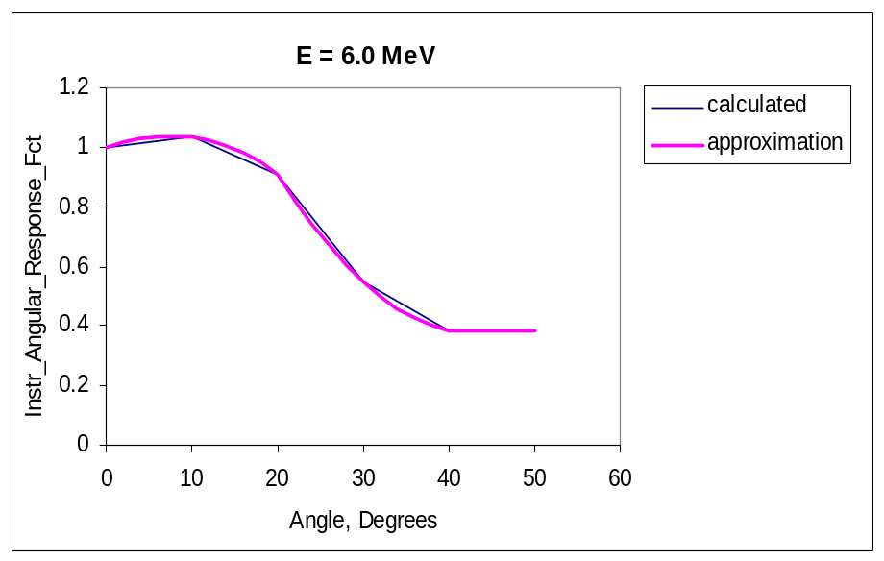

Figure 5. GRS angular response function for radiation 6.0 MeV

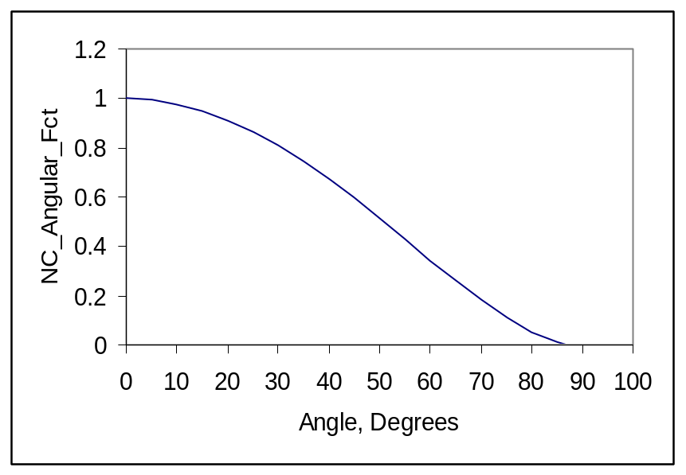

Figure 6. Angular dependence of non-elastic scattering and thermal neutron capture
gamma-ray emission from the surface (approximation).

APPENDIX 3 Location of GRS Level-2 Parameters in the U of A Database

E.8. NEAR GRS Science Housekeeping (SCI HK) Parameters: 31*(Integer*4)

No | PARAMETER NAME IN  “Requirements Specifications For Level-2 Parameters Required Stored or Derived by The Near Earth Redezvous (NEAR) Gamma-Ray Spectrometer (GRS) Ground System” | PARAMETER NAME IN  UA DATABASE | TABLE  NAME | DATABASE  NAME
0 | MET | ACQ_MET_TIME | All tables | All databases
1 | UTC | ACQ_UTC_TIME | g_nai_spec_tab,  g_bgo_spec_tab,  g_anti_coin_spec_tab,  g_sgl_esc_sft_nai_spec_tab,  g_dbl_esc_sft_nai_spec_tab,  g_sgl_esc_pk_bgo_spec_tab,  g_dbl_esc_pk_bgo_spec_tab | near_grs_db
1 | UTC | ACQ_UTC_TIME | grs_hk_tab | near_hk_db
2 | DQI | DQI | index_tab | near_grs_db
3 | TIME_TAG | ACQ_MET_TIME | All tables | All databases
4 | INTEGRATION_TIME | INT_TIME | g_nai_spec_tab,  g_bgo_spec_tab,  g_anti_coin_spec_tab,  g_sgl_esc_sft_nai_spec_tab,  g_dbl_esc_sft_nai_spec_tab,  g_sgl_esc_pk_bgo_spec_tab,  g_dbl_esc_pk_bgo_spec_tab | near_grs_db
5 | BGO_PROTON_FLARE_FLG | BGO_PROTON_FLARE_FLG | grs_hk_tab | near_hk_db
6 | BGO_LEVEL_1_SAFE_FLG | LVL1_SENSOR_SAFING_FLAG | g_bgo_spec_tab | near_grs_db
7 | BGO_LEVEL_2_SAFE_FLG | LVL2_SENSOR_SAFING_FLAG | g_bgo_spec_tab | near_grs_db
8 | NAI_LEVEL_1_SAFE_FLG | LVL1_SENSOR_SAFING_FLAG | g_nai_spec_tab | near_grs_db
9 | NAI_LEVEL_2_SAFE_FLG | LVL2_SENSOR_SAFING_FLAG | g_nai_spec_tab | near_grs_db
10 | NAI_INT_OVERFLOW_FLG | SPEC_BOF | g_nai_spec_tab | near_grs_db
11 | BGO_INT_OVERFLOW_FLG | SPEC_BOF | g_bgo_spec_tab | near_grs_db
12 | NAI_ANTICOINCID_OVFL_FLG | SPEC_BOF | g_anti_coin_spec_tab | near_grs_db
13 | NAI_SINGLE_ESCP_OVFL_FLG | SPEC_BOF | g_sgl_esc_sft_nai_spec_tab | near_grs_db
14 | NAI_DOUBLE_ESCP_OVFL_FLG | SPEC_BOF | g_dbl_esc_sft_nai_spec_tab | near_grs_db
15 | BGO_SINGLE_ESCP_OVFL_FLG | SPEC_BOF | g_sgl_esc_pk_bgo_spec_tab | near_grs_db
16 | BGO_DOUBLE_ESCP_OVFL_FLG | SPEC_BOF | g_dbl_esc_pk_bgo_spec_tab | near_grs_db
17 | NAI_RAW_EVENT_RATE | TOTAL_RAW_EVENT_RATE | g_nai_spec_tab | near_grs_db
18 | BGO_RAW_EVENT_RATE | TOTAL_RAW_EVENT_RATE | g_bgo_spec_tab | near_grs_db
19 | COINCIDENCE_COUNTER | COIN_COUNTER | g_nai_spec_tab | near_grs_db
20 | COMMAND_COUNTER | COMMAND_COUNTER | g_bgo_spec_tab | near_grs_db
21 | PROBLEM_COUNTER | PROBLEM_COUNTER | g_bgo_spec_tab | near_grs_db
22 | PROBLEM_CODE | PROBLEM_CODE | g_bgo_spec_tab | near_grs_db
23 | NUM_NAI_ANTICOINCID_EVENTS | NUM_NAI_EVENTS_WITH_ANTI_COIN | g_nai_spec_tab,  g_bgo_spec_tab | near_grs_db
24 | NUM_NAI_VALID_EVENTS | NUM_VALID_EVENTS_PROCESSED | g_nai_spec_tab | near_grs_db
25 | NUM_BGO_VALID_EVENTS | NUM_VALID_EVENTS_PROCESSED | g_bgo_spec_tab | near_grs_db
26 | NAI_DC_OFFSET | DC_OFFSET_EST | g_nai_spec_tab | near_grs_db
27 | BGO_DC_OFFSET | DC_OFFSET_EST | g_bgo_spec_tab | near_grs_db
28 | NAI_STAND_DEV | STD_DEV | g_nai_spec_tab | near_grs_db
29 | BGO_STAND_DEV | STD_DEV | g_bgo_spec_tab | near_grs_db
30 | GRAY_DATA_QUALITY_BIT | GRAY_DQI | g_nai_spec_tab | near_grs_db

E.9. NEAR GRS Engineering Housekeeping (ENG HK) Parameters: 152*(REAL*4)

No | PARAMETER NAME IN  “Requirements Specifications For Level-2 Parameters Required Stored or Derived by The Near Earth Redezvous (NEAR) Gamma-Ray Spectrometer (GRS) Ground System” | PARAMETER NAME IN  UA DATABASE |  | TABLE  NAME | DATABASE  NAME
0 | DETECTOR_ELECTR_CURR | DETECTOR_ELECTR_CURR |  | grs_hk_tab | near_hk_db
1 | XRAY_PIN_DIODE_FET_BIAS | XRAY_PIN_DIODE_FET_BIAS |  | grs_hk_tab | near_hk_db
2 | HVCE_TEMPERATURE | HVCE_TEMPERATURE |  | grs_hk_tab | near_hk_db
3 | UNF_XRAY_HVPS_VOLT | UNF_XRAY_HVPS_VOLT |  | grs_hk_tab | near_hk_db
4 | MG_XRAY_HVPS_VOLT | MG_XRAY_HVPS_VOLT |  | grs_hk_tab | near_hk_db
5 | AL_XRAY_HVPS_VOLT | AL_XRAY_HVPS_VOLT |  | grs_hk_tab | near_hk_db
6 | XRAY_GAS_HVPS_VOLT | XRAY_GAS_HVPS_VOLT |  | grs_hk_tab | near_hk_db
7 | XRAY_PIN_HVPS_VOLT | XRAY_PIN_HVPS_VOLT |  | grs_hk_tab | near_hk_db
8 | NAI_HVPS_VOLT | NAI_HVPS_VOLT |  | grs_hk_tab | near_hk_db
9 | BGO_HVPS_VOLT | BGO_HVPS_VOLT |  | grs_hk_tab | near_hk_db
10 | DPU_DC_DC_TEMP | DPU_DC_DC_TEMP |  | grs_hk_tab | near_hk_db
11 | XGRS_DC_DC_TEMP | XGRS_DC_DC_TEMP |  | grs_hk_tab | near_hk_db
12 | UNF_XRAY_HVPS_TEMP | UNF_XRAY_HVPS_TEMP |  | grs_hk_tab | near_hk_db
13 | MG_XRAY_HVPS_TEMP | MG_XRAY_HVPS_TEMP |  | grs_hk_tab | near_hk_db
14 | AL_XRAY_HVPS_TEMP | AL_XRAY_HVPS_TEMP |  | grs_hk_tab | near_hk_db
15 | XRAY_GAS_HVPS_TEMP | XRAY_GAS_HVPS_TEMP |  | grs_hk_tab | near_hk_db
16 | XRAY_PIN_HVPS_TEMP | XRAY_PIN_HVPS_TEMP |  | grs_hk_tab | near_hk_db
17 | NAI_HVPS_TEMP | NAI_HVPS_TEMP |  | grs_hk_tab | near_hk_db
18 | BGO_HVPS_TEMP | BGO_HVPS_TEMP |  | grs_hk_tab | near_hk_db
19 | TEC_CURRENT | TEC_CURRENT |  | grs_hk_tab | near_hk_db
20 | NAI_HVPS_VOLT_CMD | NAI_HVPS_VOLT_CMD |  | grs_hk_tab | near_hk_db
21 | BGO_HVPS_VOLT_CMD | BGO_HVPS_VOLT_CMD |  | grs_hk_tab | near_hk_db
22 | UNF_HVPS_VOLT_CMD | UNF_HVPS_VOLT_CMD |  | grs_hk_tab | near_hk_db
23 | MG_HVPS_VOLT_CMD | MG_HVPS_VOLT_CMD |  | grs_hk_tab | near_hk_db
24 | AL_HVPS_VOLT_CMD | AL_HVPS_VOLT_CMD |  | grs_hk_tab | near_hk_db
25 | HVPS_POWER_ON_OFF | HVPS_POWER_ON_OFF |  | grs_hk_tab | near_hk_db
26 | XRAY_CALIB_HOME_FLG | XRAY_CALIB_HOME_FLG |  | grs_hk_tab | near_hk_db
27 | XRAY_CALIB_MOTOR_ON_OFF | XRAY_CALIB_MOTOR_ON_OFF |  | grs_hk_tab | near_hk_db
28 | XRAY_CALIB_MOTOR_ENABLE | XRAY_CALIB_MOTOR_ENABLE |  | grs_hk_tab | near_hk_db
29 | GAS_HVPS_VOLT_CMD | GAS_HVPS_VOLT_CMD |  | grs_hk_tab | near_hk_db
30 | PIN_HVPS_VOLT_CMD | PIN_HVPS_VOLT_CMD |  | grs_hk_tab | near_hk_db
31 | GAMMA_RAY_HEATER_CURR | GAMMA_RAY_HEATER_CURR |  | grs_hk_tab | near_hk_db
32 | spare | spare |  | grs_hk_tab | near_hk_db
33 | XRAY_CALIB_MOTOR_DIR | XRAY_CALIB_MOTOR_DIR |  | grs_hk_tab | near_hk_db
34 | XRAY_CALIB_MOTOR_CURR | XRAY_CALIB_MOTOR_CURR |  | grs_hk_tab | near_hk_db
35 | XRAY_CALIB_MOTOR_GOAL | XRAY_CALIB_MOTOR_GOAL |  | grs_hk_tab | near_hk_db
36 | XRAY_CALIB_MOTOR_POS | XRAY_CALIB_MOTOR_POS |  | grs_hk_tab | near_hk_db
37 | XRAY_CALIB_MOTOR_FID_SENS | XRAY_CALIB_MOTOR_FID_SENS |  | grs_hk_tab | near_hk_db
38 | XRAY_CALIB_MOTOR_FID_BRIT | XRAY_CALIB_MOTOR_FID_BRIT |  | grs_hk_tab | near_hk_db
39 | XRAY_MOTOR_IN_CALIB_POSITION | XRAY_MOTOR_IN_CALIB_POSITION |  | grs_hk_tab | near_hk_db
40 | XRAY_MOTOR_IN_NORM_POSITION | XRAY_MOTOR_IN_NORM_POSITION |  | grs_hk_tab | near_hk_db
41 | ACTIVE_SOLAR_TOGGLE_MODE | ACTIVE_SOLAR_TOGGLE_MODE |  | grs_hk_tab | near_hk_db
42 | XRAY_CALIB_MAX_STEPS | XRAY_CALIB_MAX_STEPS |  | grs_hk_tab | near_hk_db
43 | spare | spare |  | grs_hk_tab | near_hk_db
44 | TEC_ENABLE | TEC_ENABLE |  | grs_hk_tab | near_hk_db
45 | XRAY_CALIB_CUM_MOTOR_STPS | XRAY_CALIB_CUM_MOTOR_STPS |  | grs_hk_tab | near_hk_db
46 | GRAY_BURST_THRESH_VAL | GRAY_BURST_THRESH_VAL |  | grs_hk_tab | near_hk_db
47 | XRAY_SAFING_THRESH | XRAY_SAFING_THRESH |  | grs_hk_tab | near_hk_db
48 | XRAY_CALIB_MOTOR_DIAG | XRAY_CALIB_MOTOR_DIAG |  | grs_hk_tab | near_hk_db
49 | TEC_POWER_ON_OFF | TEC_POWER_ON_OFF |  | grs_hk_tab | near_hk_db
50 | TEC_MODE | TEC_MODE |  | grs_hk_tab | near_hk_db
51 | TEC_COOL_HEAT_FLG | TEC_COOL_HEAT_FLG |  | grs_hk_tab | near_hk_db
52 | TEC_TEMPERATURE | TEC_TEMPERATURE |  | grs_hk_tab | near_hk_db
53 | TEC_COOL_MODE_TEMP_UP_LMT | TEC_COOL_MODE_TEMP_UP_LMT |  | grs_hk_tab | near_hk_db
54 | TEC_COOL_MODE_TEMP_LOW_LMT | TEC_COOL_MODE_TEMP_LOW_LMT |  | grs_hk_tab | near_hk_db
55 | TEC_HEAT_MODE_TEMP_UP_LMT | TEC_HEAT_MODE_TEMP_UP_LMT |  | grs_hk_tab | near_hk_db
56 | TEC_HEAT_MODE_TEMP_LOW_LMT | TEC_HEAT_MODE_TEMP_LOW_LMT |  | grs_hk_tab | near_hk_db
57 | GAMMA_RAY_TEMP_HYSTERESIS | GAMMA_RAY_TEMP_HYSTERESIS |  | grs_hk_tab | near_hk_db
58 | GAMMA_RAY_HEAT_TEMP_LOW_LMT | GAMMA_RAY_HEAT_TEMP_LOW_LMT |  | grs_hk_tab | near_hk_db
59 | FULL_GAMMA_RAY_SCIENCE_MODE | FULL_GAMMA_RAY_SCIENCE_MODE |  | grs_hk_tab | near_hk_db
60 | FULL_XRAY_SCIENCE_MODE | FULL_XRAY_SCIENCE_MODE |  | grs_hk_tab | near_hk_db
61 | SUMM_GRAY_XRAY_SCIENCE_MODE | SUMM_GRAY_XRAY_SCIENCE_MODE |  | grs_hk_tab | near_hk_db
62 | GRAY_BURST_SCI_REC_MODE | GRAY_BURST_SCI_REC_MODE |  | grs_hk_tab | near_hk_db
63 | HVCE_TEMP_SET_POINT | HVCE_TEMP_SET_POINT |  | grs_hk_tab | near_hk_db
64 | CMDED_END_XRAY_INTEG_PER | CMDED_END_XRAY_INTEG_PER |  | grs_hk_tab | near_hk_db
65 | CMDED_GAMMA_RAY_INTEG_PER | CMDED_GAMMA_RAY_INTEG_PER |  | grs_hk_tab | near_hk_db
66 | BGO_PROTON_FLARE_FLG | BGO_PROTON_FLARE_FLG |  | grs_hk_tab | near_hk_db
67 | GAMMA_RAY_BIN_OVER_FLG_CMD | GAMMA_RAY_BIN_OVER_FLG_CMD |  | grs_hk_tab | near_hk_db
68 | UNF_XRAY_BIN_OVER_FLG_CMD | UNF_XRAY_BIN_OVER_FLG_CMD |  | grs_hk_tab | near_hk_db
69 | MG_BIN_OVER_FLG_CMD | MG_BIN_OVER_FLG_CMD |  | grs_hk_tab | near_hk_db
70 | AL_BIN_OVER_FLG_CMD | AL_BIN_OVER_FLG_CMD |  | grs_hk_tab | near_hk_db
71 | ACT_BIN_OVER_FLG_CMD | ACT_BIN_OVER_FLG_CMD |  | grs_hk_tab | near_hk_db
72 | NAI_BIN_OVERFLOW_FLG | NAI_BIN_OVERFLOW_FLG |  | grs_hk_tab | near_hk_db
73 | BGO_BIN_OVERFLOW_FLG | BGO_BIN_OVERFLOW_FLG |  | grs_hk_tab | near_hk_db
74 | NAI_ANTICOIN_OVERFLOW_FLG | NAI_ANTICOIN_OVERFLOW_FLG |  | grs_hk_tab | near_hk_db
75 | NAI_SING_ESC_OVERFLOW_FLG | NAI_SING_ESC_OVERFLOW_FLG |  | grs_hk_tab | near_hk_db
76 | NAI_DOUB_ESC_OVERFLOW_FLG | NAI_DOUB_ESC_OVERFLOW_FLG |  | grs_hk_tab | near_hk_db
77 | BGO_SING_ESC_OVERFLOW_FLG | BGO_SING_ESC_OVERFLOW_FLG |  | grs_hk_tab | near_hk_db
78 | BGO_DOUB_ESC_OVERFLOW_FLG | BGO_DOUB_ESC_OVERFLOW_FLG |  | grs_hk_tab | near_hk_db
79 | UNF_XRAY_BIN_OVERFLOW_FLG | UNF_XRAY_BIN_OVERFLOW_FLG |  | grs_hk_tab | near_hk_db
80 | MG_BIN_OVERFLOW_FLG | MG_BIN_OVERFLOW_FLG |  | grs_hk_tab | near_hk_db
81 | AL_BIN_OVERFLOW_FLG | AL_BIN_OVERFLOW_FLG |  | grs_hk_tab | near_hk_db
82 | ACT_BIN_OVERFLOW_FLG | ACT_BIN_OVERFLOW_FLG |  | grs_hk_tab | near_hk_db
83 | GAMMA_RAY_HEAT_ON_OFF | GAMMA_RAY_HEAT_ON_OFF |  | grs_hk_tab | near_hk_db
84 | GAMMA_RAY_HEAT_MODE | GAMMA_RAY_HEAT_MODE |  | grs_hk_tab | near_hk_db
85 | BGO_LEVEL_1_SAFING_FLG | BGO_LEVEL_1_SAFING_FLG |  | grs_hk_tab | near_hk_db
86 | BGO_LEVEL_2_SAFING_FLG | BGO_LEVEL_2_SAFING_FLG |  | grs_hk_tab | near_hk_db
87 | spare | spare |  | grs_hk_tab | near_hk_db
88 | XRAY_INTEGR_TIME | XRAY_INTEGR_TIME |  | grs_hk_tab | near_hk_db
89 | HVPS_ON_OFF | HVPS_ON_OFF |  | grs_hk_tab | near_hk_db
90 | PIN_SENSOR_MASK_FLG | PIN_SENSOR_MASK_FLG |  | grs_hk_tab | near_hk_db
91 | GAS_SENSOR_MASK_FLG | GAS_SENSOR_MASK_FLG |  | grs_hk_tab | near_hk_db
92 | AL_SENSOR_MASK_FLG | AL_SENSOR_MASK_FLG |  | grs_hk_tab | near_hk_db
93 | MG_SENSOR_MASK_FLG | MG_SENSOR_MASK_FLG |  | grs_hk_tab | near_hk_db
94 | UNF_SENSOR_MASK_FLG | UNF_SENSOR_MASK_FLG |  | grs_hk_tab | near_hk_db
95 | BGO_SENSOR_MASK_FLG | BGO_SENSOR_MASK_FLG |  | grs_hk_tab | near_hk_db
96 | NAI_SENSOR_MASK_FLG | NAI_SENSOR_MASK_FLG |  | grs_hk_tab | near_hk_db
97 | UNF_XRAY_RISE_TIME_THRESH | UNF_XRAY_RISE_TIME_THRESH |  | grs_hk_tab | near_hk_db
98 | MG_RISE_TIME_THRESH | MG_RISE_TIME_THRESH |  | grs_hk_tab | near_hk_db
99 | AL_RISE_TIME_THRESH | AL_RISE_TIME_THRESH |  | grs_hk_tab | near_hk_db
100 | GAS_RISE_TIME_THRESH | GAS_RISE_TIME_THRESH |  | grs_hk_tab | near_hk_db
101 | UNF_RISE_TIME_VALID_THRESH | UNF_RISE_TIME_VALID_THRESH |  | grs_hk_tab | near_hk_db
102 | MG_RISE_TIME_VALID_THRESH | MG_RISE_TIME_VALID_THRESH |  | grs_hk_tab | near_hk_db
103 | AL_RISE_TIME_VALID_THRESH | AL_RISE_TIME_VALID_THRESH |  | grs_hk_tab | near_hk_db
104 | GAS_RISE_TIME_VALID_THRESH | GAS_RISE_TIME_VALID_THRESH |  | grs_hk_tab | near_hk_db
105 | GAMMA_RAY_INTEGR_TIME | GAMMA_RAY_INTEGR_TIME |  | grs_hk_tab | near_hk_db
106 | GAMMA_SING_ESC_WIND_CENTER | GAMMA_SING_ESC_WIND_CENTER |  | grs_hk_tab | near_hk_db
017 | GAMMA_SING_ESC_WIND_WIDTH | GAMMA_SING_ESC_WIND_WIDTH |  | grs_hk_tab | near_hk_db
108 | GAMMA_DOUB_ESC_WIND_CENTER | GAMMA_DOUB_ESC_WIND_CENTER |  | grs_hk_tab | near_hk_db
109 | GAMMA_DOUB_ESC_WIND_WIDTH | GAMMA_DOUB_ESC_WIND_WIDTH |  | grs_hk_tab | near_hk_db
110 | NAI_LOW_LEVEL_AMPL_THRESH | NAI_LOW_LEVEL_AMPL_THRESH |  | grs_hk_tab | near_hk_db
111 | BGO_LOW_LEVEL_AMPL_THRESH | BGO_LOW_LEVEL_AMPL_THRESH |  | grs_hk_tab | near_hk_db
112 | UNF_LOW_LEVEL_AMPL_THRESH | UNF_LOW_LEVEL_AMPL_THRESH |  | grs_hk_tab | near_hk_db
113 | MG_LOW_LEVEL_AMPL_THRESH | MG_LOW_LEVEL_AMPL_THRESH |  | grs_hk_tab | near_hk_db
114 | AL_LOW_LEVEL_AMPL_THRESH | AL_LOW_LEVEL_AMPL_THRESH |  | grs_hk_tab | near_hk_db
115 | GAS_LOW_LEVEL_AMPL_THRESH | GAS_LOW_LEVEL_AMPL_THRESH |  | grs_hk_tab | near_hk_db
116 | PIN_LOW_LEVEL_AMPL_THRESH | PIN_LOW_LEVEL_AMPL_THRESH |  | grs_hk_tab | near_hk_db
117 | GAMMA_RAY_SENSOR_TEMP | GAMMA_RAY_SENSOR_TEMP |  | grs_hk_tab | near_hk_db
118 | NAI_LEVEL_1_SAFING_FLG | NAI_LEVEL_1_SAFING_FLG |  | grs_hk_tab | near_hk_db
119 | UNF_LEVEL_1_SAFING_FLG | UNF_LEVEL_1_SAFING_FLG |  | grs_hk_tab | near_hk_db
120 | MG_LEVEL_1_SAFING_FLG | MG_LEVEL_1_SAFING_FLG |  | grs_hk_tab | near_hk_db
121 | AL_LEVEL_1_SAFING_FLG | AL_LEVEL_1_SAFING_FLG |  | grs_hk_tab | near_hk_db
122 | GAS_LEVEL_1_SAFING_FLG | GAS_LEVEL_1_SAFING_FLG |  | grs_hk_tab | near_hk_db
123 | PIN_LEVEL_1_SAFING_FLG | PIN_LEVEL_1_SAFING_FLG |  | grs_hk_tab | near_hk_db
124 | NAI_LEVEL_2_SAFING_FLG | NAI_LEVEL_2_SAFING_FLG |  | grs_hk_tab | near_hk_db
125 | UNF_LEVEL_2_SAFING_FLG | UNF_LEVEL_2_SAFING_FLG |  | grs_hk_tab | near_hk_db
126 | MG_LEVEL_2_SAFING_FLG | MG_LEVEL_2_SAFING_FLG |  | grs_hk_tab | near_hk_db
127 | AL_LEVEL_2_SAFING_FLG | AL_LEVEL_2_SAFING_FLG |  | grs_hk_tab | near_hk_db
128 | GAS_LEVEL_2_SAFING_FLG | GAS_LEVEL_2_SAFING_FLG |  | grs_hk_tab | near_hk_db
129 | PIN_LEVEL_2_SAFING_FLG | PIN_LEVEL_2_SAFING_FLG |  | grs_hk_tab | near_hk_db
130 | XRAY_SENS_SAFING_REST_LEVEL | XRAY_SENS_SAFING_REST_LEVEL |  | grs_hk_tab | near_hk_db
131 | GAMMA_SENS_SAFING_REST_LEVEL | GAMMA_SENS_SAFING_REST_LEVEL |  | grs_hk_tab | near_hk_db
132 | XRAY_SAFING_REST_MAX_RETRY | XRAY_SAFING_REST_MAX_RETRY |  | grs_hk_tab | near_hk_db
133 | GAMMA_SAFING_REST_MAX_RETRY | GAMMA_SAFING_REST_MAX_RETRY |  | grs_hk_tab | near_hk_db
134 | GAMMA_HEATER_DUTY_CYCLE | GAMMA_HEATER_DUTY_CYCLE |  | grs_hk_tab | near_hk_db
135 | GAMMA_SENS_SAFING_THRESH | GAMMA_SENS_SAFING_THRESH |  | grs_hk_tab | near_hk_db
136 | HVPS_CURRENT | HVPS_CURRENT |  | grs_hk_tab | near_hk_db
137 | BGO_PROTON_FLARE_THRESH | BGO_PROTON_FLARE_THRESH |  | grs_hk_tab | near_hk_db
138 | VERSION_NUMBER | VERSION_NUMBER |  | grs_hk_tab | near_hk_db
139 | NAI_SPECTRUM_0 | SPECTRUM_0 |  | g_nai_spec_tab | near_grs_db
140 | HW_NAI_RAW | HW_RAW |  | g_nai_spec_tab | near_grs_db
141 | NAI_HIGH_ENERGY | HIGH_ENERGY |  | g_nai_spec_tab | near_grs_db
142 | BGO_SPECTRUM_0 | SPECTRUM_0 |  | g_bgo_spec_tab | near_grs_db
143 | HW_BG | HW_RAW | g_bgo_spec_tab |  | near_grs_db
144 | BGO_HIGH_ENERGY | HIGH_ENERGY | g_bgo_spec_tab |  | near_grs_db
145 | NAI_ANTICOIN_SPECTRUM_0 | SPECTRUM_0 | g_anti_coin_spec_tab |  | near_grs_db
146 | HW_NAI_ANTICOIN | HW_RAW | g_anti_coin_spec_tab |  | near_grs_db
147 | NAI_ANTICOIN_HIGH_ENERGY | HIGH_ENERGY | g_anti_coin_spec_tab |  | near_grs_db
148 | SINGLE_ESC_SPECTRUM_0 | SPECTRUM_0 | g_sgl_esc_sft_nai_spec_tab |  | near_grs_db
149 | SINGLE_ESC_HIGH_ENERGY | HIGH_ENERGY | g_sgl_esc_sft_nai_spec_tab |  | near_grs_db
150 | DOUBLE_ESC_SPECTRUM_0 | SPECTRUM_0 | g_dbl_esc_sft_nai_spec_tab |  | near_grs_db
151 | DOUBLE_ESC_HIGH_ENERGY | HIGH_ENERGY | g_dbl_esc_sft_nai_spec_tab |  | near_grs_db

E.10. NEAR GRS Derived Engineering (DER ENG) Parameters: 17*(Real*4), 1*(Integer*4), 1*(4*Integer*4)

No | PARAMETER NAME IN  “Requirements Specifications For Level-2 Parameters Required Stored or Derived by The Near Earth Redezvous (NEAR) Gamma-Ray Spectrometer (GRS) Ground System” | PARAMETER NAME IN  UA DATABASE | TABLE  NAME | DATABASE  NAME
4 | REAL_GAIN_BGO | BGO_GAIN | grs_calib_tab | near_grs_db
5 | REAL_GAIN_NAI | NAI_GAIN | grs_calib_tab | near_grs_db
6 | REAL_ZERO_BGO | BGO_ZERO | grs_calib_tab | near_grs_db
7 | REAL_ZERO_NAI | NAI_ZERO | grs_calib_tab | near_grs_db
17 | BAD_FLAG | BAD_CODE | grs_calib_tab | near_grs_db

E.11. NEAR GRS Spatial (SPATIAL) Parameters: 1*(Integer*4), 32*(Real*4)

No | PARAMETER NAME IN  “Requirements Specifications For Level-2 Parameters Required Stored or Derived by The Near Earth Redezvous (NEAR) Gamma-Ray Spectrometer (GRS) Ground System” | PARAMETER NAME IN  UA DATABASE | TABLE  NAME | DATABASE  NAME
0 | MET | ACQ_MET_TIME | s_grs_spatial_tab | near_spatial_db
1 | PLATEID_BORESITE_INTERSECT | BSIGHT_PLATE_ID | s_grs_spatial_tab | near_spatial_db
2 | BINID_BORESIGHT_INTERSECT | BSIGHT_BIN_ID | s_grs_spatial_tab | near_spatial_db
3 | SC_POSITION, X | SC_POS_X | s_grs_spatial_tab | near_spatial_db
4 | SC_POSITION, Y | SC_POS_Y | s_grs_spatial_tab | near_spatial_db
5 | SC_POSITION, Z | SC_POS_Z | s_grs_spatial_tab | near_spatial_db
6 | BS_VECTOR, X | BSIGHT_X | s_grs_spatial_tab | near_spatial_db
7 | BS_VECTOR, Y | BSIGHT_Y | s_grs_spatial_tab | near_spatial_db
8 | BS_VECTOR, Z | BSIGHT_Z | s_grs_spatial_tab | near_spatial_db
9 | FOV_STATUS | FOV_STATUS | s_grs_spatial_tab | near_spatial_db
10 | DOWNLINK_STATUS | DOWNLINK_FLAG | s_grs_spatial_tab | near_spatial_db
11 | AVERAGE_SC_DISTANCE | AVG_SC_DISTANCE | s_grs_spatial_tab | near_spatial_db
12 | AVERAGE_EMISSION_ANGLE | AVG_EMI_ANGLE | s_grs_spatial_tab | near_spatial_db
13 | TOTAL_EFF_SOLID_ANGLE | TOT_EFF_SOLID_ANGLE | s_grs_spatial_tab | near_spatial_db
14 | TOTAL_AREA_FOOTPRINT | TOT_AREA | s_grs_spatial_tab | near_spatial_db
15 | TOTAL_VISIBLE_AREA | TOT_VIS_AREA | s_grs_spatial_tab | near_spatial_db
16 | FOOTPRINT_SOLID_ANGLE | TOT_SOLID_ANGLE | s_grs_spatial_tab | near_spatial_db
17 | NR_WEIGHT_0.3MEV | NR_WEIGHT_03 | s_grs_spatial_tab | near_spatial_db
18 | NC_WEIGHT_0.3MEV | NC_WEIGHT_03 | s_grs_spatial_tab | near_spatial_db
19 | NR_WEIGHT_0.6MEV | NR_WEIGHT_06 | s_grs_spatial_tab | near_spatial_db
20 | NC_WEIGHT_0.6MEV | NC_WEIGHT_06 | s_grs_spatial_tab | near_spatial_db
21 | NR_WEIGHT_1.0MEV | NR_WEIGHT_10 | s_grs_spatial_tab | near_spatial_db
22 | NC_WEIGHT_1.0MEV | NC_WEIGHT_10 | s_grs_spatial_tab | near_spatial_db
23 | NR_WEIGHT_3.0MEV | NR_WEIGHT_30 | s_grs_spatial_tab | near_spatial_db
24 | NC_WEIGHT_3.0MEV | NC_WEIGHT_30 | s_grs_spatial_tab | near_spatial_db
25 | NC_WEIGHT_6.0MEV | NC_WEIGHT_60 | s_grs_spatial_tab | near_spatial_db
26 | BORESIGHT_INTERSECT_LAT | BSIGHT_INTSECT_LAT | s_grs_spatial_tab | near_spatial_db
27 | BORESIGHT_INTERSECT_LON | BSIGHT_INTSECT_LON | s_grs_spatial_tab | near_spatial_db
28 | BORESIGHT_INTERSECT_R | BSIGHT_INTSECT_R | s_grs_spatial_tab | near_spatial_db
29 | SPICE_KERNEL_ID | SPICE_ID | s_grs_spatial_tab | near_spatial_db
30 | PLATE_MODEL_ID | PLATE_MODEL_ID | s_grs_spatial_tab | near_spatial_db
31 | PROCESSING_SOFTWARE_ID | SPATIAL_SOFTWARE_ID | s_grs_spatial_tab | near_spatial_db
32 | DATABASE_VERSION_ID | DB_VERSION | s_grs_spatial_tab | near_spatial_db

G. Listing of Parameters for GRS Fractional Footprint Accounting System

No | PARAMETER NAME IN  “Requirements Specifications For Level-2 Parameters Required Stored or Derived by The Near Earth Redezvous (NEAR) Gamma-Ray Spectrometer (GRS) Ground System” | PARAMETER NAME IN  UA DATABASE | TABLE  NAME | DATABASE  NAME
0 | MET | ACQ_MET_TIME | s_grs_overlap_tab | near_spatial_db
1 | FOOTPRINT_BIN_TOTAL_AREA | TOT_AREA | s_grs_overlap_tab | near_spatial_db
2 | FOOTPRINT_BIN_VISIBLE_AREA | TOT_VIS_AREA | s_grs_overlap_tab | near_spatial_db
3 | TOTAL_EFF_SOLID_ANGLE_FRACTION | TOT_EFF_SOLID_ANGLE_FRACTION | s_grs_overlap_tab | near_spatial_db
4 | NR_SPECTRUM_FRACTION | NR_SPECTRUM_FRACTION | s_grs_overlap_tab | near_spatial_db
5 | NC_SPECTRUM_FRACTION | NC_SPECTRUM_FRACTION | s_grs_overlap_tab | near_spatial_db
6 | BINID | BIN_ID | s_grs_overlap_tab | near_spatial_db

NEAR GRS Requirements Specs Revision Notes

NEAR XGRS Team Meeting, September 15, 1999, (Version 7 Upgrades)

1. Pg.3 Removed 2 Eng_hk redundant parameters from record:
Formats 1 and 2:
Eng_HK changed from 154 to 152 total parameters.
Two parameters:
gray_burst_thresh_val: Partition Offset (46,139) kept at 46
gray_burst_sci_rec_mode: positions (62,140) kept at 62
Related: Forced changes in E.9 title (pg.6) and list
(Pg.9), H.9 (title) pg.13
Modified SCIHK for new V7 totals
2. Pg.6 Added 6 SCI_HK parameters E.8 and labeled for
version 7 sofware upgrade.
3. Pg.9 Added 14 ENG_HK parameters E.9 and labeled for
version 7 software upgrade.
4. Pg.9 E.10 BADID and QUERYID is a total 5*(I*4) field in Title
5. Pg.12 Added elaboration of 6 BINID to section G.
(Fractional Footprint Accounting System)
6. Pg.13 Modified Live Time Eqns for NAI, BGO
7. Pg.21 Corrected Boresite intersection point for Lat-lon-R eqns
Spatial Partition Offsets (32,33,34) Resp.
-1. designates 180 degree rotation in longitude to match
Cornell from test data
8. Pg.15 Changed Bsite km to normal
9. Pg.29 Added elaboration of 6 BINID to section J. See item 5.
(Fractional Footprint Accounting System)
10.Pg.32 * Need to make eqn mods for Instrument_Angular_Response_Fct_0.3Mev,
20<phi<=40. Modification is not made. (Appendix 2)
11. Modified all occurences of NAL_ to NAI_

October 18, 1999 Following revision is suggested.

1. Pg.3 FORMAT 1: Position of escape windows is added to the
description of valid Derived Eng. Record parameters.
2. Pg.4 FORMAT 3: “summed” is added to the description of spectra.
3. Pg.10 E.10.: Param.14-15: “NOT VALID IF NOT CALIBRATED” note is removed.
4. Pg.13 H.9,title: Number of parameters in Eng.HK is changed from 154 to 152
5. Pg.13 H.10.: In description of param.8-9 eng.param.names are adjusted.
6. Pg.13-14 H.10.: Param.10-13 definition is modified in accordance with new
spectrum limits. Derivation algorithm is added.
7. Pg.14 H.10.: Param.14-15 (Pos_Esc_1,Pos_Esc_2): units are changed to keV
Derivation algorithm is added.
8. Pg.14 H.10.: Param.16: “NAI_INTEGRAL(I)” is replaced by “NAI(I)”
9. Pg.15 H.11.: In param.3-8 description light time correction NEAR-Eros is
removed.
10. Pg.15 H.11: Param.9: Derivation algorithm is added.
11. Pg.15-21 H.11.: Param.11-13,15-25: Added comment “Fractions of the plates
are considered”.
12. Pg.21 H.11.: Param.27: specifications for Boresight_Intersection_Lon
are changed.
13. Pg.23 I.8.: Insignificant changes in description of param.7-10.
14. Pg.28-29 J.: Param.2-5: Added comment “Fractions of the plates are
considered”.
15. Pg.32 App.2: Instrument_Angular_Response_Fct_0.3Mev, 20<phi<=40:
1.04087*10^(-1) is changed to 1.04087 (in accordance with
revision note 10 of September 15, 1999)
16. Pg.36 Revision notes are added
17. Pg.37 Pending issues are added
18. Pg.i Table of contents is added

January 25, 2000. Following revision is suggested.

- H10, param.12: (Eng_HK:111)*3.4+3 is replaced with (Eng_HK:111)
Param.13: (Eng_HK:110)*3.4+3 is replaced with (Eng_HK:110)
- H10, param.16: integration is changed to energy range instead of channel range
- H11, param.14-15: discription of fractions added
- H11, param.26-27: “degrees” added
- J, param.1-2: description of fractions added
- Appendix 1.: some symbols definitions are added

April 6-7, 2000. Following revision is suggested.

1. E8, param.26-29: description is clarified
2. E9, param.101-104,106,108,110,111: description is clarified.
3. E11, H11, param.14: set to –1 all the time.
4. G, J, param.1: set to –1 all the time.
5. H10, param.16: description is clarified.
- Appendix 3 is added

May 25, 2001 Revisions

1. Renamed all Level-1 references to Level-2.

NEAR GRS Glossary and Acronym List

AL X-ray Spectrometer: Aluminum Detector
ANTICO Gamma-ray Spectrometer: Anti-Coincidence
APL Applied Physics Laboratory
AVG Average
BGO Bismuth Germanate
CH Channel
CMD Command
CTP Command and Telemetry Processing
DER Derived Engineering
DPU Data Processing Unit
DSN Deep Space Network
DQI Data Quality Index
ENG Engineering
ESC Escape
ET Ephemeris Time
FCT Function
FLG Flag
FOV Field of View
FTP File Transfer Protocol
GCR Galactic Cosmic Rays
GAS PC Gas Proportional Counter Detector
GRS Gamma Ray Spectrometer
GSFC Goddard Space Flight Center
LT Light Time
HDF Hierarchical Data Format
HK Space Craft or Instrument House Keeping Parameters
HVPS High Voltage Power Supply
I*4 Signed Integer 4 byte parameter = 32 bits
JPL Jet Propulsion Laboratory
keV Kilo Electron Volts
LLD Lower Level Discriminator
MET Mission Elapsed Time
MeV Mega Electron Volts
MG X ray Spectrometer: Magnesium Detector
NAI Sodium Iodide
NAIF Nasa Ancillary Information Facility
NASA National Aeronautics and Space Administration
NC Neutron Capture Radiation
NR Natural Radioactivity Radiation
NEAR Near Earth Asteroid Rendezvous
POS Position
PIN X-ray Spectrometer: Silicon PIN Detector
QueryID Query IDentifier file served by Relational Database Management
System
R*4 Floating Point 4 byte Parameter = 32 bits
RDBMS Relational Database Management System
RT Rise Time
SC Space Craft
SCI Science
GRS Glossary and NEAR Acronym List Cont.

SDC Applied Physics Laboratory Science Data Center
SPICE Spacecraft – Planetary – Instrument – C-matrix – Ephemerides
TBD To Be Decided
UA University of Arizona
UA-LPL University of Arizona – Lunar and Planetary Laboratory
UA-RDBMS University of Arizona – Relational Database Management System
UNF X-ray Spectrometer: Unfiltered Detector
WWW World Wide Web
XDR eXternal Data Representation
XGRS X-ray and Gamma-ray Spectrometer
XRS X-ray Spectrometer

