Requirement Specifications for Level-2 Parameters
Required Stored or Derived by
The Near Earth Asteroid Rendezvous (NEAR) X-Ray Spectrometer (XRS) Ground System

Irina Mikheeva (UA) and Tim McClanahan (GSFC)

Revision 1.5: May 25, 2001

Table of Contents

- Introduction and Purpose.....................................................................................................................1

- The UA-LPL Ground Processing Environment.................................................................................2

- Description of NEAR GRS Data File Standards................................................................................3

- Fractional Footprint Accounting.........................................................................................................5

- Listings of Parameters for XRS Level-2 Integral Records................................................................5
E.1-E.4. NEAR XRS Spectra.................................................................................................................5
E.5. NEAR XRS Science Housekeeping (SCI HK) Parameters......................................................6
E.6. NEAR XRS Engineering Housekeeping (ENG HK) Parameters.............................................7
E.7. NEAR XRS Derived Engineering (DER ENG) Parameters...................................................10
E.8. NEAR XRS Spatial (SPATIAL) Parameters..........................................................................11
E.9. NEAR XRS Solar (SOLAR) Parameters................................................................................12

- Listings of Parameters for XRS Level-2 Summary Record.............................................................12
F.1-F.8. NEAR XRS Summarized Spectra...........................................................................................12
F.9. NEAR XRS Summarized Engineering (ENGINEERING) Parameters...................................13
F.10. NEAR XRS Summarized Spatial (SPATIAL) Parameters......................................................14
F.11. NEAR XRS Summarized Solar (SOLAR) Parameters............................................................14

- Listings of Parameters for XRS Fractional Footprint Accounting System....................................14

- Numerical Specifications for XRS Level-2 Integral Records...........................................................15
H.1-H.4. NEAR XRS Spectra................................................................................................................15
H.5. NEAR XRS Science Housekeeping (SCI HK) Parameters.....................................................15
H.6. NEAR XRS Engineering Housekeeping (ENG HK) Parameters............................................15
H.7. NEAR XRS Derived Engineering (DER ENG) Parameters....................................................15
H.8. NEAR XRS Spatial (SPATIAL) Parameters...........................................................................17
H.9. NEAR XRS Solar (SOLAR) Parameters.................................................................................23

- Numerical Specifications for XRS Level-2 Summary Record..........................................................25
I.1-I.8. NEAR XRS Summarized Spectra.......................................................................................… 25
I.9. NEAR XRS Summarized Engineering (ENGINEERING) Parameters..................................28
I.10. NEAR XRS Summarized Spatial (SPATIAL) Parameters.....................................................31
I.11. NEAR XRS Summarized Solar (SOLAR) Parameters...........................................................36

- Numerical Specifications for XRS Fractional Footprint Accounting System.................................36

APPENDIX 1. Definitions for: Collimator_Fct; Spatial_Fluorescence_Norm;
Angular_Fluor_Fct; Total_Weight_Fluor; Spatial_Scattering_Norm;
Angular_Scatter_Fct; Total_Weight_Scatt.....................................................................39

APPENDIX 2. Approximations for: Collimator_Fct; Angular_Fluor_Fct;
Angular_Scatter_Fct; FOV_Status..................................................................................43

APPENDIX 3 Location of XRS Level-2 Parameters in the U of A Database...........................................45

NEAR XRS Requirements Specs Revision Notes.................................................................................….57

NEAR XRS Glossary and Acronym List……………..........................................................................….59

Introduction and Purpose

The following document will act as one part of a two part requirement specification for all Level-2 parameters required to be stored, or derived by the Near Earth Asteroid Rendezvous (NEAR) X-ray and Gamma-Ray spectrometer ground systems (XGRS). It will relate specifically to the X-Ray spectrometer (XRS) requirements. The document will act as a primary common reference for both NEAR X-ray and Gamma-ray spectrometer (XGRS) science team members, systems development staff and future users of these data. The goal is to assist in the development and understanding of parameters defined as key to the Level-2 NEAR XGRS science objectives.

A primary data server residing at the University of Arizona, Lunar and Planetary Laboratory (UA-LPL) is designated with the function of deriving and serving these mission critical parameters during cruise and encounter phases of the NEAR mission scheduled from February 1996 through February 2001. The intent of the first level product is to include all NEAR XRS mission critical information needed for asteroid mapping, health of instrument, control, and science analysis systems.

Level -2 products will include integral spectral data in either raw or instrument calibrated format. Bundled with the spectral data products will be scientific housekeeping and engineering housekeeping data sampled by the XGRS instrumentation at the same time as the integral spectra onboard the spacecraft. This information is then telemetered through NASA’s Deep Network (DSN) managed by the Jet Propulsion Laboratory in Pasadena, California, and NEAR related telemetry is forwarded to the Applied Physics Laboratory (APL). The Level-0 XGRS raw spectral and engineering data is then broken out of the NEAR mission specific data stream and stored online at the APL Science Data Center (SDC). These data are stored in the Hierarchical Data Format (HDF) file standard. Theses files are then picked up by the automated (UA-LPL) data processing ingest system.

Figure 1.0 NEAR XGRS OPERATIONAL FLOW OF INFORMATION
NEAR
SPACECRAFT
MAX PLANCK
INSTITUTE FOR CHEMISTRY
DEEP SPACE NETWORK (DSN)

JET PROPULSION LABORATORY
NEAR Telemetry
Flow MAX PLANCK
APL Meteorite Libraries
Serve HDF Science Analysis
APPLIED PHYSICS LABORATORY
Serve SPICE
Validate SC MACROS
UA-LPL
NEAR XGRS Data Server
Level 1 Processing
NASA GODDARD SPACE FLIGHT CENTER
UNIVERSITY OF ARIZONA LUNAR AND PLANETARY
LABORATORY

Science Analysis
Raw Spectral Data Products

Calibration and Quicklook Info
GSFC
Instrument MACROS
CORNELL UNIVERSITY XGRS health of mission
Coverage Mapping Spacecraft Pointing
CORNELL
UNIVERSITY
Instrument Pointing Plan Science Analysis
- The UA-LPL Ground Processing Environment

The core of the UA-LPL data processing system (Figure 2.0) consists of a Sybase Relational Database (UA-RDBMS) that stores tables of NEAR XGRS raw spectral, science housekeeping, engineering housekeeping, derived engineering and spatial data products. XRS and GRS data processing systems are logically partitioned into separate processing environments on the UA-LPL server. A scientific data processing system has been developed around the UA-RDBMS to provide automated data ingest and science team interaction. Critical spatial and derived engineering data products are generated either at ingest time or query time. Core query time processing options include calibration and summation processing, compression and bundling of query results for return to the scientific user community over the Internet file transfer protocol (FTP).

Figure 2.0 NEAR XGRS Ground Processing System at the UA-LPL

Ingest Proc
Spatial Process
Calibration
User Comm
Bundling
Summation
WWW Interface
UA-LPL
RDBMS
NASA Goddard
Calibrate
Quicklook
Inst. Health

UA-LPL database ingest systems automatically monitor the APL SDC for new and updated postings of XGRS data sets. These file sets are recovered via the file transfer protocol (FTP) to the UA-LPL data system. Raw spectral and engineering data products are then loaded into XGRS RDBMS tables with Mission Elapsed Time (MET) acting as the primary key for database access. Mission Elapsed Time is used with spacecraft ephemeris data (SPICE system, APL Science Data Center and JPL/NASA Ancillary Information Facility) to derive spatial data products. Spacecraft navigation and pointing information is converted to SPICE data for the NEAR XGRS ground system and will be generated by participating scientists at APL/SDC. Software systems have been developed at the UA-LPL and GSFC to generate both spatial and derived engineering products. These products will then be maintained within the UA-RDBMS database system.

At Goddard Space Flight Center participating scientists will be charged with monitoring instrument health, calibration, and bad flagging systems. A feedback system is employed to move derived information to on-line ingest processes at the UA-RDBMS. The calibration system will be used to convert spectral data products to a common energy standard specified at query time. Calibration processing is optionally selected at query time. Bad flagging information is generated during instrument health checks as a function of identification of problem (MET) record sets. These (MET)’s are forwarded to the UA-LPL RDBMS for tagging.
Query time summation processes will be used to sum multple integral record sets into a single output record. This record will include one spectrum per spectral classification and selected engineering products. Summed output will generally be specific to regional coverage and science analysis. The primary motivation for summation processing is to limit large volume network transfers incurred in this distributed processing environment. Results are then accumulated in the Xternal Data Representation (XDR) binary file standard (Sun Microsystems) then compressed, bundled and forwarded to the query initiator.

C. Description of NEAR XRS Data File Standards

In the NEAR XRS data processing system there are 3 data file standards possible for output. These different file standards reflect the different UA-LPL ground processes selectable at query time. Output format type is selected at query time through the UA-LPL WWW query interface. Integral raw XRS products will be used primarily in the calibration, instrument health and mission planning activities. Calibrated data will be used primarily in the science analysis activity. Formats for the three record standards are as follows.

Figure 3.0
FORMAT 1: XRS Integral Raw:
UNF MG AL SOLAR_SP SCI HK ENG HK DER ENG SPATIAL SOLAR SPARE

Description:
- UNF 256 R*4 Unfiltered raw spectrum E.1., H.1.
- MG 256 R*4 Magnesium raw spectrum E.2., H.2.
- AL 256 R*4 Aluminum raw spectrum E.3., H.3.
- SOLAR_SP 256 R*4 Solar raw spectrum: GAS PC or PIN E.4., H.4.
- SCI HK 53 I*4 Science Housekeeping sampled at integration time E.5., H.5.
- ENG HK 163 R*4 Engineering Housekeeping sampled at integration time E.6., H.6.
- DER ENG* 28 R*4 Derived Engineering: only live times, tailing E.7., H.7.
and real gain zero** estimates are valid ELSE Default value
5 I*4 1 longword for BadFlag and 4 longwords for QueryID
- SPATIAL 1 I*4 Mission Elapsed Time (MET) in Spatial Section E.8., H.8.
38 R*4 Spatial derivations, positional and pointing information
- SOLAR 2 R*4 Solar level and Solar Integral E.9., H.9.
- SPARE 25 R*4 Spare Record (TBD)

* DER ENG total number of values may change if calibration system is not implemented.
** There is no gain and zero tracking currently
*** TBD is To Be Decided

FORMAT 2: XRS Integral Calibrated:
UNF MG AL SOLAR_SP SCI HK ENG HK DER ENG SPATIAL SOLAR SPARE

Description:
- UNF 256 R*4 Unfiltered Calibrated spectrum E.1., H.1.
- MG 256 R*4 Magnesium Calibrated spectrum E.2., H.2.
- AL 256 R*4 Aluminum Calibrated spectrum E.3., H.3.
- SOLAR_SP 256 R*4 Solar raw OR Calibrated (TBD) spectrum: PC or PIN E.4., H.4.
- SCI HK 53 I*4 Science Housekeeping sampled at integration time E.5., H.5.
- ENG HK 163 R*4 Engineering Housekeeping sampled at integration time E.6., H.6.
- DER ENG* 28 R*4 Derived Engineering: All information is valid E.7., H.7.
5 I*4 1 longword for BadFlag and 4 longwords for QueryID
- SPATIAL 1 I*4 Mission Elapsed Time (MET) in Spatial Section E.8., H.8.
38 R*4 Spatial derivations, positional and pointing information
- SOLAR 2 R*4 Solar level and Solar Integral E.9., H.9.
- SPARE 25 R*4 Spare Record (TBD)

* DER ENG total number of values may change if calibration system is not implemented.

Nomenclature for XRS integral data products: FORMATS 1 and 2 (Calibrated and Raw)
Nomenclature for XRS integral data products: FORMATS 1 and 2 (Calibrated and Raw)
x(yyyy)(ddd)(hh)(mm)(ss).xdr Example: x1998234010159.xdr

There currently is no planned calibration processing for the integral XRS data products. This may have an impact on the total number of parameters in the derived engineering sections of the XRS integral records.

NEAR XRS Summation Processing: (Format 3)
The NEAR XRS data processing ground system is a distributed system that currently spans institutions in the United States and Europe. The summation processing system has been specified to render potentially very large volumes of data (> Gbytes) returned from a single query down to a single summary record. The intention of summation processing will be to minimize the per query network data transfer size (bytes), by rendering a single summed spectrum from a relationally defined set. Correlated parameters will be bundled with this summed set. The summation ground processing step will be supported only on calibrated spectral data products.
Both Solar detector types (GAS PC and PIN) will be returned by the summation query and selected parameters will be summarized in the Format 3 product standard.

FORMAT 3: XRS Summed:
4 SPECTRA, GAS_PC 4 SPECTRA, PIN
UNF MG AL GAS_PC UNF MG AL PIN ENGINEERING SPATIAL SOLAR

Description:

4 SPECTRA, GAS_PC
- UNF 256 R*4 Unfiltered Calibrated Summed, GAS PC F.1., I.1.
- MG 256 R*4 Magnesium Calibrated Summed, GAS PC F.2., I.2.
- AL 256 R*4 Aluminum Calibrated Summed, GAS PC F.3., I.3.
- GAS_PC 256 R*4 Summed GAS PC F.4., I.4.

4 SPECTRA, PIN
- UNF 256 R*4 Unfiltered Calibrated Summed, PIN F.5., I.5.
- MG 256 R*4 Magnesium Calibrated Summed, PIN F.6., I.6.
- AL 256 R*4 Aluminum Calibrated Summed, PIN F.7., I.7.
- PIN 256 R*4 Summed PIN F.8., I.8.

- ENGINEERING 48 R*4 Averaged Engineering and Derived Eng F.9., I.9.
- SPATIAL 17 R*4 Averaged Spatial Parameters F.10., I.10.
- SOLAR 4 R*4 Solar statistics F.11., I.11.

Nomenclature for XRS integral data products: FORMATS 3 (Summed)
y(yyyy)(ddd)(hh)(mm)(ss).xdr Example: y1998234010159.xdr

Summation processing will be query specific and all derived engineering tracking is done internal to each query process. All (XDR) file sets returned from the query will be run through the summation processing system. Integral calibrated spectra will be summed into single XRS specific output sets. Selected engineering and spatial parameters are also averaged into values representative of the parameter over the range of output (MET) records and specific to each query. Parameter rendering algorithms are listed in the numerical specifications (Section I).

Fractional Footprint Accounting

The 433Eros asteroid is highly irregular in shape and deviates significantly from a spherical geometry. A system was developed by NEAR XGRS staff to partition the virtual 433Eros asteroid into surface regions (bins) of roughly equal surface area, not based on spherical geometry. The bin system is internal to the UA-RDBMS ground processing system.

Individual spectral accumulations will most likely span multiple asteroid surface bins. This system will be used to discriminate and identify the applicability of integral footprints, based on their fractional coverage of the asteroid surface bin being queried. During UA-RDBMS ingest processing each integral footprint will be broken down into a set of records, one bin record for each bin subtended by the footprint. The current plan does not include the possibility of using the fractional footprint as a weighting function when automatically summing spectral data at query time. The fractional footprint accounting will be used as a query time threshold criteria for inclusion of the integral MET to summation processing.

Figure 3.0
FOOTPRINT BIN MET = Single Integration Mission Elapsed Time (MET)

Fractional Footprint Accounting (MET in Spatial Bins)
A B

C D
BIN A BIN B BIN C BIN D

MET 0.2 MET 0.1 MET 0.4 MET 0.3

1 Integral Footprint at MET
Fraction totals = 1.0
4 total records generated Asteroid Spatial Bins A,B,C,D

A query time specification requesting all integrations (MET records) from Bin C with a fractional footprint area
>= 0.4 would return the example integration and others whose fractional coverage are at least 0.4.
Information related to the bin processing is included in sections G and J.

Listings of Parameters for XRS Level–2 Integral Records

FORMATS 1,2 - List of RDBMS parameters for Single Raw and Calibrated XRS Level-2 record (output)

E.1. – E.4. NEAR XRS Spectra: 4 spectra*256 channels*(Real*4)

0 – 255 Unfiltered spectrum (UNF)
0 – 255 Mg filtered spectrum (MG)
0 – 255 Al filtered spectrum (AL)
0 – 255 Solar spectrum (proportional counter GAS_PC or PIN) (SOLAR_SP)

E.5. NEAR XRS Science Housekeeping (SCI HK) Parameters: 53*(Integer*4)

The following parameters are described in detail in the NEAR XGRS DPU Software Requirements Specification JHU/APL Version 7 7358-9002. Version 7 of the software was uploaded in May 1999.

0 MET (Mission Elapsed Time) Primary Key to RDBMS
1 EPHEMERIS_TIME
2 DQI - Data Quality Indicator
3 TIME_TAG
4 UNF_MON_INTEG_TIME
5 MG_MON_INTEG_TIME
6 AL_MON_INTEG_TIME
7 ACTV_SOL_MON_INTEG_TIME
8 UNF_XRAY_1_SAFE_FLG
9 MG_XRAY_1_SAFE_FLG
10 AL_XRAY_1_SAFE_FLG
11 GAS_XRAY_1_SAFE_FLG
12 PIN_XRAY_1_SAFE_FLG
13 UNF_XRAY_2_SAFE_FLG
14 MG_XRAY_2_SAFE_FLG
15 AL_XRAY_2_SAFE_FLG
16 GAS_XRAY_2_SAFE_FLG
17 PIN_XRAY_2_SAFE_FLG
18 UNF_XRAY_OVERFLOW_FLG
19 MG_XRAY_OVERFLOW_FLG
20 AL_XRAY_OVERFLOW_FLG
21 ACTIVE_XRAY_OVERFLOW_FLG
22 UNF_XRAY_RAW_EVENT_RATE
23 MG_XRAY_RAW_EVENT_RATE
24 AL_XRAY_RAW_EVENT_RATE
25 GAS_XRAY_RAW_EVENT_RATE
26 PIN_XRAY_RAW_EVENT_RATE
27 UNF_XRAY_VALID_EVENTS
28 MG_XRAY_VALID_EVENTS
29 AL_XRAY_VALID_EVENTS
30 GAS_XRAY_VALID_EVENTS Version 7
31 UNF_XRAY_EVENTS_REJ_BY_RT
32 MG_XRAY_EVENTS_REJ_BY_RT
33 AL_XRAY_EVENTS_REJ_BY_RT
34 GAS_XRAY_EVENTS_REJ_BY_RT
35 PIN_SOLAR_PROCESS_EVENT Version 7
36 XTALK_COUNTER Version 7
37 CMD_OPCODE Version 7
38 CMD_ARGUMENT Version 7
39 CMDS_RECEIVED Version 7
40 PROBLEM_COUNTER Version 7
41 PROBLEM_CODE Version 7
42 UNF_XRAY_DC_OFFSET Downlinked value. No conversion to energy
bins is performed. ( no devision by 8 as required by NEAR XFRS DPU Software Requirements Specifications JHU/APL 7358-9002 Version 7)
43 MG_XRAY_DC_OFFSET - “ -
44 AL_XRAY_DC_OFFSET - “ -
45 GAS_XRAY_DC_OFFSET - “ -
46 PIN_DC_OFFSET - “ -
47 UNF_STAND_DEV - “ -
48 MG_STAND_DEV - “ -
49 AL_STAND_DEV - “ -
50 GAS_STAND_DEV - “ -
51 PIN_STAND_DEV - “ -
52 XRAY_DATA_QUALITY_BIT Version 7

E.6. NEAR XRS Engineering Housekeeping (ENG HK) Parameters: 163*(REAL*4)

The following parameters are described in detail in the NEAR XGRS DPU Software Requirements Specification JHU/APL Version 7 7358-9002. Version 7 of the software was uploaded in May 1999. The Gamma –Ray Spectrometer ENG_HK paramaters (0:137) are identical to the XRS, but sampled at the GRS sample rate.

- DETECTOR_ELECTR_CURR
- XRAY_PIN_DIODE_FET_BIAS
- HVCE_TEMPERATURE
- UNF_XRAY_HVPS_VOLT
- MG_XRAY_HVPS_VOLT
- AL_XRAY_HVPS_VOLT
- XRAY_GAS_HVPS_VOLT
- XRAY_PIN_HVPS_VOLT
- NAI_HVPS_VOLT
- BGO_HVPS_VOLT
- DPU_DC_DC_TEMP
- XGRS_DC_DC_TEMP
- UNF_XRAY_HVPS_TEMP
- MG_XRAY_HVPS_TEMP
- AL_XRAY_HVPS_TEMP
- XRAY_GAS_HVPS_TEMP
- XRAY_PIN_HVPS_TEMP
- NAI_HVPS_TEMP
- BGO_HVPS_TEMP
- TEC_CURRENT
- NAI_HVPS_VOLT_CMD
- BGO_HVPS_VOLT_CMD
- UNF_HVPS_VOLT_CMD
- MG_HVPS_VOLT_CMD
- AL_HVPS_VOLT_CMD
- HVPS_POWER_ON_OFF
- XRAY_CALIB_HOME_FLG
- XRAY_CALIB_MOTOR_ON_OFF
- XRAY_CALIB_MOTOR_ENABLE
- GAS_HVPS_VOLT_CMD
- PIN_HVPS_VOLT_CMD
- GAMMA_RAY_HEATER_CURR
- Spare0
- XRAY_CALIB_MOTOR_DIR
- XRAY_CALIB_MOTOR_CURR
- XRAY_CALIB_MOTOR_GOAL
- XRAY_CALIB_MOTOR_POS
- XRAY_CALIB_MOTOR_FID_SENS
- XRAY_CALIB_MOTOR_FID_BRIT
- XRAY_MOTOR_IN_CALIB_POSITION
- XRAY_MOTOR_IN_NORM_POSITION
- ACTIVE_SOLAR_TOGGLE_MODE
- XRAY_CALIB_MAX_STEPS
- Spare1
- TEC_ENABLE
- XRAY_CALIB_CUM_MOTOR_STPS
- GRAY_BURST_THRESH_VAL
- XRAY_SAFING_THRESH
- XRAY_CALIB_MOTOR_DIAG
- TEC_POWER_ON_OFF
- TEC_MODE
- TEC_COOL_HEAT_FLG
- TEC_TEMPERATURE
- TEC_COOL_MODE_TEMP_UP_LMT
- TEC_COOL_MODE_TEMP_LOW_LMT
- TEC_HEAT_MODE_TEMP_UP_LMT
- TEC_HEAT_MODE_TEMP_LOW_LMT
- GAMMA_RAY_TEMP_HYSTERESIS
- GAMMA_RAY_HEAT_TEMP_LOW_LMT
- FULL_GAMMA_RAY_SCIENCE_MODE
- FULL_XRAY_SCIENCE_MODE
- SUMM_GRAY_XRAY_SCIENCE_MODE
- GRAY_BURST_SCI_REC_MODE
- HVCE_TEMP_SET_POINT
- CMDED_END_XRAY_INTEG_PER
- CMDED_GAMMA_RAY_INTEG_PER
- BGO_PROTON_FLARE_FLG
- GAMMA_RAY_BIN_OVER_FLG_CMD
- UNF_XRAY_BIN_OVER_FLG_CMD
- MG_BIN_OVER_FLG_CMD
- AL_BIN_OVER_FLG_CMD
- ACT_BIN_OVER_FLG_CMD
- NAI_BIN_OVERFLOW_FLG
- BGO_BIN_OVERFLOW_FLG
- NAI_ANTICOIN_OVERFLOW_FLG
- NAI_SING_ESC_OVERFLOW_FLG
- NAI_DOUB_ESC_OVERFLOW_FLG
- BGO_SING_ESC_OVERFLOW_FLG
- BGO_DOUB_ESC_OVERFLOW_FLG
- UNF_XRAY_BIN_OVERFLOW_FLG
- MG_BIN_OVERFLOW_FLG
- AL_BIN_OVERFLOW_FLG
- ACT_BIN_OVERFLOW_FLG
- GAMMA_RAY_HEAT_ON_OFF
- GAMMA_RAY_HEAT_MODE
- BGO_LEVEL_1_SAFING_FLG
- BGO_LEVEL_2_SAFING_FLG
- Spare3
- XRAY_INTEGR_TIME
- HVPS_ON_OFF
- PIN_SENSOR_MASK_FLG
- GAS_SENSOR_MASK_FLG
- AL_SENSOR_MASK_FLG
- MG_SENSOR_MASK_FLG
- UNF_SENSOR_MASK_FLG
- BGO_SENSOR_MASK_FLG
- NAI_SENSOR_MASK_FLG
- UNF_XRAY_RISE_TIME_THRESH
- MG_RISE_TIME_THRESH
- AL_RISE_TIME_THRESH
- GAS_RISE_TIME_THRESH
- UNF_RISE_TIME_VALID_THRESH Downlinked value. No ground conversion
specified in NEAR XFRS DPU Software Requirements Specifications JHU/APL 7358-9002 Version 7 is performed.
- MG_RISE_TIME_VALID_THRESH - “ -
- AL_RISE_TIME_VALID_THRESH - “ -
- GAS_RISE_TIME_VALID_THRESH - “ -
- GAMMA_RAY_INTEGR_TIME
- GAMMA_SING_ESC_WIND_CENTER - “ -
- GAMMA_SING_ESC_WIND_WIDTH
- GAMMA_DOUB_ESC_WIND_CENTER - “ -
- GAMMA_DOUB_ESC_WIND_WIDTH
- NAI_LOW_LEVEL_AMPL_THRESH Ground conversion is: (downlinked value * 3.413 +
3.0), which is different from specified in NEAR XFRS DPU Software Requirements Specifications JHU/APL 7358-9002 Version 7
- BGO_LOW_LEVEL_AMPL_THRESH - “ -
- UNF_LOW_LEVEL_AMPL_THRESH
- MG_LOW_LEVEL_AMPL_THRESH
- AL_LOW_LEVEL_AMPL_THRESH
- GAS_LOW_LEVEL_AMPL_THRESH
- PIN_LOW_LEVEL_AMPL_THRESH
- GAMMA_RAY_SENSOR_TEMP
- NAI_LEVEL_1_SAFING_FLG
- UNF_LEVEL_1_SAFING_FLG
- MG_LEVEL_1_SAFING_FLG
- AL_LEVEL_1_SAFING_FLG
- GAS_LEVEL_1_SAFING_FLG
- PIN_LEVEL_1_SAFING_FLG
- NAI_LEVEL_2_SAFING_FLG
- UNF_LEVEL_2_SAFING_FLG
- MG_LEVEL_2_SAFING_FLG
- AL_LEVEL_2_SAFING_FLG
- GAS_LEVEL_2_SAFING_FLG
- PIN_LEVEL_2_SAFING_FLG
- XRAY_SENS_SAFING_REST_LEVEL
- GAMMA_SENS_SAFING_REST_LEVEL
- XRAY_SAFING_REST_MAX_RETRY
- GAMMA_SAFING_REST_MAX_RETRY
- GAMMA_HEATER_DUTY_CYCLE
- GAMMA_SENS_SAFING_THRESH
- HVPS_CURRENT
- BGO_PROTON_FLARE_THRESH
- VERSION_NUMBER Version 7
- CLEAR_SPECTRUM_0 Version 7
- CLEAR_HW_RAW Version 7
- CLEAR_HW_RISE_TIME_REJECT Version 7
- CLEAR_FALSE_RISE_TIME_REJECT Version 7
- CLEAR_TRUE_RISE_TIME_REJECT Version 7
- CLEAR_HIGH_ENERGY Version 7
- MG_SPECTRUM_0 Version 7
- MG_HW_RAW Version 7
- MG_HW_RISE_TIME_REJECT Version 7
- MG_FALSE_RISE_TIME_REJECT Version 7
- MG_TRUE_RISE_TIME_REJECT Version 7
- MG_HIGH_ENERGY Version 7
- AL_SPECTRUM_0 Version 7
- AL_HW_RAW Version 7
- AL_HW_RISE_TIME_REJECT Version 7
- AL_FALSE_RISE_TIME_REJECT Version 7
- AL_TRUE_RISE_TIME_REJECT Version 7
- AL_HIGH_ENERGY Version 7
- SOLAR_SPECTRUM_0 Version 7
- SOLAR_HW_RAW Version 7
- SOLAR_HW_RISE_TIME_REJECT Version 7
- SOLAR_FALSE_RISE_TIME_REJECT Version 7
- SOLAR_TRUE_RISE_TIME_REJECT Version 7
- SOLAR_HIGH_ENERGY Version 7

E.7. NEAR XRS Derived Engineering (DER ENG) Parameters: 28*(Real*4), 1*(Integer*4), 4*(Integer*4)

These parameters are not stored in the University of Arizona RDBMS but derived at a query time.

“Not valid” – is designated as = -1

- Spare
- Spare
- Spare
- Spare
- Spare
- Spare
- Spare
- Spare
- Spare
- Spare
- Spare
- Spare
- UNF_LIVE_TIME
- MG_LIVE_TIME
- AL_LIVE_TIME
- SOLAR_LIVE_TIME
- UNF_VALID_CHANNEL_HI
17 MG_VALID_CHANNEL_HI
18 AL_VALID_CHANNEL_HI
19 UNF_VALID_CHANNEL_LOW
20 MG_VALID_CHANNEL_LOW
21 AL_VALID_CHANNEL_LOW
22 UNF_RISE_TIME_CHANNEL
23 MG_RISE_TIME_CHANNEL
24 AL_RISE_TIME_CHANNEL
25 Spare
26 Spare
27 Spare
28 BAD_FLAG
29-32 QUERY_ID

E.8. NEAR XRS Spatial (SPATIAL) Parameters: 1*(Integer*4), 38*(Real*4)

These parameters are derived in the University of Arizona at the ingest phase.

“Not valid” – is designated as = -1

0 MET
- PLATEID_BORESIGHT_INTERSECT NOT VALID IF FOV_STATUS=0
- BINID_BORESIGHT_INTERSECT NOT VALID IF FOV_STATUS=0
- SC_POSITION, X
- SC_POSITION, Y
- SC_POSITION, Z
- BS_VECTOR, X
- BS_VECTOR, Y
- BS_VECTOR, Z
- EARTH_POSITION, X
- EARTH_POSITION, Y
- EARTH_POSITION, Z
- SUN_POSITION, X
- SUN_POSITION, Y
- SUN_POSITION, Z
- FOV_STATUS
- DOWNLINK_STATUS
- ANGLE_SUN_SOLAR_MON
- AVG_SC_DISTANCE NOT VALID IF FOV_STATUS=0
- SUN_DISTANCE
- AVG_EMISSION_ANGLE NOT VALID IF FOV_STATUS=0
- AVG_INCIDENCE_ANGLE NOT VALID IF FOV_STATUS=0,2,4
- PHASE_ANGLE NOT VALID IF FOV_STATUS=0,2,4
- AVG_INC_EMI_COS_RATIO NOT VALID IF FOV_STATUS=0,2,4
- SPATIAL_FLUORESCENCE_NORM =0 IF FOV_STATUS=0,2,4
- SPATIAL_SCATTERING_NORM =0 IF FOV_STATUS=0,2,4
- TOTAL_AREA_FOOTPRINT NOT VALID
- TOTAL_ILLUMINATED_AREA =0 IF FOV_STATUS=0,2,4
- TOTAL_VISIBLE_AREA =0 IF FOV_STATUS=0
- TOTAL_EFF_AREA NOT VALID
- TOTAL_EFF_SOLID_ANGLE =0 IF FOV_STATUS=0
- FOOTPRINT_SOLID_ANGLE =0 IF FOV_STATUS=0
- BORESIGHT_INTERSECTION_LAT NOT VALID IF FOV_STATUS=0
- BORESIGHT_INTERSECTION_LON NOT VALID IF FOV_STATUS=0
- BORESIGHT_INTERSECTION_R NOT VALID IF FOV_STATUS=0
- SPICE_KERNEL_ID
- PLATE_MODEL_ID
- PROCESSING_SOFTWARE_ID
- DATABASE_VERSION_ID

E.9. NEAR XRS Solar (SOLAR) Parameters: 2*(Real*4)

- SOLAR_INTEGRAL
- SOLAR_LEVEL

F. Listings of Parameters for XRS Level–2 Summary Record

FORMAT 3 - List of RDBMS parameters for Summarized XRS Level-2 record (output)

F.1. – F.8. NEAR XRS Summarized Spectra: 8 spectra*256 channels*(Real*4)

0 – 255 Unfiltered Calibrated* Summed spectrum with proportional counter GAS_PC active (UNF, GAS_PC)
0 – 255 Mg filtered Calibrated* Summed spectrum with proportional counter GAS_PC active (Mg, GAS_PC)
0 – 255 Al filtered Calibrated* Summed spectrum with proportional counter GAS_PC active (Al, GAS_PC)
0 – 255 GAS_PC Calibrated* Summed spectrum (GAS_PC)
0 – 255 Unfiltered Calibrated* Summed spectrum with proportional counter PIN active (UNF, PIN)
0 – 255 Mg filtered Calibrated* Summed spectrum with proportional counter PIN active (MG, PIN)
0 – 255 Al filtered Calibrated* Summed spectrum with PIN active (AL, PIN)
0 – 255 PIN Calibrated* Summed spectrum (PIN)

* Calibration system is not implemented currently

F.9. NEAR XRS Summarized Engineering (ENGINEERING) Parameters: 48*(Real*4)

- Spare
- Spare
- Spare
- Spare
- Spare
5 Spare
6 TOTAL_INTEG_TIME_UNF_GAS
7 TOTAL_INTEG_TIME_MG_GAS
8 TOTAL_INTEG_TIME_AL_GAS
9 TOTAL_INTEG_TIME_GAS
10 TOTAL_LIVE_TIME_UNF_GAS
11 TOTAL_LIVE_TIME_MG_GAS
12 TOTAL_LIVE_TIME_AL_GAS
13 TOTAL_LIVE_TIME_GAS
14 UNF_VALID_CHANNEL_HI_GAS
15 MG_VALID_CHANNEL_HI_GAS
16 AL_VALID_CHANNEL_HI_GAS
17 UNF_VALID_CHANNEL_LOW_GAS
18 MG_VALID_CHANNEL_LOW_GAS
19 AL_VALID_CHANNEL_LOW_GAS
20 UNF_INVALID_CHANNEL_HI_GAS
21 MG_INVALID_CHANNEL_HI_GAS
22 AL_INVALID_CHANNEL_HI_GAS
23 UNF_INVALID_CHANNEL_LOW_GAS
24 MG_INVALID_CHANNEL_LOW_GAS
25 AL_INVALID_CHANNEL_LOW_GAS
26 NUMBER_MET_GAS
27 TOTAL_INTEG_TIME_UNF_PIN
28 TOTAL_INTEG_TIME_MG_PIN
29 TOTAL_INTEG_TIME_AL_PIN
30 TOTAL_INTEG_TIME_PIN
31 TOTAL_LIVE_TIME_UNF_PIN
- TOTAL_LIVE_TIME_MG_PIN
- TOTAL_LIVE_TIME_AL_PIN
- TOTAL_LIVE_TIME_PIN
- UNF_VALID_CHANNEL_HI_PIN
36 MG_VALID_CHANNEL_HI_PIN
37 AL_VALID_CHANNEL_HI_PIN
38 UNF_VALID_CHANNEL_LOW_PIN
39 MG_VALID_CHANNEL_LOW_PIN
40 AL_VALID_CHANNEL_LOW_PIN
41 UNF_INVALID_CHANNEL_HI_PIN
42 MG_INVALID_CHANNEL_HI_PIN
43 AL_INVALID_CHANNEL_HI_PIN
44 UNF_INVALID_CHANNEL_LOW_PIN
45 MG_INVALID_CHANNEL_LOW_PIN
46 AL_INVALID_CHANNEL_LOW_PIN
47 NUMBER_MET_PIN

F.10. NEAR XRS Summarized Spatial (SPATIAL) Parameters: 17*(Real*4)

- AVG_SC_DISTANCE_GAS NOT VALID IF FOV_STATUS=0
- AVG_EMI_ANGLE_GAS NOT VALID IF FOV_STATUS=0
- AVG_INC_ANGLE_GAS NOT VALID IF FOV_STATUS=0,2,4
- AVG_PHASE_GAS NOT VALID IF FOV_STATUS=0,2,4
- AVG_INC_EMI_COS_RATIO_GAS NOT VALID IF FOV_STATUS=0,2,4
- AVG_EFF_SOLID_ANGLE_GAS =0 IF FOV_STATUS=0
- TOTAL_WEIGHT_FLUOR_GAS =0 IF FOV_STATUS=0,2,4
- TOTAL_WEIGHT_SCAT_GAS =0 IF FOV_STATUS=0,2,4
- AVG_SC_DISTANCE_PIN NOT VALID IF FOV_STATUS=0
- AVG_EMI_ANGLE_PIN NOT VALID IF FOV_STATUS=0
- AVG_INC_ANGLE_PIN NOT VALID IF FOV_STATUS=0,2,4
- AVG_PHASE_PIN NOT VALID IF FOV_STATUS=0,2,4
- AVG_INC_EMI_COS_RATIO_PIN NOT VALID IF FOV_STATUS=0,2,4
- AVG_EFF_SOLID_ANGLE_PIN =0 IF FOV_STATUS=0
- TOTAL_WEIGHT_FLUOR_PIN =0 IF FOV_STATUS=0,2,4
- TOTAL_WEIGHT_SCAT_PIN =0 IF FOV_STATUS=0,2,4
- ESTIMATED_COVERED_AREA =0 IF FOV_STATUS=0

F.11. NEAR XRS Summarized Solar (SOLAR) Parameters: 4*(Real*4)

1 AVERAGE_SOLAR_INTEGRAL_GAS
2 SOLAR_INTEGRAL_VARIANCE_GAS
3 AVERAGE_SOLAR_INTEGRAL_PIN
4 SOLAR_INTEGRAL_VARIANCE_PIN

G. Listing of Parameters for XRS Fractional Footprint Accounting System

Internal to the University of Arizona RDBMS information for accounting purposes only. This information will not be output at the query time.

- MET INTEGER*4
- FOOTPRINT_BIN_TOTAL_AREA REAL*4 NOT VALID
- FOOTPRINT_BIN_ILLUM_AREA REAL*4 =0 IF FOV_STATUS=2,4
- FOOTPRINT_BIN_VISIBLE_AREA REAL*4
- FOOTPRINT_BIN_EFF_AREA REAL*4 NOT VALID
- TOTAL_EFF_SOLID_ANGLE_FRACTION REAL*4
- SPECTRUM_FRACTION REAL*4 NOT VALID IF FOV_STATUS=2,4
- BIN_ID REAL*4

Numerical Specifications for XRS Level–2 Integral Records

FORMATS 1,2 – Numerical specifications for Single Raw and Calibrated XRS Level-2 record (output)

H.1. – H.4. NEAR XRS Spectra: 4 spectra*256 channels*(Real*4)

The following parameters are described in detail in the NEAR XGRS DPU Software Requirements Specification JHU/APL Version 7 7358-9002. Version 7 of the software was uploaded in May 1999.

H.5. NEAR XRS Science Housekeeping (SCI HK) Parameters: 53*(Integer*4)

The following parameters are described in detail in the NEAR XGRS DPU Software Requirements Specification JHU/APL Version 7 7358-9002. Version 7 of the software was uploaded in May 1999.

H.6. NEAR XRS Engineering Housekeeping (ENG HK) Parameters: 163*(REAL*4)

The following parameters are described in detail in the NEAR XGRS DPU Software Requirements Specification JHU/APL Version 7 7358-9002. Version 7 of the software was uploaded in May 1999.

H.7. NEAR XRS Derived Engineering (DER ENG) Parameters: 28*(Real*4), 1*(Integer*4), 1*(4*Integer*4)

NOTE: *’ed items are pending science team approval and development.

PARAMETER NAME UNITS

- Spare
- Spare
- Spare
- Spare
- Spare
- Spare
- Spare
- Spare
- Spare
- Spare
- Spare
- Spare
- UNF_LIVE_TIME Unitless

UNF_LIVE_TIME =
UNF_XRAY_VALID_EVENTS(SCI_HK:27)/(UNF_XRAY_RAW_EVENT_RATE(SCI_HK:22) -
0.037 * XTALK_COUNTER(SCI_HK:36))

- MG_LIVE_TIME Unitless

MG_LIVE_TIME =
MG_XRAY_VALID_EVENTS(SCI_HK:28)/(MG_XRAY_RAW_EVENT_RATE(SCI_HK:23) -
0.025 * XTALK_COUNTER(SCI_HK:36))

- AL_LIVE_TIME Unitless

AL_LIVE_TIME =
AL_XRAY_VALID_EVENTS(SCI_HK:29)/(AL_XRAY_RAW_EVENT_RATE(SCI_HK:24) -
0.031 * XTALK_COUNTER(SCI_HK:36))

- SOLAR_LIVE_TIME Unitless

IF Active Solar Monitor is GAS

SOLAR_LIVE_TIME =
GAS_XRAY_VALID_EVENTS(SCI_HK:30) / GAS_XRAY_RAW_EVENT_RATE(SCI_HK:25)

IF Active Solar Monitor is PIN

SOLAR_LIVE_TIME =
PIN_SOLAR_PROCESS_EVENTS(SCI_HK:35) / PIN_XRAY_RAW_EVENT_RATE(SCI_HK:26)

16 UNF_VALID_CHANNEL_HI Channel Highest channel of the spectrum in original
(no calibration) or new (after calibration) energy scale.
=N(253), if N(253)<=255
=255, if N(253)>255,
N(253)=253 for non-calibrated spectra.
N(253): channel number in the
new energy scale, corresponding
to 253 channel of the original spectrum, for calibrated spectra.

17 MG_VALID_CHANNEL_HI - “ - - “ -
18 AL_VALID_CHANNEL_HI - “ - - “ -
19 UNF_VALID_CHANNEL_LOW - “ – Lowest channel of the spectrum in original
(no calibration) or new (after calibration) energy scale.
=N(LLD), if N(LLD)>=0
=0, if N(LLD)<0,
N(LLD)=(Eng_HK:112) or 10, whatever is higher, for non-calibrated spectra.
N(LLD): channel number in the
new energy scale, corresponding
to low level discriminator setting of the original spectrum LLD=(Eng_HK:112) or 10, whatever is higher, for calibrated spectra.

20 MG_VALID_CHANNEL_LOW - “ - - “ - N(LLD) corresponds to Eng_HK:113
or 10, whatever is higher.
21 AL_VALID_CHANNEL_LOW - “ - - “ - N(LLD) corresponds to Eng_HK:114
or 10, whatever is higher.
22 UNF_RISE_TIME_CHANNEL - “ – Rise time threshold channel in the new
(after calibration) energy scale.
=N(RT)=(Eng_HK:101) for non-calibrated spectra.
=N(RT): channel number in the
new energy scale, corresponding
to a rise time discriminator setting in the original spectrum (Eng_HK:101), for calibrated spectra.

23 MG_RISE_TIME_CHANNEL - “ - - “ - N(RT) corresponds to Eng_HK:102
24 AL_RISE_TIME_CHANNEL - “ - - “ - N(RT) corresponds to Eng_HK:103
25 Spare
26 Spare
27 Spare
28 BAD_FLAG Provided by GSFC
29-32 QUERY_ID

H.8. NEAR XRS Spatial (SPATIAL) Parameters: 1*(Integer*4), 38*(Real*4)

All spatial derivations, unless specified differently, are made for the middle of integration period.
* ET : ephemeris time corresponding to clock fixed mission elapsed time in the middle of the integration
period. Measuring units are seconds before January 1, 2000.

PARAMETER NAME UNITS

0 MET Seconds Mission Elapsed Time at start of integration.
1 PlateID_Boresight_Intersect Plate Index ID of the plate that boresight intersects
in the middle of integration period
2 BinID_Boresight_Intersect Bin Index ID of the bin that boresight intersects
in the middle of integration period
3 SC_Position, X Coord X, km Position of spacecraft (ET*) in Erosfixed
4 SC_Position, Y Coord Y, km coord. system (ET*).
5 SC_Position, Z Coord Z, km

6 BS_Vector, X Vector X, normal Boresight vector of XRS (ET*) in Erosfixed
7 BS_Vector, Y Vector Y, normal coord. system (ET*). (Instr. Pointing Direction)
8 BS_Vector, Z Vector Z, normal

9 Earth_Position, X Coord X, km Position of the Earth (ET*) in Erosfixed
10 Earth_position, Y Coord Y, km coord. system (ET*).
11 Earth_Position, Z Coord Z, km

12 Sun_Position, X Coord X, km Position of the Sun in Erosfixed coord.
13 Sun_Position, Y Coord Y, km system (ET*), corrected for light
14 Sun_Position, Z Coord Z, km time Sun-Eros (ET*- LT^{Sun-Eros}).

15 FOV_Status Status value = 0: Field of view (FOV) is
completely off the asteroid.
= 1: The field of view is totally on the
asteroid and at least part of the footprint is lit by the sun.
= 2: The field of view is totally on the
asteroid and ALL of the plates are dark. (Asteroid darkside)
= 3: Part of the field of view is off the
asteroid and at least one plate is lit by the sun.
= 4: Part of the field of view is off the
asteroid and all plates are dark.
(Asteroid darkside)
For derivation see Appendix 2

16 Downlink_Status Status Value = 0: No downlink
= 1: Yes downlink (The angle between
antenna direction and vector
spacecraft(ET*)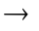Earth(ET*) is less than 2
degrees)

17 Angle_Sun_Solar_Mon Degrees Angle between Solar Monitor Normal(ET*)
and vector spacecraft(ET*)Sun(ET*-LT^{Sun-NEAR})

18 Avg_SC_Distance Kilometers Average distance from the spacecraft
to the surface of the asteroid contributing to the spectrum.
Approximation for Collimator_Fct can be found in Appendix 2.

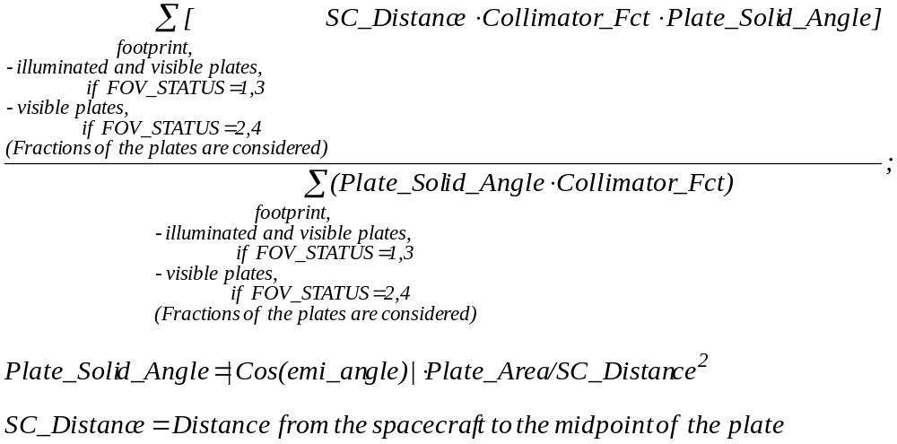

19 Sun_Distance Kilometers Sun_Position vector magnitude.

20 Avg_Emission_Angle Degrees Average emission angle (between normal to
the surface and direction from the surface to the spacecraft).
Approximation for Collimator_Fct is given in Appendix 2.

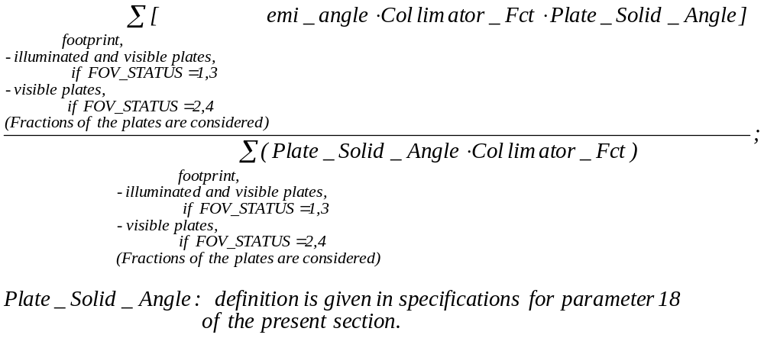

21 Avg_Incidence_Angle Degrees Average incidence angle (between normal to
the surface and direction from the surface to the sun).
Approximation for Collimator_Fct is given in Appendix 2.

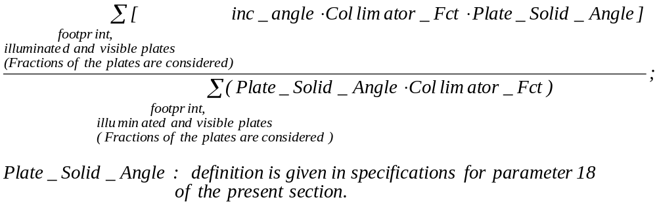

22 Phase_Angle Degrees Phase angle (between
direction from the sun to the surface and direction from the surface to the spacecraft).

23 Avg_Inc_Emi_Cos_Ratio Unitless Average ratio of the cosine of incidence
angle to the cosine of emission angle
Approximation for Collimator_Fct is given in Appendix 2.

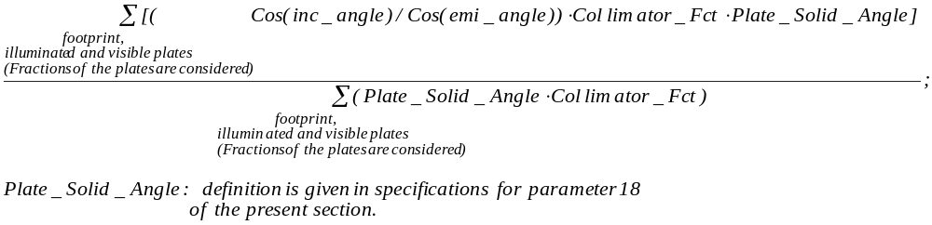

24 Spatial_Fluorescence_Norm Steradians Spatial normalization coefficient
for fluorescence flux. It relates the fluorescence flux at the detector to the fluorescence intensity from the asteroid surface in the direction normal to the surface under the condition that incidence angle =0.
For complete definition see Appendix 1.
Approximations for Angular_Fluor_Fct and Collimator_Fct are given in Appendix 2.

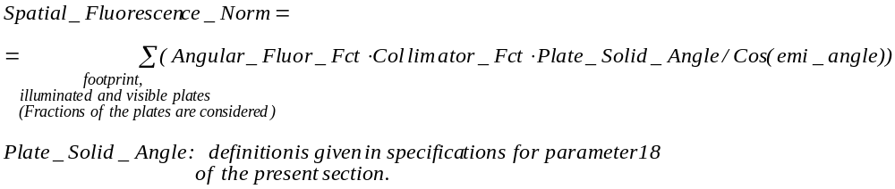

25 Spatial_Scattering_Norm Steradians Spatial normalization coefficient
for scattering. It relates the scattering flux at the detector to the intensity of scattering from the asteroid surface under the condition that incidence angle = emission angle = 0
For complete definition see Appendix 1.
Approximations for Angular_Scatter_Fct and Collimator_Fct are given in Appendix 2.

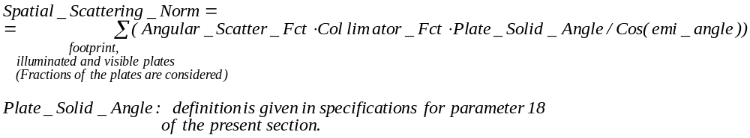

26 Total_Area_Footprint Sq. Kilometers NOT VALID (= -1)

27 Total_Illuminated_Area Sq. Kilometers Total area of plates in the
footprint contributing to
the spectrum (lit by the sun and visible from the spacecraft)

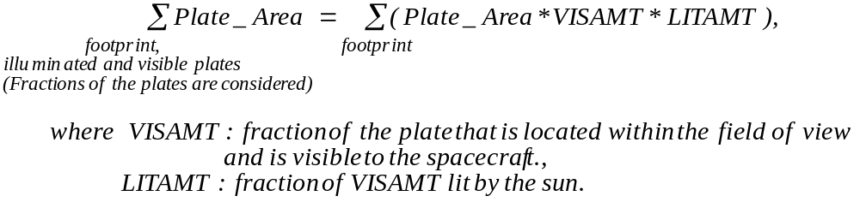

28 Total_Visible_Area Sq. Kilometers Total area of plates in the
footprint visible from the spacecraft

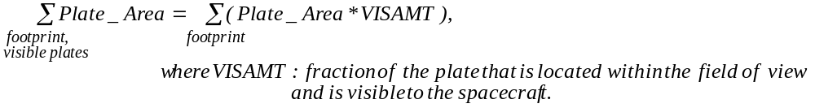

29 Total_Eff_Area Sq. Kilometers NOT VALID (= -1)

30 Total_Eff_Solid_Angle Unitless Overall solid angle of all plates
in the footprint contributing to the spectrum (lit by the sun and visible from the spacecraft) and weighted by the response function of the collimator, relatively the instrument full field of view.

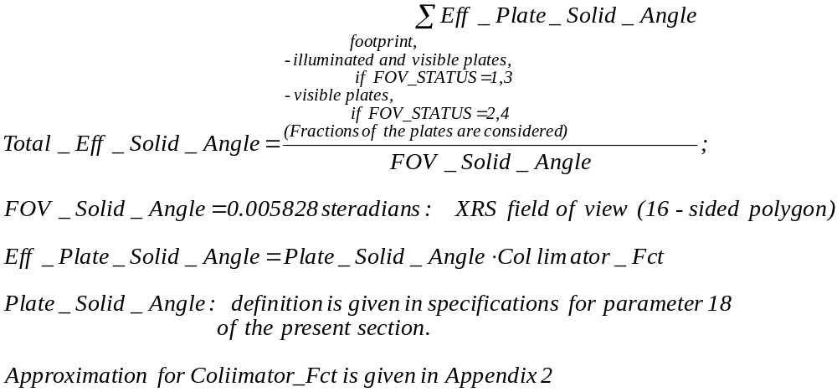

31 Footprint_Solid_Angle Unitless Overall solid angle of all plates in the
footprint as seen from the spacecraft, relatively the instrument full field of view.
* Plate solid angle is modified by plate fraction in FOV
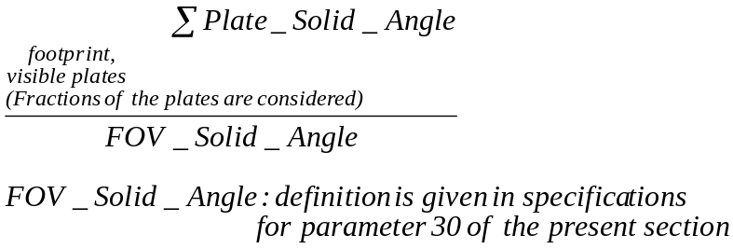

32 Boresight_Intersection_Lat Degrees Latitude of boresight intersection
in the middle of integration period

Coordinate transformation Asteroid Body Fixed, Cartesian to
Asteroid Body Fixed, Spherical. Intersection point (x,y,z) of
boresight with asteroid surface converted to Latitude.

LAT = Degrees(ARC_SIN(Z/R)) (R solved for in 34)

33 Boresight_Intersection_Lon Degrees Longitude of boresight intersection
in the middle of integration period

Coordinate transformation Asteroid Body Fixed, Cartesian to
Asteroid Body Fixed, Spherical. Intersection point (x,y,z) of
boresight with asteroid surface converted to Longitude.

1. LON = -1.*Degrees(ARC_TAN(Y/X))
2. LON = 270 for x = 0 AND y > 0
3. LON = 90 for x = 0 AND y < 0

34 Boresight_Intersection_R Kilometers Radius-vector of boresight intersection
in the middle of integration period

Coordinate transformation Asteroid Body Fixed, Cartesian to
Asteroid Body Fixed, Spherical. Intersection point (x,y,z) of
boresight with asteroid surface converted to Radius from
center of asteroid mass.

R = SQRT( X^2 + Y^2 + Z^2) (R is needed in sol’n 32)

35 SPICE_Kernel_ID Version Number Specified by NAIF
36 Plate_Model_ID Version Number
37 Processing_Software_ID Version Number
38 DataBase_Version_ID Version Number

H.9. NEAR XRS Solar (SOLAR) Parameters: 2*(Real*4)

PARAMETER NAME UNITS

- SOLAR_INTEGRAL Counts/Second Solar monitor counting rate,
corrected for the radiation incidence angle and normalized to 1.4 Astronomical Unit distance to the Sun. Reflects changes in solar x-ray flux.

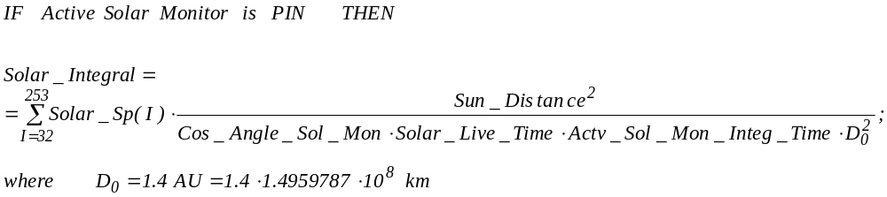

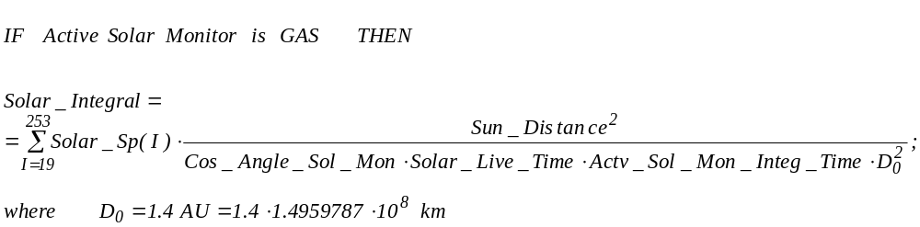

1 SOLAR_LEVEL Set correspondingly to 10 solar activity ranges provided by GSFC,
Control parameter: (Solar_Integral*300)
Takes values 0 .. 9.

V = Solar_Integral * 300

For PIN – detector: Example: V values will be modified and subject to change: Dynamically loaded runtime.

IF V< 3500 THEN SOLAR_LEVEL = 0

IF V>= 3500 AND V < 5000 THEN SOLAR_LEVEL = 1

IF V>= 5000 AND V < 7000 THEN SOLAR_LEVEL = 2

IF V>= 7000 AND V < 11000 THEN SOLAR_LEVEL = 3

IF V >= 11000 AND V < 20000 THEN SOLAR_LEVEL = 4

IF V >= 20000 AND V < 40000 THEN SOLAR_LEVEL = 5

IF V >= 40000 AND V < 80000 THEN SOLAR_LEVEL = 6

IF V >= 80000 AND V < 200000 THEN SOLAR_LEVEL = 7

IF V >= 200000 AND V < 1750000 THEN SOLAR_LEVEL = 8

IF V >= 1750000 THEN SOLAR_LEVEL = 9

For GAS – detector:

IF V < 16000 THEN SOLAR_LEVEL = 0

IF V >= 16000 AND V < 32000 THEN SOLAR_LEVEL = 1

IF V >= 32000 AND V < 63000 THEN SOLAR_LEVEL = 2

IF V >= 63000 AND V < 100000 THEN SOLAR_LEVEL = 3

IF V >= 100000 AND V < 105000 THEN SOLAR_LEVEL = 4

IF V >= 105000 AND V < 120000 THEN SOLAR_LEVEL = 5

IF V >= 120000 AND V < 140000 THEN SOLAR_LEVEL = 6

IF V >= 140000 AND V < 180000 THEN SOLAR_LEVEL = 7

IF V >= 180000 AND V < 1900000 THEN SOLAR_LEVEL = 8

IF V >= 1900000 THEN SOLAR_LEVEL = 9

I. Numerical Specifications for XRS Level–2 Summary Record

FORMAT 3 – Numerical specifications for Summarized XRS Level-2 record (output)

I.1. NEAR XRS Summarized Unfiltered Spectrum with GAS_PC Active (UNF,GAS_PC): 256 Channels*(Real*4)

Measuring units: Counts/Channel

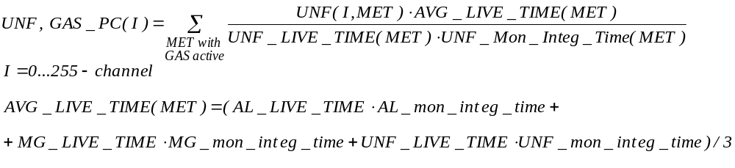

I.2. NEAR XRS Summarized MG Spectrum with GAS_PC Active (MG,GAS_PC): 256 Channels*(Real*4)

Measuring units: Counts/Channel

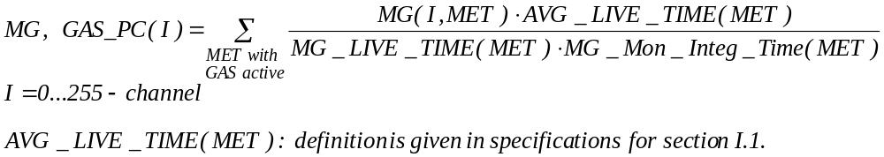

I.3. NEAR XRS Summarized AL Spectrum with GAS_PC Active (AL,GAS_PC): 256 Channels*(Real*4)

Measuring units: Counts/Channel

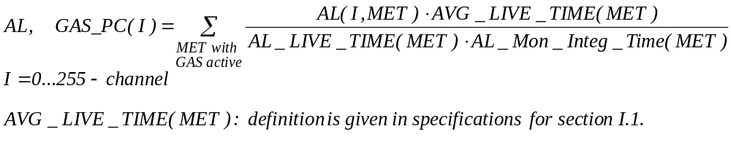

I.4. NEAR XRS Summarized GAS_PC Spectrum (GAS_PC): 256 Channels*(Real*4)

Measuring units: Counts/Channel

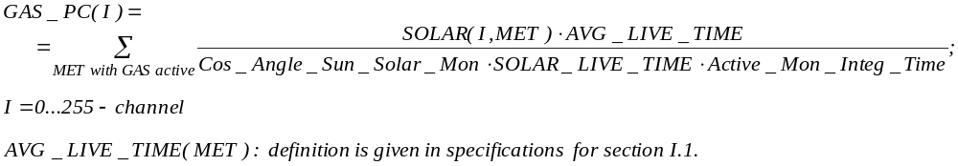

I.5. NEAR XRS Summarized Unfiltered Spectrum with PIN Active (UNF,PIN): 256 Channels*(Real*4)

Measuring units: Counts/Channel

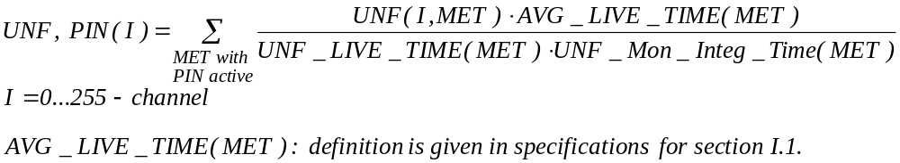

I.6. NEAR XRS Summarized MG Spectrum with PIN Active (MG,PIN): 256 Channels*(Real*4)

Measuring units: Counts/Channel

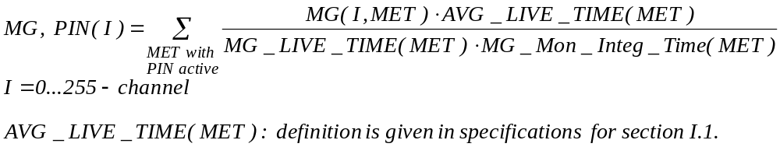

I.7. NEAR XRS Summarized AL Spectrum with PIN active (AL,PIN): 256 Channels*(Real*4)

Measuring units: Counts/Channel

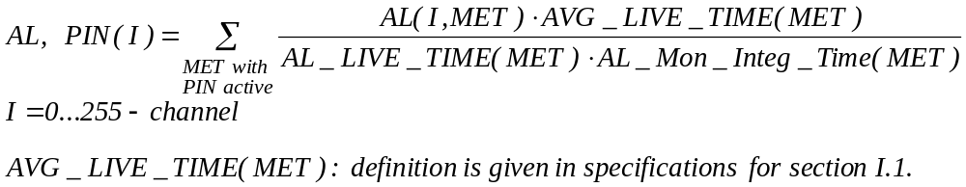

I.8. NEAR XRS Summarized PIN Spectrum (PIN): 256 Channels*(Real*4)

Measuring units: Counts/Channel

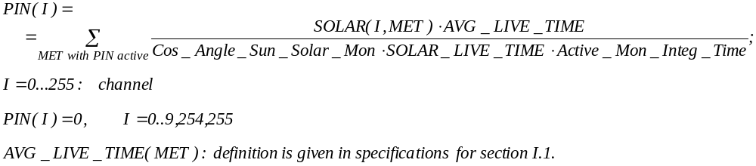

I.9. NEAR XRS Summarized Engineering (ENGINEERING) Parameters: 48*(Real*4)

PARAMETER NAME UNITS

0 Spare
1 Spare
2 Spare
3 Spare
4 Spare
5 Spare

6 TOTAL_INTEG_TIME_UNF_GAS Seconds 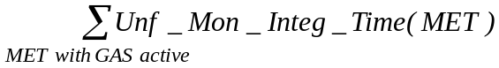

7 TOTAL_INTEG_TIME_MG_GAS Seconds 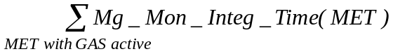

8 TOTAL_INTEG_TIME_AL_GAS Seconds 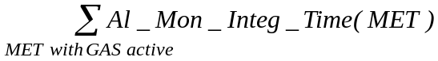

9 TOTAL_INTEG_TIME_GAS Seconds 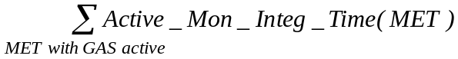

10 TOTAL_LIVE_TIME_UNF_GAS Seconds

11 TOTAL_LIVE_TIME_MG_GAS Seconds

12 TOTAL_LIVE_TIME_AL_GAS Seconds

13 TOTAL_LIVE_TIME_GAS Seconds

14 UNF_VALID_CHANNEL_HI_GAS Channel Highest channel of summed spectrum
uncorrupted by energy scale adjustments.
Lowest UNF_VALID_CHANNEL_HI among all MET records in a sum.
15 MG_VALID_CHANNEL_HI_GAS Channel - “ - Lowest MG_VALID_CHANNEL_HI
16 AL_VALID_CHANNEL_HI_GAS Channel - ‘ - Lowest AL_VALID_CHANNEL_HI
17 UNF_VALID_CHANNEL_LOW_GAS Channel Lowest channel of summed spectrum
uncorrupted by energy scale adjustments or LLD variations.
Highest UNF_VALID_CHANNEL_LOW among all MET records in a sum.
18 MG_VALID_CHANNEL_LOW_GAS Channel - ‘ - Highest MG_VALID_CHANNEL_LOW
19 AL_VALID_CHANNEL_LOW_GAS Channel - ‘ - Highest AL_VALID_CHANNEL_LOW
20 UNF_INVALID_CHANNEL_HI_GAS Channel Highest channel of rise-time transition
region in the summed spectrum formed as a result of energy scale or rise time settings variations.
Highest UNF_RISE_TIME_CHANNEL among all MET records in a sum.
21 MG_INVALID_CHANNEL_HI_GAS Channel - ‘ -Highest MG_RISE_TIME_CHANNEL
22 AL_INVALID_CHANNEL_HI_GAS Channel - ‘ - Highest AL_RISE_TIME_CHANNEL
23 UNF_INVALID_CHANNEL_LOW_GAS Channel Lowest channel of rise-time transition
region in the summed spectrum formed as a result of energy scale or rise time settings variations.
Lowest UNF_RISE_TIME_CHANNEL among all MET records in a sum.
24 MG_INVALID_CHANNEL_LOW_GAS Channel - ‘ - Lowest MG_RISE_TIME_CHANNEL
25 AL_INVALID_CHANNEL_LOW_GAS Channel - ‘ - Lowest AL_RISE_TIME_CHANNEL

26 Number_MET_GAS Number of MET records in the query when GAS solar monitor was active

27 TOTAL_INTEG_TIME_UNF_PIN Seconds 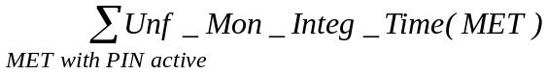

28 TOTAL_INTEG_TIME_MG_PIN Seconds 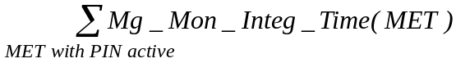

29 TOTAL_INTEG_TIME_AL_PIN Seconds 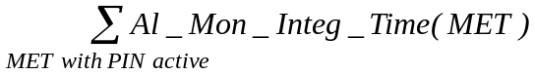

30 TOTAL_INTEG_TIME_PIN Seconds 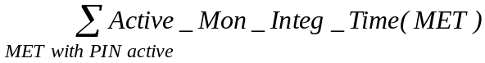

31 TOTAL_LIVE_TIME_UNF_PIN Seconds

32 TOTAL_LIVE_TIME_MG_PIN Seconds

33 TOTAL_LIVE_TIME_AL_PIN Seconds

34 TOTAL_LIVE_TIME_PIN Seconds

35 UNF_VALID_CHANNEL_HI_PIN Channel Highest channel of summed spectrum
uncorrupted by energy scale adjustments.
Lowest UNF_VALID_CHANNEL_HI among all MET records in a sum.
36 MG_VALID_CHANNEL_HI_PIN Channel - “ - Lowest MG_VALID_CHANNEL_HI
37 AL_VALID_CHANNEL_HI_PIN Channel - “ - Lowest AL_VALID_CHANNEL_HI
38 UNF_VALID_CHANNEL_LOW_PIN Channel Lowest channel of summed spectrum
uncorrupted by energy scale adjustments or LLD variations.
Highest UNF_VALID_CHANNEL_LOW among all MET records in a sum.
39 MG_VALID_CHANNEL_LOW_PIN Channel - “ - Highest MG_VALID_CHANNEL_LOW
40 AL_VALID_CHANNEL_LOW_PIN Channel - “ - Highest AL_VALID_CHANNEL_LOW
41 UNF_INVALID_CHANNEL_HI_PIN Channel Highest channel of rise-time transition
region in the summed spectrum formed as a result of energy scale or rise time settings variations.
Highest UNF_RISE_TIME_CHANNEL among all MET records in a sum.
42 MG_INVALID_CHANNEL_HI_PIN Channel - ‘ - Highest MG_RISE_TIME_CHANNEL
43 AL_INVALID_CHANNEL_HI_PIN Channel - ‘ - Highest AL_RISE_TIME_CHANNEL
44 UNF_INVALID_CHANNEL_LOW_PIN Channel Lowest channel of rise-time transition
region in the summed spectrum formed as a result of energy scale or rise time settings variations.
Lowest UNF_RISE_TIME_CHANNEL among all MET records in a sum.
45 MG_INVALID_CHANNEL_LOW_PIN Channel - ‘ - Lowest MG_RISE_TIME_CHANNEL
46 AL_INVALID_CHANNEL_LOW_PIN Channel - ‘ - Lowest AL_RISE_TIME_CHANNEL

47 Number_MET_PIN Number of MET records in the query when PIN solar monitor was active

I.10. NEAR XRS Summarized Spatial (SPATIAL) Parameters: 17*(Real*4)

PARAMETER NAME UNITS

0 AVG_SC_DISTANCE_GAS Kilometers Distance from the spacecraft to the surface
of the asteroid averaged over MET records in a sum with proportional counter active.

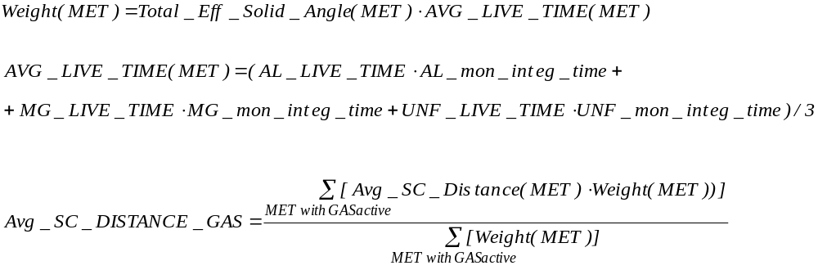

1 AVG_EMI_ANGLE_GAS Degrees Emission angle averaged over MET records
in a sum with proportional counter active.

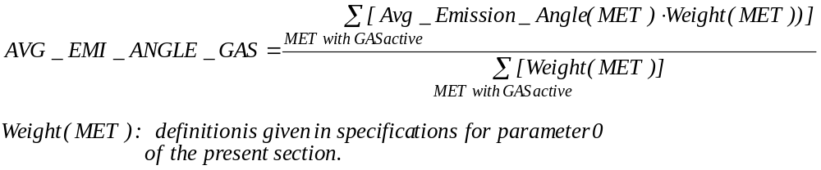

2 AVG_INC_ANGLE_GAS Degrees Incidence angle averaged over MET records
in a sum with proportional counter active.

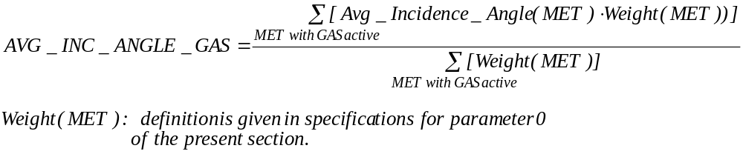

3 AVG_PHASE _GAS Degrees Phase angle
averaged over MET records in a sum
with proportional counter active.

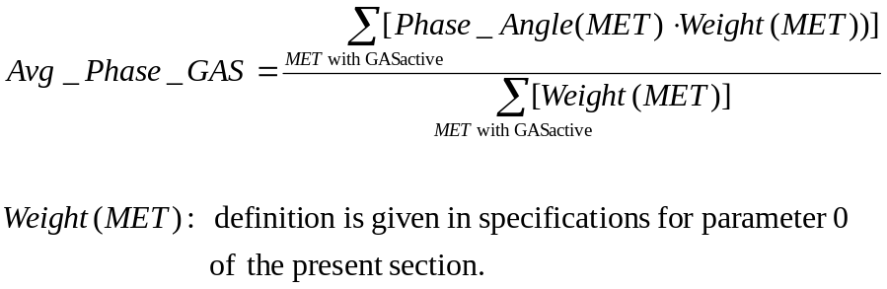

4 AVG_INC_EMI_COS_RATIO_GAS Unitless Ratio of cosines of incidence and emission
angles averaged over MET records in a sum with proportional counter active.

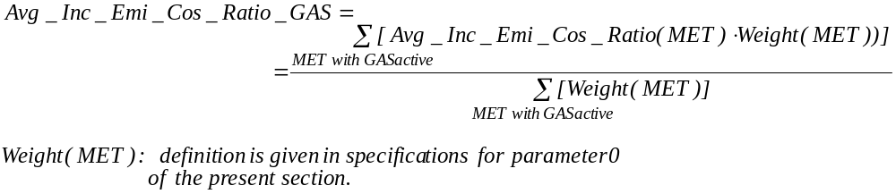

5 AVG_EFF_SOLID_ANGLE_GAS Unitless Total effective solid angle averaged over
MET records in a sum with proportional
counter active.

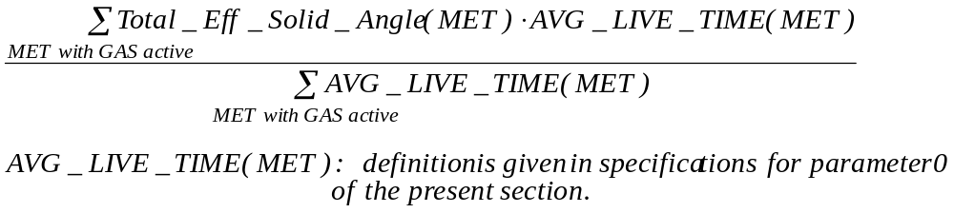

6 Total_Weight_Fluor_GAS Steradians*Counts Normalization coefficient providing the link
between the summed fluorescence spectrum and the intensity of fluorescence from the asteroid surface in the direction normal to the surface under the condition that incidence angle = 0 (for MET’s with proportional counter active).
For complete definition see Appendix 1.

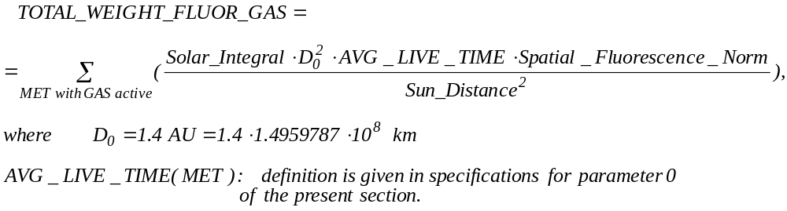

7 Total_Weight_Scat_GAS Steradians*Counts Normalization coefficient providing the
link between the summed spectrum of scattering and the intensity of scattering from the asteroid surface under the condition that incidence angle = emission angle = half-sum of incidence and emission angles averaged over all MET records participating in the sum (for MET’s with proportional counter active). For complete definition see Appendix 1.

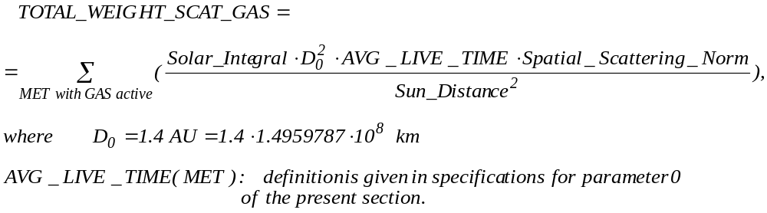

8 AVG_SC_DISTANCE_PIN Kilometers Distance from the spacecraft to the surface
of the asteroid averaged over MET records in a sum with PIN monitor active.

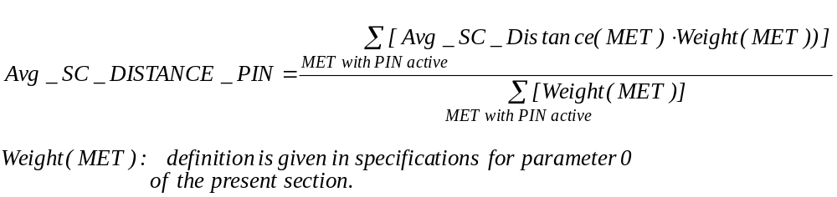

9 AVG_EMI_ANGLE_PIN Degrees Emission angle averaged over MET records
in a sum with PIN monitor active.

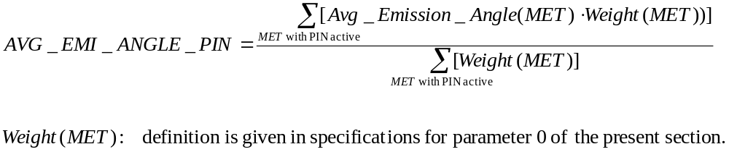

10 AVG_INC_ANGLE_PIN Degrees Incidence angle averaged over MET records
in a sum with PIN monitor active.

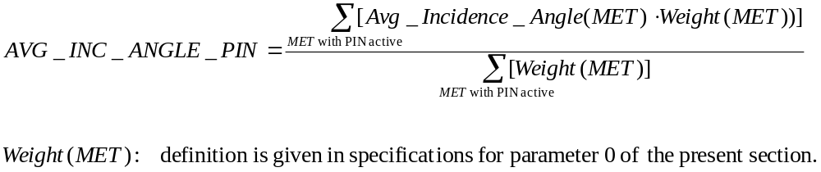

11 AVG_PHASE_PIN Degrees Phase angle
averaged over MET records in a sum
with PIN monitor active.

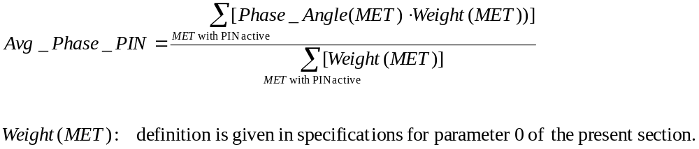

12 AVG_INC_EMI_COS_RATIO_PIN Unitless Ratio of cosines of incidence and emission
angles averaged over MET records in a sum
with PIN monitor active.

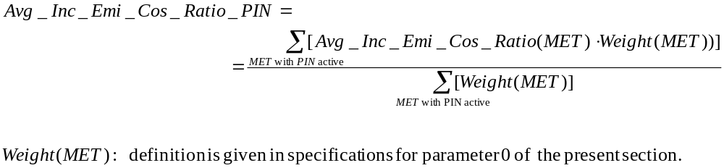

13 AVG_EFF_SOLID_ANGLE_PIN Unitless Total effective solid angle averaged over
MET records in a sum with PIN monitor
active.

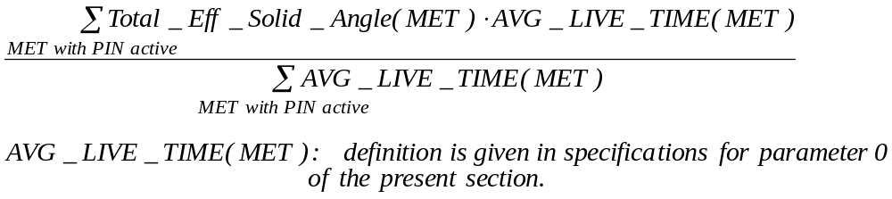

14 Total_Weight_Fluor_PIN Steradians*Counts Normalization coefficient providing the link
between the summed fluorescence spectrum and the intensity of fluorescence from the asteroid surface in the direction normal to the surface under the condition that incidence angle = 0 (for MET’s with PIN monitor active).
For complete definition see Appendix 1.
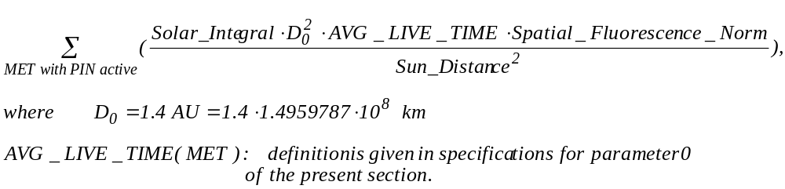

15 Total_Weight_Scat_PIN Steradians*Counts Normalization coefficient providing the
link between the summed spectrum of scattering and the intensity of scattering from the asteroid surface under the condition that incidence angle = emission angle = half-sum of incidence and emission angles averaged over all MET records participating in the sum (for MET’s with PIN monitor active). For complete definition see Appendix 1.

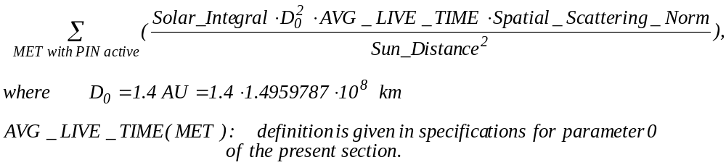

16 ESTIMATED_COVERED_AREA Sq. Kilometers Estimated area of the asteroid surface
covered by MET records in a sum

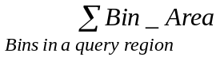 For a spatial query
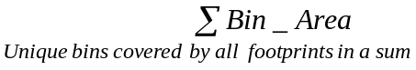 For a temporal query

I.11. NEAR XRS Summarized Solar (SOLAR) Parameters: 4*(Real*4)

PARAMETER NAME UNITS
1 Average_Solar_Integral_GAS Counts 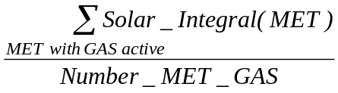

2 Solar_Integral_Variance_GAS Sq. Counts

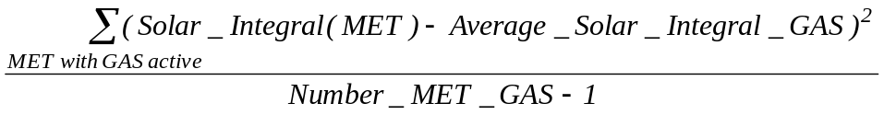

3 Average_Solar_Integral_PIN Counts 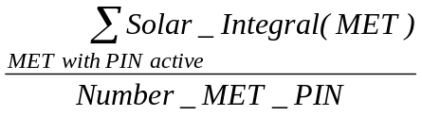

4 Solar_Integral_Variance_PIN Sq. Counts

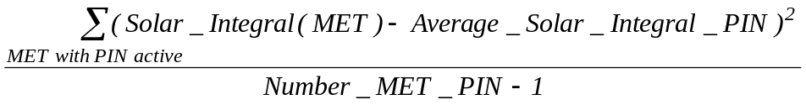

J. Numerical Specifications for XRS Fractional Footprint Accounting System

PARAMETER NAME UNITS

0 MET Seconds Mission Elapsed Time at start of integartion
1 Footprint_Bin_Total_Area Sq. Kilometers NOT VALID (= -1)
2 Footprint_Bin_Illum_Area Sq. Kilometers Total area of all plates in the footprint
that belong to the bin, contributing into the spectrum (lit by the sun and visible from the spacecraft)

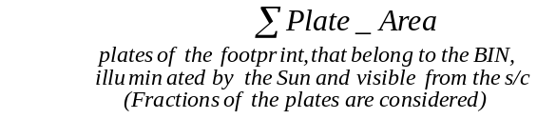 Fractions are considered as in H8 param.29

3 Footprint_Bin_Visible_Area Sq. Kilometers Total area of all plates in the
footprint that belong to the bin, visible from the spacecraft

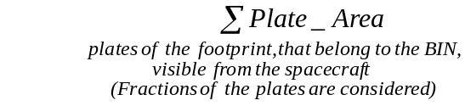 Fractions are considered as in H8 param.28

4 Footprint_Bin_Eff_Area Sq. Kilometers NOT VALID (= -1)

5 Total_Eff_Solid_Angle_Fraction Unitless Fraction of the total effective
solid angle that can be attributed to the bin.

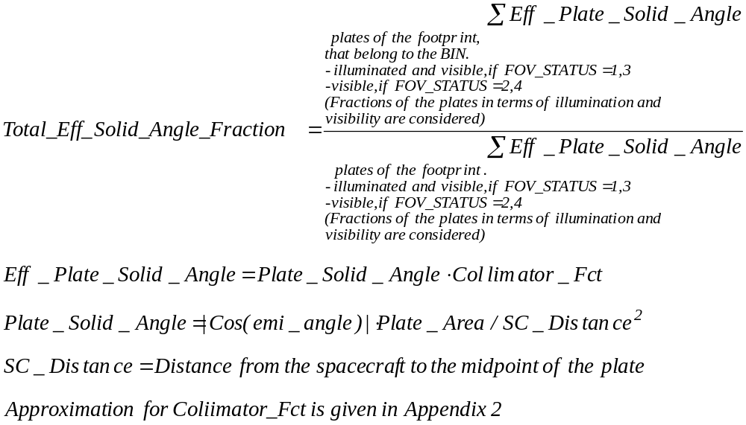

6 Spectrum_Fraction Unitless Fraction of the spectrum that can
be attributed to the bin.
Approximations for Angular_Scatter_Fct and Collimator_Fct are given in Appendix 2.

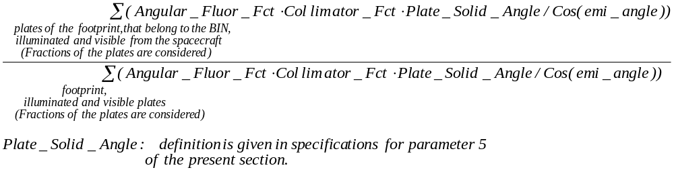

7. BINID Number Bin identifier as generated by the
Bin definition system. Each bin is unique.

APPENDIX 1. Definitions for:
Collimator_Fct;
Spatial_Fluorescence_Norm;
Angular_Fluor_Fct;
Total_Weight_Fluor;
Spatial_Scattering_Norm;
Angular_Scatter_Fct;
Total_Weight_Scatt.

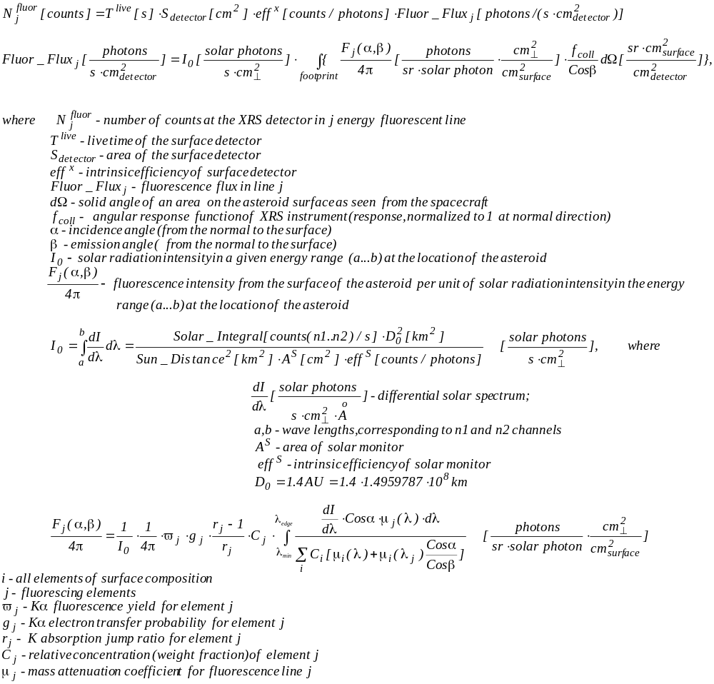

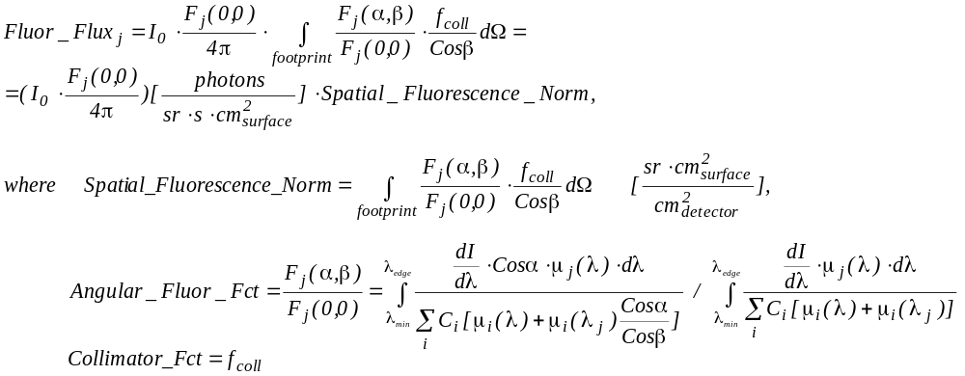

Angular_Fluor_Fct:
Ratio of intensity of fluorescence (photons/(s*sr*cm²_{surface}) from the surface
to the intensity of fluorescence from the same surface illuminated with the
same solar flux with the incidence angle = 0 in the direction of the normal to the
surface (emission angle = 0), which is a weak function of composition, energy and solar activity.

Spatial_Fluorescence_Norm:
Ratio of the fluorescence flux at the detector (photons/(s*cm²_{detector}) from the
whole footprint at given orbital configuration to the intensity of
fluorescence from the asteroid surface (photons/(s*sr*cm²_{surface}) under the same
solar flux and 0 incidence and emission angles.

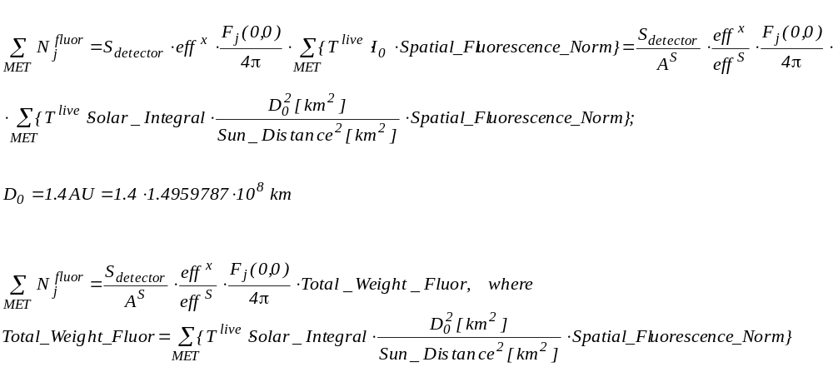

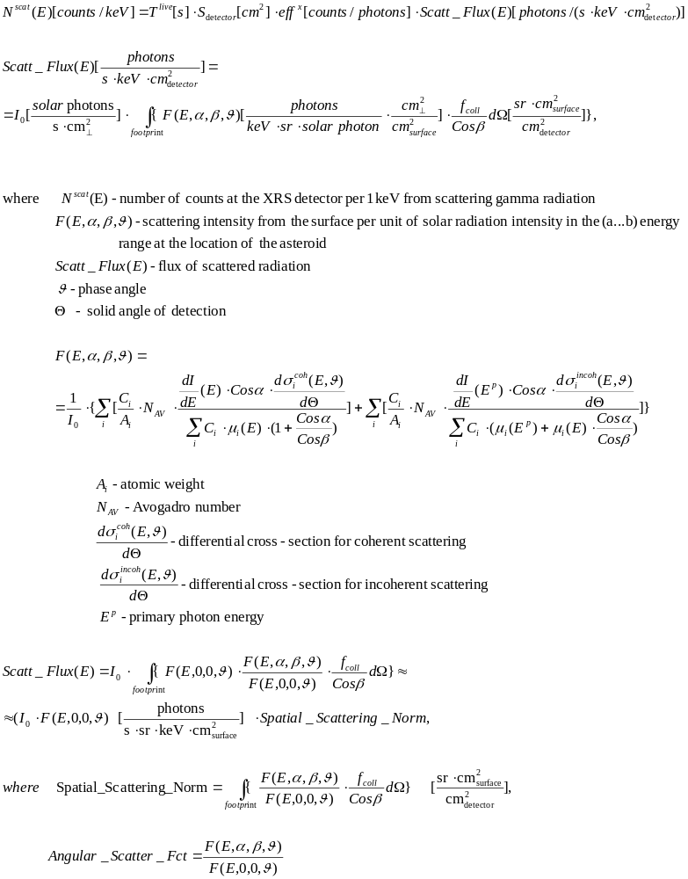

Angular_Scatter_Fct:
Ratio of intensity of scattering (photons/(s*keV*sr*cm²_{surface}) from the surface with a given incidence and emission angles, α and β, to the intensity of scattering from the same surface with the incidence angle = emission angle = 0, which is a weak function of composition, energy and solar activity.

Spatial_Scattering_Norm:
Ratio of the scattering flux at the detector (photons/(s*keV*cm²_{detector}) from the whole footprint at given orbital configuration to the scattering intensity of 1 cm² of the asteroid surface (photons/(s*keV*sr*cm²_{surface}) under the same solar flux when incidence angle = emission angle = 0.

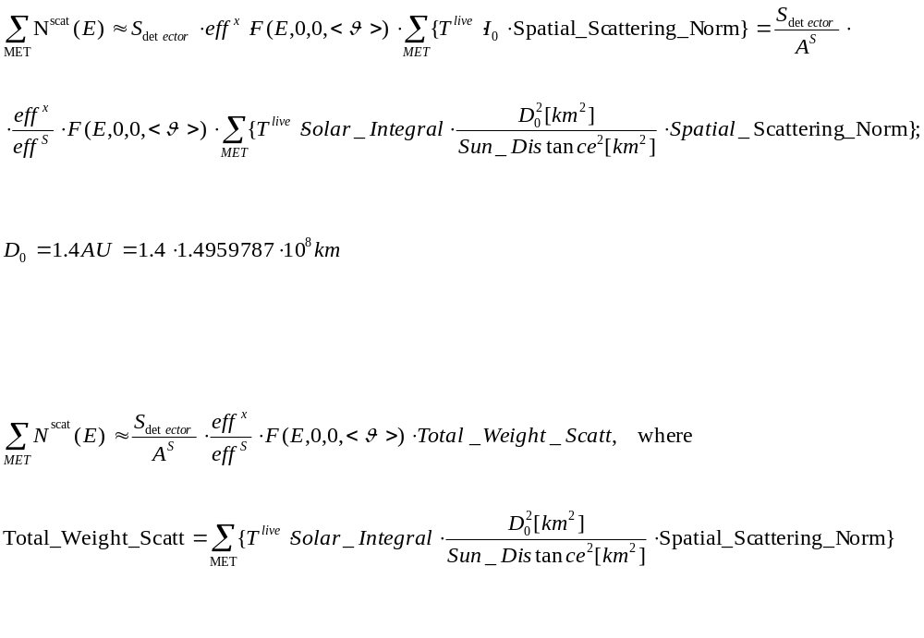

APPENDIX 2. Approximations for:
Collimator_Fct;
Angular_Fluor_Fct;
Angular_Scatter_Fct;
FOV_Status

1) Collimator_Fct = 0.97*exp(-0.5*((ϕ-0.02)/1.42)²)+0.028-0.11*ϕ +0.0256* ϕ ²,
where ϕ – the angle between the boresight and the vector directed from the spacecraft to the midpoint of
the plate.

Collimator_Fct = 0, when ϕ > 3.4 degrees.

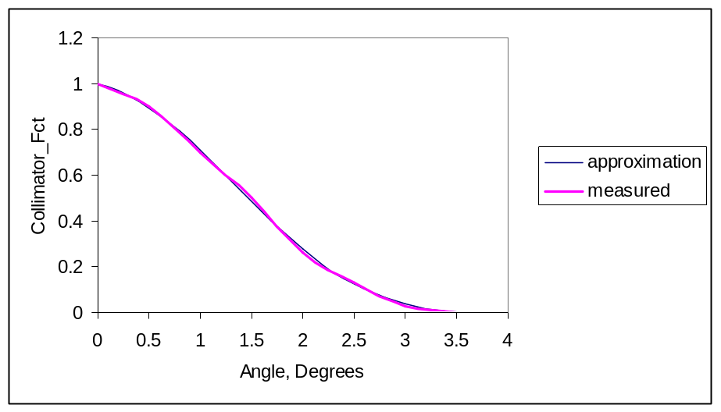
Figure 1. Angular response of the XRS collimator;
measurements vs. approximation

- When XRS field of view is represented with the 16 sided polygon if all 16 sides are located on the asteroid FOV_STATUS = 1 or 2 depending on the illumination status. If less than 16 sides are located on the asteroid FOV_STATUS = 3 or 4 depending on the illumination status. If no sides are located on the asteroid FOV_STATUS = 0.

- Angular_Fluor_Fct and Angular_Scatter_Fct – surfaces:

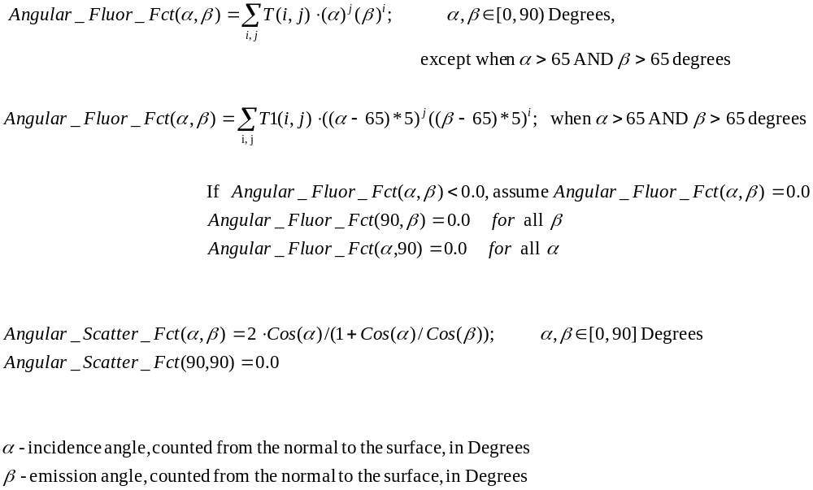

T(0,0)= 1.00172E+00 T(2,0)=-3.26751E-05 T(4,0)=2.42909E-08
T(0,1)=-5.64297E-04 T(2,1)=-8.04678E-06 T(4,1)=-4.14045E-09
T(0,2)=-1.73585E-05 T(2,2)=7.96751E-07 T(4,2)=4.06218E-10
T(0,3)=-2.17047E-06 T(2,3)=-2.74497E-08 T(4,3)=-1.41884E-11
T(0,4)=3.15083E-08 T(2,4)=4.04218E-10 T(4,4)=2.09849E-13
T(0,5)=-2.18812E-10 T(2,5)=-2.05539E-12 T(4,5)=-1.07269E-15
T(1,0)=-4.38375E-04 T(3,0)=-1.70545E-06 T(5,0)=-1.77067E-10
T(1,1)=8.20107E-05 T(3,1)=2.81293E-07 T(5,1)=2.10402E-11
T(1,2)=-7.99650E-06 T(3,2)=-2.74913E-08 T(5,2)=-2.07651E-12
T(1,3)=2.79160E-07 T(3,3)=9.59744E-10 T(5,3)=7.25547E-14
T(1,4)=-4.09545E-09 T(3,4)=-1.41387E-11 T(5,4)=-1.07835E-15
T(1,5)=2.07066E-11 T(3,5)=7.19243E-14 T(5,5)=5.55545E-18

T1(0,0)=4.22939E-01 T1(2,0)=-2.58902E-06 T1(4,0)=1.23481E-09
T1(0,1)=-1.63307E-03 T1(2,1)=-8.19620E-07 T1(4,1)=-2.18860E-10
T1(0,2)=-1.27089E-06 T1(2,2)=6.04984E-08 T1(4,2)=1.58527E-11
T1(0,3)=-1.81205E-07 T1(2,3)=-1.50287E-09 T1(4,3)=-3.97157E-13
T1(0,4)=1.61853E-09 T1(2,4)=1.58143E-11 T1(4,4)=4.21262E-15
T1(0,5)=-7.84793E-12 T1(2,5)=-5.75453E-14 T1(4,5)=-1.54659E-17
T1(1,0)=-1.67373E-03 T1(3,0)=-1.46340E-07 T1(5,0)=-6.17352E-12
T1(1,1)=2.35748E-05 T1(3,1)=2.10009E-08 T1(5,1)=7.78907E-13
T1(1,2)=-8.08433E-07 T1(3,2)=-1.50273E-09 T1(5,2)=-5.79691E-14
T1(1,3)=2.07575E-08 T1(3,3)=3.75675E-11 T1(5,3)=1.45610E-15
T1(1,4)=-2.15323E-10 T1(3,4)=-3.96237E-13 T1(5,4)=-1.55376E-17
T1(1,5)=7.61606E-13 T1(3,5)=1.44604E-15 T1(5,5)=5.75357E-20

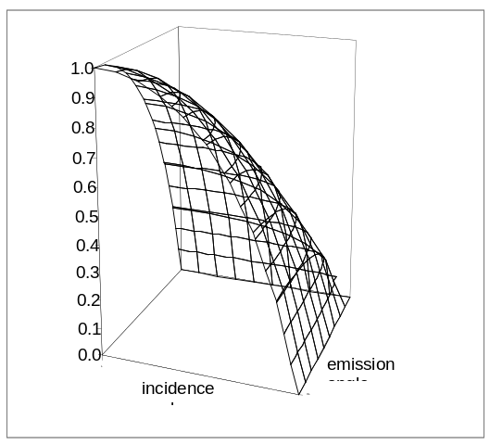
Figure 2 Angular_Fluor_Fct(α,β)

APPENDIX 3 Location of XRS Level-2 Parameters in the U of A Database

E.5. NEAR XRS Science Housekeeping (SCI HK) Parameters: 53*(Integer*4)

No | PARAMETER NAME IN  “Requirements Specifications For Level-2 Parameters Required Stored or Derived by The Near Earth Redezvous (NEAR) X-Ray Spectrometer (XRS) Ground System” | PARAMETER NAME IN  UA DATABASE | TABLE  NAME | DATABASE  NAME
0 | MET | ACQ_MET_TIME | All tables | All databases
1 | UTC | ACQ_UTC_TIME | x_unf_spec_tab,  x_mg_spec_tab,  x_al_spec_tab,  x_solar_spec_tab | near_xrs_db
1 | UTC | ACQ_UTC_TIME | xrs_hk_tab | near_hk_db
2 | DQI | DQI | index_tab | near_xrs_db
3 | TIME_TAG | ACQ_MET_TIME | All tables | All databases
4 | UNF_MON_INTEG_TIME | INT_TIME | x_unf_spec_tab | near_xrs_db
5 | MG_MON_INTEG_TIME | INT_TIME | x_mg_spec_tab | near_xrs_db
6 | AL_MON_INTEG_TIME | INT_TIME | x_al_spec_tab | near_xrs_db
7 | ACTV_SOL_MON_INTEG_TIME | INT_TIME | x_solar_spec_tab | near_xrs_db
8 | UNF_XRAY_1_SAFE_FLG | LVL1_SENSOR_SAFING_FLAG | x_unf_spec_tab | near_xrs_db
9 | MG_XRAY_1_SAFE_FLG | LVL1_SENSOR_SAFING_FLAG | x_mg_spec_tab | near_xrs_db
10 | AL_XRAY_1_SAFE_FLG | LVL1_SENSOR_SAFING_FLAG | x_al_spec_tab | near_xrs_db
11 | GAS_XRAY_1_SAFE_FLG | GAS_LVL1_SENSOR_SAFING_FLAG | x_solar_spec_tab | near_xrs_db
12 | PIN_XRAY_1_SAFE_FLG | PIN_LVL1_SENSOR_SAFING_FLAG | x_solar_spec_tab | near_xrs_db
13 | UNF_XRAY_2_SAFE_FLG | LVL2_SENSOR_SAFING_FLAG | x_unf_spec_tab | near_xrs_db
14 | MG_XRAY_2_SAFE_FLG | LVL2_SENSOR_SAFING_FLAG | x_mg_spec_tab | near_xrs_db
15 | AL_XRAY_2_SAFE_FLG | LVL2_SENSOR_SAFING_FLAG | x_al_spec_tab | near_xrs_db
16 | GAS_XRAY_2_SAFE_FLG | GAS_LVL2_SENSOR_SAFING_FLAG | x_solar_spec_tab | near_xrs_db
17 | PIN_XRAY_2_SAFE_FLG | PIN_LVL2_SENSOR_SAFING_FLAG | x_solar_spec_tab | near_xrs_db
18 | UNF_XRAY_OVERFLOW_FLG | SPEC_BOF | x_unf_spec_tab | near_xrs_db
19 | MG_XRAY_OVERFLOW_FLG | SPEC_BOF | x_mg_spec_tab | near_xrs_db
20 | AL_XRAY_OVERFLOW_FLG | SPEC_BOF | x_al_spec_tab | near_xrs_db
21 | ACTIVE_XRAY_OVERFLOW_FLG | SPEC_BOF | x_solar_spec_tab | near_xrs_db
22 | UNF_XRAY_RAW_EVENT_RATE | RAW_EVENT_RATE | x_unf_spec_tab | near_xrs_db
23 | MG_XRAY_RAW_EVENT_RATE | RAW_EVENT_RATE | x_mg_spec_tab | near_xrs_db
24 | AL_XRAY_RAW_EVENT_RATE | RAW_EVENT_RATE | x_al_spec_tab | near_xrs_db
25 | GAS_XRAY_RAW_EVENT_RATE | GAS_RAW_EVENT_RATE | x_solar_spec_tab | near_xrs_db
26 | PIN_XRAY_RAW_EVENT_RATE | PIN_RAW_EVENT_RATE | x_solar_spec_tab | near_xrs_db
27 | UNF_XRAY_VALID_EVENTS | NUM_VALID_PROCESSED_EVENTS | x_unf_spec_tab | near_xrs_db
28 | MG_XRAY_VALID_EVENTS | NUM_VALID_PROCESSED_EVENTS | x_mg_spec_tab | near_xrs_db
29 | AL_XRAY_VALID_EVENTS | NUM_VALID_PROCESSED_EVENTS | x_al_spec_tab | near_xrs_db
30 | GAS_XRAY_VALID_EVENTS | GAS_VALID_PROCESSED_EVENTS | x_solar_spec_tab | near_xrs_db
31 | UNF_XRAY_EVENTS_REJ_BY_RT | NUM_EVENTS_REJ_BY_RTD | x_unf_spec_tab | near_xrs_db
32 | MG_XRAY_EVENTS_REJ_BY_RT | NUM_EVENTS_REJ_BY_RTD | x_mg_spec_tab | near_xrs_db
33 | AL_XRAY_EVENTS_REJ_BY_RT | NUM_EVENTS_REJ_BY_RTD | x_al_spec_tab | near_xrs_db
34 | GAS_XRAY_EVENTS_REJ_BY_RT | NUM_EVENTS_REJ_BY_RTD | x_solar_spec_tab | near_xrs_db
35 | PIN_SOLAR_PROCESS_EVENT | PIN_SOLAR_PROCESSED_EVENTS | x_unf_spec_tab | near_xrs_db
36 | XTALK_COUNTER | XTALK_COUNTER | x_mg_spec_tab | near_xrs_db
37 | CMD_OPCODE | CMD_OPCODE | x_al_spec_tab | near_xrs_db
38 | CMD_ARGUMENT | CMD_ARGUMENT | x_al_spec_tab | near_xrs_db
39 | CMDS_RECEIVED | CMDS_RECD | x_solar_spec_tab | near_xrs_db
40 | PROBLEM_COUNTER | PROBLEM_COUNTER | x_solar_spec_tab | near_xrs_db
41 | PROBLEM_CODE | PROBLEM_CODE | x_solar_spec_tab | near_xrs_db
42 | UNF_XRAY_DC_OFFSET | DC_OFFSET_EST | x_unf_spec_tab | near_xrs_db
43 | MG_XRAY_DC_OFFSET | DC_OFFSET_EST | x_mg_spec_tab | near_xrs_db
44 | AL_XRAY_DC_OFFSET | DC_OFFSET_EST | x_al_spec_tab | near_xrs_db
45 | GAS_XRAY_DC_OFFSET | GAS_DC_OFFSET_EST | x_solar_spec_tab | near_xrs_db
46 | PIN_DC_OFFSET | PIN_DC_OFFSET_EST | x_solar_spec_tab | near_xrs_db
47 | UNF_STAND_DEV | STD_DEV | x_unf_spec_tab | near_xrs_db
48 | MG_STAND_DEV | STD_DEV | x_mg_spec_tab | near_xrs_db
49 | AL_STAND_DEV | STD_DEV | x_al_spec_tab | near_xrs_db
50 | GAS_STAND_DEV | GAS_STD_DEV | x_solar_spec_tab | near_xrs_db
51 | PIN_STAND_DEV | PIN_STD_DEV | x_solar_spec_tab | near_xrs_db
52 | XRAY_DATA_QUALITY_BIT | XRAY_DQI | x_unf_spec_tab | near_xrs_db

E.6. NEAR XRS Engineering Housekeeping (ENG HK) Parameters: 163*(REAL*4)

No | PARAMETER NAME IN  “Requirements Specifications For Level-2 Parameters Required Stored or Derived by The Near Earth Redezvous (NEAR) X-Ray Spectrometer (XRS) Ground System” | PARAMETER NAME IN  UA DATABASE | TABLE  NAME | DATABASE  NAME
0 | DETECTOR_ELECTR_CURR | DETECTOR_ELECTR_CURR | xrs_hk_tab | near_hk_db
1 | XRAY_PIN_DIODE_FET_BIAS | XRAY_PIN_DIODE_FET_BIAS | xrs_hk_tab | near_hk_db
2 | HVCE_TEMPERATURE | HVCE_TEMPERATURE | xrs_hk_tab | near_hk_db
3 | UNF_XRAY_HVPS_VOLT | UNF_XRAY_HVPS_VOLT | xrs_hk_tab | near_hk_db
4 | MG_XRAY_HVPS_VOLT | MG_XRAY_HVPS_VOLT | xrs_hk_tab | near_hk_db
5 | AL_XRAY_HVPS_VOLT | AL_XRAY_HVPS_VOLT | xrs_hk_tab | near_hk_db
6 | XRAY_GAS_HVPS_VOLT | XRAY_GAS_HVPS_VOLT | xrs_hk_tab | near_hk_db
7 | XRAY_PIN_HVPS_VOLT | XRAY_PIN_HVPS_VOLT | xrs_hk_tab | near_hk_db
8 | NAI_HVPS_VOLT | NAI_HVPS_VOLT | xrs_hk_tab | near_hk_db
9 | BGO_HVPS_VOLT | BGO_HVPS_VOLT | xrs_hk_tab | near_hk_db
10 | DPU_DC_DC_TEMP | DPU_DC_DC_TEMP | xrs_hk_tab | near_hk_db
11 | XGRS_DC_DC_TEMP | XGRS_DC_DC_TEMP | xrs_hk_tab | near_hk_db
12 | UNF_XRAY_HVPS_TEMP | UNF_XRAY_HVPS_TEMP | xrs_hk_tab | near_hk_db
13 | MG_XRAY_HVPS_TEMP | MG_XRAY_HVPS_TEMP | xrs_hk_tab | near_hk_db
14 | AL_XRAY_HVPS_TEMP | AL_XRAY_HVPS_TEMP | xrs_hk_tab | near_hk_db
15 | XRAY_GAS_HVPS_TEMP | XRAY_GAS_HVPS_TEMP | xrs_hk_tab | near_hk_db
16 | XRAY_PIN_HVPS_TEMP | XRAY_PIN_HVPS_TEMP | xrs_hk_tab | near_hk_db
17 | NAI_HVPS_TEMP | NAI_HVPS_TEMP | xrs_hk_tab | near_hk_db
18 | BGO_HVPS_TEMP | BGO_HVPS_TEMP | xrs_hk_tab | near_hk_db
19 | TEC_CURRENT | TEC_CURRENT | xrs_hk_tab | near_hk_db
20 | NAI_HVPS_VOLT_CMD | NAI_HVPS_VOLT_CMD | xrs_hk_tab | near_hk_db
21 | BGO_HVPS_VOLT_CMD | BGO_HVPS_VOLT_CMD | xrs_hk_tab | near_hk_db
22 | UNF_HVPS_VOLT_CMD | UNF_HVPS_VOLT_CMD | xrs_hk_tab | near_hk_db
23 | MG_HVPS_VOLT_CMD | MG_HVPS_VOLT_CMD | xrs_hk_tab | near_hk_db
24 | AL_HVPS_VOLT_CMD | AL_HVPS_VOLT_CMD | xrs_hk_tab | near_hk_db
25 | HVPS_POWER_ON_OFF | HVPS_POWER_ON_OFF | xrs_hk_tab | near_hk_db
26 | XRAY_CALIB_HOME_FLG | XRAY_CALIB_HOME_FLG | xrs_hk_tab | near_hk_db
27 | XRAY_CALIB_MOTOR_ON_OFF | XRAY_CALIB_MOTOR_ON_OFF | xrs_hk_tab | near_hk_db
28 | XRAY_CALIB_MOTOR_ENABLE | XRAY_CALIB_MOTOR_ENABLE | xrs_hk_tab | near_hk_db
29 | GAS_HVPS_VOLT_CMD | GAS_HVPS_VOLT_CMD | xrs_hk_tab | near_hk_db
30 | PIN_HVPS_VOLT_CMD | PIN_HVPS_VOLT_CMD | xrs_hk_tab | near_hk_db
31 | GAMMA_RAY_HEATER_CURR | GAMMA_RAY_HEATER_CURR | xrs_hk_tab | near_hk_db
32 | Spare0 | Spare0 | xrs_hk_tab | near_hk_db
33 | XRAY_CALIB_MOTOR_DIR | XRAY_CALIB_MOTOR_DIR | xrs_hk_tab | near_hk_db
34 | XRAY_CALIB_MOTOR_CURR | XRAY_CALIB_MOTOR_CURR | xrs_hk_tab | near_hk_db
35 | XRAY_CALIB_MOTOR_GOAL | XRAY_CALIB_MOTOR_GOAL | xrs_hk_tab | near_hk_db
36 | XRAY_CALIB_MOTOR_POS | XRAY_CALIB_MOTOR_POS | xrs_hk_tab | near_hk_db
37 | XRAY_CALIB_MOTOR_FID_SENS | XRAY_CALIB_MOTOR_FID_SENS | xrs_hk_tab | near_hk_db
38 | XRAY_CALIB_MOTOR_FID_BRIT | XRAY_CALIB_MOTOR_FID_BRIT | xrs_hk_tab | near_hk_db
39 | XRAY_MOTOR_IN_CALIB_POSITION | XRAY_MOTOR_IN_CALIB_POSITION | xrs_hk_tab | near_hk_db
40 | XRAY_MOTOR_IN_NORM_POSITION | XRAY_MOTOR_IN_NORM_POSITION | xrs_hk_tab | near_hk_db
41 | ACTIVE_SOLAR_TOGGLE_MODE | ACTIVE_SOLAR_TOGGLE_MODE | xrs_hk_tab | near_hk_db
42 | XRAY_CALIB_MAX_STEPS | XRAY_CALIB_MAX_STEPS | xrs_hk_tab | near_hk_db
43 | spare1 | spare1 | xrs_hk_tab | near_hk_db
44 | TEC_ENABLE | TEC_ENABLE | xrs_hk_tab | near_hk_db
45 | XRAY_CALIB_CUM_MOTOR_STPS | XRAY_CALIB_CUM_MOTOR_STPS | xrs_hk_tab | near_hk_db
46 | GRAY_BURST_THRESH_VAL | GRAY_BURST_THRESH_VAL | xrs_hk_tab | near_hk_db
47 | XRAY_SAFING_THRESH | XRAY_SAFING_THRESH | xrs_hk_tab | near_hk_db
48 | XRAY_CALIB_MOTOR_DIAG | XRAY_CALIB_MOTOR_DIAG | xrs_hk_tab | near_hk_db
49 | TEC_POWER_ON_OFF | TEC_POWER_ON_OFF | xrs_hk_tab | near_hk_db
50 | TEC_MODE | TEC_MODE | xrs_hk_tab | near_hk_db
51 | TEC_COOL_HEAT_FLG | TEC_COOL_HEAT_FLG | xrs_hk_tab | near_hk_db
52 | TEC_TEMPERATURE | TEC_TEMPERATURE | xrs_hk_tab | near_hk_db
53 | TEC_COOL_MODE_TEMP_UP_LMT | TEC_COOL_MODE_TEMP_UP_LMT | xrs_hk_tab | near_hk_db
54 | TEC_COOL_MODE_TEMP_LOW_LMT | TEC_COOL_MODE_TEMP_LOW_LMT | xrs_hk_tab | near_hk_db
55 | TEC_HEAT_MODE_TEMP_UP_LMT | TEC_HEAT_MODE_TEMP_UP_LMT | xrs_hk_tab | near_hk_db
56 | TEC_HEAT_MODE_TEMP_LOW_LMT | TEC_HEAT_MODE_TEMP_LOW_LMT | xrs_hk_tab | near_hk_db
57 | GAMMA_RAY_TEMP_HYSTERESIS | GAMMA_RAY_TEMP_HYSTERESIS | xrs_hk_tab | near_hk_db
58 | GAMMA_RAY_HEAT_TEMP_LOW_LMT | GAMMA_RAY_HEAT_TEMP_LOW_LMT | xrs_hk_tab | near_hk_db
59 | FULL_GAMMA_RAY_SCIENCE_MODE | FULL_GAMMA_RAY_SCIENCE_MODE | xrs_hk_tab | near_hk_db
60 | FULL_XRAY_SCIENCE_MODE | FULL_XRAY_SCIENCE_MODE | xrs_hk_tab | near_hk_db
61 | SUMM_GRAY_XRAY_SCIENCE_MODE | SUMM_GRAY_XRAY_SCIENCE_MODE | xrs_hk_tab | near_hk_db
62 | GRAY_BURST_SCI_REC_MODE | GRAY_BURST_SCI_REC_MODE | xrs_hk_tab | near_hk_db
63 | HVCE_TEMP_SET_POINT | HVCE_TEMP_SET_POINT | xrs_hk_tab | near_hk_db
64 | CMDED_END_XRAY_INTEG_PER | CMDED_END_XRAY_INTEG_PER | xrs_hk_tab | near_hk_db
65 | CMDED_GAMMA_RAY_INTEG_PER | CMDED_GAMMA_RAY_INTEG_PER | xrs_hk_tab | near_hk_db
66 | BGO_PROTON_FLARE_FLG | BGO_PROTON_FLARE_FLG | xrs_hk_tab | near_hk_db
67 | GAMMA_RAY_BIN_OVER_FLG_CMD | GAMMA_RAY_BIN_OVER_FLG_CMD | xrs_hk_tab | near_hk_db
68 | UNF_XRAY_BIN_OVER_FLG_CMD | UNF_XRAY_BIN_OVER_FLG_CMD | xrs_hk_tab | near_hk_db
69 | MG_BIN_OVER_FLG_CMD | MG_BIN_OVER_FLG_CMD | xrs_hk_tab | near_hk_db
70 | AL_BIN_OVER_FLG_CMD | AL_BIN_OVER_FLG_CMD | xrs_hk_tab | near_hk_db
71 | ACT_BIN_OVER_FLG_CMD | ACT_BIN_OVER_FLG_CMD | xrs_hk_tab | near_hk_db
72 | NAI_BIN_OVERFLOW_FLG | NAI_BIN_OVERFLOW_FLG | xrs_hk_tab | near_hk_db
73 | BGO_BIN_OVERFLOW_FLG | BGO_BIN_OVERFLOW_FLG | xrs_hk_tab | near_hk_db
74 | NAI_ANTICOIN_OVERFLOW_FLG | NAI_ANTICOIN_OVERFLOW_FLG | xrs_hk_tab | near_hk_db
75 | NAI_SING_ESC_OVERFLOW_FLG | NAI_SING_ESC_OVERFLOW_FLG | xrs_hk_tab | near_hk_db
76 | NAI_DOUB_ESC_OVERFLOW_FLG | NAI_DOUB_ESC_OVERFLOW_FLG | xrs_hk_tab | near_hk_db
77 | BGO_SING_ESC_OVERFLOW_FLG | BGO_SING_ESC_OVERFLOW_FLG | xrs_hk_tab | near_hk_db
78 | BGO_DOUB_ESC_OVERFLOW_FLG | BGO_DOUB_ESC_OVERFLOW_FLG | xrs_hk_tab | near_hk_db
79 | UNF_XRAY_BIN_OVERFLOW_FLG | UNF_XRAY_BIN_OVERFLOW_FLG | xrs_hk_tab | near_hk_db
80 | MG_BIN_OVERFLOW_FLG | MG_BIN_OVERFLOW_FLG | xrs_hk_tab | near_hk_db
81 | AL_BIN_OVERFLOW_FLG | AL_BIN_OVERFLOW_FLG | xrs_hk_tab | near_hk_db
82 | ACT_BIN_OVERFLOW_FLG | ACT_BIN_OVERFLOW_FLG | xrs_hk_tab | near_hk_db
83 | GAMMA_RAY_HEAT_ON_OFF | GAMMA_RAY_HEAT_ON_OFF | xrs_hk_tab | near_hk_db
84 | GAMMA_RAY_HEAT_MODE | GAMMA_RAY_HEAT_MODE | xrs_hk_tab | near_hk_db
85 | BGO_LEVEL_1_SAFING_FLG | BGO_LEVEL_1_SAFING_FLG | xrs_hk_tab | near_hk_db
86 | BGO_LEVEL_2_SAFING_FLG | BGO_LEVEL_2_SAFING_FLG | xrs_hk_tab | near_hk_db
87 | spare3 | spare3 | xrs_hk_tab | near_hk_db
88 | XRAY_INTEGR_TIME | XRAY_INTEGR_TIME | xrs_hk_tab | near_hk_db
89 | HVPS_ON_OFF | HVPS_ON_OFF | xrs_hk_tab | near_hk_db
90 | PIN_SENSOR_MASK_FLG | PIN_SENSOR_MASK_FLG | xrs_hk_tab | near_hk_db
91 | GAS_SENSOR_MASK_FLG | GAS_SENSOR_MASK_FLG | xrs_hk_tab | near_hk_db
92 | AL_SENSOR_MASK_FLG | AL_SENSOR_MASK_FLG | xrs_hk_tab | near_hk_db
93 | MG_SENSOR_MASK_FLG | MG_SENSOR_MASK_FLG | xrs_hk_tab | near_hk_db
94 | UNF_SENSOR_MASK_FLG | UNF_SENSOR_MASK_FLG | xrs_hk_tab | near_hk_db
95 | BGO_SENSOR_MASK_FLG | BGO_SENSOR_MASK_FLG | xrs_hk_tab | near_hk_db
96 | NAI_SENSOR_MASK_FLG | NAI_SENSOR_MASK_FLG | xrs_hk_tab | near_hk_db
97 | UNF_XRAY_RISE_TIME_THRESH | UNF_XRAY_RISE_TIME_THRESH | xrs_hk_tab | near_hk_db
98 | MG_RISE_TIME_THRESH | MG_RISE_TIME_THRESH | xrs_hk_tab | near_hk_db
99 | AL_RISE_TIME_THRESH | AL_RISE_TIME_THRESH | xrs_hk_tab | near_hk_db
100 | GAS_RISE_TIME_THRESH | GAS_RISE_TIME_THRESH | xrs_hk_tab | near_hk_db
101 | UNF_RISE_TIME_VALID_THRESH | UNF_RISE_TIME_VALID_THRESH | xrs_hk_tab | near_hk_db
102 | MG_RISE_TIME_VALID_THRESH | MG_RISE_TIME_VALID_THRESH | xrs_hk_tab | near_hk_db
103 | AL_RISE_TIME_VALID_THRESH | AL_RISE_TIME_VALID_THRESH | xrs_hk_tab | near_hk_db
104 | GAS_RISE_TIME_VALID_THRESH | GAS_RISE_TIME_VALID_THRESH | xrs_hk_tab | near_hk_db
105 | GAMMA_RAY_INTEGR_TIME | GAMMA_RAY_INTEGR_TIME | xrs_hk_tab | near_hk_db
106 | GAMMA_SING_ESC_WIND_CENTER | GAMMA_SING_ESC_WIND_CENTER | xrs_hk_tab | near_hk_db
017 | GAMMA_SING_ESC_WIND_WIDTH | GAMMA_SING_ESC_WIND_WIDTH | xrs_hk_tab | near_hk_db
108 | GAMMA_DOUB_ESC_WIND_CENTER | GAMMA_DOUB_ESC_WIND_CENTER | xrs_hk_tab | near_hk_db
109 | GAMMA_DOUB_ESC_WIND_WIDTH | GAMMA_DOUB_ESC_WIND_WIDTH | xrs_hk_tab | near_hk_db
110 | NAI_LOW_LEVEL_AMPL_THRESH | NAI_LOW_LEVEL_AMPL_THRESH | xrs_hk_tab | near_hk_db
111 | BGO_LOW_LEVEL_AMPL_THRESH | BGO_LOW_LEVEL_AMPL_THRESH | xrs_hk_tab | near_hk_db
112 | UNF_LOW_LEVEL_AMPL_THRESH | UNF_LOW_LEVEL_AMPL_THRESH | xrs_hk_tab | near_hk_db
113 | MG_LOW_LEVEL_AMPL_THRESH | MG_LOW_LEVEL_AMPL_THRESH | xrs_hk_tab | near_hk_db
114 | AL_LOW_LEVEL_AMPL_THRESH | AL_LOW_LEVEL_AMPL_THRESH | xrs_hk_tab | near_hk_db
115 | GAS_LOW_LEVEL_AMPL_THRESH | GAS_LOW_LEVEL_AMPL_THRESH | xrs_hk_tab | near_hk_db
116 | PIN_LOW_LEVEL_AMPL_THRESH | PIN_LOW_LEVEL_AMPL_THRESH | xrs_hk_tab | near_hk_db
117 | GAMMA_RAY_SENSOR_TEMP | GAMMA_RAY_SENSOR_TEMP | xrs_hk_tab | near_hk_db
118 | NAI_LEVEL_1_SAFING_FLG | NAI_LEVEL_1_SAFING_FLG | xrs_hk_tab | near_hk_db
119 | UNF_LEVEL_1_SAFING_FLG | UNF_LEVEL_1_SAFING_FLG | xrs_hk_tab | near_hk_db
120 | MG_LEVEL_1_SAFING_FLG | MG_LEVEL_1_SAFING_FLG | xrs_hk_tab | near_hk_db
121 | AL_LEVEL_1_SAFING_FLG | AL_LEVEL_1_SAFING_FLG | xrs_hk_tab | near_hk_db
122 | GAS_LEVEL_1_SAFING_FLG | GAS_LEVEL_1_SAFING_FLG | xrs_hk_tab | near_hk_db
123 | PIN_LEVEL_1_SAFING_FLG | PIN_LEVEL_1_SAFING_FLG | xrs_hk_tab | near_hk_db
124 | NAI_LEVEL_2_SAFING_FLG | NAI_LEVEL_2_SAFING_FLG | xrs_hk_tab | near_hk_db
125 | UNF_LEVEL_2_SAFING_FLG | UNF_LEVEL_2_SAFING_FLG | xrs_hk_tab | near_hk_db
126 | MG_LEVEL_2_SAFING_FLG | MG_LEVEL_2_SAFING_FLG | xrs_hk_tab | near_hk_db
127 | AL_LEVEL_2_SAFING_FLG | AL_LEVEL_2_SAFING_FLG | xrs_hk_tab | near_hk_db
128 | GAS_LEVEL_2_SAFING_FLG | GAS_LEVEL_2_SAFING_FLG | xrs_hk_tab | near_hk_db
129 | PIN_LEVEL_2_SAFING_FLG | PIN_LEVEL_2_SAFING_FLG | xrs_hk_tab | near_hk_db
130 | XRAY_SENS_SAFING_REST_LEVEL | XRAY_SENS_SAFING_REST_LEVEL | xrs_hk_tab | near_hk_db
131 | GAMMA_SENS_SAFING_REST_LEVEL | GAMMA_SENS_SAFING_REST_LEVEL | xrs_hk_tab | near_hk_db
132 | XRAY_SAFING_REST_MAX_RETRY | XRAY_SAFING_REST_MAX_RETRY | xrs_hk_tab | near_hk_db
133 | GAMMA_SAFING_REST_MAX_RETRY | GAMMA_SAFING_REST_MAX_RETRY | xrs_hk_tab | near_hk_db
134 | GAMMA_HEATER_DUTY_CYCLE | GAMMA_HEATER_DUTY_CYCLE | xrs_hk_tab | near_hk_db
135 | GAMMA_SENS_SAFING_THRESH | GAMMA_SENS_SAFING_THRESH | xrs_hk_tab | near_hk_db
136 | HVPS_CURRENT | HVPS_CURRENT | xrs_hk_tab | near_hk_db
137 | BGO_PROTON_FLARE_THRESH | BGO_PROTON_FLARE_THRESH | xrs_hk_tab | near_hk_db
138 | VERSION_NUMBER | VERSION_NUMBER | xrs_hk_tab | near_hk_db
139 | CLEAR_SPECTRUM_0 | SPECTRUM_0 | x_unf_spec_tab | near_xrs_db
140 | CLEAR_HW_RAW | HW_RAW | x_unf_spec_tab | near_xrs_db
141 | CLEAR_HW_RISE_TIME_REJECT | HW_RISE_TIME_REJ | x_unf_spec_tab | near_xrs_db
142 | CLEAR_FALSE_RISE_TIME_REJECT | FALSE_RISE_TIME_REJ | x_unf_spec_tab | near_xrs_db
143 | CLEAR_TRUE_RISE_TIME_REJECT | TRUE_RISE_TIME_REJ | x_unf_spec_tab | near_xrs_db
144 | CLEAR_HIGH_ENERGY | HIGH_ENERGY | x_unf_spec_tab | near_xrs_db
145 | MG_SPECTRUM_0 | SPECTRUM_0 | x_mg_spec_tab | near_xrs_db
146 | MG_HW_RAW | HW_RAW | x_mg_spec_tab | near_xrs_db
147 | MG_HW_RISE_TIME_REJECT | HW_RISE_TIME_REJ | x_mg_spec_tab | near_xrs_db
148 | MG_FALSE_RISE_TIME_REJECT | FALSE_RISE_TIME_REJ | x_mg_spec_tab | near_xrs_db
149 | MG_TRUE_RISE_TIME_REJECT | TRUE_RISE_TIME_REJ | x_mg_spec_tab | near_xrs_db
150 | MG_HIGH_ENERGY | HIGH_ENERGY | x_mg_spec_tab | near_xrs_db
151 | AL_SPECTRUM_0 | SPECTRUM_0 | x_al_spec_tab | near_xrs_db
152 | AL_HW_RAW | HW_RAW | x_al_spec_tab | near_xrs_db
153 | AL_HW_RISE_TIME_REJECT | HW_RISE_TIME_REJ | x_al_spec_tab | near_xrs_db
154 | AL_FALSE_RISE_TIME_REJECT | FALSE_RISE_TIME_REJ | x_al_spec_tab | near_xrs_db
155 | AL_TRUE_RISE_TIME_REJECT | TRUE_RISE_TIME_REJ | x_al_spec_tab | near_xrs_db
156 | AL_HIGH_ENERGY | HIGH_ENERGY | x_al_spec_tab | near_xrs_db
157 | SOLAR_SPECTRUM_0 | SPECTRUM_0 | x_solar_spec_tab | near_xrs_db
158 | SOLAR_HW_RAW | HW_RAW | x_solar_spec_tab | near_xrs_db
159 | SOLAR_HW_RISE_TIME_REJECT | HW_RISE_TIME_REJ | x_solar_spec_tab | near_xrs_db
160 | SOLAR_FALSE_RISE_TIME_REJECT | FALSE_RISE_TIME_REJ | x_solar_spec_tab | near_xrs_db
161 | SOLAR_TRUE_RISE_TIME_REJECT | TRUE_RISE_TIME_REJ | x_solar_spec_tab | near_xrs_db
162 | SOLAR_HIGH_ENERGY | HIGH_ENERGY | x_solar_spec_tab | near_xrs_db

E.7. NEAR XRS Derived Engineering (DER ENG) Parameters: 28*(Real*4), 1*(Integer*4), 4*(Integer*4)

No | PARAMETER NAME IN  “Requirements Specifications For Level-2 Parameters Required Stored or Derived by The Near Earth Redezvous (NEAR) X-Ray Spectrometer (XRS) Ground System” | PARAMETER NAME IN  UA DATABASE | TABLE  NAME | DATABASE  NAME
6 | REAL_GAIN_UNF | UNFIL_GAIN | xrs_calib_tab | near_xrs_db
7 | REAL_GAIN_MG | MGFIL_GAIN | xrs_calib_tab | near_xrs_db
8 | REAL_GAIN_AL | ALFIL_GAIN | xrs_calib_tab | near_xrs_db
9 | REAL_ZERO_UNF | UNF_ZERO | xrs_calib_tab | near_xrs_db
10 | REAL_ZERO_MG | MGFIL_ZERO | xrs_calib_tab | near_xrs_db
11 | REAL_ZERO_AL | ALFIL_ZERO | xrs_calib_tab | near_xrs_db
28 | BAD_FLAG | BAD_CODE | xrs_calib_tab | near_xrs_db

E.8. NEAR XRS Spatial (SPATIAL) Parameters: 1*(Integer*4), 38*(Real*4)

No | PARAMETER NAME IN  “Requirements Specifications For Level-2 Parameters Required Stored or Derived by The Near Earth Redezvous (NEAR) X-Ray Spectrometer (XRS) Ground System” | PARAMETER NAME IN  UA DATABASE | TABLE  NAME | DATABASE  NAME
0 | MET | ACQ_MET_TIME | s_xrs_spatial_tab | near_spatial_db
1 | PLATEID_BORESITE_INTERSECT | BSIGHT_PLATE_ID | s_xrs_spatial_tab | near_spatial_db
2 | BINID_BORESIGHT_INTERSECT | BSIGHT_BIN_ID | s_xrs_spatial_tab | near_spatial_db
3 | SC_POSITION, X | SC_POS_X | s_xrs_spatial_tab | near_spatial_db
4 | SC_POSITION, Y | SC_POS_Y | s_xrs_spatial_tab | near_spatial_db
5 | SC_POSITION, Z | SC_POS_Z | s_xrs_spatial_tab | near_spatial_db
6 | BS_VECTOR, X | BSIGHT_X | s_xrs_spatial_tab | near_spatial_db
7 | BS_VECTOR, Y | BSIGHT_Y | s_xrs_spatial_tab | near_spatial_db
8 | BS_VECTOR, Z | BSIGHT_Z | s_xrs_spatial_tab | near_spatial_db
9 | EARTH_POSITION,X | EARTH_POS_X | s_xrs_spatial_tab | near_spatial_db
10 | EARTH_POSITION,Y | EARTH_POS_Y | s_xrs_spatial_tab | near_spatial_db
11 | EARTH_POSITION,Z | EARTH_POS_Z | s_xrs_spatial_tab | near_spatial_db
12 | SUN_POSITION,X | SUN_POS_X | s_xrs_spatial_tab | near_spatial_db
13 | SUN_POSITION,Y | SUN_POS_Y | s_xrs_spatial_tab | near_spatial_db
14 | SUN_POSITION,Z | SUN_POS_Z | s_xrs_spatial_tab | near_spatial_db
15 | FOV_STATUS | FOV_STATUS | s_xrs_spatial_tab | near_spatial_db
16 | DOWNLINK_STATUS | DOWNLINK_FLAG | s_xrs_spatial_tab | near_spatial_db
17 | ANGLE_SUN_SOLAR_MON | SOLAR_MON_ANGLE | s_xrs_spatial_tab | near_spatial_db
18 | AVG_SC_DISTANCE | AVG_SC_DISTANCE | s_xrs_spatial_tab | near_spatial_db
19 | SUN_DISTANCE | SUN_DISTANCE | s_xrs_spatial_tab | near_spatial_db
20 | AVG_EMISSION_ANGLE | AVG_EMI_ANGLE | s_xrs_spatial_tab | near_spatial_db
21 | AVG_INCIDENCE_ANGLE | AVG_INC_ANGLE | s_xrs_spatial_tab | near_spatial_db
22 | PHASE_ANGLE | PHASE_ANGLE | s_xrs_spatial_tab | near_spatial_db
23 | AVG_INC_EMI_RATIO | AVG_INC_EMI_COS_RATIO | s_xrs_spatial_tab | near_spatial_db
24 | SPATIAL_FLUORESCENCE_NORM | SPATIAL_FLUORESCENCE | s_xrs_spatial_tab | near_spatial_db
25 | SPATIAL_SCATTERING_NORM | SPATIAL_SCATTERING_NORM | s_xrs_spatial_tab | near_spatial_db
26 | TOTAL_AREA_FOOTPRINT | TOT_AREA | s_xrs_spatial_tab | near_spatial_db
27 | TOTAL_ILLUMINATED_AREA | TOT_ILLUM_AREA | s_xrs_spatial_tab | near_spatial_db
28 | TOTAL_VISIBLE_AREA | TOT_VIS_AREA | s_xrs_spatial_tab | near_spatial_db
29 | TOTAL_EFF_AREA | TOT_EFF_AREA | s_xrs_spatial_tab | near_spatial_db
30 | TOTAL_EFF_SOLID_ANGLE | TOT_EFF_SOLID_ANGLE | s_xrs_spatial_tab | near_spatial_db
31 | FOOTPRINT_SOLID_ANGLE | TOT_SOLID_ANGLE | s_xrs_spatial_tab | near_spatial_db
32 | BORESIGHT_INTERSECTION_LAT | BSIGHT_INTSECT_LAT | s_xrs_spatial_tab | near_spatial_db
33 | BORESIGHT_INTERSECTION_LON | BSIGHT_INTSECT_LON | s_xrs_spatial_tab | near_spatial_db
34 | BORESIGHT_INTERSECTION_R | BSIGHT_INTSECT_R | s_xrs_spatial_tab | near_spatial_db
35 | SPICE_KERNEL_ID | SPICE_ID | s_xrs_spatial_tab | near_spatial_db
36 | PLATE_MODEL_ID | PLATE_MODEL_ID | s_xrs_spatial_tab | near_spatial_db
37 | PROCESSING_SOFTWARE_ID | SPATIAL_SOFTWARE_ID | s_xrs_spatial_tab | near_spatial_db
38 | DATABASE_VERSION_ID | DB_VERSION | s_xrs_spatial_tab | near_spatial_db

E.9. NEAR XRS Solar (SOLAR) Parameters: 2*(Real*4)

No | PARAMETER NAME IN  “Requirements Specifications For Level-2 Parameters Required Stored or Derived by The Near Earth Redezvous (NEAR) X-Ray Spectrometer (XRS) Ground System” | PARAMETER NAME IN  UA DATABASE | TABLE  NAME | DATABASE  NAME
0 | SOLAR_INTEGRAL | SOLAR | x_solar_spec_tab | near_xrs_db

G. Listing of Parameters for XRS Fractional Footprint Accounting System

No | PARAMETER NAME IN  “Requirements Specifications For Level-2 Parameters Required Stored or Derived by The Near Earth Redezvous (NEAR) X-Ray Spectrometer (XRS) Ground System” | PARAMETER NAME IN  UA DATABASE | TABLE  NAME | DATABASE  NAME
0 | MET | ACQ_MET_TIME | s_xrs_overlap_tab | near_spatial_db
1 | FOOTPRINT_BIN_TOTAL_AREA | TOT_AREA | s_xrs_overlap_tab | near_spatial_db
2 | FOOTPRINT_BIN_ILLUM_AREA | TOT_ILLUM_AREA | s_xrs_overlap_tab | near_spatial_db
3 | FOOTPRINT_BIN_VISIBLE_AREA | TOT_VIS_AREA | s_xrs_overlap_tab | near_spatial_db
4 | FOOTPRINT_BIN_EFF_AREA | TOT_EFF_AREA | s_xrs_overlap_tab | near_spatial_db
5 | TOTAL_EFF_SOLID_ANGLE_FRACTION | SOLID_ANG_FRACTION | s_xrs_overlap_tab | near_spatial_db
6 | SPECTRUM_FRACTION | SPECTRUM_FRACTION | s_xrs_overlap_tab | near_spatial_db
7 | BINID | BIN_ID | s_xrs_overlap_tab | near_spatial_db

NEAR XRS Requirements Specs Revision Notes

NEAR XGRS Team Meeting
September 15, 1999
(Version 7 Upgrades)

XRS Document Revisions:
1. Pg 3 Removed 2 Eng_hk redundant parameters from record:
Formats 1 and 2:
Eng_HK changed from 165 to 163 total parameters.
Two parameters:
gray_burst_thresh_val: Partition Offset (46,139) kept at 46
gray_burst_sci_rec_mode: positions (62,140) kept at 62
Related: Forced changes in E.6 title (pg. 7) and list
(Pg. 10), H.6 (title) pg.15
Modified SCIHK also for new V7 total parameters
2. Pg 6-7 Added 9 SCI_HK parameters E.5 and labeled for
version 7 sofware upgrade.
3. Pg 7-10 Added 25 ENG_HK parameters E.6 and labeled for
version 7 software upgrade.
4. Pg 10 E.7 BADID and QUERYID is a total 5*(I*4) field in Title
5. Pg 14 Added 7 BINID to Fractional Footprint Accounting (Section G)
6. Pg 15 Modified Live Time equations for MG,AL,UNF,Solar (Derived Eng) R.
Starr
7. Pg 17 Bsite vectors changed from km to unitless
8. Pg 22 Added comment * Plate solid angle modified by plate fraction
in FOV. (JSB)
9. Pg 24 Modified Equation for V.
Removed factor 3*SQRT(Solar_Integral*300)
Added Line:
V values will be modified and subject to change: -->
Dynamically loaded at Runtime.
10. Pg 37 Added elaboration of 7 BINID to section J.
Fractional Footprint Accounting System
11. Pg 42 Added Comment * Currently testing method using fractional
FOV boundaries.
12. Pg 43 Modified Angular_Fluor_Fct and Angular_Scat_Fct derivations

October 18, 1999 Following revision is suggested.

1. Pg.3 Format 1: tailing parameter is added to the description of valid
Derived Eng. Record parameters.
2. Pg.11 E.7.: Paramaters 22-24 are renamed.
Parameters 25-27 are removed.
Parameter 25 is set as TAILING_PARAMETER.
Parameter 26-27: spare.
3. Pg.11-12 E.8.: Parameters 18,20,30 are made valid for FOV_STATUS=2,4 (Darkside)
4. Pg.13-14 F.10: Param.0-1,8-9 “not valid IF FOV_STATUS=0” added,
Param.2-4,10-12 “not valid IF FOV_STATUS=0,2,4” added,
Param.5,13,16 “=0 IF FOV_STATUS=0” added,
Param.6-7,14-15 “=0 IF FOV_STATUS=0,2,4” added
5. Pg.14 G.: Param.5: “=0 IF FOV_STATUS=2,4” is removed in acc. with note 3.
6. Pg.15-16 H.7.: In description of param.12-15 eng.param.names are adjusted.
7. Pg.16 H.7.: Param.16,19-21 definition is modified in accordance with new
spectrum limits. Derivation algorith is added.
8. Pg.16 H.7.: Param.22-24 are redefined and renamed accordingly to revision
note 2.
Param.25 is set as TAILING_PARAMETER.
9. Pg.17 H.7.: Param.26-27 are removed, now spare.
10. Pg.17 H.8.: In param.3-14 description light time correction NEAR-Eros is
removed.
11. Pg.18,21 H.8.: Param.18,20,30 are redefined to characterise Darkside as well.
12. Pg.19-22 H.8.: Param.21-25,28-31: Added comment “Fractions of the plates are
considered”.
13. Pg.22 H.8.: Param.33 – specifications for Boresight_Intersection_Lon are
changed.
14. Pg.23 H.9.: For param.0 upper limit of integration is changed to 253 in
accordance with new spectrum limits.
15.Pg.28,29 I.9.: Insignificant changes in description of param.14-19,35-40
16.Pg.28-30 I.9.: Param.20-25,41-46 description is modified in accordance with
modifications to param.22-24 of Der.Eng. (revision notes 2,8).
17.Pg.30,33 I.10: Param.0,8 description is modified in accordance with new
definitions of param.18 of Spatial record (revision note 11).
18. Pg.36-37 J.: Param.3-6: Added comment “Fractions of the plates are
considered”.
19. Pg.37 J.: Param.5 is redefined in accordance with the param.30 of Spatial
record (revision note 11).
20. Pg.42 App.2: New FOV_STATUS specifications.
21. Pg.43 App.2: Figure 2 “Footprint_Solid_Angle variations” is removed
Figure 2 “Angular_Fluor_Fct(α,β)” is added.
22. Pg.44 Revision notes are added
23. Pg.45 Pending issues are added
24. Pg.i-ii Table of contents is added

January 25, 2000 Following revision is suggested.

0. C: Nomenclature for Format 1-3 is changed
- E6, multiple parameters: NaL is changed to NaI
- G, param.6: "=0 if FOV_STATUS=2,4" is replaced by "not valid if FOV_STATUS=2,4"
- H8, param.26-29: description of fractions added
- H8, param.32-33: “Degrees” added
- J, param.1-4: description of fractions added
- Appendix 1.: some symbols definitions added

April 6-7, 2000. Following revision is suggested.

1. E5, param.42-51: description is clarified
2. E6, param.101-104,106,108,110,111: description is clarified.
3. E7, H7, param.16-24: changed to valid for noncalibrated data.
4. E8, H8, param.26,27: set to –1 all the time.
5. G, J, param.1,2: set to –1 all the time.
6. H10, param.16: description is clarified.
- I9, param.14-25,35-46: changed to valid for noncalibrated data.
8. I9, param.0-5: make it real gain/zero until calibration is
implemented
9. Appendix 3 added

January 12, 2001 Revision

- Revisions of scattering treatment in Appendix 1
- E8, H8, parameter 22 redefined to PHASE_ANGLE
- F10, I10, parameters 3, 11 redefined to AVG_PHASE
4. H8, param 33 definition is changed

Revision Notes Continued…..

May 25, 2001 Revision
- Changed all Level-1 references in Document to Level 2
- E.7, H.7 (Derived Engineering) changed all references
To (Real and Standard) Gain, Zeros in Level-2 record to
Spare. Calibration system was never implemented in UA
XRS ground system. Parameters changed = (0-11)
- F.9, I.9 (Derived Engineering, Summary Record) changed all
References to (Standard) Gain, Zeros in record to
Spare. Calibration system was never implemented in UA XRS
Ground system. Parameters changed = (0-5)
- Took out references to Tailing Parameter. The system was never
implemented as part of the quicklook system.

NEAR XRS Glossary and Acronym List

AL X-ray Spectrometer: Aluminum Detector
ANTICO Gamma-ray Spectrometer: Anti-Coincidence
APL Applied Physics Laboratory
AVG Average
BGO Bismuth Germanate
CH Channel
CMD Command
CTP Command and Telemetry Processing
DER Derived Engineering
DPU Data Processing Unit
DSN Deep Space Network
DQI Data Quality Index
ENG Engineering
ESC Escape
ET Ephemeris Time
FCT Function
FLG Flag
FOV Field of View
FTP File Transfer Protocol
GCR Galactic Cosmic Rays
GAS PC Gas Proportional Counter Detector
GRS Gamma Ray Spectrometer
GSFC Goddard Space Flight Center
LT Light Time
HDF Hierarchical Data Format
HK Space Craft or Instrument House Keeping Parameters
HVPS High Voltage Power Supply
I*4 Signed Integer 4 byte parameter = 32 bits
JPL Jet Propulsion Laboratory
keV Kilo Electron Volts
LLD Lower Level Discriminator
MET Mission Elapsed Time
MeV Mega Electron Volts
MG X ray Spectrometer: Magnesium Detector
NAI Sodium Iodide
NAIF Nasa Ancillary Information Facility
NASA National Aeronautics and Space Administration
NC Neutron Capture Radiation
NR Natural Radioactivity Radiation
NEAR Near Earth Asteroid Rendezvous
POS Position
PIN X-ray Spectrometer: Silicon PIN Detector
QueryID Query IDentifier file served by Relational Database Management
System
R*4 Floating Point 4 byte Parameter = 32 bits
RDBMS Relational Database Management System
RT Rise Time
SC Space Craft
SCI Science
NEAR XRS Glossary and Acronym List Cont.

SDC Applied Physics Laboratory Science Data Center
SPICE Spacecraft – Planetary – Instrument – C-matrix – Ephemerides
TBD To Be Decided
UA University of Arizona
UA-LPL University of Arizona – Lunar and Planetary Laboratory
UA-RDBMS University of Arizona – Relational Database Management System
UNF X-ray Spectrometer: Unfiltered Detector
WWW World Wide Web
XDR eXternal Data Representation
XGRS X-ray and Gamma-ray Spectrometer
XRS X-ray Spectrometer

