Epson PowerLite1286 Quickie User's Guide
Revised 6/10/2018

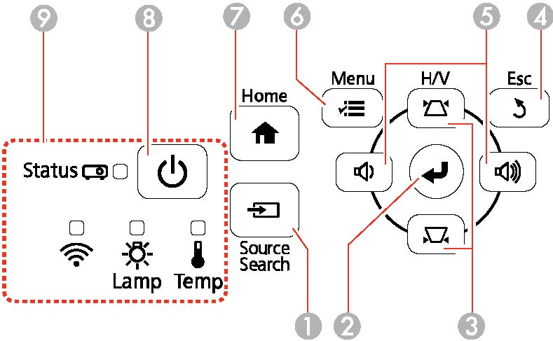
Top view of projector controls

- Set up the projector in front of the screen and as close to centered on the screen as you can get. You can project an evenly rectangular image by placing the projector directly in front of the center of the screen and keeping it level. If you place the projector at an angle to the screen, or tilted up or down, or off to the side, you may need to correct the image shape for the best display quality (see instruction 5 below). All of these corrections will have a negative effect on image quality so try to set up the projector to minimize the corrections needed.
As a quick guide to location, the projector should be approximately 1.2 X as far from the screen as the width of the screen. The projector incorporates a +/- 10% zoom so the distance doesn’t have to be exact. Here’s a table with the recommended distances.
16:10 Aspect Ratio Image or Screen
Screen or image size | Projection distance
50 inches | 58 to 71 inches
80 inches | 94 to 114 inches
100 inches | 118 to 143 inches
150 inches | 177 to 216 inches

- Open the lens cover on the front of the projector!
- Plug projector into wall. Both the status light (9) and the On/Off button (8) may flash intermittently after the projector is plugged in. Wait about 30 seconds for the On/Off button (8) to remain steadily illuminated.
- Press the power button on the projector (or the remote control) to turn on the projector. The projector beeps and the Status light flashes blue as the projector warms up. Once the projector is warmed up, the Status light stops flashing and turns blue.
- Adjust the image projected on the screens as follows:
  - To move the image up or down on the screen, adjust the front foot by pulling up on the foot release lever and lift the front of the projector to allow the foot to drop or move back into the projector.
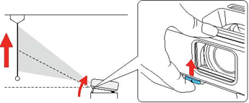
  - If the overall image is not level, adjust the rear feet of the projector to get the top of the image on the screen to be level.
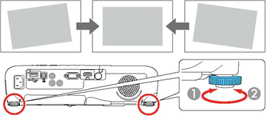
  - If the image sides are not vertical, you can correct this using the vertical keystone buttons.
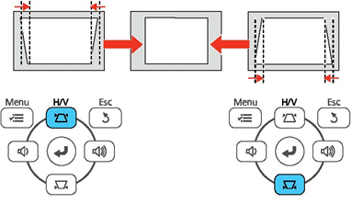

  - If the image top and bottom are not both level, you can correct this using the horizontal keystone buttons
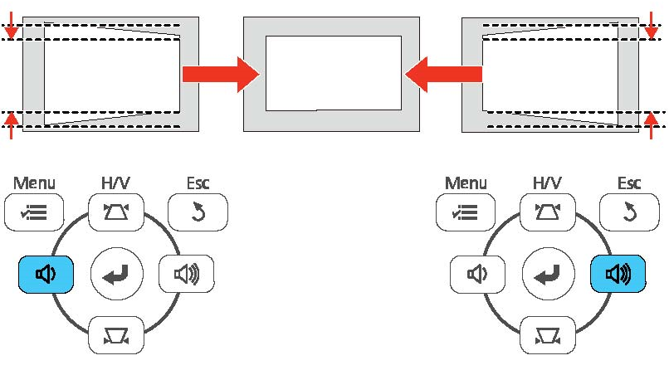
(Note: since these buttons are dual function, you may need to press the H/V button first to activate them.)
  - You can also slightly resize the image by rotating the projector's zoom ring.
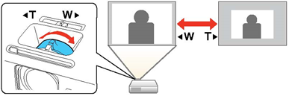
  - You can correct the focus using the focus ring. Press the home button or the menu button first to get something to focus on!
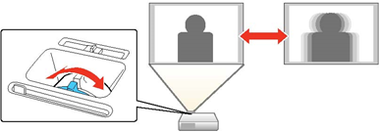

- Now plug one end of the HDMI cable into the HDMI1 connector on the back of the projector and the other end into your laptop. (Note: some Macs will require the white HDMI to Display Port adapter.)
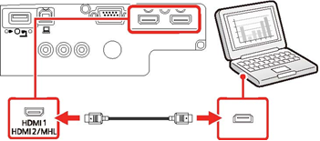
Select the program you will be using and if necessary make any final adjustments to the image (see step 5 above).
- When done, simply turn the projector off by hitting the On/Off button twice. (Note: there is no cool down cycle for this projector. It simply turns off almost immediately and can be safely put away.)

