After successfully paying for yourself, click on the link to the event to return to the event itself where you will begin the process of registering another member for this event. | 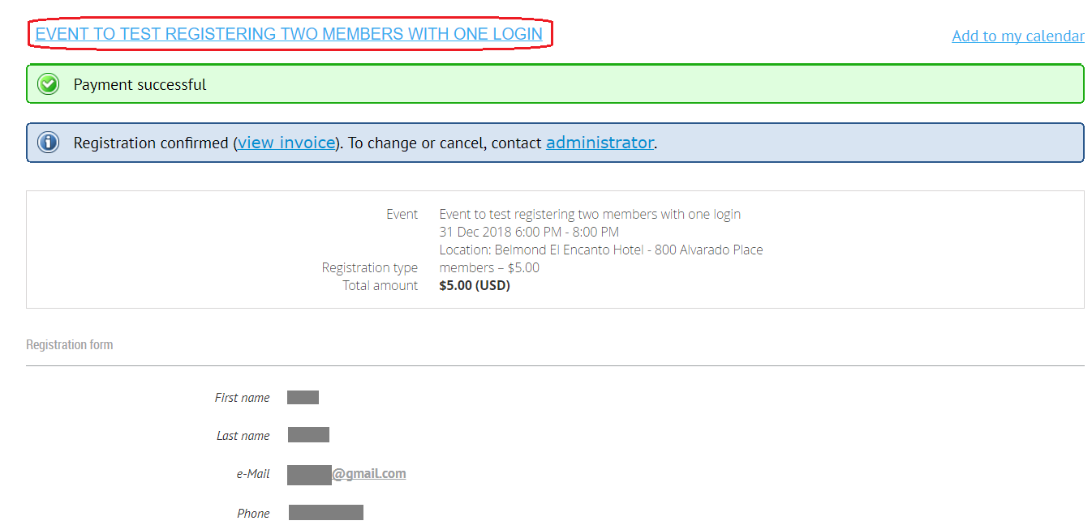
Click on the Register button or the Already registered link. Either one will take you to the next screen. | 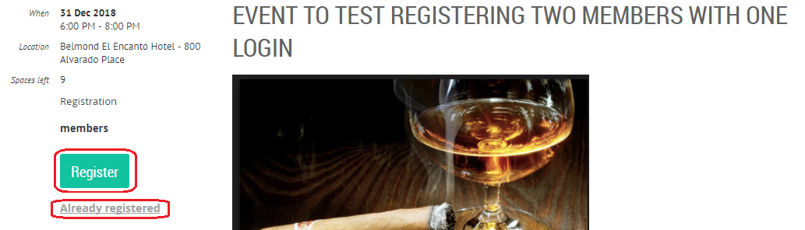
Click on one of the New Registration buttons to sign up another member. | 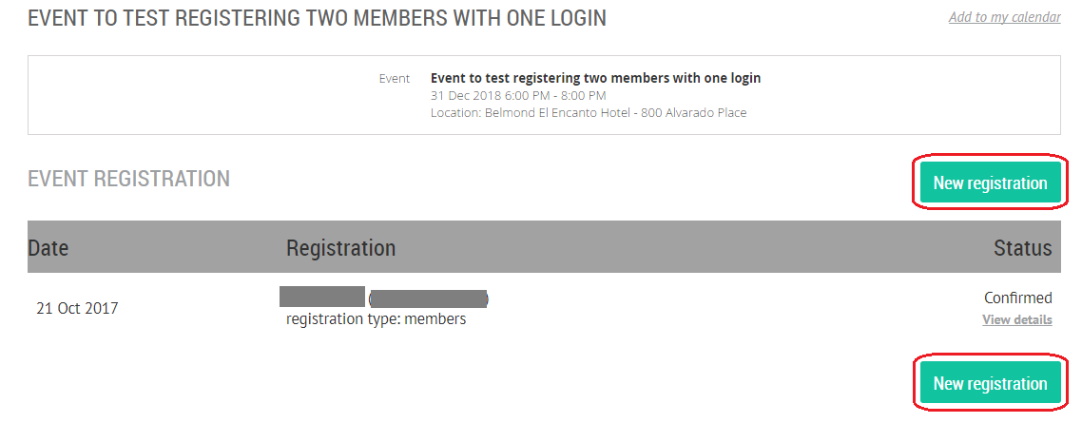
Replace your email address with the other member’s login email address and then click Next. | 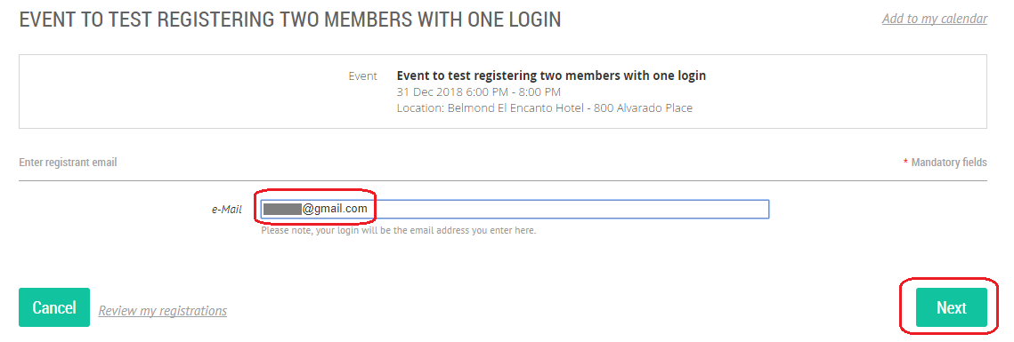
Fill in the required information for the second registrant and check both Event waiver check-boxes.  (Note: the list of required information for registration may be smaller for some events than is shown at the right.)  Then click on Next. | 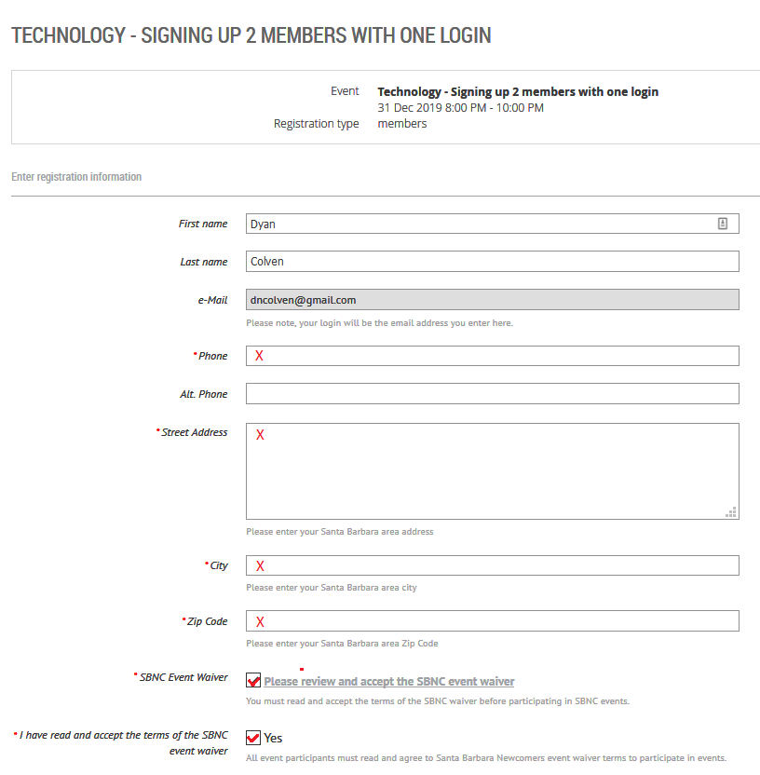
The second registrant’s information should appear on this screen.  Notice that the second payment will be billed to the first person who registered and not to the second registrant.  Review and then click on Pay Online. | 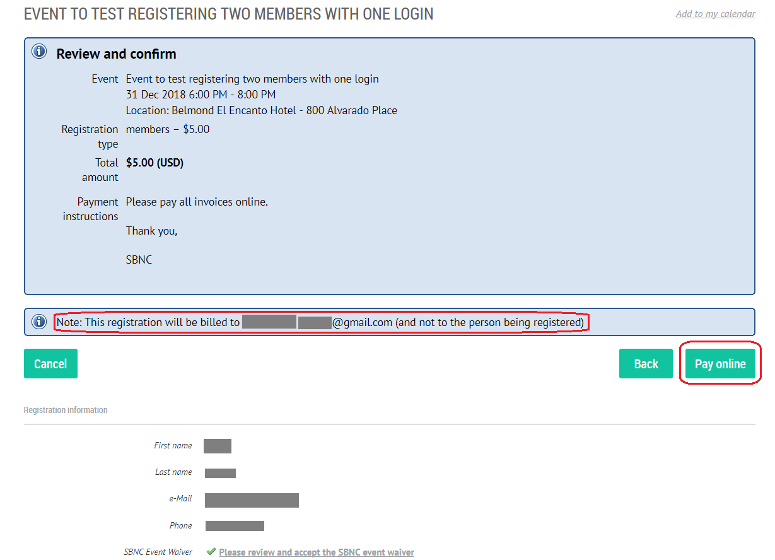
After paying online you will end up on the Newcomer’s website with a confirmation screen for the second registrant.
Click on the event link to return to the event description.
You can optionally confirm that both you and the second member are now registered for this event by clicking on Already Registered. | 