This document shows you how to change your password if you forget it.
- Go to https://www.sbnewcomers.org/ and click on the Log in icon in the upper right corner: | 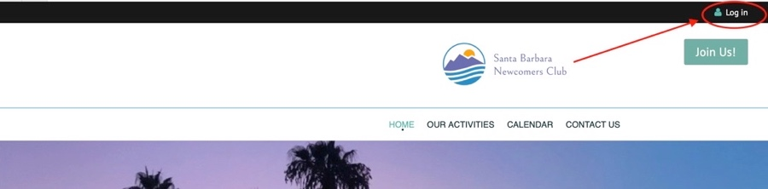
- Click the light gray link “Forgot password” located to the right of the green “Login button”. (No need to type your email address in here; you will be asked for it on the next screen.) | 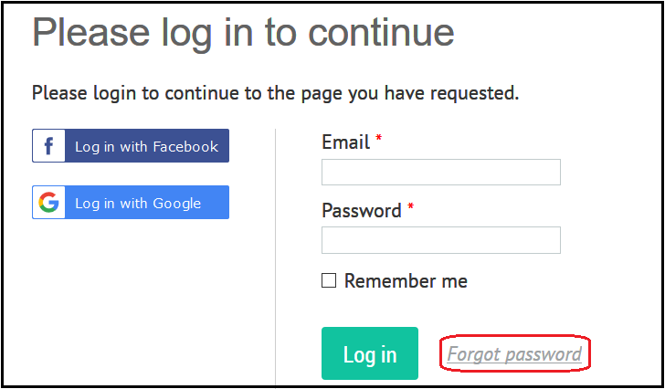
- Enter your email address into the “Your email” box, then check the box, “I am not a robot”. reCAPTCHA will present pictures and instructions for verification. Follow the instructions.  - Click the green “Submit” button. | 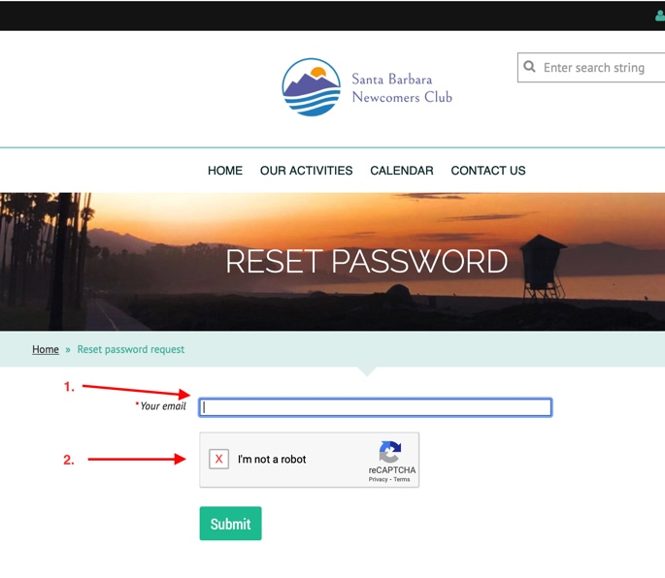
- Password reset instructions will be emailed to you. | 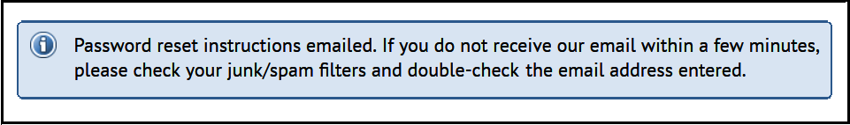
- Go to your email inbox, open the email, and click on the link. Note: the email will be sent from admin@sbnewcomers.org so make sure you can receive these emails. | 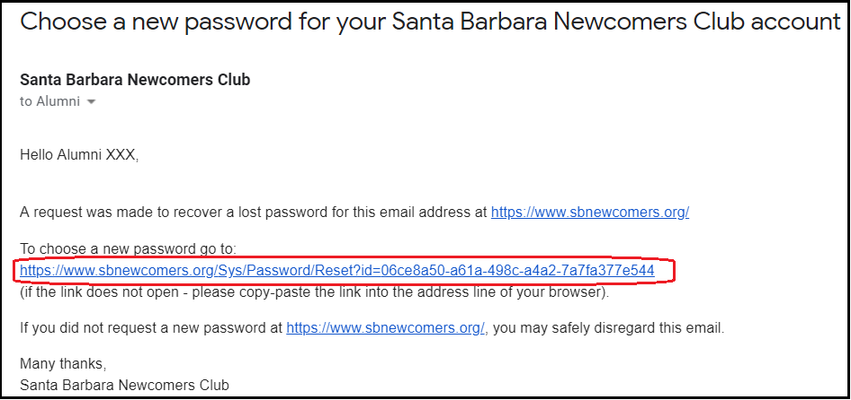
- Enter the password of your choice (7 characters minimum) into the two boxes and then click the green “Set new password” button. | 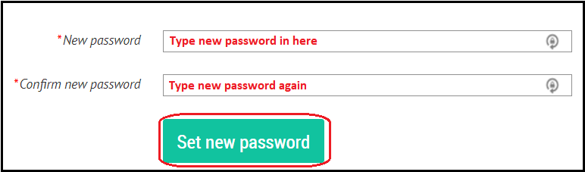
- Password change is then confirmed.

If You Need Help
If you need help, please contact the Tech Team at webmaster@sbnewcomers.org.

