RightAlert ReadmeFirst

Introduction

Thank you for your continuation on the improvement of RightAlert! This project spans a variety of different disciplines and touches upon important concepts that stretch across software and hardware. The original team has worked hours trying its best to learn and put to practice everything necessary to create an effective alert system to improve biker safety. Below are some issues and tips we have run into along the journey and we hope that you take a look at these before you go on to continue this project or begin a new one. If you would like more detailed descriptions of all the software and hardware used to make RightAlert, please refer to both the “Software Readme” and the “Hardware Readme” documents.

Things to Consider When Putting Up An Alert Sign on Public Property

- The city will not actually help unless you have the active support of a bike advocacy group or multiple influential people.
- Consider building your own alert sign. Depending on the specific intersection it may be cheaper and perhaps faster to buy a standard sign from the city, some high-intensity leds, and embed them yourself at EPIC. At least do the price calculations before ordering.
- Make ordering components your first priority, but not before you are sure its what you need.

Things to Know About the NVIDIA Jetson TK1

- If an issue occurs during updating or the power gets turned off, the Jetson’s OS may become corrupted. This happened to our team early on and caused a lot of pain and suffering, not to mention time. The fastest way to solve this problem is to reflash the OS with the help of a host computer running Linux. There is more information about this in the Hardware Readme File under the section titled “Getting Acquainted with the Jetson TK1.”
- The signals outputted from Jetson GPIO and I2C are fairly weak compared to other boards such as the Arduino and Raspberry Pi. They do not immediately work with some devices. In our case, it did not work immediately with the relay or the current sensor. To interact with these devices you will need a level shifter or transistor switch circuit to amplify the strength of the Jetson signals. This is discussed further in the Hardware Readme GPIO and I2C sections.

Things to Think About when Creating a Detection Algorithm

- The SVM and HOG function syntax for OpenCV 3.0.0 and OpenCV 2.4.8 are different.
- Windows and Visual Studios is a pain to work with for OpenCV.
- Bikers and people look very similar so don't waste too much time separating them in the beginning.
- Just using a motion detection based algorithm will not work.
- Use a confusion matrix and ROC curves to measure your performance.

Things to Consider when Installing a Solar Panel for Your Project

- In Boston and cities on east coast, using the power from streetlights directly is always the simplest way to solve the power issues.
- When choosing the solar panel to power the system, the testing location is considerably important. Any minor factors may influence the power output from solar panel dramatically.
- Pole mount for solar panel is surprisingly expensive. It’s important to leave the budget for the mount if you want to order one online.
- When selecting the battery capacity, making a power budget and use 60% efficiency for calculation.

Things to Know about Creating and Hosting a Website

- Brainstorm in advance. Before getting down to creating a website, visualize what you want it to look like first. Also think about the different functionalities.
- Make sure that the devices and components you choose to use are compatible with the other devices and components you are using. This applies for software as much as it does hardware.
- Watch your expenses. AWS charges can be expensive especially if you end up using dedicated services with greater computing power than low cost do it yourself EC2 instances.

Current State of RightAlert

As of the time this document is being written, the hardware hub of RightAlert is mounted on the cement pole outside the Department of Mechanical Engineering. It stands at about 10ft and looks down Cummington Mall and detects bikers while the detection algorithm is running.

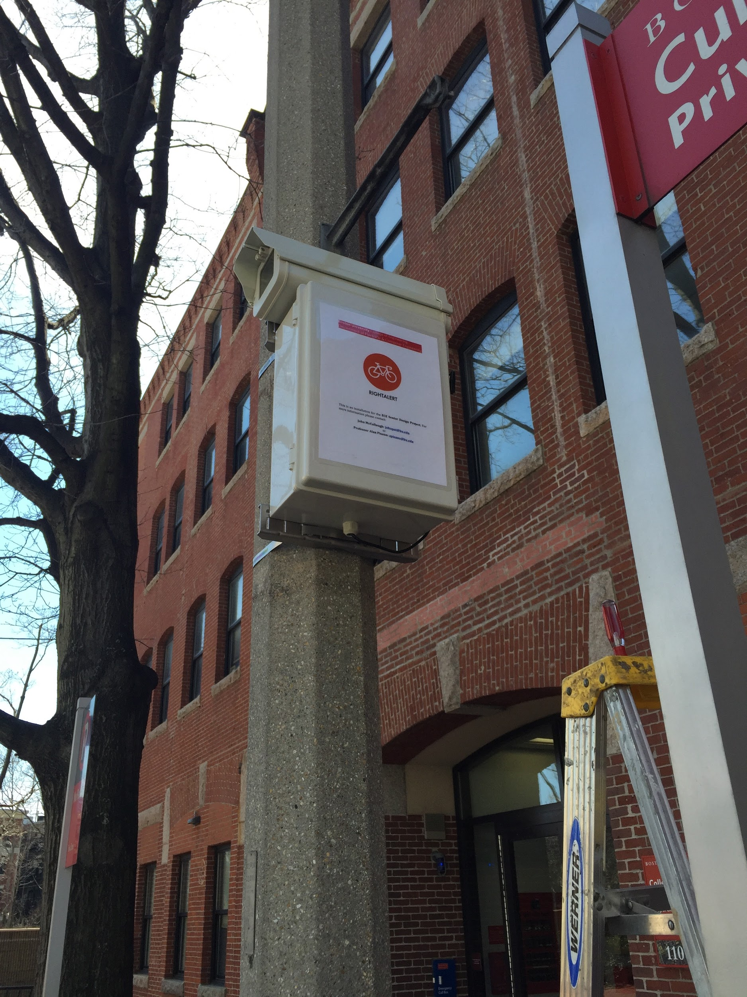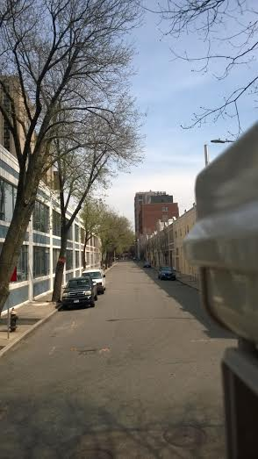
Figure 1. The hardware hub ended up looking really nice and blended in with the environment of Cummington Mall.

At the moment, the final alert sign has not arrived and neither has the solar panel mount. Despite this, the hardware hub which contains the camera, NVIDIA Jetson TK1 (which runs the algorithm), and other important components has been tested with the solar panel and a temporary sign. All these tests have indicated that once all components are present, the system as a whole will work as designed.

The website is also up and running and all data collected from the hardware hub can be observed at: admin.rightalert.net

Conclusion

The goal of RightAlert is to make Boston a safer place for bikers and drivers. By the end of the year, we believe we have put our best effort in doing so. What we got out most from this experience is taking everything we have learned and applying it to touch upon and impact the lives of everyone around us. This has truly been a challenging yet gratifying project to be a part of and we hope it will continue to help Boston for years to come.

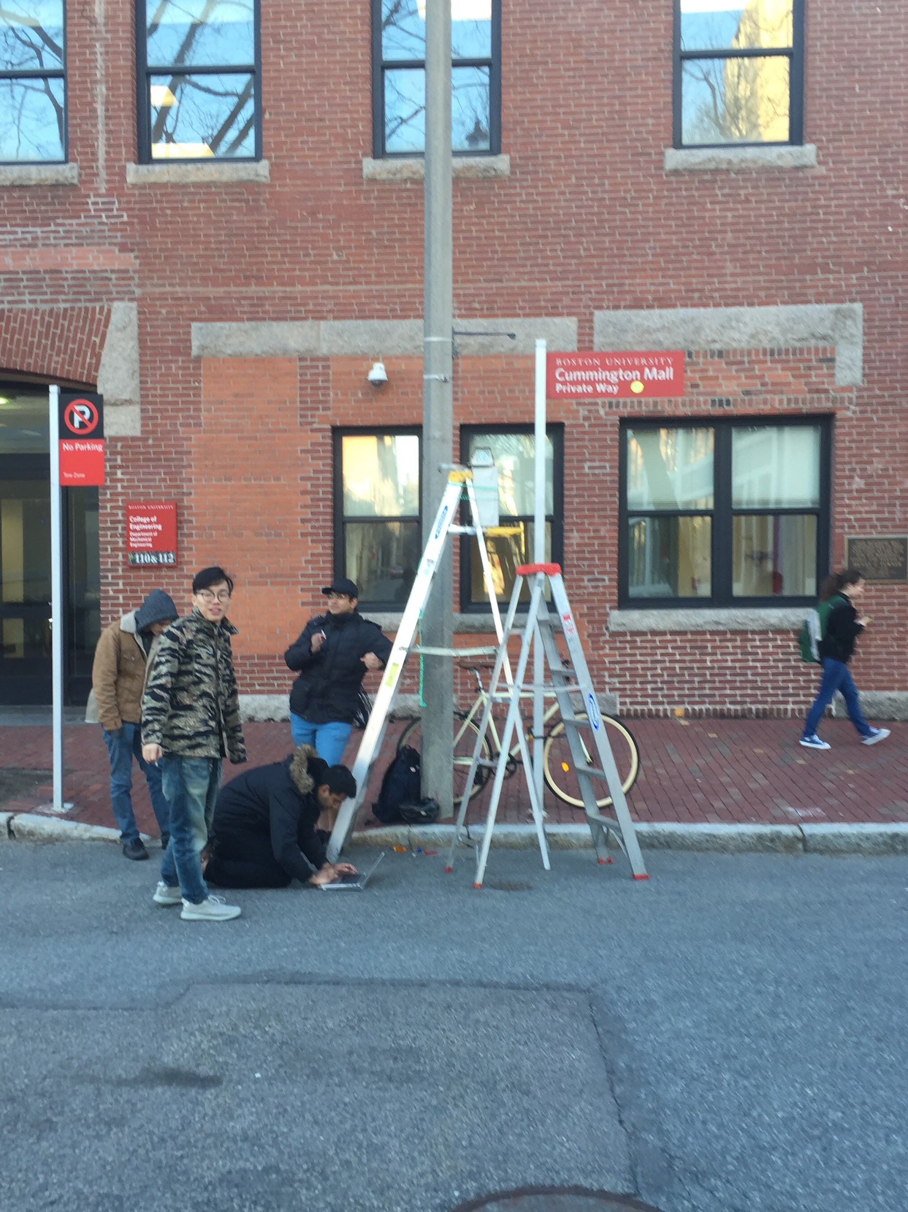
Figure 2. Team testing RightAlert for the first time on Cummington Mall. From left to right: John, Teng, Bandhan, and Shantanu. Picture by missing teammate Brian.

