Slidify Pitch Presentation

Srividya Bobji

Sunday, January 25, 2015

## Central Limit Theorem

The Central Limit Theorem (CLT) states that, given certain conditions, the arithmetic mean of a sufficiently large number of iterates of independent random variables, each with a well-defined expected value and well-defined variance, will be approximately normally distributed, regardless of the underlying distribution.

--- .class #id

## Exponential Distribution

Exponential Distribution in R is computed using

rexp(n,lambda)

For this scenario, we use n will be 50 (iterations) and lambda as 0.5.

We will try for 500 simulations and see if CLT is good.

## Simulating for 500

The code below does the simulation and Plots the graph

sampleMeans <- data.frame(x = sapply(sim, function(x) {mean(rexp(n, lambda))}))  
sampleMean <- mean(sampleMeans$x)  
theoreticalMean <- 1/lambda  
variance <- sd(sampleMeans$x)  
theoreticalVariance <- (1/lambda)/sqrt(n)

# Plotting graph  
library(ggplot2)  
ggplot(data = sampleMeans, aes(x = x)) +   
 geom_histogram(aes(y=..density..), fill = I('blue'),   
 binwidth = lambda, color = I('black')) +  
 stat_function(fun = dnorm, arg = list(mean = theoreticalMean, sd = variance))

## Graph

## Warning: package 'ggplot2' was built under R version 3.0.3

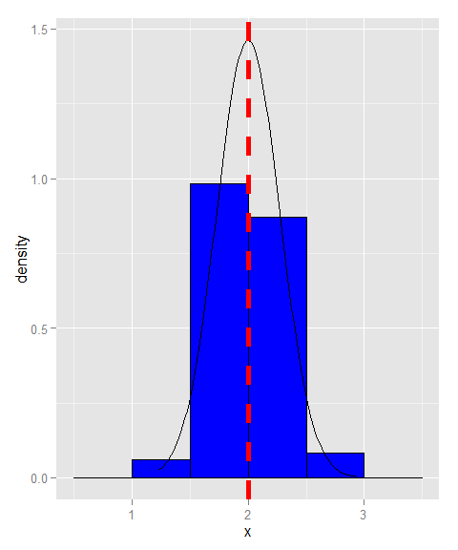

The above figure shows the theoretical mean in dotted red line and the sample mean. The actual sample mean is 1.9984 and the theoretical mean is 2.

## Conclusion

We can conclude that the CLT (Central Limit Theorem) holds good as the sample mean is close to the theoretical mean.