This documents provide a step by step procedure that allows you to do simulations in Dymola for collecting data. This data can then be used in MATLAB to do system identification and optimal experiment design.

1)

Open MATLAB and set SysIdInDymola as your working directory. Then open both GenerateSignalForDymola_SingleMachineInfiniteBus.m and SingleMachineInfiniteBus.m.

2)

Open the SingleMachineInfiniteBus.mo file (can be found in SysIdInDymola/Dymola/SingleMachineInfiniteBus directory). Unfold the package SingleMachineInfiniteBus, hit the simulation buttom (right below) and open the .mos scripts. In the .mos script, change the working directory and SimulationResults directory according to your pc.

You can have everything in one screen as follows:

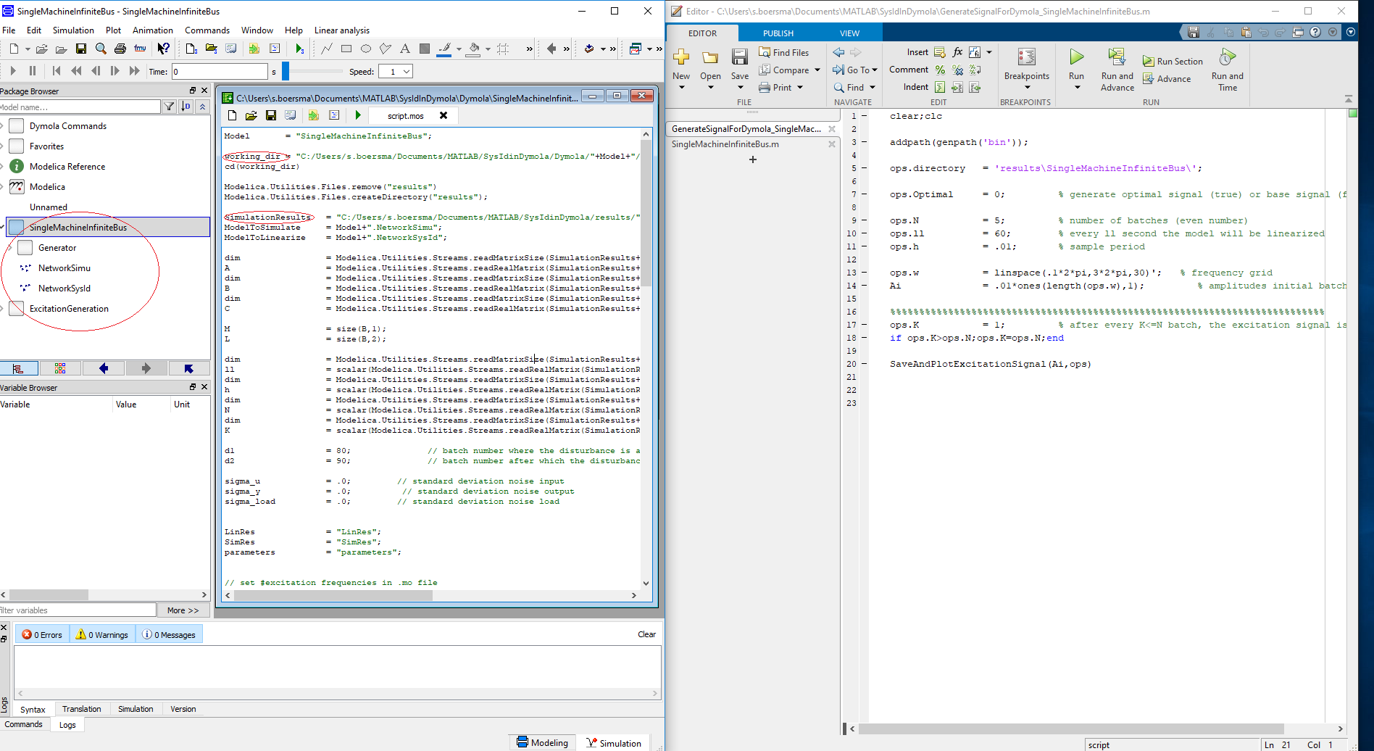

3)

Run the GenerateSignalForDymola file and inspect if you are fine with the excitation signal.

ops.w is the frequency grid of the excitation signal and Ai contains the amplitudes of the multisine. For example:

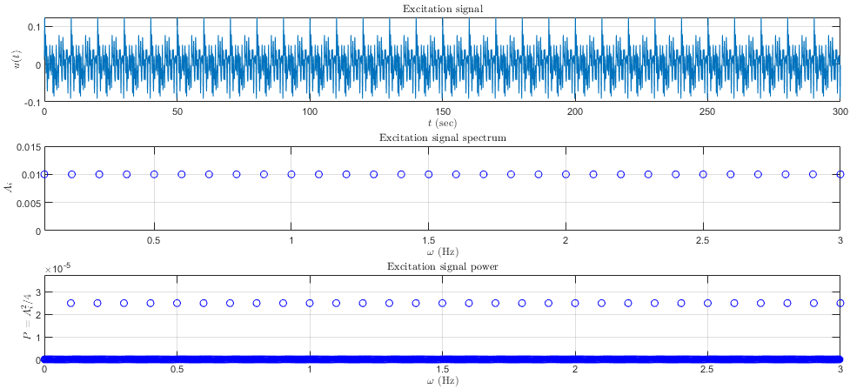

Note that each ops.ll, an identification is performed with the past data (ops.ll second in the past). So in the above case, there are ops.N=5 batches of each 60 seconds.

4)

Run the script.mos in Dymola now. Change the directories and the noise if desired, and you can also change if you want a disturbance during the simulation. When you press the run script button in Dymola, you will get a popup like in the following figure:

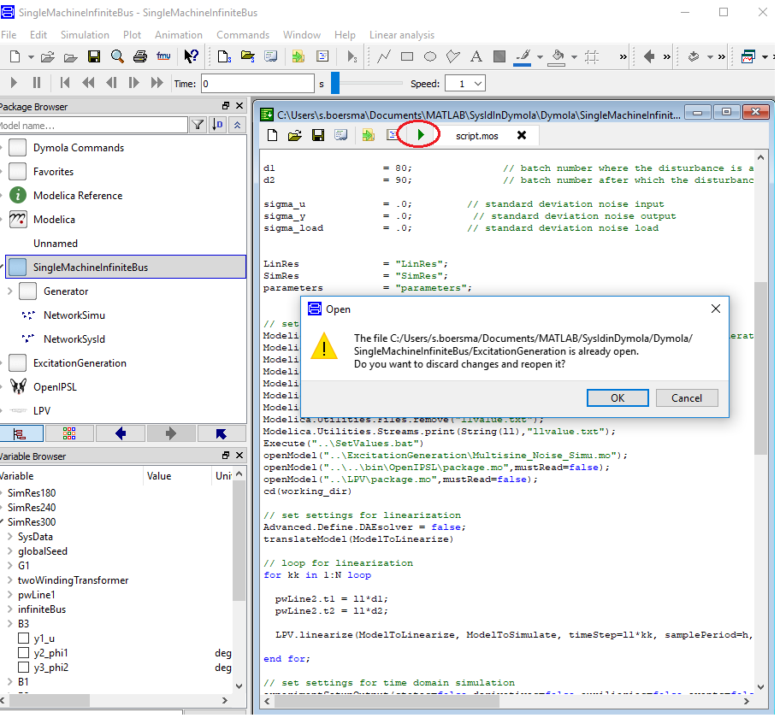

Click ‘ok’ and the Dymola script will run. Check if Dymola does not indicate an error after it finished.

5)

Go back to MATLAB and run the SingleMachineInfiniteBus.m. The script will perform ops.N identification cycles, and optimal experiment cycles. The true linearized system is stored in the structure ‘sys’ and its estimation in the structure ‘syshat’.

For example: sys{1*ops.ll} provides the true linearized system at time ops.ll seconds. Its estimation at time ops.ll is stored in syshat{1*ops.ll}.

The following figure should, among others, be presented:

