SIADS 696 Milestone II Project Report
Frequent Mental Distress Prediction Using Air Pollution
Jaeah Kim (jaeah@umich.edu), Kyle Rodriguez (kylerod@umich.edu), Sophia Boettcher (sboettch@umich.edu)
Introduction
The motivation behind this project aims to utilize previous findings from related literature and leverage supervised and unsupervised learning to answer two questions:
- Can a county’s air quality and profile reliably predict its mental health needs next year?
- Do high pollution or high distress clusters share common geographic or industrial traits?
Note that we do not aim to claim causality; we are conducting a predictive and exploratory exercise.

What problem are you trying to solve?
It’s well-known beyond anecdote that health outcomes are influenced by many environmental, economic, and social factors; yet, it remains unclear whether on a population-level (here, using county-level characteristics), if we can use data to anticipate future community mental health needs. Our project investigates whether annual air quality, climate, and socioeconomic conditions can predict next-year Frequent Mental Distress (FMD), defined by the CDC PLACES dataset as the percentage of adults reporting poor mental health for 14 or more days in the past month. As part of our project, we also explore if counties naturally group/cluster into distinct environmental and socioeconomic profiles along differing mental health outcomes. The problem we are trying to solve is if it’s at all possible to predict mental health distress at a county-level using pollution data as an informative tool.

What impact will solving the problem have?
If community mental health needs can be predicted even modestly (again, we’re not claiming causality regarding population), public health agencies could better allocate resources and identify at-risk regions pre-emptively downstream from this exploratory project. On the one hand, prediction is difficult and messy in real life. On the other hand, understanding the limits of county-level data additionally helps identify what additional information may be needed for reliable forecasting. Our work also provides an integrated county-year dataset that can support future research on environmental determinants of mental health.

What motivated you to work on it?
A growing body of literature suggests that air pollution, climate, and socioeconomic conditions are associated with mental health outcomes, but relatively few studies have examined whether these variables can predict future community-level mental distress using machine learning. Mental health needs exist at the intersection of societal and regulatory decision-making, where improved predictive ability could help governing figures with policy making and budget segmentation. We were interested in evaluating whether publicly available environmental and demographic data contain enough predictive signal to forecast next-year mental health and whether unsupervised learning could reveal meaningful county profiles beyond traditional statistical analyses.

Summarize your project’s supervised and unsupervised methods, highlighting any novel contributions.
As such, the primary objective of this project was to construct a predictive framework based on a county’s current socio-environmental and economic ecosystem. Specifically, the target variable was defined as Next-Year Frequent Mental Distress (FMD) prevalence, which is the percentage of adults in a given county reporting 14 or more mentally unhealthy days per month, measured one year following the observed features.
We constructed an enriched county-year panel containing 14,748 observations across 3,008 U.S. counties and county-equivalents from 2019–2023 by combining data from CDC PLACES, EPA AirData, NOAA climate records, the American Community Survey (ACS), and Census county geographies.
Predicting public health outcomes within a spatial panel structure introduces a critical methodological challenge: temporal data leakage. To address this, our supervised learning design employed a leakage-safe forecasting framework in which features from year t were used to predict FMD in year t + 1. We evaluated multiple regression models, including Linear Regression, Lasso, Ridge, Elastic Net, Random Forest, Gradient Boosting, and XGBoost, using cross-validation and a held-out test set.
For the unsupervised learning component, we standardized all non-FMD variables and applied DBSCAN clustering to a low-dimensional embedding. FMD was intentionally excluded during clustering and reintroduced afterward to compare mental health outcomes across the discovered clusters. Our reasoning was that FMD should function as an external validation outcome rather than a clustering variable, providing a more objective assessment of whether environmental and socioeconomic profiles correspond to differences in mental distress.
Research question | Modeling approach | Interpretation target
Can current-year county conditions predict next-year FMD? | Supervised regression with year-shifted target | Predictive usefulness and error patterns
Do counties form meaningful socio-environmental profiles? | UMAP/PCA-style embedding plus DBSCAN | Cluster differences in held-out FMD and profile variables
Are high-FMD areas geographically or economically distinctive? | Residual maps, cluster maps, and profile summaries | Exploratory evidence for follow-up study

What are your main findings for supervised and unsupervised learning?
The best supervised model was a tuned Random Forest, achieving a holdout RMSE of 2.17 and MAE of 1.83, compared with the Dummy Regressor baseline RMSE of 2.43. Holdout R² remained negative, however. This indicates that county-level environmental, climate, and socioeconomic variables alone do not provide sufficient predictive signal to reliably forecast next-year FMD. Our results suggest limitations of annual county-level data (at this point, it would not be reasonable to say that we can reliably predict mental health distress with what we have so far).
The unsupervised analysis revealed one dominant cluster along with several smaller outlier clusters. Because FMD was excluded from clustering and examined only afterward, differences in FMD across clusters can be interpreted as an independent outcome comparison. While the clustering did not reveal clear, balanced county profiles, it identified meaningful environmental and socioeconomic profiles that may serve as a useful starting point for future hypothesis generation and targeted public health investigations. We conclude that while the existing body of county-level environmental, climate, and socioeconomic data is currently limited for predicting future FMD, it remains a valuable starting point for future exploratory profiling and generating new hypotheses.
Related Work
There is an extensive and rapidly growing body of research dedicated to the environmental determinants of mental health at the community and county levels in the United States. A lot of research revolves around the impact of environmental factors on mental illness risk. This is true for “Particulate matters (PM2.5, PM10) and the risk of depression among middle-aged and older population. Analysis of the Korean Longitudinal Study of Aging (KLoSA), 2016–2020 in South Korea” (Park, et al.) found that prolonged exposure of particulate matters increased risk of depression in the elderly. Additionally, “The impact of neighborhood environment on mental health: Evidence from China” (Lei, et al.) concluded that air pollution perception, coupled with socioeconomic status, was crucial for mental health in Chinese communities. Although these studies focus on age-based cohorts in Asian communities, our research will focus solely at population level across U.S. counties to model a possible correlation between air quality and mental health. The Gulf Long-Term Follow-up Study (Werder et al., 2024), explored how PM2.5 and greenspace impact depression in the Southeastern U.S., pointing to potentially similar vulnerabilities domestically. In addition, we will also use unsupervised learning (Which wasn’t utilized in these studies) to uncover latent socio-environmental archetypes across U.S. counties.
Data Sources
This project utilizes data from three sources: AirData, CDC PLACES, and US Census (ACS) Data. The modeling panel is county-year and uses five-digit county GEOID as the primary merge key. The original imputed panel was extended with additional ACS, EPA, NOAA, and Census geography files to satisfy the project requirement for socioeconomic controls, daily exposure features, climate profile variables, industrial traits, and spatial visualization. CDC PLACES can be accessed and downloaded from data.cdc.gov in CSV format.
Source | Format | Key variables used | Coverage / role
CDC PLACES | CSV | FMD prevalence, lower and upper confidence intervals | Mental health outcome by county-year
EPA AirData annual summaries | CSV | Days with AQI, good/moderate/unhealthy days, Max AQI, Median AQI, pollutant-defining days | Annual air quality predictors
EPA AirData daily AQI | ZIP/CSV | Daily AQI mean, standard deviation, p90, max, days >100, >150, >200 | Exposure variability and extreme-event features
ACS 5-year bulk tables | pipe-delimited .dat | Income, poverty, unemployment, education, insurance, industry composition | Socioeconomic, health-access, and industrial controls
NOAA Climate at a Glance | JSON | Annual average temperature, precipitation, historical anomalies | County climate profile
Census county boundaries | Shapefile ZIP | County polygon geometries | Choropleth and spatial visualization support
Our enriched dataset contains 83 columns. ACS and NOAA features cover nearly all rows. EPA daily AQI features cover only counties with daily monitor reporting, so many missing daily features are imputed. Because of limitations in the years of data available across the main datasets (PLACES being a key bottleneck), in the harmonization step we had to accept losing granularity and also years. Although it was originally derived from BRFSS, PLACES was not a simple feature engineering downstream derivative dataset where we could have stitched together everything from scratch ourselves for the scope of the project.
Feature Engineering
The feature engineering pipeline included the following 10 major components:
- Merge ACS data with CDC PLACES and AirData on county name [CHECK]
- Perform geoimputation: use BallTree with a Haversine metric to impute missing environmental data across contiguous U.S. counties.
- Calculate demographic and pollution rates: engineer poverty rates, unemployment rates, ‘bad air day’ ratios, and ‘good air day’ ratios to encourage intensity-analysis rather than scale.
- Drop redundant raw counts: data in columns such as poverty_count were dropped to prevent multicollinearity.
- Next-year target: FMD was shifted forward within each county, so current-year features predict next-year FMD.
- Temporal holdout: 2022 features were used as the final holdout to predict 2023 FMD.
- Environmental features: annual AQI summaries, pollutant-defining days, daily AQI variability, and high-AQI threshold counts.
- Climate features: annual average temperature, annual precipitation, and 1901-2000 anomaly features.
- Socioeconomic features: income, poverty, unemployment, education attainment, insurance coverage, and industry composition.
- Unsupervised hold-out design: FMD and FMD confidence intervals were excluded from clustering and evaluated afterward.
The final output dataset was distilled to 14,748 records across 24 columns. Links to different notebooks are provided in Appendix C. Refer to Table 1 for a list of data columns used in this project.
Feature family | Variable names | Data type | Data source | Notes
Geographic identifiers | geoid, county_name, state_name, year | Integer / Categorical | Census | County and temporal identifiers used for merging datasets.
Mental health outcome | mental_health_prevalence (Frequent Mental Distress, FMD) | numerical (float64) | CDC PLACES | Target variable for supervised learning and hold-out outcome for cluster evaluation. Frequent mental distress among adults; a.k.a rate wherein mental health is not good for >=14 days among adults aged >=18 years.
Air quality | median_aqi, max_aqi, ninety_percentile_aqi, days_with_aqi, days_pm25, days_pm10, days_ozone, days_no2, days_co, unhealthy_sensgroups_days | numerical (float64) | EPA AirData | Captures annual air quality burden, pollutant-specific exposure, and extreme pollution events.
Engineered air-quality features | bad_air_day_ratio, good_air_day_ratio | numerical (float64) | Engineered from AirData | Summarizes overall exposure to unhealthy versus healthy air quality days.
Climate | Annual temperature, precipitation, climate anomalies | numerical (float64) | NOAA | Provides environmental context beyond air pollution.
Socioeconomic | median_income, population, poverty_rate, unemployed_rate | Integer / Float | ACS | Represents county-level socioeconomic conditions associated with community vulnerability.
Education & healthcare access | Bachelor’s degree attainment, uninsured rate | numerical (float64) | ACS | Proxies for educational attainment, healthcare access, and community resources.
Industry composition | Manufacturing, agriculture/mining, education & health services, professional & administrative employment shares | numerical (float64) | ACS | Characterizes county economic structure and supports interpretation of discovered clusters.

[CHECK - should we list ONLY the columns we used for supervised/unsupervised efforts?]
Column Name | Description | Data Type | Data Source
geoid |  | numerical (int64)
county_name | County name of interest | categorical
state_name | State name of interest | categorical
year | Year of data collection | numerical (int64)
median_income | Median income in USD | numerical (int64) | ACS
population | Number of people populating an area | numerical (int64) | ACS [CHECK]
mental_health_prevalence | Frequent mental distress among adults; a.k.a rate wherein mental health is not good for >=14 days among adults aged >=18 years | numerical (float64) | CDC PLACES
lower_ci | Lower confidence interval | numerical (float64) | CDC PLACES
upper_ci | Upper confidence interval | numerical (float64) | CDC PLACES
days_with_aqi | Number of days with AQI data | numerical (float64) | AirData
unhealthy_sensgroups_days | Number of days where air quality is unhealthy for sensitive groups | numerical (float64) | AirData
max_aqi |  | numerical (float64) | AirData
ninety_percentile_aqi |  | numerical (float64) | AirData
median_aqi | Median air quality index | numerical (float64) | AirData
days_co | Number of days where carbon monoxide levels were above threshold | numerical (float64) | AirData
days_no2 | Number of days where nitrogen oxide levels were above threshold | numerical (float64) | AirData
days_ozone | Number of days where ozone levels were above threshold | numerical (float64) | AirData
days_pm25 | Number of days where fine particulate matter (<2.5 microns) levels were above threshold | numerical (float64) | AirData
days_pm10 | Number of days where fine particulate matter (<10 microns) levels were above threshold | numerical (float64) | AirData
geometry
poverty_rate | The rate at which a population is in poverty | numerical (float64) | Engineered from ACS
unemployed_rate | The rate at which a population is unemployed | numerical (float64) | Engineered from ACS
bad_air_day_ratio | The ratio of unhealthy, very unhealthy, and hazardous AQI days to total AQI days | numerical (float64) | Engineered from AirData
good_air_day_ratio | The ratio of good and moderate AQI days to total AQI days | numerical (float64) | Engineered from AirData
Table 1. Column names, descriptions, respective data types and sources.
Supervised Learning
The supervised task section was primarily a regression problem: predict next-year FMD prevalence. Models included a Dummy Regressor baseline, ElasticNet, Random Forest, and Gradient Boosting. Continuous predictors were imputed when needed, and ElasticNet used standard scaling. Evaluation used RMSE, MAE, R², and grouped cross-validation by year where applicable.

Evaluation

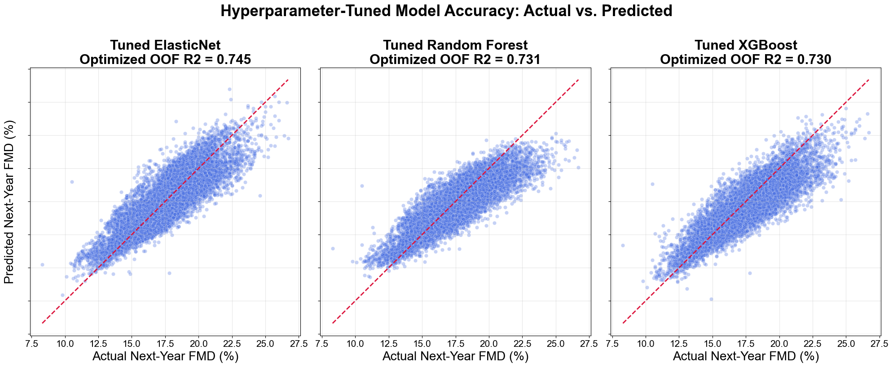
Figure 1. Hyperparameter-tuned model accuracy: (LHS) tuned ElasticNet model, (M) tuned Random Forest model, and (RHS) tuned XGBoost model
Note key feature engineering and implementation: absolute metrics were normalized to county intensities—i.e. poverty_rate, unemployed_rate, bad_air_day_ratio, and good_air_day_ratio. Redundant raw counters were also dropped to prevent multicollinearity in linear estimators. Models were evaluated using a 5-fold Cross-Validation structure. Refer to Figure 1 for the R2 scores of each model.

Findings
The best model, Random Forest tuned, reduced RMSE by about 0.26 percentage points relative to the Dummy baseline. That improvement is useful as a proof of signal, but not enough to support strong forecasting claims. The negative R² values indicate that the model did not explain holdout variation better than a simple mean predictor under the strict temporal split.
The residual analysis is therefore one of the more useful supervised outputs to visualize. Ultimately, the model underpredicted several high-FMD counties, suggesting that important local drivers are missing from the current feature set. Potential missing predictors include healthcare provider density, rurality and lack of data collection, disability prevalence, greenspace, disaster exposure, and local behavioral health infrastructure. We want to be careful to not posit too much on everything that’s missing and simply put forth a very simple observation that, especially in underseen and underrepresented communities, averages tend to erase granularity and extremes. Granularity and extremes of outcome (here, mental health status at population-level) are especially what we would be interested in.
Model | Holdout RMSE | Holdout MAE | Holdout R² | CV RMSE
Random Forest tuned | 2.17 | 1.83 | -0.22 | 2.33
Random Forest | 2.35 | 1.98 | -0.43 | --
ElasticNet tuned | 2.36 | 1.88 | -0.45 | 2.68
Gradient Boosting tuned | 2.42 | 2.05 | -0.51 | 2.41
Gradient Boosting | 2.43 | 2.07 | -0.53 | --
Dummy mean baseline | 2.43 | 1.95 | -0.54 | --
ElasticNet | 2.43 | 1.95 | -0.54 | --

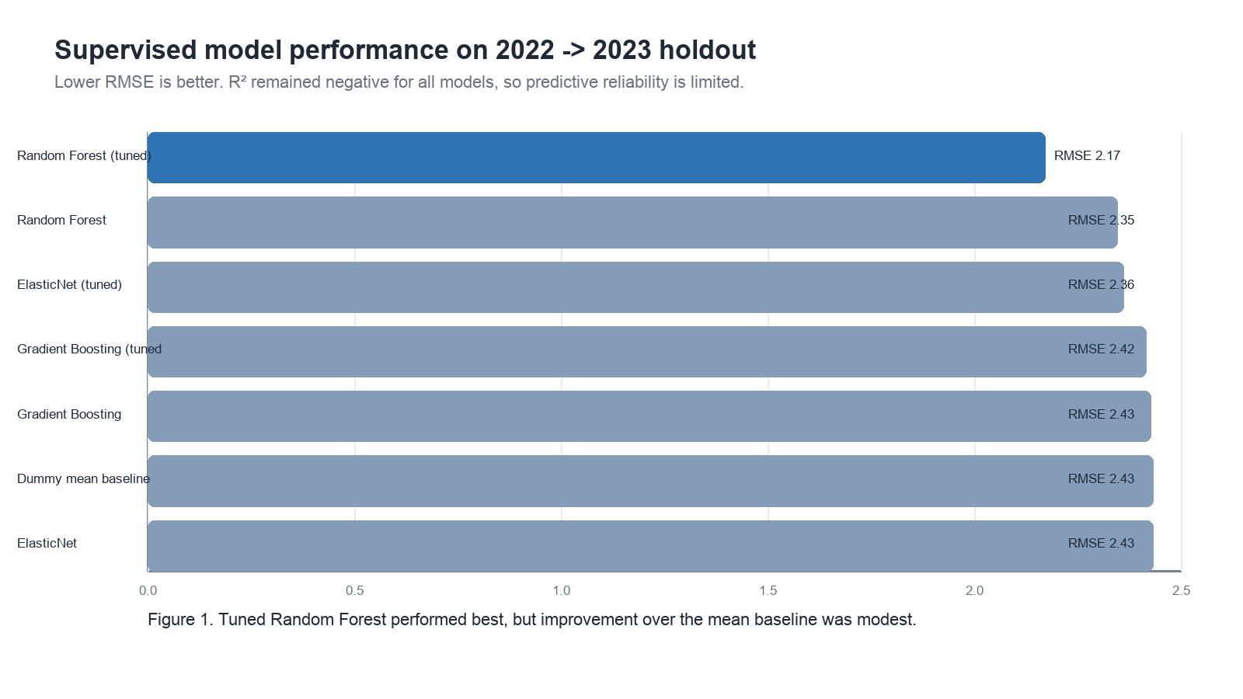Figure 2. Supervised model holdout metrics. The tuned Random Forest improved over the Dummy baseline but did not achieve positive R². This suggests that county-level environmental and socioeconomic variables alone (or at least the data scope we have now) are insufficient for reliable forecasting of next-year frequent mental distress.

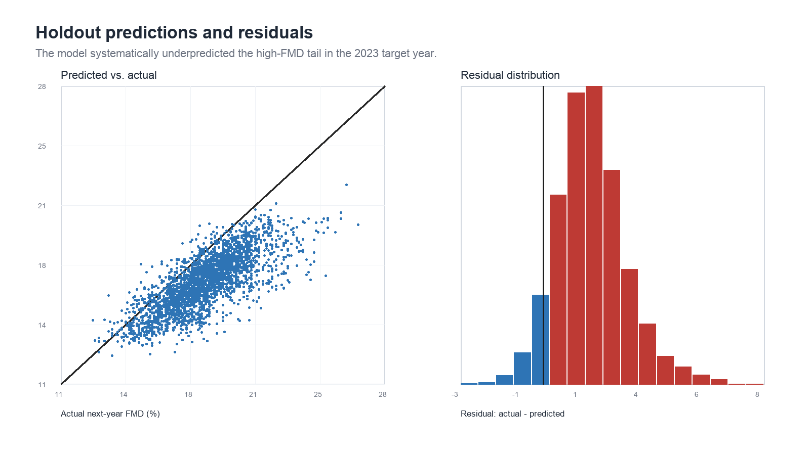Figure 3. Predicted vs. actual next-year FMD and residual distribution on the 2022→2023 holdout. We see predictions show a moderate positive relationship with observed FMD but are compressed toward the mean (scatter falls along the 45° line). This actually would point at underprediction of counties with the highest levels of mental distress. The residual distribution indicates systematic prediction error consistent with the model’s negative holdout R². Because the residuals aren’t centered around zero at all, it would make us suspicious of systemic bias working against our current initial efforts.
Methods & Motivation
Mental health needs exist at the intersection of societal and regulatory decision-making. On the one hand, being able to accurately predict future mental health needs can help individuals anticipate their [come back to this]. On a more macro-scale, this predictive ability can help governing figures with policy making and budget segmentation.
As such, the primary objective of this phase is to construct a robust and predictive framework capable of forecasting next-year public mental health vulnerabilities based on a county’s current socio-environmental and economic ecosystem. Specifically, the target variable is defined as Next-Year Frequent Mental Distress (FMD) prevalence, which is the percentage of adults in a given county reporting 14 or more mentally unhealthy days per month, captured one year following the observed features.
Predicting public health outcomes within a spatial panel structure introduces a critical methodological challenge: temporal data leakage. To establish genuine predictive legitimacy
Data Source
Please refer to the Data Sources section above for the details on data sources and features we’ve used.

In-Depth Evaluation

Random Forest Grouped Ablation
Removed feature family | Features removed | Holdout RMSE | RMSE delta
Education and health access | 5 | 2.06 | 0.08
Industry composition | 13 | 2.01 | 0.03
Annual AQI | 15 | 1.99 | 0.01
None (full model) | 0 | 1.98 | 0.00
Daily AQI exposure | 25 | 1.98 | -0.00
Socioeconomic scale | 9 | 1.94 | -0.04
Climate | 6 | 1.94 | -0.04
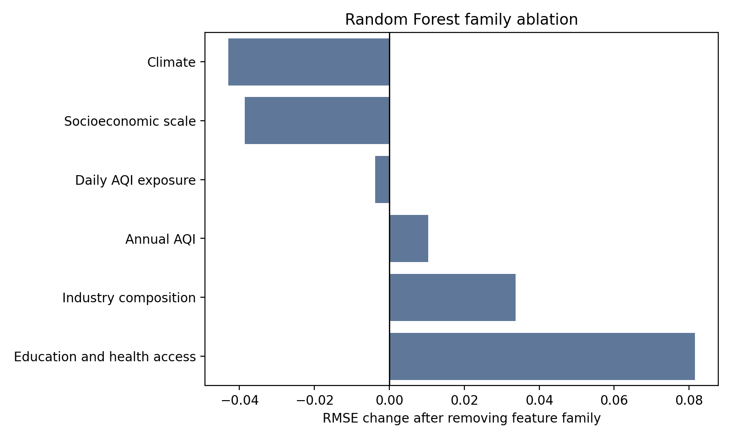
Figure 4. Family ablation for our random forest model.
For the chosen model, Random Forest, impurity-based feature importance ranked education and climate variables highly. A grouped ablation analysis retrained the model after removing each feature family. Removing education/health-access features increased holdout RMSE the most, suggesting that these variables contributed more consistently than annual or daily AQI features in the current panel.
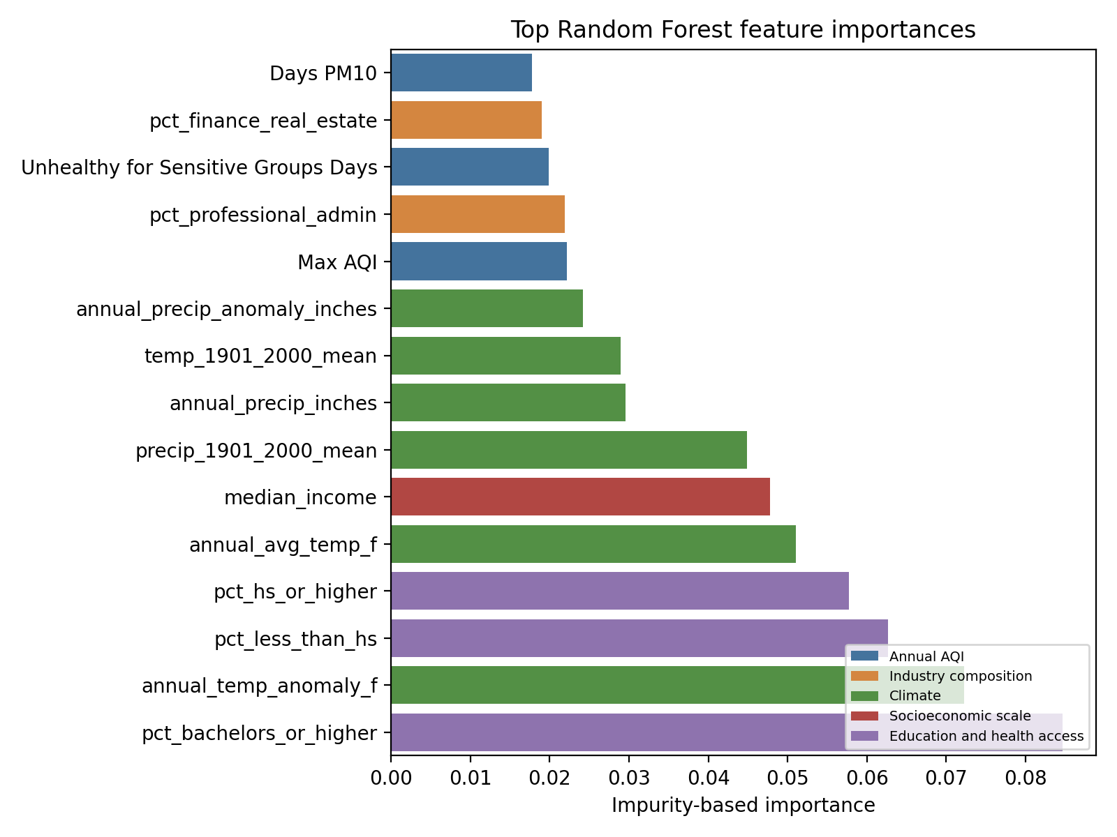
Figure 5. Top features for random forest.

Sensitivity, Tradeoffs, and Failure Analysis
Sensitivity analysis varied Random Forest minimum leaf size and max-feature sampling. The best setting used small leaves and sqrt feature sampling, while larger leaves generally reduced variance but worsened holdout RMSE. The tradeoff is interpretability and stability versus nonlinear flexibility: Random Forest performed best, but at the cost of reduced transparency relative to ElasticNet.

Random Forest sensitivity analysis, top settings
min_samples_leaf | max_features | Holdout RMSE | Holdout R²
1 | sqrt | 1.98 | -0.02
3 | sqrt | 2.00 | -0.04
8 | sqrt | 2.02 | -0.06
15 | sqrt | 2.05 | -0.09
1 | 0.7 | 2.06 | -0.10
1 | 0.5 | 2.06 | -0.10
Our failure analysis focused on the largest absolute residuals. The model mainly failed by underpredicting counties in the high-FMD tail, including Appalachian and rural counties where county-level pollution and ACS controls likely miss local behavioral-health infrastructure, disability burden and other hidden social/environmental variables.

Identified high-error examples
County | State | Actual FMD | Prediction | Residual | Failure category
Roosevelt | Montana | 22.70 | 16.35 | 6.35 | High-distress tail underprediction
Big Horn | Montana | 22.90 | 16.74 | 6.16 | High-distress tail underprediction
Marshall | West Virginia | 23.00 | 16.96 | 6.04 | Appalachian high-FMD underprediction
Corson | South Dakota | 21.90 | 15.86 | 6.04 | High-distress tail underprediction
Hancock | West Virginia | 22.70 | 16.80 | 5.90 | Appalachian high-FMD underprediction
Ohio | West Virginia | 22.10 | 16.22 | 5.88 | Appalachian high-FMD underprediction
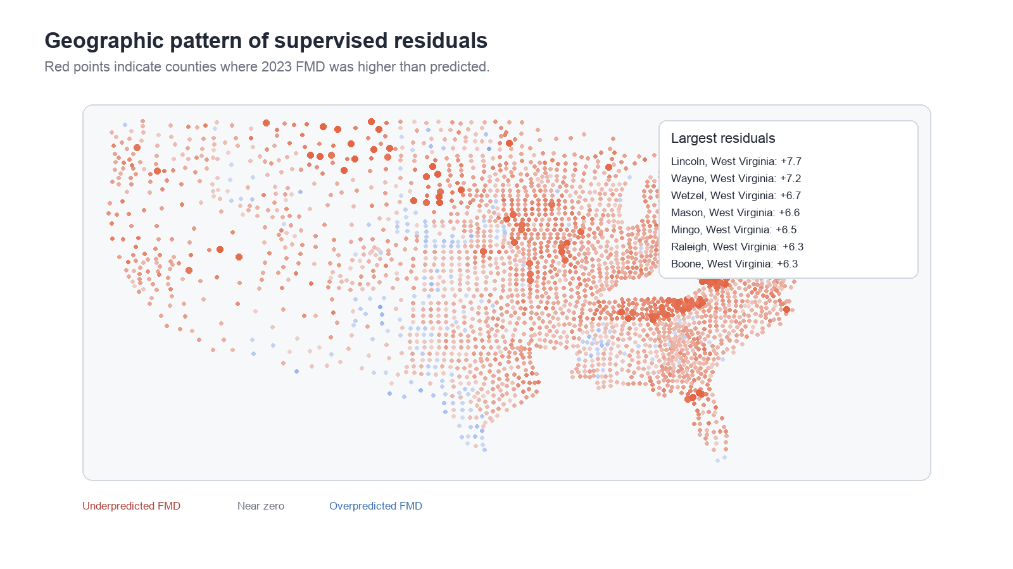
Figure 6. Geographic visualization pattern of supervised residuals. High positive residuals mark counties where actual FMD was higher than expected.
Unsupervised Learning

Methods & Motivation
Being able to form socio-environmental county profiles is important for the further study of mental health drivers. Using unsupervised learning for this can not only identify important features but can also orient the data geospatially, thereby making it easier to comprehend.
The unsupervised analysis used two methods with different mechanisms: DBSCAN, a density-based clustering method that can label noise/outliers, and K-Means, a centroid-based partitioning method. Both used standardized non-FMD features; FMD was held out and compared after clusters were formed. PCA was used for visualization and cluster-search diagnostics.
The idea behind creating characterization profiles of counties by their environmental and socioeconomic attributes is that this may, in turn, help support future investigation into community mental health. In other words, unsupervised learning is a valuable step in exploratory data science to examine whether similar county profiles emerge from the available data thus far. Furthermore, it can ground us in understanding what additional data and what future directions we should pursue next.

Unsupervised method comparison
Method | Selected parameters | Clusters | Noise % | Silhouette embedding | Silhouette scaled features
DBSCAN | eps=1.43, min_samples=5 | 2 | 0.02 | 0.76 | 0.45
KMeans | k=2 | 2 | 0.00 | 0.89 | 0.75

Held-out FMD ANOVA across unsupervised clusters
Method | F statistic | p-value | Groups
DBSCAN | 3.65 | 0.0563 | 2
KMeans | 8.63 | 0.0033 | 2
In order to address the curse of dimensionality prior to clustering, the data were normalized using standard scaling and reduced using UMAP for dimensionality reduction, with PCA serving as a fallback when UMAP was unavailable. Our final dataset consists exclusively of numerical variables, and as such we were able to leverage these dimensionality reduction techniques.
For our unsupervised section, we clustered counties using environmental, climate, socioeconomic, healthcare access, education, and industry features. We first built our pipeline by harmonizing and standardizing the features. We then reduced dimensionality using UMAP when installed and PCA as a fallback, and searched DBSCAN parameters over multiple epsilon and minimum-sample values. Noise points were labeled as -1. Because FMD was excluded from clustering, any differences in FMD across clusters represent post hoc hold-out comparisons rather than variables used to define the clusters. We then used ANOVA to test whether mean FMD differed significantly across the discovered clusters. In other words, ANOVA evaluates whether the clusters identified from environmental and socioeconomic features are associated with meaningful differences in mental health outcomes.
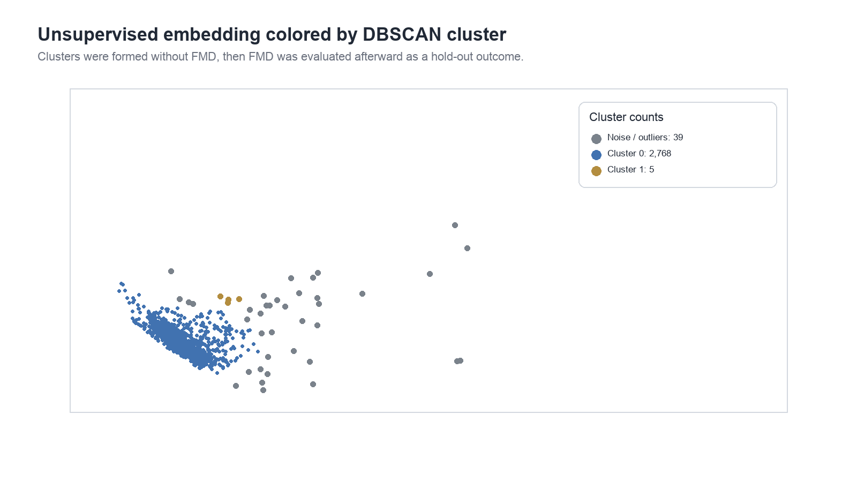
Figure 7. Low-dimensional embedding colored by DBSCAN cluster. The result is dominated by one large cluster plus small outlier groups, as mentioned previously. Given the available county-level features, they do not naturally separate into distinct county archetypes. Any emergent clustering therefore should be interpreted as exploratory not definitive or suggestive of wielding predictive or explanatory power.
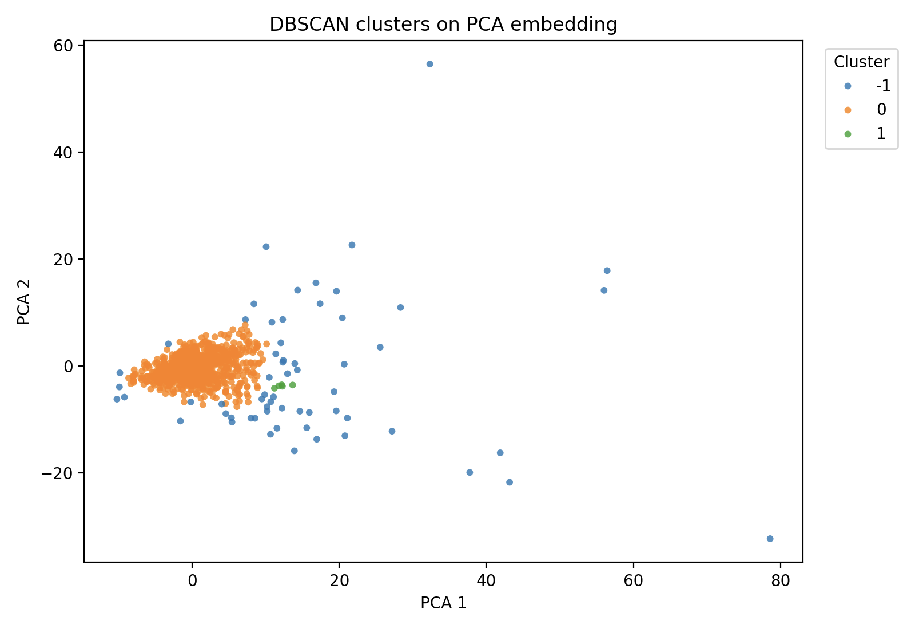
Figure 8. DBScan clusters on the PCA embedding.
Cluster | Counties | Avg FMD | Median AQI | AQI days >100 | Temp anomaly | Uninsured | Bachelor+
-1 | 39 | 17.03 | 55.1 | 30.2 | 2.29 | 9.1% | 34.3%
0 | 2,768 | 18.60 | 41.4 | 5.3 | 2.67 | 9.5% | 24.0%
1 | 5 | 15.46 | 41.8 | 4.2 | 3.33 | 7.3% | 46.5%

Unsupervised Evaluation
Ultimately, the clustering output of our unsupervised learning section did not produce evenly sized archetypes. Instead, DBSCAN identified one dominant county group, a small low-FMD group, and a small set of noise/outlier counties. This result is still informative: it suggests that, after standardization and dimensionality reduction, most counties occupy a broad shared socio-environmental region, while a small number of counties are structurally distinct.
Because the small cluster sizes make formal statistical tests weak, the unsupervised results should be treated as exploratory. The notebook attached in our Github repo includes the ANOVA-style hold-out testing. However, the final interpretation should focus on effect direction, cluster profiles, and qualitative geography rather than strong inferential claims.
We began our project noting that we were not trying to prove causality. Still, we were optimistic about perhaps uncovering some sort of predictive capability. At this point, the interesting finding has emerged through both the clustering results and the imbalanced residuals: the residuals are not centered around zero, suggesting some sort of presence of systematic prediction bias (we can’t yet pinpoint what exactly) and indicating that the current body of county-level data does not fully capture the factors associated with next-year mental distress. Rather than pointing to a specific cause, these findings suggest there is additional information yet to be collected or incorporated, particularly for counties at the extremes. This, in turn, helps inform what future data and directions may be most valuable to future researchers/stakeholders interested in this space.
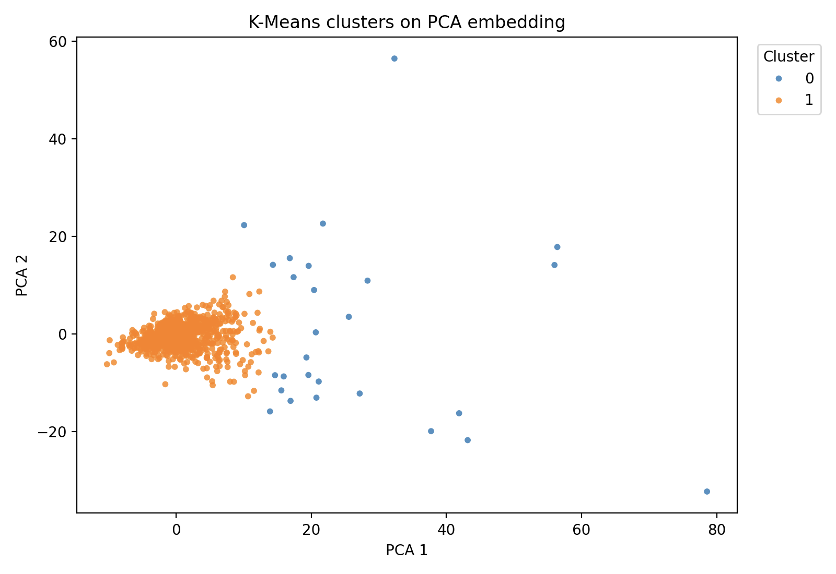
Figure 9. K-Means clusters on the PCA embedding. K-Means produced two clusters with stronger silhouette scores, but one cluster was still much smaller than the other. The held-out FMD comparison was stronger for K-Means in this rerun, while ultimately DBSCAN (discussed and shown above and below) was more useful for identifying unusual counties. These results are exploratory and do not imply causality.
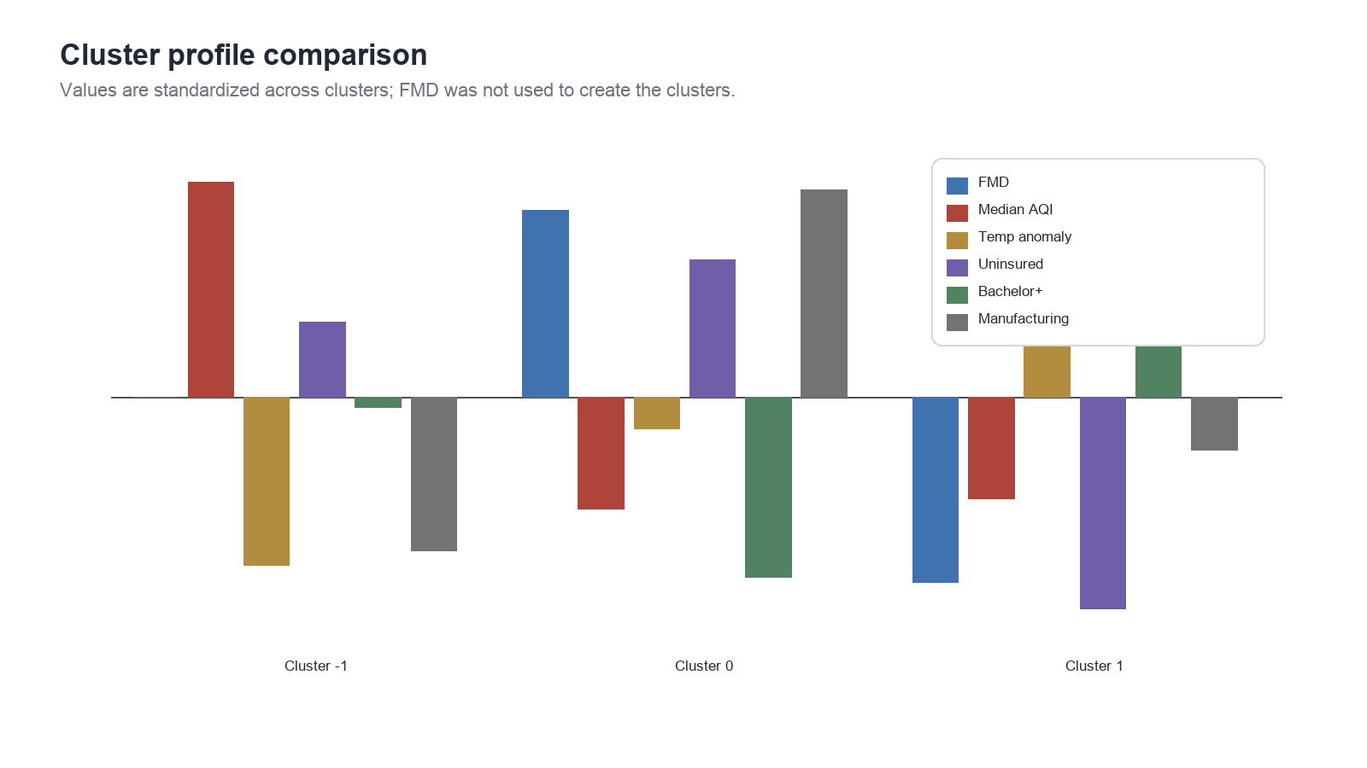
Figure 10. Standardized cluster profiles. Notice that the cluster sizes are very unbalanced. Therefore, although we do have emergent clusters occur, it would be responsible to advise that profile interpretation should be exercised with high caution/skepticism at this stage.
Discussion
The enriched feature set contains some predictive signal, but not enough for confident next-year FMD forecasting. The best model improved over the Dummy baseline and approached zero R², but large residuals remained in high-distress counties. This was surprising because adding ACS, climate, and daily AQI features helped performance but did not solve the high-FMD tail. Moreover, DBSCAN found a dominant county group plus outliers and a very small second cluster. K-Means produced two clusters with stronger silhouette scores, but one cluster was still much smaller than the other. The held-out FMD comparison was stronger for K-Means in this rerun, while DBSCAN was more useful for identifying unusual counties. (These are offered as observational and are not intended as implication).
Ultimately, the project’s empirical result is a negative finding: annual county-level air quality, climate, and socioeconomic variables did not provide strong next-year FMD prediction under a leakage-safe temporal holdout. This does not mean environmental conditions are irrelevant to mental health. We do admit that county feature space is dominated by one large group with smaller outlier groups. The main challenge was that density-based clustering did not produce balanced archetypes. Comparing DBSCAN with K-Means helped clarify the tradeoff between outlier detection and partitioning all counties into interpretable groups.
Rather, our study suggests that the current feature set, spatial scale, and annual aggregation are not enough for reliable forecasting. This is still a useful result because we do not want to overclaim, even though some interesting emergent insights arose from our exploratory analyses. A rigorous negative or weak-signal finding remains scientifically valuable, even if we do not have a policy-ready predictor to show for our work.
Overall, our work thus far suggests that county-level environmental and socioeconomic data can support exploratory mental health risk mapping, but the current annual panel is not sufficient for reliable next-year FMD forecasting. We found that stronger data are needed before county-level air quality can be used as a reliable predictor of next-year mental distress. The best supervised model only modestly improved over the mean baseline and retained negative holdout R². The unsupervised pipeline created a useful framework for county profiling, but DBSCAN produced highly unbalanced clusters, so its findings should be interpreted cautiously.
Future work should rerun the full modeling pipeline after cleaning sentinel missing values, adding healthcare access and rurality variables, and incorporating richer daily or monthly exposure data. It may be possible to rebuild essentially a bigger PLACES dataset using BFRSS data (covering more years). At this point, what we have is a harmonized county-year dataset, external data enrichment, a leakage-safe supervised forecasting framework, an unsupervised clustering pipeline with held-out outcome evaluation, and spatial residual analysis. Together, these provide a foundation for future work by identifying both what can currently be predicted and where additional data or richer features may be needed.
Ethical Considerations and Notes of Caution/Limitation
- Predictions are county-level planning signals, not individual diagnoses or risk scores. Specifically, county-level predictions should not be interpreted as individual-level mental health risk.
- High-FMD counties should not be stigmatized; maps should be used to guide support and further inquiry, not blame-directed speculation.
- Sparse monitor coverage and modeled PLACES estimates and imputed environmental values carry uncertainty that should be communicated/considered as a constraint.
- Forecasting tools for mental health resource planning should be paired with local expertise and community input.
- Because the analysis is predictive and exploratory, it should not be used as causal evidence for regulatory decisions without further study.
Limitation | Implication | Recommended next step
Annual county aggregation | Smooths short-term exposure events and local heterogeneity | Use monthly or daily exposure windows and spatially finer outcomes where possible
Sparse EPA daily AQI coverage | Daily AQI features are available only for monitored counties | Model monitor coverage explicitly or add satellite/reanalysis pollution estimates
ACS source-year backfill for 2019-2020 | Some supplemental variables use earliest available table-based ACS source year | Use a Census API key or historical ACS summary files for exact year matching
Negative income sentinel values in source panel | Requires cleaning before modeling and profile interpretation | Treat sentinel values as missing and rerun models
Missing healthcare and rurality variables | May explain residual patterns not captured by AQI/climate | Add provider density, RUCC/NCHS urban-rural class, opioid burden, disability, and greenspace
No causal identification strategy | Associations should not be framed as pollution effects | Use quasi-experimental or longitudinal causal designs for policy claims
Statement of Work
Team member | Primary contributions
Jaeah Kim | Unsupervised learning analysis support, formatting, clustering design, interpretation support
Kyle Rodriguez | Visualization support, supervised and unsupervised evaluation, repository cleanup, data gathering, initial baselines for supervised learning report synthesis
Sophia Boettcher | Dataset integration, imputation workflow, supervised and unsupervised baselines support, final report drafting support
All team members | EDA, data cleaning, modeling review, interpretation, and final presentation/report synthesis
References
Centers for Disease Control and Prevention. (n.d.). PLACES: Local Data for Better Health. Retrieved June 27, 2026, from https://www.cdc.gov/places
Lei, K., Yang, J., & Ke, X. (2025). The impact of neighborhood environment on the mental health: Evidence from China. Frontiers in Public Health, 12, 1452744. https://doi.org/10.3389/fpubh.2024.1452744
Park, H., Kang, C., AiMS-CREATE Team, & Kim, H. (2024). Particulate matters (PM2.5, PM10) and the risk of depression among middle-aged and older population: Analysis of the Korean Longitudinal Study of Aging (KLoSA), 2016–2020 in South Korea. Environmental Health, 23(1), Article 4. https://doi.org/10.1186/s12940-023-01043-1
U.S. Census Bureau. (2009–2024). American Community Survey 5-Year Estimates [Data set]. Census Data API. https://api.census.gov/data
U.S. Environmental Protection Agency. (2026). Air Quality System (AQS) Data Mart: AirData [Data set]. https://aqs.epa.gov/aqsweb/airdata/download_files.html
Werder, E., Lawrence, K., Deng, X., Jackson II, W. B., Christenbury, K., Buller, I., Engel, L., & Sandler, D. (2024). Residential air pollution, greenspace, and adverse mental health outcomes in the U.S. Gulf Long-term Follow-up Study. Science of the Total Environment, 946, 174434. https://doi.org/10.1016/j.scitotenv.2024.174434

Appendix A - Bibliography

Appendix B - Data Schema

Appendix C - Notebook Catalog

